SUPPLEMENTAL FIGURES
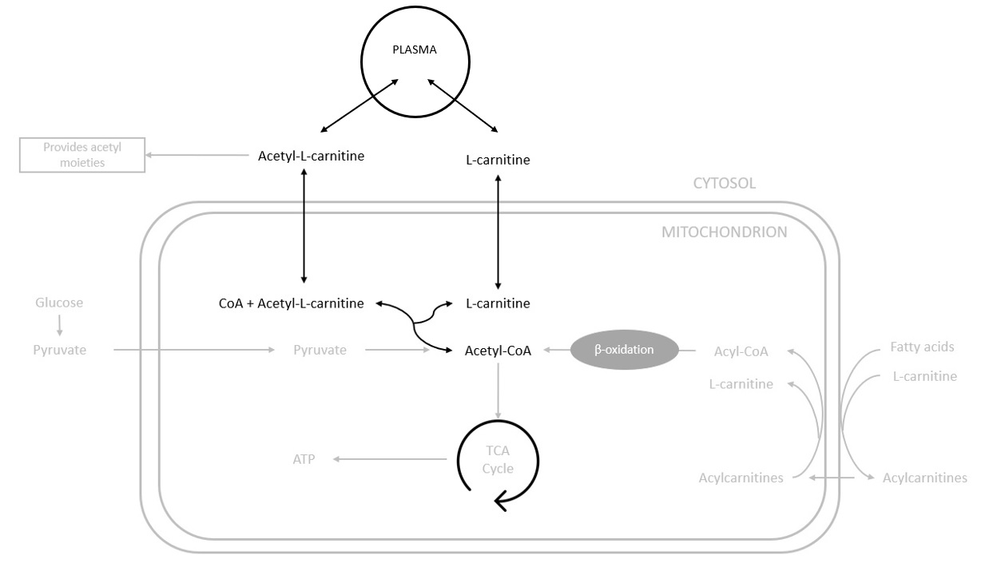
Supplemental Figure 1. Simplified representation of acetyl-L-carnitine and L-carnitine roles in acetyl-CoA homeostasis and fatty acid β-oxidation. Acetyl-CoA is produced from glucose and fatty acids thought β-oxidation. L-carnitine allows the carrier of fatty acids into the mitochondrial matrix. Acetyl-carnitine and L-carnitine contribute to the acetyl-CoA homeostasis needed for the energy production thought the citric acid cycle (TCA cycle). In case of deficiency of acetyl-CoA, acetyl-L-carnitine provides acetyl moiety to coenzyme A (CoA) to reconstitute acetyl-CoA and releases the L-carnitine. In case of excess of acetyl-CoA, L-carnitine retrieves the acetyl moiety to constitute acetyl-L-carnitine and releases CoA. These two reactions are realized by the carnitine acetyltransferase. The black font reaction was evaluated in this work. The grey font reactions were not evaluated.

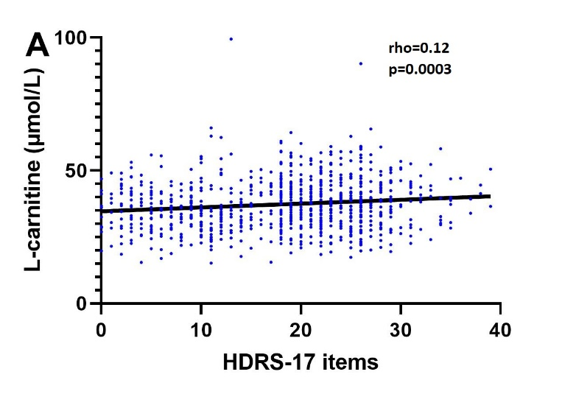 | 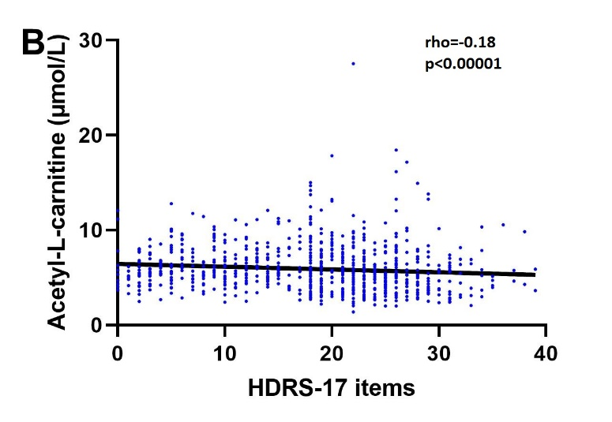
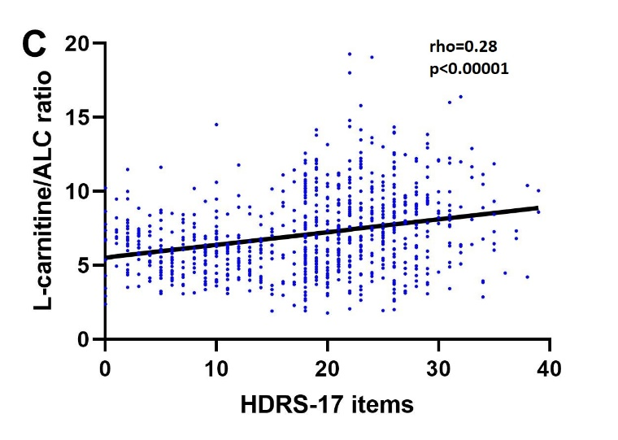 | Supplemental Figure 2. Correlation between HDRS-17-items total score and plasma L-carnitine and ALC levels and the L-carnitine/ALC ratios in depressed patients at baseline, M3 and M6. Spearman’s correlation tests were performed (A): Plasma L-carnitine levels and HDRS total score in depressed patients (B): Plasma ALC levels and HDRS total score in depressed patients (C): L-carnitine/ALC ratios and HDRS total score in depressed patients – ALC: Acetyl-L-carnitine – HDRS: Hamilton Depression Rating Scale.

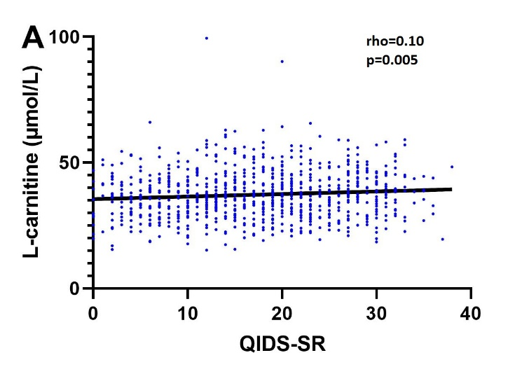 | 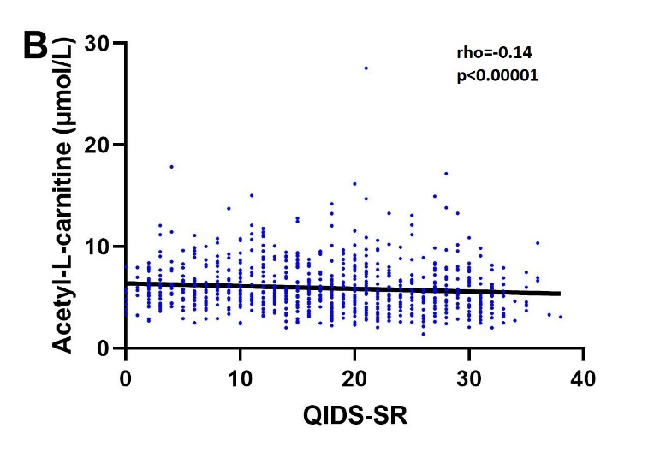
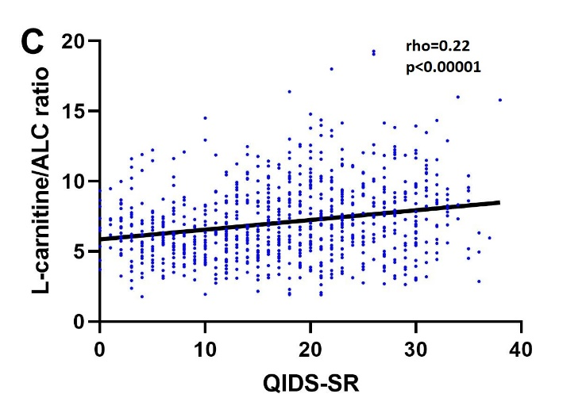 | Supplemental Figure 3. Correlation between QIDS-SR total score and plasma L-carnitine and ALC levels and the L-carnitine/ALC ratios in depressed patients at baseline, M3 and M6. Spearman’s correlation tests were performed (A): Plasma L-carnitine levels and QIDS-SR total score in depressed patients (B): Plasma ALC levels and QIDS-SR total score in depressed patients (C): L-carnitine/ALC ratios and QIDS-SR total score in depressed patients – ALC: Acetyl-L-carnitine – QIDS-SR: Quick Inventory of Depressive Symptoms-Self-Report.

SUPPLEMENTAL TABLES
 | Healthy controls | Depressed patients at baseline | p-control | Depressed patients at M3 | p-control | p-baseline | Depressed patients at M6 | p-control | p-baseline
Gender
Male
n | 457 | 145 |  | 80 |  |  | 59
L-carnitine (µmol/L) (m(SD)) | 38.0 (6.5) | 42.1 (8.4) | <0.00001 | 39.5 (9.2) | 0.12 | 0.06 | 38.5 (8.8) | 0.82 | 0.005
ALC (µmol/L) (m(SD)) | 6.73 (2.27) | 5.52 (2.28) | <0.00001 | 6.21 (1.97) | 0.06 | 0.005 | 6.78 (2.44) | 0.91 | 0.0002
L-carnitine/ALC ratio (m(SD)) | 6.13 (1.77) | 8.55 (2.88) | <0.00001 | 6.80 (2.07) | 0.009 | <0.00001 | 6.12 (1.83) | 0.81 | <0.00001
Female
n | 436 | 315 |  | 158 |  |  | 114
L-carnitine (µmol/L) (m(SD)) | 33.4 (7.5) | 37.2 (9.7) | <0.00001 | 34.1 (9.7) | 0.61 | 0.0004 | 33.5 (10.5) | 0.37 | <0.00001
ALC (µmol/L) (m(SD)) | 6.61 (2.30) | 5.55 (2.86) | <0.00001 | 6.20 (2.11) | 0.06 | <0.00001 | 6.51 (2.08) | 0.85 | <0.00001
L-carnitine/ALC ratio (m(SD)) | 5.48 (1.67) | 7.75 (2.92) | <0.00001 | 5.90 (1.92) | 0.04 | <0.00001 | 5.48 (1.77) | 0.61 | <0.00001
Age
< 50 years
n | 607 | 263 |  | 142 |  |  | 101
L-carnitine (µmol/L) (m(SD)) | 34.8 (7.2) | 36.7 (8.8) | 0.004 | 34.0 (8.1) | 0.30 | 0.006 | 33.4 (7.2) | 0.05 | 0.0008
ALC (µmol/L) (m(SD)) | 6.39 (2.18) | 5.11 (2.24) | <0.00001 | 5.98 (2.10) | 0.03 | <0.00001 | 6.20 (2.08) | 0.38 | <0.00001
L-carnitine/ALC ratio (m(SD)) | 5.89 (1.80) | 8.19 (3.05) | <0.00001 | 6.20 (2.15) | 0.24 | <0.00001 | 5.83 (1.85) | 0.47 | <0.00001
≥ 50 years
n | 286 | 197 |  | 96 |  |  | 72
L-carnitine (µmol/L) (m(SD)) | 37.9 (7.2) | 41.5 (9.8) | <0.00001 | 38.7 (11.5) | 0.71 | 0.01 | 37.6 (13.0) | 0.21 | 0.0007
ALC (µmol/L) (m(SD)) | 7.28 (2.39) | 6.12 (3.10) | <0.00001 | 6.54 (1.97) | 0.01 | 0.003 | 7.16 (2.26) | 0.93 | <0.00001
L-carnitine/ALC ratio (m(SD)) | 5.64 (1.63) | 7.74 (2.73) | <0.00001 | 6.20 (1.80) | 0.02 | <0.00001 | 5.51 (1.75) | 0.35 | <0.00001
BMI
< 25 kg/m²
n | 683 | 294 |  | 139 |  |  | 92
L-carnitine (µmol/L) (m(SD)) | 35.3 (7.4) | 37.6 (8.8) | <0.00001 | 34.3 (8.5) | 0.17 | <0.00001 | 33.0 (7.1) | 0.004 | <0.00001
ALC (µmol/L) (m(SD)) | 6.63 (2.26) | 5.12 (2.36) | <0.00001 | 5.95 (2.04) | 0.0008 | <0.00001 | 6.31 (2.17) | 0.17 | <0.00001
L-carnitine/ALC ratio (m(SD)) | 5.77 (1.76) | 8.38 (3.06) | <0.00001 | 6.24 (2.10) | 0.04 | <0.00001 | 5.69 (1.89) | 0.38 | <0.00001
≥ 25 kg/m²
n | 210 | 166 |  | 95 |  |  | 78
L-carnitine (µmol/L) (m(SD)) | 37.5 (6.9) | 40.8 (10.4) | 0.001 | 38.4 (11.3) | 0.75 | 0.05 | 37.7 (12.6) | 0.36 | 0.006
ALC (µmol/L) (m(SD)) | 6.81 (2.35) | 6.29 (3.05) | 0.001 | 6.46 (1.96) | 0.33 | 0.08 | 6.87 (2.22) | 0.67 | 0.005
L-carnitine/ALC ratio (m(SD)) | 5.97 (1.70) | 7.32 (2.55) | <0.00001 | 6.24 (1.86) | 0.37 | 0.0005 | 5.74 (1.71) | 0.21 | <0.00001
Supplemental Table I. Plasma L-carnitine and ALC levels in healthy controls and in depressed patients during the follow-up according to age, gender and BMI. Wilcoxon tests were performed – ALC: Acetyl-L-carnitine – BMI: Body mass index – M3: 3 months – M6: 6 months – n: number of subjects – m: mean – SD: Standard deviation – p-control: compared to healthy controls – p-baseline: compared to depressed patients at baseline – Bold P-value: Significance after Bonferroni corrections (P<0.0167)

 | L-carnitine (µmol/L) |  | ALC (µmol/L) |  | L-carnitine/ALC ratio
 | Values | p | Values | p | Values | p
At baseline
SSRI (n=175) | 38.1 (8.6) | 0.44 | 5.49 (2.56) | 0.60 | 8.03 (3.09) | 0.46
SNRI (n=177) | 39.0 (10.7) |  | 5.70 (2.96) |  | 7.77 (2.69)
TCA (n=38) | 39.0 (8.5) |  | 5.45 (2.14) |  | 8.72 (3.19)
Others (n=70) | 39.8 (9.1) |  | 5.21 (2.87) |  | 8.11 (2.93)
At 3 months
SSRI (n=87) | 35.7 (8.8) | 0.27 | 6.25 (2.02) | 0.99 | 6.10 (1.87) | 0.71
SNRI (n=96) | 35.5 (10.7) |  | 6.15 (2.01) |  | 6.16 (2.00)
TCA (n=19) | 34.4 (10.4) |  | 6.31 (2.59) |  | 5.92 (1.80)
Others (n=36) | 38.2 (9.9) |  | 6.18 (2.04) |  | 6.71 (2.44)
At 6 months
SSRI (n=67) | 34.7 (7.3) | 0.98 | 6.71 (2.11) | 0.43 | 5.45 (1.38) | 0.26
SNRI (n=72) | 35.3 (12.6) |  | 6.32 (2.03) |  | 5.95 (2.11)
TCA (n=16) | 35.4 (7.8) |  | 6.32 (2.09) |  | 6.04 (1.72)
Others (n=18) | 36.6 (11.2) |  | 7.53 (3.05) |  | 5.28 (1.91)
Supplemental Table II. Association between plasma L-carnitine and ALC levels and the L-carnitine/ALC ratio and antidepressant classes of depressed patients during the follow-up. Kruskal-Wallis tests were performed – ALC: Acetyl-L-carnitine – n: number of patients – m: mean – SD: Standard deviation – SSRI: Selective Serotonin Reuptake inhibitors – SNRI: Serotonin and Norepinephrine Reuptake Inhibitors – TCA: Tricyclic antidepressants – Others: Other antidepressants

 | Coefficient | 95%CI | p
L-carnitine (µmol/L)
Interaction Time x Responders at M3 (n=244) | -0.06 | [-0.44 – 0.31] | 0.73
Interaction Time x Remitters at M3 (n=244) | 0.08 | [-0.31 – 0.48] | 0.69
Interaction Time x Responders at M6 (n=178) | 0.14 | [-0.26 – 0.54] | 0.50
Interaction Time x Remitters at M6 (n=178) | -0.07 | [-0.44 – 0.31] | 0.73
ALC (µmol/L)
Interaction Time x Responders at M3 (n=244) | 0.06 | [-0.07 – 0.19] | 0.29
Interaction Time x Remitters at M3 (n=244) | 0.13 | [-0.00 – 0.25] | 0.054
Interaction Time x Responders at M6 (n=178) | -0.07 | [-0.20 – 0.07] | 0.32
Interaction Time x Remitters at M6 (n=178) | 0.01 | [-0.12 – 0.13] | 0.89
L-carnitine/ALC ratio
Interaction Time x Responders at M3 (n=244) | -0.14 | [-0.28 – -0.00] | 0.05
Interaction Time x Remitters at M3 (n=244) | -0.16 | [-0.31 – -0.01] | 0.03
Interaction Time x Responders at M6 (n=178) | 0.02 | [-0.14 – 0.18] | 0.81
Interaction Time x Remitters at M6 (n=178) | -0.02 | [-0.17 – 0.13] | 0.80
Supplemental Table III. Mixed model analyses for repeated measures for L-carnitine, ALC and the L-carnitine/ALC ratio in depressed patients over time according to the interaction between time and response/remission status. Mixed model analyses were adjusted for age, gender, BMI at baseline, and antidepressant class – M3: at 3 months – M6: at 6 months – n: number of patients – Bold P-value: P<0.05

M3 |  |  | p
Response | Responders (n=132) | Non-Responders (n=112)
L-carnitine (µmol/l) (m(SD)) | 36.3 (10.3) | 36.0 (9.7) | 0.91
ALC (µmol/l) (m(SD)) | 6.17 (2.13) | 6.37 (2.20) | 0.66
Ratio L-carnitine/ALC (m(SD)) | 6.25 (1.84) | 6.13 (2.17) | 0.81
Remission | Remitters (n=69) | Non-Remitters (n=175)
L-carnitine (µmol/l) (m(SD)) | 36.0 (8.4) | 36.2 (10.6) | 0.46
ALC (µmol/l) (m(SD)) | 5.89 (2.00) | 6.40 (2.20) | 0.03
Ratio L-carnitine/ALC (m(SD)) | 6.44 (1.66) | 6.10 (2.11) | 0.26
M6
Response | Responders (n=119) | Non-Responders (n=59)
L-carnitine (µmol/l) (m(SD)) | 35.1 (8.7) | 36.2 (13.2) | 0.48
ALC (µmol/l) (m(SD)) | 6.43 (2.06) | 7.06 (2.55) | 0.11
Ratio L-carnitine/ALC (m(SD)) | 5.80 (1.77) | 5.35 (1.61) | 0.39
Remission | Remitters (n=77) | Non-Remitters (n=101)
L-carnitine (µmol/l) (m(SD)) | 36.2 (9.1) | 34.8 (11.2) | 0.58
ALC (µmol/l) (m(SD)) | 6.72 (2.14) | 6.56 (2.32) | 0.68
Ratio L-carnitine/ALC (m(SD)) | 5.80 (1.77) | 5.46 (1.79) | 0.98
Supplemental Table IV. Plasma L-carnitine and ALC levels and L-carnitine/ALC ratio at according to response and remission status at the same time point. Multivariate analysis by logistic regressions adjusted for age, gender, BMI and antidepressant class were performed – M3: At 3 months – M6: At 6 months – ALC: Acetyl-L-carnitine – n: number of subjects – SD: Standard deviation

M3 |  |  | p
Response | Responders (n=132) | Non-Responders (n=112)
L-carnitine at baseline (µmol/l) (m(SD)) | 39.1 (10.9) | 38.1 (9.1) | 0.18
ALC at baseline (µmol/l) (m(SD)) | 5.33 (2.59) | 5.57 (2.26) | 0.52
Ratio L-carnitine/ALC at baseline (m(SD)) | 8.35 (3.02) | 7.60 (2.60) | 0.03
Remission | Remitters (n=69) | Non-Remitters (n=175)
L-carnitine at baseline (µmol/l) (m(SD)) | 38.6 (9.4) | 38.6 (10.4) | 0.92
ALC at baseline (µmol/l) (m(SD)) | 4.97 (2.11) | 5.63 (2.54) | 0.06
Ratio L-carnitine/ALC at baseline (m(SD)) | 8.75 (3.13) | 7.71 (2.70) | 0.01
M6
Response | Responders (n=119) | Non-Responders (n=59)
L-carnitine at baseline (µmol/l) (m(SD)) | 37.6 (9.6) | 40.0 (11.1) | 0.27
ALC at baseline (µmol/l) (m(SD)) | 5.33 (2.32) | 5.70 (2.50) | 0.84
Ratio L-carnitine/ALC at baseline (m(SD)) | 8.07 (3.17) | 7.77 (2.61) | 0.90
Remission | Remitters (n=77) | Non-Remitters (n=101)
L-carnitine at baseline (µmol/l) (m(SD)) | 39.1 (9.9) | 37.9 (10.4) | 0.38
ALC at baseline (µmol/l) (m(SD)) | 5.41 (2.27) | 5.48 (2.48) | 0.93
Ratio L-carnitine/ALC at baseline (m(SD)) | 8.09 (2.94) | 7.87 (3.04) | 0.61
Supplemental Table V. Plasma L-carnitine and ALC levels and L-carnitine/ALC ratio at baseline according to response and remission status during the follow-up. Multivariate analysis by logistic regressions adjusted for age, gender, BMI and antidepressant class were performed – M3: At 3 months – M6: At 6 months – ALC: Acetyl-L-carnitine – n: number of subjects – SD: Standard deviation – Bold P-value: Significance after Bonferroni corrections (P<0.0167)

