Perinatal Risk Factors and Recent Anemia

Based on the birth history questionnaire, 98% of the mothers received multivitamins during their pregnancy with the participant and none used cigarettes, alcohol, or illicit drugs. Only one participant was born prematurely, at 35 weeks. No infant received any blood transfusion but five (13%) had a significant illness during the first year of life, although none included anemia (otitis media x2, urinary tract infection x1, varicella x1, and gastroesophageal reflux disease x1). Of note, 80% of the respondents rated their confidence level in recalling the information for the birth history questionnaire as good or very good.

To rule out early-life anemia, we reviewed the pediatric medical records when available. Only two participants with hemoglobin measurements obtained between 9 and 15 months of life were found: both having normal values.

Because we had not measured hemoglobin in this study, we also reviewed the participants’ medical record to extract values obtained within a year of the research visit (mean 0.48±0.28 years). We found 19 participants with available hemoglobin values, only one (5%) suggestive of mild anemia (10.5 g/dL).

Supplementary figure:

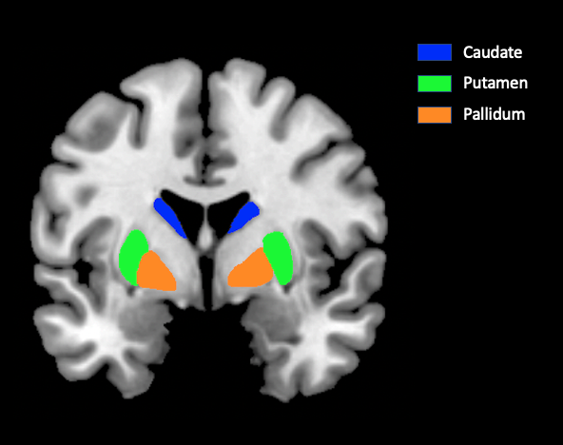

Supplemental figure: Region of Interest of a Brain MRI showing basal ganglia including: Caudate, putamen, pallidum.

