Supplementary material
Supplementary Figure 1. Relationship between variables in the model, displayed as a causal diagram.
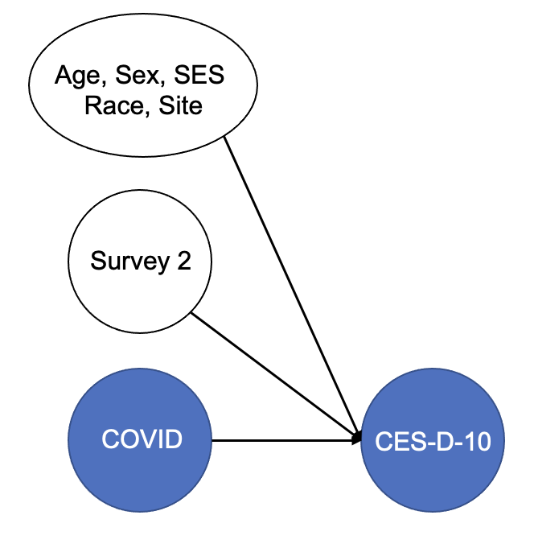

Supplementary Figure 2. Distribution of CES-D-10 within half year intervals (H1 = March to August; H2 = September to February of the following year).
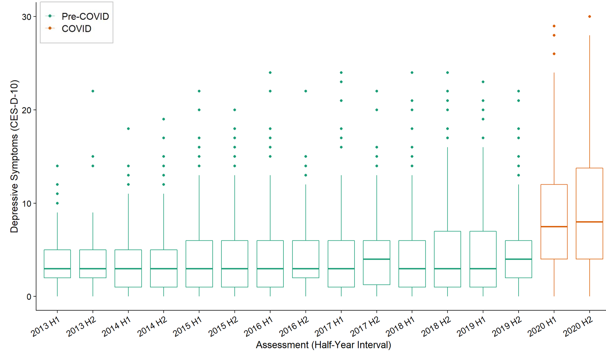

Supplementary Figure 3. Number of participants at risk and below threshold of clinical depression (CES-D-10 score > 10) at the last pre-COVID visit and at COVID Survey 1 (June 2020).
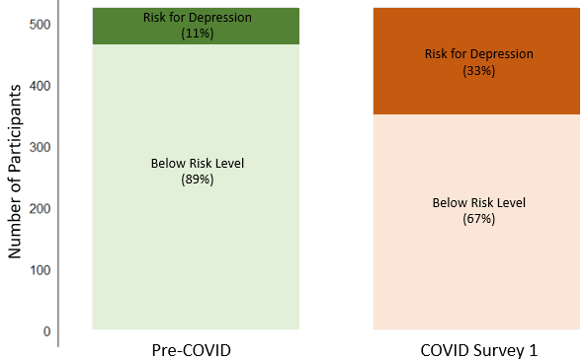
Last pre-COVID visit
COVID Survey 1

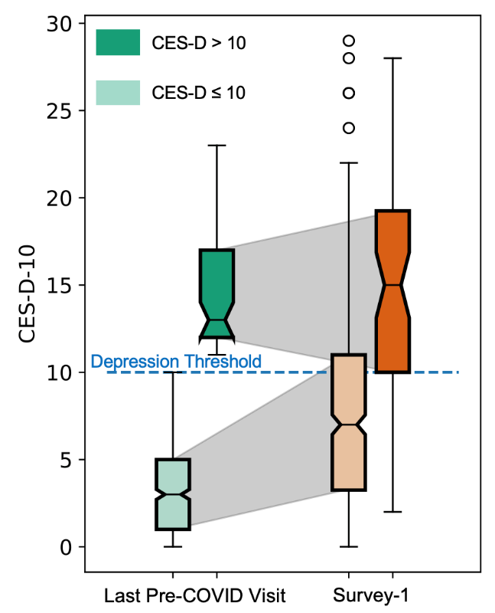
Supplementary Figure 4. Depression symptom scores at the last pre-COVID visit and the first COVID survey (June 2020), plotted separately for those at-risk for depression at their pre-COVID visit (CES-D-10 score > 10, n = 60) and those at low risk for depression at their pre-COVID visit (CES-D-10 score ≤ 10, n= 465). Those at risk for depression pre-COVID showed no change in depression scores during COVID, continuing to score, on average, above the threshold for depression risk.

Supplementary Figure 5. The increase of depressive symptoms (according to CESD-D-10) from Pre-COVID to COVID surveys was significantly greater in younger females compared with the other age-sex groups (p<0.01). Covariates were regressed out from change in CES-D-10.

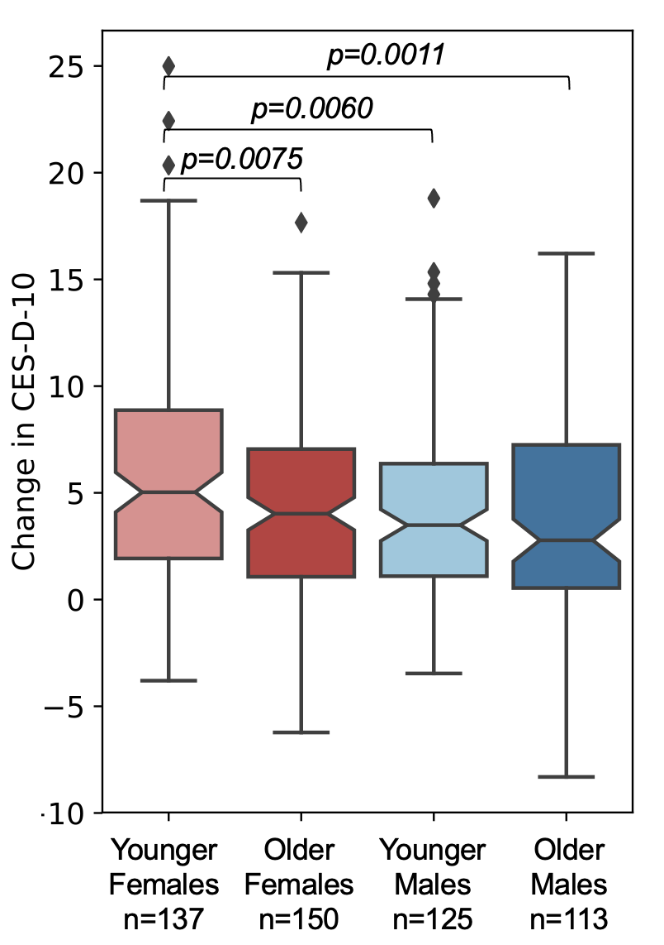

Table S1. Results of the base Poisson mixed-effect model testing for the effect of the COVID pandemic (no interactions with COVID) in 525 NCANDA participants.
 | Coefficients $β$ | SE | Z | Pr(>|Z|)
(Intercept) | 1.279519 | 0.070811 | 18.069 | < 2e-16 | ***
Age | 0.037461 | 0.005087 | 7.365 | 1.78E-13 | ***
Sex (male) | -0.170489 | 0.061571 | -2.769 | 0.00562 | **
Age*Sex | 0.007954 | 0.005453 | 1.459 | 0.145
COVID | 0.553686 | 0.024561 | 22.544 | < 2e-16 | ***
Survey 2 | 0.04969 | 0.020781 | 2.391 | 0.0168 | *
Socioeconomic Status | -0.020243 | 0.012958 | -1.562 | 0.11825
Race
Asian | 0.081075 | 0.117308 | 0.691 | 0.48948
African-American | 0.240794 | 0.115557 | 2.084 | 0.0372 | *
Others | 0.084665 | 0.107427 | 0.788 | 0.431
Site
Duke | -0.151712 | 0.100878 | -1.504 | 0.1326
OHSU | 0.222081 | 0.092404 | 2.403 | 0.01624 | *
SRI International | 0.135145 | 0.088328 | 1.53 | 0.12601
UPMC | -0.078248 | 0.098161 | -0.797 | 0.42537
Note: . = p ≤ .1; * = p ≤ .05; ** = p ≤ .01; *** = p ≤ .001. The fixed effect R² was 0.199.

Table S2. Results of the Poisson mixed-effect model testing for the effect of the COVID pandemic and its interaction with age and sex (two-way interactions) in 525 NCANDA participants.
 | Coefficients $β$ | SE | Z | Pr(>|Z|)
(Intercept) | 1.259217 | 0.070608 | 17.834 | < 2e-16 | ***
Age | 0.026533 | 0.006059 | 4.379 | 1.19E-05 | ***
Sex (male) | -0.11091 | 0.062668 | -1.77 | 0.07676 | .
Age*Sex | 0.038726 | 0.008927 | 4.338 | 1.44E-05 | ***
COVID | 0.703586 | 0.034642 | 20.31 | < 2e-16 | ***
Survey 2 | 0.061375 | 0.020927 | 2.933 | 0.00336 | **
Age*COVID | -0.02533 | 0.005572 | -4.546 | 5.46E-06 | ***
Sex*COVID | -0.199752 | 0.045672 | -4.374 | 1.22E-05 | ***
Socioeconomic Status | -0.021037 | 0.012851 | -1.637 | 0.10164
Race
Asian | 0.087545 | 0.116342 | 0.752 | 0.45176
African-American | 0.22416 | 0.114615 | 1.956 | 0.05049 | .
Others | 0.076094 | 0.106551 | 0.714 | 0.47513
Site
Duke | -0.149603 | 0.100051 | -1.495 | 0.13484
OHSU | 0.220857 | 0.091634 | 2.41 | 0.01594 | *
SRI International | 0.130171 | 0.087635 | 1.485 | 0.13744
UPMC | -0.061782 | 0.097374 | -0.634 | 0.52577
Note: . = p ≤ .1; * = p ≤ .05; ** = p ≤ .01; *** = p ≤ .001. The fixed effect R² was 0.202.

