Table S1. Demographic and Clinical Characteristics of Participants.
 | HC (N = 130) | Depression (N = 195)
Male, No. (%) | 59 (45.38) | 95 (48.7)
Age, mean (SD) [range], y | 21.25 (5.33) [12-36] | 18.14 (4.47) [11-37]
Educational level, mean (SD), y | 13.56 (4.50) | 10.11 (2.13）
Duration of illness, mean (SD), m | - | 15.74 (16.96)
HAMD score, mean (SD), [range] | - | 22.38 (5.72) [12-48]ª  39.29 (11.68) [20-61]^{b}
Handedness, right/left | 130/0 | 195/0
Age of first onset, y | - | 16.81 (4.40)
Abbreviations: HAMD, Hamilton rating scale for depression; ª,17-items HAMD for 167 patients; ^{b}, 24-items HAMD for 28 patients.

Table S2. The clinical demographics of patients at different stages and matched HCs.

 | Stage 1 |  |  | Stage 2 |  |  | Stage 3
 | depression | HC | p | depression | HC | p | depression | HC | p
Age (years), mean ± SD | 17.170 ± 3.58 | 17.020 ± 2.762 | 0.999ª | 18.146 ± 4.759 | 17.173 ± 2.821 | 0.148ª | 18.617 ± 3.645 | 17.739 ± 2.975 | 0.164ª
Gender, male : female | 44 : 44 | 36 : 40 | 0.958^{b} | 25 : 30 | 36 : 39 | 0.995^{b} | 23 : 24 | 32 : 33 | 0.971^{b}
Duration of illness (months), mean ± SD | 4.046 ± 2.458 |  |  | 12.891 ± 2.015 |  |  | 39.064 ± 17.732
Years of education, mean ± SD | 10.048 ± 2.200 | 10.553 ± 2.905 | 0.214ª | 9.816 ± 2.058 | 10.413 ± 2.727 | 0.193ª | 9.816 ± 2.058 | 10.413 ± 2.727 | 0.427ª
Handedness, right/left | 88/0 | 76/0 |  | 55/0 | 75/0 |  | 47/0 | 65/0
Age of first onset (years) | 16.796 ± 3.589 |  |  | 16.964 ± 4.710 |  |  | 15.468 ± 3.816
Note: ª two-tailed two sample t test; ^{b} Chi-square t-test; HC, healthy control

Table S3. Overall GMV alterations in depression.

Clusters | Voxles | Including regions | Peak MNI (x,y,z) | T
1 | 20260 | Thalamus | -9, -35, -3 | -7.004
 |  | Parahippocampa gyrus
 |  | Lingual Gyrus
 |  | Hippocampus
 |  | Fusiform
 |  | Cerebrum
2 | 1361 | Ventral medial prefrontal cortex | -15, 3, -18 | 4.327
 |  | Amygdala
3 | 824 | Precuneus | 23, -54, 72 | 3.877
 |  | Postcentral gyrus
 |  | Superior parietal gyrus
 |  | Superior parietal lobule

Table S4. Different GMV alterations at different stages in depression.

Stages | Clusters | Voxles | Including regions | Peak MNI (x,y,z) | T
Stage 1 | 1 | 1509 | Ventral medial prefrontal cortex | -2, 18, -12 | 3.824
 |  |  | Bilateral olfactory
 |  |  | Bilateral Amygdala
 |  |  | Temporal pole
 | 2 | 3066 | Cerebellum posterior lobe | 26, -59, -39 | -4.743
 | 3 | 1130 | Cerebellum | -21, -48, -42 | -4.313
 | 4 | 4525 | Bilateral hippocampus | 21, -35, 9 | 4.680
 |  |  | Bilateral thalamus
 |  |  | Parahippocampa gyrus
 |  |  | Right lingual
Stage 2 | 1 | 2061 | Right insula | 27, 6 , -12 | 4.329
 |  |  | Right rolandic operculum
 |  |  | Right amygdala
 |  |  | Right putamen
 |  |  | Superior temporal gyrus
 | 2 | 1055 | Inferior frontal gyrus | -42, 44, -18 | 4.515
 | 3 | 1032 | Bilateral Thalamus | 6, -3, 12 | -4.075
 | 4 | 1367 | Right dorsolateral frontal gyrus | 24, 48, 29 | 3.719
 |  |  | Right anterior cingulate
 |  |  | Superior frontal gyrus
 | 5 | 1126 | Right dorsolateral frontal gyrus | 32, 32, 33 | 3.908
Stage 3 | 1 | 32437 | Cerebellum posterior lobe | -5, -63, -27 | -6.289
 |  |  | Bilateral thalamus
 |  |  | Bilateral lingual
 |  |  | Right fusiform
 |  |  | Parahippocampa gyrus
 |  |  | Bilateral hippocampus
 | 2 | 954 | Right precuneus | 11,-72,34.5 | -3.835
 |  |  | Right cuneus
 | 3 | 1522 | Precentral gyrus | -6,-27,74 | -4.445
 |  |  | Medial frontal gyrus

Table S5. Altered GMVs in patients with shorter illness duration (< 3/6 months).

Illness duration | Clusters | Voxles | Including regions | Peak MNI (x,y,z) | T
< 3 months | 1 | 1292 | Ventral medial prefrontal cortex | -2, 18, -12 | 3.814
 | 2 | 1572 | Bilateral hippocampus | 30, -35, 9 | -3.550
 |  |  | Bilateral thalamus
< 6 months | 1 | 1247 | Ventral medial prefrontal cortex | -6, 11, 17 | 3.602
 |  |  | Parahippocampa gyrus
 |  |  | Bilateral amygdala
 | 2 | 1195 | Cerebellum | -26, -50, -38 | -2.620
 | 3 | 8244 | Cerebellum | 29, -72, -20 | -2.620
 |  |  | Bilateral thalamus
 |  |  | Bilateral hippocampus
 |  |  | Parahippocampa gyrus

Table S6. The causal effects of GMV alterations pattern in depression.

Seeds | Clusters | Voxles | Including regions | Peak MNI (x,y,z) | Z
vmPFC | 1 | 821 | Cerebellum posterior lobe | 41, -72, -29 | 7.568
 | 2 | 1069 | Anterior Cingulate | -2, 18, -12 | -52.521
 |  |  | Bilateral nucleus accumbens
 |  |  | Medial frontal gyrus
 | 3 |  | Left calcarine | -24, -63, 8 | -10.189
 |  |  | Left precuneus
 |  |  | Posterior cingulate
 | 4 | 477 | Left rolandic operculum | -45, -20, 12 | -7.862
 |  |  | Left insula
 | 5 | 623 | Left precuneus | -17, -68, 23 | 10.296
 |  |  | Left cuneus
 |  |  | Left superior occipital gyrus
Left hippocampus | 1 | 878 | Right nucleus accumbens | 14, 14, 6 | 10.081
 | 2 | 586 | Left Bilateral nucleus accumbens | -14, 11, 12 | 9.992
 | 3 | 641 | Right calcarine | 14, -69, 11 | 8.651
 |  |  | Bilateral precuneus
 | 4 | 226 | Right inferior frontal gyrus | 41, 24, 23 | -9.848
 | 5 | 379 | Left inferior parietal lobule | -32, -57, 39 | -9.043
 | 6 | 200 | Right precuneus | 5, -56, 56 | 7.636
 | 7 | 427 | Left middle occipital gyrus | -41, -74, 20 | 8.437
 |  |  | Middle temporal gyrus
Right hippocampus | 1 | 1848 | Cerebellum posterior lobe | 12, -57, -50 | 8.268
 | 2 | 232 | Right nucleus accumbens | 12, 15, 3 | 7.699
 | 3 | 231 | Superior medial frontal gyrus | 8, 51, 17 | 7.585
 | 4 | 575 | Right precuneus | 12, -54, 14 | 9.995
 |  |  | Right calcarine
 | 5 | 392 | Left cuneus | -15, -59, 18 | 10.913
 |  |  | Left precuneus
 | 6 | 287 | Right dorsolateral frontal gyrus | 42, 35, 33 | 7.650
 | 7 | 653 | Left dorsolateral frontal gyrus | -35, 20, 41 | 9.216
 | 8 | 1170 | Right dorsolateral frontal gyrus | 41, 5, 41 | 10.552

Table S7. Coefficient-based GC values from bilateral hippocampus and the vmPFC to other brain regions drawn in Figure 5.
Region | Seed
 | vmPFC | Hipp
MTG | -10.51 | -
IPL | - | -7.76
IFG | - | -9.62
MO | - | 10.20
NAc | 9.32 | 10.08
DLPFC | 7.99 | 7.70
CB | 6.21 | 8.06
Pre | -10.34 | 9.99
ACC | 10.39 | 7.58
RO | -6.42 | -
Cal | -6.64 | -
Note: vmPFC, ventral medial prefrontal cortex; Cal, calcarine; RO, rolandic operculum; ACC, anterior cingulate cortex; Pre, precuneus; CB, Cerebelum; Hip, hippocampus; DLPFC, dorsolateral frontal gyrus; NAc, nucleus accumbens; MO, middle occipital gyrus; IFG, inferior frontal gyrus; IPL, inferior parietal lobule; MTG, middle temporal gyrus.

Figure S1. Correlation between GMV and clinical characteristics.
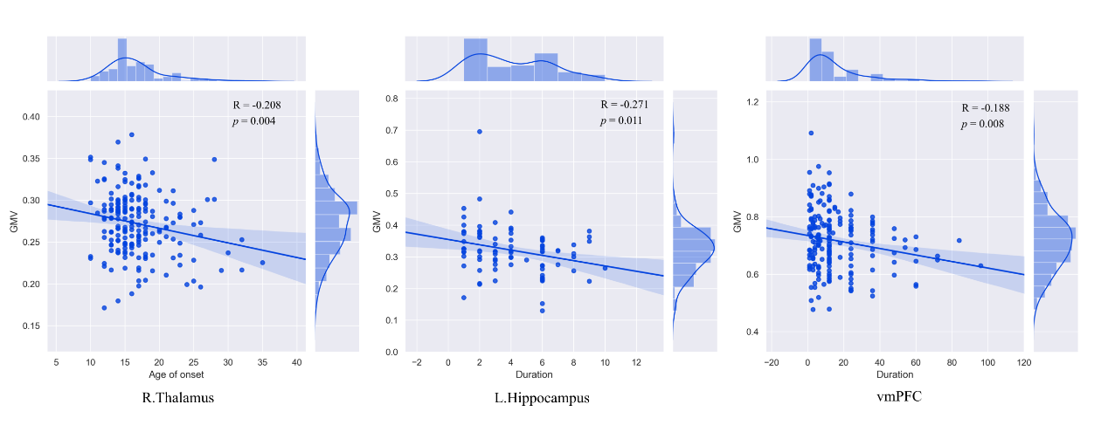

Figure S2. The comparative results of GMV alteration in patients with depression at stage 3. The results were not corrected multiple comparisons (voxel p < 0.05). As we saw, the GMV of medial fontal gyrus (temporally increased at stage 2) presented decreasing trend in patients with longer illness duration although the difference was not significant.

