Supplementary-Materials
Clustering analysis
After regressed out total methadone consumption, the DC value extracted from the 10 paired of ROIs of the 60 patients was used to make a 60 x 20 matrix M. Based on the matrix M, the next clustering analysis process was performed with R (https://www.R-project.org/) (12) and several R packages (factoextra (Kassambara and Mundt, 2020), NbClust (Charrad et al., 2014)). The Clustering procedure includes 6 primary steps, they are:
(1) Assessing clustering tendency of the matrix M
To identify whether the data was clusterable, the Hopkins' statistic and a visual approach were used. Hopkins statistic was applied to assess the clustering tendency of a dataset by measuring the probability that a given dataset that is generated by a uniform data distribution. In other words, it tests the spatial randomness of the data.
- Sample uniformly n points (p1,..., pn) from D.
- For each point pi∈D, find it’s nearest neighbor pj; then compute the distance between pi and pj and denote it as xi=dist (pi, pj).
- Generate a simulated dataset (random D) drawn from a random uniform distribution with n points (q1,..., qn) and the same variation as the original real dataset D.
- For each point qi∈ random D, find it’s nearest neighbor qj in D; then compute the distance between qi and qj and denote it yi=dist (qi,qj).
- Calculate the Hopkins statistic (H) as the mean nearest neighbor distance in the random dataset divided by the sum of the mean nearest neighbor distances in the real and simulated datasets.
- The formula is defined as follow:
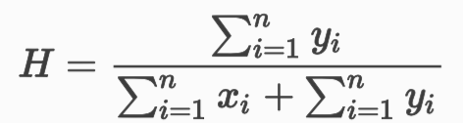
A value of H about 0.5 means that 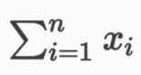and 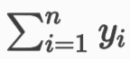 are close to each other, and thus the data D is uniformly distributed.
In our study, Hopkins statistic value for M was 0.38, far less than 0.5, meaning the clusterability of the matrix M. In addition, it was implied that the matrix M was of significant clusterability from the ODI (ordered dissimilarity image) of the matrix (Supple-Fig.1)
Supple-Fig.1 The ordered dissimilarity image of matrix M
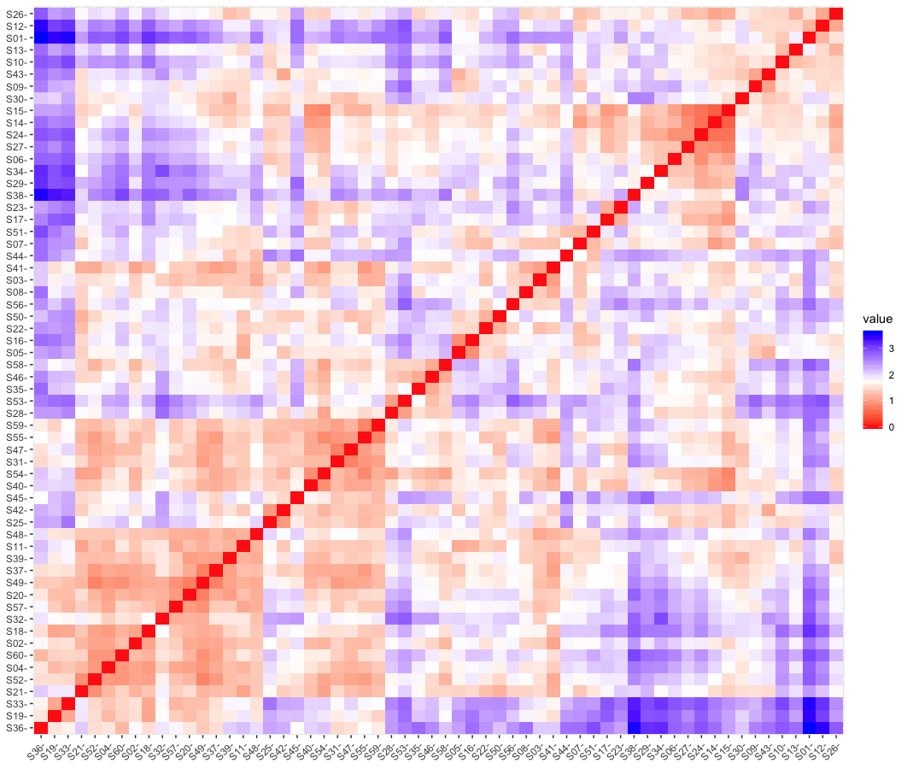
The color level is proportional to the value of the dissimilarity between observations. Objects belonging to the same cluster are displayed in consecutive order. The dissimilarity matrix image confirmed that there is a cluster structure in the HD participants data set. Two main subgroups (subgroup-1and subgroup-2) were identified. Red: High similarity, Blue: Low similarity.
(2) Identifying the optimal number of clustering
To identify the optimal clustering number K, 26 out of 30 clustering index (default option), K=1,…,10, were compared with each other using Euclidean distance of ward. D2 aggregation algorithm.
Euclidean distance: Usual square distance between the two vectors.
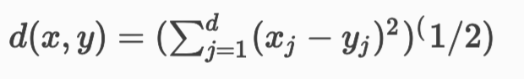
Ward. D2: Ward method minimizes the total within-cluster variance. At each step the pair of clusters with minimum cluster distance was merged. To implement this method, we did at each step find the pair of clusters that leads to minimum increase in total within-cluster variance after merging. “Ward. D2” means the dissimilarities are squared before cluster updating.
In our study, the best clustering number K was defined as 2 according to majority rule (Supple-Fig.2). The optimal clustering number K=2 depends on 7 indices out of 26 clustering indices (Supple-Fig.3).
Supple-Fig.2 Barplot of optimal number of clusters k
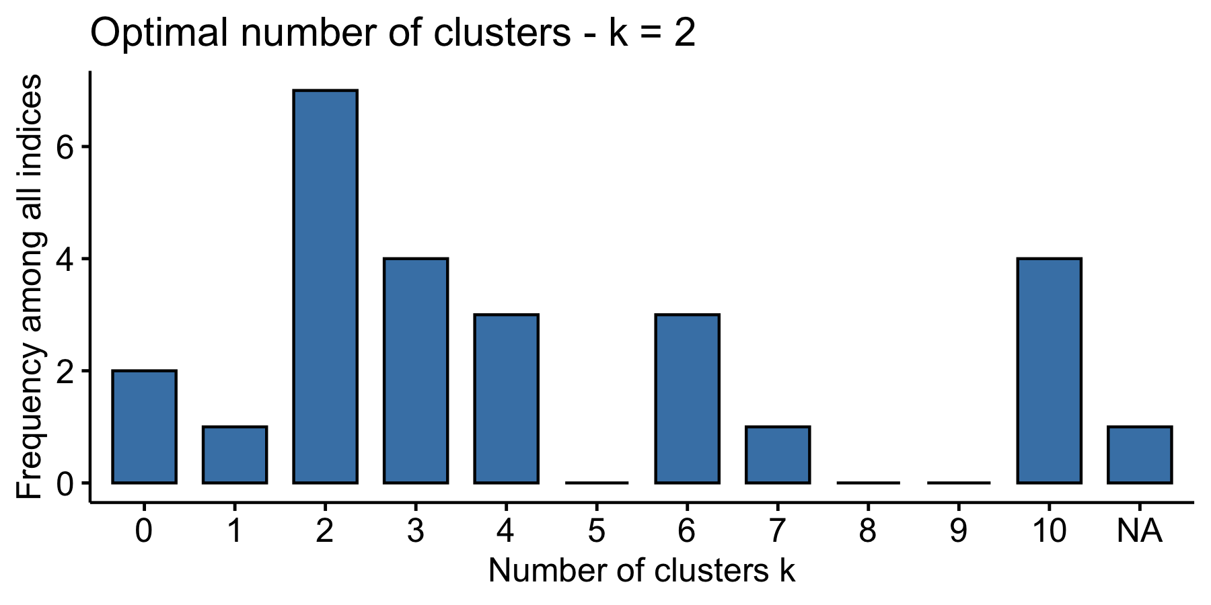
In this figure, 0 means there is no best cluster number could be calculated and NA’s means that the best cluster number is not available because the cluster index is not applicable for Ward. D2 aggregation algorithm.
Supple-Fig.3 The broken line chart of 7 clustering indices
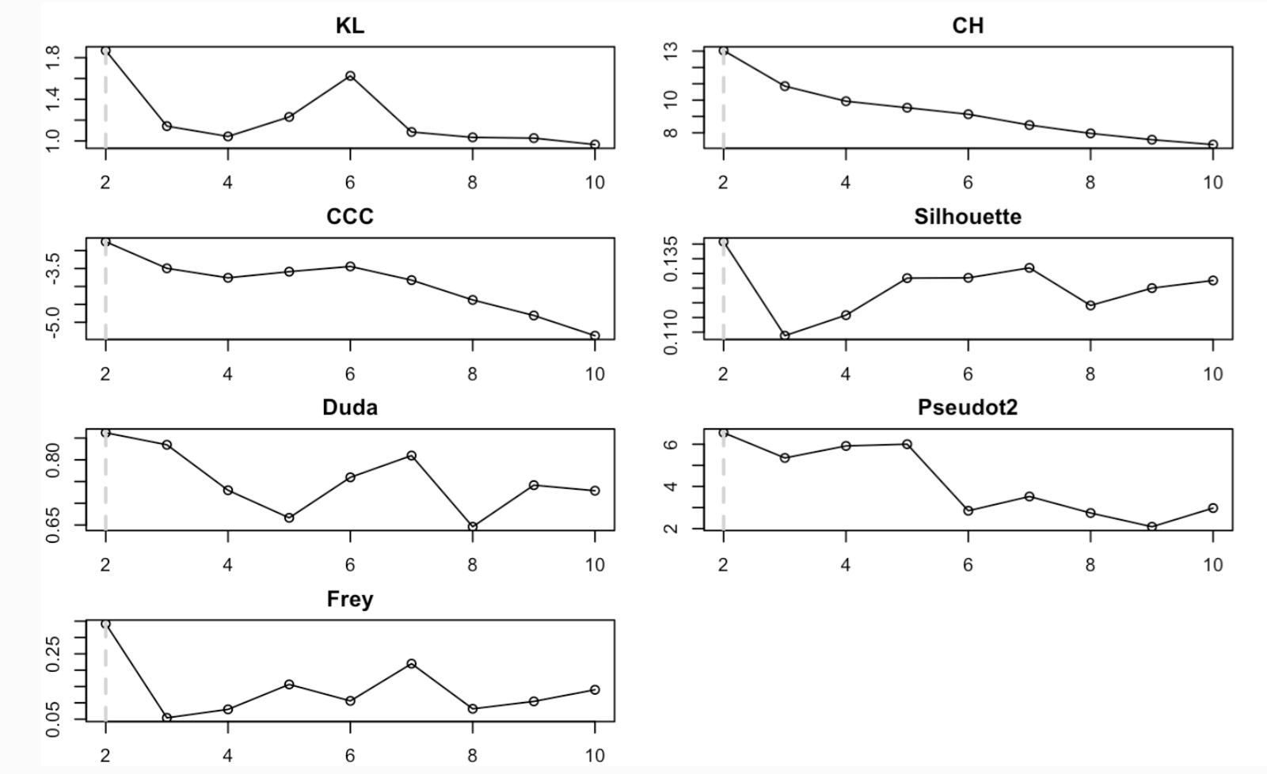

(3) Grouped the HD participants according to K-means clustering algorithm
K-means algorithm aims to partition the points into k groups such that the sum of squares from points to the assigned cluster centers is minimized. We repeated this process for 25 times to avoid finding a local minima.
In our study, 60 HD participants were divided into two groups according to the best clustering number K. There were 29 patients in group-1 and 31 patients in Group-2 (Supple-Fig.4).
Supple-Fig.4 Cluster plot of 60 HD participants
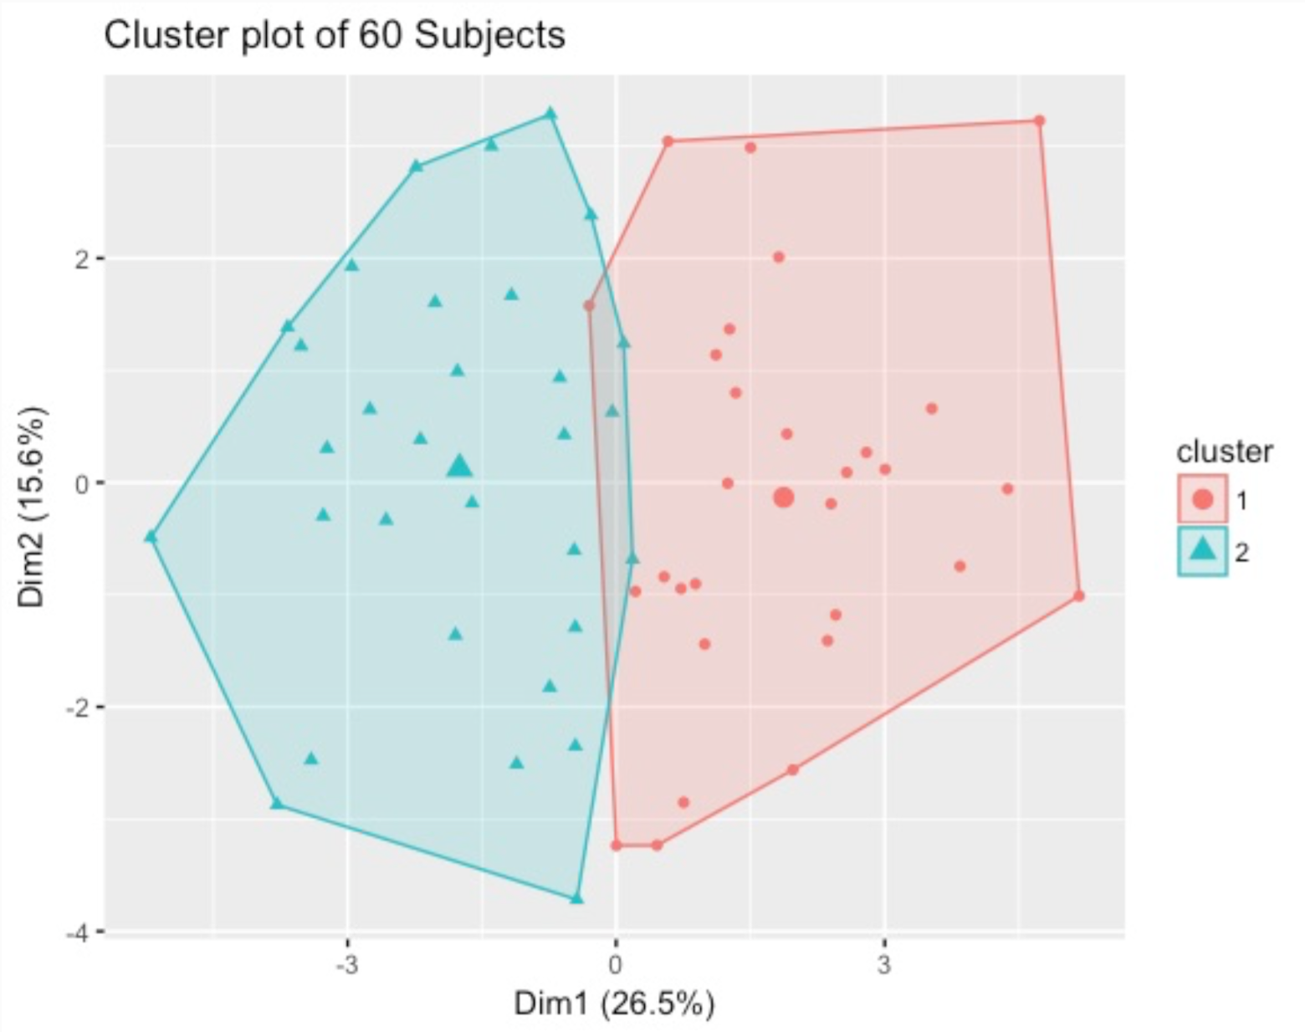
Dim1 and Dim 2 are the first two principle components obtained from the matrix M analyzed with principle component analysis.
(4) Clustering efficiency test with Silhouette analysis
Silhouette (Si) analysis (Rousseeuw, 1987) is a cluster validation approach that reflects the compactness and separation of clusters. The Silhouette widths of a sample is defined as:
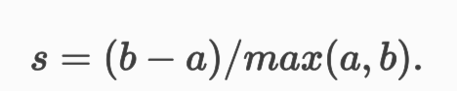
Where a represents the average distance of a sample from the other samples of the cluster to which the sample is assigned, and b represents the minimum of the average distance of the sample from samples of the other clusters. The value of Silhouette index varies from ‐1 to 1 and higher value indicates better clustering result (Rousseeuw, 1987).
After Silhouette analysis, the HD participants’ score scatter graph is shown as Supple-Fig.5.
Supple-Fig.5 Clusters Silhouette plot (Average Silhouette width: 0.18)
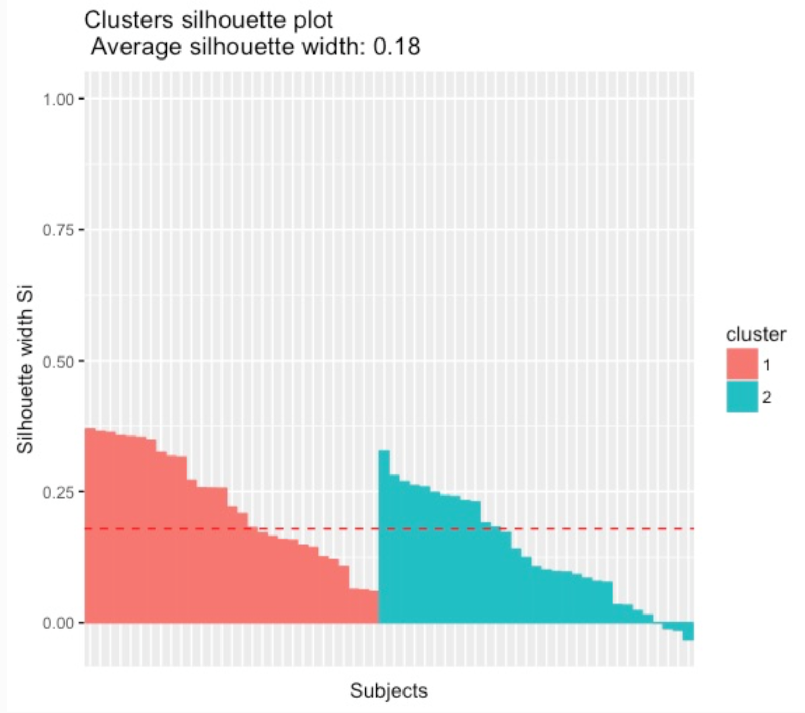
Most HD participants had a Si value more than 0. Although some HD participants in subgroup 2 had a negative Si value extremely close to 0, which means these participants’ location was between subgroup1 and subgroup2, this clustering still has a good efficient.
(5) Clustering stability test with Fowlkes-Mallows(FM) index (Halkidi et al., 2001)
Fowlkes-Mallows (FM) index is an external evaluation method that is used to determine the similarity between two clusters. The higher the Fowlkes-Mallows index value, the greater similarity between the clusters.
A subsampling method was employed to validate the stability of cluster result. The general idea about stability of clusters is that when a partition has captured the structure in the data, this partition should be stable with respect to perturbation of the data. We generated 10 random subsamples (75% of whole Real dataset) and clustered them using the same K-means Clustering method. At the same time, 10 random fake datasets were generated by a uniform distribution that had the same min and max interval as our real dataset, and we clustered these 10 random fake datasets with the same method as the real dataset, too.
Furthermore, the clustering was compared between 10 random fake datasets and our real dataset with FM index. At the same time, the comparison between 10 random fake datasets and our real dataset was made and the results of the comparison were set as a baseline for evaluating clustering stability. It is implied that the more similar of clustering results, the more stable of the clustering in accordance to the principle of similarity. FM-index ranges from 0 to 1, in which a value closer to 1 indicates greater similarity (Supple-Fig.6).
Supple-Fig.6 Clustering stability test with Fowlkes-Mallows index for the HD participant
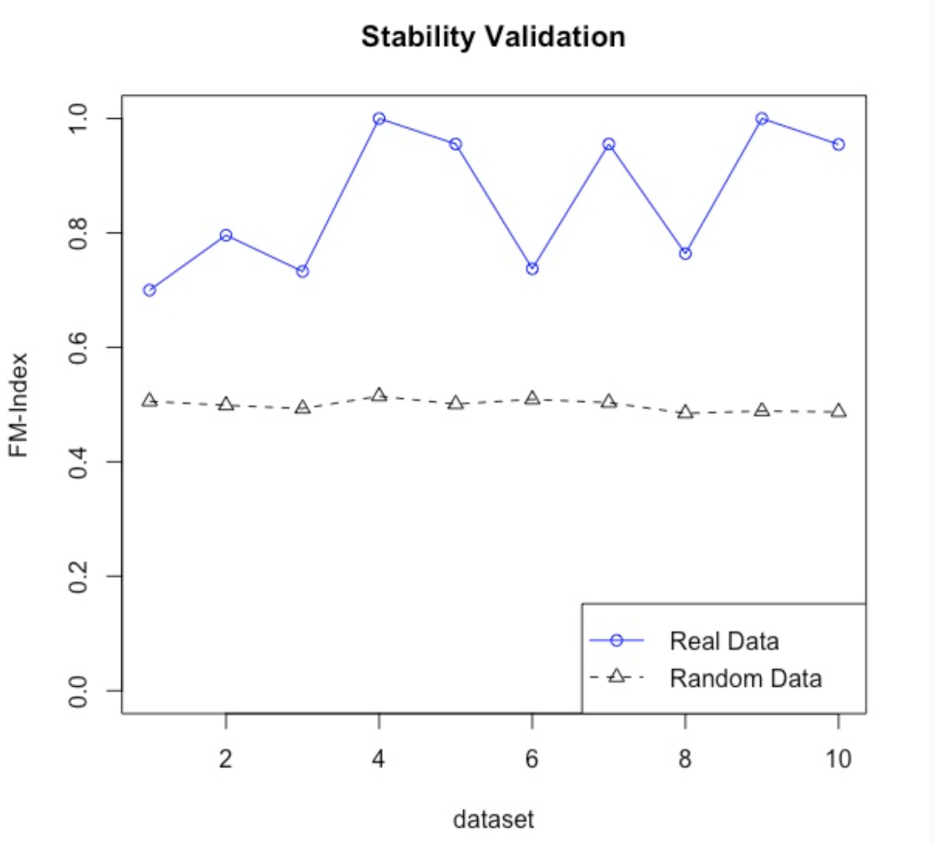
The blue circle and the black triangle represent the similarities of clustering between that of the subsampled datasets from the real data and that from the whole real data, as well as from the random data and the whole real data respectively.
(6) Further grouping stability test
Further grouping stability test was performed with the method provided by Hening C (Hennig, 2007). The data was resampled with several schemes (bootstrap, subsetting, jittering, replacement of points by noise) and the Jaccard similarities of the original clusters to the most similar clusters in the resampled data were computed. The mean over these similarities was used as an index of the stability of a cluster. “Highly stable” clusters should yield average Jaccard similarities of 0.85 and above (Hennig, 2007).
In our study, the mean Jaccard similarities of cluster 1 and cluster 2 were 0.8958 and 0.8941 respectively, both more than 0.85, which is considered to be very stable for grouping.

Reference
Charrad, M., Ghazzali, N., Boiteau, V. & Niknafs, A. (2014). NbClust: An R Package for Determining the Relevant Number of Clusters in a Data Set. Journal of Statistical Software, 61(6), 1-36. doi:10.18637/jss.v061.i06
Halkidi, M., Batistakis, Y. & Vazirgiannis, M. (2001). On Clustering Validation Techniques. Journal of Intelligent Information Systems, 17(2/3), 107-145. doi:10.1023/a:1012801612483
Hennig, C. (2007). Cluster-wise assessment of cluster stability. Computational Statistics & Data Analysis, 52(1), 258-271. doi:10.1016/j.csda.2006.11.025
Kassambara, A. & Mundt, F. (2020). factoextra: Extract and Visualize the Results of Multivariate Data Analyses. R package version 1.0.7, https://CRAN.R-project.org/package=factoextra
Rousseeuw, P. J. (1987). Silhouettes: A graphical aid to the interpretation and validation of cluster analysis. Journal of Computational and Applied Mathematics, 20, 53-65. doi:10.1016/0377-0427(87)90125-7

