Supplementary A. Odds ratios of mothers’ preconception substance use and substance use pregnancy pre-awareness, pregnancy post-awareness and one year postpartum collapsing none and adolescent only substance use

 | Substance use in pregnancy  pre-awareness |  |  | Substance use in pregnancy  post-awareness |  |  | Substance use one year postpartum
 | OR | 95% CI |  | OR | 95% CI |  | OR | 95% CI
 | Any Maternal Perinatal Alcohol Use
Preconception binge drinking
None and adolescent only
Young adulthood only | 1.98 | (1.26, 3.11) |  | 1.61 | (0.99, 2.64) |  | 2.25 | (1.49, 3.40)
Adolescence & young adult | 1.93 | (1.17, 3.18) |  | 2.54 | (1.51, 4.27) |  | 2.08 | (1.33, 3.23)
 | Any Maternal Perinatal Tobacco Use
Preconception tobacco use
None and adolescent only
Young adulthood only | 10.12 | (4.52, 22.67) |  | 14.96 | (4.20, 53.33) |  | 7.94 | (3.57, 17.67)
Adolescence & young adult | 17.11 | (8.15, 35.92) |  | 25.73 | (8.35, 79.24) |  | 15.5 | (7.51, 32.01)
 | Any Maternal Perinatal Cannabis Use
Preconception cannabis use
None and adolescent only
Young adulthood only | 5.02 | (1.65, 15.28) |  | 8.71 | (2.31, 32.87) |  | 15.41 | (4.17, 56.95)
Adolescence & young adult | 20.86 | (7.84, 55.53) |  | 18.58 | (5.31, 65.01) |  | 22.56 | (5.76, 88.42)
Adjusted for study cohort, childhood parental separation, childhood parental low education, parent ethnicity, adolescent mental health, adolescent delinquency, first child.

Supplementary B. Odds ratios of mothers’ preconception substance use and substance use pregnancy pre-awareness, pregnancy post-awareness and one year postpartum excluding adolescent only tobacco users

 | Substance use in pregnancy  pre-awareness |  |  | Substance use in pregnancy  post-awareness |  |  | Substance use one year postpartum
 | OR | 95% CI |  | OR | 95% CI |  | OR | 95% CI
 | Any Maternal Perinatal Alcohol Use
Preconception binge drinking
None
Adolescent only | 0.97 | (0.49, 1.95) |  | 2.28 | (1, 5.21) |  | 0.81 | (0.44, 1.51)
Young adulthood only | 2.04 | (1.26, 3.29) |  | 1.89 | (1.09, 3.31) |  | 2.19 | (1.43, 3.38)
Adolescence & young adult | 2.10 | (1.18, 3.74) |  | 3.19 | (1.75, 5.84) |  | 2.08 | (1.28, 3.37)
 | Any Maternal Perinatal Tobacco Use
Preconception tobacco use
None
Adolescent only | NA |  |  | NA |  |  | NA
Young adulthood only | 10.78 | (4.61, 25.2) |  | 20.04 | (4.37, 91.94) |  | 13.92 | (5.59, 34.67)
Adolescence & young adult | 18.18 | (8.2, 40.35) |  | 34.29 | (8.02, 146.67) |  | 27.08 | (11.19, 65.51)
 | Any Maternal Perinatal Cannabis Use
Preconception cannabis use
None
Adolescent only | 1.85 | (0.2, 17.22) |  | 3.28 | (0.25, 42.97) |  | 3.61 | (0.37, 35.45)
Young adulthood only | 5.44 | (1.8, 16.4) |  | 10.21 | (2.65, 39.32) |  | 18.86 | (4.59, 77.41)
Adolescence & young adult | 23.08 | (8.36, 63.71) |  | 21.74 | (6.05, 78.13) |  | 26.87 | (5.85, 123.33)
Adjusted for study cohort, childhood parental separation, childhood parental low education, parent ethnicity, adolescent mental health, adolescent delinquency, first child. NA = not applicable; sample size varied across multiple imputations

Supplementary C. Characteristics at recruitment of (a) all Australian Temperament Study (ATP) women participants, (b) those screened for ATP Generation 3 (ATPG3) eligibility, (c) those eligible for ATPG3 and (d) those participating in ATPG3

 | ATP Participants |  |  |  | ATPG3 Screened |  |  | ATPG3 Eligible |  |  | ATPG3 Participant
 | N=1168 |  |  |  | N=851 |  |  | N=460 |  |  | N=400
 | N | n | % | N |  | n | % | N | n | % |  | N | n |  | %
Participant’s mother completed high school or less | 1137 | 823 | 72 | 843 |  | 592 | 70 | 456 | 325 | 71 |  | 398 | 275 |  | 69
Participant’s father completed high school or less | 1119 | 588 | 53 | 838 |  | 421 | 50 | 454 | 214 | 47 |  | 397 | 182 |  | 46
Participant’s mother not born in Australia | 1151 | 232 | 20 | 847 |  | 145 | 17 | 457 | 65 | 14 |  | 399 | 58 |  | 15
Participant’s father not born in Australia | 1140 | 289 | 25 | 843 |  | 187 | 22 | 457 | 93 | 20 |  | 399 | 81 |  | 20
Difficult temperament in infancyª | 1153 | 212 | 18 | 847 |  | 155 | 18 | 457 | 82 | 18 |  | 399 | 71 |  | 18
Behaviour problems in infancy^{b} | 1151 | 264 | 23 | 846 |  | 197 | 23 | 456 | 107 | 23 |  | 398 | 92 |  | 23

Note: all characteristics assessed at recruitment in 1983 when cohort participants were 4-8 months old.

ª Difficult temperament at 4-8 months= mean score >3 on combined subscales of Approach-Withdrawal, Cooperation and Irritability from the Revised Infant Temperament Questionnaire (Sanson, Prior, Garino, Oberklaid & Sewell, 1987). Parents rated items on a 6-point Likert-type scale, from 1 (almost never) to 6 (almost always).
^{b} Behaviour problems at 4-8 months= mean score of > 2 from Behaviour Problems Composite scale (see Prior, Sanson, Smart & Oberklaid, 2000). Parents rated items (“Colic”, “Sleep problems”, and “Excessive crying”) on a 4-point Likert-type scale, from 1 (none) to 4 (severe).

Sanson, A., Prior, M., Garino, E., Oberklaid, F., & Sewell, J. (1987). The structure of infant temperament: Factor analysis of the Revised Infant Temperament Questionnaire. Infant Behavior and Development, 10(1), 97-104.

Prior, M., Sanson, A., Smart, D., & Oberklaid, F. (2000). Pathways from infancy to adolescence: Australian Temperament Project 1983-2000. Melbourne, Australia: Australian Institute of Family Studies

Supplementary D. Characteristics of (a) all Victorian Adolescent Health Cohort Study (VAHCS) women participants, (b) those screened for the Victorian Intergenerational Health Cohort study (VIHCS) eligibility, (c) those eligible for VIHCS and (d) those participating in VIHCS

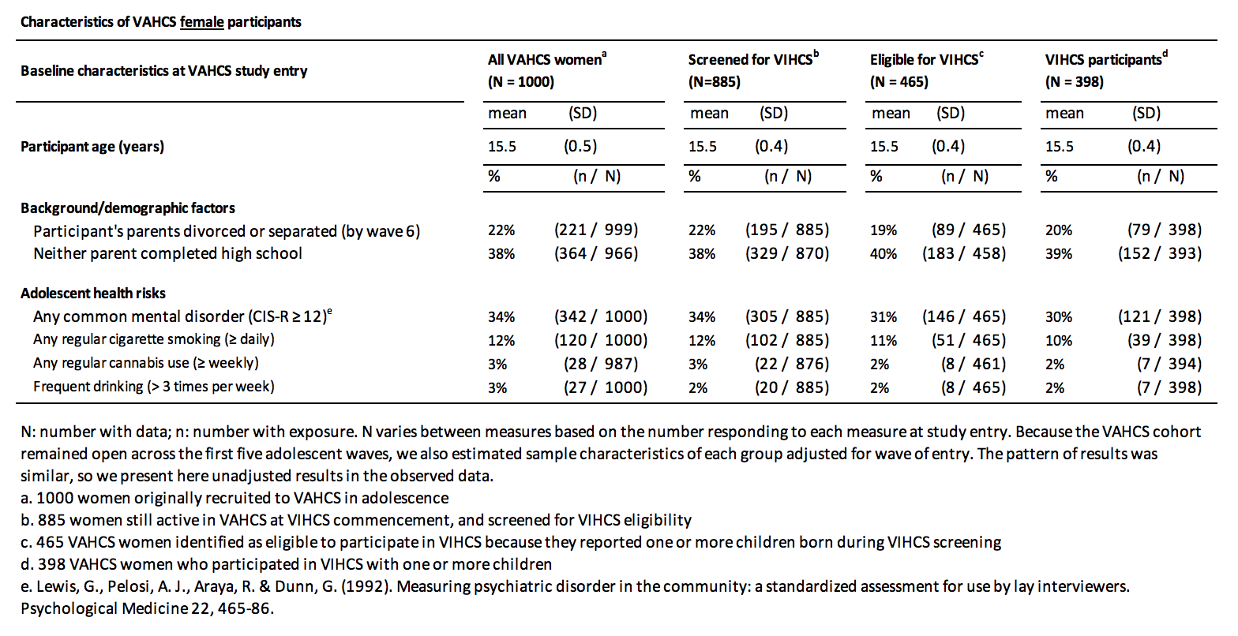
Table adapted from Spry, E., Olsson, C. A., Hearps, S. J. C., Aarsman, S., Carlin, J. B., Howard, L. M., Moreno-Betancur, M., Romaniuk, H., Doyle, L. W., Brown, S., Borschmann, R., Alway, Y., Coffey, C., & Patton, G. C. (2020). The Victorian Intergenerational Health Cohort Study (VIHCS): Study design of a preconception cohort from parent adolescence to offspring childhood. Paediatric and Perinatal Epidemiology, 34(1), 86–98. https://doi.org/10.1111/ppe.12602

Supplementary E. Flow diagram of sampling and ascertainment of Victorian Intergenerational Health Cohort study (VIHCS) eligibility and the Australian Temperament Study (ATPG3)

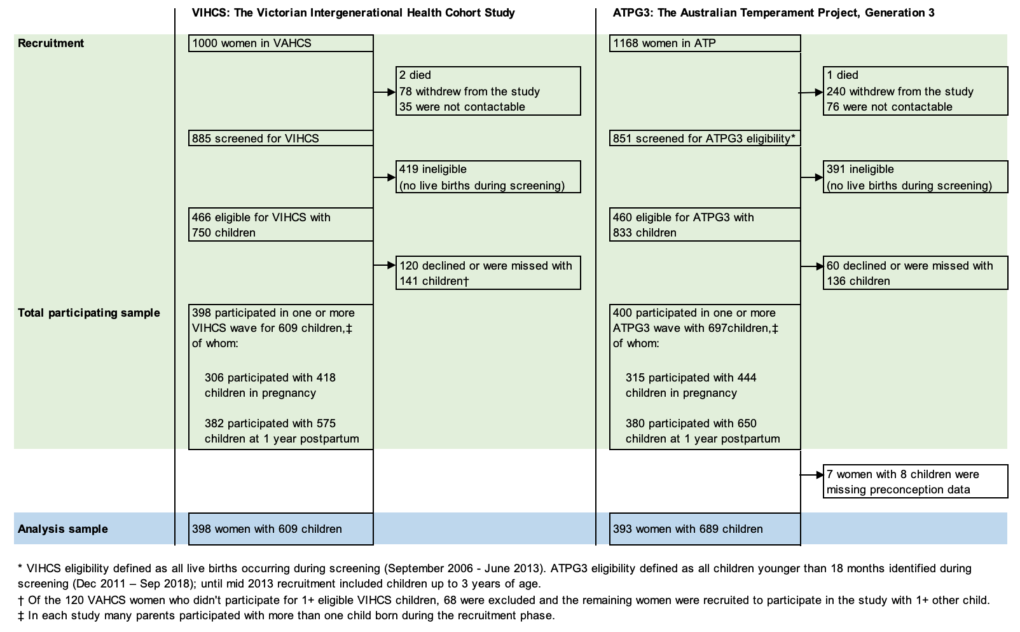
Figure adapted from Spry, E., Moreno-Betancur, M., Becker, D., Romaniuk, H., Carlin, J. B., Molyneaux, E., Howard, L. M., Ryan, J., Letcher, P., McIntosh, J., Macdonald, J. A., Greenwood, C. J., Thomson, K. C., McAnally, H., Hancox, R., Hutchinson, D. M., Youssef, G. J., Olsson, C. A., & Patton, G. C. (2020). Maternal mental health and infant emotional reactivity: a 20-year two-cohort study of preconception and perinatal exposures. Psychological Medicine, 50(5), 827–837. https://doi.org/10.1017/S0033291719000709.

Supplementary F. Frequency of perinatal substance use outcomes by preconception substance use exposure category
 | Substance use in pregnancy  pre-awareness |  | Substance use in pregnancy  post-awareness |  | Substance use  one year  postpartum |  | Substance use  In any perinatal period
 | No | Yes | No | Yes | No | Yes | No | Yes
Preconception binge drinking | Any Maternal Perinatal Alcohol Use
None | 156 | 343 | 449 | 51 | 154 | 345 | 97 | 402
Adolescence only | 31 | 69 | 78 | 22 | 32 | 67 | 19 | 81
Young adulthood only | 70 | 338 | 327 | 81 | 63 | 345 | 27 | 381
Adolescence & young adult | 52 | 239 | 214 | 77 | 49 | 242 | 22 | 269
Preconception tobacco use | Any Maternal Perinatal Tobacco Use
None | 708 | 17 | 720 | 5 | 717 | 8 | 702 | 23
Adolescence only | 75 | 3 | 76 | 2 | 71 | 7 | 70 | 8
Young adulthood only | 107 | 35 | 121 | 21 | 118 | 25 | 101 | 40
Adolescence & young adult | 221 | 133 | 265 | 88 | 246 | 107 | 191 | 162
Preconception cannabis use | Any Maternal Perinatal Cannabis Use
None | 1077 | 22 | 1092 | 7 | 1093 | 6 | 1070 | 29
Adolescence only | 59 | 3 | 60 | 2 | 60 | 2 | 57 | 5
Young adulthood only | 70 | 10 | 74 | 6 | 71 | 9 | 65 | 15
Adolescence & young adult | 37 | 20 | 47 | 10 | 47 | 10 | 34 | 23
Frequency estimates were calculated from imputed percentage estimates and total number of participants.
To estimate frequencies for each perinatal period 9 imputed samples (18%) were removed for tobacco and 11 imputed samples (22%) were removed for cannabis.

