Online Supplementary Material

Impact of data extraction errors in meta-analyses on the association between depression and peripheral inflammatory biomarkers: An umbrella review

Supplementary Appendix 1. PRISMA Checklist and MOOSE Checklist
Supplementary Figure 1. Forest plot of primary studies that investigated TNF-α.
Supplementary Figure 2. Forest plot of primary studies that investigated IL-1β.
Supplementary Figure 3. Forest plot of primary studies that investigated IL-6.
Supplementary Figure 4. Forest plot of primary studies that investigated CRP.
Supplementary Figure 5. Funnel plot of primary studies that investigated TNF-α.
Supplementary Figure 6. Funnel plot of primary studies that investigated IL-1β.
Supplementary Figure 7. Funnel plot of primary studies that investigated IL-6.
Supplementary Figure 8. Funnel plot of primary studies that investigated CRP.
Supplementary References

Number of eAppendix: 1
Number of eFigure: 8

Supplementary Appendix 1. PRISMA checklist and MOOSE Checklist
PRISMA 2009 Checklist
Section/topic | # | Checklist item | Reported on page #
TITLE
Title | 1 | Identify the report as a systematic review, meta-analysis, or both. | 1
ABSTRACT
Structured summary | 2 | Provide a structured summary including, as applicable: background; objectives; data sources; study eligibility criteria, participants, and interventions; study appraisal and synthesis methods; results; limitations; conclusions and implications of key findings; systematic review registration number. | 4-5
INTRODUCTION
Rationale | 3 | Describe the rationale for the review in the context of what is already known. | 6
Objectives | 4 | Provide an explicit statement of questions being addressed with reference to participants, interventions, comparisons, outcomes, and study design (PICOS). | 7
METHODS
Protocol and registration | 5 | Indicate if a review protocol exists, if and where it can be accessed (e.g., Web address), and, if available, provide registration information including registration number. | 8
Eligibility criteria | 6 | Specify study characteristics (e.g., PICOS, length of follow-up) and report characteristics (e.g., years considered, language, publication status) used as criteria for eligibility, giving rationale. | 8-9
Information sources | 7 | Describe all information sources (e.g., databases with dates of coverage, contact with study authors to identify additional studies) in the search and date last searched. | 8-9
Search | 8 | Present full electronic search strategy for at least one database, including any limits used, such that it could be repeated. | 8-9
Study selection | 9 | State the process for selecting studies (i.e., screening, eligibility, included in systematic review, and, if applicable, included in the meta-analysis). | 8-9
Data collection process | 10 | Describe method of data extraction from reports (e.g., piloted forms, independently, in duplicate) and any processes for obtaining and confirming data from investigators. | 9
Data items | 11 | List and define all variables for which data were sought (e.g., PICOS, funding sources) and any assumptions and simplifications made. | 9
Risk of bias in individual studies | 12 | Describe methods used for assessing risk of bias of individual studies (including specification of whether this was done at the study or outcome level), and how this information is to be used in any data synthesis. | 10-11
Section/topic | # | Checklist item | Reported on page #
Summary measures | 13 | State the principal summary measures (e.g., risk ratio, difference in means). | 10-11
Synthesis of results | 14 | Describe the methods of handling data and combining results of studies, if done, including measures of consistency (e.g., I²) for each meta-analysis. | 10-11
Risk of bias across studies | 15 | Specify any assessment of risk of bias that may affect the cumulative evidence (e.g., publication bias, selective reporting within studies). | 10-11
Additional analyses | 16 | Describe methods of additional analyses (e.g., sensitivity or subgroup analyses, meta-regression), if done, indicating which were pre-specified. | 10-11
RESULTS
Study selection | 17 | Give numbers of studies screened, assessed for eligibility, and included in the review, with reasons for exclusions at each stage, ideally with a flow diagram. | 12
Study characteristics | 18 | For each study, present characteristics for which data were extracted (e.g., study size, PICOS, follow-up period) and provide the citations. | 12
Risk of bias within studies | 19 | Present data on risk of bias of each study and, if available, any outcome level assessment (see item 12). | 12
Results of individual studies | 20 | For all outcomes considered (benefits or harms), present, for each study: (a) simple summary data for each intervention group (b) effect estimates and confidence intervals, ideally with a forest plot. | 12-13,  Table 4
Synthesis of results | 21 | Present results of each meta-analysis done, including confidence intervals and measures of consistency. | 13-14  Table 4
Risk of bias across studies | 22 | Present results of any assessment of risk of bias across studies (see Item 15). | 13-14, Supplements
Additional analysis | 23 | Give results of additional analyses, if done (e.g., sensitivity or subgroup analyses, meta-regression [see Item 16]). | 12-14
DISCUSSION
Summary of evidence | 24 | Summarize the main findings including the strength of evidence for each main outcome; consider their relevance to key groups (e.g., healthcare providers, users, and policy makers). | 15-17
Limitations | 25 | Discuss limitations at study and outcome level (e.g., risk of bias), and at review-level (e.g., incomplete retrieval of identified research, reporting bias). | 17-18
Conclusions | 26 | Provide a general interpretation of the results in the context of other evidence, and implications for future research. | 18
FUNDING
Funding | 27 | Describe sources of funding for the systematic review and other support (e.g., supply of data); role of funders for the systematic review. | 19
From: Moher D, Liberati A, Tetzlaff J, Altman DG, The PRISMA Group (2009). Preferred Reporting Items for Systematic Reviews and Meta-Analyses: The PRISMA Statement. PLoS Med 6(7): e1000097. doi:10.1371/journal.pmed1000097

MOOSE Checklist for Meta-analyses of Observational Studies
Item No | Recommendation | Reported on Page No
Reporting of background should include
1 | Problem definition | 6-7
2 | Hypothesis statement | 6-7
3 | Description of study outcome(s) | 6-7
4 | Type of exposure or intervention used | 6-7
5 | Type of study designs used | 6-7
6 | Study population | 6-7
Reporting of search strategy should include
7 | Qualifications of searchers (e.g., librarians and investigators) | NA
8 | Search strategy, including time period included in the synthesis and key words | 8
9 | Effort to include all available studies, including contact with authors | 8-9
10 | Databases and registries searched | 8
11 | Search software used, name and version, including special features used (e.g., explosion) | 9-10
12 | Use of hand searching (e.g., reference lists of obtained articles) | 8-9
13 | List of citations located and those excluded, including justification | Figure 1
14 | Method of addressing articles published in languages other than English | 9
15 | Method of handling abstracts and unpublished studies | NA
16 | Description of any contact with authors | NA
Reporting of methods should include
17 | Description of relevance or appropriateness of studies assembled for assessing the hypothesis to be tested | 8-9
18 | Rationale for the selection and coding of data (e.g., sound clinical principles or convenience) | 8-9
19 | Documentation of how data were classified and coded (e.g., multiple raters, blinding and interrater reliability) | 9-10, 18
20 | Assessment of confounding (e.g., comparability of cases and controls in studies where appropriate) | 8-9
21 | Assessment of study quality, including blinding of quality assessors, stratification or regression on possible predictors of study results | NA
22 | Assessment of heterogeneity | 11
23 | Description of statistical methods (e.g., complete description of fixed or random effects models, justification of whether the chosen models  account for predictors of study results, dose-response models, or cumulative meta-analysis) in sufficient detail to be replicated | 10-11
24 | Provision of appropriate tables and graphics | Tables 1-4,  Figure 1, Supplement file

Item No | Recommendation | Reported on Page  No
Reporting of results should include
25 | Graphic summarizing individual study estimates and overall estimate | Tables 3, Supplement file
26 | Table giving descriptive information for each study included | Table 1
27 | Results of sensitivity testing (e.g., subgroup analysis) | NA
28 | Indication of statistical uncertainty of findings | 12-14
Reporting of discussion should include
29 | Quantitative assessment of bias (e.g., publication bias) | NA
30 | Justification for exclusion (e.g., exclusion of non-English language citations) | NA
31 | Assessment of quality of included studies | NA
Reporting of conclusions should include
32 | Consideration of alternative explanations for observed results | 15-17
33 | Generalization of the conclusions (i.e., appropriate for the data presented and within the domain of the literature review) | 15-17
34 | Guidelines for future research | NA
35 | Disclosure of funding source | 19

From: Stroup DF, Berlin JA, Morton SC, et al, for the Meta-analysis Of Observational Studies in Epidemiology (MOOSE) Group. Meta-analysis of Observational Studies in Epidemiology. A Proposal for Reporting. JAMA. 2000;283(15):2008-2012. doi: 10.1001/jama.283.15.2008.

Transcribed from the original paper within the NEUROSURGERY® Editorial Office, Atlanta, GA, United Sates. August 2012.

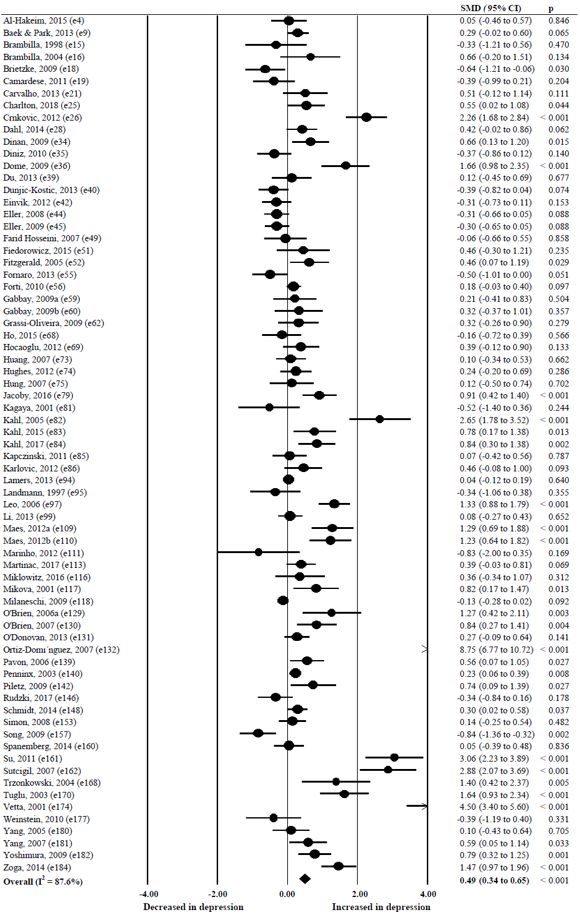
Supplementary Figure 1. Forest plot of primary studies that investigated TNF-α. TNF-α, tumor necrosis factor-alpha; SMD, standardized mean difference; CI, confidence interval.
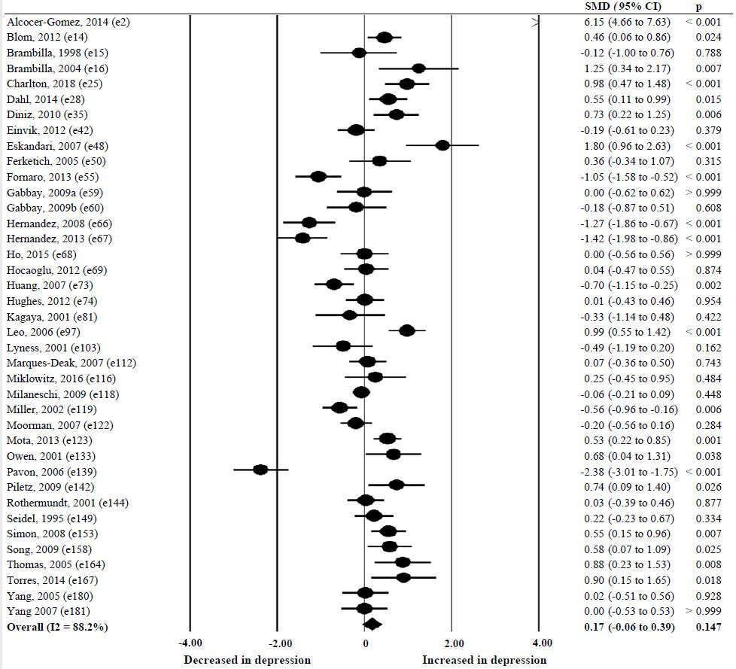
Supplementary Figure 2. Forest plot of primary studies that investigated IL-1β. IL-1β, interleukin 1-beta; SMD, standardized mean difference; CI, confidence interval.

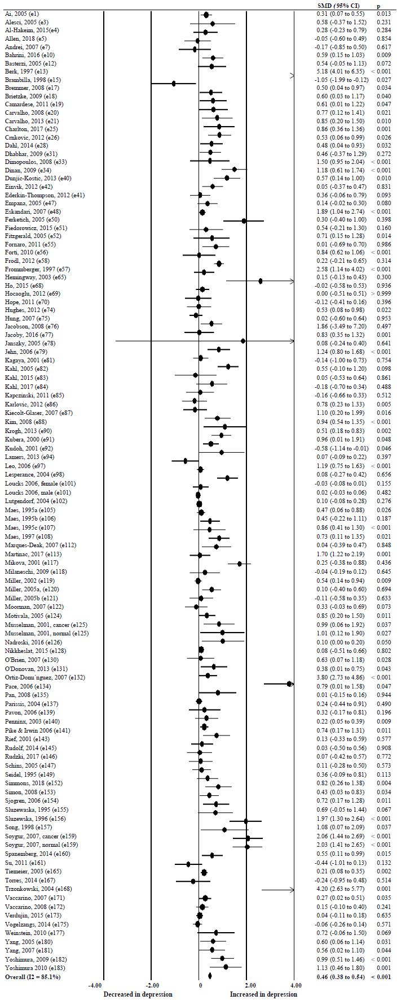
Supplementary Figure 3. Forest plot of primary studies that investigated IL-6. IL-6, interleukin 6; SMD, standardized mean difference; CI, confidence interval.
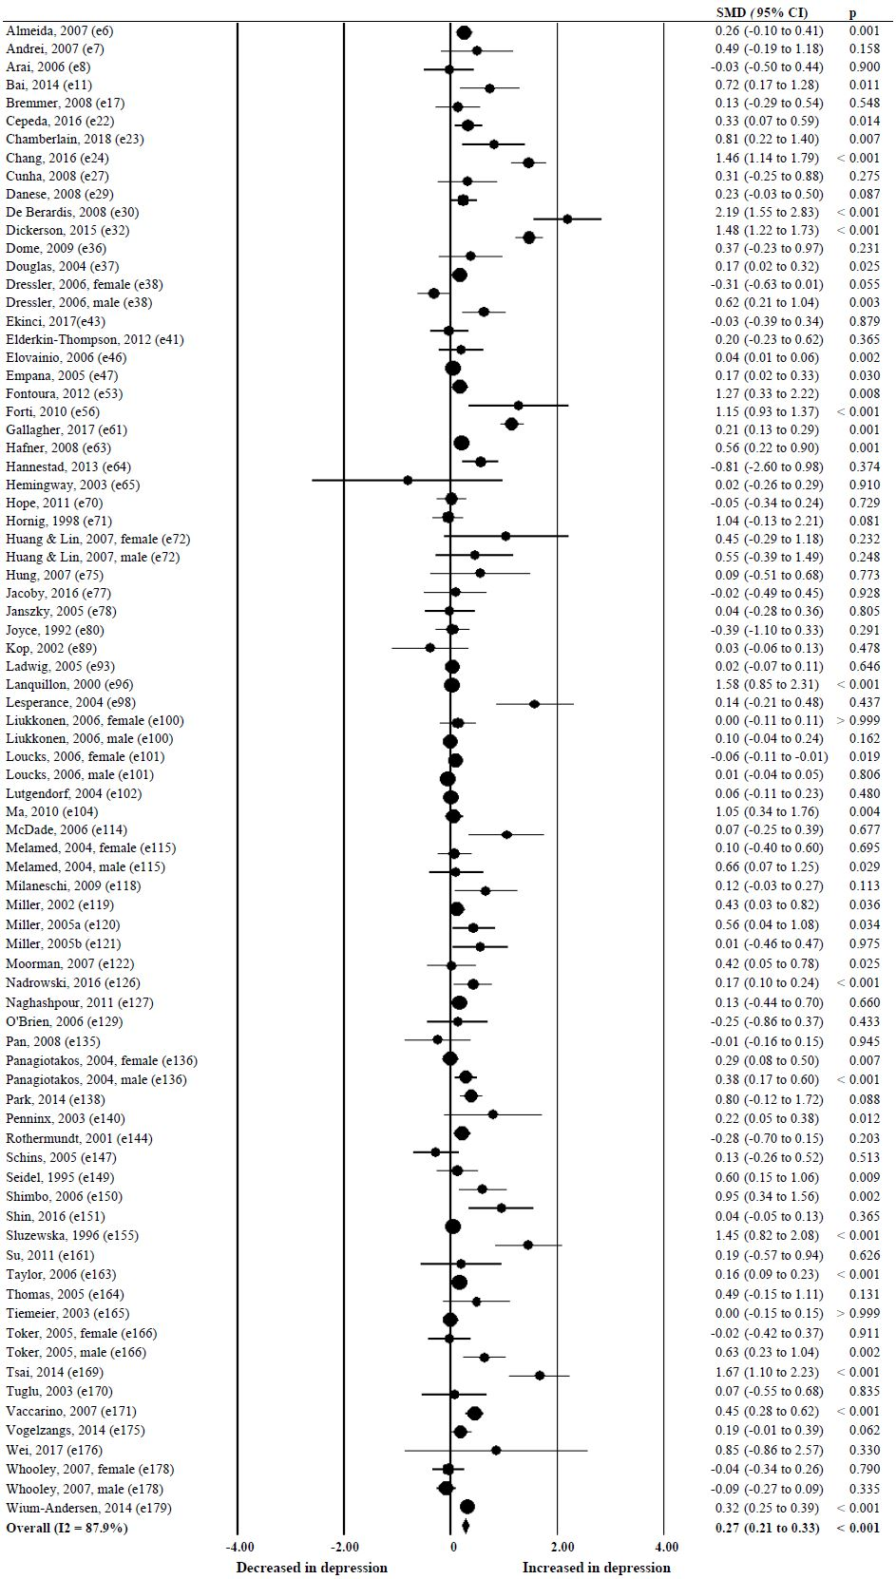
Supplementary Figure 4. Forest plot of primary studies that investigated CRP. CRP, C-reactive protein; SMD, standardized mean difference; CI, confidence interval.

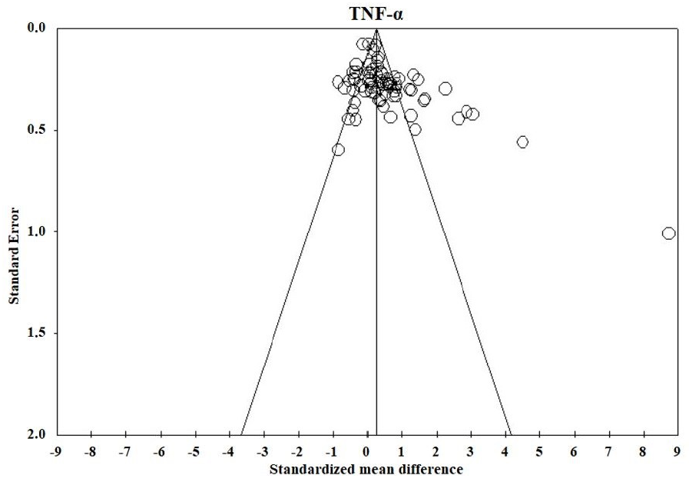
Supplementary Figure 5. Funnel plot of primary studies that investigated TNF-α. TNF-α, tumor necrosis factor-alpha.

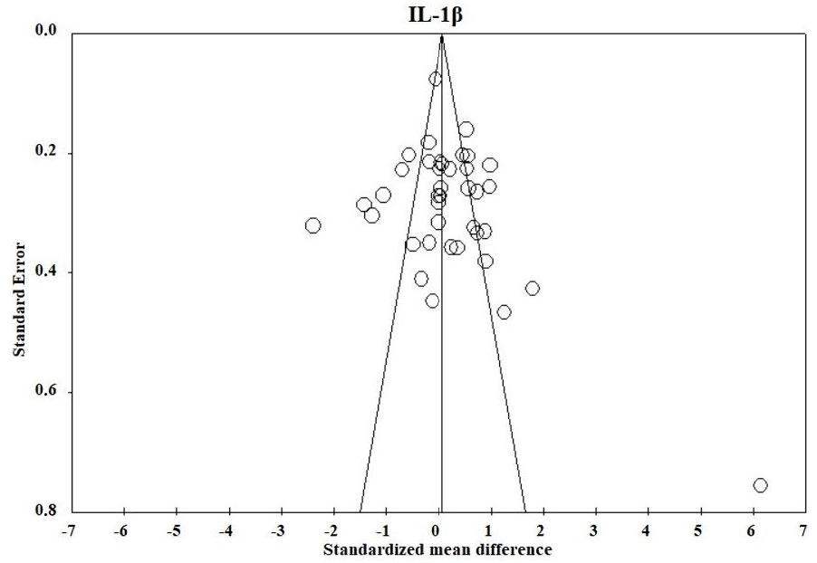
Supplementary Figure 6. Funnel plot of primary studies that investigated IL-1β. IL-1β, interleukin 1-beta.

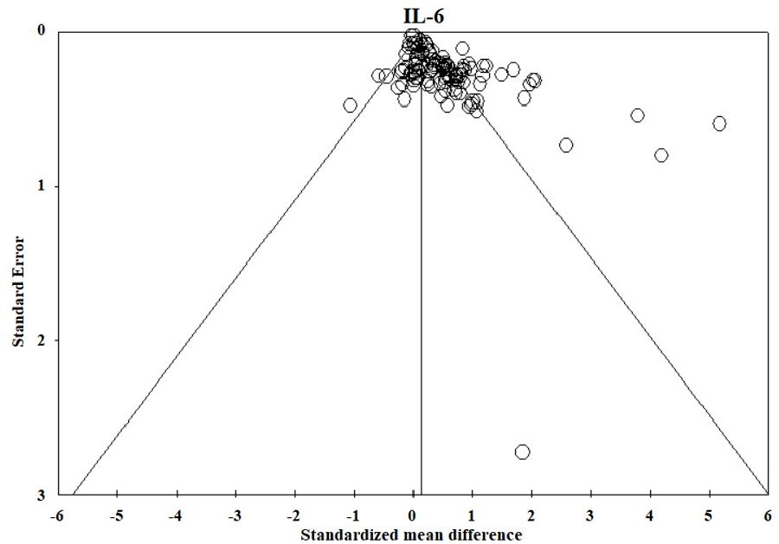
Supplementary Figure 7. Funnel plot of primary studies that investigated IL-6. IL-6, interleukin 6.

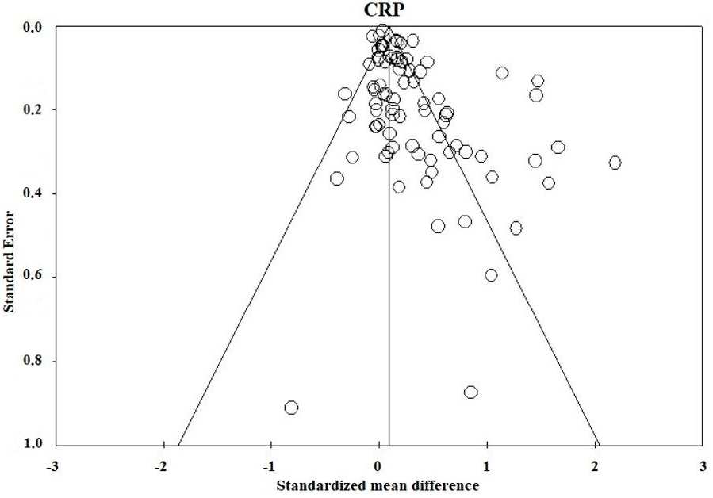
Supplementary Figure 8. Funnel plot of primary studies that investigated CRP. CRP, C-reactive protein.

Supplementary References
1 Ai, A. L., Kronfol, Z., Seymour, E., & Bolling, S. F. (2005). Effects of mood state and psychosocial functioning on plasma Interleukin-6 in adult patients before cardiac surgery. International Journal of Psychiatry in Medicine, 35(4), 363-376. doi: 10.2190/2elg-rdun-x6tu-fgc8
2 Alcocer-Gomez, E., de Miguel, M., Casas-Barquero, N., Nunez-Vasco, J., Sanchez-Alcazar, J. A., Fernandez-Rodriguez, A., & Cordero, M. D. (2014). NLRP3 inflammasome is activated in mononuclear blood cells from patients with major depressive disorder. Brain, Behavior and Immunity, 36, 111-117. doi: 10.1016/j.bbi.2013.10.017
3 Alesci, S., Martinez, P. E., Kelkar, S., Ilias, I., Ronsaville, D. S., Listwak, S. J., . . . Gold, P. W. (2005). Major depression is associated with significant diurnal elevations in plasma interleukin-6 levels, a shift of its circadian rhythm, and loss of physiological complexity in its secretion: clinical implications. Journal of Clinical Endocrinology and Metabolism, 90(5), 2522-2530. doi: 10.1210/jc.2004-1667
4 Al-Hakeim, H. K., Al-Rammahi, D. A., & Al-Dujaili, A. H. (2015). IL-6, IL-18, sIL-2R, and TNFα proinflammatory markers in depression and schizophrenia patients who are free of overt inflammation. Journal of Affective Disorders, 182, 106-114.
5 Allen, A. P., Naughton, M., Dowling, J., Walsh, A., O'Shea, R., Shorten, G., . . . Dinan, T. G. (2018). Kynurenine pathway metabolism and the neurobiology of treatment-resistant depression: Comparison of multiple ketamine infusions and electroconvulsive therapy. Journal of Psychiatric Research, 100, 24-32. doi: 10.1016/j.jpsychires.2018.02.011
6 Almeida, O. P., Norman, P., Hankey, G. J., Jamrozik, K., & Flicker, L. (2007). The association between C-reactive protein concentration and depression in later life is due to poor physical health: results from the Health in Men Study (HIMS). Psychological Medicine, 37(12), 1775-1786. doi: 10.1017/s0033291707000827
7 Andrei, A. M., Fraguas, R., Jr., Telles, R. M., Alves, T. C., Strunz, C. M., Nussbacher, A., . . . Wajngarten, M. (2007). Major depressive disorder and inflammatory markers in elderly patients with heart failure. Psychosomatics, 48(4), 319-324. doi: 10.1176/appi.psy.48.4.319
8 Arai, H., Takechi, H., Wada, T., Ishine, M., Wakatsuki, Y., Horiuchi, H., . . . Kita, T. (2006). Usefulness of measuring serum markers in addition to comprehensive geriatric assessment for cognitive impairment and depressive mood in the elderly. Geriatrics & Gerontology International, 6(1), 7-14.
9 Baek, D., & Park, Y. (2013). Association between erythrocyte n-3 polyunsaturated fatty acids and biomarkers of inflammation and oxidative stress in patients with and without depression. Prostaglandins, Leukotrienes and Essential Fatty Acids, 89(5), 291-296. doi: 10.1016/j.plefa.2013.09.008
10 Bahrini, L., Ouanes, S., & Ghachem, R. (2016). Inflammatory profile in depression and associated clinical and sociodemographic features in a Middle-Eastern North-African population. Journal of Affective Disorders, 198, 122-126. doi: 10.1016/j.jad.2016.03.036
11 Bai, Y. M., Su, T. P., Tsai, S. J., Wen-Fei, C., Li, C. T., Pei-Chi, T., & Mu-Hong, C. (2014). Comparison of inflammatory cytokine levels among type I/type II and manic/hypomanic/euthymic/depressive states of bipolar disorder. Journal of Affective Disorders, 166, 187-192. doi: 10.1016/j.jad.2014.05.009
12 Basterzi, A. D., Aydemir, C., Kisa, C., Aksaray, S., Tuzer, V., Yazici, K., & Goka, E. (2005). IL-6 levels decrease with SSRI treatment in patients with major depression. Human Psychopharmacology, 20(7), 473-476. doi: 10.1002/hup.717
13 Berk, M., Wadee, A. A., Kuschke, R. H., & O'Neill-Kerr, A. (1997). Acute phase proteins in major depression. Journal of Psychosomatic Research, 43(5), 529-534.
14 Blom, E. H., Lekander, M., Ingvar, M., Åsberg, M., Mobarrez, F., & Serlachius, E. (2012). Pro-inflammatory cytokines are elevated in adolescent females with emotional disorders not treated with SSRIs. Journal of Affective Disorders, 136(3), 716-723.
15 Brambilla, F., & Maggioni, M. (1998). Blood levels of cytokines in elderly patients with major depressive disorder. Acta Psychiatrica Scandinavica, 97(4), 309-313.
16 Brambilla, F., Monteleone, P., & Maj, M. (2004). Interleukin-1beta and tumor necrosis factor-alpha in children with major depressive disorder or dysthymia. Journal of Affective Disorders, 78(3), 273-277. doi: 10.1016/s0165-0327(02)00315-4
17 Bremmer, M. A., Beekman, A. T., Deeg, D. J., Penninx, B. W., Dik, M. G., Hack, C. E., & Hoogendijk, W. J. (2008). Inflammatory markers in late-life depression: results from a population-based study. Journal of Affective Disorders, 106(3), 249-255. doi: 10.1016/j.jad.2007.07.002
18 Brietzke, E., Stertz, L., Fernandes, B. S., Kauer-Sant'anna, M., Mascarenhas, M., Escosteguy Vargas, A., . . . Kapczinski, F. (2009). Comparison of cytokine levels in depressed, manic and euthymic patients with bipolar disorder. Journal of Affective Disorders, 116(3), 214-217. doi: 10.1016/j.jad.2008.12.001
19 Camardese, G., Pizi, G., Marino, M., Bartoccioni, E., Grillo, R., Mattioli, B., . . . Bria, P. (2011). Immune-inflammatory response changes in patients with major depressive disorder. Journal of Psychopathology, 17, 396-403.
20 Carvalho, L. A., Juruena, M. F., Papadopoulos, A. S., Poon, L., Kerwin, R., Cleare, A. J., & Pariante, C. M. (2008). Clomipramine in vitro reduces glucocorticoid receptor function in healthy subjects but not in patients with major depression. Neuropsychopharmacology : official publication of the American College of Neuropsychopharmacology, 33(13), 3182-3189. doi: 10.1038/npp.2008.44
21 Carvalho, L. A., Torre, J. P., Papadopoulos, A. S., Poon, L., Juruena, M. F., Markopoulou, K., . . . Pariante, C. M. (2013). Lack of clinical therapeutic benefit of antidepressants is associated overall activation of the inflammatory system. Journal of Affective Disorders, 148(1), 136-140. doi: 10.1016/j.jad.2012.10.036
22 Cepeda, M. S., Stang, P., & Makadia, R. (2016). Depression Is Associated With High Levels of C-Reactive Protein and Low Levels of Fractional Exhaled Nitric Oxide: Results From the 2007-2012 National Health and Nutrition Examination Surveys. Journal of Clinical Psychiatry, 77(12), 1666-1671. doi: 10.4088/JCP.15m10267
23 Chamberlain, S. R., Cavanagh, J., de Boer, P., Mondelli, V., Jones, D. N. C., Drevets, W. C., . . . Bullmore, E. T. (2019). Treatment-resistant depression and peripheral C-reactive protein. The British journal of psychiatry : the journal of mental science, 214(1), 11-19. doi: 10.1192/bjp.2018.66
24 Chang, H. H., Wang, T. Y., Lee, I. H., Lee, S. Y., Chen, K. C., Huang, S. Y., . . . Chen, P. S. (2017). C-reactive protein: A differential biomarker for major depressive disorder and bipolar II disorder. World Journal of Biological Psychiatry, 18(1), 63-70. doi: 10.3109/15622975.2016.1155746
25 Charlton, R. A., Lamar, M., Zhang, A., Ren, X., Ajilore, O., Pandey, G. N., & Kumar, A. (2018). Associations between pro-inflammatory cytokines, learning, and memory in late-life depression and healthy aging. International Journal of Geriatric Psychiatry, 33(1), 104-112. doi: 10.1002/gps.4686
26 Crnkovic, D., Buljan, D., Karlovic, D., & Krmek, M. (2012). Connection between inflammatory markers, antidepressants and depression. Acta Clinica Croatica, 51(1), 25-33.
27 Cunha, A. B., Andreazza, A. C., Gomes, F. A., Frey, B. N., da Silveira, L. E., Goncalves, C. A., & Kapczinski, F. (2008). Investigation of serum high-sensitive C-reactive protein levels across all mood states in bipolar disorder. European Archives of Psychiatry and Clinical Neuroscience, 258(5), 300-304. doi: 10.1007/s00406-007-0797-0
28 Dahl, J., Ormstad, H., Aass, H. C., Malt, U. F., Bendz, L. T., Sandvik, L., . . . Andreassen, O. A. (2014). The plasma levels of various cytokines are increased during ongoing depression and are reduced to normal levels after recovery. Psychoneuroendocrinology, 45, 77-86. doi: 10.1016/j.psyneuen.2014.03.019
29 Danese, A., Moffitt, T. E., Pariante, C. M., Ambler, A., Poulton, R., & Caspi, A. (2008). Elevated inflammation levels in depressed adults with a history of childhood maltreatment. Archives of General Psychiatry, 65(4), 409-415. doi: 10.1001/archpsyc.65.4.409
30 De Berardis, D., Conti, C. M., Campanella, D., Carano, A., Scali, M., Valchera, A., . . . Ferro, F. M. (2008). Evaluation of C-reactive protein and total serum cholesterol in adult patients with bipolar disorder. International Journal of Immunopathology and Pharmacology, 21(2), 319-324. doi: 10.1177/039463200802100208
31 Dhabhar, F. S., Burke, H. M., Epel, E. S., Mellon, S. H., Rosser, R., Reus, V. I., & Wolkowitz, O. M. (2009). Low serum IL-10 concentrations and loss of regulatory association between IL-6 and IL-10 in adults with major depression. Journal of Psychiatric Research, 43(11), 962-969. doi: 10.1016/j.jpsychires.2009.05.010
32 Dickerson, F., Katsafanas, E., Schweinfurth, L. A., Savage, C. L., Stallings, C., Origoni, A., . . . Yolken, R. (2015). Immune alterations in acute bipolar depression. Acta Psychiatrica Scandinavica, 132(3), 204-210. doi: 10.1111/acps.12451
33 Dimopoulos, N., Piperi, C., Psarra, V., Lea, R. W., & Kalofoutis, A. (2008). Increased plasma levels of 8-iso-PGF2alpha and IL-6 in an elderly population with depression. Psychiatry Research, 161(1), 59-66. doi: 10.1016/j.psychres.2007.07.019
34 Dinan, T., Siggins, L., Scully, P., O'Brien, S., Ross, P., & Stanton, C. (2009). Investigating the inflammatory phenotype of major depression: focus on cytokines and polyunsaturated fatty acids. Journal of Psychiatric Research, 43(4), 471-476. doi: 10.1016/j.jpsychires.2008.06.003
35 Diniz, B. S., Teixeira, A. L., Talib, L. L., Mendonca, V. A., Gattaz, W. F., & Forlenza, O. V. (2010). Increased soluble TNF receptor 2 in antidepressant-free patients with late-life depression. Journal of Psychiatric Research, 44(14), 917-920. doi: 10.1016/j.jpsychires.2010.02.008
36 Dome, P., Teleki, Z., Rihmer, Z., Peter, L., Dobos, J., Kenessey, I., . . . Dome, B. (2009). Circulating endothelial progenitor cells and depression: a possible novel link between heart and soul. Molecular Psychiatry, 14(5), 523-531. doi: 10.1038/sj.mp.4002138
37 Douglas, K. M., Taylor, A. J., & O'Malley, P. G. (2004). Relationship between depression and C-reactive protein in a screening population. Psychosomatic Medicine, 66(5), 679-683. doi: 10.1097/01.psy.0000138132.66332.85
38 Dressler, W. W., Balieiro, M. C., Ribeiro, R. P., & Dos-Santos, J. E. (2006). Depressive symptoms and C-reactive protein in a Brazilian urban community. Brazilian Journal of Medical and Biological Research, 39(8), 1013-1019. doi: 10.1590/s0100-879x2006000800003
39 Du, Y.-J., Li, B., Zhang, H.-Y., Cao, Y.-X., Duan, X.-H., Gong, W.-Y., & Dong, J.-C. (2013). Airway inflammation and hypothalamic-pituitary-adrenal axis activity in asthmatic adults with depression. The Journal of asthma : official journal of the Association for the Care of Asthma, 50(3), 274-281. doi: 10.3109/02770903.2013.765891
40 Dunjic-Kostic, B., Ivkovic, M., Radonjic, N. V., Petronijevic, N. D., Pantovic, M., Damjanovic, A., . . . Jasovic-Gasic, M. (2013). Melancholic and atypical major depression--connection between cytokines, psychopathology and treatment. Progress in Neuro-Psychopharmacology & Biological Psychiatry, 43, 1-6. doi: 10.1016/j.pnpbp.2012.11.009
41 Elderkin-Thompson, V., Irwin, M. R., Hellemann, G., & Kumar, A. (2012). Interleukin-6 and memory functions of encoding and recall in healthy and depressed elderly adults. American Journal of Geriatric Psychiatry, 20(9), 753-763. doi: 10.1097/JGP.0b013e31825d08d6
42 Einvik, G., Vistnes, M., Hrubos-Strom, H., Randby, A., Namtvedt, S. K., Nordhus, I. H., . . . Omland, T. (2012). Circulating cytokine concentrations are not associated with major depressive disorder in a community-based cohort. General Hospital Psychiatry, 34(3), 262-267. doi: 10.1016/j.genhosppsych.2012.01.017
43 Ekinci, O., & Ekinci, A. (2017). The connections among suicidal behavior, lipid profile and low-grade inflammation in patients with major depressive disorder: a specific relationship with the neutrophil-to-lymphocyte ratio. Nordic Journal of Psychiatry, 71(8), 574-580. doi: 10.1080/08039488.2017.1363285
44 Eller, T., Vasar, V., Shlik, J., & Maron, E. (2008). Pro-inflammatory cytokines and treatment response to escitalopram in major depressive disorder. Progress in Neuro-Psychopharmacology & Biological Psychiatry, 32(2), 445-450. doi: 10.1016/j.pnpbp.2007.09.015
45 Eller, T., Aluoja, A., Maron, E., & Vasar, V. (2009). Soluble interleukin-2 receptor and tumor necrosis factor levels in depressed patients in Estonia. Medicina (Kaunas, Lithuania), 45(12), 971-977.
46 Elovainio, M., Keltikangas-Jarvinen, L., Pulkki-Raback, L., Kivimaki, M., Puttonen, S., Viikari, L., . . . Raitakari, O. T. (2006). Depressive symptoms and C-reactive protein: the Cardiovascular Risk in Young Finns Study. Psychological Medicine, 36(6), 797-805. doi: 10.1017/s0033291706007574
47 Empana, J. P., Sykes, D. H., Luc, G., Juhan-Vague, I., Arveiler, D., Ferrieres, J., . . . Ducimetiere, P. (2005). Contributions of depressive mood and circulating inflammatory markers to coronary heart disease in healthy European men: the Prospective Epidemiological Study of Myocardial Infarction (PRIME). Circulation, 111(18), 2299-2305. doi: 10.1161/01.Cir.0000164203.54111.Ae
48 Eskandari, F., Martinez, P. E., Torvik, S., Phillips, T. M., Sternberg, E. M., Mistry, S., . . . Cizza, G. (2007). Low bone mass in premenopausal women with depression. Archives of Internal Medicine, 167(21), 2329-2336. doi: 10.1001/archinte.167.21.2329
49 Farid Hosseini, R., Jabbari Azad, F., Talaee, A., Miri, S., Mokhber, N., Farid Hosseini, F., . . . Mohammadi, M. (2007). Assessment of the immune system activity in Iranian patients with Major Depression Disorder (MDD). Iranian Journal of Immunology, 4(1), 38-43. doi: IJIv4i1A5
50 Ferketich, A. K., Ferguson, J. P., & Binkley, P. F. (2005). Depressive symptoms and inflammation among heart failure patients. American Heart Journal, 150(1), 132-136. doi: 10.1016/j.ahj.2004.08.029
51 Fiedorowicz, J. G., Prossin, A. R., Johnson, C. P., Christensen, G. E., Magnotta, V. A., & Wemmie, J. A. (2015). Peripheral inflammation during abnormal mood states in bipolar I disorder. Journal of Affective Disorders, 187, 172-178. doi: 10.1016/j.jad.2015.08.036
52 Fitzgerald, P., O'Brien, S. M., Scully, P., Rijkers, K., Scott, L. V., & Dinan, T. G. (2006). Cutaneous glucocorticoid receptor sensitivity and pro-inflammatory cytokine levels in antidepressant-resistant depression. Psychological Medicine, 36(1), 37-43. doi: 10.1017/S003329170500632X
53 Fontoura, P. C., Pinto, V. L., Matsuura, C., Resende Ade, C., de Bem, G. F., Ferraz, M. R., . . . Mendes-Ribeiro, A. C. (2012). Defective nitric oxide-cyclic guanosine monophosphate signaling in patients with bipolar disorder: a potential role for platelet dysfunction. Psychosomatic Medicine, 74(8), 873-877. doi: 10.1097/PSY.0b013e3182689460
54 Fornaro, M., Martino, M., Battaglia, F., Colicchio, S., & Perugi, G. (2011). Increase in IL-6 levels among major depressive disorder patients after a 6-week treatment with duloxetine 60 mg/day: a preliminary observation. Neuropsychiatric Disease and Treatment, 7, 51-56. doi: 10.2147/ndt.S16382
55 Fornaro, M., Rocchi, G., Escelsior, A., Contini, P., & Martino, M. (2013). Might different cytokine trends in depressed patients receiving duloxetine indicate differential biological backgrounds. Journal of Affective Disorders, 145(3), 300-307. doi: 10.1016/j.jad.2012.08.007
56 Forti, P., Rietti, E., Pisacane, N., Olivelli, V., Mariani, E., Chiappelli, M., . . . Ravaglia, G. (2010). Blood inflammatory proteins and risk of incident depression in the elderly. Dementia and Geriatric Cognitive Disorders, 29(1), 11-20. doi: 10.1159/000261644
57 Frommberger, U. H., Bauer, J., Haselbauer, P., Fraulin, A., Riemann, D., & Berger, M. (1997). Interleukin-6-(IL-6) plasma levels in depression and schizophrenia: comparison between the acute state and after remission. European Archives of Psychiatry and Clinical Neuroscience, 247(4), 228-233.
58 Frodl, T., Carballedo, A., Hughes, M. M., Saleh, K., Fagan, A., Skokauskas, N., . . . Connor, T. J. (2012). Reduced expression of glucocorticoid-inducible genes GILZ and SGK-1: high IL-6 levels are associated with reduced hippocampal volumes in major depressive disorder. Translational Psychiatry, 2, e88. doi: 10.1038/tp.2012.14
59 Gabbay, V., Klein, R. G., Alonso, C. M., Babb, J. S., Nishawala, M., De Jesus, G., . . . Gonzalez, C. J. (2009a). Immune system dysregulation in adolescent major depressive disorder. Journal of Affective Disorders, 115(1-2), 177-182. doi: 10.1016/j.jad.2008.07.022
60 Gabbay, V., Klein, R. G., Guttman, L. E., Babb, J. S., Alonso, C. M., Nishawala, M., . . . Gonzalez, C. J. (2009b). A preliminary study of cytokines in suicidal and nonsuicidal adolescents with major depression. Journal of Child and Adolescent Psychopharmacology, 19(4), 423-430. doi: 10.1089/cap.2008.0140
61 Gallagher, D., Kiss, A., Lanctot, K., & Herrmann, N. (2017). Depression with inflammation: longitudinal analysis of a proposed depressive subtype in community dwelling older adults. International Journal of Geriatric Psychiatry, 32(12), e18-e24. doi: 10.1002/gps.4645
62 Grassi-Oliveira, R., Brietzke, E., Pezzi, J. C., Lopes, R. P., Teixeira, A. L., & Bauer, M. E. (2009). Increased soluble tumor necrosis factor-alpha receptors in patients with major depressive disorder. Psychiatry and Clinical Neurosciences, 63(2), 202-208. doi: 10.1111/j.1440-1819.2008.01918.x
63 Hafner, S., Baghai, T. C., Eser, D., Schule, C., Rupprecht, R., Bondy, B., . . . von Schacky, C. (2008). C-reactive protein is associated with polymorphisms of the angiotensin-converting enzyme gene in major depressed patients. Journal of Psychiatric Research, 42(2), 163-165. doi: 10.1016/j.jpsychires.2007.02.002
64 Hannestad, J., DellaGioia, N., Gallezot, J.-D., Lim, K., Nabulsi, N., Esterlis, I., . . . Carson, R. E. (2013). The neuroinflammation marker translocator protein is not elevated in individuals with mild-to-moderate depression: a [¹¹C]PBR28 PET study. Brain, behavior, and immunity, 33, 131-138. doi: 10.1016/j.bbi.2013.06.010
65 Hemingway, H., Shipley, M., Mullen, M. J., Kumari, M., Brunner, E., Taylor, M., . . . Marmot, M. (2003). Social and psychosocial influences on inflammatory markers and vascular function in civil servants (the Whitehall II study). American Journal of Cardiology, 92(8), 984-987. doi: 10.1016/s0002-9149(03)00985-8
66 Hernandez, M. E., Mendieta, D., Martinez-Fong, D., Loria, F., Moreno, J., Estrada, I., . . . Pavon, L. (2008). Variations in circulating cytokine levels during 52 week course of treatment with SSRI for major depressive disorder. European Neuropsychopharmacology, 18(12), 917-924. doi: 10.1016/j.euroneuro.2008.08.001
67 Hernandez, M. E., Mendieta, D., Perez-Tapia, M., Bojalil, R., Estrada-Garcia, I., Estrada-Parra, S., & Pavon, L. (2013). Effect of selective serotonin reuptake inhibitors and immunomodulator on cytokines levels: an alternative therapy for patients with major depressive disorder. Clinical & Developmental Immunology, 2013, 267871. doi: 10.1155/2013/267871
68 Ho, P. S., Yeh, Y. W., Huang, S. Y., & Liang, C. S. (2015). A shift toward T helper 2 responses and an increase in modulators of innate immunity in depressed patients treated with escitalopram. Psychoneuroendocrinology, 53, 246-255. doi: 10.1016/j.psyneuen.2015.01.008
69 Hocaoglu, C., Kural, B., Aliyazicioglu, R., Deger, O., & Cengiz, S. (2012). IL-1beta, IL-6, IL-8, IL-10, IFN-gamma, TNF-alpha and its relationship with lipid parameters in patients with major depression. Metabolic Brain Disease, 27(4), 425-430. doi: 10.1007/s11011-012-9323-9
70 Hope, S., Dieset, I., Agartz, I., Steen, N. E., Ueland, T., Melle, I., . . . Andreassen, O. A. (2011). Affective symptoms are associated with markers of inflammation and immune activation in bipolar disorders but not in schizophrenia. Journal of Psychiatric Research, 45(12), 1608-1616. doi: 10.1016/j.jpsychires.2011.08.003
71 Hornig, M., Goodman, D. B., Kamoun, M., & Amsterdam, J. D. (1998). Positive and negative acute phase proteins in affective subtypes. Journal of Affective Disorders, 49(1), 9-18.
72 Huang, T. L., & Lin, F. C. (2007). High-sensitivity C-reactive protein levels in patients with major depressive disorder and bipolar mania. Progress in Neuro-Psychopharmacology & Biological Psychiatry, 31(2), 370-372. doi: 10.1016/j.pnpbp.2006.09.010
73 Huang, T. L., & Lee, C. T. (2007). T-helper 1/T-helper 2 cytokine imbalance and clinical phenotypes of acute-phase major depression. Psychiatry and Clinical Neurosciences, 61(4), 415-420. doi: 10.1111/j.1440-1819.2007.01686.x
74 Hughes, M. M., Carballedo, A., McLoughlin, D. M., Amico, F., Harkin, A., Frodl, T., & Connor, T. J. (2012). Tryptophan depletion in depressed patients occurs independent of kynurenine pathway activation. Brain, Behavior and Immunity, 26(6), 979-987. doi: 10.1016/j.bbi.2012.05.010
75 Hung, Y. J., Hsieh, C. H., Chen, Y. J., Pei, D., Kuo, S. W., Shen, D. C., . . . Chen, Y. C. (2007). Insulin sensitivity, proinflammatory markers and adiponectin in young males with different subtypes of depressive disorder. Clinical Endocrinology, 67(5), 784-789. doi: 10.1111/j.1365-2265.2007.02963.x
76 Jacobson, C. M., Rosenfeld, B., Pessin, H., & Breitbart, W. (2008). Depression and IL-6 blood plasma concentrations in advanced cancer patients. Psychosomatics, 49(1), 64-66. doi: 10.1176/appi.psy.49.1.64
77 Jacoby, A. S., Munkholm, K., Vinberg, M., Pedersen, B. K., & Kessing, L. V. (2016). Cytokines, brain-derived neurotrophic factor and C-reactive protein in bipolar I disorder - Results from a prospective study. Journal of Affective Disorders, 197, 167-174. doi: 10.1016/j.jad.2016.03.040
78 Janszky, I., Lekander, M., Blom, M., Georgiades, A., & Ahnve, S. (2005). Self-rated health and vital exhaustion, but not depression, is related to inflammation in women with coronary heart disease. Brain, Behavior and Immunity, 19(6), 555-563. doi: 10.1016/j.bbi.2005.01.001
79 Jehn, C. F., Kuehnhardt, D., Bartholomae, A., Pfeiffer, S., Krebs, M., Regierer, A. C., . . . Flath, B. C. (2006). Biomarkers of depression in cancer patients. Cancer, 107(11), 2723-2729. doi: 10.1002/cncr.22294
80 Joyce, P. R., Hawes, C. R., Mulder, R. T., Sellman, J. D., Wilson, D. A., & Boswell, D. R. (1992). Elevated levels of acute phase plasma proteins in major depression. Biological Psychiatry, 32(11), 1035-1041.
81 Kagaya, A., Kugaya, A., Takebayashi, M., Fukue-Saeki, M., Saeki, T., Yamawaki, S., & Uchitomi, Y. (2001). Plasma concentrations of interleukin-1beta, interleukin-6, soluble interleukin-2 receptor and tumor necrosis factor alpha of depressed patients in Japan. Neuropsychobiology, 43(2), 59-62. doi: 10.1159/000054867
82 Kahl, K. G., Bester, M., Greggersen, W., Rudolf, S., Dibbelt, L., Stoeckelhuber, B. M., . . . Schweiger, U. (2005). Visceral fat deposition and insulin sensitivity in depressed women with and without comorbid borderline personality disorder. Psychosomatic Medicine, 67(3), 407-412. doi: 10.1097/01.psy.0000160458.95955.f4
83 Kahl, K. G., Schweiger, U., Pars, K., Kunikowska, A., Deuschle, M., Gutberlet, M., . . . Hartung, D. (2015). Adrenal gland volume, intra-abdominal and pericardial adipose tissue in major depressive disorder. Psychoneuroendocrinology, 58, 1-8. doi: 10.1016/j.psyneuen.2015.04.008
84 Kahl, K. G., Herrmann, J., Stubbs, B., Krüger, T. H. C., Cordes, J., Deuschle, M., . . . Hartung, D. (2017). Pericardial adipose tissue and the metabolic syndrome is increased in patients with chronic major depressive disorder compared to acute depression and controls. Progress in Neuro-Psychopharmacology & Biological Psychiatry, 72, 30-35. doi: 10.1016/j.pnpbp.2016.08.005
85 Kapczinski, F., Dal-Pizzol, F., Teixeira, A. L., Magalhaes, P. V., Kauer-Sant'Anna, M., Klamt, F., . . . Post, R. (2011). Peripheral biomarkers and illness activity in bipolar disorder. Journal of Psychiatric Research, 45(2), 156-161. doi: 10.1016/j.jpsychires.2010.05.015
86 Karlovic, D., Serretti, A., Vrkic, N., Martinac, M., & Marcinko, D. (2012). Serum concentrations of CRP, IL-6, TNF-alpha and cortisol in major depressive disorder with melancholic or atypical features. Psychiatry Research, 198(1), 74-80. doi: 10.1016/j.psychres.2011.12.007
87 Kiecolt-Glaser, J. K., Belury, M. A., Porter, K., Beversdorf, D. Q., Lemeshow, S., & Glaser, R. (2007). Depressive symptoms, omega-6:omega-3 fatty acids, and inflammation in older adults. Psychosomatic Medicine, 69(3), 217-224. doi: 10.1097/PSY.0b013e3180313a45
88 Kim, Y. K., Lee, S. W., Kim, S. H., Shim, S. H., Han, S. W., Choi, S. H., & Lee, B. H. (2008). Differences in cytokines between non-suicidal patients and suicidal patients in major depression. Progress in Neuro-Psychopharmacology & Biological Psychiatry, 32(2), 356-361. doi: 10.1016/j.pnpbp.2007.08.041
89 Kop, W. J., Gottdiener, J. S., Tangen, C. M., Fried, L. P., McBurnie, M. A., Walston, J., . . . Tracy, R. P. (2002). Inflammation and coagulation factors in persons > 65 years of age with symptoms of depression but without evidence of myocardial ischemia. American Journal of Cardiology, 89(4), 419-424. doi: 10.1016/s0002-9149(01)02264-0
90 Krogh, J., Benros, M. E., Jorgensen, M. B., Vesterager, L., Elfving, B., & Nordentoft, M. (2014). The association between depressive symptoms, cognitive function, and inflammation in major depression. Brain, Behavior and Immunity, 35, 70-76. doi: 10.1016/j.bbi.2013.08.014
91 Kubera, M., Kenis, G., Bosmans, E., Zieba, A., Dudek, D., Nowak, G., & Maes, M. (2000). Plasma levels of interleukin-6, interleukin-10, and interleukin-1 receptor antagonist in depression: comparison between the acute state and after remission. Polish Journal of Pharmacology, 52(3), 237-241.
92 Kudoh, A., Katagai, H., & Takazawa, T. (2001). Plasma inflammatory cytokine response to surgical trauma in chronic depressed patients. Cytokine, 13(2), 104-108. doi: 10.1006/cyto.2000.0802
93 Ladwig, K.-H., Marten-Mittag, B., Löwel, H., Döring, A., Koenig, W., & Study, M.-K. A. C. (2005). C-reactive protein, depressed mood, and the prediction of coronary heart disease in initially healthy men: results from the MONICA-KORA Augsburg Cohort Study 1984-1998. European Heart Journal, 26(23), 2537-2542. doi: 10.1093/eurheartj/ehi456
94 Lamers, F., Vogelzangs, N., Merikangas, K. R., de Jonge, P., Beekman, A. T. F., & Penninx, B. W. J. H. (2013). Evidence for a differential role of HPA-axis function, inflammation and metabolic syndrome in melancholic versus atypical depression. Molecular Psychiatry, 18(6), 692-699. doi: 10.1038/mp.2012.144
95 Landmann, R., Schaub, B., Link, S., & Wacker, H. R. (1997). Unaltered monocyte function in patients with major depression before and after three months of antidepressive therapy. Biological Psychiatry, 41(6), 675-681. doi: 10.1016/S0006-3223(96)00176-X
96 Lanquillon, S., Krieg, J. C., Bening-Abu-Shach, U., & Vedder, H. (2000). Cytokine production and treatment response in major depressive disorder. Neuropsychopharmacology, 22(4), 370-379. doi: 10.1016/s0893-133x(99)00134-7
97 Leo, R., Di Lorenzo, G., Tesauro, M., Razzini, C., Forleo, G. B., Chiricolo, G., . . . Romeo, F. (2006). Association between enhanced soluble CD40 ligand and proinflammatory and prothrombotic states in major depressive disorder: pilot observations on the effects of selective serotonin reuptake inhibitor therapy. Journal of Clinical Psychiatry, 67(11), 1760-1766.
98 Lesperance, F., Frasure-Smith, N., Theroux, P., & Irwin, M. (2004). The association between major depression and levels of soluble intercellular adhesion molecule 1, interleukin-6, and C-reactive protein in patients with recent acute coronary syndromes. American Journal of Psychiatry, 161(2), 271-277. doi: 10.1176/appi.ajp.161.2.271
99 Li, Z., Qi, D., Chen, J., Zhang, C., Yi, Z., Yuan, C., . . . Cui, D. (2013). Venlafaxine inhibits the upregulation of plasma tumor necrosis factor-alpha (TNF-α) in the Chinese patients with major depressive disorder: a prospective longitudinal study. Psychoneuroendocrinology, 38(1), 107-114.
100 Liukkonen, T., Silvennoinen-Kassinen, S., Jokelainen, J., Räsänen, P., Leinonen, M., Meyer-Rochow, V. B., & Timonen, M. (2006). The Association Between C-Reactive Protein Levels and Depression: Results from the Northern Finland 1966 Birth Cohort Study. Biological Psychiatry, 60(8), 825-830. doi: https://doi.org/10.1016/j.biopsych.2006.02.016
101 Loucks, E. B., Berkman, L. F., Gruenewald, T. L., & Seeman, T. E. (2006). Relation of social integration to inflammatory marker concentrations in men and women 70 to 79 years. American Journal of Cardiology, 97(7), 1010-1016. doi: 10.1016/j.amjcard.2005.10.043
102 Lutgendorf, S. K., Russell, D., Ullrich, P., Harris, T. B., & Wallace, R. (2004). Religious participation, interleukin-6, and mortality in older adults. Health Psychology, 23(5), 465-475. doi: 10.1037/0278-6133.23.5.465
103 Lyness, J. M., Moynihan, J. A., Williford, D. J., Cox, C., & Caine, E. D. (2001). Depression, medical illness, and interleukin-1beta in older cardiac patients. International Journal of Psychiatry in Medicine, 31(3), 305-310. doi: 10.2190/0jj0-4bhw-fm8k-d5rh
104 Ma, Y., Chiriboga, D. E., Pagoto, S. L., Rosal, M. C., Li, W., Merriam, P. A., . . . Ockene, I. S. (2010). Association between Depression and C-Reactive Protein. Cardiology Research and Practice, 2011, 286509-286509. doi: 10.4061/2011/286509
105 Maes, M., Meltzer, H. Y., Bosmans, E., Bergmans, R., Vandoolaeghe, E., Ranjan, R., & Desnyder, R. (1995a). Increased plasma concentrations of interleukin-6, soluble interleukin-6, soluble interleukin-2 and transferrin receptor in major depression. Journal of Affective Disorders, 34(4), 301-309.
106 Maes, M., Meltzer, H. Y., Buckley, P., & Bosmans, E. (1995b). Plasma-soluble interleukin-2 and transferrin receptor in schizophrenia and major depression. European Archives of Psychiatry and Clinical Neuroscience, 244(6), 325-329.
107 Maes, M., Bosmans, E., & Meltzer, H. Y. (1995c). Immunoendocrine aspects of major depression. Relationships between plasma interleukin-6 and soluble interleukin-2 receptor, prolactin and cortisol. European Archives of Psychiatry and Clinical Neuroscience, 245(3), 172-178.
108 Maes, M., Bosmans, E., De Jongh, R., Kenis, G., Vandoolaeghe, E., & Neels, H. (1997). Increased serum IL-6 and IL-1 receptor antagonist concentrations in major depression and treatment resistant depression. Cytokine, 9(11), 853-858. doi: 10.1006/cyto.1997.0238
109 Maes, M., Ringel, K., Kubera, M., Berk, M., & Rybakowski, J. (2012a). Increased autoimmune activity against 5-HT: a key component of depression that is associated with inflammation and activation of cell-mediated immunity, and with severity and staging of depression. Journal of Affective Disorders, 136(3), 386-392. doi: 10.1016/j.jad.2011.11.016
110 Maes, M., Mihaylova, I., Kubera, M., & Ringel, K. (2012b). Activation of cell-mediated immunity in depression: association with inflammation, melancholia, clinical staging and the fatigue and somatic symptom cluster of depression. Progress in Neuro-Psychopharmacology & Biological Psychiatry, 36(1), 169-175. doi: 10.1016/j.pnpbp.2011.09.006
111 Marinho, P. E., Castro, C. M., Raposo, M. C., Guerra, R. O., & de Andrade, A. D. (2012). Depressive symptoms, inflammatory markers and body composition in elderly with and without chronic obstructive pulmonary disease (COPD). Archives of Gerontology and Geriatrics, 54(3), 453-458. doi: 10.1016/j.archger.2011.05.006
112 Marques-Deak, A. H., Neto, F. L., Dominguez, W. V., Solis, A. C., Kurcgant, D., Sato, F., . . . Prado, E. B. (2007). Cytokine profiles in women with different subtypes of major depressive disorder. Journal of Psychiatric Research, 41(1-2), 152-159. doi: 10.1016/j.jpsychires.2005.11.003
113 Martinac, M., Babić, D., Bevanda, M., Vasilj, I., Glibo, D. B., Karlović, D., & Jakovljević, M. (2017). Activity of the hypothalamic-pituitary-adrenal axis and inflammatory mediators in major depressive disorder with or without metabolic syndrome. Psychiatria Danubina, 29(1), 39-50.
114 McDade, T. W., Hawkley, L. C., & Cacioppo, J. T. (2006). Psychosocial and behavioral predictors of inflammation in middle-aged and older adults: the Chicago health, aging, and social relations study. Psychosomatic Medicine, 68(3), 376-381. doi: 10.1097/01.psy.0000221371.43607.64
115 Melamed, S., Shirom, A., Toker, S., Berliner, S., & Shapira, I. (2004). Association of fear of terror with low-grade inflammation among apparently healthy employed adults. Psychosomatic Medicine, 66(4), 484-491. doi: 10.1097/01.psy.0000130963.52755.b9
116 Miklowitz, D. J., Portnoff, L. C., Armstrong, C. C., Keenan-Miller, D., Breen, E. C., Muscatell, K. A., . . . Irwin, M. R. (2016). Inflammatory cytokines and nuclear factor-kappa B activation in adolescents with bipolar and major depressive disorders. Psychiatry Research, 241, 315-322. doi: 10.1016/j.psychres.2016.04.120
117 Mikova, O., Yakimova, R., Bosmans, E., Kenis, G., & Maes, M. (2001). Increased serum tumor necrosis factor alpha concentrations in major depression and multiple sclerosis. European Neuropsychopharmacology, 11(3), 203-208.
118 Milaneschi, Y., Corsi, A. M., Penninx, B. W., Bandinelli, S., Guralnik, J. M., & Ferrucci, L. (2009). Interleukin-1 receptor antagonist and incident depressive symptoms over 6 years in older persons: the InCHIANTI study. Biological Psychiatry, 65(11), 973-978. doi: 10.1016/j.biopsych.2008.11.011
119 Miller, G. E., Stetler, C. A., Carney, R. M., Freedland, K. E., & Banks, W. A. (2002). Clinical depression and inflammatory risk markers for coronary heart disease. American Journal of Cardiology, 90(12), 1279-1283. doi: 10.1016/s0002-9149(02)02863-1
120 Miller, G. E., Freedland, K. E., Duntley, S., & Carney, R. M. (2005a). Relation of depressive symptoms to C-reactive protein and pathogen burden (cytomegalovirus, herpes simplex virus, Epstein-Barr virus) in patients with earlier acute coronary syndromes. American Journal of Cardiology, 95(3), 317-321. doi: 10.1016/j.amjcard.2004.09.026
121 Miller, G. E., Rohleder, N., Stetler, C., & Kirschbaum, C. (2005b). Clinical depression and regulation of the inflammatory response during acute stress. Psychosomatic Medicine, 67(5), 679-687. doi: 10.1097/01.psy.0000174172.82428.ce
122 Moorman, A. J., Mozaffarian, D., Wilkinson, C. W., Lawler, R. L., McDonald, G. B., Crane, B. A., . . . Levy, W. C. (2007). In patients with heart failure elevated soluble TNF-receptor 1 is associated with higher risk of depression. Journal of Cardiac Failure, 13(9), 738-743. doi: 10.1016/j.cardfail.2007.06.301
123 Mota, R., Gazal, M., Acosta, B. A., de Leon, P. B., Jansen, K., Pinheiro, R. T., . . . Kaster, M. P. (2013). Interleukin-1beta is associated with depressive episode in major depression but not in bipolar disorder. Journal of Psychiatric Research, 47(12), 2011-2014. doi: 10.1016/j.jpsychires.2013.08.020
124 Motivala, S. J., Sarfatti, A., Olmos, L., & Irwin, M. R. (2005). Inflammatory markers and sleep disturbance in major depression. Psychosomatic Medicine, 67(2), 187-194. doi: 10.1097/01.psy.0000149259.72488.09
125 Musselman, D. L., Miller, A. H., Porter, M. R., Manatunga, A., Gao, F., Penna, S., . . . Nemeroff, C. B. (2001). Higher than normal plasma interleukin-6 concentrations in cancer patients with depression: preliminary findings. American Journal of Psychiatry, 158(8), 1252-1257. doi: 10.1176/appi.ajp.158.8.1252
126 Nadrowski, P., Chudek, J., Skrzypek, M., Puzianowska-Kuznicka, M., Mossakowska, M., Wiecek, A., . . . Kozakiewicz, K. (2016). Associations between cardiovascular disease risk factors and IL-6 and hsCRP levels in the elderly. Experimental Gerontology, 85, 112-117. doi: 10.1016/j.exger.2016.10.001
127 Naghashpour, M., Amani, R., Nutr, R., Nematpour, S., & Haghighizadeh, M. H. (2011). Riboflavin status and its association with serum hs-CRP levels among clinical nurses with depression. Journal of the American College of Nutrition, 30(5), 340-347. doi: 10.1080/07315724.2011.10719977
128 Nikkheslat, N., Zunszain, P. A., Horowitz, M. A., Barbosa, I. G., Parker, J. A., Myint, A.-M., . . . Pariante, C. M. (2015). Insufficient glucocorticoid signaling and elevated inflammation in coronary heart disease patients with comorbid depression. Brain, behavior, and immunity, 48, 8-18. doi: 10.1016/j.bbi.2015.02.002
129 O'Brien, S. M., Scully, P., Scott, L. V., & Dinan, T. G. (2006). Cytokine profiles in bipolar affective disorder: focus on acutely ill patients. Journal of Affective Disorders, 90(2-3), 263-267. doi: 10.1016/j.jad.2005.11.015
130 O'Brien, S. M., Scully, P., Fitzgerald, P., Scott, L. V., & Dinan, T. G. (2007). Plasma cytokine profiles in depressed patients who fail to respond to selective serotonin reuptake inhibitor therapy. Journal of Psychiatric Research, 41(3-4), 326-331. doi: 10.1016/j.jpsychires.2006.05.013
131 O'Donovan, A., Rush, G., Hoatam, G., Hughes, B. M., McCrohan, A., Kelleher, C., . . . Malone, K. M. (2013). Suicidal ideation is associated with elevated inflammation in patients with major depressive disorder. Depression and Anxiety, 30(4), 307-314. doi: 10.1002/da.22087
132 Ortiz‐Domínguez, A., Hernández, M. E., Berlanga, C., Gutiérrez‐Mora, D., Moreno, J., Heinze, G., & Pavón, L. (2007). Immune variations in bipolar disorder: phasic differences. Bipolar Disorders, 9(6), 596-602.
133 Owen, B. M., Eccleston, D., Ferrier, I. N., & Young, A. H. (2001). Raised levels of plasma interleukin-1beta in major and postviral depression. Acta Psychiatrica Scandinavica, 103(3), 226-228.
134 Pace, T. W., Mletzko, T. C., Alagbe, O., Musselman, D. L., Nemeroff, C. B., Miller, A. H., & Heim, C. M. (2006). Increased stress-induced inflammatory responses in male patients with major depression and increased early life stress. American Journal of Psychiatry, 163(9), 1630-1633. doi: 10.1176/ajp.2006.163.9.1630
135 Pan, A., Ye, X., Franco, O. H., Li, H., Yu, Z., Wang, J., . . . Lin, X. (2008). The association of depressive symptoms with inflammatory factors and adipokines in middle-aged and older Chinese. PLoS One, 3(1), e1392. doi: 10.1371/journal.pone.0001392
136 Panagiotakos, D. B., Pitsavos, C., Chrysohoou, C., Tsetsekou, E., Papageorgiou, C., Christodoulou, G., & Stefanadis, C. (2004). Inflammation, coagulation, and depressive symptomatology in cardiovascular disease-free people; the ATTICA study. European Heart Journal, 25(6), 492-499. doi: 10.1016/j.ehj.2004.01.018
137 Parissis, J. T., Adamopoulos, S., Rigas, A., Kostakis, G., Karatzas, D., Venetsanou, K., & Kremastinos, D. T. (2004). Comparison of circulating proinflammatory cytokines and soluble apoptosis mediators in patients with chronic heart failure with versus without symptoms of depression. American Journal of Cardiology, 94(10), 1326-1328. doi: 10.1016/j.amjcard.2004.07.127
138 Park, S., Joo, Y. H., McIntyre, R. S., & Kim, B. (2014). Metabolic syndrome and elevated C-reactive protein levels in elderly patients with newly diagnosed depression. Psychosomatics, 55(6), 640-649. doi: 10.1016/j.psym.2013.12.010
139 Pavon, L., Sandoval-Lopez, G., Eugenia Hernandez, M., Loria, F., Estrada, I., Perez, M., . . . Heinze, G. (2006). Th2 cytokine response in Major Depressive Disorder patients before treatment. Journal of Neuroimmunology, 172(1-2), 156-165. doi: 10.1016/j.jneuroim.2005.08.014
140 Penninx, B. W., Kritchevsky, S. B., Yaffe, K., Newman, A. B., Simonsick, E. M., Rubin, S., . . . Pahor, M. (2003). Inflammatory markers and depressed mood in older persons: results from the Health, Aging and Body Composition study. Biological Psychiatry, 54(5), 566-572.
141 Pike, J. L., & Irwin, M. R. (2006). Dissociation of inflammatory markers and natural killer cell activity in major depressive disorder. Brain, Behavior and Immunity, 20(2), 169-174. doi: 10.1016/j.bbi.2005.05.004
142 Piletz, J. E., Halaris, A., Iqbal, O., Hoppensteadt, D., Fareed, J., Zhu, H., . . . Devane, C. L. (2009). Pro-inflammatory biomakers in depression: treatment with venlafaxine. World Journal of Biological Psychiatry, 10(4), 313-323. doi: 10.3109/15622970802573246
143 Rief, W., Pilger, F., Ihle, D., Bosmans, E., Egyed, B., & Maes, M. (2001). Immunological differences between patients with major depression and somatization syndrome. Psychiatry Research, 105(3), 165-174.
144 Rothermundt, M., Arolt, V., Peters, M., Gutbrodt, H., Fenker, J., Kersting, A., & Kirchner, H. (2001). Inflammatory markers in major depression and melancholia. Journal of Affective Disorders, 63(1-3), 93-102.
145 Rudolf, S., Greggersen, W., Kahl, K. G., Huppe, M., & Schweiger, U. (2014). Elevated IL-6 levels in patients with atypical depression but not in patients with typical depression. Psychiatry Research, 217(1-2), 34-38. doi: 10.1016/j.psychres.2014.02.016
146 Rudzki, L., Pawlak, D., Pawlak, K., Waszkiewicz, N., Małus, A., Konarzewska, B., . . . Szulc, A. (2017). Immune suppression of IgG response against dairy proteins in major depression. BMC Psychiatry, 17(1), 268-268. doi: 10.1186/s12888-017-1431-y
147 Schins, A., Tulner, D., Lousberg, R., Kenis, G., Delanghe, J., Crijns, H. J., . . . Honig, A. (2005). Inflammatory markers in depressed post-myocardial infarction patients. Journal of Psychiatric Research, 39(2), 137-144. doi: 10.1016/j.jpsychires.2004.05.009
148 Schmidt, F. M., Lichtblau, N., Minkwitz, J., Chittka, T., Thormann, J., Kirkby, K. C., . . . Himmerich, H. (2014). Cytokine levels in depressed and non-depressed subjects, and masking effects of obesity. Journal of Psychiatric Research, 55, 29-34. doi: 10.1016/j.jpsychires.2014.04.021
149 Seidel, A., Arolt, V., Hunstiger, M., Rink, L., Behnisch, A., & Kirchner, H. (1995). Cytokine production and serum proteins in depression. Scandinavian Journal of Immunology, 41(6), 534-538.
150 Shimbo, D., Rieckmann, N., Paulino, R., & Davidson, K. W. (2006). Relation between C reactive protein and depression remission status in patients presenting with acute coronary syndrome. Heart (British Cardiac Society), 92(9), 1316-1318. doi: 10.1136/hrt.2005.075861
151 Shin, Y.-C., Jung, C.-H., Kim, H.-J., Kim, E.-J., & Lim, S.-W. (2016). The associations among vitamin D deficiency, C-reactive protein, and depressive symptoms. Journal of Psychosomatic Research, 90, 98-104. doi: 10.1016/j.jpsychores.2016.10.001
152 Simmons, W. K., Burrows, K., Avery, J. A., Kerr, K. L., Taylor, A., Bodurka, J., . . . Drevets, W. C. (2018). Appetite changes reveal depression subgroups with distinct endocrine, metabolic, and immune states. Molecular Psychiatry, 10.1038/s41380-41018-40093-41386. doi: 10.1038/s41380-018-0093-6
153 Simon, N. M., McNamara, K., Chow, C. W., Maser, R. S., Papakostas, G. I., Pollack, M. H., . . . Wong, K. K. (2008). A detailed examination of cytokine abnormalities in Major Depressive Disorder. European Neuropsychopharmacology, 18(3), 230-233. doi: 10.1016/j.euroneuro.2007.06.004
154 Sjogren, E., Leanderson, P., Kristenson, M., & Ernerudh, J. (2006). Interleukin-6 levels in relation to psychosocial factors: studies on serum, saliva, and in vitro production by blood mononuclear cells. Brain, Behavior and Immunity, 20(3), 270-278. doi: 10.1016/j.bbi.2005.08.001
155 Sluzewska, A., Rybakowski, J. K., Laciak, M., Mackiewicz, A., Sobieska, M., & Wiktorowicz, K. (1995). Interleukin-6 serum levels in depressed patients before and after treatment with fluoxetine. Annals of the New York Academy of Sciences, 762, 474-476. doi: 10.1111/j.1749-6632.1995.tb32372.x
156 Sluzewska, A., Rybakowski, J., Bosmans, E., Sobieska, M., Berghmans, R., Maes, M., & Wiktorowicz, K. (1996). Indicators of immune activation in major depression. Psychiatry Research, 64(3), 161-167.
157 Song, C., Lin, A., Bonaccorso, S., Heide, C., Verkerk, R., Kenis, G., . . . Maes, M. (1998). The inflammatory response system and the availability of plasma tryptophan in patients with primary sleep disorders and major depression. Journal of Affective Disorders, 49(3), 211-219.
158 Song, C., Halbreich, U., Han, C., Leonard, B. E., & Luo, H. (2009). Imbalance between pro- and anti-inflammatory cytokines, and between Th1 and Th2 cytokines in depressed patients: the effect of electroacupuncture or fluoxetine treatment. Pharmacopsychiatry, 42(5), 182-188. doi: 10.1055/s-0029-1202263
159 Soygur, H., Palaoglu, O., Akarsu, E. S., Cankurtaran, E. S., Ozalp, E., Turhan, L., & Ayhan, I. H. (2007). Interleukin-6 levels and HPA axis activation in breast cancer patients with major depressive disorder. Progress in Neuro-Psychopharmacology & Biological Psychiatry, 31(6), 1242-1247. doi: 10.1016/j.pnpbp.2007.05.001
160 Spanemberg, L., Caldieraro, M. A., Vares, E. A., Wollenhaupt-Aguiar, B., Kauer-Sant'Anna, M., Kawamoto, S. Y., . . . Fleck, M. P. (2014). Biological differences between melancholic and nonmelancholic depression subtyped by the CORE measure. Neuropsychiatric Disease and Treatment, 10, 1523-1531. doi: 10.2147/ndt.S66504
161 Su, S. C., Sun, M. T., Wen, M. J., Lin, C. J., Chen, Y. C., & Hung, Y. J. (2011). Brain-derived neurotrophic factor, adiponectin, and proinflammatory markers in various subtypes of depression in young men. International Journal of Psychiatry in Medicine, 42(3), 211-226. doi: 10.2190/PM.42.3.a
162 Sutcigil, L., Oktenli, C., Musabak, U., Bozkurt, A., Cansever, A., Uzun, O., . . . Sengul, A. (2007). Pro- and anti-inflammatory cytokine balance in major depression: effect of sertraline therapy. Clinical & Developmental Immunology, 2007, 76396. doi: 10.1155/2007/76396
163 Taylor, S. E., Lehman, B. J., Kiefe, C. I., & Seeman, T. E. (2006). Relationship of early life stress and psychological functioning to adult C-reactive protein in the coronary artery risk development in young adults study. Biological Psychiatry, 60(8), 819-824. doi: 10.1016/j.biopsych.2006.03.016
164 Thomas, A. J., Davis, S., Morris, C., Jackson, E., Harrison, R., & O'Brien, J. T. (2005). Increase in interleukin-1beta in late-life depression. American Journal of Psychiatry, 162(1), 175-177. doi: 10.1176/appi.ajp.162.1.175
165 Tiemeier, H., Hofman, A., van Tuijl, H. R., Kiliaan, A. J., Meijer, J., & Breteler, M. M. (2003). Inflammatory proteins and depression in the elderly. Epidemiology, 14(1), 103-107. doi: 10.1097/01.Ede.0000037978.71588.2a
166 Toker, S., Shirom, A., Shapira, I., Berliner, S., & Melamed, S. (2005). The association between burnout, depression, anxiety, and inflammation biomarkers: C-reactive protein and fibrinogen in men and women. Journal of Occupational Health Psychology, 10(4), 344-362. doi: 10.1037/1076-8998.10.4.344
167 Torres, K. C., Lima, G. S., Fiamoncini, C. M., Rezende, V. B., Pereira, P. A., Bicalho, M. A., . . . Romano‐Silva, M. A. (2014). Increased frequency of cluster of differentiation 14 (CD14+) monocytes expressing interleukin 1 beta (IL‐1β) in Alzheimer's disease patients and intermediate levels in late‐onset depression patients. International Journal of Geriatric Psychiatry, 29(2), 137-143.
168 Trzonkowski, P., Myśliwska, J., Godlewska, B., Szmit, E., Łukaszuk, K., Wieckiewicz, J., . . . Myśliwski, A. (2004). Immune consequences of the spontaneous pro-inflammatory status in depressed elderly patients. Brain, behavior, and immunity, 18(2), 135-148. doi: 10.1016/S0889-1591(03)00111-9
169 Tsai, S. Y., Chung, K. H., Huang, S. H., Chen, P. H., Lee, H. C., & Kuo, C. J. (2014). Persistent inflammation and its relationship to leptin and insulin in phases of bipolar disorder from acute depression to full remission. Bipolar Disorders, 16(8), 800-808. doi: 10.1111/bdi.12240
170 Tuglu, C., Kara, S. H., Caliyurt, O., Vardar, E., & Abay, E. (2003). Increased serum tumor necrosis factor-alpha levels and treatment response in major depressive disorder. Psychopharmacology, 170(4), 429-433. doi: 10.1007/s00213-003-1566-z
171 Vaccarino, V., Johnson, B. D., Sheps, D. S., Reis, S. E., Kelsey, S. F., Bittner, V., . . . Bairey Merz, C. N. (2007). Depression, inflammation, and incident cardiovascular disease in women with suspected coronary ischemia: the National Heart, Lung, and Blood Institute-sponsored WISE study. Journal of the American College of Cardiology, 50(21), 2044-2050. doi: 10.1016/j.jacc.2007.07.069
172 Vaccarino, V., Brennan, M. L., Miller, A. H., Bremner, J. D., Ritchie, J. C., Lindau, F., . . . Hazen, S. L. (2008). Association of major depressive disorder with serum myeloperoxidase and other markers of inflammation: a twin study. Biological Psychiatry, 64(6), 476-483. doi: 10.1016/j.biopsych.2008.04.023
173 Verduijn, J., Milaneschi, Y., Schoevers, R. A., van Hemert, A. M., Beekman, A. T. F., & Penninx, B. W. J. H. (2015). Pathophysiology of major depressive disorder: mechanisms involved in etiology are not associated with clinical progression. Translational Psychiatry, 5(9), e649-e649. doi: 10.1038/tp.2015.137
174 Vetta, F., Ronzoni, S., Lupattelli, M. R., Fabbriconi, B., Ficoneri, C., Cicconetti, P., . . . Bollea, M. R. (2001). Tumor necrosis factor-alpha and mood disorders in the elderly. Archives of Gerontology and Geriatrics. Supplement, 7, 435-442.
175 Vogelzangs, N., Comijs, H. C., Oude Voshaar, R. C., Stek, M. L., & Penninx, B. W. (2014). Late-life depression symptom profiles are differentially associated with immunometabolic functioning. Brain, Behavior and Immunity, 41, 109-115. doi: 10.1016/j.bbi.2014.05.004
176 Wei, L., Du, Y., Wu, W., Fu, X., & Xia, Q. (2018). Elevation of plasma neutrophil gelatinase-associated lipocalin (NGAL) levels in schizophrenia patients. Journal of Affective Disorders, 226, 307-312. doi: 10.1016/j.jad.2017.10.002
177 Weinstein, A. A., Deuster, P. A., Francis, J. L., Bonsall, R. W., Tracy, R. P., & Kop, W. J. (2010). Neurohormonal and inflammatory hyper-responsiveness to acute mental stress in depression. Biological Psychology, 84(2), 228-234. doi: 10.1016/j.biopsycho.2010.01.016
178 Whooley, M. A., Caska, C. M., Hendrickson, B. E., Rourke, M. A., Ho, J., & Ali, S. (2007). Depression and inflammation in patients with coronary heart disease: findings from the Heart and Soul Study. Biological Psychiatry, 62(4), 314-320. doi: 10.1016/j.biopsych.2006.10.016
179 Wium-Andersen, M. K., Orsted, D. D., & Nordestgaard, B. G. (2014). Elevated C-reactive protein, depression, somatic diseases, and all-cause mortality: a mendelian randomization study. Biological Psychiatry, 76(3), 249-257. doi: 10.1016/j.biopsych.2013.10.009
180 Yang, K., Zhang, Z., Xie, G., Wang, C., Tang, Y., & Lui, G. (2005). Serum levels of cytokine, C-reactive protein and zinc in patients with depression: Changes worth paying attention to. Chinese J Clin Rehab, 9, 37-39.
181 Yang, K., Xie, G., Zhang, Z., Wang, C., Li, W., Zhou, W., & Tang, Y. (2007). Levels of serum interleukin (IL)-6, IL-1beta, tumour necrosis factor-alpha and leptin and their correlation in depression. Australian and New Zealand Journal of Psychiatry, 41(3), 266-273. doi: 10.1080/00048670601057759
182 Yoshimura, R., Hori, H., Ikenouchi-Sugita, A., Umene-Nakano, W., Ueda, N., & Nakamura, J. (2009). Higher plasma interleukin-6 (IL-6) level is associated with SSRI- or SNRI-refractory depression. Progress in Neuro-Psychopharmacology & Biological Psychiatry, 33(4), 722-726. doi: 10.1016/j.pnpbp.2009.03.020
183 Yoshimura, R., Umene-Nakano, W., Hoshuyama, T., Ikenouchi-Sugita, A., Hori, H., Katsuki, A., . . . Nakamura, J. (2010). Plasma levels of brain-derived neurotrophic factor and interleukin-6 in patients with dysthymic disorder: comparison with age- and sex-matched major depressed patients and healthy controls. Human Psychopharmacology, 25(7-8), 566-569. doi: 10.1002/hup.1155
184 Zoga, M., Oulis, P., Chatzipanagiotou, S., Masdrakis, V. G., Pliatsika, P., Boufidou, F., . . . Papageorgiou, C. (2014). Indoleamine 2,3-dioxygenase and immune changes under antidepressive treatment in major depression in females. In Vivo (Athens, Greece), 28(4), 633-638.

