Supplement
Efficacy
Change from baseline to week 3
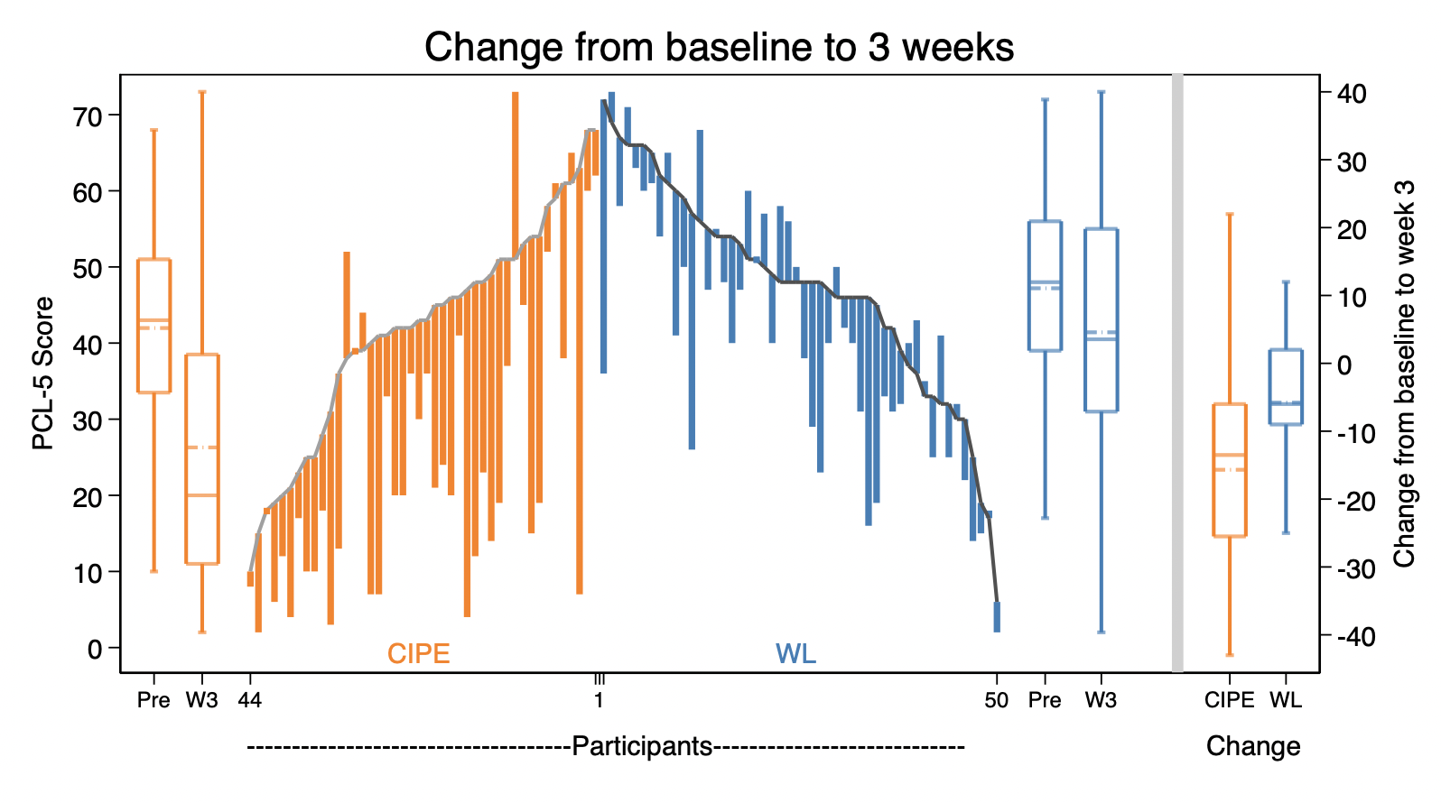
Efig 1. The distribution of changes in the PTSD Checklist for DSM-5 (PCL-5) sum scores from baseline to end of intervention after three weeks (W3). The parallel line plot is sorted by intervention group and displays the pre- and post-values of each participant, with differences depicted by the length of the line that runs between them. The box plots summarize the pre-, post-, and change scores for each group, with dashed lines that indicate the mean scores.
Abbreviations: CIPE, Condensed Internet-delivered Prolonged Exposure; WL; waiting list; PCL-5, PTSD Checklist for DSM-5.

Change from baseline to week 7
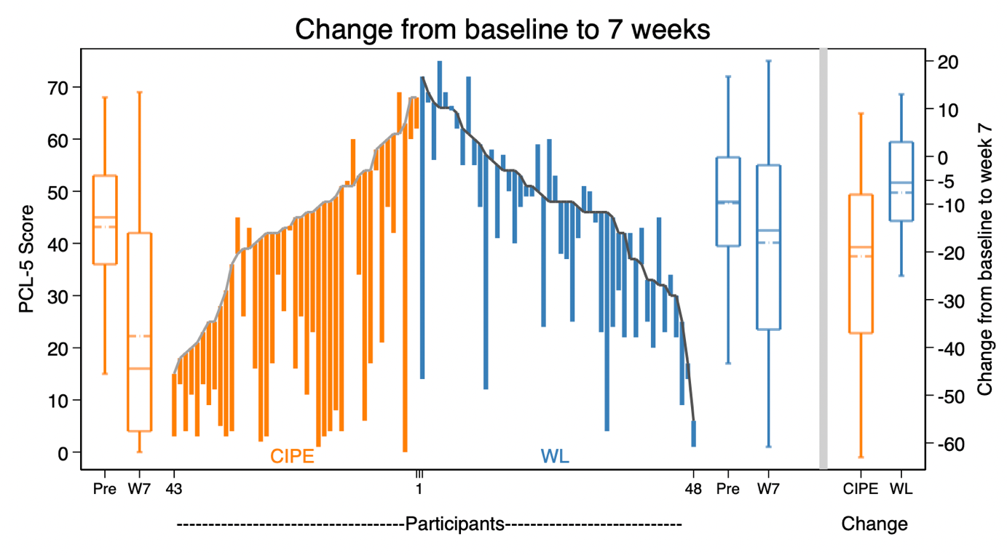
Efig 2. The distribution of changes in the PTSD Checklist for DSM-5 (PCL-5) sum scores from baseline to week 7 (1-month follow up). The parallel line plot is sorted by intervention group and displays the pre- and post-values of each participant, with differences depicted by the length of the line that runs between them. The box plots summarize the pre-, post-, and change scores for each group, with dashed lines that indicate the mean scores.
Abbreviations: CIPE, Condensed Internet-delivered Prolonged Exposure; WL; waiting list; PCL-5, PTSD Checklist for DSM-5.
Changes in PTSD symptom clusters
eTable 1. Change in PTSD symptom clusters from baseline
 | CIPE |  | Waiting List |  | Group x Time |  |  | Effect Size
PCL-5 Subscale | M | (SD) | M | (SD) | β | Z | P | Bootstrapped d  (95% CI)
Reexperiencing
Baseline | 11.67 | (3.87) | 12.62 | (3.76)
Week 1 | 10.00 | (4.16) | 11.42 | (4.26)
Week 2 | 8.09 | (4.71) | 10.96 | (4.30)
Week 3 | 6.97 | (5.26) | 10.52 | (5.04) | 0.95 | 4.22 | <.0001 | 0.64 (0.25 to 1.04)
Week 4 | 6.10 | (5.23) | 10.26 | (5.23)
Week 5 | 5.27 | (4.61) | 9.51 | (5.26)
Week 6 | 4.14 | (4.67) | 9.62 | (5.10)
Week 7 | 5.67 | (5.39) | 9.94 | (6.67) | 0.53 | 6.46 | <.0001 | 0.78 (0.38 to 1.18)
Avoidance
Baseline | 5.15 | (1.95) | 5.68 | (2.04)
Week 1 | 3.93 | (2.14) | 5.53 | (2.15)
Week 2 | 3.09 | (2.15) | 5.49 | (2.20)
Week 3 | 2.55 | (2.16) | 5.14 | (2.29) | 0.68 | 5.59 | <.0001 | 0.96 (0.53 to 1.38)
Week 4 | 2.11 | (1.90) | 4.63 | (2.53)
Week 5 | 1.92 | (2.01) | 4.78 | (2.38)
Week 6 | 1.74 | (2.06) | 5.11 | (2.48)
Week 7 | 2.16 | (2.32) | 5.04 | (2.48) | 0.30 | 6.89 | <.0001 | 0.93 (0.52 to 1.34)
NACM
Baseline | 12.59 | (6.25) | 13.56 | (5.39)
Week 1 | 11.80 | (5.78) | 11.80 | (4.98)
Week 2 | 9.00 | (5.81) | 12.37 | (5.22)
Week 3 | 7.59 | (6.36) | 12.06 | (55.35) | 1.21 | 4.43 | <.0001 | 0.64 (0.38 to 1.02)
Week 4 | 7.07 | (6.52) | 11.67 | (5.55)
Week 5 | 5.75 | (5.54) | 11.02 | (5.81)
Week 6 | 5.35 | (5.78) | 11.16 | (5.99)
Week 7 | 6.49 | (6.47) | 12.02 | (5.79) | 0.71 | 7.41 | <.0001 | 0.83 (0.45 to 1.21)
Hyperarousal
Baseline | 11.59 | (5.06) | 13.31 | (4.72)
Week 1 | 10.84 | (5.74) | 12.12 | (4.30)
Week 2 | 9.30 | (5.40) | 12.41 | (5.57)
Week 3 | 8.14 | (5.98) | 11.94 | (5.21) | 0.75 | 3.24 | <.0001 | 0.43 (0.12 to 0.74)
Week 4 | 7.34 | (5.64) | 11.34 | (5.33)
Week 5 | 6.84 | (5.46) | 10.71 | (5.77)
Week 6 | 5.91 | (5.07) | 11.04 | (5.93)
Week 7 | 7.04 | (6.31) | 11.46 | (6.21) | 0.42 | 5.08 | <.0001 | 0.54 (0.17 to 0.90)
Abbreviations: CIPE, Condensed Internet-Delivered Prolonged Exposure; NACM, Negative Alterations in Cognitions and Mood; PCL-5, PTSD Checklist for DSM-5

