Supplementary Material

Table S1. Patients and controls divided into sites
site
Subject status |  |  | N | Percent %
Case |  | London | 38 | 9.6
 |  | Cambridge | 34 | 8.6
 |  | Amsterdam | 30 | 7.6
 |  | Gouda and Voorhout | 67 | 16.9
 |  | Madrid | 23 | 5.8
 |  | Barcelona | 17 | 4.3
 |  | Oviedo | 20 | 5.0
 |  | Valencia | 21 | 5.3
 |  | Creteil (Paris) | 12 | 3.0
 |  | Puy de Dome (Clermont-Ferrand) | 6 | 1.5
 |  | Bologne | 24 | 6.0
 |  | Palermo | 13 | 3.3
 |  | Sao Paulo WP2 | 22 | 5.5
 |  | Galicia | 17 | 4.3
 |  | Verona | 40 | 10.1
 |  | Cuenca | 13 | 3.3
Control |  | London | 86 | 12.3
 |  | Cambridge | 90 | 12.8
 |  | Amsterdam | 46 | 6.6
 |  | Gouda and Voorhout | 74 | 10.5
 |  | Madrid | 25 | 3.6
 |  | Barcelona | 20 | 2.8
 |  | Oviedo | 14 | 2.0
 |  | Valencia | 14 | 2.0
 |  | Creteil (Paris) | 39 | 5.6
 |  | Puy de Dome (Clermont-Ferrand) | 32 | 4.6
 |  | Bologne | 27 | 3.8
 |  | Palermo | 29 | 4.1
 |  | Sao Paulo WP2 | 62 | 8.8
 |  | Galicia | 28 | 4.0
 |  | Verona | 89 | 12.7
 |  | Cuenca | 27 | 3.8
Patients and controls were recruited from 16 different sites as part of the EU-GEI study. (for more detailed information please see (Jongsma et al., 2018).

S2. Flowchart.
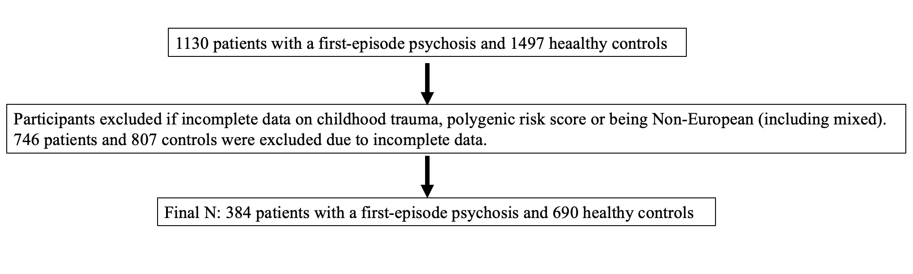

Table S3. Sensitivity analysis, prevalence of childhood adversities as a continuous measure amongst first-episode psychosis cases and unaffected controls
Total adversity exposure, CTQ  Total score | Unadjusted  ß | 95% CI | p | Adjusted ß * | 95% CI | p
 | 0.94 | 0.93-0.95 | ˂0.001 | 0.94 | 0.92-0.95 | ˂0.001
Notes: CI, confidence interval.
*Adjusted for site, gender, age at interview, and years of education.
Childhood adversities were measured as a continues score following the description by Bernstein et al., (1994), with a minimum score of 25 and a maximum score of 125.

Table S4. Sensitivity analysis, prevalence of childhood adversities subtypes as a continuous measure amongst first-episode psychosis cases and unaffected controls
Emotional abuse | Unadjusted  ß | 95% CI | p | Adjusted ß * | 95% CI | p
 | 0.88 | 0.85-0.91 | ˂0.001 | 0.86 | 0.83-0.90 | ˂0.001
Physical abuse | Unadjusted  ß | 95% CI | p | Adjusted ß * | 95% CI | p
 | 0.82 | 0.77-0.88 | ˂0.001 | 0.81 | 0.75-0.87 | ˂0.001
Sexual abuse | Unadjusted  ß | 95% CI | p | Adjusted ß * | 95% CI | p
 | 0.87 | 0.81-0.93 | ˂0.001 | 0.86 | 0.79-0.93 | ˂0.001
Emotional neglect | Unadjusted  ß | 95% CI | p | Adjusted ß * | 95% CI | p
 | 0.88 | 0.86-0.91 | ˂0.001 | 0.88 | 0.86-0.92 | ˂0.001
Physical neglect | Unadjusted  ß | 95% CI | p | Adjusted ß * | 95% CI | p
 | 0.81 | 0.77-0.85 | ˂0.001 | 0.81 | 0.76-0.85 | ˂0.001
Notes: CI, confidence interval.
*Adjusted for site, gender, age at interview, and years of education.
Childhood trauma subtypes were measured as a continues score following the description by Bernstein et al., (1994), with a minimum score of 5 and a maximum score of 25.

Table S5. Sensitivity analysis, schizophrenia polygenic risk score and reports of childhood adversity as a continuous measure
Gene–Environment correlation | Adjusted ß * | 95% CI | p | Adjusted ß ** | 95% CI | p
Psychosis cases | 0.01 | -0.08-0.10 | 0.85 | 0.02 | -0.08-0.11 | 0.74
Unaffected controls | 0.08 | 0.03-0.15 | 0.02 | 0.09 | 0.02-0.16 | 0.02
Notes: linear regression.
*adjusted for ten principal components, and site.
**further adjusted for gender, age at interview and education level.
Childhood adversities were measured as a continues score following the description by Bernstein et al., (1994), with a minimum score of 25 and a maximum score of 125.

Table S6. Sensitivity analysis, schizophrenia polygenic risk score and reports of childhood trauma subtypes as a continuous measure
Gene–Emotional abuse correlation | Adjusted ß * | 95% CI | p
Psychosis cases | -0.004 | -0.09-0.10 | 0.94
Unaffected controls | 0.09 | 0.02-0.15 | 0.02
Gene– Physical abuse correlation | Adjusted ß * | 95% CI | p
Psychosis cases | 0.003 | -0.12-0.06 | 0.51
Unaffected controls | 0.06 | -0.01-0.13 | 0.10
Gene–Sexual abuse correlation | Adjusted ß * | 95% CI | p
Psychosis cases | -0.05 | -0.14-0.05 | 0.32
Unaffected controls | 0.07 | -0.05-0.13 | 0.07
Gene– Emotional neglect correlation | Adjusted ß * | 95% CI | p
Psychosis cases | 0.04 | -0.05-0.13 | 0.37
Unaffected controls | 0.06 | -0.01-0.13 | 0.11
Gene–Physical neglect correlation | Adjusted ß * | 95% CI | p
Psychosis cases | 0.04 | -0.06-0.13 | 0.44
Unaffected controls | 0.04 | -0.03-0.11 | 0.29

Notes: linear regression.
* Adjusted for ten principal components, site, gender, age at interview and education level.
Childhood trauma subtypes were measured as a continues score following the description by Bernstein et al., (1994), with a minimum score of 5 and a maximum score of 25.

