Supplementary Material
S1. The probabilistic reversal learning task

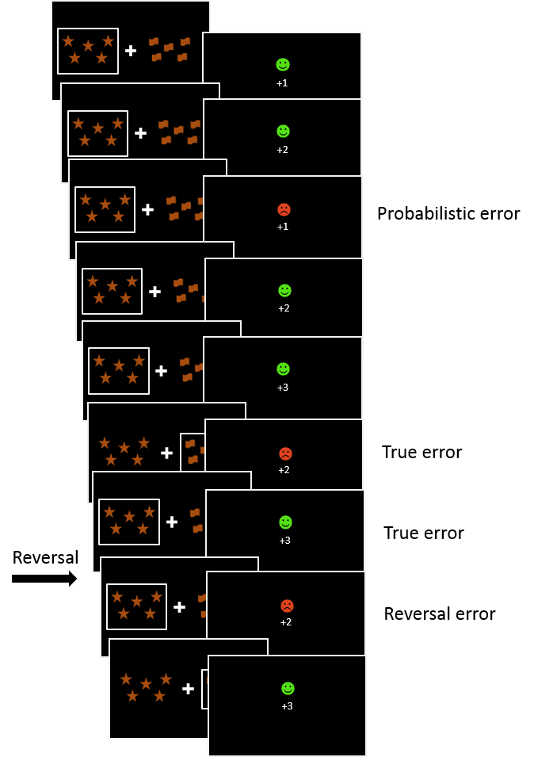
An example of several consecutive trials is shown (running from top to bottom). On each trial, participants were presented with two visual stimuli. Using feedback, participants discover which stimulus most probably leads to reward. White squares indicate which stimulus the participant selected. Feedback was shown after the participant had selected one of the stimuli. Probabilistic error resulted from an invalid negative feedback after the participant selected the correct stimulus. True error resulted from a valid negative feedback after the participant selected the false stimulus. Reversal error resulted from the reversal of the rule.

S2. An exemplary BADE task

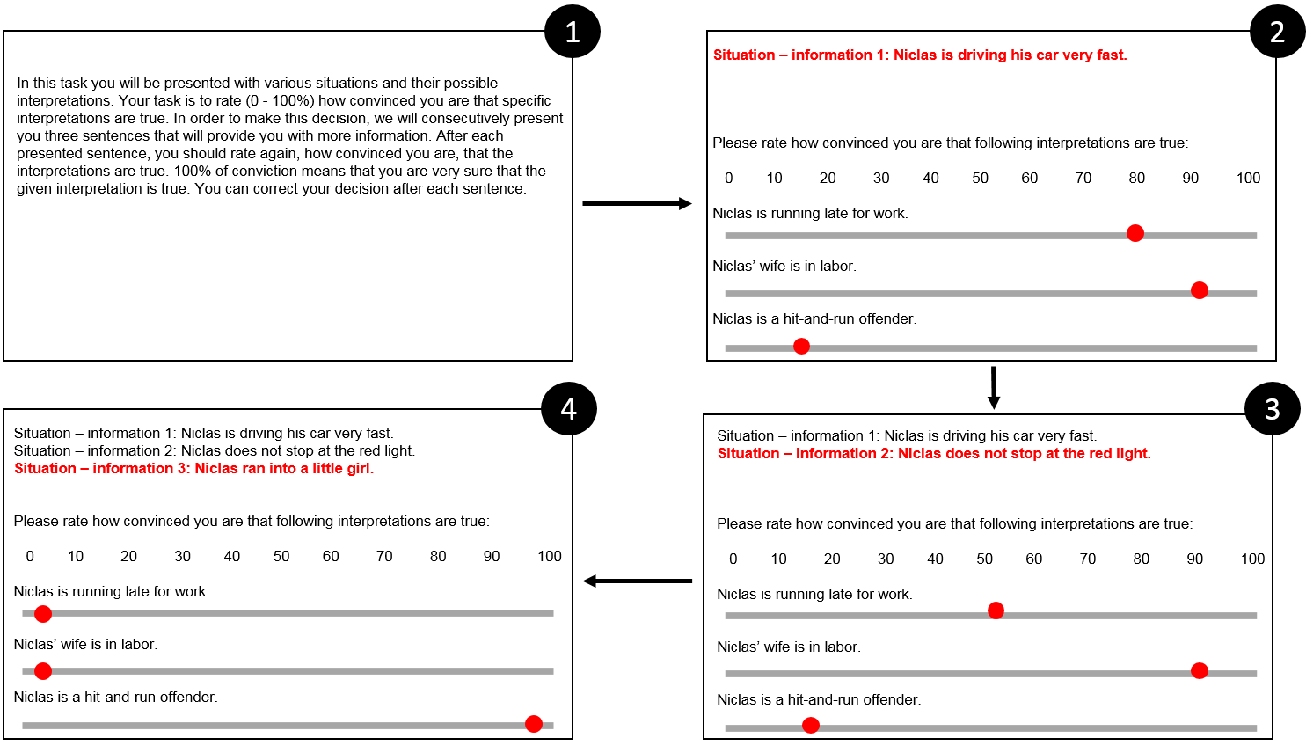
An example of a BADE task: 1 = Instruction; 2 = ”Information 1” is provided and participants need to rate how convinced they are that the three interpretations are plausible; 3 = ”Information 2” is provided and participants can revise their plausibility ratings; 4 = ”Information 3” disambiguates the task and participants can revise their plausibility ratings for the last time.

S3. Model fit comparisons: Model fit comparisons: random intercept - fixed slope versus random intercept – random slope
Table S3. Model fit comparisons: random intercept - fixed slope versus random intercept – random slope
Model | random intercept –  fixed slope BIC | random intercept – random slope BIC
Condition as a predictor of stress | 1515.559 | 1514.091
Condition as a predictor of paranoia | 1349.045 | 1327.914
Condition as a predictor of RL | 1598.965 | 1609.897
Condition as a predictor of JTC | 2238.747 | 2247.514
Condition as a predictor of BADE | 2602.491 | 2613.945
Notes. BIC = Condition = stress condition versus control condition; Bayesian Information Criterion; RL = Reversal Learning; JTC = Jumping To Conclusions; BADE = Bias Against Discriminatory Evidence. Bold = . ΔBIC > 10.

S4. Test of order effects (first stress condition, then control condition and vice versa) on subjective stress, paranoia, RL, BADE and JTC.

Table S4. Test of condition order effects.
 | F | df | p
Dependent variable: State subjective stress
Condition | 127.89 | 1, 154 | <.001
Order | 0.10 | 1, 154 | .749
Condition x Order | 3.69 | 1, 154 | .057
Dependent variable: State paranoia
Condition | 148.47 | 1, 154 | <.001
Order | 0.04 | 1, 154 | .850
Condition x Order | 3.32 | 1, 154 | .070
Dependent variable: RL
Condition | 1.18 | 1, 150 | .280
Order | 0.04 | 1, 155 | .843
Condition x Order | 0.91 | 1, 150 | .342
Dependent variable: BADE
Condition | 0.24 | 1, 154 | .626
Order | 2.47 | 1, 154 | .118
Condition x Order | 0.01 | 1, 154 | .913
Dependent variable: JTC
Condition | 0.11 | 1, 155 | .746
Order | 2.49 | 1, 159 | .116
Condition x Order | 1.67 | 1, 155 | .198
Note. Df = df denominator, df numerator; RL = Reversal Learning; BADE = Bias Against Disconfirmatory Evidence; JTC = Jumping to Conclusions; Condition = stress versus control condition; Order = first stress then control condition versus first control then stress condition.

