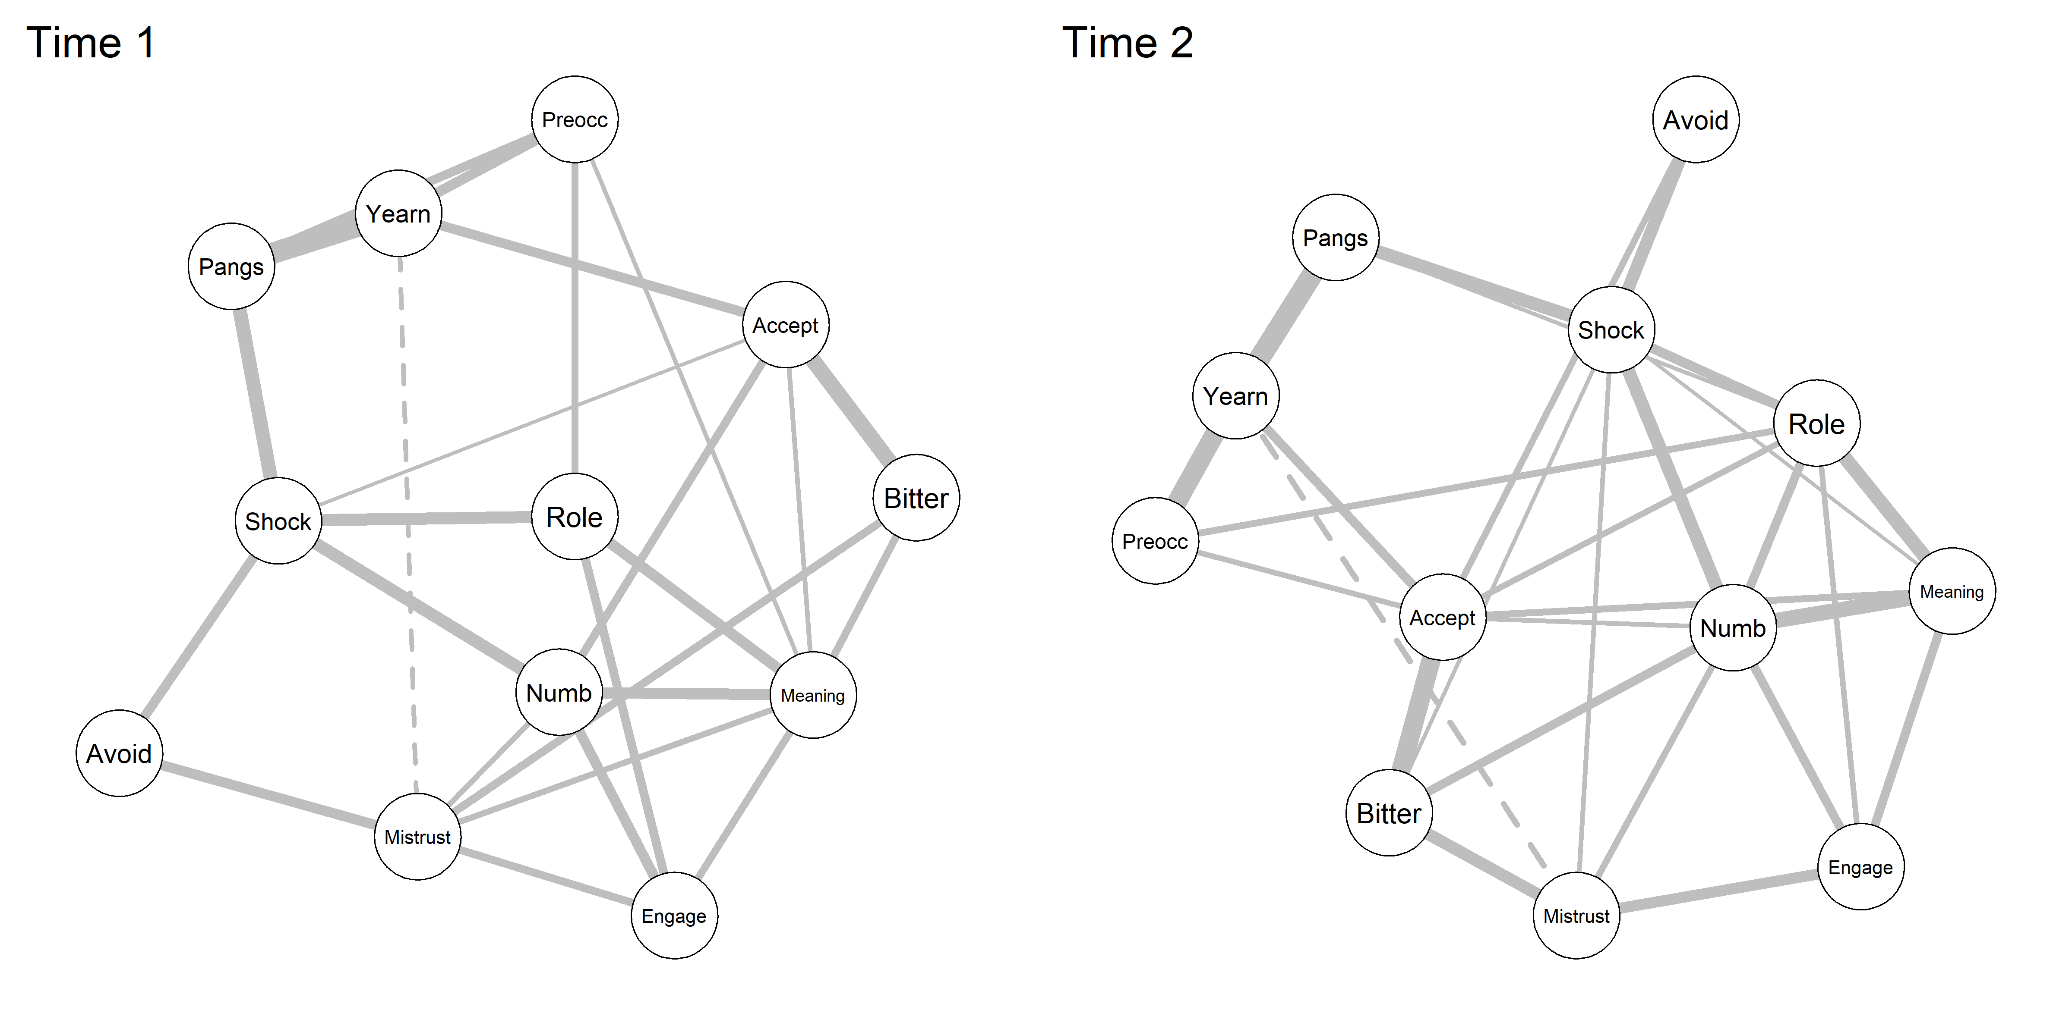

Figure S1: Glasso networks for male and female data sets combined at Time 1 (two months) and Time 2 (eleven months) after the death
Note: Yearn = yearning, Pangs = emotional distress/pangs of grief, Preocc = Preoccupation with circumstances of the death, Accept = Difficulties with acceptance, Shock = Sense of shock, Bitter = Bitterness relating to the loss; Role = self-identity/role disturbance, Numb = emotional numbness, Mistrust = trust difficulties, Avoid = avoidance of reminders, Engage = difficulties reengaging with life; Meaning = meaninglessness.

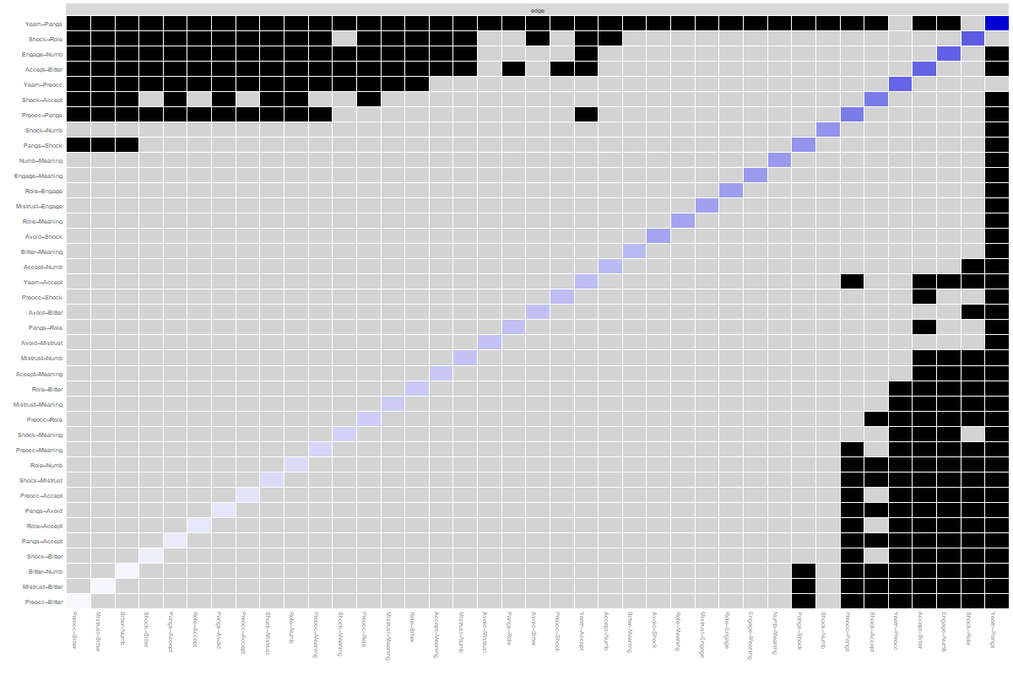
Figure S2: Bootstrapped Significance of Differences Between Non-Zero Edges in Estimated Network, Male Network Time 1
Note: Grey boxes indicate edges that do not differ significantly from one-another (p <.05) and black boxes represent edges that do differ significantly from one-another.

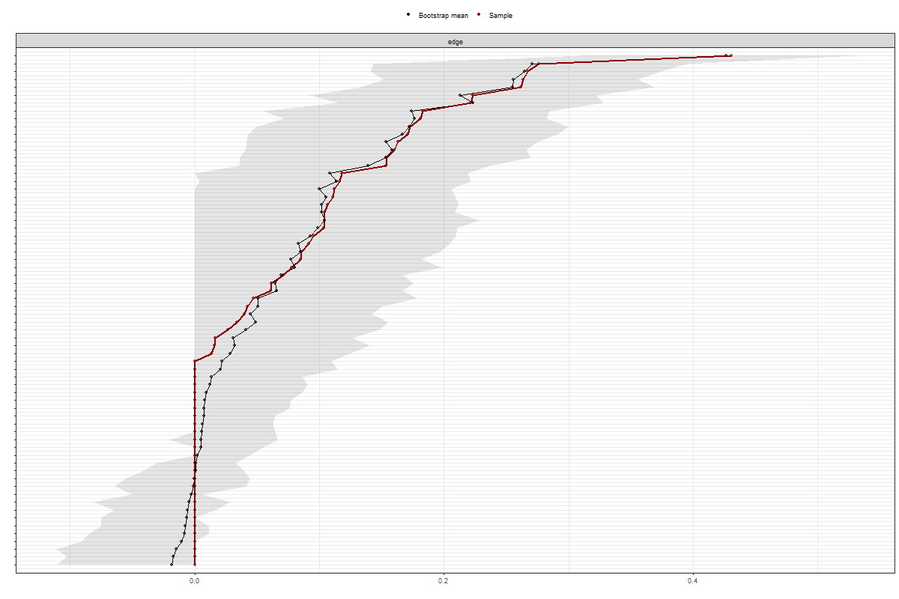
Figure S3: Bootstrapped 95% Confidence Intervals Around Network Edges, Male Network Time 1

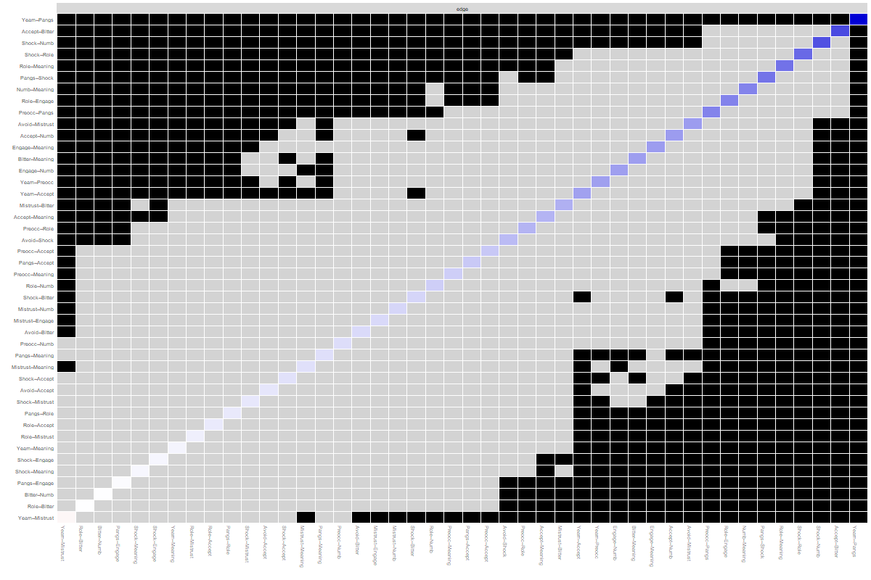
Figure S4: Bootstrapped Significance of Differences Between Non-Zero Edges in Estimated Network, Female Network Time 1
Note: Grey boxes indicate edges that do not differ significantly from one-another (p <.05) and black boxes represent edges that do differ significantly from one-another.

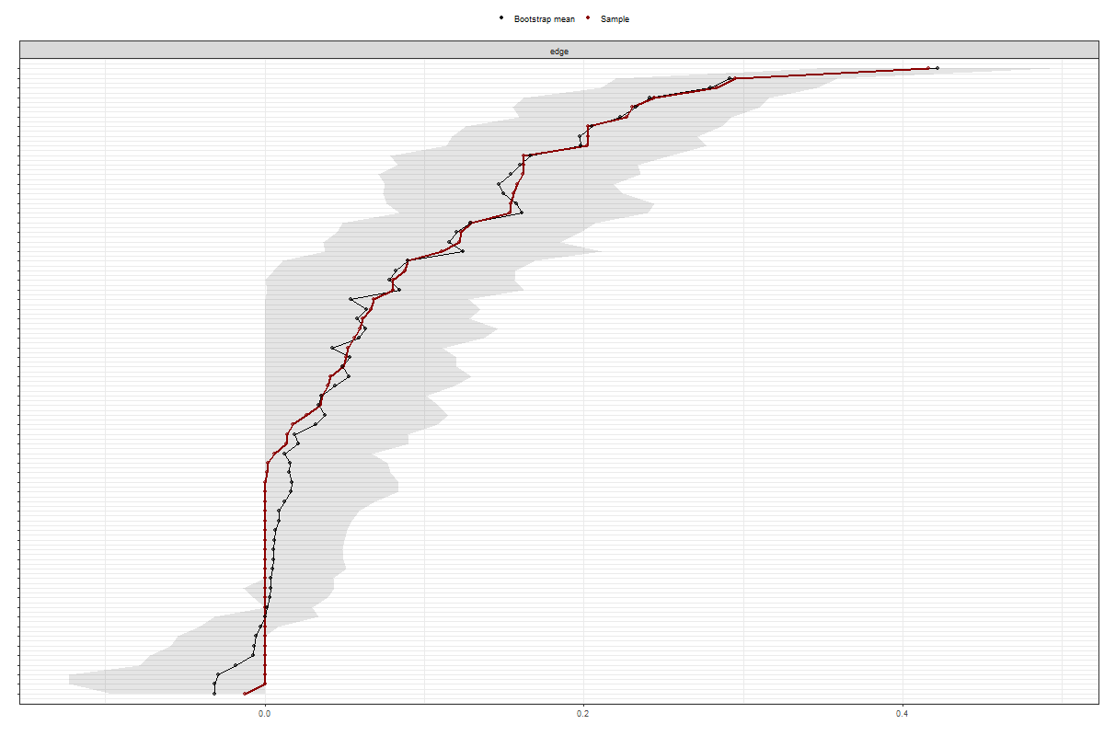
Figure S5: Bootstrapped 95% Confidence Intervals Around Network Edges, Female Network Time 1

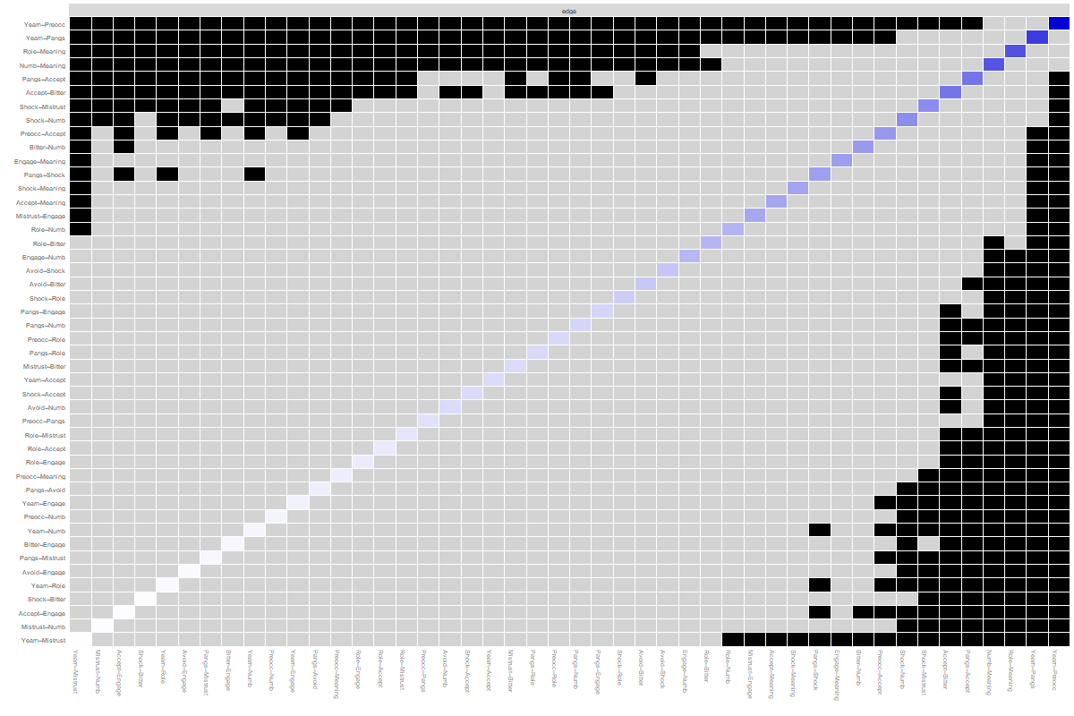
Figure S6: Bootstrapped Significance of Differences Between Non-Zero Edges in Estimated Network, Male Network Time 2
Note: Grey boxes indicate edges that do not differ significantly from one-another (p <.05) and black boxes represent edges that do differ significantly from one-another.

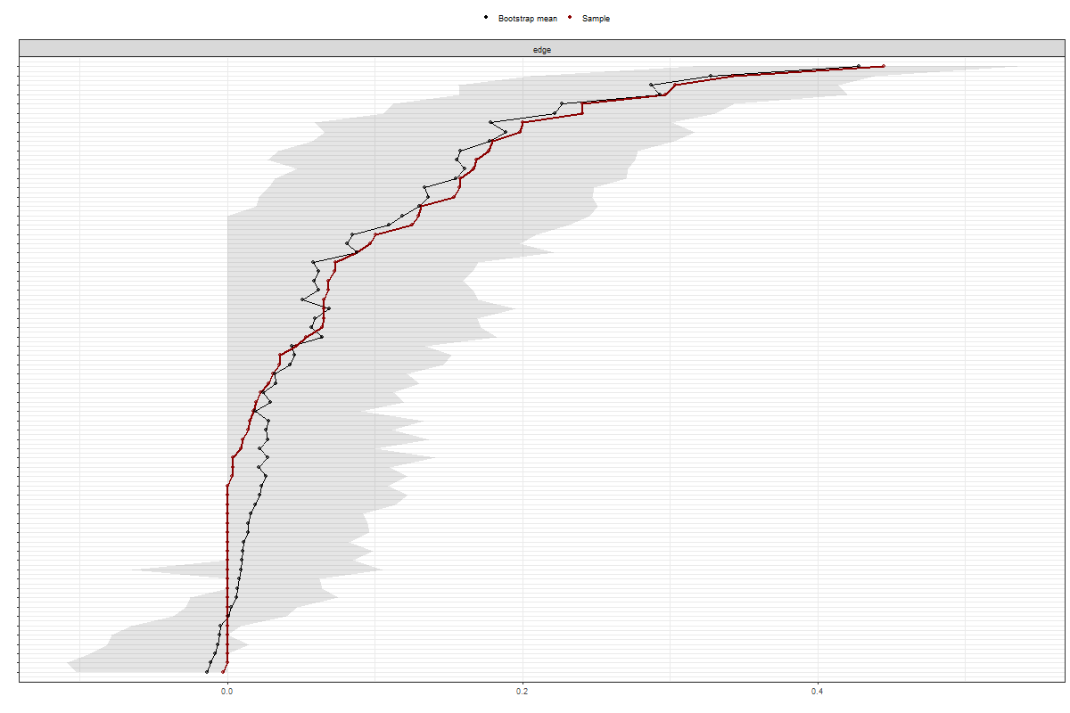
Figure S7: Bootstrapped 95% Confidence Intervals Around Network Edges, Male Network Time 2

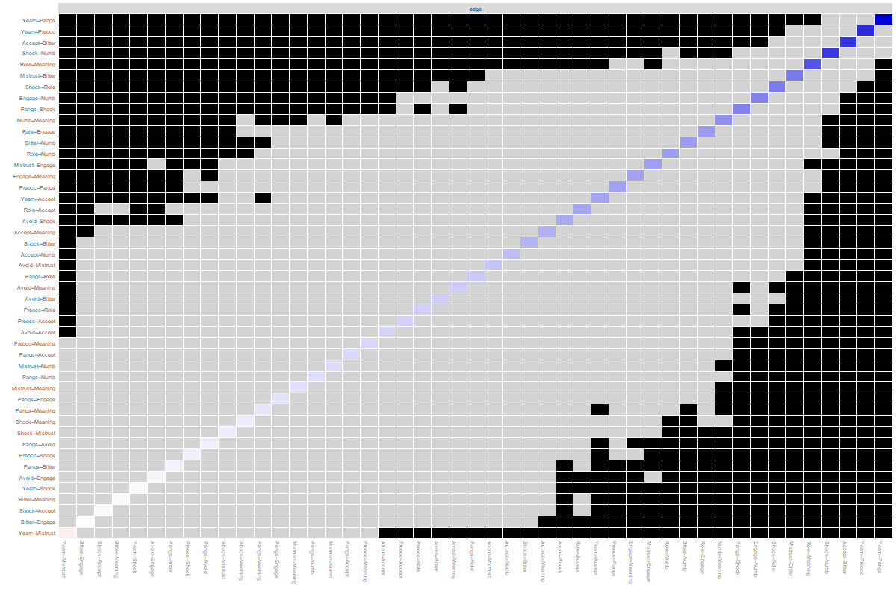
Figure S8: Bootstrapped Significance of Differences Between Non-Zero Edges in Estimated Network, Female Network Time 2
Note: Grey boxes indicate edges that do not differ significantly from one-another (p <.05) and black boxes represent edges that do differ significantly from one-another.

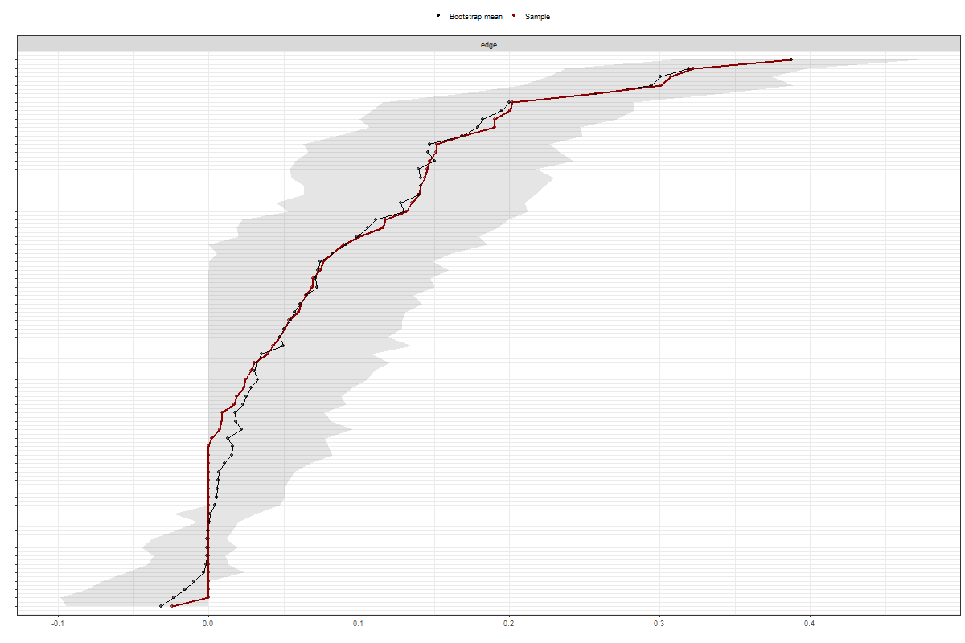
Figure S9: Bootstrapped 95% Confidence Intervals Around Network Edges, Female Network Time 2

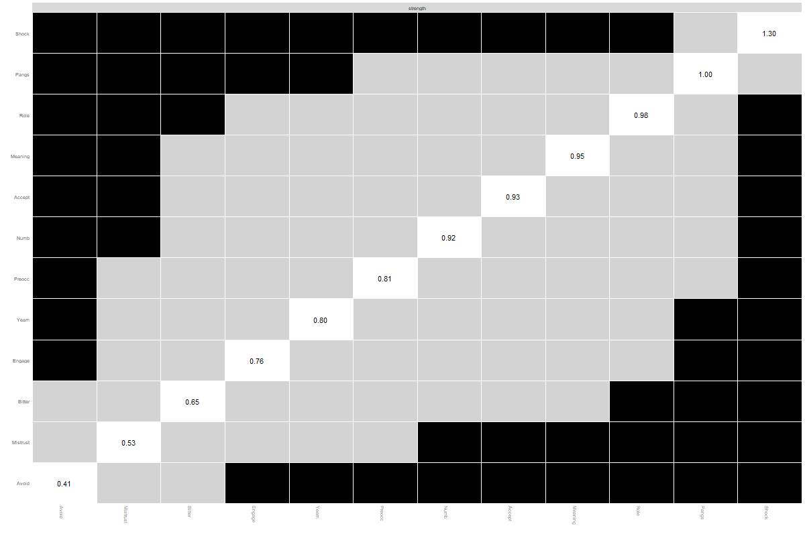

Figure S10: Bootstrapped Significant Differences in Strength Centrality in Estimated Network, Male Time 1
Note: Grey boxes indicate nodes that do not differ significantly from one-another (p <.05) and black boxes represent nodes that do differ significantly from one-another. White boxes in the centrality plot show the value of node strength

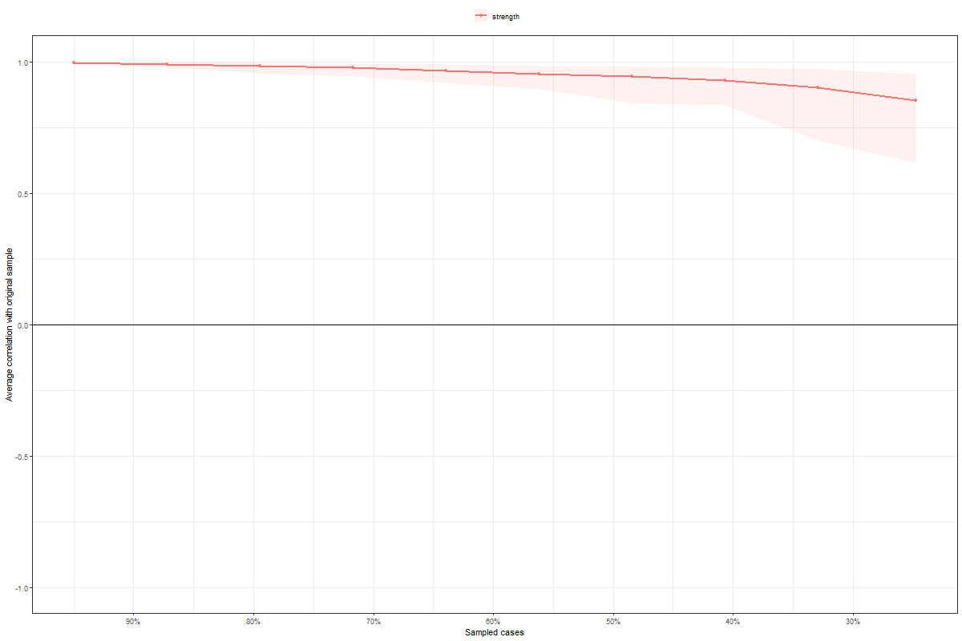
Figure S11: Bootstrapped Stability of Centralities Indices When % Cases Removed from Estimated Network, Males Time 1
Note: the x-axis represents the % of the original sample used to calculate the centrality indices

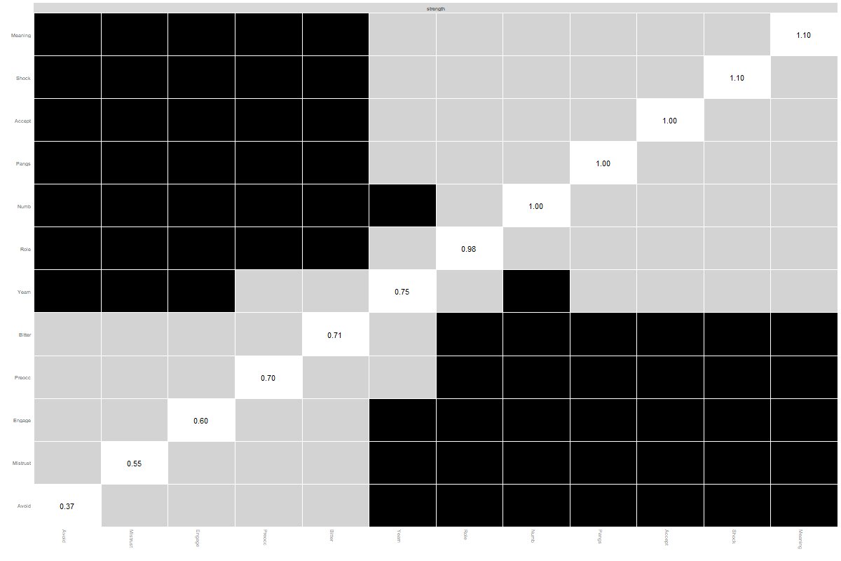
Figure S12: Bootstrapped Significant Differences in Strength Centrality in Estimated Network, Female Time 1
Note: Grey boxes indicate nodes that do not differ significantly from one-another (p <.05) and black boxes represent nodes that do differ significantly from one-another. White boxes in the centrality plot show the value of node strength

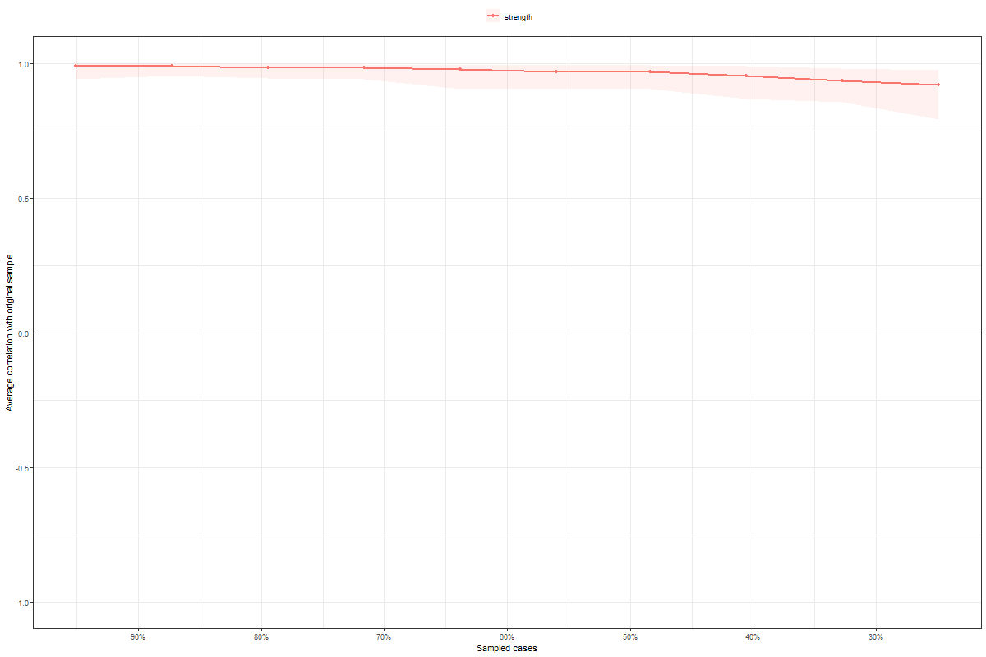
Figure S13: Bootstrapped Stability of Centralities Indices When % Cases Removed from Estimated Network, Female Time 1
Note: the x-axis represents the % of the original sample used to calculate the centrality indices

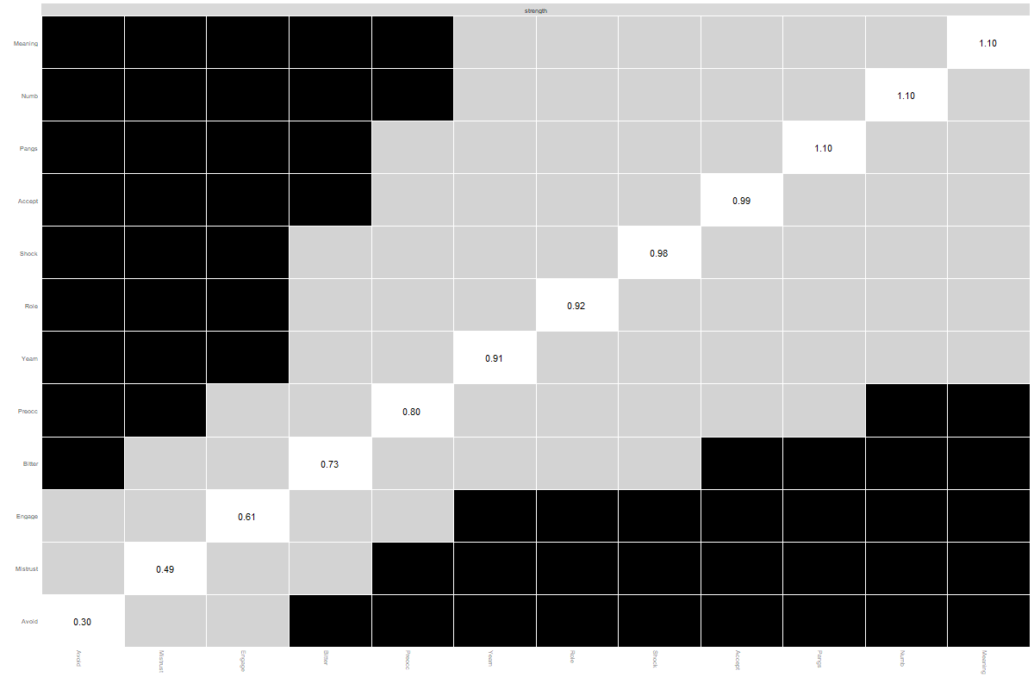Figure S14: Bootstrapped Significant Differences in Strength Centrality in Estimated Network, Male Time 2
Note: Grey boxes indicate nodes that do not differ significantly from one-another (p <.05) and black boxes represent nodes that do differ significantly from one-another. White boxes in the centrality plot show the value of node strength

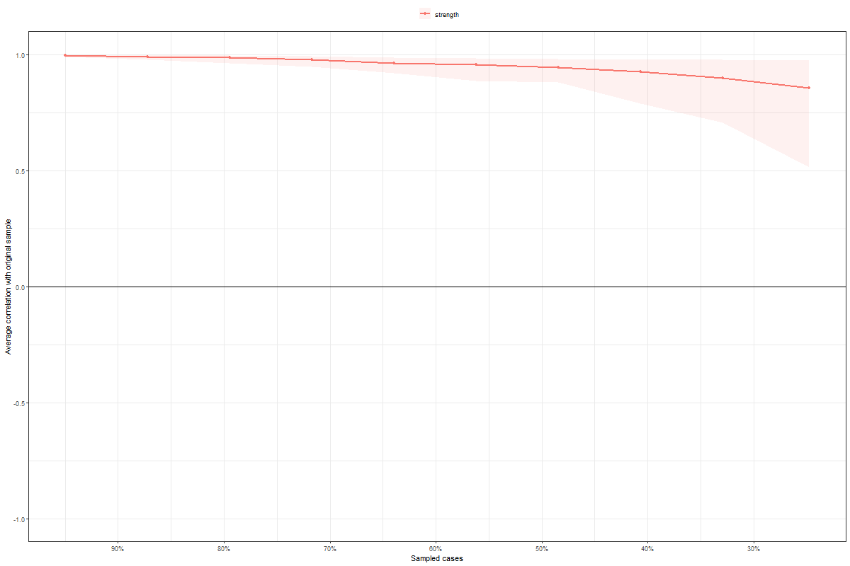
Figure S15: Bootstrapped Stability of Centralities Indices When % Cases Removed from Estimated Network, Male Time 2
Note: the x-axis represents the % of the original sample used to calculate the centrality indices

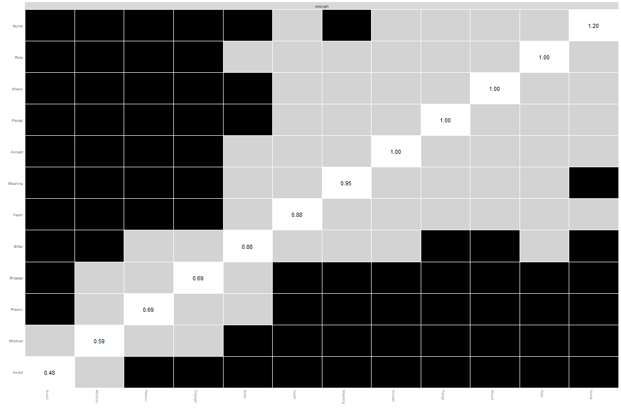Figure S16: Bootstrapped Significant Differences in Strength Centrality in Estimated Network, Female Time 2
Note: Grey boxes indicate nodes that do not differ significantly from one-another (p <.05) and black boxes represent nodes that do differ significantly from one-another. White boxes in the centrality plot show the value of node strength

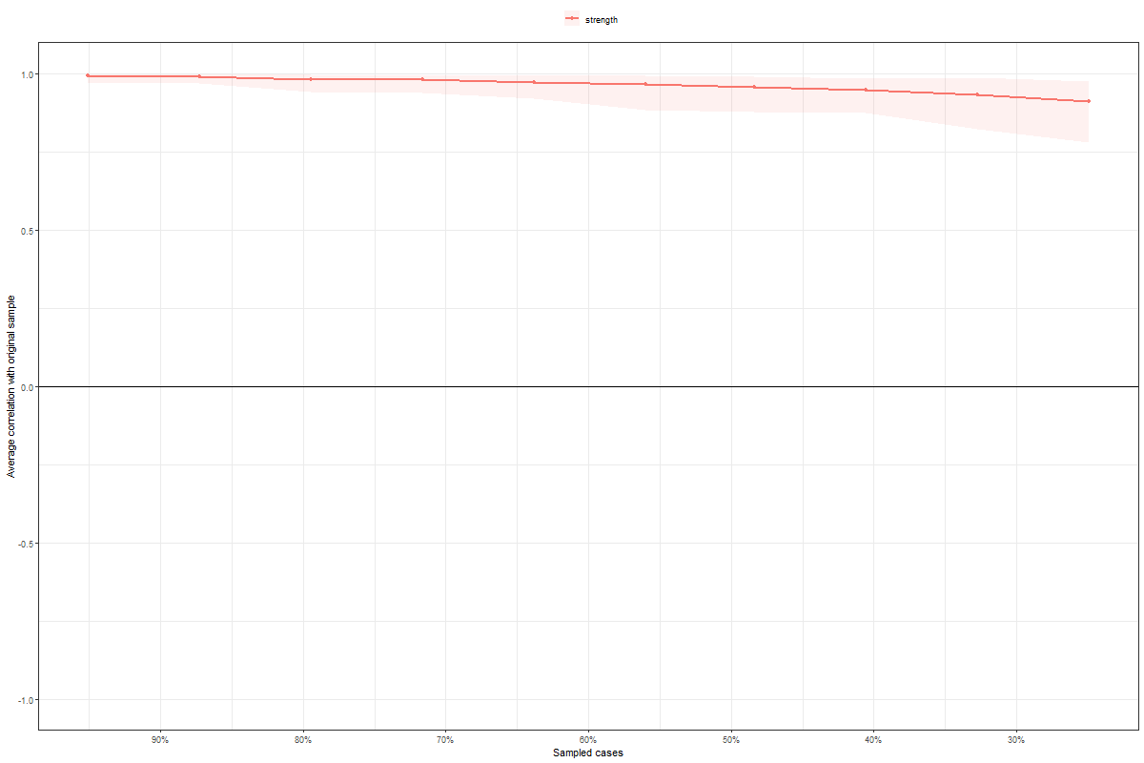
Figure S17: Bootstrapped Stability of Centralities Indices When % Cases Removed from Estimated Network, Female Time 2
Note: the x-axis represents the % of the original sample used to calculate the centrality indices

Supplementary Table 1: Network comparison test outcomes comparing male and female networks using random sampling of female network to equate sample size

 | Sample 1 | Sample 1 | Sample 1 | Sample 1 | Sample 1
Network structure
Time 1 | 0.1017 | 0.5125 | 0.0776 | 0.2984 | 0.0879
Time 2 | 0.7833 | 0.5229 | 0.5854 | 0.6039 | 0.5121
Network strength
Time 1 | 0.1017 | 0.5125 | 0.0776 | 0.2984 | 0.0879
Time 2 | 0.2786 | 0.0012 | 0.0862 | 0.0169 | 0.1644
Edge Differences
Time 1 | 4 | 8 | 5 | 6 | 4
Time 2 | 2 | 7 | 4 | 5 | 3
Note: Values are p values except for Edge Differences which is the number of edges identified as significantly different.

