Supplemental Material

Supplement 1. Search strategies to identify eligible randomized controlled trials.

In MEDLINE (with Limitation “clinical trial”, “randomized controlled trial”):
("mental disorders"[MeSH TermS] OR ("mental"[All Fields] AND "disorder"[All Fields]) OR "mental disorders"[All Fields] OR "depressive disorder"[MeSH Terms] OR ("depressive"[All Fields] AND "disorder"[All Fields]) OR "depressive disorder"[All Fields] OR "depression"[All Fields] OR "depression"[MeSH Terms] OR "bipolar disorder"[MeSH Terms] OR ("bipolar"[All Fields] AND "disorder"[All Fields]) OR "bipolar disorder"[All Fields] OR "anxiety disorders"[MeSH Terms] OR ("anxiety"[All Fields] AND "disorders"[All Fields]) OR "anxiety disorders"[All Fields] OR "psychotic disorders"[MeSH Terms] OR ("psychotic"[All Fields] AND "disorders”[All Fields]) OR "psychotic disorders"[All Fields] OR "psychosis"[All Fields]) OR ("substance use"[All Fields] AND "disorders"[All Fields]);
AND
("prevention and control"[Subheading] OR "prevention"[All Fields] OR "intervention"[All Fields] OR "drug therapy"[Subheading] OR ("drug"[All Fields] AND "therapy"[All Fields]) OR "drug therapy"[All Fields] OR "pharmacotherapy"[All Fields] OR "drug therapy"[MeSH Terms] OR "psychotherapy"[MeSH Terms] OR "psychotherapy"[All Fields]);
AND
("parents"[MeSH Terms] OR "parents"[All Fields] OR "mothers"[MeSH Terms] OR "mothers"[All Fields] OR "fathers"[MeSH Terms] OR "fathers"[All Fields]);
AND
("adolescent"[MeSH Terms] OR "adolescent"[All Fields] OR "adolescents"[All Fields] OR "child"[MeSH Terms] OR "child"[All Fields] OR "children"[All Fields] OR "infant"[MeSH Terms] OR "infant"[All Fields] OR "infants"[All Fields]).
In CENTRAL, Cochrane Library (with limitation “trials”):
"mental disorders" OR "mood disorder" OR "depressive disorder" OR "bipolar disorder" OR "psychotic disorder" OR "anxiety disorder" OR "substance use disorder" [All Text]
AND "prevention" OR "intervention" OR "control" [All Text]
AND "parent" OR "parents" OR "mother" OR "mothers" OR "father" OR "fathers" [All Text]
AND "child" OR "youth" OR "infant" OR "adolescent" OR "offspring" OR "children" [All Text]
In WEB OF SCIENCES (with limitation “Articles”):
#1 AND #2
#1: TS=(mental disorders OR depressive disorder OR mood disorder OR bipolar disorder OR psychotic disorder OR anxiety disorder OR substance use disorder) AND TS=(parents OR parent OR mothers OR mother OR fathers OR father) AND TS=(prevention OR intervention OR control) AND TS=(child OR adolescent OR youth OR infant OR offspring) AND DOCUMENT TYPES: (Article)
# 2: ((WC = Psychiatry)) AND DOCUMENT TYPES: (Article)
In EMBASE:
'mental disease'/exp AND ('prevention and control'/exp OR 'therapy'/exp OR intervention) AND 'parent'/exp AND ([adolescent]/lim OR [child]/lim OR [infant]/lim OR [newborn]/lim OR [preschool]/lim OR [school]/lim) AND [embase]/lim NOT ([embase]/lim AND [medline]/lim) AND ('clinical trial'/de OR 'controlled clinical trial'/de OR 'randomized controlled trial'/de OR 'randomized controlled trial (topic)'/de)
In PSYCINFO, PSYCHARTICLES, ERIC, MEDLINE In Process (with limitations “Humans”, “Clinical Trial” and “Articles” or [All Text]):
“mental disorders or mood disorder or depressive disorder or bipolar disorder or psychotic disorder or anxiety disorder or substance use disorder” [AB résumé]
AND “parents or caregivers or mother or father or parent” [AB résumé]
AND “prevention or intervention or treatment or program” [AB résumé]
AND “children or adolescents or youth or child or teenager” [AB résumé]
OR “offspring or infant or baby or child” [AB résumé]
In OPENGREY:
discipline:(06E - Medicine) keyword:(Psychiatry) AND prevention*

Tables

Table S1. Characteristics of mental disorders of parents and children’s symptoms at baseline in the 20 randomized controlled trials included.

Study | Classification and Instruments Used in Parents | Mothers/ Fathers with Disorders (%) | Inclusion Criteria | Exclusion Criteria | Recruitment | Child symptoms at baseline | Measure report
Catalano et al. 1999  Haggerty et al. 2008  (USA) | DSM-IV  CIDI | 75/25 | Methadone treatment at least 90 days prior inclusion  Close to clinic | None | Two methadone clinics in Seattle and Washington | Around 20% with substance use initiation | Children interview
Clarke et al.  2001  (USA) | DSM-III-R  F-SADS | 80/20 | Current major depressive episode or in the past 12 month or in treatment | None | HMO computer pharmacy database, Portland | Medium severity group: subsyndromal symptoms or CES-D>24 | Assessors for diagnostic instrument  Parents and children self-reports for symptoms scores
Coiro et al.  2012  (USA) | DSM-IV  CIDI, HRDS | 100/0 | Current major depression  Low-income mothers | Mania, psychosis, past month substance drug abuse/ dependence | County health and welfare services in Washington, Maryland and Virginia | Behavioural problems (mean baseline BSI: 54.05) | Mothers’ reports
Compas et al. 2009, 2010, 2011, 2012  (USA) | DSM-IV  SCID, BDI | 89/11 | Major depressive disorder currently or during the lifetime of their children | Bipolar-I, schizophrenia schizo-affective disorder | Mental health clinics, general medical practices, media outlets, in Tennessee and Vermont | CES-D>16: 27% in FGCB, 35% in WI | Assessors for diagnostic instrument Children self-reports and parents’ reports
Forman et al.  2007  (Canada) | DSM-IV  SCID, IDD, HRDS | 100/0 | Post-partum depressed women, >18 y-o, married or living with partner | Bipolar, schizophrenia mental retardation, antisocial personality, substance abuse, panic disorder, somatization disorder, >3 schizotypal features | Letters to women delivering in 4 Iowa counties | None | Mothers’ reports
Garber et al. 2009  Beardslee et al. 2013  Brent et al.  2015  (USA) | DSM IV  SCI, CES-D | Not reported | Major depression or dysthymia (3 recurrences or at least 3 years duration or in the last 3 years) | Bipolar I or schizophrenia | Health computerized database, medical centers, local schools, media outlets in Tennessee, Pennsylvania, Oregon and Massachusetts | Previous depressive disorder in complete remission > 2 months or subsyndromal symptoms (CES-D >20) | Assessors for diagnostic instrument. Youth self-reports for symptoms
Giannakopoulos et al. 2021  (Greece) | ICD 10  BDI-SF  SSAI, SAS-SR | 81/19 | Single episode or recurrent major depressive disorder, at least one child aged 8-16 y-o | Bipolar disorder, schizophrenia disorders, a life-threatening  physical illness, ongoing family  therapy, dispute over child custody or urgent need for child protection  services | Outpatient  mental health services for adults | Int/ext symptoms | Parents’ reports  Child and mothers’ reports
Ginsburg et al.  2009, 2015, 2020  Pella et al.  2016  (USA) | DSM-IV-  TR  Client-ADIS,  State-Trait Anxiety Inventory, BSI, Learning History Questionnaire-Revised | 79/21 | Current or lifetime diagnosis of anxiety disorder | Post-traumatic or acute stress disorder, substance use disorder, severe psychiatric disorders | Volunteer families, recruited through media outlets, mailing physicians and psychiatrists | Subclinical anxiety (51%) | Independent evaluators supervised by a senior child psychiatrist
Jones et al.  2017  (UK) | DSM IV  SCID, HAM-D, MAS, ISS, CES-D, ASRM | 79/21 | BD diagnosis, internet access, >10h face-to-face contact with child per week | Alcohol or substance abuse, current parenting intervention or intensive psychotherapy | Recruitment from 17 UK National Health Services Trusts and media outlets | Behavior problems | Parents’ reports
Kelley et al.  2002  (USA) | DSM-III-R  TLFB | 0/100 | Between 20-60 y-o, be married for at least 1 year or living with partner for at least 2 years, medical clearance compatible to engage abstinence | Partner with psychoactive substance use disorder in the last 6 months, in methadone maintenance, schizophrenia paranoid or psychotic disorder | Two clinics specializing in the treatment of alcohol problems and two other clinics for drug-abusing men in Buffalo | None | Mothers’ reports
Lenze et al.  2020  (USA) | DSM-IV  SCID-IV | 100/0 | Between 12–30 weeks gestation, >18 y-o, English speaking, and scoring ≥10 on the EDS + criteria for depression | Psychotic disorders, suicidal  ideation acute mania, substance  abuse in the past 3 months and medically high-risk pregnancy. | Flyers posted in an urban OB-Gyn clinic, OB-Gyn clinic staff referral,  and referrals from local community social service agencies | None | Assessors for diagnostic instrument
Van Doesum et al.  2008  Kersten Alvarez et al.  2010  (Netherlands) | DSM-IV  BDI | 100/0 | Concurrent outpatient treatment for their depression by a qualified local therapist or psychiatrist, fluent in Dutch | Psychotic disorder, manic depression, and/or substance dependence | 8 mental healthcare centers across the Netherlands, through local therapists and media outlets | None | Teachers and mothers’ reports
Lam et al.  2008  (USA) | DSM-IV  SCI  TLFB | 0/100 | At least 18 years, were married (>1 year) or cohabitating (> 2 year) with a female partner | Female partner did not meet DSM-IV criteria for substance abuse or dependence | Unclear | Int/ext symptoms | Parents’ reports  Children self-reports
Murray et al.  2003  (UK) | DSM-III-R  EPDS, SCID | 100/0 | Primiparous, close to maternity hospital, English language. Post-natal EPDS>12 | Prematurely delivered, child with any gross congenital abnormality, not a singleton birth | Primiparous  women identified through the  birth records of Addenbrooke’s Hospital,  Cambridge | 50% mothers reported difficulties with some area of infant behavior | Mothers’ reports  Teachers’ reports
Solantus et al.  2010  Punamaki et al.  2013  (Finland) | ICD-10  BDI  SSAI | 73/27 | Treatment for mood disorder | Schizophrenia, ongoing family therapy, a custody dispute, child-protection services, palliative stage of somatic disease | 16 health-care units from eight regional  national health organizations in Finland | Int/ext symptoms | Parents’ reports  Child and mothers’ reports
Stanger et al.  2011  (USA, China) | DSM-IV  VSDI  ASR | 100/0 | Drug and/or alcohol abuse or dependence  during the child’s lifetime | Active psychosis, severe medical or  psychiatric illness | Substance abuse treatment agencies, courts, or  self-referred, Arkansas | Int. symptoms: 23.5%  Ext. symptoms: 34% | Mothers’ reports
Stein et al.  2018  (UK) | DSM-IV-R  SCID-IV-R  EPDS | 100/0 | Current major depressive disorder for at least the previous 3 months or the first postnatal 3 months | Another severe psychiatric  diagnosis or serious physical illness, not cohabiting  with the child, receiving psychological therapy | General practitioners, health visitors, psychological services, posters and leaflets in Oxfordshire, Buckinghamshire, and  Berkshire counties | Difficult temperament: 21.5% | Mothers’ reports
Van Santvoort et al.  2013  (Netherlands) | DSM-IV or ICD 10  BSI | 81/19 | Criteria for a mental disorder or substance  use disorder | Children who had received psychological treatment during  the last year | Parent’s therapist or agency in  20 mental health centers and addiction clinics  all over the Netherlands | Clinical or sub-clinical problems: 70% in experimental group, 63.5% in control group | Parents’ reports
Verduyn et al.  2003  (UK) | DSM IV  SCID, HRSD, BDI | 100/0 | Seeking outpatient treatment for their substance use disorder | Major  psychiatric disorder other than depression, not living with children | Mothers identified using the Community Child Health Register in areas of south Manchester | Child problems  (BSQ  score >8) | Mothers’ reports
Zhang et al.  2017  (USA) | DSM-IV  Form-90 | 100/0 | Seeking outpatient treatment for their substance use disorder | Children living < 50% with their mothers | Community treatment  center for substance use in a large Midwestern city | Unclear | Mothers’ reports
ASR: Adult Self-Report; ASRM: Altman Rating Scale; BD: Bipolar Disease; BDI: Beck Depression Inventory; BDI-SF : Beck Depression Inventory Short Form ; BSI: Brief Symptom Inventory; BSQ: Behavioural Screening Questionnaire; CES-D: Center for Epidemiologic Studies Depression Scale; CIDI: Composite International Diagnostic Interview; Client-ADIS: Anxiety Disorders Interview Schedule; EPDS: Edinburgh Postnatal Depression Scale; FGCB: Family Group Cognitive-Behavioural intervention; F-SADS: Family Schedules for Affective Disorders and Schizophrenia; HAM-D: Hamilton Depression Rating Scale; HMO: Health Maintenance Organization; HRSD: Hamilton Rating Scale for Depression; IDD: Inventory to Diagnose Depression; Int/ext: Internalizing/Externalizing symptoms; ISS: Internal States Scale; MAS: Bech-Rafaelsen Mania Scale; SAS-SR : Social
Adjustment Scale Self-Report ; SCID: Structured Clinical Interview; SSAI: Spielberger State Anxiety Inventory; TLFB: Timeline Followback Interview; VSDI: Vermont Structured Diagnostic Interview; WI: Written Information.

Table S2. Characteristics of interventions to prevent mental disorders in children of parents with mental illness used in the 20 randomized controlled trials included, based on the TIDieR (Template for Intervention Description and Replication) Checklist.

Study | Sessions and delivery | Place | Main strategies and materials | Therapists | Incentives | Participation in the intervention and drop-out rates | Program fidelity criteria | Assessment time point
Catalano et al. 1999  Haggerty et al. 2008  (USA) | 53 hours of training in small family groups (face-to-face, 5-hours family retreat + 1.5-hour twice-weekly including 12 sessions with children) +  1 home visit and 2 phone calls per week during 9 months | Clinic + Home | Parents skills training (cognitive-affective-behavioural-skills) for positive family management practices, reinforced by home-based case managers, based on the social development model.  Structured training curriculum with guide practice developed for the project | Master's level therapists with background in addiction | 3$ per session  2$ per homework assessment  Transportation and child care were provided  Small toys for children and tickets by local organizations. | 46.8% of the sessions on average (13.3% with not parents attending a single session). 17 home visits on average (range 0-39). Drop-out: 8% at M12, 14.7% at Y12-15. | Not available | Baseline, post-test, M6, M12, Y12-15
Clarke et al.  2001  (USA) | 15 one-hour group sessions + homeworks  3 parents informational meetings face-to-face | HMO clinic office | Cognitive restructuring techniques, focused on beliefs related to having a depressed parent. Abbreviated version of “Adolescent Coping With Depression Course” program. Workbook for adolescents and parents. | Therapists with a master’s degree, trained in this approach, weekly supervised | None | 9.5 sessions on average (median 12, range 0-15). Homework assignments of 46% of the attended sessions.  Drop-out: 2% for all follow-up, 4% at post-test, 9.6% at M12 and 17% at M18 | All intervention sessions were audiotaped, and 2 or 3 sessions were randomly selected and rated by a senior supervisor on a 10-item fidelity scale. Mean therapist compliance was 95.9%. | Baseline, post-test, M12, M24
Coiro et al.  2012  (USA) | 4 education meetings CBT group face-to-face: 8 weekly sessions, in group or individually, extendible, with homework and daily monitoring  Medication group: 6 months of paroxetine or bupropion with adjustments in dosage. | Clinic, Women Entering Care office or at home if necessary | Focus on cognitive management on mood, engaging in pleasant activities, improving relationships. CBT manual guide adapted for 8 sessions.  Face-to-face meeting for medication intervention. | Psychotherapists and primary care nurse practitioners supervised, trained in PTSD and trauma understanding | Mothers: 35$ per interview  Children: 10$ gift  Transportation to care visits were provided. | Received minimally therapeutic “dose” of treatment: 30% in medication and 29% in CBT. Drop-out: 19% at M6, 25% at M12. | Not available | Baseline, M6, M12
Compas et al. 2009,  2010,  2011,  2012  (USA) | 12 sessions face-to-face: 8 weekly, 4 booster sessions monthly.  Parents and children  meet separately on most sessions.  Homework  Control group: mailing of written materials (internet) | Clinic | Improve parenting skills and coping skills, educate about depressive disorders, problem solve difficulties. Manualized program. | Clinical social workers and doctoral level students in clinical psychology, trained with audiotapes and role-playing, with supervisions | None | Mean of 7.9 sessions (range 0-12). Drop-out: 7% at M18, 12% at M24. | Intervention sessions were audio-recorded, and 23% were randomly selected for fidelity coding. Ratio of number of checklist items covered to total items: 92% | Baseline, post-test, M6, M12, M18, M24
Forman et al.  2007  (Canada) | 12 hours-long individual sessions face-to-face, each week. Home-visits (at onset and after treatment) with videotapes. | Clinic + Home | Biopsychosocial perspective, interpersonal problems (conflicts, social role transitions, loss and grief) | Therapists in private practice with PhD or PsyD degrees, trained with Interpersonal Psychotherapy for post-partum Depression (unpublished manual) + videotapes sessions | None | 89% completed study. 67% returned complete data at the follow-up | Monitoring of therapists for adherence to IPT manuals. | M6, M18
Garber et al. 2009  Beardslee et al. 2013  Brent et al.  2015  (USA) | 8 weekly 90-min acute and 6 monthly continuation sessions, 3-10 adolescents. Parent meetings at week 1 and week 8 (information sessions, face-to-face) | Clinic | Cognitive restructuring techniques focused on negative thoughts, problem-solving skills. Relaxation, Behavioural activation and assertiveness were taught.  Sessions were digitally audio recorded. | Masters’ level therapists, supervised by doctoral-level clinicians | None | Average of 6.5 acute session (median, 8.0; range, 0-8 sessions) and 3.8 continuation sessions (median, 5.0; range, 0-6 sessions). Drop-out: 4.8% in post-acute assessments and 9.5% in post-continuation assessments. | All intervention sessions were digitally audio recorded. 2 sessions randomly selected from each group and rated by a senior supervisor using a 9-item fidelity scale. Therapist compliance rating scores ranged from 88.1% to  95.8%. | Baseline, M3, M9, M21, M33, M75
Giannakopoulos et al. 2021  (Greece) | LTC discussion with parent, face-to-face: 2 sessions of 45min  FTI: 6-8 weekly or fortnightly sessions of 60 min, during 6 to 18 weeks | Clinic | FTI: psychoeducation about depression and resilience  LTC: child-focused discussion, information for support of children. Greek version of the self-help  Booklet « How Can I Help My Children » | Mental health professionals that had been extensively trained and supervised | None | 62 out of 64 families completed all assessments | Fidelity logbook for each case | Baseline, M4, M10, and M18
Ginsburg et al.  2009, 2015, 2020  Pella et al.  2016  (USA) | 8 weekly 60-min sessions, each family in individual. Parents alone in the first two sessions, face-to-face.  3 optional monthly booster sessions | Clinic | Cognitive restructuring, in vivo desensitization, problem solving, parenting strategies.  Intervention group; manualized program “The Coping and Promoting Strength”. Control group: 36-page pamphlet containing information about anxiety disorder | One experienced and two postdoctoral psychologists | None | Total mean number of sessions attended: 9.01 out of 11 (range: 0-11). Drop-out (CAPS vs control): at post-test 10% vs 9%, M6 27% vs 18%, M12 18.5% vs 6% | Assessed  on 25% of each family’s recorded. Independent  evaluators. Average adherence rating: 86.36% to 100%. Mean adherence rating across all sessions: 97.58% | Baseline, post-test (W8), M6, M12
Jones et al.  2017  (UK) | Online access to 8 modules self-management + 8 modules Triple P during 16 weeks (30 minutes per module) | Online | Mixture of online information about BD, video clips from professionals, service users and self-evaluation exercises + parenting program | Online sessions developed with service users with BD and parenting experience | None | 77% accessed bipolar modules, 53% accessed Triple P modules. Drop-out: W48 13% (intervention) vs 8% (control) | Not applicable (online video clip) | Baseline, W16, W24, W36, W48
Kelley et al.  2002  (USA) | BCT: 32 sessions (12 couples + 20 individual)  IBT: 32 individual sessions (20 BCT + 12 coping skills-based).  PACT: 20 individuals + 12 couples non active (lectures). Face-to-face | Clinic | Support abstinence/ compliance, communication skills, increase positive Behavioural exchanges. Based on written manuals, remained flexible. | Unclear | None | 8/64 and 8/71 did not received a therapeutic dose of treatment. 18% of couples: at least one missing observation during follow-up. | Not available | Baseline, post-test, M6, M12
Lenze et al.  2020  (USA) | 8 sessions  of IPT during pregnancy (brief-IPT) + minimum 10 post-partum session during 1st year, face-to-face | Patient’s choice (in-home, in clinic, or other community location) | Behavioural strategies to enhance maternal sensitivity and responsiveness, positive touch, and mutual regulation, with attachment-based exploration of the maternal-infant relationship. Education of baby development. Brief-IPT model followed | Clinical psychologist or a master's level licensed professional counsellors. Supervision sessions | 15 diapers at  each session attended or for each telephone  questionnaire session completed in the two groups | Average number of sessions completed: 8 (range 0 to 24).  43% of women completed eight or more sessions. Six (29%) did not attend more than two sessions. Retention rate <80%. | Weekly supervision meetings to ensure fidelity. IPT Adherence and Quality scale used. | Baseline, 37–39 weeks gestation, M3, M6, M9, and M12 postpartum
Van Doesum et al.  2008  Kersten Alvarez et al.  2010  (Netherlands) | 8-10 home visits,each lasting approximately 60-90 min during 3-4 months. One visit 3 months after intervention. Control group: 3 phone calls during 3 months | Home | Home visits with videotapes + modeling/ cognitive restructuring/ practical pedagogical support/baby massages. Video feedback after analysis of interactions. Manual program available for home visitors. | Prevention specialists with a master's degree in psychology or social psychiatry | None | Drop-out rate from M6 to Y3-4: 18.3% | Not available | Baseline, post-test, M6, Y3-4
Lam et al.  2008  (USA) | PSBCT: 6 BCT sessions + 6 parent skills training + 12 standard care  BCT: 12 BCT sessions + 12 standard care | Clinic | BCT: improving communication and problem-solving skills, reinforcing sobriety  PSBCT: BCT + improving parent and child  functioning | Master's level therapists experienced in BCT and coping skills therapy | None | 83% provide complete data at all assessments. 7% provided incomplete data, 10% were lost to contact | Not available | Baseline, post-test, M6, M12
Murray et al.  2003  (UK) | Weekly sessions, from 8 to 18 weeks post-partum, at women’s homes | Home | CBT: supportive therapeutic relationship based on interaction guidance treatment  PDT: understand mother’s representation and attachment history  NDC: discussion about mother’s feelings and current concerns | 6 study therapists: 3 specialists in each treatment and 3 non-specialists with training, weekly supervision sessions | None | At 5 years 71% of controls and 81% of those who completed therapy were assessed | Therapy Rating Scale (completed by participants). Pairwise comparisons of subscales confirm treatments were delivered as intended | Baseline, post-test, M18  and Y5 post-partum
Solantus et al.  2010  Punamaki et al.  2013  (Finland) | FTI: >6 sessions, 30-45min, increased with number of children. 2 sessions for parents, 1 session for children and the rest of the sessions for families. Face-to-face.  LTC discussion with parent: between 1 and 2 sessions (<45min), face-to-face | Clinic | FTI: psychoeducation about depression and resilience  LTC: child-focused discussion, information for support of children.  Give of manualized self-help guides (“How Can I Help My Children, A Guide Book for Parents with Mental Health Problems”) + standard information booklet about depression | Clinicians working in mental health centers trained to do the interventions (LT: 3 h; FTI: 2 years with 17 training days a year). Supervision. | None | Drop-out rate: 21.4% (LTC) and 24.5% (FTI) at 18 months | Logbooks filled out by clinicians: both interventions were carried out with fidelity | Baseline, 10 months and 18 months follow-up
Stanger et al.  2011  (USA, China) | 12 2-hours  weekly group parent training sessions + prizes for attendance, homework completion and daily telephone call + bonus pulls | Clinic | Incentives: improve abstinence and reinforce attendance and parenting/ behavior problems | Master’s level counselors who were certified by Incredible Years staff. Weekly 2-h supervision meetings | PT: $25 for completing questionnaires  PTI: 91 draws, or $252.19 on average | Mean attendance of 9–10 sessions. PTI mothers making on average 41% of the possible calls versus 21% for PT mothers. Drop-out: 10%. | All group sessions were videotaped to ensure treatment integrity. | Baseline, post-test
Stein et al.  2018  (UK) | 11 sessions (6 weekly and 5 fortnightly) + 2 booster sessions 6-10 months, face-to-face  CBT=1.5h and VFT or PMR= 45min | Home | CBT: cognitive and Behavioural activation techniques, targets symptoms of depression, information sheets provided  VFT: improve the quality of the mother–child interaction by enhancing 3 core parenting skills. PMR: tensing and relaxing major  muscle groups | 4 therapists qualified clinical psychologists, all with specialist CBT training, weekly 90-min face-to-face supervision and Skype supervision calls | None | 90·3% attended nine or more sessions; 91·7% in the PMR group and 88·9% in the VFT group. Drop-out at 2y-o: 5.5% (PMR), 11% (VFT) | Therapy adherence: digitally audio-recorded and written records, assessed by independent masked raters. High levels of fidelity to each treatment were found (i.e. 0.77 for CBT, 0.80 for PMR and 1.00 for VFT) | Baseline, 2 y-o
Van Santvoort et al.  2013  (Netherlands) | 8 weekly 90-min sessions for youth and a booster session after 3 months + 1 meeting for parents and 1 family final talk, face-to-face. | Clinic | 1 topic per session (emotions, social network, social skills…) with role plays, games, psychoeducation, videos and discussions. Standardized theory- and practice-based manual developed by the Dutch National Institute for Mental Health and Addiction | Two mental health or prevention experts (child psychologist, clinical social  worker, psychiatric nurse) | €10  reward at each assessment returned | 82.2 % of the children attended > six sessions and 53.6 % of the parent attended the parent sessions. | Program fidelity forms: completed by 80 % of the group trainers. Program goals had been followed by  91 % of the support groups. | Baseline, M3, M6, Y1
Verduyn et al.  2003  (UK) | 16 group sessions of 6-8 mother-child pairs separately, 90min weekly, face-to-face Placebo group: 16 sessions, informal and non-directed discussion | Clinic  Home visits | Cognition and problem-solving related to parenting, coping with depression, positive parenting skills | Two clinical psychologists with support from two nurses qualified in child care and health visitors | Transport was  provided to all groups. Follow-up contacts and telephone reminders before sessions and after missed sessions | 39% of women completed a substantial number of sessions. Drop-out at M12: 25% (CBT), 30% (placebo) and 46% (no treatment) | Weekly supervision from one of three clinical psychologists experienced  in CBT supervision. | Baseline, post-test, M6, M12
Zhang et al.  2017  (USA) | 12 sessions family systems therapy  WHE: a 12-session manualized educational intervention | Home or Office | Focused on the family relationship, cognitive-Behavioural skills training,  aiming to change individuals’ symptom-related thoughts,  communication and coping skills, and emotional reactions | Licensed counselors or clinical graduate students | Mothers: $75 gift card. Children: $40 gift card at each assessment | Follow-up completion rate  across the four time points ranged from 88% to 90% | Ongoing supervision and independent treatment fidelity coding | Baseline, M3, M6, M12, and M18
BCT: Behavioural Couple Therapy; BD: Bipolar Disorder; CBT: Cognitive Behavior Therapy; FTI: Family Talk Intervention; HMO: Health Maintenance Organization; LTC: Let’s Talk about the Children; M: Months; NDC: Non-Directive Counselling; PDT: Psychodynamic Therapy; PMR: Progressive Muscle Relaxation; PSBCT: Parents Skills with Behavioural Couples Therapy; PT: Parent Training; PTI: Parent Training + Incentives; VTF: Video Feedback Therapy; W: Week; WHE: Women’s Health Education; Y: Year
Figure S1: Subgroup analyses assessing differences in change in internalizing symptoms. Note: A) active versus non active control group; B) target of the intervention; C) children's symptoms versus no symptoms at baseline; D) parental symptoms versus no symptoms at baseline. E) age of children.
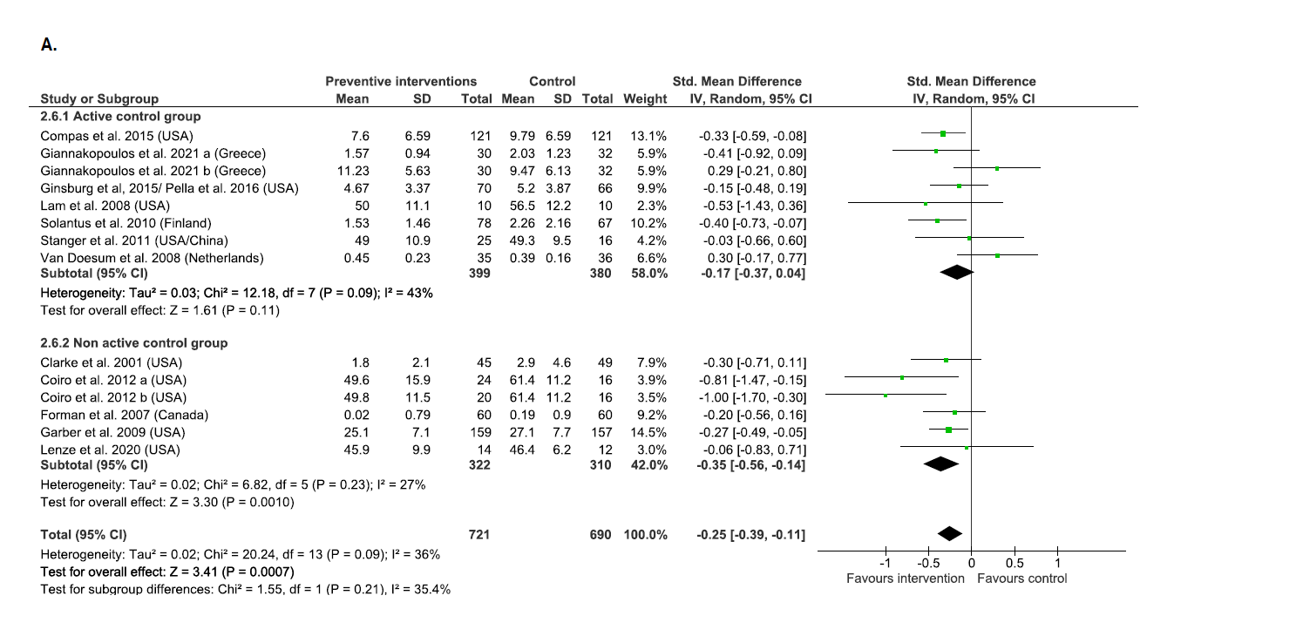

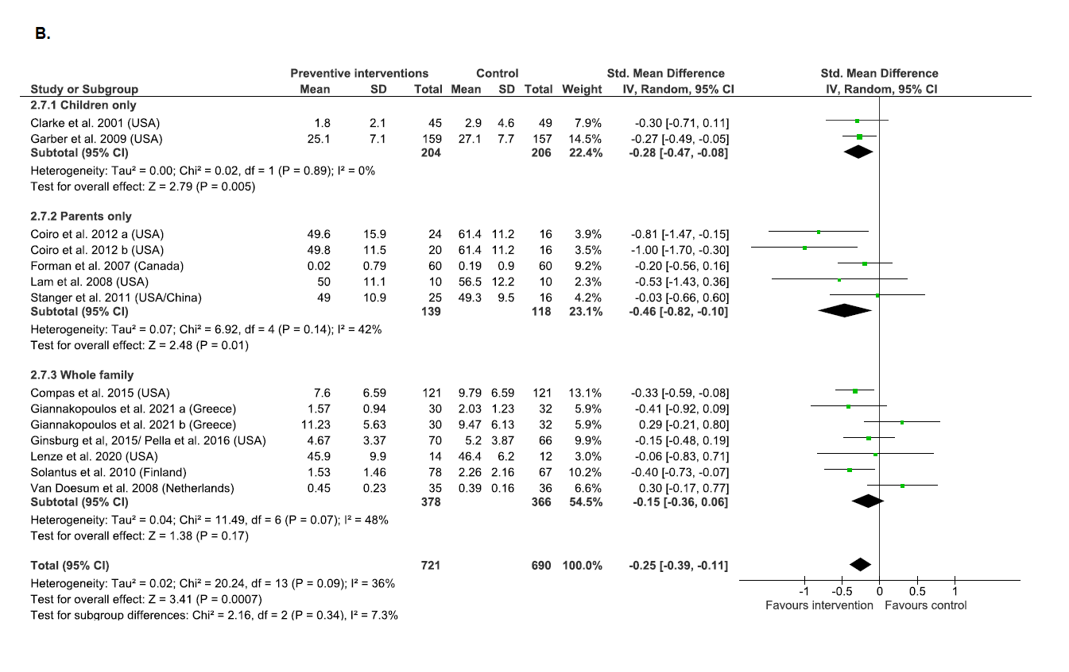
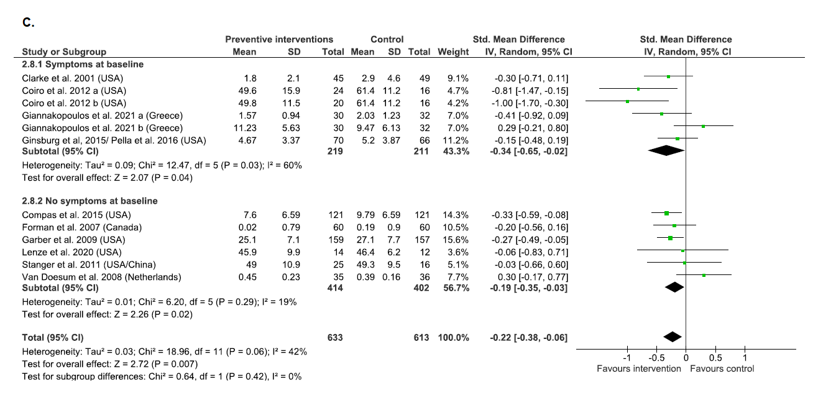

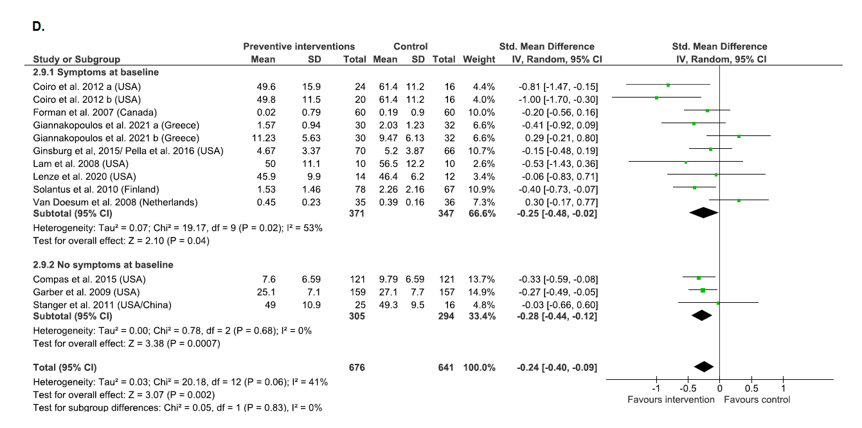

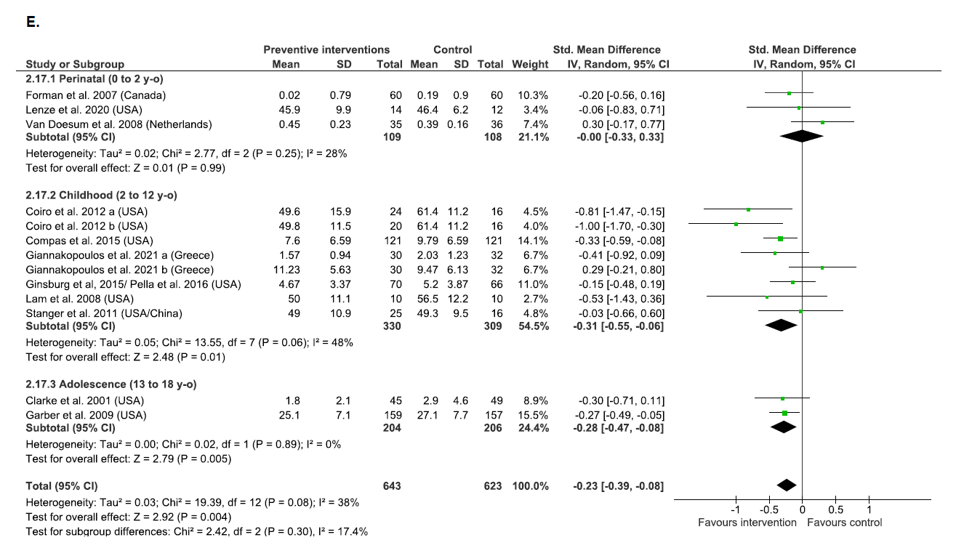

Figure S2: Subgroup analyses assessing differences in change in externalizing symptoms. Note: A) active versus non active control group; B) target of the intervention; C) children's symptoms versus no symptoms at baseline; D) parental symptoms versus no symptoms at baseline. E) age of children.
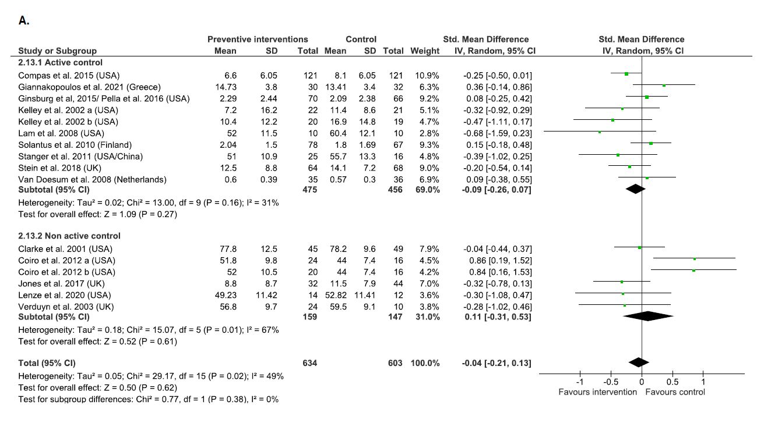

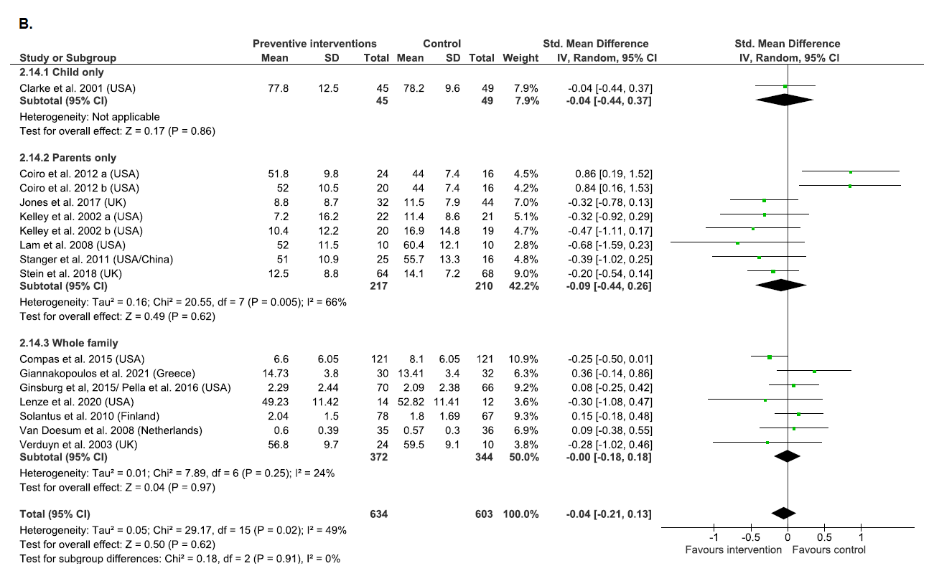

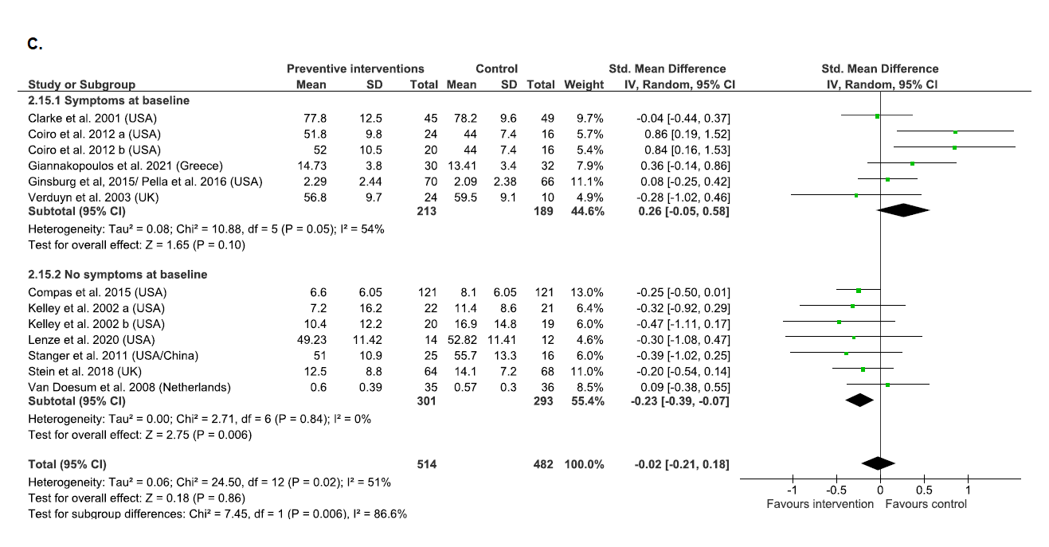

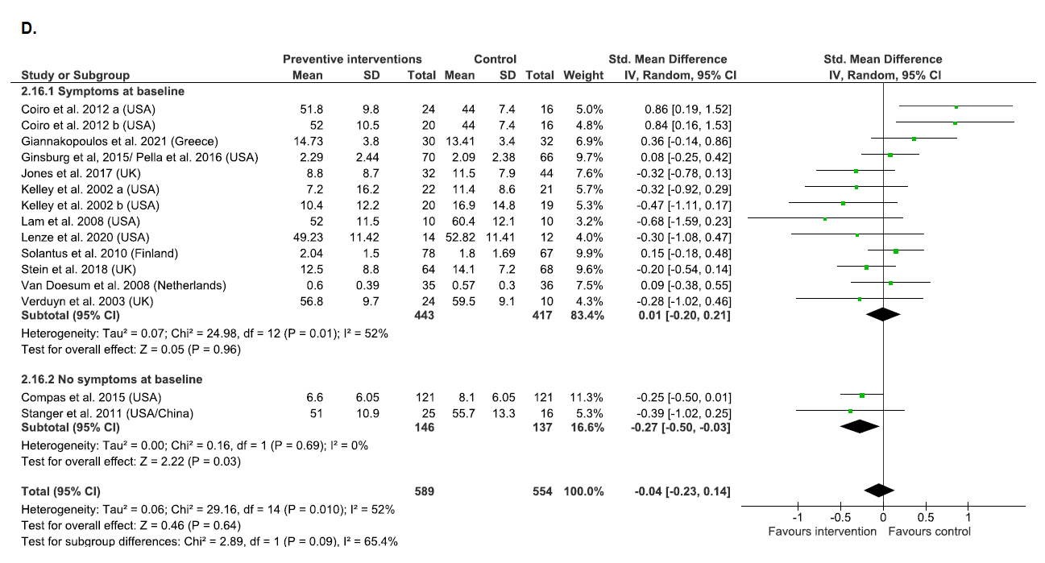

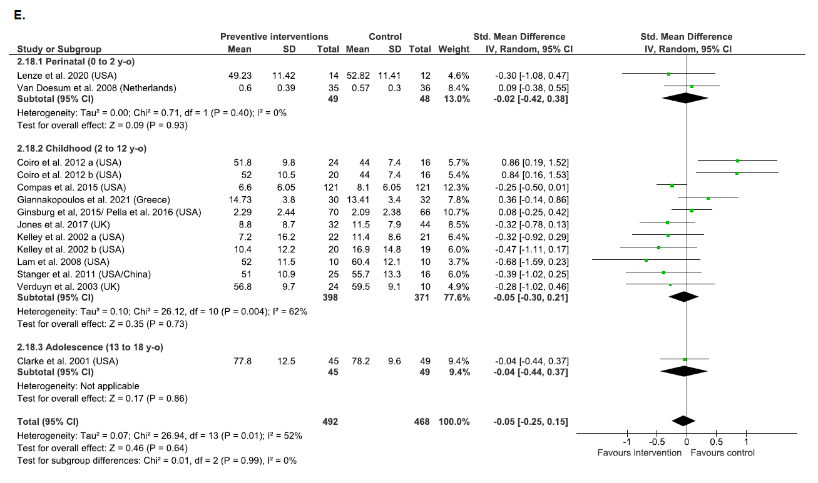

Figure S3: Funnel-plots of standard error using SMD for observed and imputed comparisons. Note: A) using data from 10 trials of internalizing symptoms at post-intervention; B) using data from 11 trials of externalizing symptoms at post-intervention. S.E of SMD: standard error of the standardized mean difference.

