APPENDIX
Description of Registers
Multi-Generation Register
The Multi-Generation Register is a register made up of persons who have been registered in Sweden at some time since 1961 and those who were born in 1932 or later. These are called index persons. The register contains connections between index persons and their biological parents. There are about 11 million index persons in the register. The Multi-Generation Register is a part of the register system for Total Population Register, where information comes from the National Tax Board. Every year, a new version of the register is created, including new index persons who immigrated or were born during the year. Information from the Multi-Generation Register may be disclosed for research and statistical purposes. For more information, see Statistics Sweden, Background Facts, Population and Welfare Statistics 2017:2, Multi-generation register 2016. A description of contents and quality

National Patient Register
In the 1960's the National Board of Health and Welfare started to collect information regarding in-patients at public hospitals, the National Patient Register (NPR). Initially it contained information about all patients treated in psychiatric care and approximately 16 percent of patients in somatic care. The register at that time covered six of the 26 county councils in Sweden. In 1984, the Ministry of Health and Welfare together with the Federation of County Councils decided a mandatory participation for all county councils. From 1987, NPR includes all in-patient care in Sweden. Since 2001, the register also covers outpatient doctor visits including day surgery and psychiatric care from both private and public caregivers. For more information, see https://www.socialstyrelsen.se/en/statistics-and-data/registers/register-information/the-national-patient-register/

Primary Care Registry
We also used information from our new Primary Care Registry (PCR), a research dataset including individual-level information on clinical diagnoses from primary health care centers from the following 15 of the 21 Swedish counties: Blekinge (2009-2016), Värmland (2005-2015), Kalmar (2007-2016), Sörmland (1997-2017), Uppsala (2005-2015), Västernorrland (2008-2015), Norrbotten (2009-2016), Gävleborg (2010-2016), Halland (2007-2014), Jönköping (2008-2014), Kronoberg (2006-2016), Skåne (1998-2013), Östergötland (1997-2014), Stockholm (2003-2016), and Västergötland (2000-2013). In 2016, these counties included 87% of the Swedish population. For more information see Sundquist, J., Ohlsson, H., Sundquist, K. et al. Common adult psychiatric disorders in Swedish primary care where most mental health patients are treated. BMC Psychiatry 17, 235 (2017).

Table 1 - Definition of Phenotypes
The following codes were used to define the traits:
 | Registers Used | Definition
Suicide Death | The Swedish Mortality Register | ICD-8: E950-E959, E980-987  ICD-9: E950-E959, E980-987  ICD-10: X60-X84, Y10-Y34
Suicide Attempt | The Swedish Hospital Discharge Register (coverage 1973-2017); Outpatient Care Register (national coverage 2001-2017); | ICD-8: E950-E959, E980-987  ICD-9: E950-E959, E980-987  ICD-10: X60-X84, Y10-Y34
Major Depression (MD) | The Swedish Hospital Discharge Register (coverage 1973-2017); Outpatient Care Register (national coverage 2001-2017); Primary Care Registry (Partly coverage from 1999-2017) | ICD-8: 296.2, 298.0, 300.4; ICD-9: 296.2, 296.4, 298.0, 300.4; ICD-10: F32, F33.
Drug Use Disorder (DUD) | The Swedish Hospital Discharge Register (coverage 1973-2017); Outpatient Care Register (national coverage 2001-2017); Primary Care Registry (Partly coverage from 1999-2017); the Swedish Drug Register (2005-2017); the Swedish Mortality Register, and the Swedish Criminal Register (1973-2017) and the Swedish Suspicion Register (1998-2017) | Drug Use Disorder (DUD) was identified in the Swedish medical and mortality registries by ICD codes (ICD8: Drug dependence (304); ICD9: Drug psychoses (292) and Drug dependence (304); ICD10: Mental and behavioral disorders due to psychoactive substance use (F10-F19), except those due to alcohol (F10) or tobacco (F17)); in the Suspicion Register by codes 3070, 5010, 5011, and 5012, that reflect crimes related to DA; and in the Crime Register by references to laws covering narcotics (law 1968:64, paragraph 1, point 6) and drug-related driving offences (law 1951:649, paragraph 4, subsection 2 and paragraph 4A, subsection 2). DA was identified in individuals (excluding those suffering from cancer) in the Prescribed Drug Register who had retrieved (in average) more than four defined daily doses a day for 12 months from either of Hypnotics and Sedatives (Anatomical Therapeutic Chemical (ATC) Classification System N05C and N05BA) or Opioids (ATC: N02A).
Bipolar Disorder (BD) | The Swedish Hospital Discharge Register (coverage 1973-2017); Outpatient Care Register (national coverage 2001-2017); Primary Care Registry (Partly coverage from 1999-2017) | ICD-8: 296.1, 296.3, 296.8, 296.9, 298.1; ICD-9: 296A, 296C, 296D, 296E, 296W, 298B; ICD-10: F30, F31.
Schizophrenia (SZ) | The Swedish Hospital Discharge Register (coverage 1973-2017); Outpatient Care Register (national coverage 2001-2017); Primary Care Registry (Partly coverage from 1999-2017) | ICD-8: 295.1, 295.2, 2953, 295.9, 295.6; ICD-9: 295B, 295C, 295D, 295G, 295X; ICD-10: F200, F201, F202, F203, F205, F209.
Alcohol Use Disorder (AUD) | The Swedish Hospital Discharge Register (coverage 1973-2017); Outpatient Care Register (national coverage 2001-2017); Primary Care Registry (Partly coverage from 1999-2017); the Swedish Drug Register (2005-2017); the Swedish Mortality Register, and the Swedish Criminal Register (1973-2017) and the Swedish Suspicion Register (1998-2017) | Alcohol Use Disorder (AUD) was identified in the Swedish medical and mortality registries by ICD codes: ICD9: V79B, 305A, 357F, 571A-D, 425F, 535D, 291, 303, 980; ICD 10: E244, G312, G621, G721, I426, K292, K70, K852, K860, O354, T51, F10); in the Crime Register by codes 3005, 3201, which reflect crimes related to alcohol abuse; in the Suspicion Register by codes 0004, 0005 (Only those individuals with at least two alcohol-related crimes or suspicion of crimes from both Crime Register and Suspicion Register were included); in the Prescribed Drug Register by the drugs disulfiram (Anatomical Therapeutic Chemical (ATC) Classification System N07BB01), acamprosate (N07BB03), and naltrexone (N07BB04).
Figure 1
Flow chart for the calculation of the Family Genetic Risk Score (FFGRS):
Step 2
Step 1
Information on relatives: Year of birth, sex, age at first registration for all traits, age at end of follow-up (2017-12-31 or age at death, age at emigration whichever came first)
Relative: 1st, 2nd, 3rd, 4th, and 5th degree relatives to the probands. The mean (SD) number of proband were as follows: 1st 4.55 (2.1); 2nd 7.63 (4.5); 3rd 8.61 (6.7); 4th 12.44 (10.2); 5th 6.90 (6.3). For 1st degree relatives, we considered parents, children and full siblings. For 2nd degree relatives, we considered aunts/uncles, grandparents, half-siblings, double first-cousins, grandchildren and nieces/nephews. For 3rd degree relatives, we considered first cousins, grand aunts/uncles, aunts/uncles based on half-siblings to parent, nieces/nephews based on half-siblings, and grandchildren to full siblings. For 4th degree relatives, we examined cousins based on half-siblings to parents, grand aunts/uncles based on half sibling to grandparent, first cousin once removed. For 5th degree, relatives we examined children to grand aunts/uncles based on half-siblings and first cousin once removed based on half siblings.

Proband: All individuals born 1932-1995 in Sweden to Swedish born parents

Calculate the morbid risk for the trait by using age at first registration for traits among relatives

Use the distribution of age at first registration to weight relatives. The morbid risk followed a normal distribution with weights reflecting the proportion of risk period they had completed starting at age 15. All relatives registered for the specific trait were weighted 1 regardless of age

Registrations for traits are only available from 1973 and onwards, suggesting that relatives at older age do not have the possibility to be registered for the traits at younger ages. Therefore, we moved the weighting scale for each year for relatives born prior to 1958. This means that the risk period started at age 16 for relatives born 1957, at age 17 for relatives born 1956 and so on.
Step 2.1

Transform the binary variable (trait yes/no) into a z-score based on the threshold for each trait. We used separate thresholds for each decade of birth and sex.
Step 3
Step 4
Step 3.2
Apply the mean z-score among individuals above the threshold to all relatives with an registration for the traits and the mean z-score below the threshold for relatives without the trait
Calculate mean z-score for individuals above the threshold and for individuals below the threshold (within each decade of birth and sex). This was done by assigning individuals a z-score from a normal distribution and then calculate the mean z-score for all individuals above/below the threshold.
Step 3.1

Correct for cohabitation effects.
To estimate the cohabitation effect, we created a database with all individuals in the Swedish population born in Sweden 1955-1990. We also included the number of years, during ages 0-15, that individuals resided in the same household as their biological father. We thereby were able to define two kinds of families: i) “not-lived-with” father families (offspring never resided a maximum of 1 year in the same household as their biological father); ii) “lived-with” father (offspring resided a minimum of 13 year in the same household as their biological father. We performed a logistic regression model with the MD in offspring as outcome and MD in father, type of father, and their interaction as predictors. We used the interaction term as the difference of effect between genes only and genes + environment. The same approach was performed for half-siblings. Interaction terms: Parent/Children Siblings
MD 0.80 0.85
BD 0.67 0.77
SZ 0.93 0.84
AUD 0.99 0.69
DA 0.92 0.52
SD 0.70 0.98
SA 0.66 0.76

Step 8
Correct for the number of relatives. We multiplied the risk score with a shrinkage factor (SF) used in multilevel models based on (A) the variance of the z-score of the trait across all relatives, (B) the variance in the mean z-score across all probands, and (C) the number of weighted number of relatives for each proband. The SF is calculated as B / (B+A/C) and produces more shrinkage if B and C are small and A is large.
Average the relative-specific risk score across all relatives to a proband
Step 7
Step 6
Calculate the genetic risk score for each specific relative:
Z-score * weights reflecting the proportion of risk period they had completed * environmental correction * genetic resemblance
Step 5

Correct for difference by year of birth and county differences. There are 21 counties in Sweden. For each proband we used the county they had resided in during the maximum number of years (measured from 1969 and onwards) We standardized the risk score by year of birth and county of the proband into a z-score with mean 0 and SD 1. This was then used as the FGRS in the analyses

Table 2 - Correlation with the FGRS used in the Paper with Various Modifications of the FGRS Calculation
 | MD FGRS | DUD FGRS | BP FGRS | SZ FGRS | AUD FGRS | SA FGRS | SD FGRS
Correlation with the FGRS used in the ms
FGRS(a) - 1st degree relatives | 0.760 | 0.763 | 0.763 | 0.748 | 0.812 | 0.760 | 0.745
FGRS(b) - no age correction | 0.949 | 0.995 | 0.992 | 0.987 | 0.806 | 0.998 | 0.982
FGRS(c) - no cohabitation correction | 0.961 | 0.980 | 0.988 | 0.998 | 0.992 | 0.987 | 0.988
FGRS(d) - no weighting for # relatives | 0.912 | 0.971 | 0.960 | 0.966 | 0.952 | 0.955 | 0.952
FGRS(e) -std by YoB only | 0.973 | 0.990 | 0.994 | 0.990 | 0.992 | 0.962 | 0.996
FGRS(f) - std by geography only | 0.955 | 0.951 | 0.952 | 0.923 | 0.969 | 0.962 | 0.952
FGRS(g) - std only by entire sample | 0.935 | 0.946 | 0.948 | 0.919 | 0.962 | 0.927 | 0.950

Table 3 – Results from AUC Calculations with Various Modifications of the FGRS Calculation
AREA UNDER THE CURVE | SA FGRS | SD FGRS
FGRS used in ms | 0.616 (0.615; 0.618) | 0.665 (0.662; 0.667)
FGRS(a) - 1st degree relatives | 0.571 (0.570; 0.573) | 0.529 (0.526; 0.534)
FGRS(b) - no age correction | 0.618 (0.617; 0.619) | 0.665 (0.662; 0.668)
FGRS(c) - no cohabitation correction | 0.617 (0.616; 0.618) | 0.663 (0.660; 0.666)
FGRS(d) - no weighting for # relatives | 0.613 (0.611; 0.614) | 0.633 (0.631; 0.636)
FGRS(e) -std by YoB only | 0.628 (0.627; 0.630) | 0.669 (0.666; 0.672)
FGRS(f) - std by geography only | 0.611 (0.610; 0.613) | 0.577 (0.573; 0.580)
FGRS(g) - std only by entire sample | 0.623 (0.622; 0.624) | 0.589 (0.576; 0.583)

Figure 2 Rates of SA By Quintiles of SA FGRS
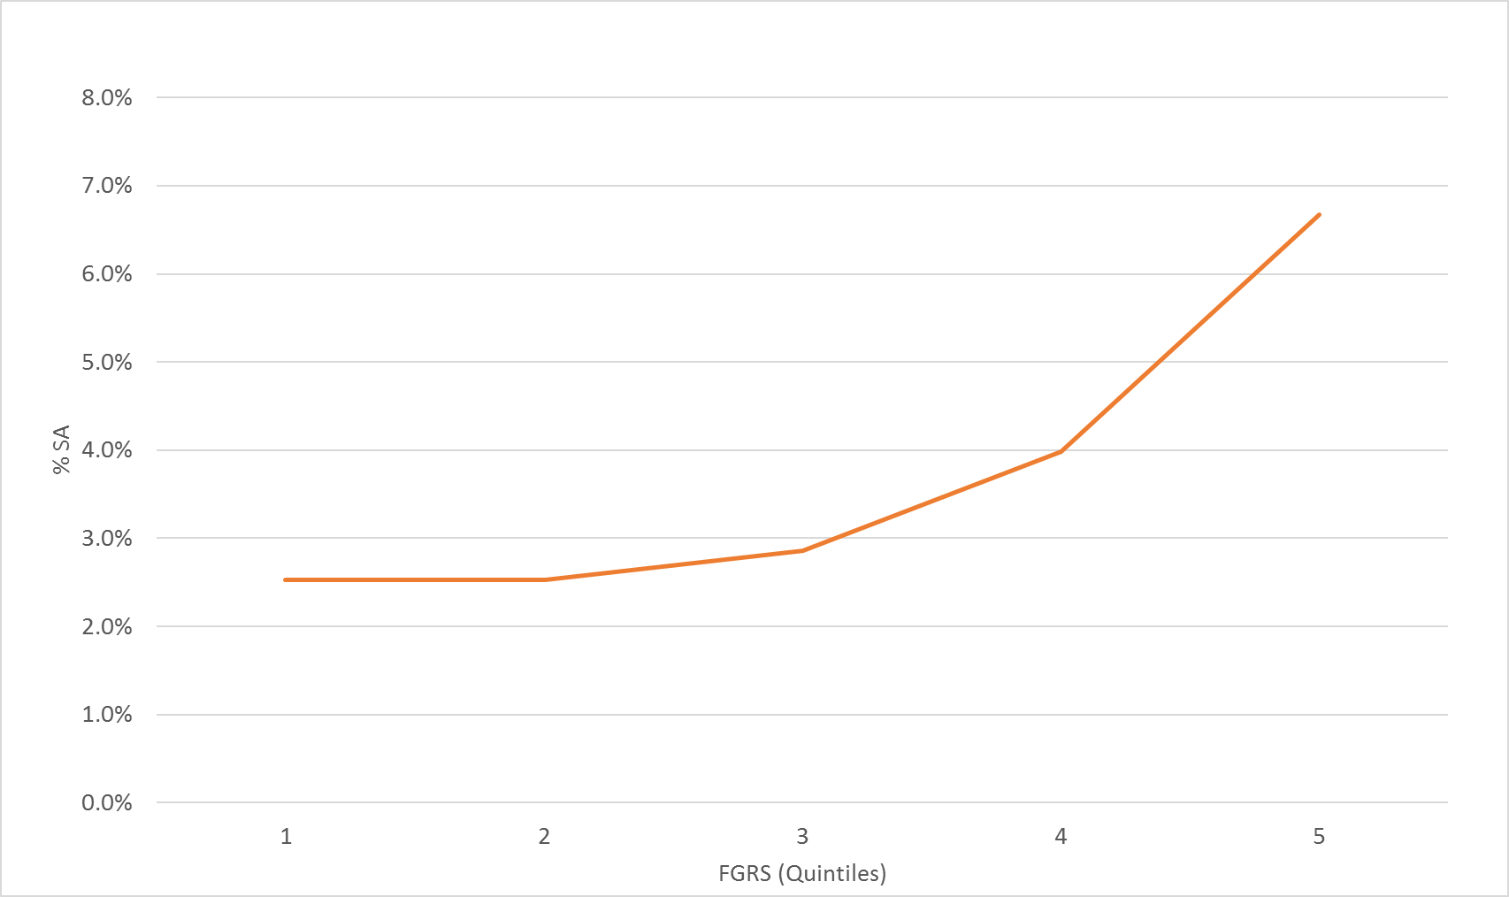

Figure 3 - Rates of SD Quintiles of SA FGRS
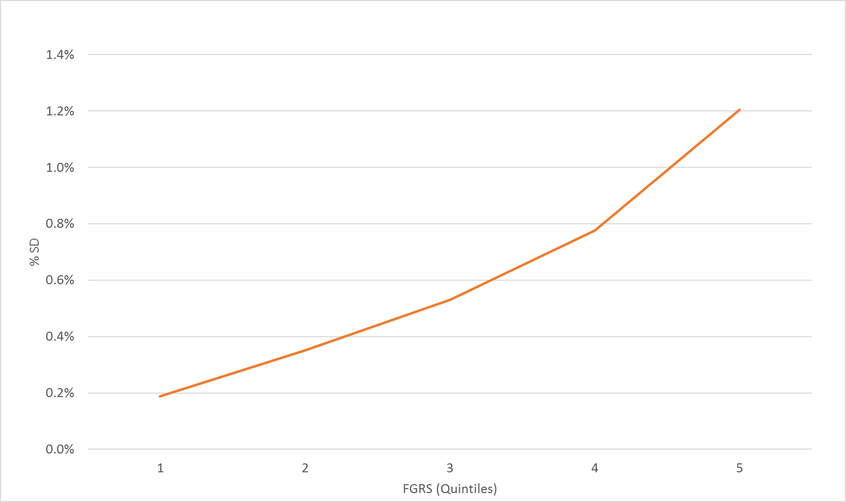

Figure 4 Stability of FGRS Scores for SA and SD by Median Splits for Cohort and Geographical Region within Sweden
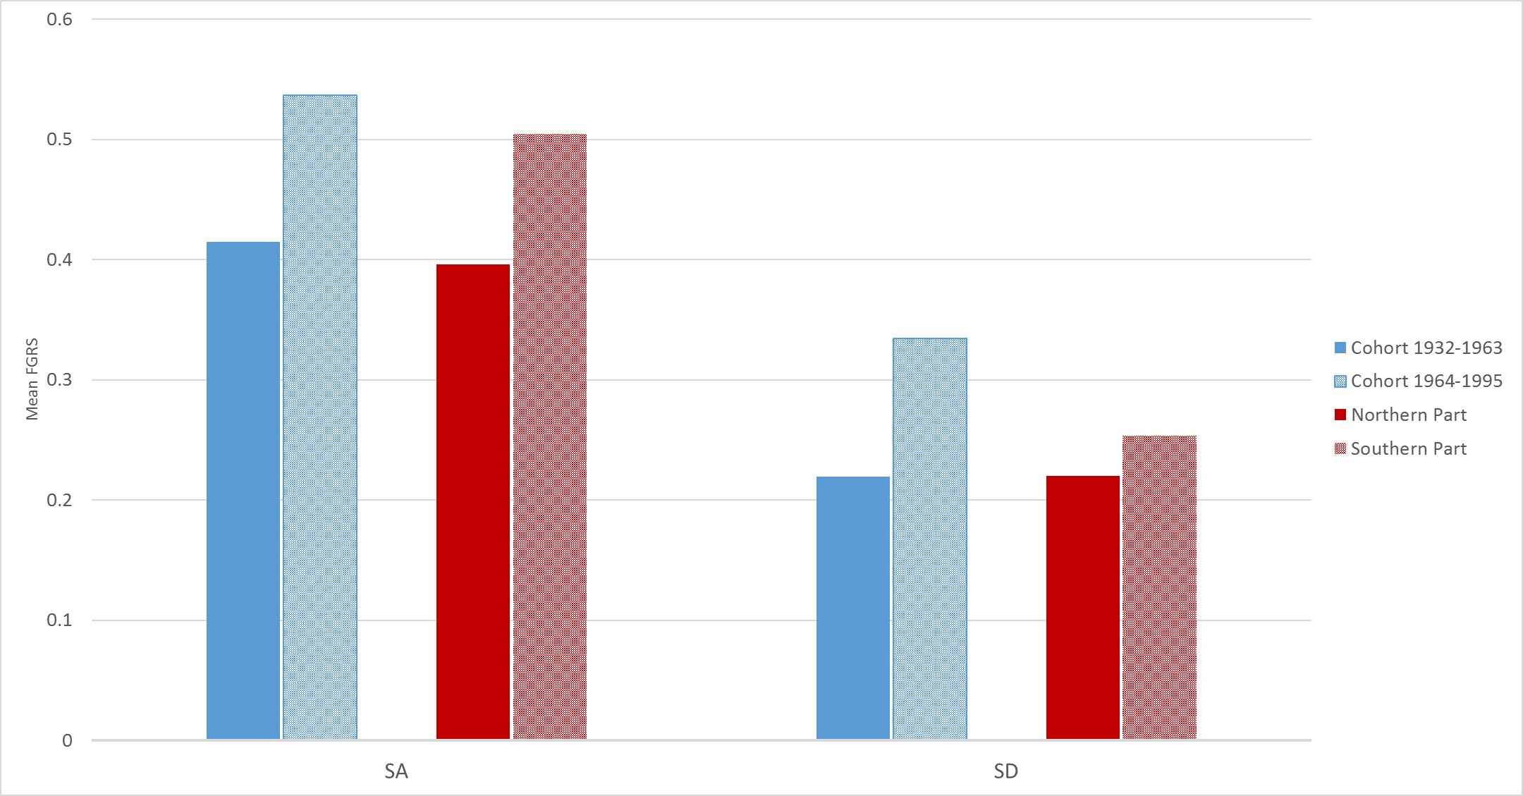

Figure 5 - Taking into Account Neighborhood deprivation in the calculation of AUD FGRS

In the calculation of the FGRS, we accounted for neighborhood deprivation in step 2. This means that instead of using a specific threshold for each decade of birth and sex, we calculated a specific threshold for each decade of birth, sex and neighborhood deprivation. Each relative was assigned to the SAMS area (these are small administrative areas in Sweden of around 1,000 people each) in which they resided for the most number of years during the period 1975-2014. Each SAMS area were defined yearly (between 1990 to 2014) into high, mid or low deprivation (see below for a definition of deprivation). We calculated the number of years that the SAMS area was defined as high, mid or low and used the most common definition. A number of relatives (2.25%) were not assigned to a specific SAMS area (due to death or emigration) and were excluded from the analyses (hence the numbers are not identical compared to the analyses in presented in the main analyses). The correlation between AUD FGRS (without controlling for neighborhood deprivation) and AUD FGRS controlling for neighborhood deprivation was 0.96. We looked at AUD because it has a fairly strong positive correlation with neighborhood deprivation – that is, as in many prior studies, rates of AUD are higher in deprived communities in Sweden compared to more affluent communities. Here we illustrate the results from figure 1 (mean AUD FGRS among individuals with Suicide Attempt and Suicide Death) with and without controlling for Neighborhood deprivation. As it clear for this one example, correcting for neighborhood deprivation makes no appreciable change in the FGRS.
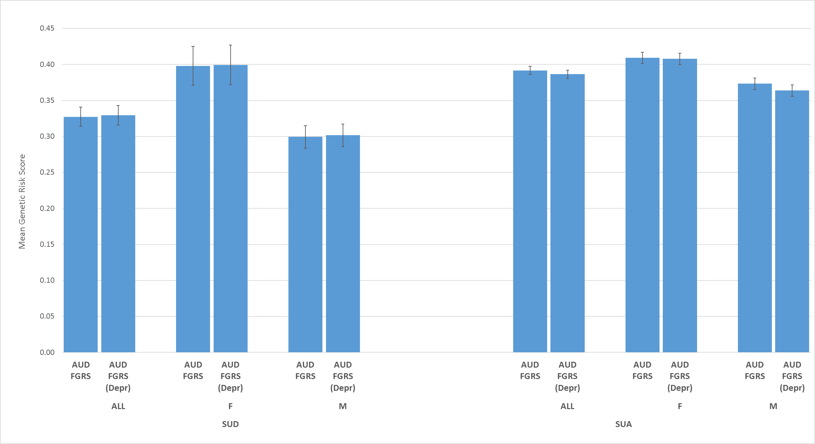
Figure 6a
Recalculation of figure 4a in the Manuscript Predicting SD now Controlling for Year of Birth
(Solid fill = direct effect; Dotted fill = indirect effect)

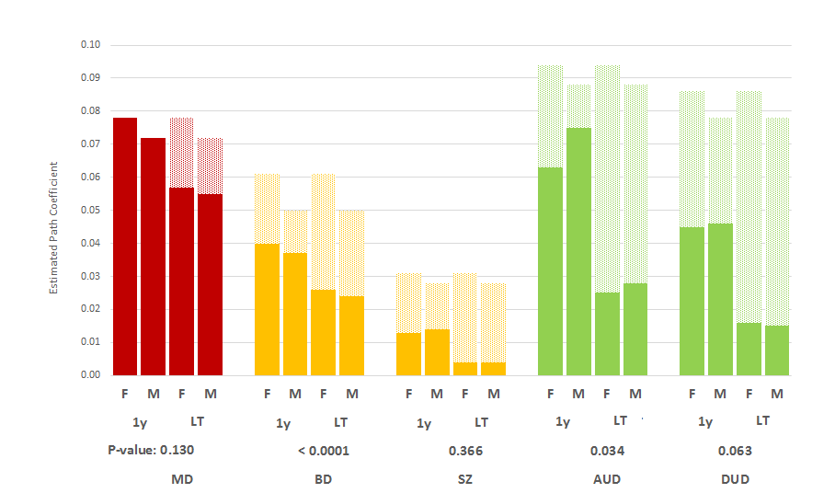
Figure 6b
Recalculation of figure 4b in the Manuscript Predicting SA now Controlling for Year of Birth
(Solid fill = direct effect; Dotted fill = indirect effect)

