Longitudinal changes in within-salience network functional connectivity mediate the relationship between childhood abuse and neglect, and problematic substance use during adolescence.

Supplementary Material

Table of Contents
Supplementary Methods 2
Participants 2
Abuse and Neglect Distributions 3
Definition of problematic substance use 6
Supplementary Figure S3: Correlation between total CTQ, abuse, neglect, and depression, anxiety, problematic substance use, SES, and IQ 6
Supplementary Figure S4: Correlation between abuse, neglect, and depression, anxiety, problematic substance use, SES, and IQ 7
Supplementary Figure S5: Correlation between total CTQ, and depression, anxiety, problematic substance use, SES, and IQ 8
Collinearity of model including both abuse and neglect parameters 8
MRI acquisition and fMRIPrep pipeline 9
Calculation of within-network connectivity 9
Linear Mixed Model Equations 10
Mediation Analyses 11
Supplementary Results 11
Supplementary Table S1 – Model Output 12
Non-significant findings for change in abuse- and neglect-associated change in within-network connectivity 14
Supplementary Table S2: Model output for sex moderating the relationship between neglect and within-DMN connectivity 15
Non-significant findings for sex differences in change in abuse- and neglect-associated change in within-network connectivity 15
Cross-sectional relationships for within-DMN connectivity and neglect in males and females at T1 17
Results excluding participants with mean FD > 0.2mm 18
Longitudinal abuse/neglect*age results: 18
Cross-sectional abuse/neglect*age results for significant longitudinal results: 18
Longitudinal abuse/neglect*age*sex results: 19
Cross-sectional abuse/neglect*age*sex results for significant longitudinal results: 19
Non-significant mediation results excluding participants with mean FD > 0.2mm 20
References 21

Supplementary Methods

Participants
Participants were from a large longitudinal study; the Orygen Adolescent Development Study (OADS). Please refer to Whittle et al. (1) for a detailed description. Briefly, the OADS is a longitudinal study that aims to investigate biological and psychosocial risk and resilience factors for mental health problems in adolescence and emerging adulthood. Participants were originally selected from schools in metropolitan Melbourne, Australia, after being screened for temperament. Participants (n=2,479) were originally administered the Early Adolescent Temperament Questionnaire–Revised (EATQ-R), from which 415 were selected for the study based on their temperament scores. Of these, 245 participants agreed to participate in longitudinal research. Informed consent was obtained for all participants and their parent or guardian before their inclusion in the study (and at each study wave) in accordance with the human research ethics committee of The University of Melbourne (Melbourne, Australia). Demographic information was collected from participants and parents, including date of birth, sex, and home address. The 2006 Socio-Economic Indexes for Areas Index of Relative Socioeconomic Disadvantage and the Wechsler Intelligence Scale for Children (WISC) IV were used to assess socioeconomic status (SES) and IQ, respectively (2). Full scale IQ was estimated using a short form of WISC-IV, based on three subtests (Vocabulary, Matric Reasoning, Symbol Search). The participants in this study did not differ in key demographic variables (i.e., sex and socioeconomic status (SES)) from the original sample (p > 0.05).
In order to assess whether the sample in the present study was representative of the catchment area (i.e. Greater Melbourne), we compared the distribution of SES and temperament between the original screening sample (n=2323) and the present sample (n=130) using chi-squared tests. SES was assessed using the Socio-Economic Indexes For Areas (SEIFA) advantage and disadvantage (IRSAD) score. The IRSAD is a summary measure of several characteristics related to relative socioeconomic advantage and disadvantage in a given geographical area based upon households’ responses to a compulsory national population and household census, conducted every five years by the Australian Bureau of Statistics (ABS) (Pink 2008). Temperament was assessed with the Early Adolescent Temperament Questionnaire-Revised (EATQ-R, which has four higher-order dimensions of surgency, affiliation, effortful control, and negative affect). Temperament data was discretized using mean ± 0.5 up to 3 standard deviations prior to conducting the chi-squared test, and deciles were used for the IRSAD. We found that the sample used in the current study did not differ in SES (IRSAD) from the original sample (p > 0.05). The present sample also did not differ in temperament from the original sample (p > 0.05 for all four higher-order factors).

Abuse and Neglect Distributions
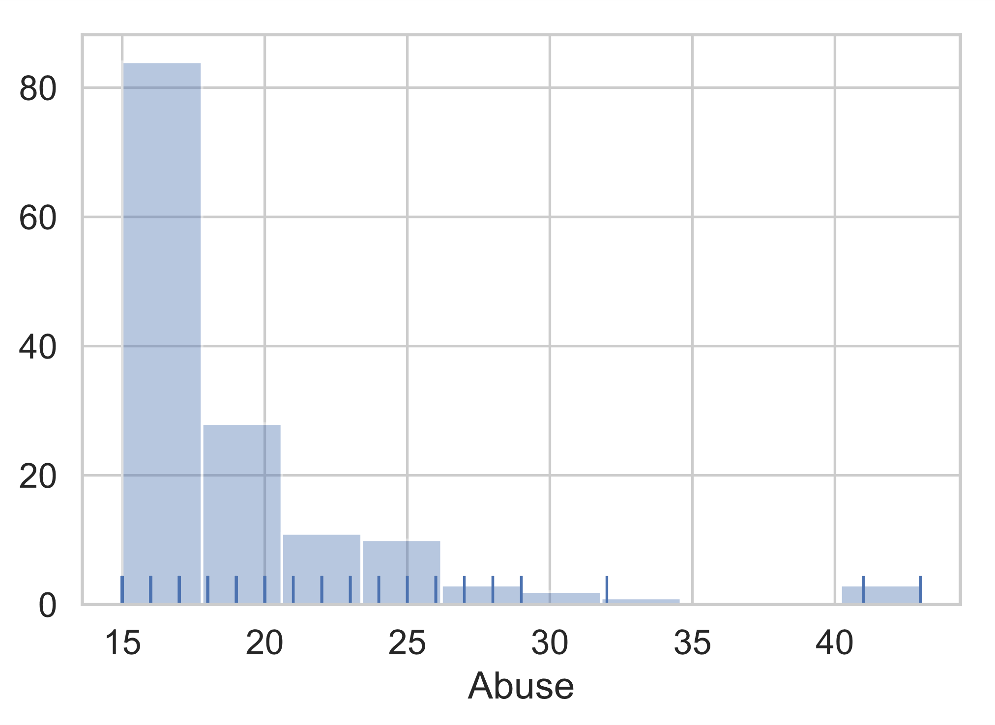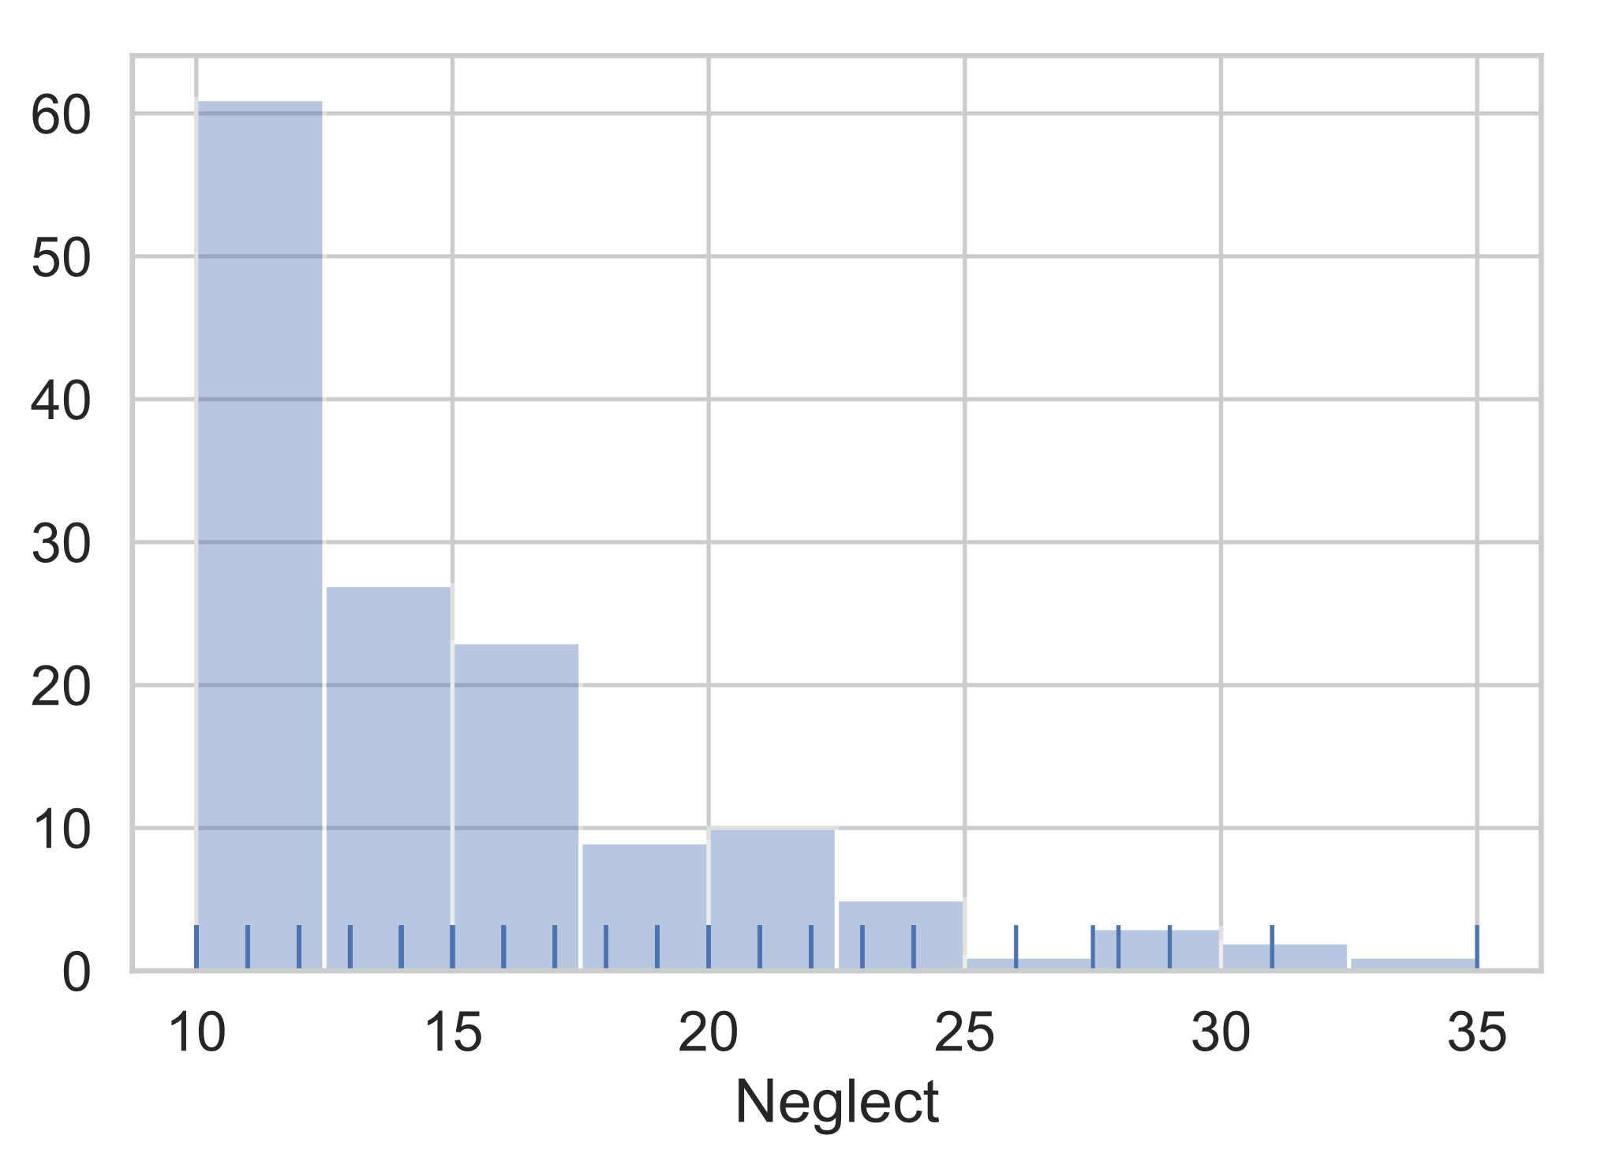
Supplementary Figure S1: Histograms of abuse and neglect scores

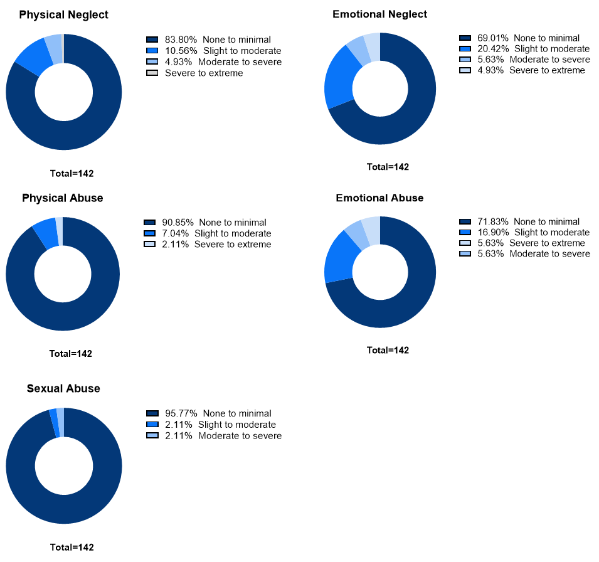

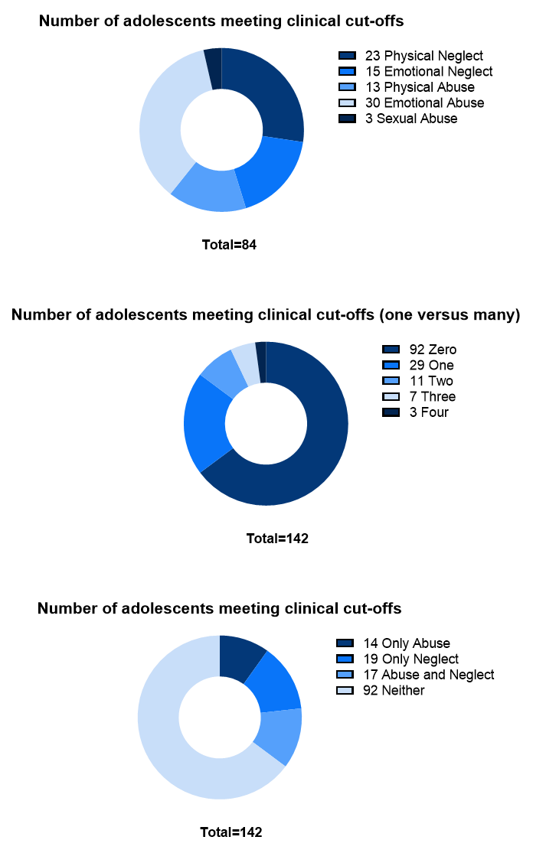
Supplementary Figure S2: % adolescents in severity bins for each maltreatment type for the total sample (n=142) based on Bernstein et al. (3,4). Bottom panel depicts number of adolescents meeting clinical cut-off for each maltreatment type (top), number of maltreatment types each adolescent met clinical cut-off for (middle), and number of adolescents meeting clinical cut-off for abuse/neglect (bottom) based on Walker et al. (5).

Definition of problematic substance use

While there are no standard definitions of problematic substance use during adolescence, we defined problematic use based on prior literature suggesting that specific quantities/patterns of use can significantly increase risk of dependence and other mental health problems during adulthood (6–11) and a definition used previously (12). Criteria were: i) at least four alcohol binges in the last month and recently (past year) experienced an alcohol associated problem (e.g., getting so inebriated that they were sick or passed out or having trouble at home, work or school due to alcohol), and/or ii) smoked tobacco cigarettes daily and/or iii) smoked cannabis at least 12 times in the last month were classified in the current problematic use group (n = 38 at T2).

Supplementary Figure S3: Correlation between total CTQ, abuse, neglect, and depression, anxiety, problematic substance use, SES, and IQ

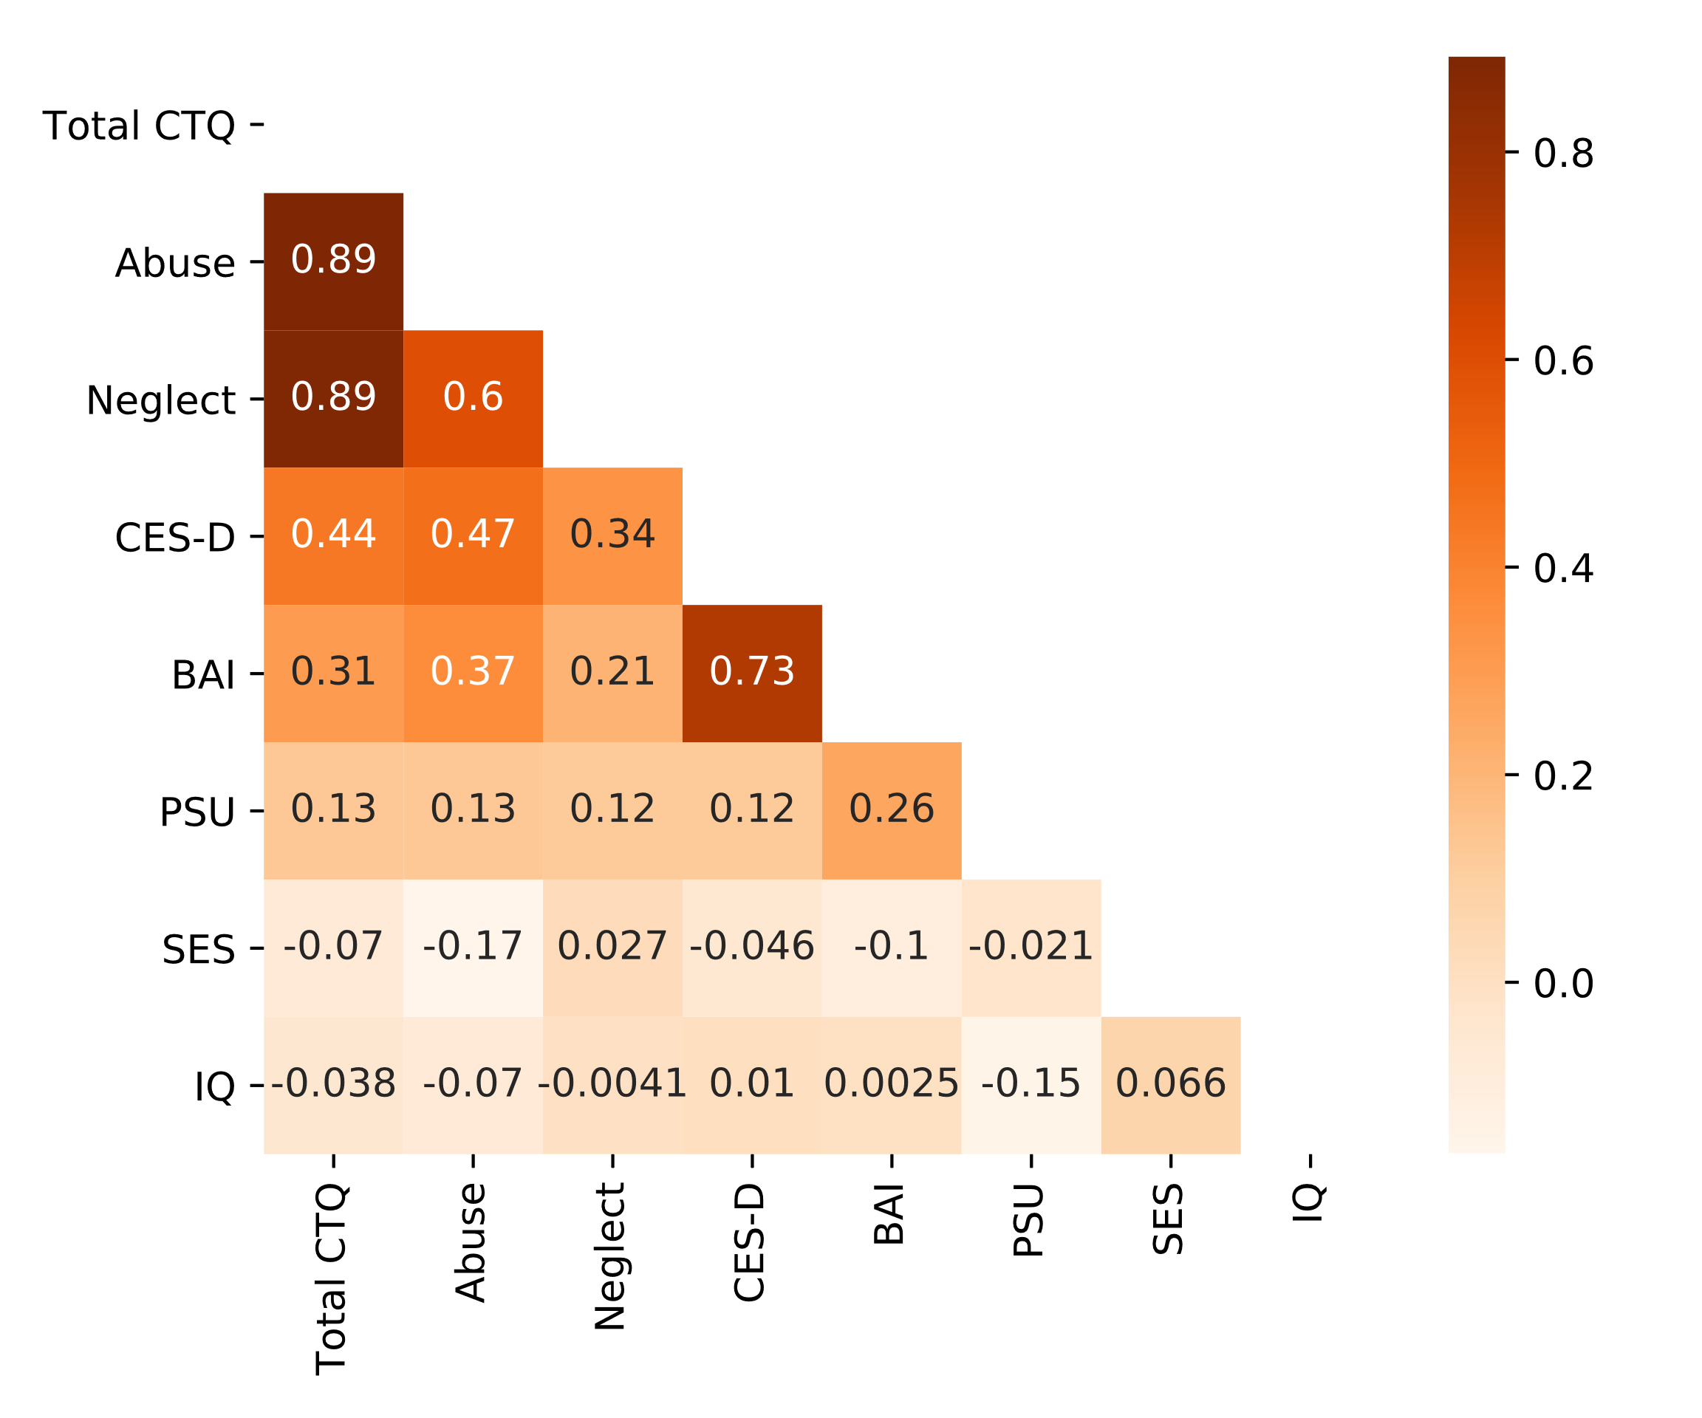

Supplementary Figure S4: Correlation between abuse, neglect, and depression, anxiety, problematic substance use, SES, and IQ

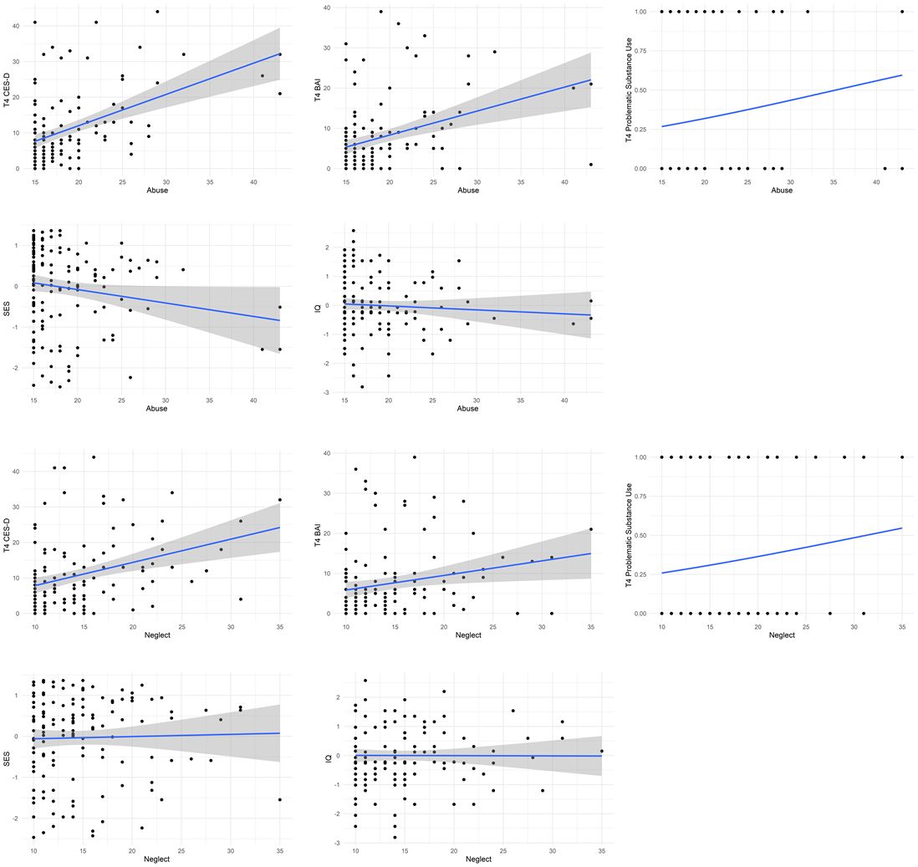

Supplementary Figure S5: Correlation between total CTQ, and depression, anxiety, problematic substance use, SES, and IQ

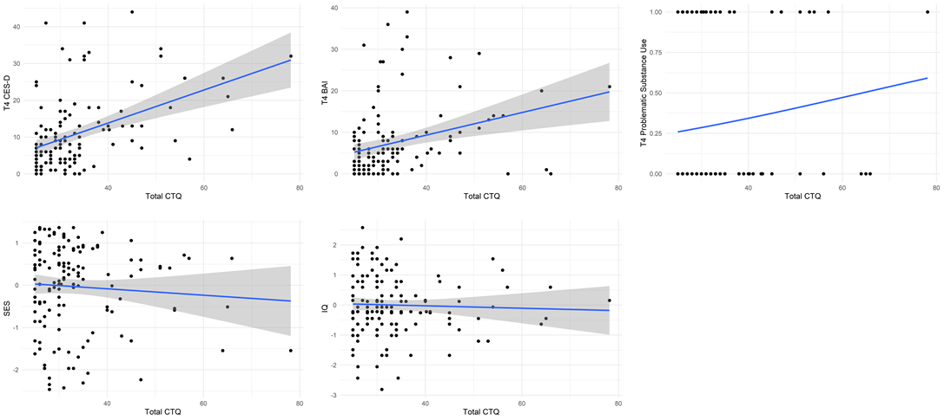

Collinearity of model including both abuse and neglect parameters (without interaction terms), where CTQa = abuse, CTQn = neglect:
Y = Intercept + d_{ij} + β1 (Sex) + β2 (Time) + β3 (CTQa) + β4 (CTQn) + β5 (FD) + β7 (SES) + β8 (IQ) + covariates + e.
Parameter | VIF | Increased SE
Abuse | 1.76 | 1.33
Neglect | 1.7 | 1.31
Time | 1.02 | 1.01
Sex | 1.05 | 1.03
IQ | 1.05 | 1.02
FD | 1.1 | 1.05
SES | 1.12 | 1.06

The dij term represents the random effect of the intercept in each subject. The e represents the normally distributed residual error term

MRI acquisition and fMRIPrep pipeline

For each participant, whole-brain resting-state fMRI (eyes closed) was acquired using a 3T Siemens Magnetom Trio (Siemens, Germany) equipped with a 32-channel head coil at the Royal Children’s Hospital (Melbourne, Australia). The fMRI imaging parameters are as follow: TR=1400ms; TE=30ms; flip angle=90°, field of view of 120 mm×120mm; 24 interleaved slices; voxel size=3.3 × 3.3 × 5.0 mm, volume number=510, duration=11.9 minutes. Complex fieldmaps were acquired in order to correct for the distortion caused by inhomogeneities in the magnetic field. In addition, a high resolution T1-weighted (T1w) anatomical image was also acquired for each participant for the purpose of registering the functional images to standard space using a gradient echo volumetric acquisition sequence (TR=1900ms; TE=2.24ms; FOV = 230mm; Slice number=176; Voxel size = 0.9×0.9×0.9 mm).
The T1w image was corrected for intensity non-uniformity (INU) with N4BiasFieldCorrection (13), distributed in ANTs 2.2.0 (14), and used as the structural reference for spatial registration of fMRI. For functional images, a reference volume and its skull-stripped version were generated using a custom methodology of fMRIPrep. The BOLD reference was then co-registered to the T1w reference using bbregister (FreeSurfer) (15). Head-motion parameters with respect to the BOLD reference were estimated before any spatiotemporal filtering using mcflirt (FSL 5.0.9) (16). BOLD runs were slice-time corrected using 3dTshift from AFNI (Cox and Hyde 1997). Automatic removal of motion artifacts was done using independent component analysis (ICA-AROMA) (17) after removal of non-steady state volumes and spatial smoothing with an isotropic, Gaussian kernel of 6mm full-width half-maximum. The functional images were then registered and resampled to MNI152 2mm standard space.

Calculation of within-network connectivity

To perform focused analyses on the impact of abuse and neglect on network cohesion, data was extracted from the dorsal DMN (DMN; which contains the mPFC, PCC, precuneus etc.), anterior SN (which contains the dACC and insula), and bilateral ECN in the present study (Figure 1). Within-network connectivity was computed for the SN, DMN, and ECN using a commonly used parcellation scheme (20). Shirer et al. (20) was chosen because of the finely grained parcellation of the anterior SN (containing the insula and dACC) and the dorsal DMN rooted in the PCC. In the parcellation scheme, each of these networks is divided into individual regions (n = 9 for DMN, n = 7 for SN, and n = 12 for the ECN). The Pearson correlation value for each pair of nodes within each network was computed. In order to calculate network integration, we computed the mean of all pairwise correlation coefficients within each network. In sum, this analysis yielded three values for each participant at T1 and T2, which represented within-network connectivity for the SN, DMN, and ECN at each time point.

Linear Mixed Model Equations

Connectivity was modeled within each ith subject using the following equations (lower order main effects are automatically included):
- Effects of abuse/neglect on connectivity (where CTQa = abuse, CTQn = neglect):
  - Y = Intercept + d_{ij} + β(time-point*CTQa) + covariates + e.
  - Y = Intercept + d_{ij} + β(time-point*CTQn) + covariates + e.
While covarying for abuse in neglect models and vice-versa
  - Y = Intercept + d_{ij} + β(time-point*CTQa) + β(time-point*CTQn) + covariates + e.

- Sex effects in model 1 (lower order main effects and interaction effects are automatically included):
  - Y = Intercept + d_{ij} + β (time-point*sex*CTQa) + covariates + e.
While covarying for abuse in neglect models and vice-versa
  - Y = Intercept + d_{ij} + β(time-point*sex* CTQa) + β(time-point*sex* CTQn) + covariates + e.
The dij term represents the random effect of the intercept in each subject. The e represents the normally distributed residual error term. Age, sex, and CTQ were fixed effects, with β representing the parameter estimate. All models were run with mean-centered continuous variables.

Mediation Analyses

Further, although mediation without temporally separated variables can be considered problematic, given our prior work on this sample, and to explore mechanisms, we also examined the relationship between abuse/neglect, within-network FC for those networks where a significant relationship was found longitudinally, and mental health at T2 using mediation models, with CTQ abuse/neglect scores as the predictor, change in within-network connectivity as the mediator (obtained using random slopes from LMM), and CES-D, BAI, and problematic substance use scores at T2 as the outcome variable. IQ, SES, sex (where relevant), and the respective T1 psychopathology score were included as covariates. Mediation analyses were conducted using the PROCESS Macro in SPSS (Hayes, 2018).

Supplementary Results

Supplementary Table S1 – Model Output

Model | Network | B | SE | T | P | Conditional R² | Marginal R²
Abuse models
Salience |  |  |  |  |  | 0.265 | 0.097
 | Abuse | -0.016 | 0.006 | -2.596 | 0.011
 | Time | -0.139 | 0.071 | -1.962 | 0.053
 | Sex | -0.013 | 0.021 | -0.628 | 0.531
 | IQ | 0.025 | 0.010 | 2.410 | 0.018
 | FD | 0.004 | 0.010 | 0.409 | 0.683
 | SES | 0.015 | 0.011 | 1.409 | 0.161
 | Abuse × Time | 0.011 | 0.004 | 2.862 | 0.005
DMN |  |  |  |  |  | 0.374 | 0.056
 | Abuse | -0.005 | 0.006 | -0.847 | 0.399
 | Time | -0.043 | 0.063 | -0.676 | 0.501
 | Sex | 0.005 | 0.021 | 0.218 | 0.828
 | IQ | 0.028 | 0.010 | 2.773 | 0.007
 | FD | 0.013 | 0.010 | 1.354 | 0.179
 | SES | 0.013 | 0.011 | 1.185 | 0.238
 | Abuse × Time | 0.004 | 0.003 | 1.117 | 0.267
ECN |  |  |  |  |  | 0.3 | 0.04
 | Abuse | -0.005 | 0.006 | -0.841 | 0.402
 | Time | -0.022 | 0.065 | -0.343 | 0.732
 | Sex | 0.004 | 0.021 | 0.181 | 0.857
 | IQ | 0.021 | 0.010 | 2.140 | 0.035
 | FD | 0.008 | 0.010 | 0.851 | 0.397
 | SES | 0.009 | 0.011 | 0.855 | 0.394
 | Abuse × Time | 0.003 | 0.003 | 0.831 | 0.408
Neglect models
Salience |  |  |  |  |  | 0.273 | 0.104
 | Neglect | -0.014 | 0.006 | -2.536 | 0.012
 | Time | -0.102 | 0.055 | -1.860 | 0.066
 | Sex | -0.011 | 0.021 | -0.517 | 0.606
 | IQ | 0.026 | 0.010 | 2.520 | 0.014
 | FD | 0.004 | 0.010 | 0.362 | 0.718
 | SES | 0.015 | 0.011 | 1.419 | 0.158
 | Neglect × Time | 0.011 | 0.003 | 3.072 | 0.003
DMN |  |  |  |  |  | 0.365 | 0.051
 | Neglect | -0.002 | 0.005 | -0.417 | 0.677
 | Time | 0.005 | 0.049 | 0.094 | 0.926
 | Sex | 0.006 | 0.021 | 0.286 | 0.775
 | IQ | 0.027 | 0.010 | 2.671 | 0.009
 | FD | 0.014 | 0.010 | 1.347 | 0.182
 | SES | 0.012 | 0.011 | 1.120 | 0.265
 | Neglect × Time | 0.001 | 0.003 | 0.467 | 0.641
ECN |  |  |  |  |  | 0.319 | 0.066
 | Neglect | -0.013 | 0.005 | -2.521 | 0.013
 | Time | -0.062 | 0.049 | -1.256 | 0.213
 | Sex | 0.002 | 0.020 | 0.082 | 0.935
 | IQ | 0.021 | 0.010 | 2.189 | 0.031
 | FD | 0.012 | 0.010 | 1.214 | 0.228
 | SES | 0.012 | 0.010 | 1.120 | 0.265
 | Neglect × Time | 0.006 | 0.003 | 2.000 | 0.049
Abuse + Neglect models
Salience |  |  |  |  |  | 0.284 | 0.11
 | Abuse | -0.011 | 0.008 | -1.409 | 0.161
 | Time | -0.163 | 0.072 | -2.268 | 0.026
 | Neglect | -0.009 | 0.007 | -1.252 | 0.213
 | Sex | -0.009 | 0.021 | -0.403 | 0.688
 | IQ | 0.026 | 0.010 | 2.506 | 0.014
 | FD | 0.004 | 0.010 | 0.353 | 0.725
 | SES | 0.014 | 0.011 | 1.241 | 0.217
 | Abuse × Time | 0.006 | 0.005 | 1.282 | 0.203
 | Neglect × Time | 0.008 | 0.004 | 1.737 | 0.086
DMN |  |  |  |  |  | 0.373 | 0.056
 | Abuse | -0.005 | 0.007 | -0.747 | 0.456
 | Time | -0.039 | 0.064 | -0.609 | 0.544
 | Neglect | 0.001 | 0.006 | 0.110 | 0.913
 | Sex | 0.003 | 0.022 | 0.145 | 0.885
 | IQ | 0.028 | 0.010 | 2.738 | 0.008
 | FD | 0.014 | 0.010 | 1.361 | 0.177
 | SES | 0.013 | 0.011 | 1.218 | 0.225
 | Abuse × Time | 0.004 | 0.004 | 1.064 | 0.291
 | Neglect × Time | -0.001 | 0.004 | -0.286 | 0.775
ECN |  |  |  |  |  | 0.31 | 0.072
 | Abuse | 0.005 | 0.007 | 0.756 | 0.451
 | Time | -0.043 | 0.066 | -0.656 | 0.513
 | Neglect | -0.016 | 0.006 | -2.456 | 0.015
 | Sex | -0.003 | 0.021 | -0.129 | 0.897
 | IQ | 0.022 | 0.010 | 2.250 | 0.027
 | FD | 0.012 | 0.010 | 1.247 | 0.216
 | SES | 0.014 | 0.011 | 1.344 | 0.181
 | Abuse × Time | -0.002 | 0.004 | -0.388 | 0.699
 | Neglect × Time | 0.007 | 0.004 | 1.764 | 0.081
Marginal R² provides the variance explained only by fixed effects and Conditional R² provides the variance explained by the entire model, i.e., both fixed effects and random effects.

Non-significant findings for change in abuse- and neglect-associated change in within-network connectivity

Non-significant association between abuse and changes in within-DMN connectivity (B = 0.004, SE = 0.003, p = .267; Figure 2B), within-ECN connectivity (B = 0.003, SE = 0.003, p = .408; Figure 2C) and neglect and changes in within-DMN connectivity (B = 0.001, SE = 0.003, p = .641; Figure 2E) and change in within-ECN connectivity (B = 0.006, SE = 0.003, p = 0.049)

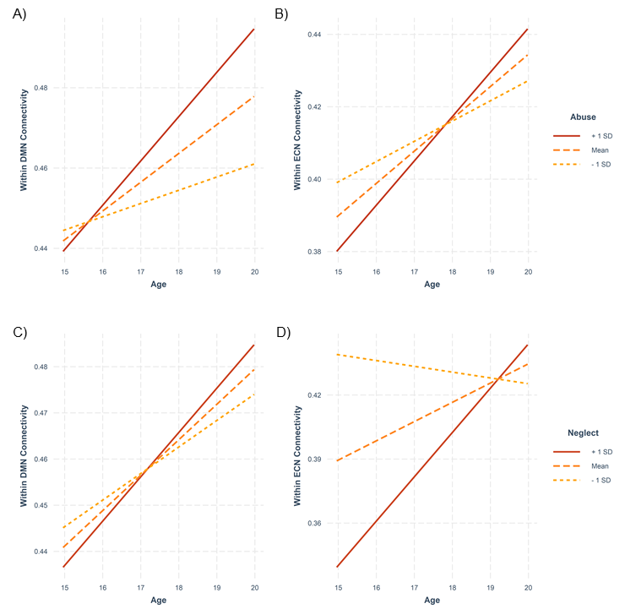

Supplementary Figure S6
Developmental trajectories are represented for within-DMN connectivity (A,C), and within-ECN connectivity (B,D) for adolescents with relatively high and low abuse (A,B) and neglect (D,E) scores. The slopes represent the average trajectories for groups based on +1SD, mean, and -1SD of abuse and neglect scores. * = p_{FDR} < 0.05

Supplementary Table S2: Model output for sex moderating the relationship between neglect and within-DMN connectivity

Model | Network | B | SE | T | P | Conditional R² | Marginal R²
Neglect × Sex model |  |  |  |  |  | 0.407 | 0.072
 | Neglect | -0.012 | 0.007 | -1.638 | 0.104
 | Time | -0.106 | 0.071 | -1.503 | 0.137
 | Sex | -0.256 | 0.155 | -1.648 | 0.102
 | IQ | 0.027 | 0.010 | 2.687 | 0.009
 | FD | 0.012 | 0.010 | 1.202 | 0.233
 | SES | 0.011 | 0.011 | 1.035 | 0.303
 | Neglect × Time | 0.009 | 0.004 | 2.122 | 0.037
 | Neglect × Sex | 0.020 | 0.010 | 1.944 | 0.054
 | Time × Sex | 0.207 | 0.095 | 2.183 | 0.032
 | Neglect × Time × Sex | -0.015 | 0.006 | -2.514 | 0.014
Marginal R² provides the variance explained only by fixed effects and Conditional R² provides the variance explained by the entire model, i.e., both fixed effects and random effects.

Non-significant findings for sex differences in change in abuse- and neglect-associated change in within-network connectivity

Abuse (Supplementary Figure S7)

We found that sex did not significantly moderated the relationship between abuse and:
Within SN connectivity: B = 0.0007, SE = 0.003, p = .842; Figure S7 A,B
Within DMN connectivity: B = -0.001, SE = 0.003, p = .68; Figure S7 C,D
Within ECN connectivity: B = -0.003, SE = 0.003, p = .383; Figure S7 E,F

Supplementary Figure S7

Neglect (Supplementary Figure S8)

We found that sex did not significantly moderated the relationship between neglect and:
Within SN connectivity: B = 0.001, SE = 0.003, p = .583; Figure S8 A, B
Within ECN connectivity: B = -0.004, SE = 0.003, p = .155; Figure S8 C, D
Supplementary Figure S8

Cross-sectional relationships for within-DMN connectivity and neglect in males and females at T1
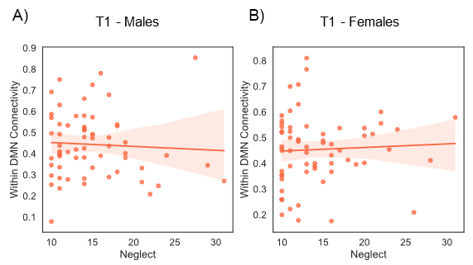

Supplementary Figure S9 Sex was not found to moderate the relationship between neglect and within-DMN connectivity at T1 (R² = 0.079, F(5,96) = 1.768, B = 0.004, p = 0.382).

Results excluding participants with mean FD > 0.2mm

Longitudinal abuse/neglect*age results:

Significant effects: When excluding any participants with mean FD > 0.2mm, we still found a significant association between change in within-SN connectivity and abuse (B = 0.01, t = 2.63, p = 0.01) and neglect (B = 0.012, t = 3.03, p = 0.003). In addition to

Non-significant effects:

Abuse:
Within-DMN: B = 0.002, t = 0.996, p = 0.323
Within-ECN: B = 0.001, t = 0.381, p = 0.704
Neglect:
Within-DMN: B = 0.001, t = 0.754, p = 0.452
Within-ECN: B = 0.003, t = 1.802, p = 0.075

Cross-sectional abuse/neglect*age results for significant longitudinal results:

T1:

Abuse and within-SN: R² = .079, F(5,107) = 2.93, B = -0.004, t = -1.507, p = 0.135
Neglect and within-SN: R² = .078, F(5,107) = 2.89, B = -0.004, t = -1.446, p = 0.151

T2:

Abuse and within-SN: R² = .029, F(5,87) = 1.56, B = 0.005, t = 1.459, p = 0.148
Neglect and within-SN: R² = .061, F(5,87) = 2.2, B = 0.007, t = 2.276, p = 0.025

Longitudinal abuse/neglect*age*sex results:

Significant Effects: Sex significantly moderated the relationship between change in within DMN connectivity and neglect (B = -0.015, t = -2.29, p = 0.02).

Non-significant effects:

Abuse:
Within-DMN: B = -0.002, t = -0.57, p = 0.570
Within-SN: B = 0.001, t = 0.272, p = 0.786
Within-ECN: B = -0.002, t = -0.684, p = 0.496
Neglect:
Within-SN: B = 0.003, t = 0.674, p = 0.502
Within-ECN: B = -0.005, t = 1.53, p = 0.128

Cross-sectional abuse/neglect*age*sex results for significant longitudinal results:

T1, neglect and within DMN: R² = .056, F(5,106) = 2.11, B = 0.004, t = 0.877, p = 0.382
T2, neglect and within DMN: R² = .0001, F(5,86) = 1.01, B = -0.008, t = -1.493, p = 0.139
Non-significant mediation models
We did not find a significant mediatory role of change in within-SN connectivity between abuse/neglect and CES-D (C.I. -0.002 to .187, C.I. -0.001 to 0.216 respectively) or BAI (C.I. -0.003 to 0.121, C.I. -0.004 to 0.147 respectively) scores. We also did not find evidence for change in within-DMN connectivity as the mediator between neglect and T2 problematic substance use, CES-D, or BAI scores in males (C.I. -0.066 to 0.051, C.I. -0.141 to 0.230, C.I. -0.101 to 0.201 respectively).

Non-significant mediation results excluding participants with mean FD > 0.2mm

We did not find a significant mediatory role of change in within-SN connectivity between abuse/neglect and BAI scores (C.I. -0.01 to 0.122, C.I. -0.012 to 0.154 respectively) scores. We also did not find evidence for change in within-DMN connectivity as the mediator between neglect and T2 problematic substance use, CES-D, or BAI scores in males (C.I. -0.067 to 0.0541, C.I. -0.075 to 0.3179, C.I. -0.09 to 0.224 respectively).

References
1. Whittle S, Yap MBH, Yucel M, Fornito A, Simmons JG, Barrett A, et al. (2008): Prefrontal and amygdala volumes are related to adolescents’ affective behaviors during parent-adolescent interactions. Proc Natl Acad Sci 105: 3652–3657.
2. Wechler D (2003): Wechsler Intelligence Scale for Children, 4th ed. San Antonio, Tex, Harcourt Assessment.
3. Bernstein DP, Stein JA, Newcomb MD, Walker E, Pogge D, Ahluvalia T, et al. (2003): Development and validation of a brief screening version of the Childhood Trauma Questionnaire. Child Abus Negl 27: 169–190.
4. Glaesmer H (2016): Assessing childhood maltreatment on the population level in Germany: Findings and methodological challenges. Child Adolesc Psychiatry Ment Health 10: 15.
5. Walker EA, Gelfand A, Katon WJ, Koss MP, Von Korff M, Bernstein D, Russo J (1999): Adult health status of women with histories of childhood abuse and neglect. Am J Med 107: 332–339.
6. Zimmermann K, Walz C, Derckx RT, Kendrick KM, Weber B, Dore B, et al. (2017): Emotion regulation deficits in regular marijuana users. Hum Brain Mapp 38: 4270–4279.
7. Ham LS, Hope DA (2003): College students and problematic drinking: A review of the literature. Clin Psychol Rev 23: 719–759.
8. Jacobsen LK, Mencl WE, Constable RT, Westerveld M, Pugh KR (2007): Impact of smoking abstinence on working memory neurocircuitry in adolescent daily tobacco smokers. Psychopharmacology (Berl) 193: 557–566.
9. Odgers CL, Caspi A, Nagin DS, Piquero AR, Slutske WS, Milne BJ, et al. (2008): Is it important to prevent early exposure to drugs and alcohol among adolescents? Psychol Sci 19: 1037–44.
10. Breslau N, Peterson EL (1996): Smoking cessation in young adults: age at initiation of cigarette smoking and other suspected influences. Am J Public Health 86: 214–20.
11. Behrendt S, Wittchen HU, Höfler M, Lieb R, Beesdo K (2009): Transitions from first substance use to substance use disorders in adolescence: Is early onset associated with a rapid escalation? Drug Alcohol Depend 99: 68–78.
12. Rakesh D, Lv J, Zalesky A, Allen NB, Lubman DI, Yücel M, Whittle S (2020): Altered resting functional connectivity patterns associated with problematic substance use and substance use disorders during adolescence. J Affect Disord 279: 599–608.
13. Tustison NJ, Avants BB, Cook PA, Zheng Y, Egan A, Yushkevich PA, Gee JC (2010): N4ITK: improved N3 bias correction. IEEE Trans Med Imaging 29: 1310–20.
14. Avants BB, Epstein CL, Grossman M, Gee JC (2008): Symmetric diffeomorphic image registration with cross-correlation: Evaluating automated labeling of elderly and neurodegenerative brain. Med Image Anal 12: 26–41.
15. Greve DN, Fischl B (2009): Accurate and robust brain image alignment using boundary-based registration. Neuroimage 48: 63–72.
16. Jenkinson M, Bannister P, Brady M, Smith S (2002): Improved Optimization for the Robust and Accurate Linear Registration and Motion Correction of Brain Images. Neuroimage 17: 825–841.
17. Pruim RHR, Mennes M, van Rooij D, Llera A, Buitelaar JK, Beckmann CF (2015): ICA-AROMA: A robust ICA-based strategy for removing motion artifacts from fMRI data. Neuroimage 112: 267–277.
18. Alves PN, Foulon C, Karolis V, Bzdok D, Margulies DS, Volle E, Thiebaut de Schotten M (2019): An improved neuroanatomical model of the default-mode network reconciles previous neuroimaging and neuropathological findings. Commun Biol 2. https://doi.org/10.1038/s42003-019-0611-3
19. Sheline YI, Barch DM, Price JL, Rundle MM, Vaishnavi SN, Snyder AZ, et al. (2009): The default mode network and self-referential processes in depression. Proc Natl Acad Sci U S A 106: 1942–1947.
20. Shirer WR, Ryali S, Rykhlevskaia E, Menon V, Greicius MD (2012): Decoding subject-driven cognitive states with whole-brain connectivity patterns. Cereb Cortex 22: 158–165.

