SUPPLEMENTARY MATERIALS 1 - Complete item pool

HOME BASED:
- Open all the curtains in your home.
- Look out of a front window for 2mins.
- Sit in a communal/shared area by yourself for 5mins.
- Sit in a communal or shared area with others for 5mins.
- Open the front door and stand in the doorway for 5mins.
- Stand outside your home with someone you know for 5mins.
- Stand outside your home on your own for 5mins.
OUTDOORS:
- Walk down a quiet street with someone you know.
- Walk down a quiet street on your own.
- Walk down a busy street with someone you know.
- Walk down a busy street on your own.
- Walk through a park with someone you know for 10mins.
- Walk through a park on your own for 10mins.
- Sit on a bench in a public place, with someone you know for 5mins.
- Sit on a bench in a public place on your own for 5mins.
TRANSPORTATION:
- Wait at a bus stop with someone you know for 5mins.
- Travel with someone you know on the bus for one stop.
- Travel with someone you know on the bus for several stops.
- Wait at a bus stop on your own for 5mins.
- Travel on your own on the bus for one stop.
- Travel on your own on the bus for several stops.
- Sit next to a stranger on the bus.
APPOINTMENTS:
- Walk into the waiting room of your GP/health centre with someone you know.
- Walk into the waiting room of your GP/health centre on your own.
- Sit in the waiting room of your GP/health centre with someone you know for 5mins.
- Sit in the waiting room of your GP/health centre on your own for 5mins.
- Queue to speak with the receptionist in your GP/health centre.
- See your GP for a health appointment.
SHOPPING:
- Go into a local shop with someone you know for 5mins.
- Go into a local shop on your own for 5mins.
- Purchase an item in a local shop, from a shop assistant.
- Go to a shopping centre with someone you know for 15mins.
- Go to a shopping centre on your own for 15mins.
- Speak to a shop assistant in local shopping centre (e.g., ask if they have a specific item in stock?)
CAFÉ:
- Go into a café with someone you know.
- Go into a café on your own.
- Sit in a café with someone you know for 10mins.
- Sit in a café on your own for 10mins.
- Order a drink on your own in a cafe.
- Sit near to other people (strangers) in the cafe for 10mins.

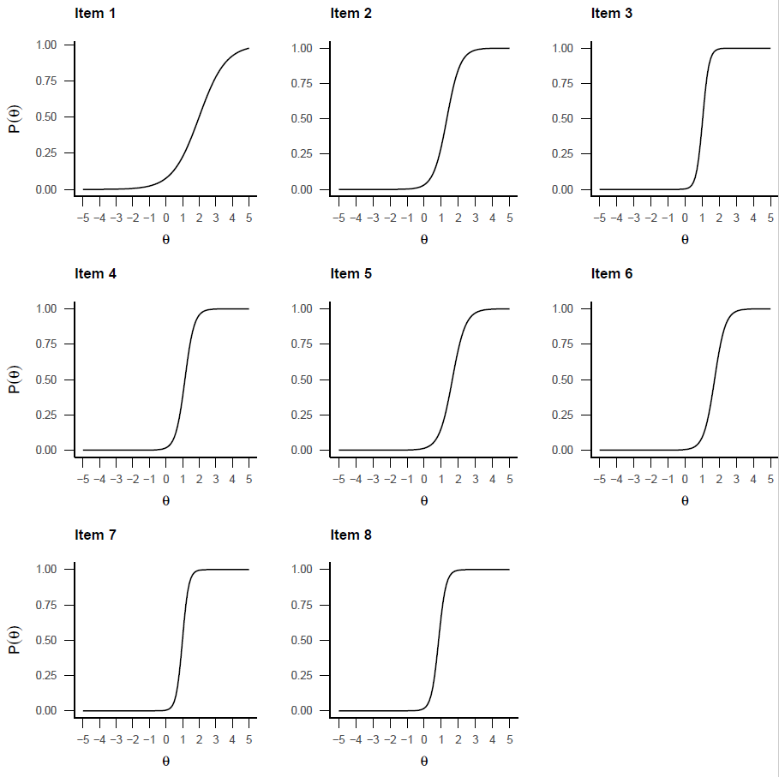
SUPPLEMENTARY MATERIALS 2. Item probability trace lines

Figure S1. Item characteristic curves for the binary O-AS avoidance items. Plot lines represent the probability (y axis) of endorsing that item across the theta (i.e. severity) spectrum (x axis).

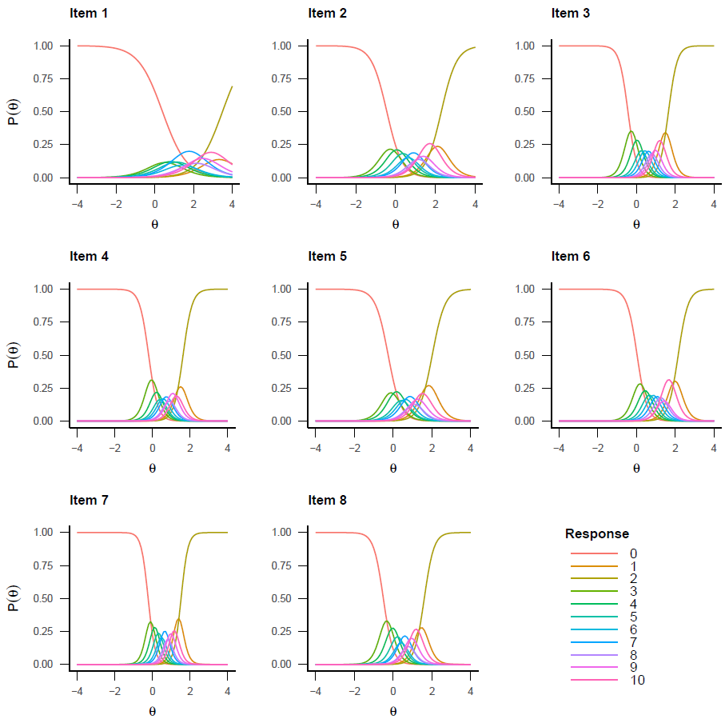

Figure S2. Category response curves for the polytomous O-AS distress items. Plot lines represent the probability (y axis) of responding to each scale option (0-10) across the theta (i.e. severity) spectrum (x axis).

SUPPLEMENTARY MATERIALS 3. Item information functions
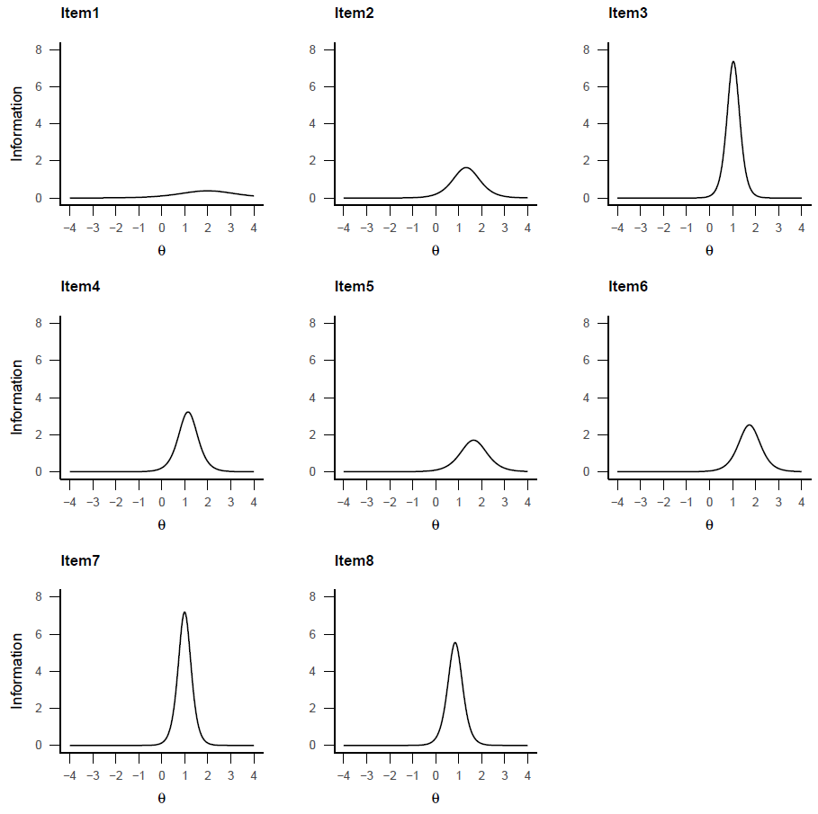

Figure S3. Item information functions for all O-AS avoidance items

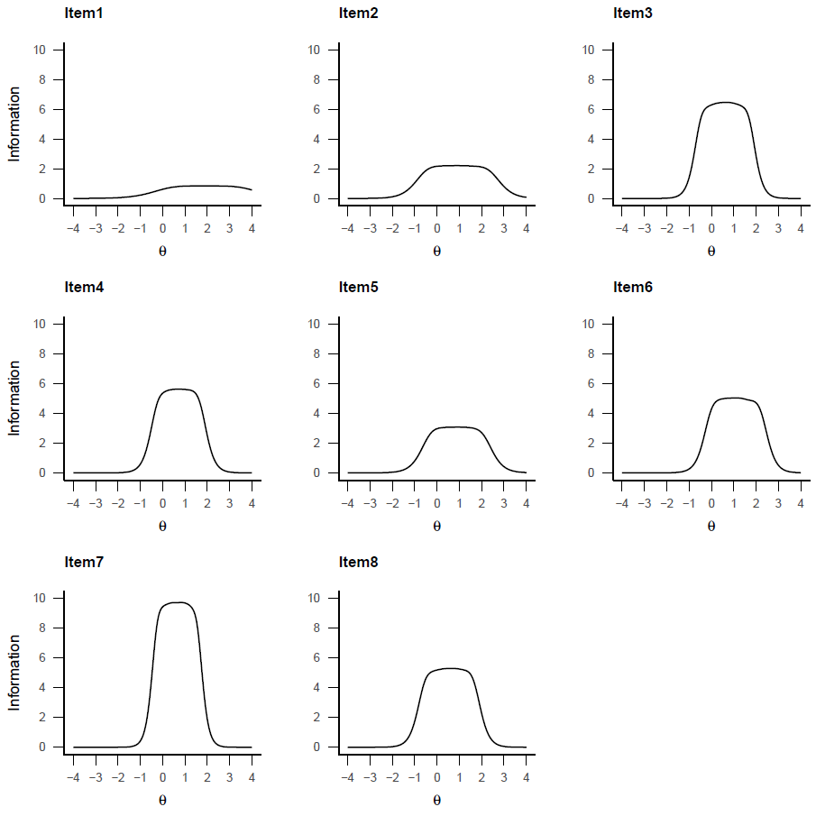

Figure S4. Item information functions for all O-AS distress items

SUPPLEMENTARY MATERIALS 4. Receiver Operating Characteristic (ROC) plots
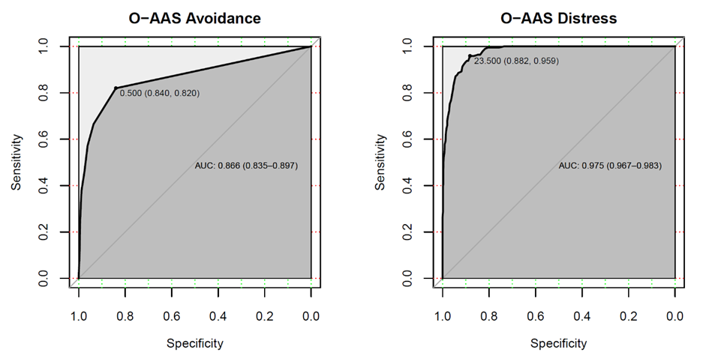

Figure S5. Receiver Operator Curve plots for the O-AS avoidance and distress scores. The area under the curve (AUC) and the optimal threshold for discriminating patients with psychosis and agoraphobia (n=194) and controls from the general population (n=1094) are displayed.

