Supplemental Materials for

Associations between mental wellbeing and fMRI neural bases underlying responses to positive emotion in a twin sample

Haeme R.P. Park^{1,2}, Miranda R. Chilver^{1,2}, Arthur Montalto^{1,2}, Javad Jamshidi^{1,2}, Peter R. Schofield^{1,3}, Leanne M. Williams⁴, Justine M. Gatt^{1,2}

¹ Neuroscience Research Australia, Sydney, NSW, Australia
² School of Psychology, University of New South Wales, Sydney, NSW, Australia
³ School of Medical Science, University of New South Wales, Sydney, NSW, Australia
⁴ Psychiatry and Behavioral Sciences, Stanford School of Medicine, Stanford University, Stanford, California, USA

This document contains:
Supplementary Methods S1 and S2
Supplementary Results Figure S1, Table S1 and S2

Corresponding author:
Haeme Park
Neuroscience Research Australia
Margarete Ainsworth Building
Barker Street
Randwick 2031
Australia
Email: h.park@neura.edu.au
Phone: +61 2 9399 1884
Supplementary Methods
S1 Psychometric measures.
COMPAS-W is a 26-item composite scale of wellbeing that measures both subjective and psychological wellbeing across six components (composure during stress, own-worth, mastery over environment, positivity, achievement and goal orientation, satisfaction with physical, psychological health and social relationships). It has shown moderate to strong internal consistency, test-retest reliability, and validity, and provides a reliable and valid index of mental health (Gatt et al., 2014). The DASS-42 is a 42-item measure of depression, anxiety, and stress symptoms, consisting of three subscales (DASS-Depression, DASS-Anxiety, DASS-Stress) that are based on the tripartite model of anxiety and depression (low positive affect, physiological hyperarousal, and negative affect; Clark & Watson, 1991). In this current study, these are labelled collectively as negative mood symptoms. Good construct validity, excellent internal consistency, reliability and concurrent validity have been reported (Brown, Chorpita, Korotitsch, & Barlow, 1997; Lovibond & Lovibond, 1995).

S2 Univariate twin analysis.
It is assumed that MZ twins share 100% of additive genetic variance and common environmental variance, while DZ twins only share 50% of additive genetic variance and 100% common environmental variance. Depending on the intra-class correlation values calculated for the MZ and DZ twins, either an ACE or an ADE model is tested. If the MZ correlation is greater than twice the DZ correlation, an ADE model would be appropriate due to non-additive genetic effects; otherwise, an ACE model would be chosen.
Supplementary Results
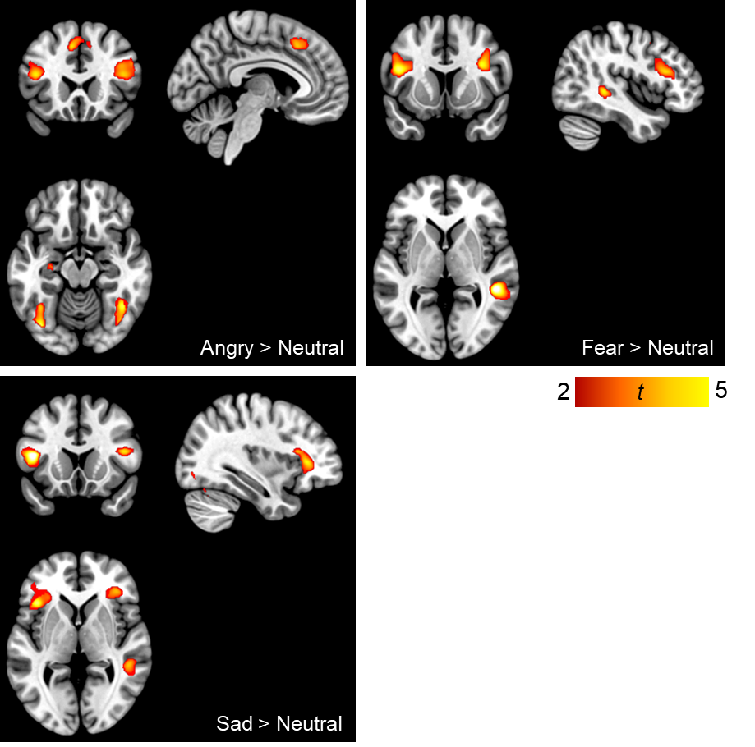

Figure S1. Voxel-wise activation of the three negative emotion contrasts (Angry > Neutral; Fear > Neutral; Sad > Neutral) showing significant clusters in the frontal and temporal regions. There were no significant regions for the Disgust > Neutral contrast. These clusters were not taken to univariate and multivariate modelling as they did not show significant associations with wellbeing in the linear mixed models.

Table S1
Full Width at Half Maximum (FWHM) of the Gaussian kernel and Resel values for the five emotion contrasts.
Contrast | FWHM (voxels) | Resels
- Happy > Neutral | 11.2 11.5 7.5 | 180.7
- Angry > Neutral | 11.3 11.5 7.5 | 177.1
- Fear > Neutral | 12.4 12.6 8.4 | 133.5
- Disgust > Neutral | 11.9 12.1 7.9 | 153.7
- Sad > Neutral | 13.5 14.0 8.9 | 104.4

Table S2
Univariate heritability estimates for the COMPAS-W scores indexing wellbeing levels.
Model | ICC |  |  | Model fit |  |  |  |  |  |  | Parameter estimates
 | MZ | DZ |  | Comparison | -2LL | AIC | df | Δχ2 | p |  |  | A [CI] | D [CI] | E [CI]
ADE | .447 | .106 | vs. saturated | 639.82 | 191.82 | 224 | .05 | - | 0 | .420  [0, .57] | .580  [.43, .77]
AE |  |  | vs. ADE | 640.45 | 190.45 | 225 | .63 | 0.426 | .406  [.22, .56] | 0 | .594  [.44, .78]
E |  |  | vs. AE | 656.25 | 204.25 | 230 | 15.80 | <0.001 |  |  | 1
Note. ICC = intra-class correlation; MZ = monozygotic twins; DZ = dizygotic twins; -2LL = minus twice the log likelihood; df = degrees of freedom; AIC = Akaike’s information criterion; CI = 95% confidence intervals. The variance was decomposed into additive (A), non-additive (D), and unique environmental (E) factors. The AE model (in bold) was selected as the best-fitting model based on parsimony and lowest AIC value.

References
Brown, T.A., Chorpita, B.F., Korotitsch, W., & Barlow, D.H. (1997). Psychometric
properties of the Depression Anxiety Stress Scales (DASS) in clinical samples.
Behaviour Research and Therapy, 35(1), 79-89. doi:10.1016/S0005-7967(96)00068-X
Clark, L.A., & Watson, D. (1991). Tripartite model of anxiety and depression: psychometric
evidence and taxonomic implications. Journal of Abnormal Psychology, 100(3), 316-
336. doi:10.1037/0021-843X.100.3.316
Gatt, J.M., Burton, K.L.O., Schofield, P.R., Bryant, R.A., & Williams, L.M. (2014). The
heritability of mental health and wellbeing defined using COMPAS-W, a new
composite measure of wellbeing. Psychiatry Research, 219, 204-213.
doi:10.1016/j.psychres.2014.04.033
Lovibond, P.F., & Lovibond, S.H. (1995). The structure of negative emotion states:
comparison of the Depression Anxiety Stress Scales (DASS) with the Beck
Depression and Anxiety Inventories. Behaviour Research and Therapy, 33(3), 335-
343. doi:10.1016/0005-7967(94)00075-U

