Supplementary Materials

Supplementary Methods

Structured Clinical Interview for DSM-IV Axis I Disorders
The Structured Clinical Interview for DSM-IV Axis I Disorders (SCID) is a semi-structured interview for assessing major psychiatric disorders (First, Spitzer, Gibbon, & Williams, 1997). These diagnoses include: affective disorders, anxiety disorders, disruptive disorders, and substance use disorders.

Montgomery-Åsberg Depression Rating Scale
The Montgomery-Åsberg Depression Rating Scale (MADRS) is a clinician rated assessment of depressive symptom severity (Montgomery & Asberg, 1979). The questionnaire concerns the past week and is comprised of 10 items which include: apparent sadness, reported sadness, inner tension, reduced sleep, reduced appetite, concentration difficulties, lassitude, inability to feel, pessimistic thoughts and suicidal thoughts. Items are rated from 0 to 6, with higher scores reflecting greater symptom severity.

General Anxiety Disorder-7

The General Anxiety Disorder-7 (GAD-7) is a brief measure for assessing general anxiety symptom severity (Spitzer, Kroenke, Williams, & Lowe, 2006). Participants are required to evaluate their own anxiety symptoms over the last two weeks rating items from 0 to 3, with higher scores reflecting greater symptom severity. The 7 items in this questionnaire include: nervousness, inability to stop worrying, excessive worry, difficulty in relaxing, restlessness, irritability, and fear of something awful happening.

Working Alliance Inventory-Revised Short Form
The Working Alliance Inventory-Revised Short Form (WAI-SR) is a 12-item participant rated self-reported questionnaire (Tracey & Kokotovic, 1989), which measure therapeutic alliance between patients and therapists. These items are equal split into three domains of the therapeutic alliance: agreement on therapy tasks, agreement on therapy goals and affective bond. Items are rated between 1 = ‘never’ to 5 = ‘always’, with higher scores being indicative of greater therapeutic alliance.

Implicit Emotional Face Matching Task
The fMRI task was a variation of the face matching task first described by Hariri and colleges (Hariri, Bookheimer, & Mazziotta, 2000). It involved 3 conditions: one shape matching and two implicit face processing conditions, involving either fearful or sad facial expressions. In the shape matching condition, participants were required to match the orientation of the shape presented in the top half of the screen to one of the two shapes presented on the left and right in the bottom half of the screen. Similarly, in the two face processing conditions, participants were required to match the gender of the target face, presented in the top half of the screen, with the gender of one of the faces presented on the left and right in the bottom half of the screen (Figure S1). All faces presented within each block would convey either a sad or fearful facial expression.
The order in which the conditions were presented was counterbalanced between participants (either version A [shapes, sad, fearful] or B [shapes, fearful, sad]). Each session involved six blocks for each of the three conditions (18 blocks total); a 10 second white fixation cross was also presented between each block, and before the first and after the final block. Each block consisted of six trials, with each trial having a duration of 3.75 seconds followed by a 0.25 second inter-trial interval. For the face processing blocks, these trials comprised three male and three female faces, which were sampled from a total of 18 male and 18 female faces. All of the face stimuli were collected from the Radboud Face Database (Langner et al., 2010). The task was presented with Paradigm software (http://www.paradigmexperiments.com) and ran on a Dell computer. The LCD screen that presented stimuli was visible via a reverse mirror mounted to the participants’ head coil and behavioral responses were captured using an optical-fiber button-box.

Statistical Analysis
Analyses of between-group differences for clinical and demographic characteristics were calculated using two-sample independent and performed in SPSS version 26 (IBMCorp., Armonk, NY). Differences in reaction time (RT) between groups were compared through the use of a mixed model ANOVA, while differences in accuracy were compared with Friedman and Mann-Whitney U tests. Comparisons were adjusted for multiple comparisons using multiple comparisons using the Benjamini–Hochberg correction (Benjamin & Hochberg, 1995) to determine significance (p < 0.05).

Image Acquisition
A 3T General Electric Signa Excite system with an eight-channel phased-array head coil was used in combination with ASSET parallel imaging. The functional sequence consisted of a single shot gradient-recalled echo-planar imaging (EPI) sequence in the steady state (repetition time, 2000 ms; echo time, 35 ms; and pulse angle, 90°) in a 23-cm field-of-view, with a 64 x 64-pixel matrix and a slice thickness of 3.5mm (no gap). Thirty-six interleaved slices were acquired parallel to the anterior-posterior commissure line with a 20° anterior tilt to better cover ventral prefrontal brain regions. The total sequence duration was 10 minutes and 32 seconds, corresponding to 311 whole-brain EPI volumes. The first four volumes from each run were automatically discarded to allow for signal equilibration. A T1-weighted high-resolution anatomical image was acquired for each participant to assist with functional time-series co-registration (140 contiguous slices; repetition time, 7.9 s; echo time, 3 s; flip angle, 13°; in a 25.6 cm field-of-view, with a 256 x 256-pixel matrix and a slice thickness of 1 mm). To assist with noise reduction and head immobility, all participants used earplugs and had their heads supported with foam-padding inserts.

Image Processing
Imaging data was transferred to a Unix-based platform that ran MATLAB Version 9.3 (The MathWorks Inc., Natick, USA) and Statistical Parametric Mapping (SPM) Version 12- v7487 (Wellcome Trust Centre for Neuroimaging, London, UK). Motion correction was performed by aligning each participant’s time-series to the first image using least-squares minimization and a six-parameter rigid-body spatial transformation. Motion fingerprint (SPM toolbox; Wilke, 2012) was used to quantify participant head motion. Participants were excluded if movement exceeded ~1 native voxel (mean total displacement; maximum scan-to-scan displacement). Following this, images were corrected for differences in slice acquisition time and then coregistered to their respective T1 weighted scans, which had been spatially normalized and segmented using the International Consortium for Brain Mapping template. These functional images were resliced to 2 mm isotropic resolution and were smoothed with a 5 mm Gaussian kernel (full width at half maximum).

General Linear Modelling: Second Level
At the group-level, single sample t-tests were conducted, which were thresholded with a whole-brain, family-wise error rate (FWE) corrected threshold of P < 0.05, K_{E} ≥ 10 voxels. For between-group analysis, independent sample t-tests were conducted, which were similarly thresholded with a whole-brain, family-wise error rate (FWE) corrected threshold of P < 0.05, K_{E} ≥ 10 voxels. We also examined the relationship between brain activation and variables of interest including gender, IQ, lifetime number of episodes and depressive symptom severity (for the patient group). This was conducted by repeating the aforementioned analyses with these variables included as covariates of interest.

Supplementary Results
Within Scanner Behavioral Results
Regarding task performance, there was a statistically significant difference in the RT between the different condition types (Mixed ANOVA: F(1.32 235.59) = 1285.28, p < 0.001). Post hoc testing revealed significantly faster RTs for shape matching compared with both fearful (p > 0.001) and sad face matching (p > 0.001). Moreover, the RT for fearful face matching was significantly longer than for sad faces (p > 0.001).
Similarly, there was a significant difference in the accuracy between the different condition types for both controls and patients (Friedman test: χ²(2) = 42.876, p < 0.001 and χ²(2) = 22.817, p > 0.001, respectively). The matching of sad faces was less accurate than for either the fearful face (p > 0.001, both groups) and shape matching conditions (p > 0.001, both groups). Both groups demonstrated equivalent accuracy in matching fearful faces and shape matching conditions (p = 0.957 and p = .987, respectively).

Mapping Brain Activation and Deactivation Responses to Sad and Fearful Faces
Both groups demonstrated similar patterns of regional activity change across the face processing network during task performance. This included significant activation throughout the visual cortex including the OFA, as well as the FFA, superior temporal sulcus, amygdala, dorsal midbrain, dorsomedial thalamus, dlPFC, and supplementary motor area (Figure S3A and B). Moreover, both groups demonstrated significant deactivation through the default mode network, including the mPFC, posterior cingulate and lateral parietal cortex.
When comparing the groups directly across the primary contrasts, there were no significant differences in regional activation or deactivation observed (p_{FWE} < 0.05). However, at a lower threshold, differences were observed for the fearful face > shape matching contrast (p < 0.001, uncorrected). Depressed participants demonstrated greater deactivation of pregenual ACC (peak voxel, x = 4, y = 46, z = 10; cluster size = 51; peak t-value = 3.74). Conversely, control participants demonstrated greater activation of the right anterior insular cortex (peak voxel, x = 36, y = 30, z = -4; cluster size = 55; peak t-value = 4.08), tail of the caudate nucleus and medial thalamus (peak voxels, x = 10, y = 0, z = 4 and x = 8, y = -14, z = 2; cluster size =102; peak t-values = 4.38 and 3.93; Figure S3C).
No significant effects for gender, IQ, lifetime number of episodes or depressive symptom severity were observed for the emotional face > shape, sad face > shape or fearful face > shape contrasts in whole-brain analyses.

Parametric Empirical Bayes: Interaction Between Response and Treatment Type
Some parameters demonstrated a meaningful interaction between response and the two treatment arms, suggesting that they may have been specifically predictive for one treatment type. This included intrinsic connectivity from the self-connectivity from both the amygdala (expected value = -.09 Hz, PP = .99) and dlPFC (expected value = -.09 Hz, PP = 1.00) and the sad modulation from the FFA to vmPFC (expected value = -.08 Hz, PP = .99).

Parametric Empirical Bayes: Leave-one-out cross-validation Anxiety Symptoms, Response and Treatment Interaction, and Percentage Change in MADRS.
We examined whether any of the fearful modulations that were different between diagnostic or prognostic groups were associated with anxiety symptom severity (Supplementary Table S5). We observed that the fearful modulation from the vmPFC to amygdala, which was shown to be reduced in those with depression, was significantly associated with the severity of anxiety symptoms.
We additionally investigated whether those parameters associated with categorical response would also be useful in predicting the percentage change in depressive symptom severity. The inclusion of patients from both treatment arms resulted in an out-of-sample correlation of r =.32, p = .002 (Supplementary Figure 4A). Using just the CBT and fluoxetine group there was a correlation of r = .29, p = .030 (Supplementary Figure 4B) and a correlation of r = .43, p = .005 for the CBT and placebo group (Supplementary Figure 4C), which mirrored our findings using categorical outcomes.
Finally, we explored whether for each parameter that demonstrated a response or interaction effect also showed a different predictive ability dependent on the treatment type (Table S6). Of the interaction parameters, only the sad modulation from the FFA to vmPFC was significantly associated with response for those treated with CBT and fluoxetine.

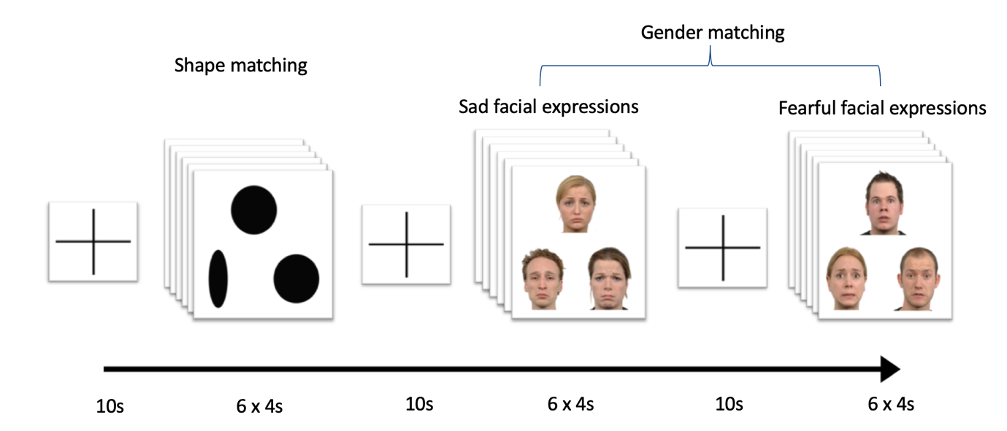
Supplementary Figure S1. Design of the implicit face processing paradigm. All participants were present with triples of shapes or emotional faces (sad or fearful expression). The task involved matching the image presented above with the corresponding image below based on either the orientation (shape conditions) or gender (faces conditions).

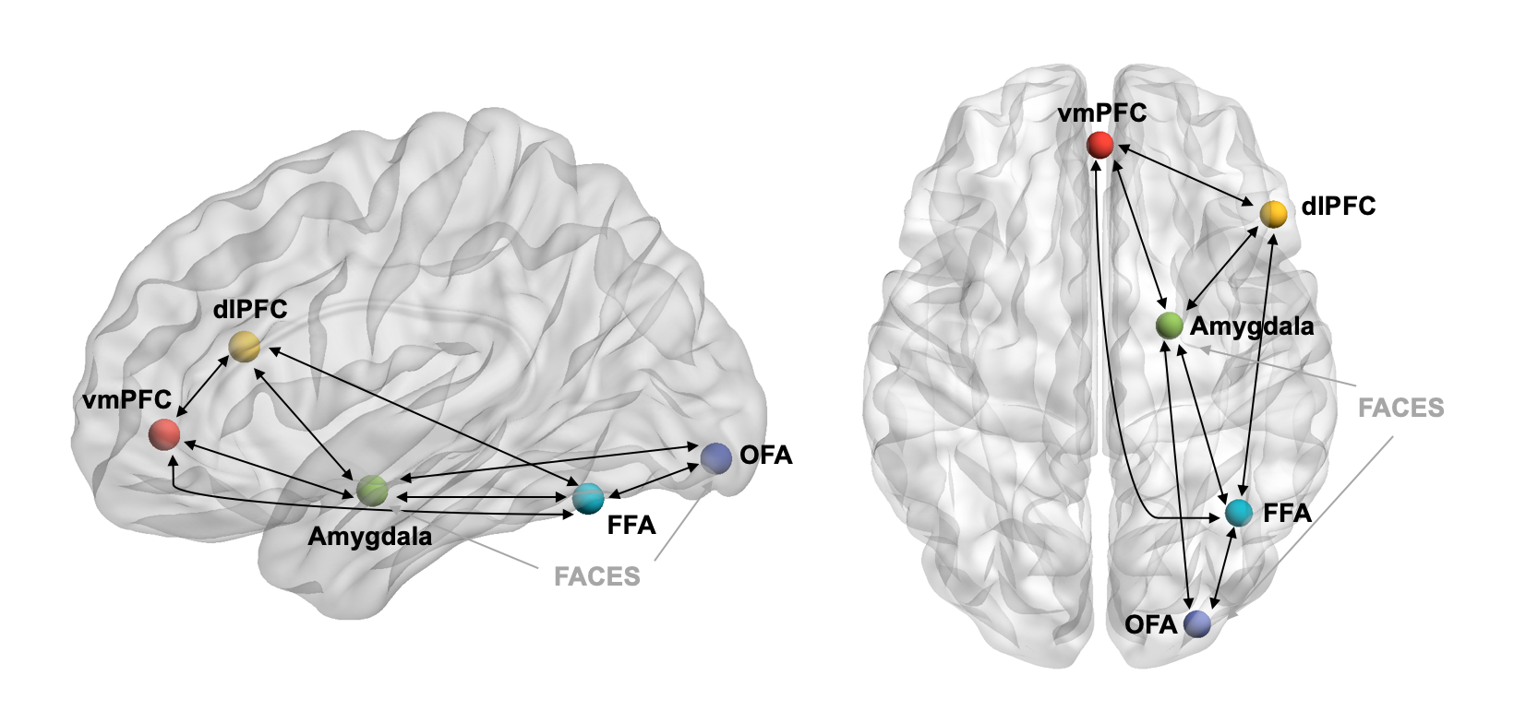
Supplementary Figure S2. Model of intrinsic connections (black) and extrinsic input (grey) specified in our DCM analysis. Render visualized using BrainNet Viewer (Xia, Wang, & He, 2013).
Note. OFA, occipital face area; FFA, fusiform face area; dlPFC, dorsolateral prefrontal cortex; vmPFC, ventromedial prefrontal cortex

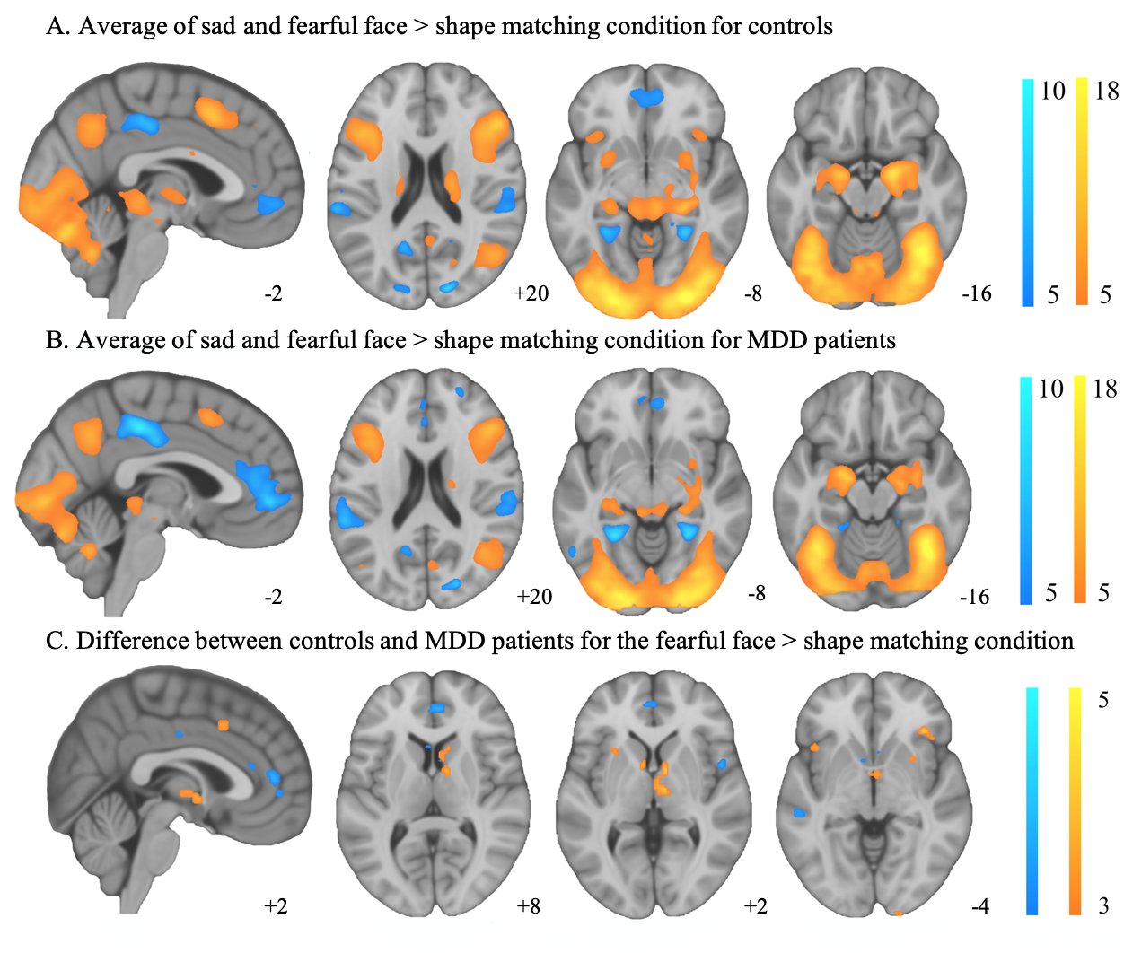
Supplementary Figure S3. Brain activation (warm) and deactivation (cool) during the emotional face and shape matching conditions. (A) Both sad and fearful faces > shapes for controls, (B) Both sad and fearful faces > shapes for depressed participants (P_{FWE} < 0.05). Also shown is (C) the comparison of fearful and shape matching conditions between controls and depressed participants, warm indicating greater activation in controls and cool indicating greater deactivation in patients (P < 0.001, uncorrected).

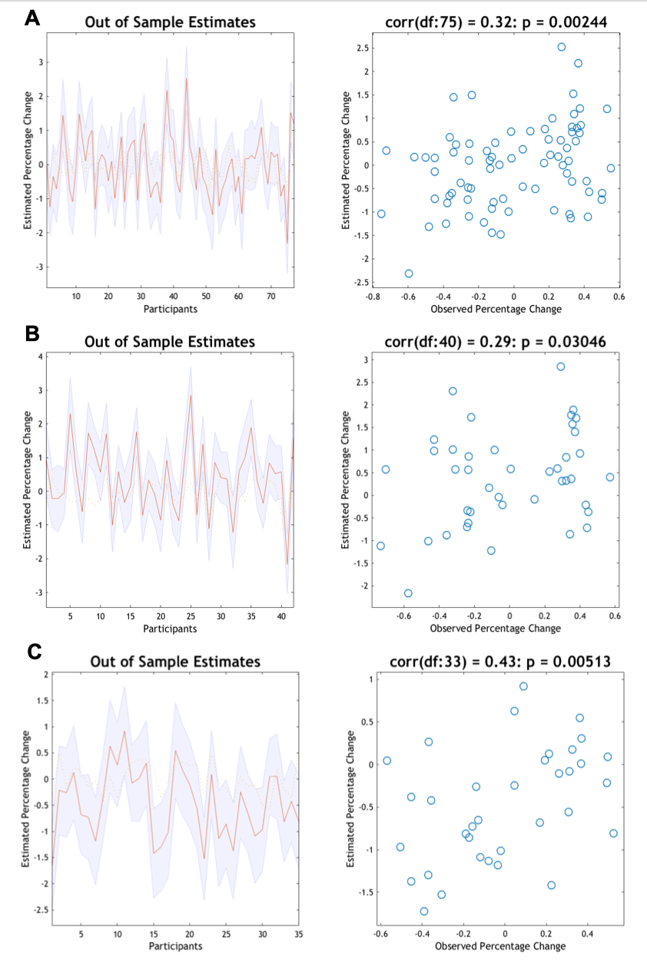
Supplementary Figure S4. Leave-one-out cross-validation predicting response status after treatment for depression. Left: The out-of-sample estimate of the percentage change in MADRS symptoms following treatment with 90% confidence interval (shaded area) for each participant. Right: The correlation between observed scores and the expected values for each individual. For (A) both treatment arms, (B) only those treated with CBT and fluoxetine, and (C) only those treated with CBT and a placebo.
Supplementary Table S1.
Group level Coordinates of VOI

Regions | MNI coordinates |  |  | t value
 | X | Y | Z
Controls
OFA | 28 | -92 | -8 | 21.70
FFA | 40 | -60 | -18 | 19.70
Amygdala | 20 | -6 | -16 | 15.67
dlPFC | 50 | 26 | 20 | 12.60
vmPFC | 0 | 46 | -2 | 6.11
MDD
OFA | 24 | -94 | -4 | 19.85
FFA | 38 | -58 | -16 | 18.90
Amygdala | 22 | -6 | -12 | 12.68
dlPFC | 46 | 26 | 22 | 11.81
vmPFC | 2 | 48 | 0 | 8.57

Note. OFA, occipital face area; FFA, fusiform face area; dlPFC, dorsolateral prefrontal cortex; vmPFC, ventromedial prefrontal cortex

Supplementary Table S2.
CONSORT Checklist

Section/Topic | Item No | Checklist item | Reported on page No
Title and abstract
 | 1a | Identification as a randomised trial in the title | 1
 | 1b | Structured summary of trial design, methods, results, and conclusions (for specific guidance see CONSORT for abstracts) | 2
Introduction
Background and objectives | 2a | Scientific background and explanation of rationale | 4-6
 | 2b | Specific objectives or hypotheses | 6
Methods
Trial design | 3a | Description of trial design (such as parallel, factorial) including allocation ratio | 7
 | 3b | Important changes to methods after trial commencement (such as eligibility criteria), with reasons | NA
Participants | 4a | Eligibility criteria for participants | 7
 | 4b | Settings and locations where the data were collected | 7
Interventions | 5 | The interventions for each group with sufficient details to allow replication, including how and when they were actually administered | 7
Outcomes | 6a | Completely defined pre-specified primary and secondary outcome measures, including how and when they were assessed | 8-12
 | 6b | Any changes to trial outcomes after the trial commenced, with reasons | NA
Sample size | 7a | How sample size was determined | See citation 58
 | 7b | When applicable, explanation of any interim analyses and stopping guidelines | NA
Randomisation:
Sequence generation | 8a | Method used to generate the random allocation sequence | See citation 58
 | 8b | Type of randomisation; details of any restriction (such as blocking and block size) | See citation 58
Allocation concealment mechanism | 9 | Mechanism used to implement the random allocation sequence (such as sequentially numbered containers), describing any steps taken to conceal the sequence until interventions were assigned | See citation 58
Implementation | 10 | Who generated the random allocation sequence, who enrolled participants, and who assigned participants to interventions | See citation 58
Blinding | 11a | If done, who was blinded after assignment to interventions (for example, participants, care providers, those assessing outcomes) and how | See citation 58
 | 11b | If relevant, description of the similarity of interventions | See citation 58
Statistical methods | 12a | Statistical methods used to compare groups for primary and secondary outcomes | 10-12
 | 12b | Methods for additional analyses, such as subgroup analyses and adjusted analyses | 11-12
Results
Participant flow (a diagram is strongly recommended) | 13a | For each group, the numbers of participants who were randomly assigned, received intended treatment, and were analysed for the primary outcome | Figure 1
 | 13b | For each group, losses and exclusions after randomisation, together with reasons | Figure 1
Recruitment | 14a | Dates defining the periods of recruitment and follow-up | See citation 58
 | 14b | Why the trial ended or was stopped | See citation 58
Baseline data | 15 | A table showing baseline demographic and clinical characteristics for each group | Table 1, 2 and S3
Numbers analysed | 16 | For each group, number of participants (denominator) included in each analysis and whether the analysis was by original assigned groups | 8, 11, Table 1, 2 and S3
Outcomes and estimation | 17a | For each primary and secondary outcome, results for each group, and the estimated effect size and its precision (such as 95% confidence interval) | 11-13 and Table S4
 | 17b | For binary outcomes, presentation of both absolute and relative effect sizes is recommended | 13
Ancillary analyses | 18 | Results of any other analyses performed, including subgroup analyses and adjusted analyses, distinguishing pre-specified from exploratory | 13
Harms | 19 | All important harms or unintended effects in each group (for specific guidance see CONSORT for harms) | Figure 1 and citation 58
Discussion
Limitations | 20 | Trial limitations, addressing sources of potential bias, imprecision, and, if relevant, multiplicity of analyses | 18 and Citation 58
Generalisability | 21 | Generalisability (external validity, applicability) of the trial findings | 16-18 and Citation 58
Interpretation | 22 | Interpretation consistent with results, balancing benefits and harms, and considering other relevant evidence | 14-17
Other information
Registration | 23 | Registration number and name of trial registry | 3
Protocol | 24 | Where the full trial protocol can be accessed, if available | Citation 58
Funding | 25 | Sources of funding and other support (such as supply of drugs), role of funders | 20

Supplementary Table S3.
Comparison of Characteristics Between Patients Treated with Cognitive Behavioral Therapy and a Placebo and Those Treated with Cognitive Behavioral Therapy and Fluoxetine.

 | CBT + Placebo  (N = 35) |  | CBT + Fluoxetine  (N = 42)
Characteristics | Mean or N | SD or percentage | Mean or N | SD or percentage | d | p
Female | 19 | 54.3 | 31 | 73.8 | -.41 | .303
Age (years) | 18.86 | 2.2 | 20.64 | 2.8 | -.70 | .027*
Age of Onset | 14.91 | 2.3 | 15.69 | 2.9 | -.29 | .515
Number of Episodes | 2.00 | 2.7 | 2.26 | 1.6 | -.12 | .902
Baseline MADRS | 33.77 | 5.2 | 31.69 | 5.7 | .38 | .303
Baseline GAD 7 | 13.60 | 4.7 | 13.31 | 5.8 | .05 | .902
No. of therapy sessions | 6.83 | 2.3 | 6.73 | 2.7 | .04 | .902
WAI-S | 62.21 | 9.6 | 62.49 | 8.4 | -.03 | .902
MADRS change | 15.23 | 11.3 | 13.88 | 11.1 | .12 | .902
Reaction time for shape matching (seconds) | .77 | .14 | .80 | .18 | -.18 | .321
% of correct response for shape matching | 96.98 | 3.8 | 97.16 | 3.3 | .05 | .948
Reaction time for sad facial expression (seconds) | 1.25 | .20 | 1.31 | .23 | -.27 | .321
% of correct response for sad facial expression | 95.71 | 2.5 | 95.44 | 2.9 | .10 | .948
Reaction time for fearful facial expression (seconds) | 1.28 | .22 | 1.34 | .24 | -.26 | .321
% of correct response for fearful facial expression | 97.94 | 2.6 | 96.49 | 3.7 | .45 | .162

Note. * Significant at p < .05

Supplementary Table S4.
Parametric Empirical Bayes Estimates for Connectivity Parameters and their Posterior Probabilities.
 | Mean Connectivity |  | Group Difference  (MDD > Controls) |  | Response Difference (Response > Non-Response) |  |  | Treatment Type  (SSRI>Placebo) |  |  | Response x Treatment Interaction |  |  |  |  | Age
Connection type | Expected value | PP | Expected value | PP | Expected value | PP |  | Expected value | PP |  | Expected value | PP |  |  |  | Expected value |  | PP
Intrinsic connectivity
OFA→OFA | .24 | 1.00 | .00 | .51 | .00 | .50 |  | .00 | .53 |  | -.07 | .84 |  |  |  | .00 |  | .59
OFA→FFA | .00 | .71 | .00 | .53 | .00 | .54 |  | .00 | .60 |  | .00 | .54 |  |  |  | .00 |  | .68
OFA→Amygdala | -.04 | 1.00 | .00 | .58 | .00 | .55 |  | .01 | .87 |  | .00 | .65 |  |  |  | .00 |  | .52
FFA→OFA | -.82 | 1.00 | .00 | .60 | .00 | .61 |  | .00 | .51 |  | .00 | .51 |  |  |  | .02 |  | .81
FFA→FFA | .33 | 1.00 | -.07 | 1.00 | .00 | .65 |  | .00 | .56 |  | .05 | .87 |  |  |  | .00 |  | .60
FFA→Amygdala | -.12 | 1.00 | -.04 | 1.00 | .00 | .51 |  | .00 | .52 |  | -.01 | .84 |  |  |  | .00 |  | .54
FFA→ dlPFC | -.35 | 1.00 | .00 | .51 | .10 | .99 |  | .00 | .52 |  | .00 | .57 |  |  |  | .03 |  | 1.00
FFA→vmPFC | -.09 | 1.00 | .02 | .85 | .00 | .60 |  | -.01 | .68 |  | .01 | .66 |  |  |  | .00 |  | .52
Amygdala→OFA | .26 | 1.00 | -.04 | .79 | .00 | .53 |  | -.14 | .99 |  | .00 | .58 |  |  |  | .00 |  | .59
Amygdala→FFA | .48 | 1.00 | .00 | .56 | .00 | .54 |  | .00 | .51 |  | .00 | .53 |  |  |  | .02 |  | .85
Amygdala→Amygdala | -.69 | 1.00 | .00 | .66 | .00 | .58 |  | .00 | .51 |  | -.09 | .99 |  |  |  | .00 |  | .59
Amygdala→ dlPFC | .53 | 1.00 | .00 | .57 | .00 | .64 |  | .00 | .58 |  | .00 | .52 |  |  |  | .01 |  | .55
Amygdala→vmPFC | .08 | 1.00 | .00 | .53 | .00 | .59 |  | .00 | .52 |  | .00 | .63 |  |  |  | .02 |  | .99
dlPFC→FFA | -.23 | 1.00 | -.08 | 1.00 | -.01 | .68 |  | .00 | .53 |  | .04 | .83 |  |  |  | .00 |  | .61
dlPFC→Amygdala | .00 | .75 | .01 | .84 | .00 | .67 |  | .01 | .73 |  | .01 | .75 |  |  |  | .00 |  | .78
dlPFC→dlPFC | -.12 | 1.00 | .00 | .64 | .00 | .59 |  | .00 | .56 |  | -.09 | 1.00 |  |  |  | .00 |  | .54
dlPFC→vmPFC | -.08 | 1.00 | -.03 | .86 | .00 | .65 |  | .00 | .58 |  | .00 | .65 |  |  |  | .00 |  | .67
vmPFC→FFA | -.31 | 1.00 | -.07 | 1.00 | .00 | .51 |  | .01 | .66 |  | -.01 | .69 |  |  |  | .00 |  | .63
vmPFC→Amygdala | -.04 | 1.00 | .00 | .50 | .00 | .64 |  | .00 | .60 |  | .01 | .86 |  |  |  | .00 |  | .68
vmPFC→dlPFC | -.25 | 1.00 | .00 | .52 | -.01 | .67 |  | .00 | .54 |  | .01 | .68 |  |  |  | .00 |  | .57
vmPFC→vmPFC | -.63 | 1.00 | .00 | .53 | -.13 | 1.00 |  | .00 | .65 |  | .00 | .57 |  |  |  | .00 |  | .50
Sad modulation
OFA→FFA | .50 | 1.00 | .02 | .78 | -.01 | .57 |  | -.03 | .75 |  | -.04 | .86 |  |  |  | .00 |  | .55
OFA→AMY | -.07 | .98 | .04 | .91 | .01 | .58 |  | -.04 | .76 |  | .00 |  | .53 |  |  | .00 | .65
FFA→OFA | -.47 | 1.00 | .02 | .65 | .01 | .59 |  | -.05 | .75 |  | -.07 |  | .84 |  |  | .02 | .92
FFA→AMY | -.42 | 1.00 | -.02 | .73 | -.07 | .89 |  | -.03 | .70 |  | .03 |  | .70 |  |  | .02 | .94
FFA→ dlPFC | .21 | 1.00 | -.01 | .74 | -.04 | .87 |  | -.02 | .70 |  | -.04 |  | .90 |  |  | .00 | .53
FFA→vmPFC | .16 | 1.00 | -.03 | .91 | -.03 | .80 |  | -.02 | .72 |  | -.08 |  | .99 |  |  | .00 | .57
Amygdala→OFA | .72 | 1.00 | -.03 | .75 | .07 | .85 |  | .11 | .93 |  | -.03 |  | .66 |  |  | -.01 | .66
Amygdala→FFA | .95 | 1.00 | .00 | .53 | .02 | .63 |  | .04 | .73 |  | .01 |  | .59 |  |  | -.01 | .63
Amygdala→ dlPFC | .84 | 1.00 | .03 | .81 | .10 | .96 |  | .06 | .84 |  | -.08 |  | .92 |  |  | -.02 | .95
Amygdala→vmPFC | .03 | .80 | .02 | .72 | -.03 | .67 |  | -.02 | .63 |  | .10 |  | .95 |  |  | -.01 | .77
dlPFC→FFA | -27 | 1.00 | -.02 | .72 | .05 | .88 |  | -.05 | .87 |  | .01 |  | .60 |  |  | -.01 | .68
dlPFC→Amygdala | .04 | .87 | -.08 | .99 | .05 | .88 |  | .06 | .89 |  | -.05 |  | .85 |  |  | .02 | .92
dlPFC→vmPFC | .03 | .84 | .06 | .97 | -.01 | .56 |  | .03 | .75 |  | .01 |  | .62 |  |  | -.01 | .82
vmPFC→FFA | -.02 | .74 | -.01 | .59 | -.03 | .75 |  | -.02 | .63 |  | -.02 |  | .64 |  |  | .02 | .92
vmPFC→Amygdala | -.10 | 1.00 | .03 | .78 | -.06 | .89 |  | -.08 | .94 |  | -.02 |  | .66 |  |  | .01 | .66
vmPFC→dlPFC  Fearful modulation | .08 | 1.00 | .02 | .78 | .01 | .59 |  | -.06 | .91 |  | .01 |  | .55 |  |  | -.01 | .84
OFA→FFA | .49 | 1.00 | .03 | .91 | .03 | .80 |  | -.01 | .55 |  | .03 |  | .79 |  |  | .00 | .62
OFA→AMY | -.15 | 1.00 | .00 | .53 | -.01 | .59 |  | .00 | .52 |  | .00 |  | .51 |  |  | -.01 | .88
FFA→OFA | -.46 | 1.00 | .02 | .65 | -.01 | .55 |  | .00 | .51 |  | .01 |  | .55 |  |  | .01 | .66
FFA→AMY | -.49 | 1.00 | .04 | .87 | -.02 | .61 |  | .02 | .62 |  | -.03 |  | .68 |  |  | .03 | 1.00
FFA→ dlPFC | .20 | 1.00 | .03 | .90 | -.01 | .65 |  | .02 | .67 |  | -.04 |  | .89 |  |  | .01 | .84
FFA→vmPFC | .15 | 1.00 | .02 | .86 | .03 | .82 |  | -.01 | .58 |  | -.03 |  | .79 |  |  | .01 | .81
Amygdala→OFA | .68 | 1.00 | -.03 | .74 | .02 | .59 |  | -.05 | .75 |  | -.06 |  | .80 |  |  | -.02 | .83
Amygdala→FFA | .85 | 1.00 | -.01 | .59 | .08 | .90 |  | -.03 | .66 |  | .04 |  | .71 |  |  | -.01 | .70
Amygdala→ dlPFC | .93 | 1.00 | -.09 | .99 | .02 | .65 |  | -.02 | .61 |  | .03 |  | .69 |  |  | -.06 | .99
Amygdala→vmPFC | .04 | .84 | .05 | .90 | -.12 | .98 |  | .01 | .55 |  | .00 |  | .54 |  |  | .01 | .68
dlPFC→FFA | -.21 | 1.00 | -.03 | .80 | -.03 | .75 |  | -.03 | .71 |  | -.03 |  | .77 |  |  | .01 | .80
dlPFC→Amygdala | .05 | .95 | .01 | .63 | -.05 | .86 |  | -.12 | 1.00 |  | -.06 |  | .92 |  |  | .01 | .86
dlPFC→vmPFC | .02 | .78 | -.04 | .93 | -.03 |  | .74 | .00 |  | .51 | .01 |  |  | .54 | -.02 |  |  | .93
vmPFC→FFA | -.07 | .98 | -.02 | .74 | .01 |  | .60 | -.07 |  | .93 | -.07 |  |  | .91 | .00 |  |  | .58
vmPFC→Amygdala | -.11 | 1.00 | .07 | .98 | .00 |  | .51 | .04 |  | .77 | -.03 |  |  | .69 | .02 |  |  | .92
vmPFC→dlPFC | .06 | .98 | -.01 | .58 | -.03 |  | .79 | -.02 |  | .69 | -.01 |  |  | .60 | -.01 |  |  | .67
Direct input
OFA
Sad | .82 | 1.00 | -.01 | .57 | .05 |  | .81 | .02 |  | .67 | .07 |  |  | .90 | -.02 |  |  | .90
Fearful | .84 | 1.00 | -.02 | .75 | .01 |  | .57 | .03 |  | .70 | .01 |  |  | .59 | .00 |  |  | .56
Amygdala
Sad | .53 | 1.00 | .00 | .52 | .08 |  | .97 | .03 |  | .74 | .04 |  |  | .80 | -.01 |  |  | .77
Fearful | .65 | 1.00 | -.05 | .92 | .06 |  | .87 | -.01 |  | .55 | .05 |  |  | .83 | -.02 |  |  | .91
Note. OFA, occipital face area; FFA, fusiform face area; dlPFC, dorsolateral prefrontal cortex; vmPFC, ventromedial prefrontal cortex

Supplementary Table S5.
Out-of-samples Correlation Between Observed Anxiety Severity and Predicted Anxiety Severity Using Leave-one-out Cross-validation and the Parameters of Interest.

Parameters | Correlation
Fearful Modulation
vmPFC→amygdala | .27*
amygdala→dlPFC | -.19
amygdala→vmPFC | .11

Note. * Significant at p < .05

Supplementary Table S6.
Out-of-samples Correlation Between Observed Response Status and Predicted Response Status Using Leave-one-out Cross-validation and the Parameters of Interest.

Correlation
Parameters | FLX | PLB
Response
Intrinsic Connectivity
vmPFC→ vmPFC | .18 | .24
FFA→ dlPFC | .01 | .11
Sad Modulation
Amygdala→dlPFC | -.28 | .34*
Fearful Modulation
Amygdala→vmPFC | .16 | .25*
All response parameter | .35* | .59*
Interaction
Intrinsic Connectivity
Amygdala→Amygdala | .18 | -.05
dlPFC→dlPFC | .10 | -.57
Sad Modulation
FFA→vmPFC | .28* | -.19
Amygdala→vmPFC | -.08 | .07
All interaction parameters | .06 | .02

Note. * Significant at p < .05

Supplementary References

Benjamin, Y., & Hochberg, Y. (1995). Controlling the False Discovery Rate: A Practical and Powerful Approach to Multiple Testing. Journal of the Royal Statistical Society. Series B (Methodological), 57(1), 289-300. doi:10.1111/j.2517-6161.1995.tb02031.x
First, M. B., Spitzer, R. L., Gibbon, M., & Williams, J. B. W. (1997). Structured Clinical Interview for DSM-IV Axis I Disorders: Clinician Version. In P. D. Werner & T. A. Widiger (Eds.), SCID-CV.
Hariri, A. R., Bookheimer, S. Y., & Mazziotta, J. C. (2000). Modulating emotional responses: effects of a neocortical network on the limbic system. Neuroreport, 11(1), 43-48. doi: 10.1097/00001756-200001170-00009.
Langner, O., Dotsch, R., Bijlstra, G., Wigboldus, D. H. J., Hawk, S. T., & van Knippenberg, A. (2010). Presentation and validation of the Radboud Faces Database. Cognition & Emotion, 24(8), 1377-1388. doi:Pii 930020275 10.1080/02699930903485076
Montgomery, S. A., & Asberg, M. (1979). A new depression scale designed to be sensitive to change. The British Journal of Psychiatry, 134, 382-389. doi:10.1192/bjp.134.4.382
Spitzer, R. L., Kroenke, K., Williams, J. B., & Lowe, B. (2006). A brief measure for assessing generalized anxiety disorder: the GAD-7. Archives of Internal Medicine, 166(10), 1092-1097. doi:10.1001/archinte.166.10.1092
Tracey, T. J., & Kokotovic, A. M. (1989). Factor Structure of the Working Alliance Inventory. Psychological Assessment, 1(3), 207-210. doi:10.1037/1040-3590.1.3.207
Wilke, M. (2012). An alternative approach towards assessing and accounting for individual motion in fMRI timeseries. Neuroimage, 59(3), 2062-2072. doi:10.1016/j.neuroimage.2011.10.043
Xia, M., Wang, J., & He, Y. (2013). BrainNet Viewer: a network visualization tool for human brain connectomics. PLoS One, 8(7), e68910. doi:10.1371/journal.pone.0068910

