Supplemental Material

LSD, Madness and Healing: Mystical Experiences as Possible Link between Psychosis Model and Therapy Model

Isabel Wießner^{1,2}*, Marcelo Falchi^{1,2}, Fernanda Palhano-Fontes³, Amanda Feilding⁴, Sidarta Ribeiro³, Luís Fernando Tófoli^{1,2}

1 - Department of Medical Psychology and Psychiatry, School of Medical Sciences, University of Campinas, Campinas, São Paulo, Brazil
2 - Interdisciplinary Cooperation for Ayahuasca Research and Outreach (ICARO), School of Medical Sciences, University of Campinas, Campinas, São Paulo, Brazil
3 - Brain Institute, Federal University of Rio Grande do Norte, Natal, Rio Grande do Norte, Brazil
4 - The Beckley Foundation, Beckley Park, Oxford, United Kingdom

*Corresponding author:
Isabel Wießner
School of Medical Sciences
Rua Tessália Vieira de Camargo, 126
Cidade Universitária Zeferino Vaz
Campinas, São Paulo, 13083-887 - Brazil
isabel.wiessner@gmail.com

Supplemental Methods

Altered State of Consciousness
The Altered States of Consciousness Questionnaire (ASC) assesses psychedelic-induced altered states of consciousness and is rated on a visual analogue scale (VAS) from 0 (No, not more than usual) to 100 (Yes, much more than usual) (Dittrich, 1998; Dittrich, Lamparter, & Maurer, 2006). The ASC contains 42 items that load on 11 factors: 1) Experience of Unity; 2) Spiritual Experience; 3) Blissful State; 4) Insightfulness; 5) Disembodiment; 6) Impaired Control and Cognition; 7) Anxiety; 8) Complex Imagery; 9) Elementary Imagery; 10) Audio-Visual Synaesthesia; 11) Changed Meaning of Percepts (Studerus, Gamma, & Vollenweider, 2010). Additionally, the 42 items were summed to a total score (Total). Notably, we applied the most extensive version with 94 items comprising five dimensions (Oceanic Boundlessness; Dread of Ego Dissolution; Visionary Restructuralization; Vigilance Reduction; Auditive Alteration) (Dittrich, 1998; Dittrich et al., 2006). However, for the purpose of this study, only the items relevant for the lower 11 factors demonstrating desirable psychometric properties (Studerus et al., 2010) are reported.
As there was no version in Portuguese available, we translated the scale following the guidelines for translation and cross-cultural adaptation (Douglas & Craig, 2007; Guillemin, 1995). Therefore, two independent native speakers translated the scale into Brazilian Portuguese and two independent native speakers back-translated these versions into American English. Discrepancies between versions were discussed to reach a final version. Validation of the scale is currently in progress.

Mystical Experiences
The Mystical Experiences Questionnaire (MEQ) measures mystical experiences elicited by psychedelics (Pahnke & Richards, 1966). The revised version comprises 30 items rated on a 6-point Likert scale from 0 (none, not at all) to 5 (extreme, more than ever before in my life) (MacLean, Leoutsakos, Johnson, & Griffiths, 2012). The questionnaire contains four factors: 1) Mystical; 2) Positive Mood; 3) Transcendence of Time and Space; 4) Ineffability. Additionally, a total score (Total) is calculated throughout all items. A Brazilian Portuguese version was applied (Schenberg, Tófoli, Rezinovsky, & Da Silveira, 2017).

Challenging Experiences
The Challenging Experiences Questionnaire (CEQ) was developed to characterize challenging experiences with psilocybin (Barrett, Bradstreet, Leoutsakos, Johnson, & Griffiths, 2016). The 26 items are rated on a 6-point Likert scale from 0 (none, not at all) to 5 (extreme, more than ever before in my life). The CEQ contains seven factors: 1) Fear; 2) Grief; 3) Physical Distress; 4) Insanity; 5) Isolation; 6) Death; 7) Paranoia. A total score (Total) is calculated over all items. A translated and validated version was applied (Schenberg, n.d.).

Ego-Dissolution
The Ego-Dissolution Inventory (EDI) measures psychedelic induced ego-dissolution (Nour, Evans, Nutt, & Carhart-Harris, 2016). The single factor instrument consists of eight items rated on a VAS from 0 (No, not more than usually) to 100 (Yes, entirely or completely). A translated version was applied; validation is currently in progress (Bienemann et al., 2020).

Suggestibility
The Creative Imagination Scale (CIS) (Wilson & Barber, 1978) was translated by a Brazilian Portuguese native speaker and back-translated by an American English native speaker. Discrepancies between original and back-translation were used to discuss the Portuguese translation and develop a final version (available upon request with the author).
To avoid learning effects, the scale was split into two versions with similar modalities applied over both sessions: Version A – Items 1. arm heaviness; 3. finger anesthesia; 4. water taste; 6. hearing music; 8. time distortion. Version B – Items 2. hand levitation; 7. hot hand; 5. orange smell and taste; 9. age regression; 10. mind-body relaxation.
To assure that the item split yielded parallel versions, the subjects’ ratings in both version (A and B) were analyzed independently of treatment or treatment order. For this, a repeated measures General Linear Model (GLMrep) was conducted with ‘version’ as within-subject factor and ‘version order’ as between-subjects factor. There was no significant main effect (F(1,22)=2.51, p=n.s.), indicating comparable means in both versions and, therefore, both versions being parallel.

Mindfulness
The Five Facet Mindfulness Questionnaire (FFMQ) consists of 39 items (Baer, Smith, Hopkins, Krietemeyer, & Toney, 2006). The Brazilian Portuguese version is rated on a 5-point Likert scale from 1 (never or rarely true) to 5 (almost always or always true) (Barros, Kozasa, Souza, & Ronzani, 2014) and loads on seven factors: 1) Observe; 2) Describe–Positive; 3) Describe–Negative; 4) Act with Awareness–Autopilot; 5) Act with Awareness–Distraction; 6) Nonjudge; 7) Nonreact. Additionally, a total factor (Total) is calculated over all items. The Mindful Attention Awareness Scale (MAAS) consists of 15 items rated on a 6-point Likert scale from 1 (almost always) to 6 (almost never) (Brown & Ryan, 2003). Just as in the original version, the Brazilian MAAS measures awareness as a single factor (De Barros, Kozasa, De Souza, & Ronzani, 2015). The Experiences Questionnaire (EQ) consists of 20 items rated on a 5-point Likert scale from 1 (never) to 5 (all the time) (Fresco et al., 2007). Of these, 11 items load on one factor Decentering. The unifactorial structure was confirmed for the Brazilian version, but the results have not yet been published (P. Lucena-Santos, personal communication, 29 June 2020).

Supplemental Tables

Table S1. Details on the repeated measures GLM for each mindfulness scale
Scale | Main effect of treatment
FFMQ | F(1,22)=1.60, p=0.219, η_{p}²=0.07
MAAS | F(1,22)=0.34, p=0.568, η_{p}²=0.02
EQ | F(1,22)=2.97, p=0.099, η_{p}²=0.12
FFMQ, Five Facet Mindfulness Questionnaire. MAAS, Mindful Attention Awareness Scale. EQ, Experiences Questionnaire.

Table S2. Spearman’s rank correlation coefficients between total and factor scores on psychedelic experience scales
 |  | ΔMEQ |  |  |  |  | ΔCEQ |  |  |  | ΔEDI | ΔInt | ΔVal
 |  | Total | Mystic | Mood | Transc | Ineffa | Total | Fear | Insan | Others | Total | any | Min | AUCn
ΔASC | Total | 0,86*** | 0,73*** | 0,50 | 0,78*** | 0,56 | 0,43 | 0,32 | 0,35 | n.s. | 0,81*** | n.s. | n.s. | -0,21
 | Unit | 0,84*** | 0,83*** | 0,52 | 0,63* | 0,41 | 0,24 | 0,07 | 0,18 |  | 0,86*** |  |  | -0,34
 | Spirit | 0,72** | 0,72** | 0,55 | 0,43 | 0,35 | 0,14 | 0,08 | -0,19 |  | 0,61* |  |  | -0,37
 | Bliss | 0,67** | 0,55 | 0,72** | 0,44 | 0,55 | 0,09 | -0,08 | -0,04 |  | 0,66** |  |  | -0,25
 | Insig | 0,58* | 0,65** | 0,69** | 0,18 | 0,15 | -0,06 | -0,19 | -0,34 |  | 0,58* |  |  | -0,64*
 | Disem | 0,74*** | 0,57 | 0,39 | 0,81*** | 0,44 | 0,42 | 0,29 | 0,36 |  | 0,63* |  |  | -0,17
 | Impair | 0,35 | 0,18 | 0,04 | 0,56 | 0,19 | 0,56 | 0,54 | 0,64* |  | 0,39 |  |  | 0,13
 | Anxi | 0,30 | 0,15 | 0,01 | 0,42 | 0,32 | 0,58* | 0,59* | 0,73*** |  | 0,06 |  |  | 0,01
 | CImag | 0,73*** | 0,69** | 0,72** | 0,45 | 0,52 | 0,00 | -0,10 | -0,23 |  | 0,76*** |  |  | -0,47
 | EImag | 0,48 | 0,30 | 0,13 | 0,60* | 0,68** | 0,11 | 0,00 | 0,17 |  | 0,50 |  |  | -0,07
 | Synae | 0,59* | 0,52 | 0,19 | 0,55 | 0,40 | 0,48 | 0,48 | 0,41 |  | 0,55 |  |  | 0,19
 | Mean | 0,72** | 0,69** | 0,32 | 0,52 | 0,39 | 0,45 | 0,37 | 0,29 |  | 0,62* |  |  | 0,02
ΔMEQ | Total |  |  |  |  |  | 0,32 | 0,24 | 0,17 | n.s. | 0,88*** | n.s. | n.s. | n.s.
 | Mystic |  |  |  |  |  | 0,27 | 0,18 | 0,11 |  | 0,83***
 | Mood |  |  |  |  |  | 0,11 | -0,03 | -0,28 |  | 0,65**
 | Transc |  |  |  |  |  | 0,23 | 0,27 | 0,25 |  | 0,71**
 | Ineffa |  |  |  |  |  | 0,10 | -0,01 | 0,16 |  | 0,33
ΔCEQ | Total |  |  |  |  |  |  |  |  |  | n.s. | n.s. | -0,34 | n.s.
 | Fear |  |  |  |  |  |  |  |  |  |  |  | -0,32
 | Grief |  |  |  |  |  |  |  |  |  |  |  | -0,26
 | Distr |  |  |  |  |  |  |  |  |  |  |  | -0,04
 | Insan |  |  |  |  |  |  |  |  |  |  |  | -0,38
 | Isola |  |  |  |  |  |  |  |  |  |  |  | -0,58*
 | Death |  |  |  |  |  |  |  |  |  |  |  | 0,06
 | Paran |  |  |  |  |  |  |  |  |  |  |  | -0,29
Values are depicted for n=23 (ΔASC) and n=24 subjects (all others). Bold numbers indicate significant correlations. * p≤0.05, ** p≤0.01, *** p≤0.001, Bonferroni-corrected.
ASC, Altered State of Consciousness Questionnaire: Unit, Experience of Unity; Spirit, Spiritual Experience; Bliss, Blissful State; Insig, Insightfulness; Disem, Disembodiment; Impair, Impaired Control and Cognition; Anxi, Anxiety; CImag, Complex Imagery; EImag, Elementary Imagery; Synae, Audio-Visual Synaesthesia; Mean, Changed Meaning of Percepts. MEQ, Mystical Experiences Questionnaire: Mystic, Mystical; Mood, Positive Mood; Transc, Transcendence of Time and Space; Ineffa, Ineffability. CEQ, Challenging Experiences Questionnaire: Distr, Physical Distress; Insan, Insanity; Isola, Isolation; Paran, Paranoia. EDI, Ego-Dissolution Inventory. Int, Intensity: any, any parameter. Val, Valence: Min, Minimum score; AUCn, Area under the curve for negative scores.

Supplemental Figures

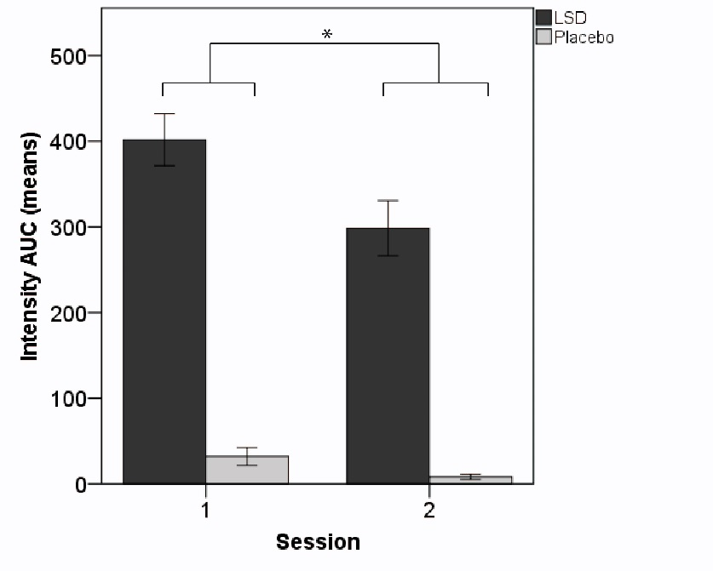
Figure S1. Period effect for Intensity Area under the Curve (AUC). There were higher overall ratings in the first than in the second session independent of treatment, probably pointing to increased expectations and insecurity regarding the forthcoming drug effects.

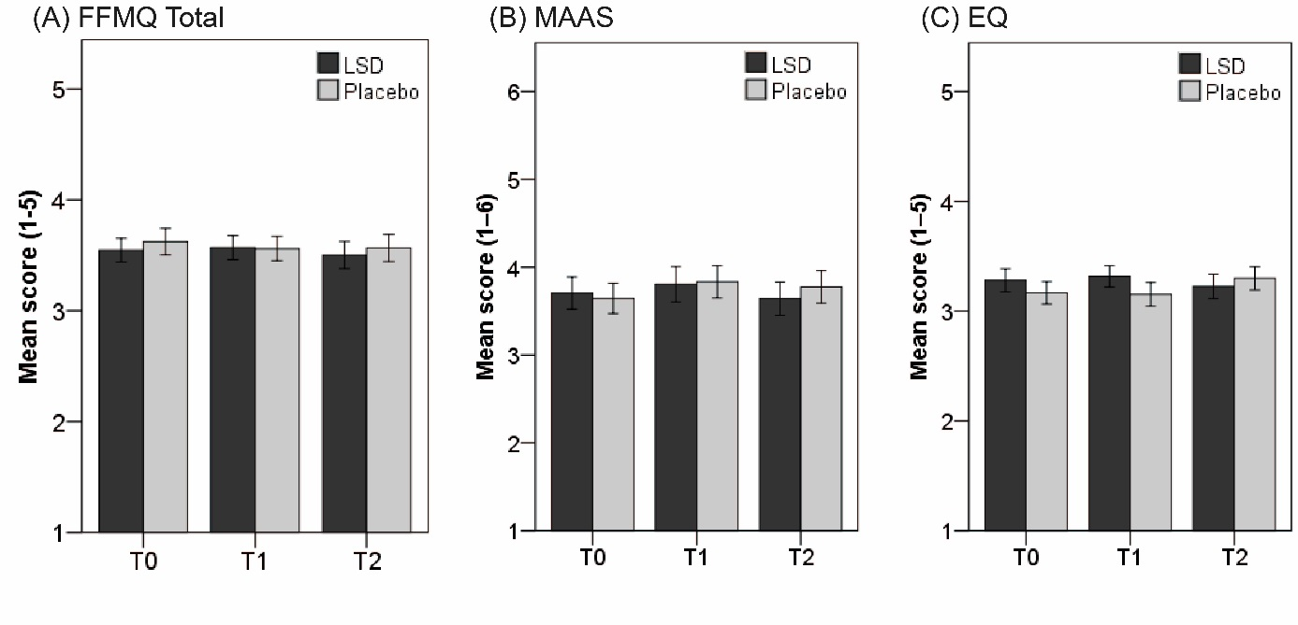
Figure S2. Mindfulness ratings for LSD and placebo before treatment (T0), 24 hours after treatment (T1), and two weeks after treatment (T2). (A) Five Facet Mindfulness Questionnaire (FFMQ) (only total score displayed), (B) Mindful Attention Awareness Scale (MAAS), and (C) Experiences Questionnaire. Mean scores (±SEM) are displayed for 24 subjects. No main effects or differences in pairwise comparisons were observed (all p>0.05, Bonferroni-corrected post hoc pairwise comparisons).

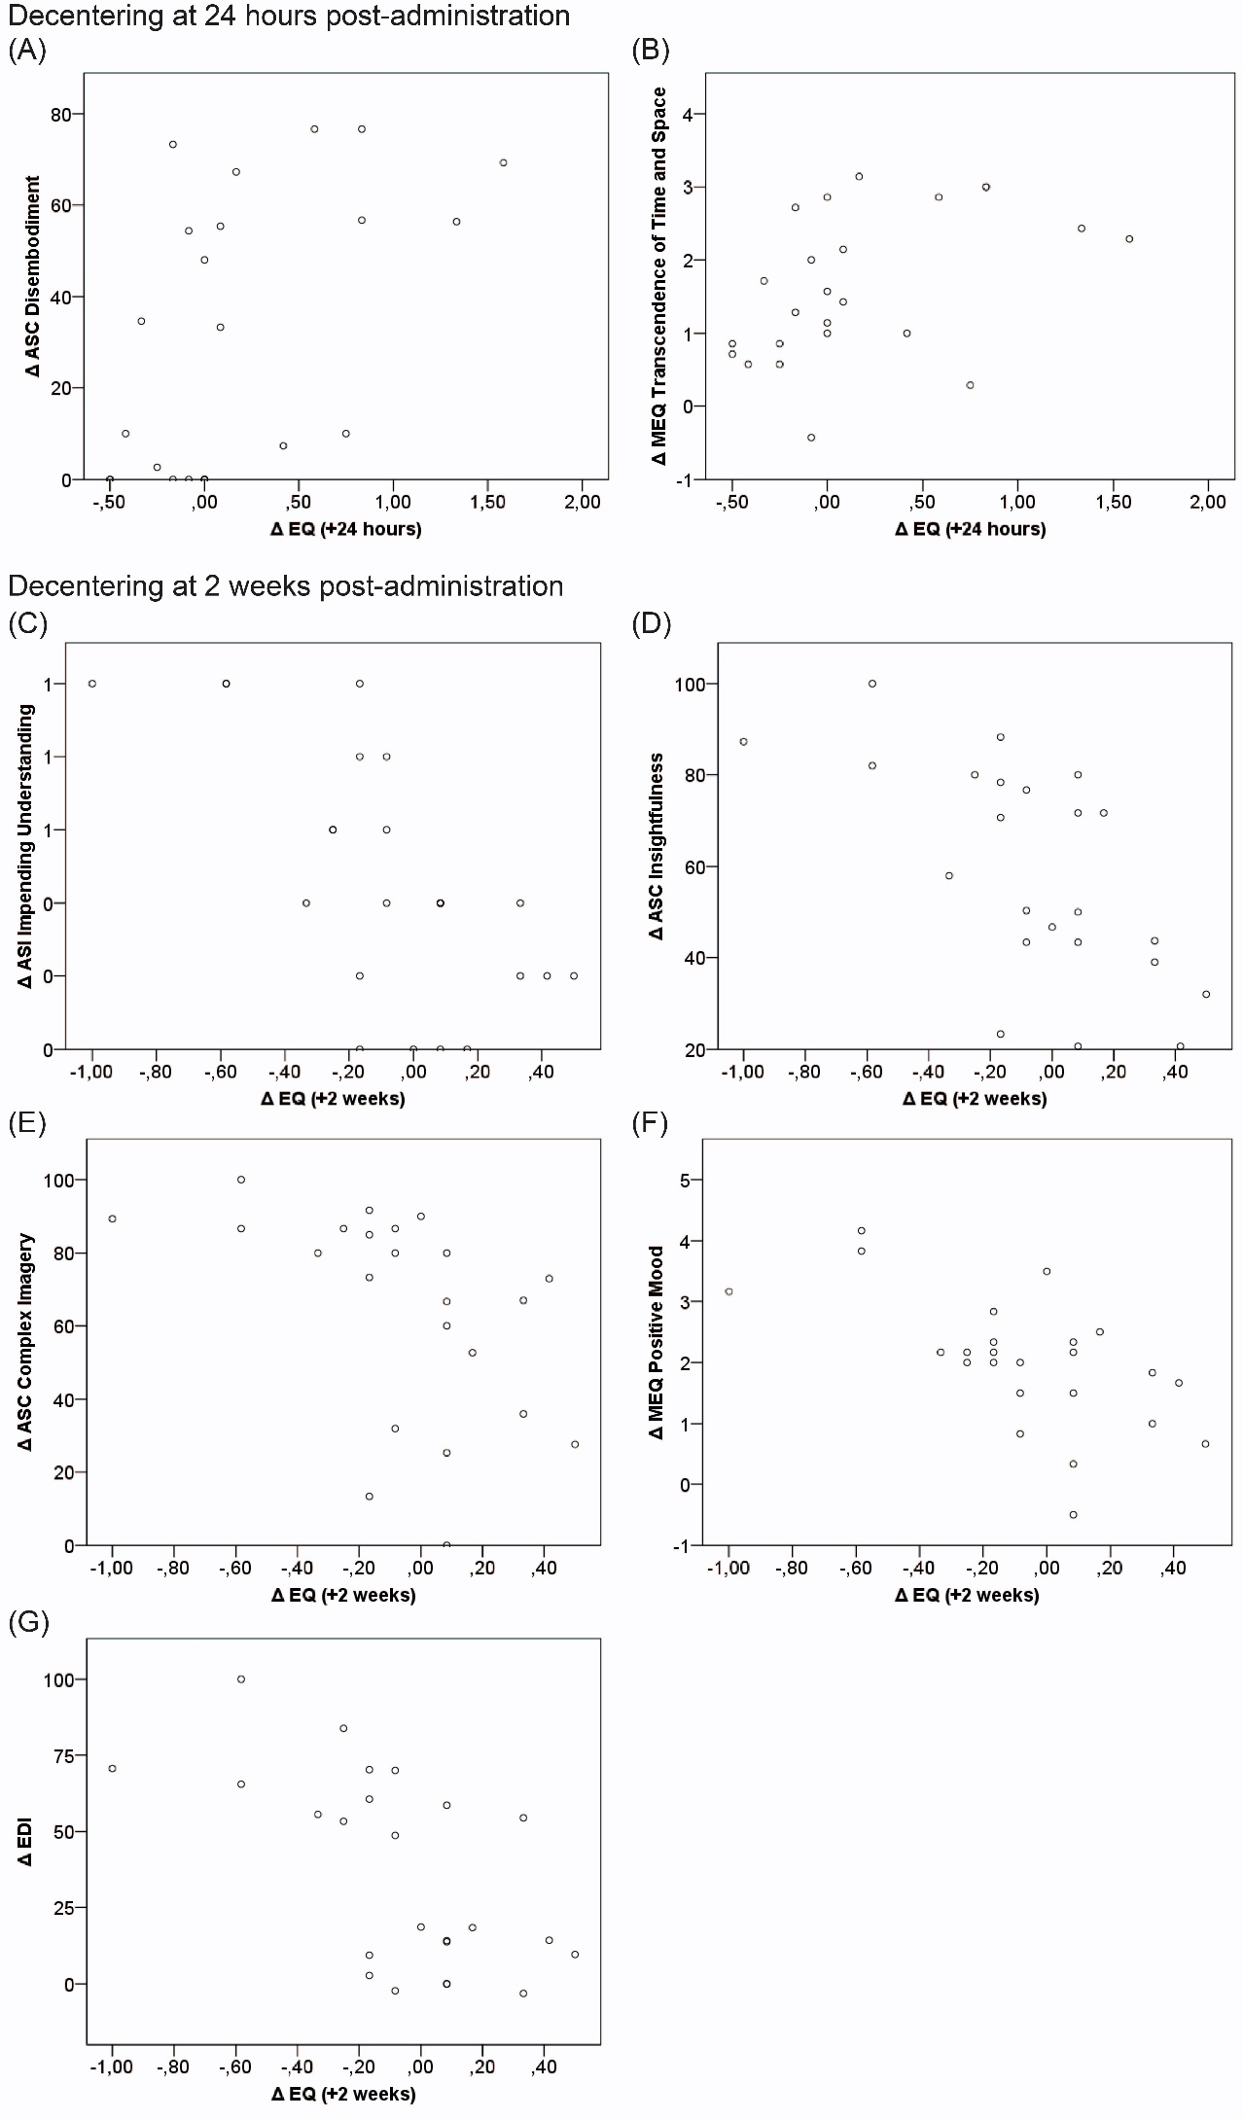
Figure S3. Scatterplots depicting the relationship between LSD-induced psychedelic experiences (ΔASC, ΔMEQ, ΔEDI), aberrant salience (ΔASI), and individual changes in mindfulness scale Decentering (ΔEQ) at 24 hours and 2 weeks after drug administration. Decentering at +24 hours (x-axis) was moderately positively correlated with (A) Disembodiment (ΔASC, y-axis; $r_{s}$=0.60, n=23, p=0.030) and (B) Transcendence of Time and Space (ΔMEQ, y-axis; $r_{s}$=0.56, n=24, p=0.048). In contrast, Decentering at +2 weeks (x-axis) was moderately negatively correlated with (C) Impending Understanding (ΔASI, y-axis; $r_{s}$=-0.65, n=24, p=0.006), (D) Insightfulness (ΔASC, y-axis; $r_{s}$=-0.65, n=23, p=0.008); (E) Complex Imagery (ΔASC, y-axis; $r_{s}$=-0.62, n=23, p=0.019); (F) Positive Mood (ΔMEQ, y-axis; $r_{s}$=-0.61, n=24, p=0.016); and (G) ego-dissolution (ΔEDI, $r_{s}$=-0.62, n=24, p=0.014; all p-values Bonferroni-corrected post hoc for multiple comparisons).
ASC, Altered States of Consciousness Questionnaire. MEQ, Mystical Experiences Questionnaire. EDI, Ego-Dissolution Inventory. ASI, Aberrant Salience Inventory. EQ, Experiences Questionnaire.

Supplemental References

Baer, R. A., Smith, G. T., Hopkins, J., Krietemeyer, J., & Toney, L. (2006). Using self-report assessment methods to explore facets of mindfulness. Assessment, 13(1), 27–45. https://doi.org/10.1177/1073191105283504
Barrett, F. S., Bradstreet, M. P., Leoutsakos, J. M. S., Johnson, M. W., & Griffiths, R. R. (2016). The Challenging Experience Questionnaire: Characterization of challenging experiences with psilocybin mushrooms. Journal of Psychopharmacology, 30(12), 1279–1295. https://doi.org/10.1177/0269881116678781
Bienemann, B., Longo, M., Multedo, M., Ruschel, N. S., Negreiros, M. A., Tófoli, L. F., … Mograbi, D. C. (2020). Adaptation and validation of the Ego-Dissolution Inventory in a Brazilian context. Unpublished Raw Data.
Brown, K. W., & Ryan, R. M. (2003). The Benefits of Being Present: Mindfulness and Its Role in Psychological Well-Being. Journal of Personality and Social Psychology, 84(4), 822–848. https://doi.org/10.1037/0022-3514.84.4.822
De Barros, V. V., Kozasa, E. H., De Souza, I. C. W., & Ronzani, T. M. (2014). Validity Evidence of the Brazilian Version of the Five Facet Mindfulness Evidências de Validade da Versão Brasileira do Questionário das Cinco Facetas de Mindfulness ( FFMQ-BR ). Psicologia: Teoria e Pesquisa, 30(3), 317–327. https://doi.org/10.1590/S0102-37722014000300009
De Barros, V. V., Kozasa, E. H., De Souza, I. C. W., & Ronzani, T. M. (2015). Validity evidence of the Brazilian version of the mindful attention awareness scale (MAAS). Psicologia: Reflexao e Critica, 28(1), 87–95. https://doi.org/10.1590/1678-7153.201528110
Dittrich, A. (1998). The standardized psychometric assessment of altered states of consciousness (ASCs) in humans. Pharmacopsychiatry, 31(SUPPL. 2), 80–84. https://doi.org/10.1055/s-2007-979351
Dittrich, A., Lamparter, D., & Maurer, M. (2006). 5D-ABZ: Fragebogen zur Erfassung Aussergewöhnlicher Bewusstseinszustände. Eine kurze Einführung [5D-ASC: Questionnaire for the assessment of altered states of consciousness. A short introduction]. PSIN PLUS.
Douglas, S. P., & Craig, C. S. (2007). Collaborative and iterative translation: An alternative approach to back translation. Journal of International Marketing, 15(1), 30–43. https://doi.org/10.1509/jimk.15.1.030
Fresco, D. M., Moore, M. T., van Dulmen, M. H. M., Segal, Z. V., Ma, S. H., Teasdale, J. D., & Williams, J. M. G. (2007). Initial Psychometric Properties of the Experiences Questionnaire: Validation of a Self-Report Measure of Decentering. Behavior Therapy, 38(3), 234–246. https://doi.org/10.1016/j.beth.2006.08.003
Guillemin, F. (1995). Cross-cultural adaptation and validation of heatth status measures. Scandinavian Journal of Rheumatology, 24(2), 61–63. https://doi.org/10.3109/03009749509099285
MacLean, K. A., Leoutsakos, J. M. S., Johnson, M. W., & Griffiths, R. R. (2012). Factor Analysis of the Mystical Experience Questionnaire: A Study of Experiences Occasioned by the Hallucinogen Psilocybin. Journal for the Scientific Study of Religion, 51(4), 721–737. https://doi.org/10.1111/j.1468-5906.2012.01685.x
Nour, M. M., Evans, L., Nutt, D., & Carhart-Harris, R. L. (2016). Ego-dissolution and psychedelics: Validation of the ego-dissolution inventory (EDI). Frontiers in Human Neuroscience, 10(June), 1–13. https://doi.org/10.3389/fnhum.2016.00269
Pahnke, W. N., & Richards, W. A. (1966). Implications of LSD and experimental mysticism. J Religion Health, 5, 175–208. https://doi.org/10.1080/02791072.1970.10471366
Schenberg, E. E. et al. (n.d.). Translation, cultural adaptation and validation of the Challenging Experience Questionnaire (CEQ) to Brazilian Portuguese. Psychology & Neuroscience, Submitted.
Schenberg, E. E., Tófoli, L. F., Rezinovsky, D., & Da Silveira, D. X. (2017). Translation and cultural adaptation of the states of consciousness questionnaire (SOCQ) and statistical validation of the mystical experience questionnaire (MEQ30) in brazilian portuguese. Revista de Psiquiatria Clinica, 44(1), 1–5. https://doi.org/10.1590/0101-60830000000105
Studerus, E., Gamma, A., & Vollenweider, F. X. (2010). Psychometric evaluation of the altered states of consciousness rating scale (OAV). PLoS ONE, 5(8). https://doi.org/10.1371/journal.pone.0012412
Wilson, S. C., & Barber, T. X. (1978). The Creative Imagination Scale as a Measure of Hypnotic Responsiveness: Applications to Experimental and Clinical Hypnosis. American Journal of Clinical Hypnosis, 20(4), 235–249. https://doi.org/10.1080/00029157.1978.10403940

