Online supplementary file

Changes in the adult consequences of adolescent mental ill-health: findings from the 1958 and 1970 British birth cohorts
Ellen J. Thompson, PhD ¹, Marcus Richards, PhD² George B. Ploubidis, PhD ¹ Peter Fonagy, PhD³ and Praveetha Patalay, PhD^{1,2}

Contents
Supplementary Table 1. Measurement invariance in the Rutter questionnaire at age 16 years between the cohorts
Supplementary Table 2. Multi-group item-factor loadings (two factor model) in each cohort
Supplementary Table 3. Multi-group item-factor loadings (bi-factor model) in each cohort
Supplementary Table 4. Count and percentage of complete case and missing exposures and outcomes.
Supplementary Table 5. Bivariate correlations between adolescent mental health and age 42 health and social outcomes
Supplementary Figure 1. Predicted probabilities (from the two-factor model) for externalising (1) and internalising symptoms (2) at age 16 (x-axis) association with each outcome at age 42 in the two cohorts
Supplementary Figure 2. Predicted probabilities (from the bi-factor model) for externalising (3) and internalising (4) symptoms at age 16 (x-axis) association with each outcome at age 42 in the two cohorts.
Supplementary Figure 3. Predicted probabilities (from the bi-factor model) in males and females for general psychopathology at age 16 (x-axis) association with high psychological distress
Supplementary Figure 4. Predicted probabilities (from the two-factor model) in males and females for externalising symptoms at age 16 (x-axis) association with professional employment.
Supplementary Figure 5. Frequency histogram of age 16 externalising and internalising symptoms (from the two-factor model)
Supplementary Figure 6. Frequency histogram of age 16 externalising, internalising and general psychopathology symptoms (from the bi-factor model)
Supplementary Table 6. Independent samples t-test comparing NCDS 1958 and BCS 1970 cohorts on age 16 mental health.

Supplementary Table 1. Measurement invariance analysis for the Rutter scales at age 16 across cohorts
 | Configural invariance model | Metric invariance model | Scalar invariance model
RMSEA | .069 | .067 | .065
SRMR | .083 | .084 | .084
CFI | .865 | .862 | .864

Note. For the RMSEA and SRMR, a score closest to zero indicates good model fit, whereas for CFI it is closest to one. Rules of thumb for model comparison applied are from Chen (2007) as follows: for RMSEA invariance is met if a change between models is smaller than 0.015, for SRMR if it is smaller than 0.03 and for CFI if it is smaller than 0.01 (Chen, 2007).

Supplementary Table 2. Standardised factor loadings (two factor model) for 1958 NCDS and 1970 BCS cohort (multigroup model)
 | 1958 NCDS |  | 1970 BCS
Items | Factor Loadings  (SE) |  | Factor Loadings  (SE)
 | EXT | INT | EXT | INT
restless, difficulty staying seated | 0.73  (.01) | - | 0.63  (.01) | -
squirmy, fidgety child | 0.78  (.01) | - | 0.65  (.01) | -
often destroys others property | 0.71  (.02) | - | 0.73  (.02) | -
frequently fights, quarrelsome | 0.68  (.01) | - | 0.74  (.01) | -
not much liked by other children | 0.56  (.02) | - | 0.63  (.02) | -
irritable, flies off the handle | 0.65  (.01) | - | 0.73  (.01) | -
twitches, mannerisms, tics-face or body | 0.41  (.02) | - | 0.45  (.03) | -
is often disobedient | 0.70  (.01) |  | 0.81  (.001)
cannot settle more than a few moments | 0.69  (.01) |  | 0.71  (.01)
often tells lies | 0.69  (.01) | - | 0.76  (.01) | -
bullies other children | 0.65  (.01) | - | 0.76  (.01) | -
often worries about things | - | 0.62  (.01) | - | 0.69  (.01)
does things on own, rather solitary | - | 0.32  (.01) | - | 0.50  (.01)
appears miserable, unhappy & tearful |  | 0.86  (.01) |  | 0.86  (.01)
fearful of new situations or things | - | 0.54  (.01) | - | 0.59  (.01)
fussy, over particular | - | 0.35  (.01) | - | 0.47  (.01)
Note. Model fit was assessed using the comparative fit index (CFI), Tucker Lewis index (TLI) and root mean square error of approximation (RMSEA). CFI and TLI closer to 1 indicate good fit to the data and RMSEA closer to 0 indicates good fit. Owing to the non-nested nature of the models, models could not be compared directly using a difference in fit statistic (e.g. Akaike information criterion) as they cannot be estimated when WLSMV estimation is used. Hence, model fit criteria and factor loadings were used to assess the quality of models. Externalising factor (EXT); Internalising factor (INT). Model fit indices for the two-factor CFA: 1958 NCDS (n = 11654): RMSEA = 0.07; CFI = 0.86; TLI =0.84; 1970 BCS (n = 8904): RMSEA = 0.06; CFI = 0.91; TLI =0.89

Supplementary Table 3. Standardised factor loadings (two factor model) for 1958 NCDS and 1970 BCS cohort (multigroup model)
 | 1958 NCDS (1958) |  |  | 1970 BCS (1970)
Items | Factor Loadings  (SE) |  |  | Factor Loadings  (SE)
 | EXT | INT | GEN | EXT | INT | GEN
restless, difficulty staying seated | 0.67  (.02) | - | 0.61  (.02) | 0.71  (.02) | - | 0.53  (.02)
squirmy, fidgety child | 0.62  (.02) | - | 0.63  (.02) | 0.64  (.02) | - | 0.60  (.02)
often destroys others property | 0.04  (.03) | - | 0.73  (.02) | 0.03  (.02) | - | 0.74  (.01)
frequently fights, quarrelsome | 0.28  (.03) | - | 0.71  (.01) | 0.23  (.02) | - | 0.67  (.011)
not much liked by other children | 0.08  (.03) | - | 0.57  (.02) | 0.09  (.02) | - | 0.60  (.01)
irritable, flies off the handle | 0.09  (.02) | - | 0.69  (.01) | 0.05  (.02) | - | 0.67  (.01)
twitches, mannerisms, tics-face, or body | 0.18  (.03) | - | 0.39  (.02) | 0.22  (.03) | - | 0.40  (.02)
is often disobedient | 0.17  (.03) |  | 0.73  (.01) | 0.15  (.02) |  | 0.75  (.01)
cannot settle more than a few moments | 0.33  (.03) |  | 0.65  (.02) | 0.33  (.02) |  | 0.67  (.01)
often tells lies | 0.16  (.03) | - | 0.71  (.01) | 0.14  (.02) | - | 0.71  (.01)
bullies other children | 0.32  (.03) | - | 0.67  (.02) | 0.30  (.02) | - | 0.68  (.01)
often worries about things | - | 0.71  (.02) | 0.30  (.01) | - | 0.74  (.02) | 0.32  (.01)
does things on own, rather solitary | - | 0.32  (.01) | 0.16  (.01) | - | 0.27  (.01) | 0.27  (.01)
appears miserable, unhappy & tearful |  | 0.39  (.02) | 0.57  (.02) |  | 0.34  (.01) | 0.58  (.01)
fearful of new situations or things | - | 0.60  (.02) | 0.23  (.01) | - | 0.56  (.02) | 0.30  (.01)
fussy, over particular | - | 0.32  (.01) | 0.19  (.01) | - | 0.27  (.01) | 0.23  (.01)
Note. The model fit indices for the bi-factor CFA: 1958 NCDS (n = 11654): RMSEA = 0.04; CFI = 0.96; TLI =0.94 (just under the accepted threshold for very good model fit (0.95); 1970 BCS (n = 8904): RMSEA = 0.04 CFI = 0.94; TLI =0.94

Supplementary Table 4. Count and percentage of available data for the exposures and outcomes in each cohort

 |  |  | Cohort
 |  |  | 1958 NCDS |  |  |  |  | 1970 BCS70
 | Domain | Measure | Age | year | N valid (%) | N missing (%) | N of total valid sample*  (%) | age | year | N valid (%) | N missing (%) | N of total valid sample  (%)
Exposure at age 16 | Adolescent internalising symptoms | Rutter Behavioural Scale | 16 | 1974 | 11080 (61.4) | 5011  (38.6) | 16091 (100) | 16 | 1986 | 7882  (51.6) | 7376 (48.4) | 15258 (100)
 | Adolescent internalising symptoms | Rutter Behavioural Scale | 16 | 1974 | 11080  (61.4) | 5011  (38.6) | 16091 (100) | 16 | 1986 | 7885  (51.7) | 7373 (48.3) | 15258 (100)
Outcomes at age 42 | Health and well-being | Malaise Inventory | 42 | 2000 | 11277 (60.8) | 4814  (39.2) | 16091 (100) | 42 | 2012 | 7979 (52.3) | 7279 (47.7) | 15258 (100)
 |  | General Health | 42 | 2000 | 11374  (70.7) | 4717  (29.3) | 16091 (100) | 42 | 2012 | 9069  (56.6) | 7527  (43.4) | 15258 (100)
 |  | Life Satisfaction | 42 | 2000 | 11268  (70) | 4823  (30) | 16091 (100) | 42 | 2012 | 8973  (58.8) | 6285  (41.2) | 15258 (100)
 | Socio-economic | Whether CM lives with a spouse or partner | 42 | 2000 | 11380 (70.7) | 4711  (29.3) | 16091 (100) | 42 | 2012 | 9106  (59.7) | 6152 (40.3) | 15258 (100)
 |  | Voting behaviour | 42 | 2000 | 11350  (70.5) | 4741  (29.5) | 16091 (100) | 42 | 2012 | 7890  (51.7) | 7368  (48.3) | 15258 (100)
 |  | Highest NVQ level up to 2000/2012 | 42 | 2000 | 11397  (70.8) | 4694  (29.2) | 16091 (100) | 42 | 2012 | 9106  (59.7) | 6152 (40.3) | 15258 (100)
 |  | Employment Status | 42 | 2000 | 8285 (51.49) | 7806 (48.51) | 16091 (100) | 42 | 2012 | 7854 (51.5) | 7404 (48.5) | 15258 (100)

Supplementary Table 5. Bivariate correlations between adolescent mental health and age 42 health and social outcomes.

Cohort | Age 16 mental health exposure variables |  |  | Age 42 health and social outcomes  correlations
 |  |  |  | Mental Health | Mental Health  (Binary variable) | General Health | Life Satisfaction | Co-habitation | Voted in the last general election | Obtained a degree | Employment type
1958 | Mental Health (2-factor model) | Externalising Symptoms |  | .15 | .13 | .14 | -0.10 | -.07 | -.08 | -.14 | -.12
 |  | Internalising Symptoms |  | .19 | .14 | .12 | -0.11 | -.07 | -.04 | -.06 | -.06
 | Mental Health (Bi-factor model) | Externalising Symptoms |  | -.03 | .02 | .01 | .01 | -.01 | .005 | -.01 | -.01
 |  | Internalising Symptoms |  | .15 | .09 | .02 | -.05 | -.03 | .01 | .02 | .02
 |  | General psychopathology |  | .16 | .12 | .14 | -.11 | -.07 | -.08 | -.13 | -.11
1970 | Mental Health (2-factor model) | Externalising Symptoms |  | .17 | .14 | .18 | -.13 | -.11 | -.11 | -.16 | -.13
 |  | Internalising Symptoms |  | .22 | .17 | .16 | -.13 | -.10 | -.06 | -.09 | -.07
 | Mental Health (Bi-factor model) | Externalising Symptoms |  | -.02 | -.01 | -.03 | .01 | .01 | -.04 | .01 | .04
 |  | Internalising Symptoms |  | .16 | .10 | .05 | -.04 | -.02 | .05 | .04 | .02
 |  | General psychopathology |  | .18 | .15 | .19 | -.14 | -.11 | -.02 | -.16 | -.13

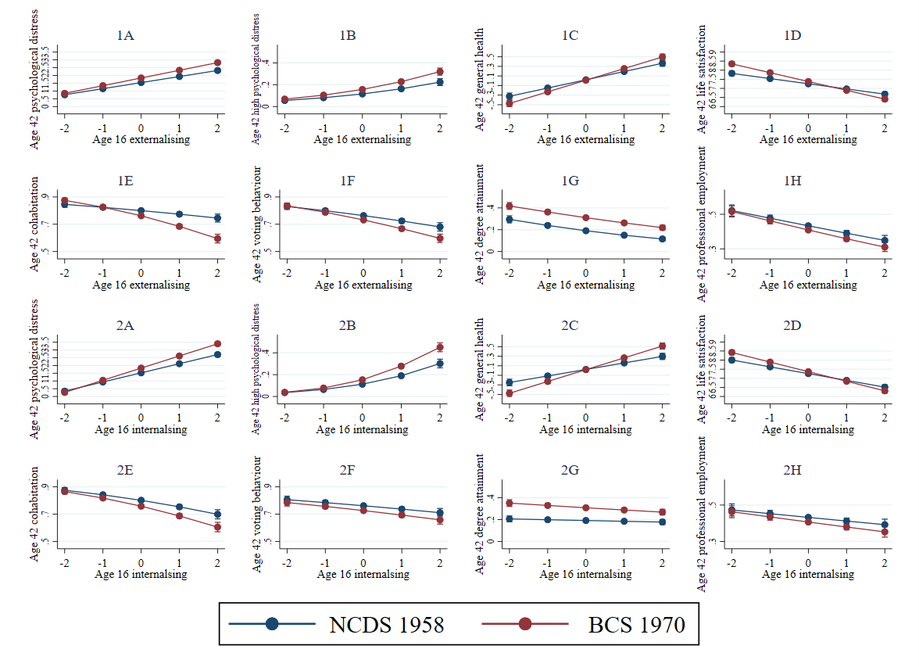

Supplementary Figure 1. Predicted probabilities or means (from the two-factor model) for externalising (1) and internalising (2) symptoms at age 16 (x-axis) association with each outcome at age 42 in the two cohorts.

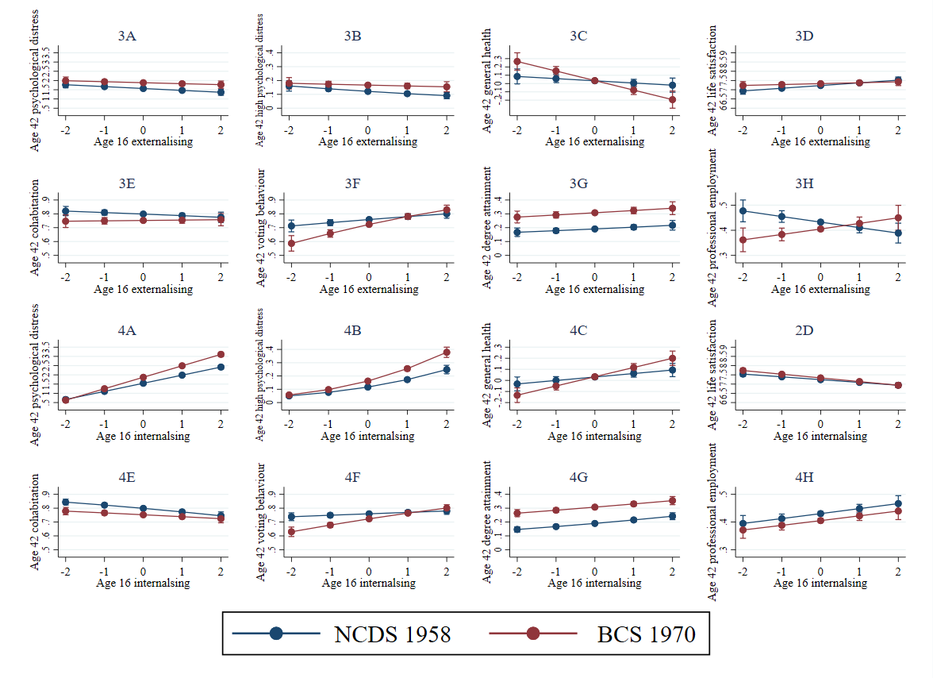

Supplementary Figure 2. Predicted probabilities or means (from the bi-factor model) for externalising (3) and internalising (4) symptoms at age 16 (x-axis) association with each outcome at age 42 in the two cohorts.

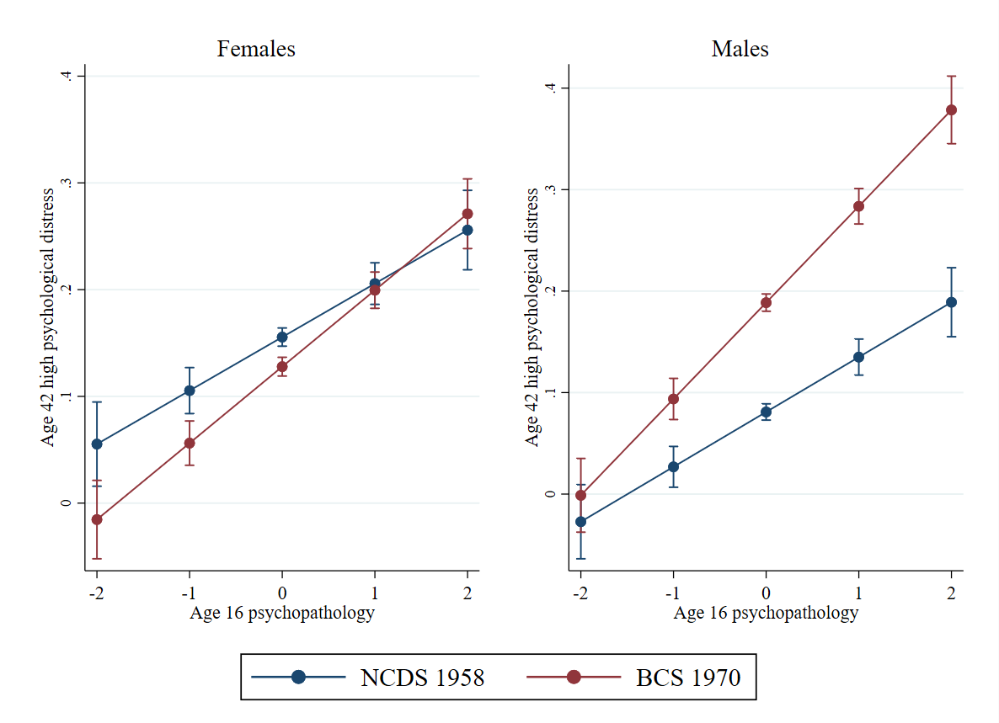

Supplementary Figure 3. Predicted probabilities (from the bi-factor model) in males and females for general psychopathology at age 16 (x-axis) association with high psychological distress

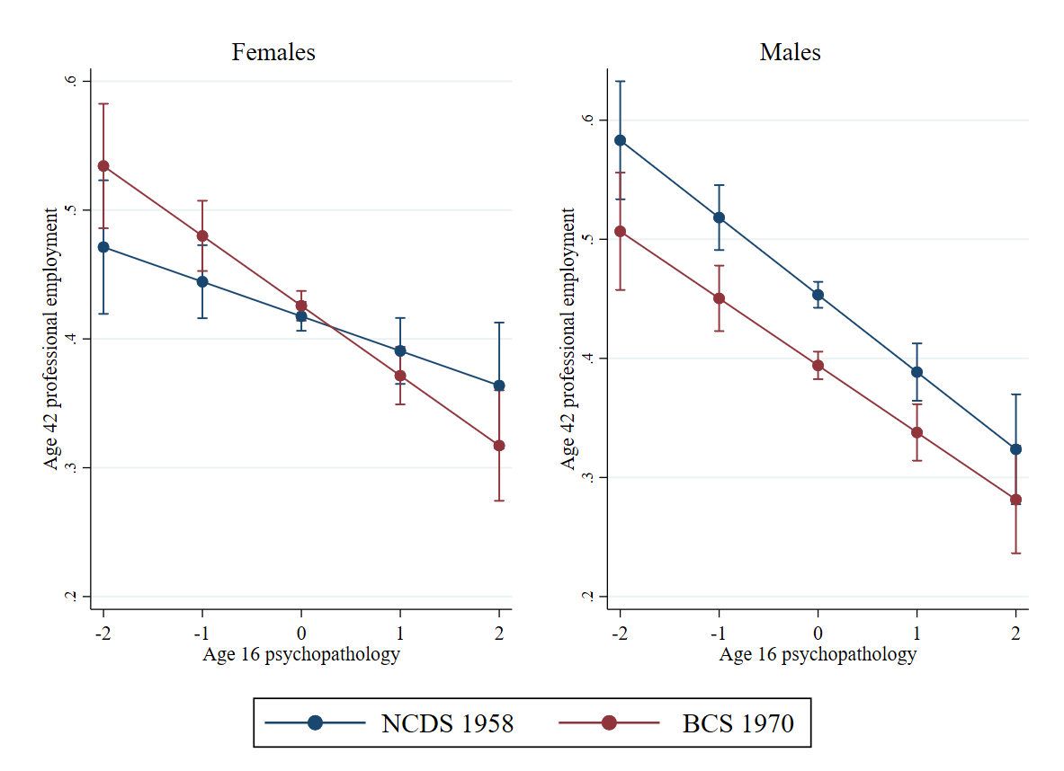

Supplementary Figure 4. Predicted probabilities (from the two-factor model) in males and females for externalising symptoms at age 16 (x-axis) association with professional employment.

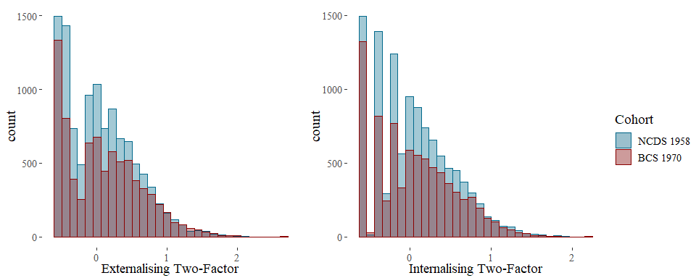

Supplementary Figure 5. Frequency histogram of age 16 externalising and internalising symptoms (from the two-factor model)

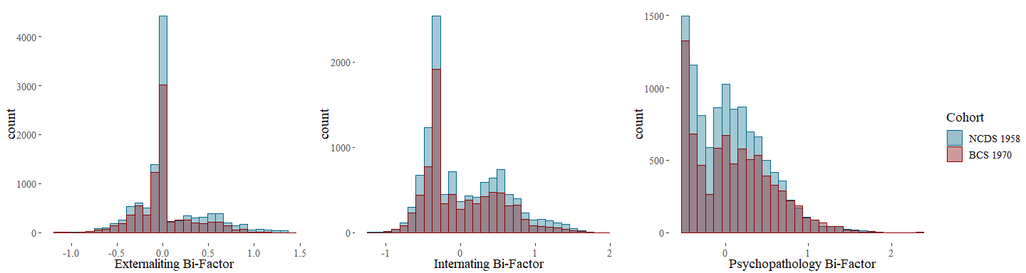

Supplementary Figure 6. Frequency histogram of age 16 externalising, internalising and general psychopathology symptoms (from the bi-factor model)

Supplementary Table 6. Independent samples t-test comparing NCDS 1958 and BCS 1970 cohorts on age 16 mental health.
 | Age 16 mental health exposure variables | NCDS 1958 Mean (SD) | BCS 1970 Mean (SD) | t (df) | p value
Mental Health (2-factor model) | Externalising Symptoms | .04 (.04) | .09 (.53) | -5.65 (16113) | <.001
 | Internalising Symptoms | .05 (.47) | .06 (.5) | -1.18 (16366) | 0.239
Mental Health (Bi-factor model) | Externalising Symptoms | .06 (.35) | .01 (.3) | 9.08 (18236) | <.001
 | Internalising Symptoms | .04 (.52) | .02 (.49) | 2.98 (17312) | <.001
 | General psychopathology | .06 (.43) | .1 (.47) | -5.76 (16000) | <.001

References
Chen, F.F. (2007) Sensitivity of goodness of fit indexes to lack of measurement invariance. Structural Equation Modeling. 14 (3), pp. 464–504. doi:10.1080/10705510701301834.

