Supplementary materials
Brain correlates of impaired goal-management in bipolar mania
M. Madre, P. Fuentes-Claramonte, P. Palau, N. Sáez, N. Moro, C. Blanch, N. Verdolini, M.A. Garcia-Leon, I. Feria, J. Munuera, S. Sarró, J. Raduà, R. Salvador, P.J. Mckenna, E. Pomarol-Clotet

Supplementary Methods
We ran an additional analysis with an alternative first-level design that aimed to control for the effect of playing the game and performing game switches throughout the task. For this, seven regressors were defined. The first four regressors defined the time spent playing each of the four games, thus capturing the variance associated to playing the games per se, without taking into account if this is done during the executive or control blocks. The fifth regressor coded the switching events that occurred during the automatic blocks, given that transitory changes in brain activity were expected when switching games. These events were given a 2-second duration. Similarly, the sixth regressor coded the same but for voluntary switching blocks. In this case, each switching event was given a 4-second duration (2 seconds prior + 2 seconds after the actual switching event), to capture the transitory changes in brain activity associated to the decision to switch and the switching costs. Finally, the last regressor defined the voluntary switching blocks. This captured the sustained changes in brain activity associated to playing the games during the voluntary switching blocks, while the effect of playing the games per se and the switching costs were controlled through the other regressors. The relevant comparison (voluntary > automatic) was achieved with a contrast on this last regressor. This analysis is however limited in that the contrast of interest includes fixation (baseline) periods within the control condition. The statistical threshold was p < 0.05, corrected at cluster level using Gaussian random field methods, with a cluster-defining threshold of z > 2.6 (p < 0.005).

Supplementary Results

Additional imaging analysis: within-group activation maps
During the executive condition (voluntary switching) compared to the rest of the task, healthy subjects showed activation in the dorsolateral and inferior frontal cortex, the ACC extending to the pre-supplementary motor area (pre-SMA) and SMA, the frontal pole, and the inferior parietal cortex, all bilateral but more predominantly in the right hemisphere. Left-lateralized activity was observed in the pre/post-central gyrus. Significant signal increase was also observed in the basal ganglia, thalamus and cerebellum (Supplementary Figure 4A and Supplementary Table S2). As shown in Supplementary Figure 4B, manic patients showed significant activity in the left precentral gyrus and superior parietal cortex, and in the right inferior frontal cortex, SMA, precentral gyrus, and supramarginal gyrus, but in a considerably reduced pattern of activation relative to the healthy controls.

Additional imaging analysis: between-group comparison
The manic patients showed significantly less activation than the controls in the frontal cortex, comprising the right DLPFC, extending into the dorsal ACC and the bilateral anterior frontal cortex (see Supplementary Figure 4C and Supplementary Table S2). No regions showed greater activation in the mania group relative to the control group.
When excluding the two healthy subjects that were behavioral outliers, the mean activation map in the control group remained mostly the same; however, in the group comparison three additional regions of difference emerged: the left precentral gyrus (MNI coordinates x = -38, y, -18, z = 60; Z = 4.19; cluster size = 398 voxels; p < 0.001), the right inferior frontal cortex (MNI coordinates x = 30, y, 28, z = -8; Z = 4.03; cluster size = 348 voxels; p < 0.001) and the right inferior parietal cortex (MNI coordinates x = 48, y, -50, z = 40; Z = 4.31; cluster size = 246 voxels; p = 0.01).

Association with behavioral performance
To further characterize this hypoactivation in terms of its association with executive impairment, we extracted the beta values (parameter estimates) from the two clusters of significant differences for each subject (the first including right DLPFC and ACC, and the second including the left anterior frontal cortex), and examined correlations between these and the deviation from optimal playing time as index of behavioral performance (given that variables were not normally distributed, we used Spearman’s rho). Activation in the right DLPFC/ACC cluster was significantly associated with behavioral performance in the whole sample (ρ = -0.68, p < 0.001), and separately in the control group (ρ = -0.38, p = 0.0407) and in the mania group (ρ = -0.57, p = 0.0073). Similarly, left anterior frontal activation was significantly associated with behavior in the whole sample (ρ = -0.54, p < 0.001), although not in the control group (ρ = -0.10, p = 0.5897) and only at a trend level in the mania group (ρ = -0.40, p = 0.0703). Negative correlations indicate that reduced activity is linked to worse performance.

Supplementary Tables

Supplementary Table S1. Results from the linear mixed model to test the effect of learning in deviation time.
Fixed effects:
 | Estimate | Std. Error | df* | t-value | p-value
Intercept | 24.430 | 3.830 | 103.572 | 6.378 | <0.0001
Block | -2.344 | 0.893 | 151.000 | -2.624 | 0.0095
Group | 23.056 | 5.969 | 103.572 | 3.863 | 0.0002
Block*Group | 0.983 | 1.392 | 151.000 | 0.706 | 0.4813
Random effects:
 | Variance | Std. Dev.
Subject | 260.5 | 16.14
Residual | 11937 | 10.94
*Degrees of freedom (df) were estimated using the Satterthwaite's method within the ‘lmerTest’ R package.

Supplementary Table S2. Regions of significant activation increase in the executive > rest of the task contrast.

 | MNI coordinates
Region | x | y | z | Z | Cluster size | p
Control group
ACC | 10 | 36 | 22 | 6.88 | 19781 | <0.001
SMA | 2 | 18 | 48 | 6.52
Superior frontal gyrus | 16 | 20 | 58 | 6.25
DLPFC | 40 | 28 | 38 | 5.79
Frontal pole | 30 | 52 | 18 | 6.04
 | -28 | 48 | 26 | 5.35
Inferior frontal cortex | 52 | 14 | -2 | 5.72
Pre/Post-central gyrus | -38 | -18 | 60 | 5.95 | 3523 | <0.001
Inferior parietal cortex | 48 | -48 | 40 | 6.00 | 2147 | <0.001
Cerebellum | 24 | -58 | -22 | 5.06 | 1340 | <0.001
Cerebellum | -38 | -60 | -40 | 4.55 | 648 | <0.001
Inferior parietal cortex | -56 | -58 | 42 | 4.18 | 260 | 0.007
Middle temporal cortex | 58 | -22 | -14 | 4.21 | 206 | 0.027
Midbrain | -2 | -18 | -20 | 4.46 | 200 | 0.031
Mania group
Precentral gyrus | -28 | -12 | 64 | 4.61 | 2356 | <0.001
SMA | 0 | -4 | 52 | 4.50
Superior parietal cortex | -34 | -44 | 64 | 4.24
Supramarginal gyrus | 54 | -42 | 46 | 4.16 | 462 | <0.001
Inferior frontal cortex | 58 | 10 | 22 | 4.94 | 283 | 0.004
Control > Mania
DLPFC | 44 | 24 | 42 | 5.06 | 2727 | <0.001
ACC | 10 | 36 | 22 | 4.08
Frontal pole | 14 | 60 | 28 | 4.41
Superior frontal gyrus | 16 | 56 | 30 | 4.20
Superior frontal gyrus | -20 | 52 | 20 | 4.04 | 260 | 0.007
ACC: Anterior cingulate cortex; DLPFC: Dorsolateral prefrontal cortex; SMA: Supplementary Motor Area

Supplementary Figures

Supplementary Figure 1. Learning across the CMET task. Bipolar patients within a manic episode showed greater deviation from optimal playing time in the four blocks, but in both groups there was a progressive improvement in task performance, reflected in a decrease in deviation time throughout the four blocks.

Supplementary Figure 2. Mean activation maps for each condition against fixation, by group. (A) Activation in automatic switching blocks in healthy controls. (B) Activation in voluntary switching blocks in healthy controls. (C) Activation in automatic switching blocks in bipolar patients. (D) Activation in voluntary switching blocks in bipolar patients. Images are displayed in neurological convention (right is right). Color bar depicts z values.

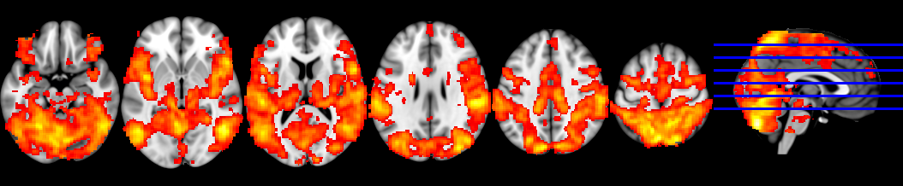
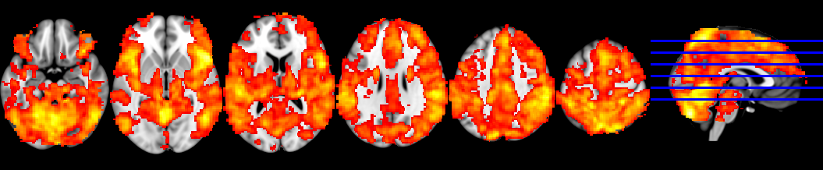
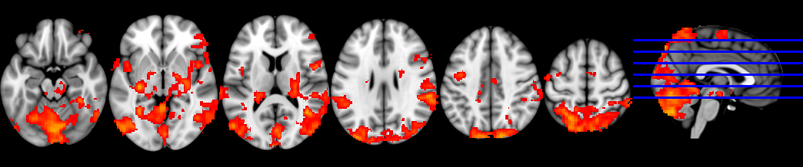
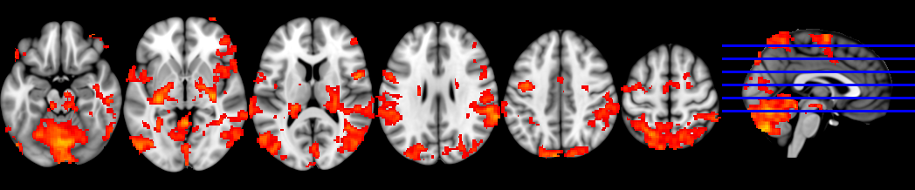
A
B
C
z = -18
z = -3
z = 12
z = 27
z = 42
z = 57
D

Supplementary Figure 3. Association between behavioral performance in the CMET and brain activity in the executive > control contrast in the regions of significant differences between groups. Group is identified by color.

DLPFC: Dorsolateral prefrontal cortex; ACC: Anterior cingulate cortex; IFC: Inferior frontal cortex; OFC: Orbitofrontal cortex; PCC: Posterior cingulate cortex.

Supplementary Figure 4. Brain activation maps for the executive condition compared to the rest of the task for the control group (A) and the mania group (B). (C) shows regions where the activation increase during the executive condition was significantly reduced in the mania group relative to the control group. Images are displayed in neurological convention (right is right). Color bars depict z values.
