Supplemental material

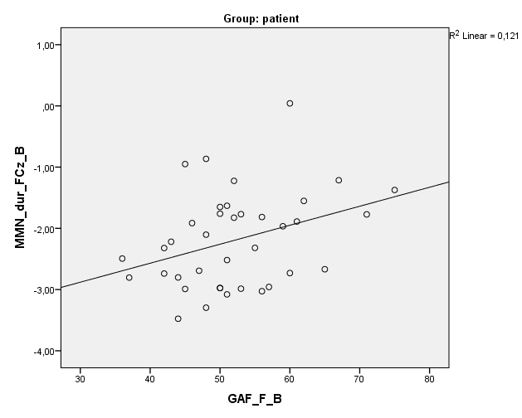 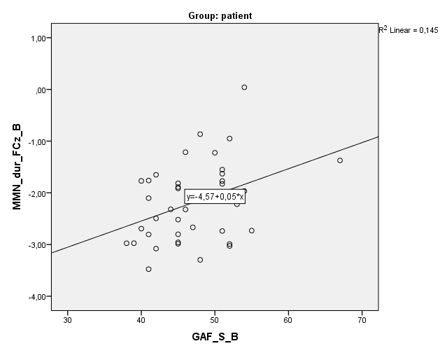

Figure S1. Correlation between GAF-F Figure S2. Correlation between GAF-S

and MMN (durFCz) amplitude at baseline and MMN (durFCz) amplitude at baseline

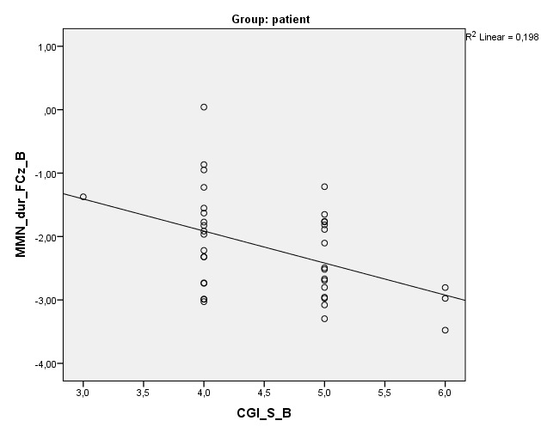 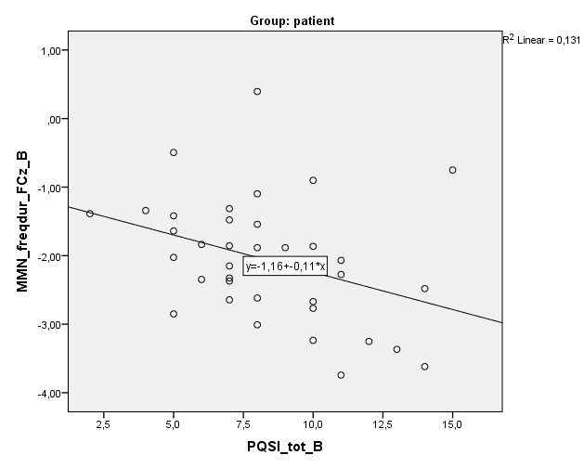

Figure S3. Correlation between GAF-F Figure S4. Correlation between PQSI-Total and

and MMN (durFCz) amplitude at baseline MMN (freqdurFCz) amplitude at baseline

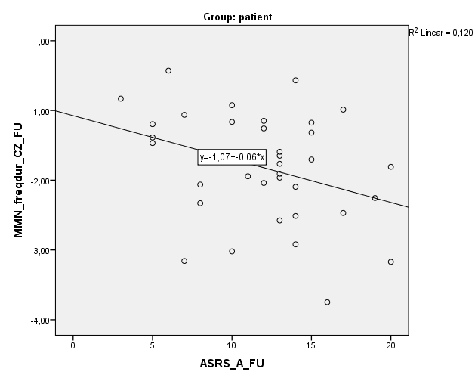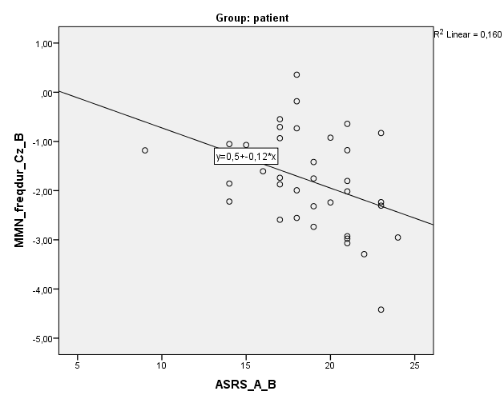

Figure S5. Correlation between ASRS-A Figure S6. Correlation between ASRS-A and

and MMN (freqdur Cz) amplitude at baseline MMN (freqDur Cz) amplitude af FU

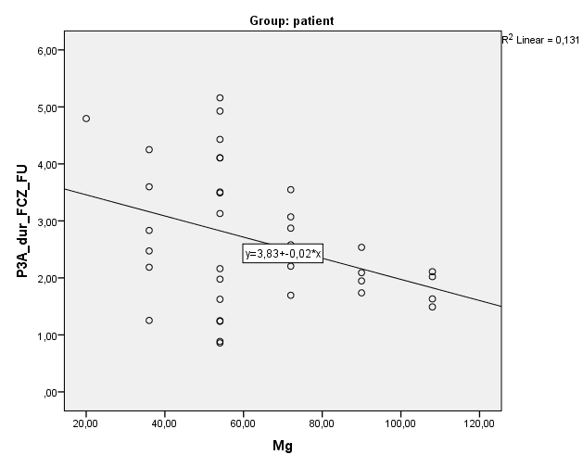 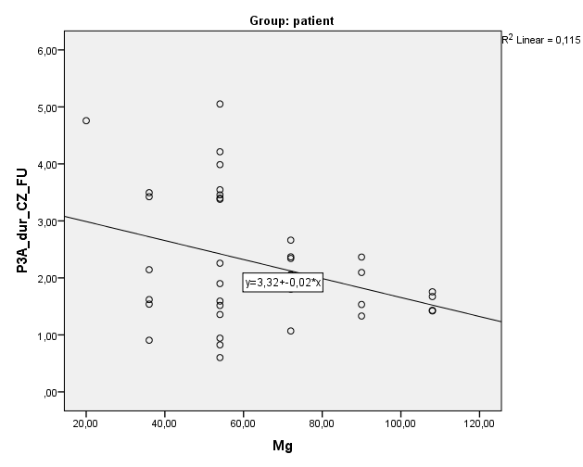

Figure S7. Correlation between MPH dosage  Figure S8. Correlation between MPH dosage and

and P3a (dur FCz) amplitude at FU P3a (dur Cz) amplitude at FU.

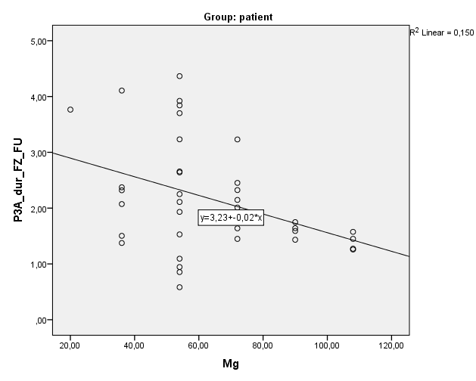

Figure S9. Correlation between MPH dosage and

and P3a (dur Fz) amplitude at FU