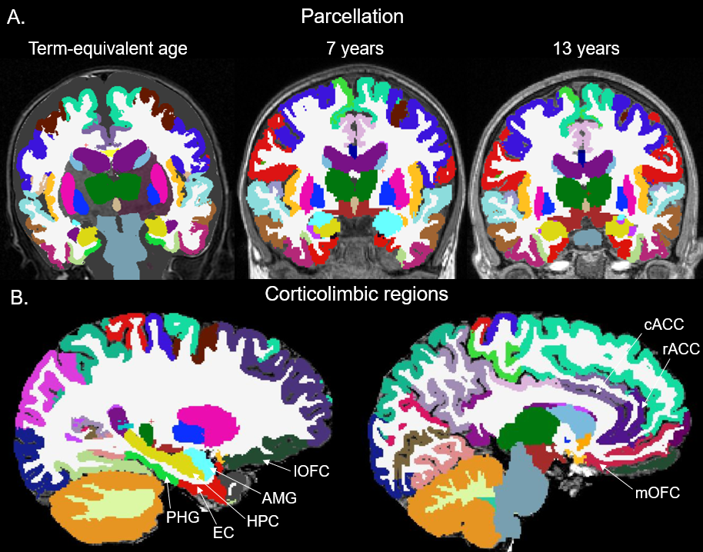
Supplementary Figure 1. Cortical and subcortical parcellations. (A) M-CRIB and FreeSurfer parcellations in a single subject across term-equivalent, 7 and 13 years of age. (B) Parcellations of corticolimbic regions in the same subject at 13 years. PHG, parahippocampal gyrus; EC, entorhinal cortex; HPC, hippocampus; AMG, amygdala; lOFC, lateral orbitofrontal cortex; mOFC, medial orbitofrontal cortex; rACC, rostral anterior cingulate gyrus; cACC. Caudal anterior cingulate gyrus.

Supplementary Figure 2. Trajectory of corticolimbic region volumes across the first 13 years in very preterm individuals with and without anxiety disorder after adjustment for total brain volume and social risk. False discovery rate (FDR) corrected p-values for group-by-age interaction term in the linear mixed effect model are presented in boxes in the bottom right corner for each region. No limbic regions displayed significant group-by-age interactions after adjustment for total brain volume and social risk and thus 0-7 and 7-13 year group-by-age interactions and cross-sectional group differences were not explored. Error bars represent 95% confidence intervals.

Supplementary Table 1. Model selection
Region | Covariance structure | Random | AIC | BIC
Intracranial volume | Unstructured | Intercept | 713.23 | 758.37
 | Unstructured | Intercept + Slope | - | -
 | Exchangeable | Intercept | 745.08 | 775.17
 | Exchangeable | Intercept + Slope | 742.47 | 776.33
Total brain volume | Unstructured | Intercept | 715.16 | 760.30
 | Unstructured | Intercept + Slope | - | -
 | Exchangeable | Intercept | 751.85 | 781.95
 | Exchangeable | Intercept + Slope | 746.97 | 780.82
Hippocampus (L) | Unstructured | Intercept | 694.59 | 738.88
 | Unstructured | Intercept + Slope | - | -
 | Exchangeable | Intercept | 713.14 | 742.67
 | Exchangeable | Intercept + Slope | 706.18 | 739.39
Hippocampus (R) | Unstructured | Intercept | 686.94 | 731.23
 | Unstructured | Intercept + Slope | - | -
 | Exchangeable | Intercept | 712.00 | 741.52
 | Exchangeable | Intercept + Slope | 707.46 | 740.67
Amygdala (L) | Unstructured | Intercept | 787.62 | 831.91
 | Unstructured | Intercept + Slope | - | -
 | Exchangeable | Intercept | 798.48 | 828.00
 | Exchangeable | Intercept + Slope | 793.72 | 826.93
Amygdala (R) | Unstructured | Intercept | 754.81 | 799.09
 | Unstructured | Intercept + Slope | - | -
 | Exchangeable | Intercept | 761.36 | 790.88
 | Exchangeable | Intercept + Slope | 761.56 | 794.77
Entorhinal cortex (L) | Unstructured | Intercept | 794.62 | 838.91
 | Unstructured | Intercept + Slope | - | -
 | Exchangeable | Intercept | 845.94 | 875.46
 | Exchangeable | Intercept + Slope | 834.53 | 867.74
Entorhinal cortex (R) | Unstructured | Intercept | 776.70 | 820.98
 | Unstructured | Intercept + Slope | - | -
 | Exchangeable | Intercept | 841.60 | 871.12
 | Exchangeable | Intercept + Slope | 831.96 | 865.18
Parahippocampal gyrus (L) | Unstructured | Intercept | 761.63 | 805.91
 | Unstructured | Intercept + Slope | - | -
 | Exchangeable | Intercept | 860.19 | 889.71
 | Exchangeable | Intercept + Slope | 841.45 | 874.66
Parahippocampal gyrus (R) | Unstructured | Intercept | 787.51 | 831.80
 | Unstructured | Intercept + Slope | - | -
 | Exchangeable | Intercept | 813.28 | 842.80
 | Exchangeable | Intercept + Slope | 811.28 | 844.49
Caudal anterior cingulate (L) | Unstructured | Intercept | 728.28 | 772.56
 | Unstructured | Intercept + Slope | - | -
 | Exchangeable | Intercept | 787.22 | 816.74
 | Exchangeable | Intercept + Slope | 773.75 | 806.97
Caudal anterior cingulate (R) | Unstructured | Intercept | 673.23 | 717.52
 | Unstructured | Intercept + Slope | - | -
 | Exchangeable | Intercept | 723.19 | 752.71
 | Exchangeable | Intercept + Slope | 717.54 | 750.75
Rostral anterior cingulate (L) | Unstructured | Intercept | 681.37 | 725.66
 | Unstructured | Intercept + Slope | - | -
 | Exchangeable | Intercept | 759.01 | 788.54
 | Exchangeable | Intercept + Slope | 751.04 | 784.26
Rostral anterior cingulate (R) | Unstructured | Intercept | 713.42 | 757.7
 | Unstructured | Intercept + Slope | - | -
 | Exchangeable | Intercept | 771.50 | 801.03
 | Exchangeable | Intercept + Slope | 762.58 | 795.79
Medial orbitofrontal cortex (L) | Unstructured | Intercept | 712.44 | 756.72
 | Unstructured | Intercept + Slope | - | -
 | Exchangeable | Intercept | 724.14 | 753.66
 | Exchangeable | Intercept + Slope | 720.41 | 753.62
Medial orbitofrontal cortex (R) | Unstructured | Intercept | 725.84 | 770.12
 | Unstructured | Intercept + Slope | - | -
 | Exchangeable | Intercept | 741.54 | 771.06
 | Exchangeable | Intercept + Slope | 739.83 | 773.04
Lateral orbitofrontal cortex (L) | Unstructured | Intercept | 699.89 | 744.17
 | Unstructured | Intercept + Slope | - | -
 | Exchangeable | Intercept | 744.17 | 784.78
 | Exchangeable | Intercept + Slope | 740.36 | 773.57
Lateral orbitofrontal cortex (R) | Unstructured | Intercept | 724.99 | 769.27
 | Unstructured | Intercept + Slope | - | -
 | Exchangeable | Intercept | 741.27 | 770.79
 | Exchangeable | Intercept + Slope | 733.39 | 766.60
Note: AIC = Akaike information criterion; BIC = Bayesian information criterion; (L) = left; (R) = right.
Smallest AIC and BIC values (bolded) indicate best model fit. In majority of regions, an unstructured correlation structure with a random intercept provided the best model.

Supplementary Table 2. Corticolimbic volume trajectories of very preterm children with and without anxiety diagnosis at 13 years.
 | Overall group-by-age interaction |  |  | TEA – 7 year  group-by-age interaction |  | 7 – 13 year  group-by-age interaction |  | TEA years |  |  | 7 years |  | 13 years
 | β | P | β |  | P | β | P | β | P |  | β | P | β | P
Intracranial Volume | - | <.001 | -0.461 |  | .020 | -0.224 | .19 | 0.237 |  | .67 | -.224 | .35
Total Brain Volume | - | .029 | -0.503 |  | .021 | -0.063 | .72 | .165 |  | .67 | -.338 | .21
Amygdala (L) | - | .46
Amygdala (R) | - | <.001 | -0.20 |  | .49 | -.421 | .19
Hippocampus (L) | - | .029 | -.518 |  | .020 | -.058 | .72 | .129 | .67 |  | -.389 | .17
Hippocampus (R) | - | .062 | -0.469 |  | .020 | -.055 | .72 | .004 | .99 |  | -.472 | .085
Parahippocampal gyrus (L) | - | .33
Parahippocampal gyrus (R) | - | .26
Entorhinal cortex (L) | - | .64
Entorhinal cortex (R) | - | .46
Medial orbitofrontal cortex (L) | - | .079 | -.761 |  | .020 | .263 | .19 | -.214 | .67 |  | -.547 | .085
Medial orbitofrontal cortex (R) | - | .13
Lateral orbitofrontal cortex (L) | - | .21
Lateral orbitofrontal cortex (R) | - | .21
Rostral anterior cingulate (L) | - | .46
Rostral anterior cingulate (R) | - | .81
Caudal anterior cingulate (L) | - | .64
Caudal anterior cingulate (R) | - | .36
Secondary analysis
Amygdala (R) | - | .20
Hippocampus (L) | - | .58
Hippocampus (R) | - | .64
Medial orbitofrontal cortex (L) | - | .58
Note: p-values presented are false discovery rate-corrected, p < .05 indicated in bold; trends are italicised. Secondary analysis additionally adjusted for total brain volume and high social risk.

