Supplementary Online Content

Supplementary Figure 1. Study outline.

Supplementary Table 1. Demographic comparisons of included and excluded participants.

Supplementary Methods: Survey questions and annotation.

Supplementary Table 2. Survey items.

Supplementary Table 3. Mental health longitudinal confirmatory factor analyses results.

Supplementary Methods: Results of random-intercept cross-lagged panel models.

Supplementary Figure 2. Illustrating the random-intercept cross lagged panel model.

Supplementary Table 4. The fit of models that held the lagged effects constant over the 15 days (constrained) over those that allowed them to vary freely (unconstrained).

Supplementary Table 5. Means and standard deviations for daily variables.

Supplementary Figure 3. Significant cross lagged effects following FDR correction for multiple testing both within and across domains of behavior, mental health and substance use.

Supplementary Table 6. Results considering physical contact within and outside the home.

Supplementary Table 7. Moderation by race/ethnicity and by income level.

Supplementary Table 8. Moderation by previous diagnoses of depression and anxiety.

Supplementary Table 9. Results for COVID-related worry, treated as two factors.

Supplementary Table 10. Results when adjusting the models for gender (coded as female vs other), age (in years), date of study entry (21st May vs 27th May) and state (states with increasing vs decreasing rates of confirmed infections).

Supplementary Methods: The complete daily survey.

Supplementary References
Supplement

Supplementary Figure 1. Study outline.
Panel A: Demographics details: state, age, household income and race/ethnicity
Panel B: Outline of random intercept cross-lag panel model. Cross-lagged and autoregressive within person paths are shown in the brown panel, with manifest and latent measures of variables N and W each day. Associations between more stable, individual differences are given by the correlation between random intercepts (RI as shown in the blue box).

1A

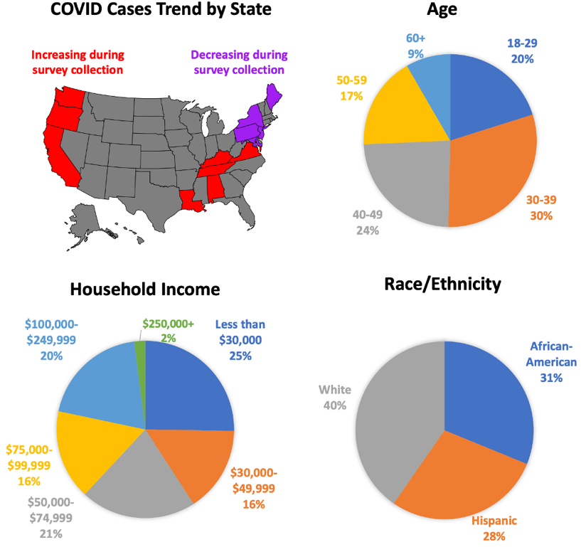

1B
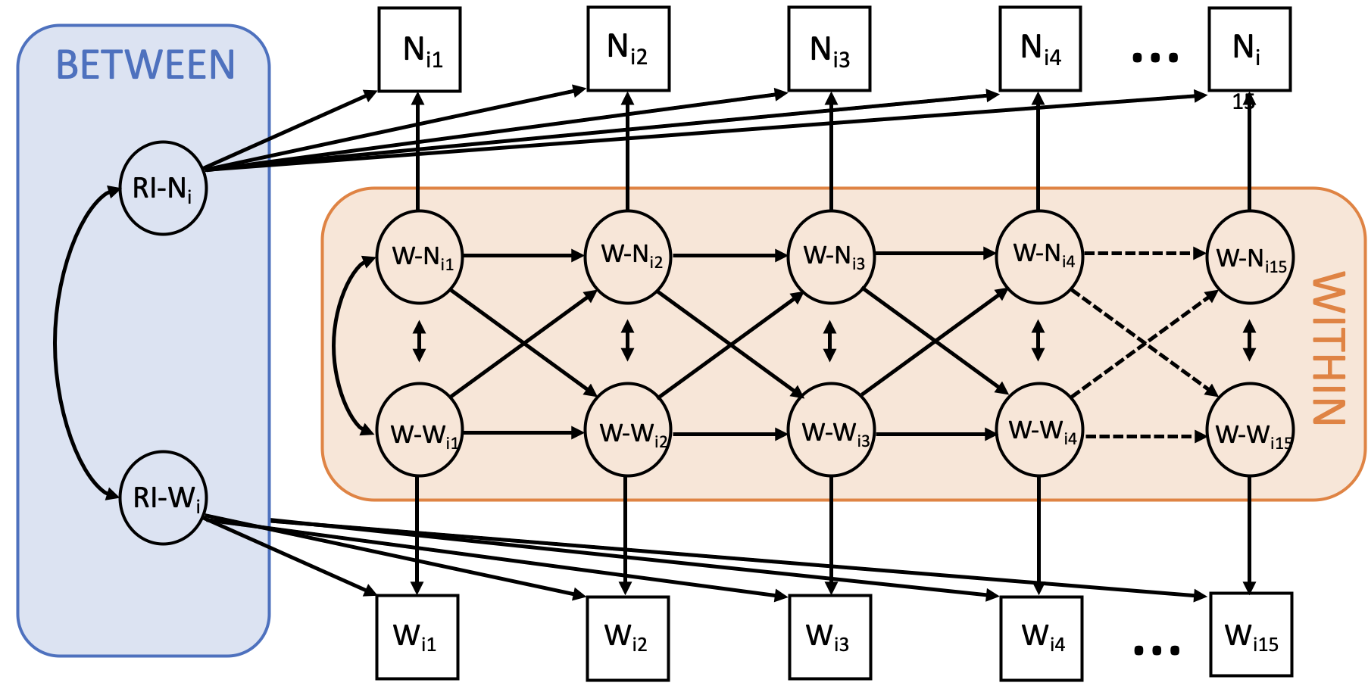

Supplementary Table 1. Demographic comparisons of included and excluded participants.

Demographic | Included (N=1148) | Excluded (N=571) | Statistic
Age | mean=40.7  sd= 12.4 | mean=35.8  sd=11.5 | t=-8.1  df=1223  p < 0.0001
Gender | 57.2% female  42.2% male  0.4% non-binary/other | 42.0% female  57.8% male  0.2% non-binary/other | χ²=38.1  df=2  p < 0.0001
Race/Ethnic Identity | 31.2% African-American, non-Hispanic  28.5% Hispanic  40.3% White, non-Hispanic | 38.7% African-American, non-Hispanic  37.8% Hispanic  23.5% White, non-Hispanic | χ²=48.2  df=2  p < 0.0001
Household Income | 25.3% < $30,000  74.7% ≥ $30,000 | 41.5% < $30,000  58.5% ≥ $30,000 | χ²=46.6  df=1  p < 0.0001
State COVID-19 Case Trend | 51.7% decreasing trend  48.3% increasing trend | 38.2% decreasing trend  61.8% increasing trend | χ²=27.3  df=1  p < 0.0001

Supplementary Methods: Survey questions and annotation.

The survey used an on-line panel build by Qualtrics and is given as the Supplementary Survey at the end of the supplement. We aimed to have equal representation of African American (non-Hispanic), White non-Hispanic and Hispanic groups, but the final cohort contained fewer Hispanic members than anticipated (Supplementary Fig 1a).

Supplementary Table 2: Survey items.

Variable | Questions | Source | Range of response
Struggling | How sad or depressed did you feel today? | PHQ-9 | 0 (minimum) to  4 (maximum)
 | How stressed did you feel today? | GAD-7
 | How anxious did you feel today? | GAD-7
 | How lonely did you feel today?
Striving | How happy did you feel today? | Adapted from PHQ-9
 | How optimistic did you feel today? | Adapted from PHQ-9
 | How much pleasure or interest did you have in doing things today? | Adapted from PHQ-9
COVID-related worries | How often have you thought about your chances of getting COVID-19 today? | Adapted from Disease Worry and Risk Perception scale(Lerman et al., 1991) | 0 (minimum) to  3 (maximum)
 | How often have thoughts about your chances of getting COVID-19 affected your mood today?
 | How often did thoughts about your chances of getting COVID-19 affect your ability to perform daily activities today?
 | How much did you worry today about the new coronavirus (COVID-19) affecting your loved ones?
PHQ-9 = Patient Health Questionnaire-9, GAD-7 = General Anxiety Disorder-7
Supplementary Table 3. Mental health longitudinal confirmatory factor analysis results. Factor analyses were performed on four potential factor divisions of the eleven mental health questions. We used analyses that accounted for the non-independence of observations (with repeated observations for each person). Factor models considered included a one factor solution containing all eleven questions, a two-factor solution splitting mental health from COVID-related worry, and three factor solutions containing questions split by (1) source (GAD-7, PHQ-9, DWRPC), and (2) positive valence mental health, negative valence mental health, and COVID-related worry. Models were established in configural models, then additional constraints were added for each additional model: constrained thresholds (threshold), constrained thresholds and loadings (metric), constrained thresholds, loadings, and intercepts (scalar), and constrained thresholds, loadings, intercepts, and residuals (strict). Differences in CFI and RMSEA between adjacent models are also shown. At all levels of constraint, the three-factor solution using striving, struggling, and COVID-related worry indicated the best fit. In addition, the difference in fits were minimal (<0.0003 for all CFI and RMSEA measures) and thus meet the criterion of invariance over time. All analyses were run in the R package lavaan using model syntax created by the measEq.syntax function in the package semTools.

Model | Fit variable | One factor | Two factor (mental health, COVID worry) | Three factor (anxiety, depression, COVID worry | Three factor (striving, struggling, COVID worry)
Configural | CFI | 0.937 | 0.978 | 0.989 | 0.999
 | RMSEA | 0.181 | 0.107 | 0.085 | 0.025
 | Δ CFI | - | - | - | -
 | Δ RMSEA | - | - | - | -
Threshold | CFI | 0.937 | 0.978 | 0.989 | 0.999
 | RMSEA | 0.179 | 0.106 | 0.084 | 0.025
 | Δ CFI (threshold to configural) | <0.001 | <0.001 | <0.001 | <0.001
 | Δ RMSEA (threshold to configural) | -0.002 | -0.001 | -0.001 | <0.001
Metric | CFI | 0.937 | 0.978 | 0.989 | 0.999
 | RMSEA | 0.178 | 0.106 | 0.083 | 0.025
 | Δ CFI (metric to threshold) | <0.001 | <0.001 | <0.001 | <0.001
 | Δ RMSEA (metric to threshold) | -0.001 | <0.001 | -0.001 | <0.001
Scalar | CFI | 0.937 | 0.978 | 0.989 | 0.999
 | RMSEA | 0.177 | 0.105 | 0.083 | 0.025
 | Δ CFI (scalar to metric) | <0.001 | <0.001 | <0.001 | <0.001
 | Δ RMSEA (scalar to metric) | -0.001 | -0.001 | <0.001 | <0.001
Strict | CFI | 0.936 | 0.978 | 0.988 | 0.999
 | RMSEA | 0.177 | 0.106 | 0.084 | 0.028
 | Δ CFI (strict to scalar) | -0.001 | <0.001 | -0.001 | <0.001
 | Δ RMSEA (strict to scalar) | <0.001 | 0.001 | 0.001 | 0.003

Supplementary Methods: Results of random-intercept cross-lagged panel models.

Supplementary Figure 1 below illustrates a random-intercept cross lagged panel model for the relationship between news/media consumption and psychological struggling. This model disentangles time-variant within person processes from time-invariant between-persons components(Hamaker, Kuiper, & Grasman, 2015; Mulder & Hamaker, 2020; Mund & Nestler, 2019).The daily items are modelled as within-person latent factors and a latent intercept factor. The dynamic processes relating behavior and mental health within persons are delineated as lagged effects, both autoregressive and cross-lagged. These within-person cross-lagged measures indicate the degree to which a daily deviation from usual levels of one variable (e.g. news/media consumption) is related to change the following day in another measure (e.g. struggling).

The random intercepts are specified by creating a latent variable with the repeated measures as its indicators and fixing all the factor loadings to 1. The covariance between the random intercepts indicates how stable individual differences in one measure is associated to another. The within-person components are specified as a latent variable for each measurement and constraining measurement error variances to zero. The model also specifies that within-person components at the first observation and the within-person residuals at all subsequent occasions are correlated within each occasion. For the between-person components, we specify that the random intercepts are correlated.

Supplementary Figure 2. Illustrating the random-intercept cross-lagged panel model. Example given is of the relationships of news/media consumption and struggling. Significant within-person cross-lagged effects and between-person covariance of random intercepts are highlighted in red. Lagged effects are shown as estimates with 95% confidence intervals; other estimates show the standard error.
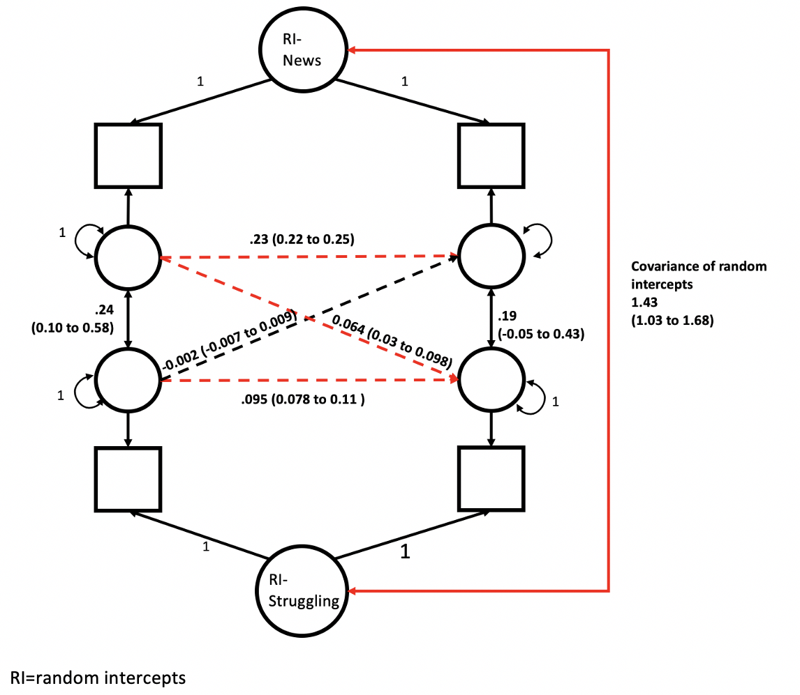

Supplementary Table 4. The fit of models that held the lagged effects constant over the 15 days (constrained) over those that allowed them to vary freely (unconstrained).

Model | Constrained |  | Unconstrained |  | Model fit difference
 | CFI | RMSEA | CFI | RMSEA | ΔCFI | ΔRMSEA
News + COVID-worry | 0.9795 | 0.0405 | 0.9844 | 0.0378 | -0.0049 | 0.0027
News + struggling | 0.9871 | 0.0243 | 0.9899 | 0.0231 | -0.0028 | 0.0012
News + striving | 0.9780 | 0.0380 | 0.9863 | 0.0305 | -0.0025 | 0.0006
Physical contact + COVID-worry | 0.9812 | 0.02956 | 0.9821 | 0.0367 | -0.0041 | 0.0013
Physical contact + struggling | 0.9837 | 0.0228 | 0.9849 | 0.0235 | -0.0012 | -0.0007
Physical contact+ striving | 0.9777 | 0.0380 | 0.9826 | 0.0304 | -0.0014 | -0.0008
Virtual contact + COVID-worry | 0.9800 | 0.0301 | 0.9820 | 0.0365 | -0.0043 | 0.0015
Virtual contact + struggling | 0.9806 | 0.0247 | 0.9825 | 0.0251 | -0.0019 | -0.0004
Virtual contact+ striving | 0.9720 | 0.0536 | 0.9824 | 0.0302 | -0.0024 | -0.0001
Substances + COVID-worry | 0.9732 | 0.0471 | 0.9780 | 0.0508 | -0.0060 | 0.0028
Substances + struggling | 0.9743 | 0.0421 | 0.9797 | 0.0400 | -0.0054 | 0.0021
Substances + striving | 0.9610 | 0.0514 | 0.9782 | 0.0454 | -0.0051 | 0.0017
Alcohol + COVID-worry | 0.9592 | 0.0442 | 0.9687 | 0.0492 | -0.0077 | 0.0022
Alcohol + struggling | 0.9512 | 0.0407 | 0.9591 | 0.0399 | -0.0078 | 0.0008
Alcohol + striving | 0.9818 | 0.0331 | 0.9660 | 0.0431 | -0.0068 | 0.0010
Struggling + striving | 0.9805 | 0.0280 | 0.9825 | 0.0283 | -0.0021 | -0.0003
Struggling + COVID-worry | 0.9734 | 0.0392 | 0.9784 | 0.0377 | -0.0050 | 0.0015
Striving + COVID-worry | 0.9751 | 0.0424 | 0.9802 | 0.0400 | -0.0045 | 0.0014
News + physical contact | 0.9661 | 0.0440 | 0.9854 | 0.0303 | -0.0022 | 0.0001
News + virtual contact | 0.9770 | 0.0459 | 0.9864 | 0.0292 | -0.0023 | 0.0003
News + Alcohol | 0.9824 | 0.0269 | 0.9721 | 0.0427 | -0.0060 | 0.0013
News + substances | 0.9548 | 0.0445 | 0.9824 | 0.0430 | -0.0054 | 0.0029
Physical contact + virtual contact | 0.9733 | 0.0457 | 0.9839 | 0.0275 | -0.0015 | -0.0006
Physical contact + alcohol | 0.9548 | 0.0440 | 0.9619 | 0.0437 | -0.0070 | 0.0008
Physical contact + substances | 0.9730 | 0.0458 | 0.9790 | 0.0434 | -0.0057 | 0.0023
Virtual contact + alcohol | 0.9564 | 0.0596 | 0.9617 | 0.0434 | -0.0069 | 0.0007
Virtual contact + substances | 0.9780 | 0.0380 | 0.9787 | 0.0435 | -0.0057 | 0.0023
Alcohol + substances | 0.9809 | 0.0299 | 0.9648 | 0.0572 | -0.0085 | 0.0024

Supplementary Table 5. Means and standard deviations, reported as mean (SD), for each variable each day.

Day | Daily N | Striving | Struggling | COVID-related worry | News/media consumption | Physical contact | Virtual contact | Alcohol use | Substance use
1 | 1102 | 8.58 (2.72) | 8.13 (3.51) | 3.20 (2.93) | 4.83 (2.58) | 2.63 (1.87) | 1.21 (0.95) | 0.43 (1.05) | 0.27 (0.57)
2 | 1112 | 8.50 (2.74) | 8.09 (3.55) | 3.03 (2.85) | 4.75 (2.62) | 2.60 (1.88) | 1.13 (0.92) | 0.46 (1.08) | 0.25 (0.55)
3 | 1113 | 8.60 (2.85) | 8.06 (3.58) | 3.02 (2.98) | 4.78 (2.68) | 2.63 (1.94) | 1.10 (0.92) | 0.46 (1.08) | 0.26 (0.54)
4 | 1098 | 8.68 (2.89) | 7.78 (3.69) | 2.89 (2.95) | 4.65 (2.74) | 2.75 (1.99) | 1.08 (0.95) | 0.62 (1.26) | 0.27 (0.57)
5 | 1068 | 8.44 (2.87) | 8.02 (3.68) | 2.78 (2.92) | 4.80 (2.75) | 2.65 (1.94) | 1.05 (0.94) | 0.61 (1.27) | 0.26 (0.56)
6 | 1104 | 8.18 (2.78) | 8.34 (3.76) | 2.85 (2.92) | 5.02 (2.61) | 2.61 (1.95) | 1.05 (0.94) | 0.42 (1.03) | 0.26 (0.55)
7 | 1123 | 8.16 (2.79) | 8.32 (3.77) | 2.82 (2.94) | 4.79 (2.64) | 2.57 (1.91) | 1.07 (0.95) | 0.38 (0.98) | 0.25 (0.54)
8 | 1107 | 8.36 (2.79) | 8.06 (3.76) | 2.78 (2.98) | 4.78 (2.66) | 2.59 (1.94) | 1.07 (0.95) | 0.41 (1.02) | 0.24 (0.52)
9 | 1095 | 8.59 (2.75) | 7.75 (3.55) | 2.80 (2.88) | 4.56 (2.66) | 2.59 (1.95) | 1.04 (0.96) | 0.40 (1.03) | 0.24 (0.53)
10 | 1102 | 8.47 (2.76) | 7.77 (3.61) | 2.74 (2.88) | 4.56 (2.60) | 2.61 (1.93) | 1.07 (0.94) | 0.46 (1.08) | 0.24 (0.54)
11 | 1091 | 8.80 (2.82) | 7.48 (3.61) | 2.64 (2.83) | 4.21 (2.66) | 2.69 (2.01) | 1.00 (0.93) | 0.65 (1.29) | 0.25 (0.54)
12 | 1103 | 8.81 (2.85) | 7.27 (3.40) | 2.53 (2.82) | 4.08 (2.62) | 2.72 (2.04) | 0.96 (0.93) | 0.66 (1.31) | 0.26 (0.55)
13 | 1101 | 8.61 (2.82) | 7.56 (3.50) | 2.62 (2.85) | 4.28 (2.56) | 2.58 (1.93) | 1.04 (0.94) | 0.47 (1.14) | 0.26 (0.56)
14 | 1089 | 8.67 (2.78) | 7.53 (3.42) | 2.64 (2.89) | 4.36 (2.58) | 2.60 (1.92) | 1.02 (0.94) | 0.41 (1.05) | 0.23 (0.51)
15 | 1057 | 8.70 (2.74) | 7.57 (3.45) | 2.61 (2.86) | 4.35 (2.56) | 2.52 (1.97) | 1.02 (0.95) | 0.40 (1.04) | 0.23 (0.51)

Supplementary Figure 3. All significant cross-lagged effects. Supplementary Figure 2 is derived from Table 1 in the main manuscript and shows significant cross-lagged effects following FDR correction for multiple testing, both within and across domains of behavior, mental health, and substance use. Significant positive lags are in blue; negative lags in red. Thickness of the connecting lines is proportional to the -log10 FDR p value.

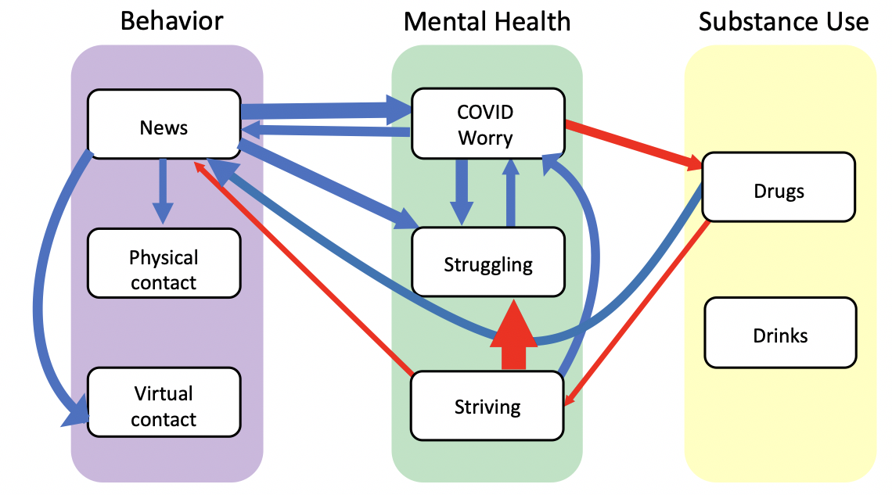
Supplementary Table 6. Results considering physical contact within and outside the home separately. As can be seen, no cross-lagged effects on mental health variables emerged, as was the case for total amount of daily physical contact. Furthermore, no cross-lagged effects emerged when we added amount of time spend in virtual contact with work colleagues or distantly connected others (results not shown).

 | Contact Psychological variable |  |  |  | Psychological variable contact
 | Outside home |  | Inside home |  | Outside home |  | Inside home
 | Est (95% CI) | P | Est (95% CI) | P | Est (95% CI) | P | Est (95% CI) | P
Worry | 0.0008  (-0.0366 to 0.0382) | 0.96 | -0.008  (-0.0294 to 0.0133) | 0.45 | 0.0026  (-0.005 to  0.0101) | 0.51 | -0.003  (-0.0161 to 0.0099) | 0.64
Struggling | -0.0041  (-0.0637 to 0.0556) | 0.89 | 0.0125  (-.0216 to .0467) | 0.47 | .00062  (-0.00403  to 0.00528) | 0.79 | 0.0001  (-0.0079 to 0.0082) | 0.97
Striving | 0.0143  (0.0356 to 0.0641) | 0.57 | 0.0035  (-0.0249 to 0.0318) | 0.81 | -0.003  (0.0088 to  0.0028) | 0.31 | -0.004  (-0.0138 to 0.006) | 0.44

Supplementary Table 7. Moderation by race/ethnicity and by income level. The table below compares the fits of models that allowed lagged effects to vary by race/ethnicity and by income level (unconstrained) against models that held lagged effects constant (constrained). Results included are the dyads with significant cross-lagged effects as seen in Figure 2. This provides a test of possible moderation of lagged effect by ethnicity/race and income level. We used the approach detailed above, comparing the global fit indices of the CFI and the RMSEA. In all cases, the constrained, more parsimonious model (which did not allow lagged effects to differ by ethnicity/race or by income) did not differ substantially in fit from the unconstrained model (allowing lagged effects to vary by ethnicity/race). Thus, we conclude that there were no substantive differences in lagged effects between ethnic/racial groups or between income groups.

 | Constrained |  | Unconstrained |  | Difference
 | CFI | RMSEA | CFI | RMSEA | ΔCFI | ΔRMSEA
Race/Ethnicity

News + COVID-worry | 0.9674 | 0.0511 | 0.9680 | 0.0508 | -0.0006 | 0.0003
News + struggling | 0.9738 | 0.0408 | 0.9726 | 0.0408 | 0.0012 | 0.0000
News + striving | 0.9751 | 0.0385 | 0.9751 | 0.0386 | 0.0000 | -0.0001
Substances + COVID-worry | 0.9458 | 0.0755 | 0.9464 | 0.0753 | -0.0006 | 0.0002
Substances + striving | 0.9474 | 0.0669 | 0.9475 | 0.0671 | -0.0001 | -0.0002
Income level

News + COVID-worry | 0.9738 | 0.0459 | 0.9741 | 0.0457 | -0.0003 | 0.0001
News + struggling | 0.9764 | 0.0387 | 0.9767 | 0.0386 | -0.0001 | 0.0001
News + striving | 0.9770 | 0.0371 | 0.9772 | 0.0370 | -0.0002 | 0.0001
Substances + COVID-worry | 0.9569 | 0.0667 | 0.9575 | 0.0664 | -0.0006 | 0.0003
Substances + striving | 0.9553 | 0.0610 | 0.9560 | 0.0607 | -0.0007 | 0.0003

Supplementary Table 8. Moderation by previous mental health diagnosis. Similar to Table 7, The table below compares the fits of models that allowed lagged effects to vary by previous mental health diagnosis status (unconstrained) against models that held lagged effects constant (constrained). In all cases, the constrained, more parsimonious model (which did not allow lagged effects to differ by diagnosis status) did not differ substantially in fit from the unconstrained model (allowing lagged effects to vary by previous diagnosis). Thus, we conclude that there were no substantive differences in lagged effects between those who had either a previous depression or anxiety diagnosis and those that did not.

 | Constrained |  | Unconstrained |  | Difference
 | CFI | RMSEA | CFI | RMSEA | ΔCFI | ΔRMSEA
Past Depression Diagnosis

News + COVID-worry | 0.9743 | 0.0456 | 0.974 | 0.0457 | -0.0003 | 0.0001
News + struggling | 0.9794 | 0.0308 | 0.9794 | 0.0308 | 0 | 0
News + striving | 0.9773 | 0.0366 | 0.9768 | 0.0369 | -0.0005 | 0.0003
Substances + COVID-worry | 0.9575 | 0.0665 | 0.9573 | 0.0665 | -0.0002 | 0
Substances + striving | 0.9556 | 0.0608 | 0.9553 | 0.0609 | -0.0003 | 0.0001
Past Anxiety Diagnosis

News + COVID-worry | 0.9746 | 0.0451 | 0.9744 | 0.0452 | -0.0002 | 0.0001
News + struggling | 0.9791 | 0.0307 | 0.9791 | 0.0306 | 0 | -0.0001
News + striving | 0.9814 | 0.0331 | 0.9813 | 0.0332 | -0.0001 | 0.0001
Substances + COVID-worry | 0.9557 | 0.0683 | 0.9555 | 0.0682 | -0.0002 | -0.0001
Substances + striving | 0.955 | 0.0617 | 0.9548 | 0.0617 | -0.0002 | 0

Supplementary Table 9. Results for COVID-related worry, treated as two factors. The factors are worry about self or loved ones contracting COVID-19 and worry impacting mood or daily life. Significant cross-lagged effects are bolded (all p values were adjusted using the FDR procedures) and are consistent with the results from the more parsimonious three factor mental health analyses treating worry as a single factor.

 | Cross-lagged |  |  |  | Autoregressive
 | 1 2 |  | 2 1 |  | 1 1 |  | 2 2
 | Est (CI) | P | Est (CI) | P | Est (CI) | P | Est (CI) | P
1. News  2. Contraction worry | 0.023  (0.014 to 0.032) | <0.00001 | 0.051  (0.021 to  0.083) | 0.002 | 0.23  (0.21 to  0.25) | <0.00001 | 0.19  (0.17 to 0.21) | <0.00001
1. News  2. Worry impact | 0.012  (0.034 to 0.021) | 0.01 | 0.039  (0.008 to  0.07) | 0.02 | 0.23  (0.21 to  0.25) | <0.00001 | 0.16  (0.14 to 0.17) | <0.00001
1. Physical  contact  2. Contraction worry | -0.0007  (-0.011 to 0.009) | 0.90 | 0.0051  (-0.023 to  0.033) | 0.78 | 0.12  (0.10 to  0.13) | <0.00001 | 0.19  (0.18 to 0.21) | <0.00001
1. Physical  contact  2. Worry impact | -0.0037  (-0.013 to 0.006) | 0.53 | -.011  (-0.040 to  0.018) | 0.53 | 0.12  (0.10 to  0.13) | <0.00001 | 0.16  (0.14 to 0.18) | <0.00001
1. Virtual  contact  2. Contraction worry | 0.0055  (-0.005 to 0.016) | 0.38 | 0.0082  (-0.018 to  0.0035) | 0.62 | 0.12  (0.11 to  0.14) | <0.00001 | 0.19  (0.17 to 0.20) | <0.00001
1. Virtual  contact  2. Worry impact | 0.00045  (-0.0099 to 0.011) | 0.93 | -0.011  (-0.039 to  0.016) | 0.50 | 0.12  (0.11 to  0.14) | <0.00001 | 0.16  (0.14 to 0.18) | <0.00001
1. Drugs  2. Contraction worry | 0.0050  (-0.057 to 0.067) | 0.90 | -0.0069  (-0.11 to  10.002) | 0.004 | 0.18  (0.16 to  0.20) | <0.00001 | 0.19  (0.18 to 0.21) | <0.00001
1. Drugs  2. Worry impact | 0.016  (-0.045 to  0.077) | 0.68 | -0.0055  (-0.010 to  -0.0010) | 0.02 | 0.18  (0.16 to  0.20) | <0.00001 | 0.16  (0.14 to 0.18) | <0.00001
1. Alcohol  2. Contraction worry | 0.010  (-0.0069 to 0.027) | 0.31 | 0.0038  (-0.012 to  0.020) | 0.69 | 0.18  (0.16 to  0.19) | <0.00001 | 0.19  (0.17 to 0.20) | <0.00001
1. Alcohol  2. Worry impact | 0.0025  (-0.014 to 0.019) | 0.82 | -0.0073  (-0.023 to  0.0089) | 0.47 | 0.17  (0.16 to  0.19) | <0.00001 | 0.16  (0.14 to 0.18) | <0.00001
Supplementary Table 10. Results when adjusting the models for gender (coded as female vs other), age, date of study entry (21st May vs 27th May) and state (states with increasing vs decreasing rates of confirmed infections). Significant cross-lagged effects are bolded (all p values were adjusted using the FDR procedures).
 | Cross-lagged |  |  |  | Autoregressive
 | 1 2 |  | 2 1 |  | 1 1 |  | 2 2
 | Est (CI) | Adj. P | Est (CI) | P | Est (CI) | P | Est (CI) | P
1. News  2. Worry | 0.034  (0.018 to 0.049) | 0.00005 | 0.030  (0.012 to  0.048) | 0.002 | 0.23  (0.21 to 0.25) | <0.00001 | 0.19  (0.17 to 0.21) | <0.00001
1. News  2. Struggling | 0.064  (0.029 to  0.098) | 0.0005 | 0.0009  (-0.007 to 0.009) | 0.89 | 0.23  (0.22 to 0.25) | <0.00001 | 0.095  (0.078 to 0.11) | <0.00001
1. News  2. Striving | -0.019  (-0.039 to 0.002) | 0.11 | -0.016  (-0.030 to  -0.0027) | 0.03 | 0.23  (0.22 to 0.25) | <0.00001 | 0.20  (0.19 to 0.22) | <0.00001
1. Physical  contact  2. Worry | -0.0051  (-0.022 to 0.012) | 0.66 | -0.0017  (-0.018 to  0.015) | 0.89 | 0.12  (0.099 to 0.13) | <0.00001 | 0.20  (0.18 to 0.21) | <0.00001
1. Physical  contact  2. Struggling | -0.0067  (-0.045 to 0.031) | 0.80 | 0.0032  (-0.004 to  0.011) | 0.51 | 0.12  (0.099 to 0.13) | <0.00001 | 0.097  (0.080 to 0.11) | <0.00001
1. Physical  contact  2. Striving | 0.0054  (-0.017 to 0.028) | 0.74 | -0.0077  (-0.020 to 0.0048) | 0.31 | 0.12  (0.099 to 0.13) | <0.00001 | 0.20  (0.19 to 0.22) | <0.00001
1. Virtual  contact  2. Worry | 0.0065  (-0.012 to 0.025) | 0.60 | -0.00063  (-0.016 to  0.015) | 0.97 | 0.12  (0.11 to 0.14) | <0.00001 | 0.20  (0.18 to 0.21) | <0.00001
1. Virtual  contact  2. Struggling | 0.032  (-0.008 to 0.072) | 0.17 | 0.0021  (-0.005 to  0.009) | 0.66 | 0.12  (0.11 to 0.14) | <0.00001 | 0.097  (0.080 to 0.11) | <0.00001
1. Virtual  contact  2. Striving | 0.022  (-0.0018 to 0.047) | 0.11 | 0.0059  (-0.006 to  0.018) | 0.43 | 0.12  (0.11 to 0.14) | <0.00001 | 0.20  (0.18 to 0.22) | <0.00001
1. Drugs  2. Worry | 0.022  (-0.085 to  0.13) | 0.78 | -0.0041  (-0.007 to  -0.002) | 0.003 | 0.18  (0.16 to 0.20) | <0.00001 | 0.20  (0.18 to 0.21) | <0.00001
1. Drugs  2. Struggling | 0.072  (-0.17 to  0.31) | 0.66 | -0.0007  (-0.002 to 0.0005) | 0.35 | 0.18  (0.16 to 0.20) | <0.00001 | 0.096  (0.079 to 0.11) | <0.00001
1. Drugs  2. Striving | -0.17  (-0.31 to  -0.027) | 0.03 | 0.0007  (-0.001 to  0.003) | 0.60 | 0.18  (0.16 to 0.20) | <0.00001 | 0.20  (0.19 to 0.22) | <0.00001
1. Alcohol  2. Worry | 0.012  (-0.018 to  0.042) | 0.53 | -0.0010  (-0.010 to  0.008) | 0.89 | 0.17  (0.16 to 0.19) | <0.00001 | 0.20  (0.18 to 0.21) | <0.00001
1. Alcohol  2. Struggling | -0.035  (-0.10 to 0.031) | 0.41 | 0.0017  (-0.002 to 0.006) | 0.53 | 0.17  (0.16 to 0.19) | <0.00001 | 0.097  (0.079 to 0.11) | <0.00001
1. Alcohol  2. Striving | -0.0018  (-0.041 to  0.038) | 0.97 | 0.0065  (-0.0004 to 0.014) | 0.10 | 0.17  (0.16 to 0.19) | <0.00001 | 0.20  (0.19 to 0.22) | <0.00001

Supplementary Methods: The complete daily survey.

COVID Daily Assessment

Start of Block: Questions

Welcome Thank you for your willingness to participate in this study! We would like to know how you felt today. Please answer the following questions to the best of your ability.

Q1 How sad or depressed did you feel today?
- Not at all (1)
- Slightly (2)
- Moderately (3)
- Very (4)
- Extremely (5)

Q2 How much pleasure or interest did you have in doing things today?
- None (1)
- A little (2)
- A moderate amount (3)
- A lot (4)
- Extreme amount (5)

Q3 How stressed did you feel today?
- Not at all (1)
- Slightly (2)
- Moderately (3)
- Very (4)
- Extremely (5)

Q4 How happy did you feel today?
- Not at all (1)
- Slightly (2)
- Moderately (3)
- Very (4)
- Extremely (5)

Q5 How anxious did you feel today?
- Not at all (1)
- Slightly (2)
- Moderately (3)
- Very (4)
- Extremely (5)

Q6 How lonely did you feel today?
- Not at all (1)
- Slightly (2)
- Moderately (3)
- Very (4)
- Extremely (5)

Q7 How optimistic did you feel today?
- Not at all (1)
- Slightly (2)
- Moderately (3)
- Very (4)
- Extremely (5)

Q8 Do you feel physically well today?
- Yes (1)
- No (2)
- Don't know (3)

Skip To: Q11 If Do you feel physically well today? != Yes

Q9 Do you have a fever?
- Yes (1)
- No (2)
- Don't know (3)

Q10 Do you have a cough?
- Yes (1)
- No (2)
- Don't know (3)

Display This Question:
If Do you have a fever? = Yes
And Do you have a cough? = Yes

Pop-up If you are concerned that you may have COVID-19, the disease caused by the new coronavirus, CONTACT YOUR HEALTH CARE PROVIDER.
There are other resources available
https://www.cdc.gov/coronavirus/2019-ncov/if-you-are-sick/steps-when-sick.html

Page Break

Q11 Were any of your close contacts diagnosed with COVID-19 today?
- Yes (1)
- No (2)
- Don't know (3)
- Prefer not to answer (4)

Q12 Are you currently being treated for COVID-19?
- Yes (1)
- No (2)
- Don't know (3)
- Prefer not to answer (4)

Skip To: Screen 2 If Are you currently being treated for COVID-19? = Yes

Q13 How often have you thought about your chances of getting COVID-19 today?
- Not at all (1)
- Sometimes (2)
- Often (3)
- A lot (4)

Q14 How often have thoughts about your chances of getting COVID-19 affected your mood today?
- Not at all (1)
- Sometimes (2)
- Often (3)
- A lot (4)

Q15 How often did thoughts about your chances of getting COVID-19 affect your ability to perform daily activities today?
- Not at all (1)
- Sometimes (2)
- Often (3)
- A lot (4)

Q16 How much did you worry today about the new coronavirus (COVID-19) affecting your loved ones?
- Not at all (1)
- Sometimes (2)
- Often (3)
- A lot (4)

Page Break

Screen 2 Next, we would like to know how you spent your day.

Q17 Did you spend the entire day at home today?
- Yes (1)
- No (2)

Q18 How many people did you have physical contact with in your home today (i.e., come within 20 feet)?
________________________________________________________________

Q19 Did anyone come to visit you today in your home?
- Yes (1)
- No (2)

Skip To: Q21 If Did anyone come to visit you today in your home? = No

Q20 How many people visited you?
________________________________________________________________

Q21 Did you do anything outside the home today?
- Yes (1)
- No (2)

Skip To: Q61 If Did you do anything outside the home today? = No

Q22 What did you do today outside the home? Please check all that apply.
- Went shopping or ran errands (1)
- Went to work (2)
- Met a friend (3)
- Met two or more friends at the same time (4)
- Went for a walk or did leisure activity outside the home alone (5)
- Went for a walk or did leisure activity outside the home with others (6)
- Went to an organized meeting, such as a religious service or party (7)

Display This Question:
If What did you do today outside the home? Please check all that apply. = Went shopping or ran errands

Q22a Did you come within 6 feet of others when shopping or running errands?
- Yes (1)
- No (2)

Display This Question:
If What did you do today outside the home? Please check all that apply. = Went to work

Q22b Did you come within 6 feet of others when working?
- Yes (1)
- No (2)

Display This Question:
If What did you do today outside the home? Please check all that apply. = Met a friend

Q22c Did you come within 6 feet of others when meeting a friend?
- Yes (1)
- No (2)

Display This Question:
If What did you do today outside the home? Please check all that apply. = Met two or more friends at the same time

Q22d Did you come within 6 feet of others when meeting two or more friends at the same time?
- Yes (1)
- No (2)

Display This Question:
If What did you do today outside the home? Please check all that apply. = Went for a walk or did leisure activity outside the home alone

Q22e Did you come within 6 feet of others when going for a walk or doing a leisure activity outside the home alone?
- Yes (1)
- No (2)

Display This Question:
If What did you do today outside the home? Please check all that apply. = Went for a walk or did leisure activity outside the home with others

Q22f Did you come within 6 feet of others when when going for a walk or doing a leisure activity outside the home with others?
- Yes (1)
- No (2)

Display This Question:
If What did you do today outside the home? Please check all that apply. = Went to an organized meeting, such as a religious service or party

Q22g Did you come within 6 feet of others when going to an organized meeting?
- Yes (1)
- No (2)

Page Break

Q61 In the last 24 hours, did you drink alcohol?
- Yes (1)
- No (2)
- Prefer not to answer (3)

Display This Question:
If In the last 24 hours, did you drink alcohol? = Yes

Q62 How many drinks did you have in the last 24 hours?
- 1 drink (1)
- 2 drinks (2)
- 3 drinks (3)
- 4 drinks (4)
- More than 5 drinks (5)

Q63 In the last 24 hours, did you vape, smoke cigarettes, or use other tobacco products?
- Yes (1)
- No (2)
- Prefer not to answer (3)

Q64 In the last 24 hours, did you use marijuana/cannabis (e.g., joint, blunt, pipe, bong)?
- Yes (1)
- No (2)
- Prefer not to answer (3)

Q65 In the last 24 hours, did you use opiates, heroin, or narcotics?
- Yes (1)
- No (2)
- Prefer not to answer (3)

Q66 In the last 24 hours, did you use other drugs, such as cocaine, crack, amphetamine, methamphetamine, hallucinogens, or ecstasy?
- Yes (1)
- No (2)
- Prefer not to answer (3)

Q67 In the last 24 hours, did you take sleeping medications or sedatives?
- Yes (1)
- No (2)
- Prefer not to answer (3)

Page Break

Screen 3 Next, we would like to know about the interactions that you had with others by phone, email, or video today.

Q23 Did you communicate today with family by phone, text, email or video?
- Yes (1)
- No (2)

Skip To: Q26 If Did you communicate today with family by phone, text, email or video? = No

Q24 How many family members did you communicate with in this way?
________________________________________________________________

Q25 Roughly how much time did you spend communicating with family by phone, text, email or video?
- Less than 30 minutes (1)
- More than 30 minutes, but less than 1 hour (2)
- Between 1 and 2 hours (3)
- More than 2 hours (4)

Q26 Did you communicate today with close friends by phone, text, email or video?
- Yes (1)
- No (2)

Skip To: Q29 If Did you communicate today with close friends by phone, text, email or video? = No

Q27 How many close friends did you communicate with?
________________________________________________________________

Q28 Roughly how much time did you spend communicating with close friends by phone, text, email or video?
- Less than 30 minutes (1)
- More than 30 minutes, but less than 1 hour (2)
- Between 1 and 2 hours (3)
- More than 2 hours (4)

Q29 Did you communicate today with work colleagues, more distant friends or people that you do not know well by phone, text, email or video?
- Yes (1)
- No (2)

Skip To: Q31 If Did you communicate today with work colleagues, more distant friends or people that you do not kn... = No

Q30 Roughly how much time did you spend communicating with these colleagues and distant friends?
- Less than 30 minutes (1)
- More than 30 minutes, but less than 1 hour (2)
- Between 1 and 2 hours (3)
- More than 2 hours (4)

Q31 Did you communicate simultaneously with more than one person today through group text, chat, or video?
- Yes (1)
- No (2)

Skip To: Screen 4 If Did you communicate simultaneously with more than one person today through group text, chat, or v... = No

Q32 Who did you communicate with using group text, chat or video? Please check all that apply.
- Family (1)
- Close friends (2)
- Distant friends (3)
- Work colleagues (4)
- Other (5) ________________________________________________

Page Break

Screen 4 Now we would like to know a bit more about how you spent your day.

Q34 How much time did you spend reading or listening to the news today?
- No time at all (0)
- Less than 30 minutes (1)
- More than 30 minutes, but less than 1 hour (2)
- Between 1 and 2 hours (3)
- More than 2 hours (4)

Q35 Overall, how much time did you spend browsing social media today (for example, Facebook, Twitter, TikTok, Instagram)?
- No time at all (0)
- Less than 30 minutes (1)
- More than 30 minutes, but less than 1 hour (2)
- Between 1 and 2 hours (3)
- More than 2 hours (4)

Q36 How much did you read or hear about the coronavirus pandemic today?
- Not at all (1)
- Very little (2)
- Some (3)
- A lot (4)

End of Block: Questions

Supplementary References

Hamaker, E. L., Kuiper, R. M., & Grasman, R. P. (2015). A critique of the cross-lagged panel model. Psychological Methods, 20(1), 102-116. doi:10.1037/a0038889
Lerman, C., Trock, B., Rimer, B. K., Jepson, C., Brody, D., & Boyce, A. (1991). Psychological side effects of breast cancer screening. Health Psychology, 10(4), 259-267. doi:10.1037/0278-6133.10.4.259
Mulder, J. D., & Hamaker, E. L. (2020). Three Extensions of the Random Intercept Cross-Lagged Panel Model. Structural Equation Modeling: A Multidisciplinary Journal, 1-11. doi:10.1080/10705511.2020.1784738
Mund, M., & Nestler, S. (2019). Beyond the Cross-Lagged Panel Model: Next-generation statistical tools for analyzing interdependencies across the life course. Advances in Life Course Research, 41. doi:10.1016/j.alcr.2018.10.002

