Perinatal and Early-Life Factors Associated with Stable and Unstable Trajectories of Psychopathic Traits Across Childhood
Bégin, V., Fontaine, N.M.G., Vitaro, F., Boivin, M., Tremblay, R.E., & Côté, S.M.
Online Supplementary Material
Table S1
Mean differences between children included and excluded from the current study
Early-life factor | Means (s.d.) |  |  | Difference Test
 | Included (n = 1631) | Excluded (n = 489) |  | t | df | p
Perinatal factors
Fetal growth adversities | 0.22 (0.62) | 0.22 (0.63) |  | -0.20 | 2118 | .840
Pregnancy complications | 0.07 (0.26) | 0.08 (0.27) |  | -0.63 | 2118 | .526
Birth/delivery adversities | 1.22 (1.10) | 1.24 (1.13) |  | -0.34 | 2118 | .732
Psychotropic exposures | 1.27 (0.85) | 1.12 (0.81) |  | 3.54 | 833.54 | .000
Socioeconomic adversities | 0.89 (0.95) | 0.98 (0.99) |  | -1.87 | 2118 | .061
Cumulative perinatal index | 3.68 (1.91) | 3.65 (1.82) |  | 0.23 | 2118 | .817
Child-level early-life factors
Difficult temperament | 2.45 (1.57) | 2.25 (1.47) |  | 2.42 | 2030 | .016
Hyperactivity | 3.53 (2.17) | 3.28 (2.22) |  | 2.14 | 2043 | .032
Physical aggression | 1.36 (1.27) | 1.23 (1.23) |  | 1.76 | 2043 | .079
Opposition | 3.48 (2.18) | 3.16 (2.00) |  | 2.88 | 704.15 | .004
Family-level early-life factors
Socioeconomic status | 0.05 (0.99) | -0.15 (1.03) |  | 3.82 | 2107 | .000
Marital support | 8.10 (1.87) | 8.08 (1.93) |  | 0.14 | 1865 | .890
Maternal efficacy | 8.78 (1.15) | 8.78 (1.18) |  | -0.12 | 2025 | .907
Maternal impact | 8.43 (1.82) | 8.14 (2.07) |  | 2.66 | 659.10 | .008
Mother’s dep. sympt. (5 m.) | 1.39 (1.33) | 1.46 (1.38) |  | -1.08 | 2111 | .282
Mother’s dep. sympt. (17 m.) | 1.37 (1.35) | 1.28 (1.47) |  | 1.23 | 2032 | .219
Positive parenting | 6.96 (1.12) | 7.00 (1.21) |  | -0.59 | 1993 | .552
Hostile parenting | 2.57 (1.14) | 2.56 (1.21) |  | 0.10 | 1987 | .921
Consistent parenting | 6.91 (1.38) | 6.90 (1.44) |  | 0.09 | 1987 | .930
Note. Values in bold denote significance at the p < .05 level. Effect sizes of significant differences (Cohen’s d): Psychotropic exposures: d = 0.18, Socioeconomic status: d = 0.15, Difficult temperament: d = 0.14, Hyperactivity: d = 0.12, Opposition: d = 0.15, Maternal impact: d = 0.15. s.d.: standard deviation. df: degrees of freedom. dep. sympt.: depressive symptoms. m.: months.

Table S2
Items included in the psychopathic traits scale
In the past 6 months, would you say that this child…
- … was unconcerned about the feelings of others (CU)
- … did not keep promises (CU)
- … didn’t seem to feel guilty after misbehaving (CU)
- … bragged about accomplishments (NA)
- … used or conned others (NA)
- … reacted in an aggressive manner when contradicted (NA)
- … told lies or cheated (NA)
- … engaged in risky or dangerous activities (IM)
- … accepts responsibility for actions (IM)
- … was impulsive, acted without thinking (IM)
Note. The same set of items was used at ages 6, 7, 8, 10 and 12 years old. Items were originally answered by a teacher on a 3-point ordinal scale: 1 = Often or very true, 2 = Sometimes or somewhat true, 3 = Never or not true, and were recoded as follows for the analyses of the current study : 0 = Never or not true, 1 = Sometimes or somewhat true, 2 = Often or very true. Scores of item 9 « … accepts responsibility for actions » were reversed. CU: item referring to the callous-unemotional dimension. NA: item referring to the narcissism-grandiosity dimension. IM: item referring to the impulsivity-irresponsibility dimension.
Table S3
Fit indices and standardized factor loadings of confirmatory factor analyses of the psychopathic traits scale at each assessment ages
 | 6 years old | 7 years old | 8 years old | 10 years old | 12 years old
Fit indices
RMSEA | 0.05 | 0.04 | 0.06 | 0.05 | 0.05
90% CI | 0.04 – 0.06 | 0.03 – 0.04 | 0.05 – 0.07 | 0.04 – 0.06 | 0.04 – 0.06
CFI | 0.99 | 0.99 | 0.98 | 0.99 | 0.99
TLI | 0.98 | 0.99 | 0.97 | 0.99 | 0.98
Standardized factor loadings
Item 1 | .77 | .75 | .77 | .81 | .81
Item 2 | .87 | .85 | .81 | .84 | .83
Item 3 | .81 | .85 | .86 | .88 | .90
Item 4 | .66 | .59 | .61 | .65 | .66
Item 5 | .78 | .78 | .80 | .81 | .82
Item 6 | .79 | .78 | .80 | .84 | .76
Item 7 | .80 | .78 | .83 | .83 | .80
Item 8 | .73 | .71 | .61 | .75 | .70
Item 9 | .79 | .81 | .84 | .87 | .84
Item 10 | .79 | .81 | .80 | .84 | .81
Note. All models used the weighted least squares means and variance adjusted (WLSMV) estimator and theta parameterization. RMSEA = Root mean square error of approximation. CI = RMSEA confidence interval. CFI = Comparative fit index. TLI = Tucker-Lewis Index.

Table S4
Sex and longitudinal invariance of the psychopathic traits scale
 | Sex –  6 years old | Sex –  7 years old | Sex –  8 years old | Sex –  10 years old | Sex –  12 years old | Longitudinal –  all ages
Configural – Fit indices
RMSEA | 0.05 | 0.04 | 0.06 | 0.04 | 0.05 | 0.02
90% CI | 0.03 – 0.06 | 0.03 – 0.05 | 0.05 – 0.07 | 0.03 – 0.05 | 0.04 – 0.06 | 0.01 – 0.02
CFI | 0.99 | 0.99 | 0.98 | 0.99 | 0.99 | 0.99
TLI | 0.99 | 0.99 | 0.97 | 0.99 | 0.98 | 0.99
Metric invariant – Difftest results
Δχ² | 11.20 | 3.29 | 14.52 | 10.61 | 11.63 | 36.56
Δdf | 9 | 9 | 9 | 9 | 9 | 36
p value | .26 | .95 | .11 | .30 | .23 | .44
Metric invariant – Fit indices
RMSEA | 0.04 | 0.02 | 0.05 | 0.04 | 0.04 | 0.01
90% CI | 0.03 – 0.05 | 0.01 – 0.03 | 0.04 – 0.06 | 0.02 – 0.05 | 0.03 – 0.05 | 0.01 – 0.02
CFI | 0.99 | 1.00 | 0.99 | 0.99 | 0.99 | 0.99
TLI | 0.99 | 1.00 | 0.98 | 0.99 | 0.99 | 0.99
Note. All models used the weighted least squares means and variance adjusted (WLSMV) estimator and theta parameterization. Configural models constrained the factorial structure to be the same across sexes/ages. Metric invariant models constrained all factor loadings to be equal across sexes/ages. RMSEA = Root mean square error of approximation. CI = RMSEA confidence interval. CFI = Comparative fit index. TLI = Tucker-Lewis Index.

Table S5
Variables | PT – 6 years old | PT – 7 years old | PT – 8 years old | PT – 10 years old | PT – 12 years old
6 years old
Physical aggression | .83** | .55** | .41** | .45** | .41**
NA conduct problems | .65** | .45** | .30** | .32** | .29**
Opposition | .80** | .56** | .40** | .39** | .37**
Prosocial behavior | -.23** | -.12** | -.09* | -.16** | -.17**
7 years old
Physical aggression | .56** | .82** | .52** | .47** | .40**
NA conduct problems | .42** | .63** | .36** | .34** | .30**
Opposition | .58** | .80** | .51** | .48** | .45**
Prosocial behavior | -.15** | -.17** | -.11** | -.07 | -.15**
8 years old
Physical aggression | .41** | .50** | .81** | .45** | .41**
NA conduct problems | .32** | .37** | .60** | .37** | .36**
Opposition | .46** | .53** | .81** | .49** | .44**
Prosocial behavior | -.08 | -.10** | -.17** | -.05 | -.11**
10 years old
Physical aggression | .42** | .43** | .49** | .83** | .42**
NA conduct problems | .33** | .33** | .32** | .61** | .38**
Opposition | .48** | .49** | .52** | .85** | .47**
Prosocial behavior | -.15** | -.10* | -.11** | -.14** | -.16**
12 years old
Physical aggression | .35** | .43** | .45** | .42** | .79**
NA conduct problems | .30** | .28** | .29** | .32** | .56**
Opposition | .42** | .45** | .45** | .48** | .83**
Prosocial behavior | -.07 | -.09* | -.03 | -.11* | -.18**
Cross-sectional and longitudinal correlations between scores on the psychopathic traits scale and external criteria scales
Note. *: p < .05. **: p < .01. Cross-sectional correlations are identified in bold. All coefficients are Pearson’s r. PT = Psychopathic traits. NA = Non-aggressive.

Table S6
Physical aggression
In the past 6 months, would you say that this child…
- … got into fights
- … encouraged other children to pick on a particular child
- … reacted in an aggressive manner when teased
- … tried to dominate other children
- … scared other children to get what he/she wanted
- … when somebody accidentally hurt him/her (such as by bumping into him/her), he/she reacted with anger and fighting
- … physically attacked people
- … hit, bit or kicked other children
- … reacted in an aggressive manner when something was taken from him/her
Non-aggressive conduct problems
In the past 6 months, would you say that this child…
- … damaged or broke his/her own things
- … stole things
- … damaged or broke things belonging to others
- … committed any acts of vandalism
Opposition
In the past 6 months, would you say that this child…
- … was defiant or refuse to comply with adults’ requests or rules
- … punishment didn’t change his/her behavior
- … had temper tantrums or hot temper
Prosocial behavior
In the past 6 months, would you say that this child…
- … tried to help someone who has been hurt
- … comforted a child (friend, brother or sister) who was crying or upset
- … helped other children (friend, brother or sister) who were feeling sick
Items included in the external criteria scales
Note. The same set of items was used at ages 6, 7, 8, 10 and 12 years old. Items were originally answered by a teacher on a 3-point ordinal scale : 1 = Often or very true, 2 = Sometimes or a bit true, 3 = Never or not true, and were recoded as follows for the analyses of the current study : 0 = Never or not true, 1 = Sometimes or a bit true, 2 = Often or very true.

Table S7
Perinatal factors | Operationalization
- Short birth length | Length at birth < VS. ≥ 47 cm
- Low birth weight | Weight at birth < VS. ≥ 2500 grams
- Short head circumference | Head circumference < VS. ≥ 10th percentile (33 cm)
- Prematurity | Gestational age at birth < VS. ≥ 37 weeks
- Mother hemorrhage | ICD-9 code 641 in mother’s medical record VS. not
- Mother hypertension | ICD-9 code 642 in mother’s medical record VS. not
- Mother diabetes | ICD-9 code 648.0 in mother’s medical record VS. not
- Long hospitalization | Discharged from hospital > VS. ≤ 3 days after birth
- Transfer hospital | Transferred to a specialized hospital after birth VS. not
- Low APGAR | 5 minutes APGAR score < VS. ≥ 7
- Birth induction | Use of induction for delivery VS. not
- Delivery acceleration | Use of acceleration for delivery VS. not
- Caesarean section | Method of delivery as Caesarean VS. not
- Child hypoxia/asphyxia | ICD-9 code 768 in child’s medical record VS. not
- Maternal smokingª | Any smoking during pregnancy VS. not
- Maternal alcoholª | Any alcohol consumption during pregnancy VS. not
- Maternal drugsª | Any illegal drugs consumption during pregnancy VS. not
- Maternal medicationª | Any medication consumption during pregnancy VS. not
- Low maternal educationª | Did not VS. did obtain high school diploma
- Low paternal education^{b} | Did not VS. did obtain high school diploma
- Non-intact familyª | Non-intact VS. intact family at childbirth
- Low maternal ageª | Mother’s age < VS. ≥ 20 years at childbirth
- Advanced paternal age^{b} | Father’s age ≥ VS. < 35 years at childbirth
- High birth orderª | 4th or later VS. 3rd or lower
Fetal growth adversities | Sum of factors 1-4.
Pregnancy complications | Sum of factors 5-7.
Birth/delivery adversities | Sum of factors 8-14.
Psychotropic exposures | Sum of factors 15-18.
Socioeconomic adversities | Sum of factors 19-24.
Cumulative perinatal index | Sum of factors 1-24.
Operationalization of perinatal factors
Note. ICD-9 codes are reported as these were used in participants’ medical records in the QLSCD. Data were collected from medical records where not otherwise specified. ªData collected from mother report at child age 5 months. ^{b}Data collected from father/partner report at child age 5 months. APGAR: appearance, pulse, grimace, activity, respiration.

Table S8
Frequencies of perinatal factors in total sample and across trajectory groups
Perinatal factor |  | Descriptive statistics – n (% among valid data)
 |  | Total sample (n = 1631) | High stable  (n = 73) | Increasing  (n = 143) | Decreasing  (n = 187) | Low stable (n = 1228)
Short birth length |  | 71 (4.7%) | 4 (5.9%) | 6 (4.5%) | 12 (7.1%) | 49 (4.3%)
Low birth weight |  | 54 (3.3%) | 0 (0.0%) | 2 (1.4%) | 11 (5.9%) | 41 (3.3%)
Short head circumference |  | 148 (9.8%) | 8 (11.8%) | 15 (11.3%) | 23 (13.7%) | 102 (8.9%)
Prematurity |  | 80 (4.9%) | 0 (0.0%) | 4 (2.8%) | 15 (8.0%) | 61 (5.0%)
Mother hemorrhage |  | 46 (2.8%) | 2 (2.7%) | 2 (1.4%) | 3 (1.6%) | 39 (3.2%)
Mother hypertension |  | 65 (4.0%) | 1 (1.4%) | 6 (4.2%) | 8 (4.3%) | 50 (4.1%)
Mother diabetes |  | 5 (0.3%) | 0 (0.0%) | 0 (0.0%) | 0 (0.0%) | 5 (0.4%)
Long hospitalization |  | 315 (19.8%) | 11 (15.1%) | 26 (18.7%) | 33 (18.2%) | 245 (20.4%)
Transfer hospital |  | 25 (2.0%) | 2 (3.6%) | 2 (1.9%) | 1 (0.7%) | 20 (2.1)
Low APGAR |  | 23 (1.4%) | 1 (1.4%) | 4 (2.8%) | 4 (2.2%) | 14 (1.2%)
Birth induction |  | 488 (30.7%) | 27 (37.0%) | 47 (33.6%) | 61 (33.5%) | 353 (29.5%)
Delivery acceleration |  | 745 (51.0%) | 33 (50.0%) | 75 (56.4%) | 96 (55.8%) | 541 (49.6%)
Caesarean section |  | 243 (15.0%) | 11 (15.1%) | 25 (17.5%) | 24 (12.9%) | 183 (15.0%)
Child hypoxia/asphyxia |  | 157 (9.6%) | 5 (6.8%) | 16 (11.2%) | 18 (9.6%) | 118 (9.6%)
Maternal smoking |  | 417 (25.7%) | 32 (43.8%) | 48 (33.8%) | 52 (28.1%) | 285 (23.3%)
Maternal alcohol |  | 615 (37.9%) | 21 (28.8%) | 58 (40.8%) | 74 (40.0%) | 462 (37.8%)
Maternal drugs |  | 22 (1.4%) | 3 (4.1%) | 2 (1.4%) | 3 (1.6%) | 14 (1.1%)
Maternal medication |  | 1025 (63.2%) | 47 (64.4%) | 96 (67.6%) | 120 (64.9%) | 762 (62.3%)
Low maternal education |  | 278 (17.1%) | 27 (37.0%) | 35 (24.6%) | 39 (20.9%) | 177 (14.4%)
Low paternal education |  | 303 (20.1%) | 24 (36.9%) | 31 (25.2%) | 39 (23.2%) | 209 (18.2%)
Non-intact family |  | 301 (18.5%) | 22 (30.1%) | 42 (29.4%) | 45 (24.2%) | 192 (15.7%)
Low maternal age |  | 46 (2.8%) | 6 (8.2%) | 2 (1.4%) | 6 (3.2%) | 32 (2.6%)
Advanced paternal age |  | 450 (29.7%) | 17 (26.2%) | 33 (26.4%) | 45 (26.5%) | 355 (30.7%)
High birth order |  | 75 (4.6%) | 5 (6.8%) | 6 (4.2%) | 8 (4.3%) | 56 (4.6)
Note. APGAR: Appearance, pulse, grimace, activity, respiration.

Figure S9
Perinatal and early-life factors associated with membership to the Decreasing trajectory versus the Low stable trajectory of psychopathic traits.
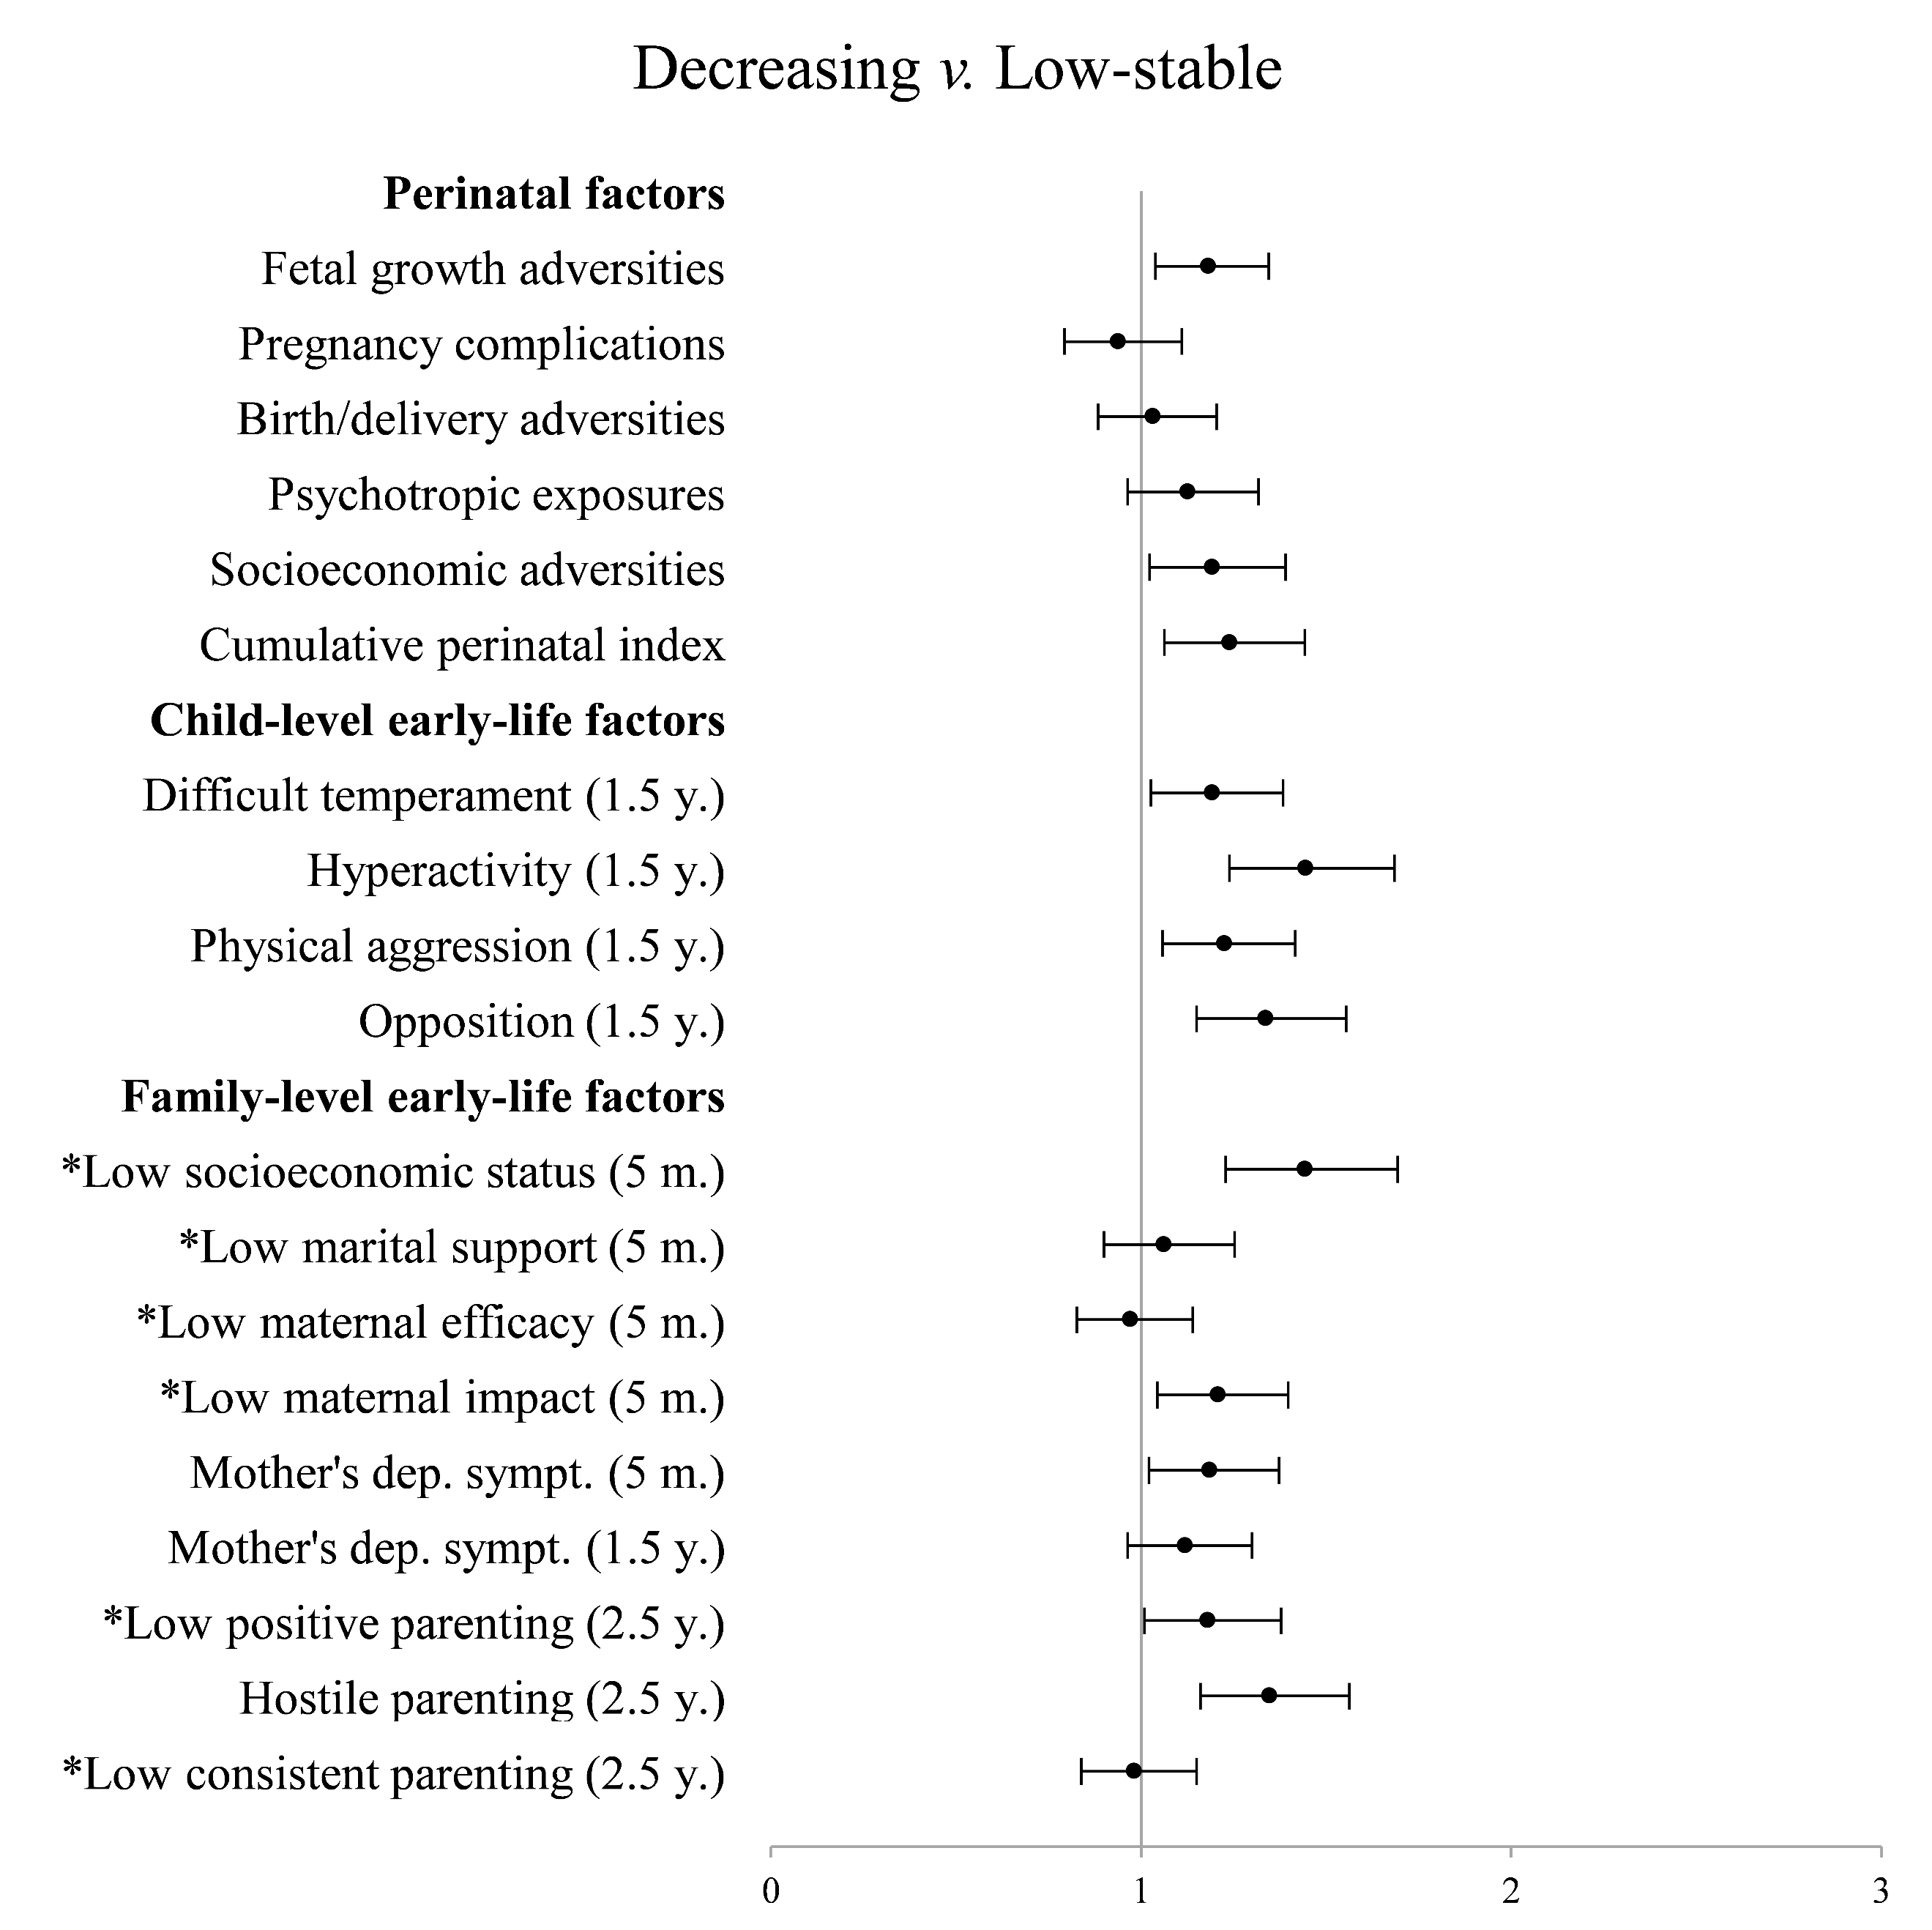
Note. Dependent variable: membership to the Decreasing versus the Low stable trajectory as the reference group. Scales of variables identified with an asterisk were reversed for interpretation purposes: higher scores indicate greater levels of impairment for all variables. All variables are z standardized. Odds ratios are adjusted for child sex. y.: years. m.: months.

Figure S10
Perinatal and early-life factors associated with membership to the High stable trajectory versus the Increasing trajectory of psychopathic traits.
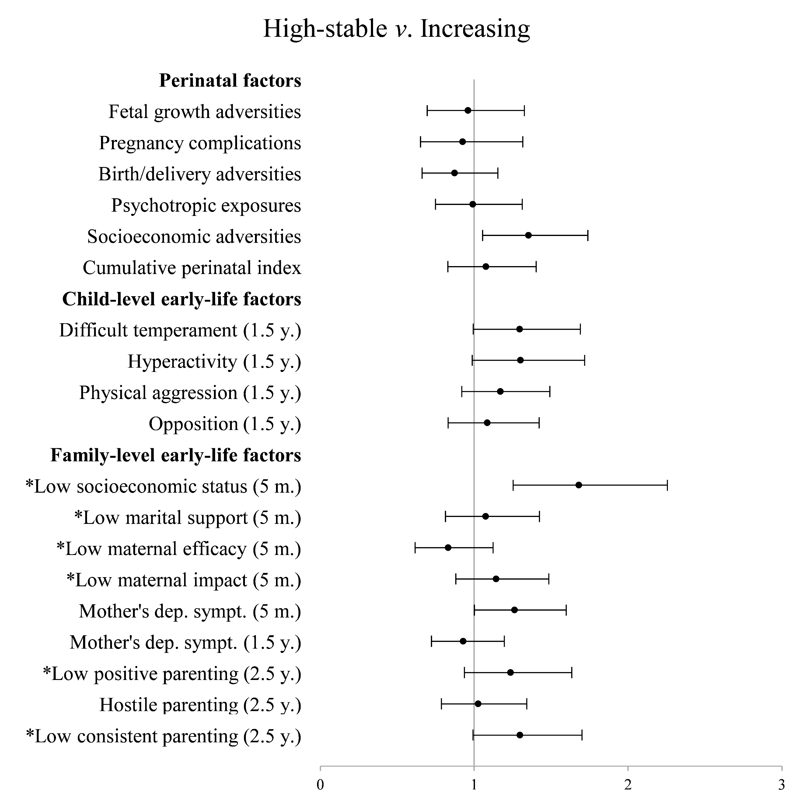
Note. Dependent variable: membership to the High stable versus the Increasing trajectory as the reference group. Scales of variables identified with an asterisk were reversed for interpretation purposes: higher scores indicate greater levels of impairment for all variables. All variables are z standardized. Odds ratios are adjusted for child sex. y.: years. m.: months.

Figure S11
Perinatal and early-life factors associated with membership to the Increasing trajectory versus the Decreasing trajectory of psychopathic traits.
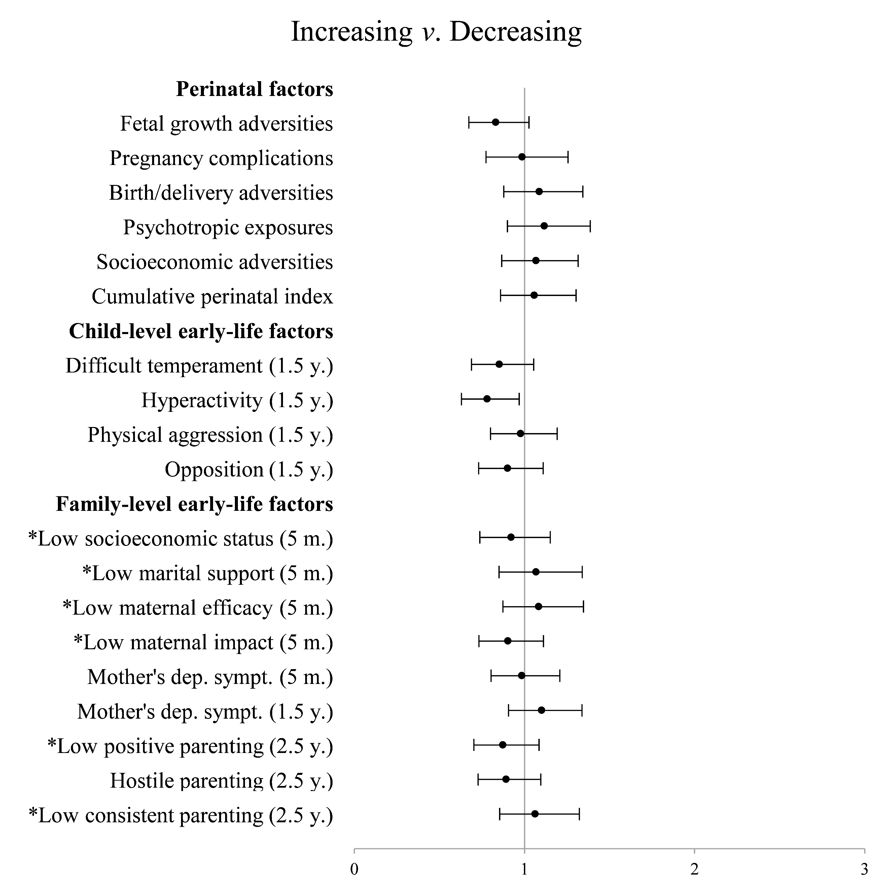
Note. Dependent variable: membership to the Increasing versus the Decreasing trajectory as the reference group. Scales of variables identified with an asterisk were reversed for interpretation purposes: higher scores indicate greater levels of impairment for all variables. All variables are z standardized. Odds ratios are adjusted for child sex. y.: years. m.: months.

Table S12
Multinomial logistic regression models of perinatal factors
 |  | Odds ratios (95% CI)
Early-life factors |  | High stable VS  Low stable | Increasing VS  Low stable | High stable VS  Decreasing | Decreasing VS  Low stable | High stable VS Increasing | Increasing VS  Decreasing
Short birth length |  | 1.61 (0.55 ˗ 4.72) | 1.14 (0.48 ˗ 2.75) | 0.87 (0.27 ˗ 2.82) | 1.85 (0.95 ˗ 3.60) | 1.41 (0.38 ˗ 5.20) | 0.62 (0.23 ˗ 1.69)
Low birth weight |  | - | 0.39 (0.09 ˗ 1.65) | - | 0.39 (0.09 ˗ 1.65) | - | 0.23 (0.05 ˗ 1.04)
Short head circumference |  | 1.63 (0.75 ˗ 3.57) | 1.44 (0.81 ˗ 2.58) | 0.91 (0.38 ˗ 2.15) | 1.80 (1.10 ˗ 2.95) | 1.13 (0.45 ˗ 2.83) | 0.80 (0.40 ˗ 1.61)
Prematurity |  | - | 0.52 (0.19 ˗ 1.47) | - | 1.58 (0.87 ˗ 2.88) | - | 0.33 (0.11 ˗ 1.02)
Mother hemorrhage |  | 0.94 (0.22 ˗ 4.06) | 0.46 (0.11 ˗ 1.92) | 1.79 (0.29 ˗ 10.99) | 0.52 (0.16 ˗ 1.73) | 2.06 (0.28 ˗ 14.99) | 0.87 (0.14 ˗ 5.28)
Mother hypertension |  | 0.35 (0.05 ˗ 2.56) | 1.07 (0.44 ˗ 2.55) | 0.32 (0.04 ˗ 2.59) | 1.09 (0.50 ˗ 2.35) | 0.32 (0.04 ˗ 2.75) | 0.98 (0.33 ˗ 2.89)
Mother diabetes |  | - | - | - | - | - | -
Long hospitalization |  | 0.64 (0.33 ˗ 1.25) | 0.86 (0.54 ˗ 1.35) | 0.77 (0.37 ˗ 1.63) | 0.83 (0.55 ˗ 1.25) | 0.75 (0.35 ˗ 1.62) | 1.03 (0.58 ˗ 1.82)
Transfer hospital |  | 1.48 (0.33 ˗ 1.25) | 0.81 (0.18 ˗ 3.54) | 5.26 (0.47 ˗ 59.23) | 0.28 (0.04 ˗ 2.13) | 1.83 (0.25 ˗ 13.41) | 2.87 (0.26 ˗ 32.04)
Low APGAR |  | 0.70 (0.09 ˗ 5.44) | 1.75 (0.56 ˗ 5.45) | 0.52 (0.06 ˗ 4.70) | 1.36 (0.44 ˗ 4.22) | 0.40 (0.04 ˗ 3.66) | 1.29 (0.32 ˗ 5.27)
Birth induction |  | 1.36 (0.83 ˗ 2.25) | 1.19 (0.82 ˗ 1.73) | 1.15 (0.65 ˗ 2.03) | 1.18 (0.85 ˗ 1.66) | 1.15 (0.64 ˗ 2.08) | 1.00 (0.63 ˗ 1.60)
Delivery acceleration |  | 1.02 (0.61 ˗ 1.68) | 1.31 (0.91 ˗ 1.89) | 0.79 (0.45 ˗ 1.40) | 1.28 (0.92 ˗ 1.78) | 0.77 (0.43 ˗ 1.40) | 1.02 (0.65 ˗ 1.62)
Caesarean section |  | 0.95 (0.49 ˗ 1.85) | 1.16 (0.73 ˗ 1.84) | 1.17 (0.54 ˗ 2.53) | 0.81 (0.51 ˗ 1.29) | 0.82 (0.38 ˗ 1.77) | 1.43 (0.78 ˗ 2.63)
Child hypoxia/asphyxia |  | 0.59 (0.23 ˗ 1.50) | 1.07 (0.61 ˗ 1.88) | 0.65 (0.23 ˗ 1.82) | 0.91 (0.53 ˗ 1.54) | 0.55 (0.19 ˗ 1.56) | 1.18 (0.58 ˗ 2.42)
Maternal smoking |  | 2.73 (1.67 ˗ 4.47) | 1.74 (1.20 ˗ 2.54) | 2.05 (1.17 ˗ 3.60) | 1.33 (0.94 ˗ 1.90) | 1.57 (0.88 ˗ 2.80) | 1.31 (0.81 ˗ 2.10)
Maternal alcohol |  | 0.69 (0.41 ˗ 1.17) | 1.16 (0.81 ˗ 1.66) | 0.61 (0.34 ˗ 1.11) | 1.12 (0.81 ˗ 1.54) | 0.59 (0.32 ˗ 1.09) | 1.04 (0.66 ˗ 1.62)
Maternal drugs |  | 3.08 (0.83 ˗ 11.38) | 1.10 (0.24 ˗ 4.95) | 2.42 (0.48 ˗ 12.35) | 1.27 (0.36 ˗ 4.53) | 2.80 (0.46 ˗ 17.22) | 0.87 (0.14 ˗ 5.25)
Maternal medication |  | 1.09 (0.66 ˗ 1.80) | 1.26 (0.87 ˗ 1.83) | 0.98 (0.56 ˗ 1.72) | 1.11 (0.80 ˗ 1.55) | 0.87 (0.48 ˗ 1.57) | 1.13 (0.71 ˗ 1.80)
Low maternal education |  | 3.88 (2.32 ˗ 6.49) | 2.07 (1.36 ˗ 3.15) | 2.33 (1.29 ˗ 4.22) | 1.66 (1.12 ˗ 2.47) | 1.87 (1.02 ˗ 3.46) | 1.24 (0.74 ˗ 2.09)
Low paternal education |  | 2.91 (1.70 ˗ 4.98) | 1.61 (1.04 ˗ 2.50) | 2.01 (1.08 ˗ 3.73) | 1.45 (0.98 ˗ 2.15) | 1.81 (0.94 ˗ 3.47) | 1.11 (0.65 ˗ 1.91)
Non-intact family |  | 2.53 (1.48 ˗ 4.32) | 2.35 (1.58 ˗ 3.50) | 1.40 (0.77 ˗ 2.57) | 1.80 (1.24 ˗ 2.63) | 1.08 (0.58 ˗ 1.99) | 1.30 (0.80 ˗ 2.13)
Low maternal age |  | 2.84 (1.12 ˗ 7.21) | 0.48 (0.11 ˗ 2.03) | 2.54 (0.79 ˗ 8.16) | 1.12 (0.46 ˗ 2.74) | 5.93 (1.16 ˗ 30.22) | 0.43 (0.09 ˗ 2.15)
Advanced paternal age |  | 0.80 (0.45 ˗ 1.42) | 0.81 (0.53 ˗ 1.23) | 0.98 (0.51 ˗ 1.89) | 0.81 (0.56 ˗ 1.17) | 0.99 (0.50 ˗ 1.95) | 1.00 (0.59 ˗ 1.68)
High birth order |  | 1.69 (0.64 ˗ 4.45) | 0.97 (0.41 ˗ 2.31) | 1.71 (0.54 ˗ 5.43) | 0.99 (0.46 ˗ 2.13) | 1.75 (0.51 ˗ 5.95) | 0.98 (0.33 ˗ 2.89)
Note. Dashes indicate insufficient frequencies in at least one of the two contrasted groups to conduct the analysis. All regression models controlled for child sex. CI: confidence interval. APGAR: Appearance, pulse, grimace, activity, respiration.

