Supplementary
Supplementary Table
Table S1. Characters of SNPs of neuroticism extracted from GWAS
Table S2. Characters of SNPs of extraversion extracted from GWAS
Table S3. Association information of neuroticism and extraversion SNPs with risk of breast cancer
Table S4. Association information of neuroticism and extraversion SNPs with survival of breast cancer
Table S5. Mendelian Randomization using different models
Supplementary Figure
Figure S1. Leave-one-out analysis of neuroticism and breast cancer
Figure S2. Leave-one-out analysis for extraversion and breast cancer
Figure S3. Funnel plot of neuroticism and breast cancer
Figure S4. Funnel plot of extraversion and breast cancer

Table S1. Characters of SNPs of neuroticism extracted from GWAS
Chr | SNP | β | SE | EA | NEA | EAF | P value | nearest gene
1 | rs4653218 | -0.038068 | 0.0056111 | T | C | 0.57135 | 1.17E-11 | .
1 | rs169235 | 0.033031 | 0.0056122 | A | G | 0.25003 | 3.97E-09 | CACNA1E
2 | rs2042555 | 0.039164 | 0.0055916 | G | A | 0.41045 | 2.49E-12 | .
2 | rs2678897 | 0.032999 | 0.0055896 | G | A | 0.61144 | 3.56E-09 | VRK2
2 | rs4673866 | 0.032568 | 0.0056941 | A | G | 0.85598 | 1.07E-08 | .
2 | rs7567451 | 0.032477 | 0.0057035 | G | T | 0.72029 | 1.24E-08 | .
2 | rs10497655 | -0.03172 | 0.0055758 | T | C | 0.31434 | 1.28E-08 | ZNF804A
2 | rs78323352 | 0.031446 | 0.0055323 | C | T | 0.095563 | 1.32E-08 | VRK2
2 | rs7578651 | 0.030648 | 0.0055918 | T | C | 0.49677 | 4.24E-08 | .
3 | rs6791611 | -0.040436 | 0.0056087 | G | C | 0.42412 | 5.62E-13 | STAG1
3 | rs6773869 | 0.039687 | 0.0055753 | A | G | 0.35855 | 1.09E-12 | NA
3 | rs1542212 | 0.038547 | 0.0055875 | T | G | 0.39305 | 5.25E-12 | ARPP21
3 | rs1282545 | 0.03487 | 0.0056205 | T | C | 0.43633 | 5.51E-10 | .
3 | rs75976 | -0.033172 | 0.0055909 | G | A | 0.4175 | 2.97E-09 | IL20RB
3 | rs189298483# | 0.030373 | 0.0054128 | G | A | 0.003344 | 2.01E-08 | ENTPD3-AS1
3 | rs4585149 | 0.030585 | 0.0055495 | T | C | 0.82293 | 3.56E-08 | .
4 | rs7696796 | 0.038673 | 0.0056819 | G | A | 0.25319 | 1.00E-11 | TENM3
4 | rs59143394 | 0.031861 | 0.0056759 | A | G | 0.30789 | 1.99E-08 | .
5 | rs13163891 | -0.035421 | 0.0056497 | C | A | 0.62103 | 3.63E-10 | .
5 | rs1422192 | 0.034587 | 0.0057392 | G | A | 0.1656 | 1.68E-09 | LINC00461
5 | rs7723944 | -0.03113 | 0.005638 | G | A | 0.066009 | 3.36E-08 | FAM172A
6 | rs2269426 | 0.037762 | 0.0055953 | G | A | 0.3594 | 1.49E-11 | TNXB
6 | rs17508548 | 0.036185 | 0.0057344 | T | G | 0.12644 | 2.79E-10 | GABBR1
6 | rs9398586 | 0.03467 | 0.0056479 | A | G | 0.13207 | 8.34E-10 | RP11-436D23.1
6 | rs240764 | 0.032743 | 0.0056061 | G | A | 0.47527 | 5.21E-09 | ASCC3
6 | rs6986 | 0.032117 | 0.0056886 | G | C | 0.22334 | 1.65E-08 | RPP21
6 | rs11759026 | -0.031082 | 0.0056151 | A | G | 0.22914 | 3.11E-08 | .
7 | rs4731328 | 0.03968 | 0.0056119 | T | C | 0.47532 | 1.55E-12 | GRM8
7 | rs13239186 | 0.035111 | 0.0055773 | C | T | 0.29807 | 3.07E-10 | CTTNBP2
7 | rs2056477 | -0.034188 | 0.0056382 | G | C | 0.23128 | 1.33E-09 | MAD1L1
7 | rs76335349 | 0.032205 | 0.0055133 | G | A | 0.091731 | 5.18E-09 | GRM8
7 | rs802425 | -0.032848 | 0.0056251 | C | T | 0.43998 | 5.24E-09 | GRM3
7 | rs57506017 | 0.032529 | 0.0055853 | A | T | 0.29304 | 5.75E-09 | TMEM106B
7 | rs2690837 | -0.032297 | 0.0055897 | G | C | 0.55582 | 7.57E-09 | FOXP2
7 | rs60668206 | 0.030238 | 0.0055416 | C | T | 0.19744 | 4.86E-08 | GTF2IRD1
8 | rs2921036 | -0.058815 | 0.0055974 | T | C | 0.51254 | 8.04E-26 | .
8 | rs10097870 | -0.057217 | 0.0056141 | G | A | 0.46759 | 2.18E-24 | LINC00208
8 | rs7005884 | 0.055959 | 0.0056083 | A | G | 0.55167 | 1.92E-23 | XKR6
8 | rs2953805 | -0.054392 | 0.0056071 | T | C | 0.46939 | 3.02E-22 | U3
8 | rs6982308 | 0.052542 | 0.0055998 | C | G | 0.51337 | 6.46E-21 | MSRA
8 | rs6601444 | 0.047151 | 0.0058206 | C | T | 0.20003 | 5.48E-16 | MSRA
8 | rs192083738 | 0.038202 | 0.005477 | G | C | 0.081583 | 3.07E-12 | XKR6
8 | 8:12184258_A_G | 0.03835 | 0.0055788 | A | G | 0.29444 | 6.24E-12 | FAM86B1
8 | rs35169606 | 0.03837 | 0.0055875 | T | G | 0.37454 | 6.56E-12 | TNKS
8 | rs17662402 | 0.035091 | 0.0054659 | T | C | 0.057625 | 1.36E-10 | RP11-115J16.1:ENSG00000254237
8 | rs79487346 | -0.035302 | 0.0056264 | T | C | 0.090412 | 3.51E-10 | .
8 | rs2407746 | 0.034196 | 0.0055678 | C | G | 0.30179 | 8.17E-10 | ENSG00000253262
8 | rs73190080 | 0.034064 | 0.0055643 | C | T | 0.12813 | 9.25E-10 | MFHAS1
8 | rs76333288 | -0.032959 | 0.0054549 | C | A | 0.083404 | 1.52E-09 | TNKS
8 | rs117374667 | 0.032272 | 0.0054643 | T | G | 0.081061 | 3.51E-09 | .
8 | rs17711777 | -0.031865 | 0.0054615 | T | C | 0.069526 | 5.40E-09 | PINX1
8 | rs4841132 | 0.032205 | 0.0055827 | A | G | 0.9081 | 7.99E-09 | RP11-115J16.1
8 | rs77156030 | -0.032537 | 0.0056464 | G | A | 0.112 | 8.30E-09 | .
8 | rs7814925 | 0.033033 | 0.0057983 | C | G | 0.14731 | 1.22E-08 | SGCZ
8 | rs80279740 | -0.031386 | 0.0056033 | A | C | 0.063033 | 2.13E-08 | RP11-115J16.1
9 | rs72700239# | -0.041836 | 0.0055103 | T | C | 0.17676 | 3.15E-14 | .
9 | rs60150206 | 0.038299 | 0.0055872 | G | A | 0.090373 | 7.15E-12 | PTCH1
9 | rs2380937 | -0.035732 | 0.0055844 | T | C | 0.39916 | 1.57E-10 | GLIS3
9 | rs2149351 | -0.035437 | 0.0055438 | T | G | 0.76101 | 1.64E-10 | ENSG00000251847
9 | rs10757410 | -0.035061 | 0.0056377 | T | C | 0.60865 | 5.01E-10 | .
9 | rs1521732 | 0.033271 | 0.0056041 | C | A | 0.62567 | 2.91E-09 | LINGO2
9 | rs3793577 | 0.032741 | 0.005579 | A | G | 0.53388 | 4.40E-09 | ELAVL2
9 | rs72694263 | -0.030659 | 0.0054725 | G | C | 0.079736 | 2.12E-08 | .
9 | rs7857183 | 0.032071 | 0.0057674 | A | G | 0.14343 | 2.69E-08 | FAM120A
10 | rs860626 | -0.032304 | 0.0056439 | T | G | 0.29763 | 1.04E-08 | EMX2OS
10 | rs2683653 | -0.031159 | 0.005709 | G | C | 0.11648 | 4.82E-08 | .
11 | rs7111031 | 0.044796 | 0.0055859 | C | A | 0.63974 | 1.06E-15 | .
11 | rs4936277 | -0.040991 | 0.0055839 | A | G | 0.44814 | 2.13E-13 | .
11 | rs34862781 | -0.041242 | 0.0056308 | G | A | 0.56987 | 2.40E-13 | ARNTL
11 | rs7107356 | 0.039555 | 0.0055923 | A | G | 0.50499 | 1.52E-12 | AGBL2
11 | rs11214589 | -0.038833 | 0.0056321 | G | A | 0.49847 | 5.40E-12 | TTC12
11 | rs2071754 | -0.038319 | 0.0057154 | C | T | 0.7895 | 2.02E-11 | PAX6
11 | rs10896636 | 0.034712 | 0.0055673 | C | G | 0.33647 | 4.52E-10 | ZDHHC5
11 | rs496939 | 0.034727 | 0.0055986 | A | G | 0.45226 | 5.55E-10 | GRM5
11 | rs10789929 | 0.032289 | 0.0056267 | C | T | 0.39395 | 9.55E-09 | RP11-629G13.1
11 | rs297346 | -0.031816 | 0.0056023 | A | G | 0.63388 | 1.36E-08 | SOX6
11 | rs11605020 | 0.031822 | 0.0056048 | G | A | 0.5023 | 1.37E-08 | ENSG00000272981
11 | rs72995548 | -0.030028 | 0.0054647 | C | T | 0.062183 | 3.91E-08 | NCAM1
12 | rs6606710 | 0.037417 | 0.0056155 | T | C | 0.41267 | 2.69E-11 | MYO1H
12 | rs3741475 | 0.03397 | 0.0056418 | G | A | 0.20039 | 1.73E-09 | NOS1
12 | rs11068926 | 0.033664 | 0.00561 | T | A | 0.17661 | 1.97E-09 | TAOK3
12 | rs10507274 | 0.03071 | 0.0055216 | T | C | 0.06151 | 2.67E-08 | C12orf49
13 | rs9572015 | 0.033687 | 0.005563 | G | A | 0.31691 | 1.40E-09 | .
13 | rs61361413 | 0.034656 | 0.005806 | C | G | 0.15637 | 2.39E-09 | MIR548X2
13 | rs4772079 | 0.033216 | 0.0055774 | G | C | 0.37482 | 2.60E-09 | FARP1
13 | rs9541687 | 0.032044 | 0.0055948 | G | C | 0.62843 | 1.02E-08 | .
14 | rs12896360 | 0.040739 | 0.005607 | A | C | 0.67995 | 3.72E-13 | YLPM1
14 | rs4140799 | -0.033127 | 0.0056039 | G | A | 0.54415 | 3.39E-09 | SIPA1L1
14 | rs112850127 | -0.031987 | 0.0054551 | A | G | 0.040313 | 4.53E-09 | .
14 | rs1275411# | -0.03134 | 0.0055702 | T | C | 0.34118 | 1.84E-08 | DCAF5
15 | rs7175083 | -0.034027 | 0.0055905 | T | C | 0.51843 | 1.16E-09 | LINGO1
15 | rs4362360 | -0.032966 | 0.0056526 | T | C | 0.48711 | 5.48E-09 | AGBL1
15 | rs12441402 | 0.031634 | 0.0055772 | G | C | 0.40667 | 1.41E-08 | .
15 | rs8039690 | 0.031502 | 0.0055841 | A | G | 0.7224 | 1.69E-08 | .
15 | rs76064345 | 0.030503 | 0.00549 | T | G | 0.052883 | 2.76E-08 | ZNF609
15 | rs1563245 | 0.031079 | 0.0055972 | T | G | 0.40275 | 2.82E-08 | SEMA6D
16 | rs1870293 | 0.035635 | 0.0056333 | T | C | 0.62782 | 2.52E-10 | SETD1A
16 | rs3785232 | 0.032548 | 0.0055886 | C | T | 0.67234 | 5.75E-09 | RBFOX1
16 | rs1050846 | -0.031983 | 0.0056288 | G | A | 0.44187 | 1.33E-08 | ZCCHC14
16 | rs8063603 | -0.032168 | 0.0057173 | G | A | 0.66465 | 1.84E-08 | ENSG00000260411
17 | rs77804065* | 0.057242 | 0.0055267 | C | T | 0.21716 | 3.91E-25 | CRHR1
17 | rs2532386* | 0.055118 | 0.0055264 | G | A | 0.21567 | 2.00E-23 | LRRC37A
17 | rs199534* | 0.051464 | 0.0055195 | T | G | 0.20566 | 1.13E-20 | NSF
17 | rs7502590 | -0.0371 | 0.0055642 | A | G | 0.14738 | 2.61E-11 | BAIAP2
17 | rs1109451 | -0.031803 | 0.0055939 | G | A | 0.37746 | 1.31E-08 | ENSG00000272911
17 | rs2244497 | 0.031228 | 0.0056524 | C | T | 0.63868 | 3.30E-08 | PRKCA
18 | rs11082011 | -0.047133 | 0.0056933 | C | T | 0.656 | 1.25E-16 | CELF4
18 | rs56403421 | 0.03675 | 0.0055758 | A | C | 0.32703 | 4.38E-11 | CTD-2171N6.1
18 | rs11152363 | 0.034534 | 0.0055872 | G | A | 0.1844 | 6.38E-10 | TCF4
18 | rs4267411 | -0.031223 | 0.0055797 | C | T | 0.187 | 2.20E-08 | .
18 | rs77484855 | 0.030473 | 0.005491 | T | G | 0.073748 | 2.87E-08 | .
18 | rs72899043 | -0.030541 | 0.005589 | C | T | 0.4221 | 4.64E-08 | .
19 | rs8100891 | -0.032131 | 0.0056485 | C | G | 0.26821 | 1.28E-08 | ZNF507
19 | rs534666677# | 0.029685 | 0.0053742 | C | T | 0.000564 | 3.33E-08 | PPP5C
20 | rs4911448 | 0.031661 | 0.0056212 | C | T | 0.18144 | 1.78E-08 | ACSS2
22 | rs11090045 | 0.039957 | 0.0055799 | G | A | 0.30231 | 8.04E-13 | ZC3H7B
#: SNPs unavailable in outcome datasets were red colored;
*:SNPs overlap with outcome were blue colored.
β, per allele effect on neuroticism levels; SE, standard error; EA, effect allele; NEA, non-effect allele; EAF, effect allele frequency.

Table S2. Characters of SNPs of extraversion extracted from GWAS
Chromosome | SNP | β | SE | EA | NEA | EAF | P value | nearest gene
3 | rs57590327 | 0.026 | 0.006 | T | G | 0.287 | 1.00E-09 | HSPE1P19
8 | rs2164273 | 0.024 | 0.006 | G | A | 0.426 | 2.00E-09 | MTMR9
10 | rs2045147 | 0.018 | 0.005 | A | G | 0.444 | 5.00E-10 | PCDH15
12 | rs3764002 | 0.022 | 0.006 | C | T | 0.285 | 1.00E-14 | WSCD2
16 | rs7498702 | 0.026 | 0.006 | T | C | 0.317 | 2.00E-06 | RBFOX1
β, per allele effect on extraversion levels; SE, standard error; EA, effect allele; NEA, non-effect allele; EAF, effect allele frequency.

Table S3. Association information of neuroticism and extraversion SNPs with risk of breast cancer
SNPs | EA | Overall BC |  |  | luminal A like BC |  |  | luminal B like BC |  |  | luminal B HER2- BC |  |  | HER2 enriched BC |  |  | Triple negative BC
 |  | β | SE | P | β | SE | P | β | SE | P | β | SE | P | β | SE | P | β | SE | P
Neuroticism
rs4653218 | C | 0.0006 | 0.0067 | 0.923 | 0.0057 | 0.0089 | 0.519 | -0.0077 | 0.0191 | 0.686 | 0.0314 | 0.0166 | 0.059 | -0.0327 | 0.0279 | 0.242 | -0.0145 | 0.0169 | 0.391
rs169235 | G | -0.0083 | 0.0069 | 0.230 | -0.0029 | 0.0091 | 0.752 | -0.0111 | 0.0203 | 0.584 | -0.0036 | 0.0173 | 0.837 | -0.0274 | 0.0296 | 0.355 | 0.0024 | 0.0175 | 0.892
rs2042555 | A | 0.0156 | 0.0062 | 0.011 | 0.0248 | 0.0081 | 0.002 | -0.0005 | 0.0180 | 0.978 | 0.0048 | 0.0153 | 0.754 | 0.0778 | 0.0258 | 0.003 | -0.0130 | 0.0156 | 0.404
rs2678897 | A | 0.0021 | 0.0062 | 0.733 | 0.0020 | 0.0081 | 0.803 | -0.0196 | 0.0180 | 0.277 | -0.0028 | 0.0154 | 0.853 | 0.0243 | 0.0264 | 0.357 | -0.0049 | 0.0156 | 0.756
rs4673866 | G | -0.0124 | 0.0086 | 0.149 | -0.0231 | 0.0113 | 0.040 | -0.0310 | 0.0247 | 0.210 | 0.0029 | 0.0214 | 0.894 | 0.0347 | 0.0368 | 0.346 | -0.0355 | 0.0214 | 0.098
rs7567451 | T | -0.0039 | 0.0068 | 0.572 | -0.0006 | 0.0090 | 0.946 | 0.0056 | 0.0200 | 0.781 | -0.0356 | 0.0170 | 0.036 | 0.0174 | 0.0293 | 0.554 | -0.0094 | 0.0173 | 0.586
rs10497655 | C | -0.0030 | 0.0066 | 0.649 | -0.0099 | 0.0087 | 0.254 | 0.0181 | 0.0192 | 0.345 | -0.0229 | 0.0165 | 0.166 | 0.0181 | 0.0280 | 0.517 | -0.0003 | 0.0167 | 0.985
rs78323352 | T | 0.0328 | 0.0104 | 0.002 | 0.0133 | 0.0137 | 0.335 | 0.0405 | 0.0303 | 0.181 | 0.0603 | 0.0257 | 0.019 | 0.0824 | 0.0432 | 0.056 | 0.0500 | 0.0261 | 0.055
rs7578651 | C | -0.0067 | 0.0063 | 0.285 | -0.0031 | 0.0083 | 0.707 | 0.0060 | 0.0181 | 0.739 | -0.0165 | 0.0156 | 0.289 | -0.0200 | 0.0265 | 0.451 | 0.0030 | 0.0159 | 0.849
rs6791611 | C | -0.0072 | 0.0061 | 0.238 | -0.0146 | 0.0080 | 0.068 | 0.0087 | 0.0178 | 0.627 | -0.0106 | 0.0152 | 0.486 | 0.0000 | 0.0258 | 1.000 | -0.0034 | 0.0154 | 0.823
rs6773869 | G | -0.0035 | 0.0063 | 0.572 | -0.0020 | 0.0083 | 0.809 | -0.0196 | 0.0184 | 0.288 | 0.0280 | 0.0156 | 0.073 | -0.0278 | 0.0268 | 0.301 | -0.0101 | 0.0159 | 0.525
rs1542212 | G | -0.0083 | 0.0063 | 0.187 | -0.0175 | 0.0083 | 0.035 | -0.0193 | 0.0183 | 0.293 | -0.0027 | 0.0156 | 0.862 | -0.0126 | 0.0266 | 0.635 | 0.0095 | 0.0158 | 0.548
rs1282545 | C | -0.0042 | 0.0061 | 0.494 | -0.0009 | 0.0080 | 0.910 | 0.0118 | 0.0178 | 0.505 | -0.0222 | 0.0152 | 0.146 | 0.0399 | 0.0257 | 0.121 | -0.0438 | 0.0154 | 0.005
rs75976 | A | -0.0090 | 0.0062 | 0.148 | -0.0090 | 0.0082 | 0.273 | -0.0112 | 0.0181 | 0.537 | -0.0235 | 0.0155 | 0.129 | -0.0088 | 0.0263 | 0.738 | -0.0128 | 0.0157 | 0.414
rs4585149 | C | 0.0209 | 0.0078 | 0.008 | 0.0208 | 0.0103 | 0.044 | 0.0130 | 0.0230 | 0.570 | 0.0185 | 0.0197 | 0.347 | 0.0228 | 0.0337 | 0.499 | 0.0236 | 0.0199 | 0.237
rs7696796 | A | -0.0135 | 0.0073 | 0.066 | -0.0293 | 0.0097 | 0.003 | -0.0013 | 0.0210 | 0.952 | 0.0009 | 0.0182 | 0.960 | -0.0290 | 0.0309 | 0.348 | 0.0190 | 0.0184 | 0.302
rs59143394 | G | 0.0172 | 0.0079 | 0.029 | 0.0062 | 0.0103 | 0.550 | 0.0325 | 0.0228 | 0.154 | 0.0260 | 0.0195 | 0.183 | 0.0337 | 0.0331 | 0.307 | -0.0158 | 0.0199 | 0.426
rs13163891 | A | 0.0000 | 0.0062 | 0.996 | 0.0046 | 0.0082 | 0.575 | -0.0380 | 0.0182 | 0.036 | -0.0021 | 0.0156 | 0.892 | 0.0261 | 0.0266 | 0.327 | -0.0078 | 0.0157 | 0.620
rs1422192 | A | -0.0043 | 0.0083 | 0.603 | -0.0076 | 0.0110 | 0.491 | -0.0038 | 0.0242 | 0.875 | 0.0132 | 0.0206 | 0.520 | -0.0429 | 0.0356 | 0.228 | 0.0277 | 0.0207 | 0.182
rs7723944 | A | 0.0000 | 0.0131 | 0.997 | -0.0035 | 0.0170 | 0.837 | -0.0580 | 0.0385 | 0.132 | 0.0143 | 0.0319 | 0.654 | 0.0471 | 0.0535 | 0.378 | 0.0452 | 0.0320 | 0.157
rs2269426 | A | 0.0065 | 0.0062 | 0.294 | 0.0105 | 0.0081 | 0.196 | 0.0083 | 0.0180 | 0.644 | 0.0062 | 0.0153 | 0.686 | 0.0308 | 0.0259 | 0.235 | 0.0057 | 0.0155 | 0.715
rs17508548 | G | 0.0109 | 0.0095 | 0.251 | 0.0009 | 0.0125 | 0.945 | 0.0231 | 0.0272 | 0.396 | -0.0266 | 0.0238 | 0.262 | 0.0379 | 0.0392 | 0.333 | 0.0214 | 0.0236 | 0.365
rs9398586 | G | 0.0019 | 0.0089 | 0.831 | 0.0128 | 0.0143 | 0.369 | -0.0041 | 0.0294 | 0.889 | 0.0131 | 0.0261 | 0.615 | -0.0471 | 0.0446 | 0.291 | -0.0017 | 0.0270 | 0.951
rs240764 | A | -0.0023 | 0.0061 | 0.706 | -0.0115 | 0.0081 | 0.156 | -0.0069 | 0.0179 | 0.702 | -0.0059 | 0.0153 | 0.701 | 0.0185 | 0.0259 | 0.475 | -0.0105 | 0.0155 | 0.498
rs6986 | C | 0.0050 | 0.0071 | 0.484 | 0.0059 | 0.0093 | 0.523 | -0.0187 | 0.0207 | 0.365 | -0.0131 | 0.0176 | 0.456 | -0.0098 | 0.0298 | 0.743 | -0.0056 | 0.0178 | 0.754
rs11759026 | G | 0.0008 | 0.0072 | 0.908 | -0.0107 | 0.0094 | 0.254 | 0.0216 | 0.0206 | 0.295 | 0.0172 | 0.0176 | 0.330 | -0.0583 | 0.0305 | 0.056 | -0.0198 | 0.0180 | 0.271
rs4731328 | C | -0.0029 | 0.0060 | 0.628 | 0.0029 | 0.0080 | 0.719 | -0.0091 | 0.0177 | 0.608 | -0.0084 | 0.0151 | 0.578 | 0.0057 | 0.0258 | 0.825 | -0.0229 | 0.0153 | 0.136
rs13239186 | T | 0.0032 | 0.0065 | 0.624 | 0.0272 | 0.0085 | 0.001 | -0.0039 | 0.0191 | 0.839 | -0.0115 | 0.0163 | 0.480 | -0.0747 | 0.0282 | 0.008 | -0.0181 | 0.0165 | 0.274
rs2056477 | C | -0.0041 | 0.0070 | 0.558 | -0.0040 | 0.0285 | 0.888 | -0.0335 | 0.0644 | 0.603 | -0.0594 | 0.0560 | 0.289 | -0.0889 | 0.0964 | 0.357 | -0.0014 | 0.0544 | 0.979
rs76335349 | A | -0.0092 | 0.0120 | 0.443 | 0.0026 | 0.0157 | 0.869 | -0.0576 | 0.0353 | 0.103 | -0.0216 | 0.0298 | 0.469 | 0.0413 | 0.0495 | 0.404 | -0.0293 | 0.0305 | 0.336
rs802425 | T | 0.0119 | 0.0061 | 0.052 | 0.0052 | 0.0081 | 0.520 | -0.0023 | 0.0179 | 0.896 | 0.0412 | 0.0152 | 0.007 | 0.0047 | 0.0259 | 0.857 | 0.0209 | 0.0154 | 0.175
rs57506017 | T | -0.0033 | 0.0066 | 0.619 | -0.0099 | 0.0088 | 0.256 | 0.0133 | 0.0194 | 0.495 | 0.0035 | 0.0166 | 0.835 | 0.0113 | 0.0283 | 0.691 | -0.0078 | 0.0169 | 0.643
rs2690837 | C | 0.0163 | 0.0063 | 0.009 | 0.0140 | 0.0100 | 0.162 | 0.0359 | 0.0207 | 0.083 | 0.0038 | 0.0184 | 0.836 | 0.0072 | 0.0306 | 0.815 | -0.0156 | 0.0188 | 0.407
rs60668206 | T | -0.0022 | 0.0076 | 0.768 | 0.0060 | 0.0099 | 0.544 | 0.0003 | 0.0222 | 0.989 | -0.0245 | 0.0190 | 0.197 | 0.0064 | 0.0321 | 0.842 | -0.0041 | 0.0191 | 0.832
rs2921036 | C | -0.0169 | 0.0074 | 0.023 | -0.0158 | 0.0099 | 0.111 | -0.0243 | 0.0224 | 0.279 | 0.0263 | 0.0174 | 0.130 | -0.0168 | 0.0292 | 0.566 | 0.0081 | 0.0183 | 0.656
rs10097870 | A | -0.0219 | 0.0077 | 0.005 | -0.0147 | 0.0104 | 0.156 | -0.0174 | 0.0236 | 0.462 | 0.0115 | 0.0179 | 0.519 | -0.0088 | 0.0302 | 0.771 | -0.0106 | 0.0190 | 0.576
rs7005884 | G | 0.0073 | 0.0073 | 0.319 | 0.0036 | 0.0098 | 0.712 | 0.0068 | 0.0219 | 0.758 | -0.0162 | 0.0173 | 0.350 | 0.0201 | 0.0291 | 0.490 | -0.0069 | 0.0181 | 0.705
rs2953805 | C | -0.0194 | 0.0075 | 0.010 | -0.0161 | 0.0101 | 0.110 | -0.0095 | 0.0227 | 0.674 | 0.0126 | 0.0176 | 0.475 | -0.0125 | 0.0298 | 0.673 | -0.0072 | 0.0186 | 0.699
rs6982308 | G | 0.0119 | 0.0075 | 0.110 | 0.0106 | 0.0100 | 0.287 | 0.0277 | 0.0226 | 0.220 | -0.0192 | 0.0174 | 0.269 | 0.0185 | 0.0293 | 0.529 | -0.0079 | 0.0183 | 0.669
rs6601444 | T | 0.0046 | 0.0082 | 0.573 | 0.0055 | 0.0108 | 0.609 | -0.0354 | 0.0241 | 0.141 | -0.0166 | 0.0203 | 0.415 | 0.0483 | 0.0337 | 0.151 | 0.0076 | 0.0205 | 0.712
rs192083738 | C | 0.0019 | 0.0120 | 0.872 | -0.0131 | 0.0159 | 0.408 | 0.0293 | 0.0347 | 0.398 | 0.0250 | 0.0295 | 0.397 | 0.0704 | 0.0491 | 0.151 | 0.0058 | 0.0303 | 0.847
8:12184258_A_G | G | -0.0076 | 0.0104 | 0.464 | 0.0053 | 0.0137 | 0.701 | -0.0196 | 0.0303 | 0.518 | -0.0392 | 0.0255 | 0.124 | 0.0239 | 0.0427 | 0.575 | 0.0085 | 0.0259 | 0.743
rs35169606 | G | 0.0072 | 0.0072 | 0.320 | 0.0003 | 0.0095 | 0.974 | 0.0014 | 0.0211 | 0.947 | -0.0044 | 0.0171 | 0.797 | 0.0400 | 0.0287 | 0.163 | -0.0030 | 0.0178 | 0.866
rs17662402 | C | 0.0095 | 0.0138 | 0.490 | 0.0210 | 0.0181 | 0.245 | -0.0320 | 0.0414 | 0.440 | -0.0176 | 0.0346 | 0.612 | -0.0162 | 0.0591 | 0.783 | 0.0490 | 0.0344 | 0.154
rs79487346 | C | 0.0066 | 0.0111 | 0.552 | 0.0075 | 0.0146 | 0.605 | -0.0572 | 0.0331 | 0.083 | -0.0263 | 0.0278 | 0.344 | 0.0222 | 0.0465 | 0.633 | 0.0353 | 0.0276 | 0.202
rs2407746 | G | 0.0084 | 0.0069 | 0.224 | 0.0203 | 0.0091 | 0.025 | 0.0144 | 0.0198 | 0.467 | -0.0251 | 0.0173 | 0.146 | -0.0434 | 0.0295 | 0.141 | 0.0128 | 0.0174 | 0.463
rs73190080 | T | 0.0215 | 0.0092 | 0.019 | 0.0197 | 0.0121 | 0.103 | 0.0308 | 0.0266 | 0.246 | -0.0098 | 0.0229 | 0.668 | -0.0207 | 0.0393 | 0.598 | 0.0100 | 0.0232 | 0.665
rs76333288 | A | 0.0133 | 0.0115 | 0.247 | 0.0182 | 0.0151 | 0.231 | 0.0014 | 0.0338 | 0.966 | 0.0003 | 0.0288 | 0.991 | 0.0105 | 0.0486 | 0.829 | 0.0322 | 0.0289 | 0.264
rs117374667 | G | 0.0162 | 0.0114 | 0.155 | 0.0308 | 0.0149 | 0.038 | -0.0162 | 0.0336 | 0.629 | 0.0068 | 0.0281 | 0.809 | -0.0346 | 0.0485 | 0.476 | -0.0352 | 0.0290 | 0.224
rs17711777 | C | 0.0067 | 0.0136 | 0.624 | 0.0098 | 0.0175 | 0.576 | -0.0173 | 0.0387 | 0.654 | 0.0529 | 0.0322 | 0.101 | 0.0097 | 0.0558 | 0.862 | 0.0950 | 0.0325 | 0.003
rs4841132 | G | 0.0210 | 0.0108 | 0.053 | 0.0230 | 0.0143 | 0.108 | -0.0141 | 0.0317 | 0.657 | 0.0469 | 0.0275 | 0.088 | 0.0560 | 0.0471 | 0.234 | 0.0008 | 0.0273 | 0.976
rs77156030 | A | -0.0045 | 0.0101 | 0.657 | -0.0086 | 0.0133 | 0.520 | 0.0046 | 0.0291 | 0.875 | -0.0154 | 0.0250 | 0.537 | -0.0225 | 0.0421 | 0.594 | 0.0555 | 0.0248 | 0.025
rs7814925 | G | -0.0011 | 0.0087 | 0.903 | -0.0023 | 0.0115 | 0.843 | -0.0266 | 0.0258 | 0.302 | 0.0227 | 0.0217 | 0.296 | 0.0780 | 0.0361 | 0.031 | -0.0045 | 0.0222 | 0.838
rs80279740 | C | -0.0147 | 0.0145 | 0.312 | -0.0159 | 0.0191 | 0.406 | 0.0143 | 0.0415 | 0.730 | -0.0197 | 0.0359 | 0.582 | -0.0262 | 0.0603 | 0.663 | -0.0375 | 0.0366 | 0.305
rs60150206 | A | 0.0355 | 0.0102 | 0.000 | 0.0488 | 0.0132 | 0.000 | 0.0351 | 0.0295 | 0.234 | 0.0250 | 0.0250 | 0.317 | 0.0217 | 0.0431 | 0.614 | -0.0233 | 0.0260 | 0.370
rs2380937 | C | -0.0081 | 0.0063 | 0.203 | -0.0144 | 0.0083 | 0.084 | -0.0021 | 0.0184 | 0.911 | 0.0183 | 0.0157 | 0.243 | -0.0081 | 0.0267 | 0.763 | -0.0051 | 0.0160 | 0.750
rs2149351 | G | -0.0063 | 0.0073 | 0.393 | -0.0208 | 0.0096 | 0.031 | -0.0045 | 0.0213 | 0.831 | -0.0025 | 0.0183 | 0.892 | 0.0416 | 0.0315 | 0.187 | 0.0153 | 0.0187 | 0.412
rs10757410 | C | 0.0107 | 0.0063 | 0.090 | 0.0033 | 0.0083 | 0.693 | 0.0120 | 0.0185 | 0.519 | 0.0206 | 0.0158 | 0.193 | 0.0086 | 0.0269 | 0.749 | 0.0080 | 0.0160 | 0.615
rs1521732 | A | -0.0075 | 0.0064 | 0.240 | -0.0103 | 0.0084 | 0.219 | -0.0032 | 0.0185 | 0.863 | -0.0120 | 0.0158 | 0.450 | -0.0100 | 0.0270 | 0.711 | 0.0092 | 0.0161 | 0.566
rs3793577 | G | 0.0046 | 0.0066 | 0.479 | -0.0019 | 0.0087 | 0.829 | -0.0219 | 0.0191 | 0.250 | 0.0342 | 0.0165 | 0.038 | 0.0052 | 0.0277 | 0.851 | 0.0012 | 0.0166 | 0.941
rs72694263 | C | -0.0022 | 0.0116 | 0.849 | 0.0092 | 0.0152 | 0.545 | -0.0194 | 0.0335 | 0.563 | -0.0268 | 0.0290 | 0.355 | -0.1123 | 0.0512 | 0.028 | 0.0121 | 0.0290 | 0.678
rs7857183 | G | 0.0078 | 0.0088 | 0.374 | 0.0095 | 0.0116 | 0.413 | 0.0213 | 0.0256 | 0.406 | 0.0302 | 0.0218 | 0.167 | -0.0192 | 0.0379 | 0.612 | 0.0074 | 0.0222 | 0.739
rs860626 | G | -0.0083 | 0.0067 | 0.214 | 0.0008 | 0.0088 | 0.925 | 0.0049 | 0.0195 | 0.800 | -0.0289 | 0.0168 | 0.085 | 0.0162 | 0.0282 | 0.564 | 0.0030 | 0.0168 | 0.858
rs2683653 | C | 0.0102 | 0.0095 | 0.280 | 0.0049 | 0.0124 | 0.695 | 0.0517 | 0.0270 | 0.056 | -0.0039 | 0.0237 | 0.868 | -0.0378 | 0.0407 | 0.352 | 0.0232 | 0.0236 | 0.326
rs7111031 | A | 0.0018 | 0.0064 | 0.781 | 0.0123 | 0.0085 | 0.147 | -0.0033 | 0.0186 | 0.858 | -0.0147 | 0.0159 | 0.355 | -0.0151 | 0.0270 | 0.576 | -0.0202 | 0.0161 | 0.211
rs4936277 | G | -0.0066 | 0.0063 | 0.290 | -0.0154 | 0.0082 | 0.063 | -0.0302 | 0.0182 | 0.097 | 0.0049 | 0.0155 | 0.752 | 0.0288 | 0.0263 | 0.275 | 0.0255 | 0.0157 | 0.105
rs34862781 | A | -0.0026 | 0.0061 | 0.664 | -0.0032 | 0.0080 | 0.686 | -0.0211 | 0.0177 | 0.235 | 0.0003 | 0.0152 | 0.982 | 0.0056 | 0.0259 | 0.830 | 0.0005 | 0.0154 | 0.974
rs7107356 | G | -0.0093 | 0.0060 | 0.123 | -0.0018 | 0.0079 | 0.825 | -0.0117 | 0.0175 | 0.504 | -0.0035 | 0.0150 | 0.817 | -0.0447 | 0.0256 | 0.080 | 0.0166 | 0.0152 | 0.275
rs11214589 | A | -0.0038 | 0.0061 | 0.530 | -0.0002 | 0.0081 | 0.976 | -0.0280 | 0.0180 | 0.120 | 0.0062 | 0.0153 | 0.684 | -0.0078 | 0.0260 | 0.765 | 0.0092 | 0.0155 | 0.552
rs2071754 | T | -0.0044 | 0.0078 | 0.568 | -0.0132 | 0.0102 | 0.197 | -0.0066 | 0.0225 | 0.771 | -0.0042 | 0.0194 | 0.830 | 0.0299 | 0.0332 | 0.367 | -0.0276 | 0.0194 | 0.156
rs10896636 | G | 0.0159 | 0.0065 | 0.014 | 0.0202 | 0.0086 | 0.018 | -0.0129 | 0.0190 | 0.497 | 0.0346 | 0.0161 | 0.032 | 0.0080 | 0.0276 | 0.772 | 0.0218 | 0.0164 | 0.185
rs496939 | G | 0.0014 | 0.0061 | 0.818 | -0.0006 | 0.0080 | 0.942 | 0.0152 | 0.0177 | 0.390 | -0.0054 | 0.0151 | 0.719 | -0.0165 | 0.0258 | 0.521 | 0.0014 | 0.0153 | 0.929
rs10789929 | T | -0.0013 | 0.0063 | 0.839 | 0.0014 | 0.0083 | 0.867 | -0.0010 | 0.0184 | 0.958 | -0.0139 | 0.0156 | 0.374 | 0.0492 | 0.0264 | 0.063 | -0.0282 | 0.0159 | 0.075
rs297346 | G | -0.0021 | 0.0064 | 0.740 | -0.0027 | 0.0084 | 0.745 | 0.0135 | 0.0185 | 0.465 | -0.0074 | 0.0158 | 0.638 | -0.0162 | 0.0269 | 0.546 | 0.0136 | 0.0161 | 0.397
rs11605020 | A | -0.0024 | 0.0060 | 0.688 | -0.0095 | 0.0079 | 0.233 | 0.0186 | 0.0176 | 0.292 | -0.0061 | 0.0151 | 0.686 | 0.0173 | 0.0258 | 0.502 | 0.0032 | 0.0153 | 0.833
rs72995548 | T | -0.0201 | 0.0160 | 0.208 | -0.0391 | 0.0213 | 0.067 | 0.0386 | 0.0468 | 0.409 | 0.0052 | 0.0404 | 0.897 | -0.0218 | 0.0706 | 0.758 | 0.0114 | 0.0407 | 0.779
rs6606710 | C | -0.0171 | 0.0066 | 0.009 | -0.0094 | 0.0086 | 0.275 | -0.0128 | 0.0190 | 0.503 | -0.0326 | 0.0163 | 0.046 | -0.0744 | 0.0277 | 0.007 | -0.0141 | 0.0165 | 0.394
rs3741475 | A | -0.0045 | 0.0075 | 0.553 | -0.0001 | 0.0121 | 0.992 | 0.0254 | 0.0248 | 0.306 | 0.0284 | 0.0220 | 0.196 | 0.0052 | 0.0368 | 0.887 | 0.0036 | 0.0227 | 0.874
rs11068926 | A | -0.0093 | 0.0078 | 0.235 | -0.0058 | 0.0126 | 0.647 | -0.0073 | 0.0260 | 0.780 | -0.0093 | 0.0231 | 0.688 | -0.0867 | 0.0398 | 0.029 | -0.0170 | 0.0238 | 0.475
rs10507274 | C | -0.0114 | 0.0162 | 0.481 | -0.0623 | 0.0256 | 0.015 | -0.0236 | 0.0525 | 0.653 | 0.0498 | 0.0454 | 0.273 | -0.0659 | 0.0788 | 0.403 | -0.0815 | 0.0487 | 0.094
rs9572015 | A | 0.0037 | 0.0064 | 0.561 | 0.0047 | 0.0084 | 0.574 | 0.0123 | 0.0188 | 0.512 | -0.0141 | 0.0161 | 0.379 | -0.0340 | 0.0274 | 0.215 | 0.0018 | 0.0162 | 0.912
rs61361413 | G | -0.0072 | 0.0086 | 0.397 | 0.0050 | 0.0112 | 0.658 | 0.0056 | 0.0249 | 0.822 | -0.0302 | 0.0216 | 0.162 | 0.0111 | 0.0362 | 0.758 | -0.0417 | 0.0219 | 0.057
rs4772079 | C | -0.0061 | 0.0065 | 0.345 | -0.0005 | 0.0085 | 0.954 | -0.0202 | 0.0189 | 0.286 | 0.0136 | 0.0161 | 0.398 | 0.0243 | 0.0275 | 0.376 | 0.0064 | 0.0164 | 0.698
rs9541687 | C | 0.0073 | 0.0063 | 0.243 | 0.0080 | 0.0082 | 0.331 | -0.0078 | 0.0183 | 0.672 | 0.0168 | 0.0158 | 0.286 | 0.0025 | 0.0266 | 0.926 | -0.0092 | 0.0158 | 0.559
rs12896360 | C | 0.0015 | 0.0064 | 0.820 | -0.0072 | 0.0084 | 0.393 | 0.0265 | 0.0188 | 0.160 | 0.0020 | 0.0160 | 0.901 | 0.0024 | 0.0272 | 0.930 | 0.0173 | 0.0162 | 0.286
rs4140799 | A | 0.0007 | 0.0061 | 0.912 | 0.0035 | 0.0079 | 0.659 | 0.0025 | 0.0177 | 0.887 | -0.0179 | 0.0150 | 0.234 | 0.0031 | 0.0256 | 0.904 | 0.0105 | 0.0152 | 0.490
rs112850127 | G | 0.0070 | 0.0167 | 0.677 | -0.0064 | 0.0221 | 0.771 | 0.0152 | 0.0488 | 0.755 | 0.0391 | 0.0411 | 0.341 | -0.0403 | 0.0735 | 0.584 | 0.0394 | 0.0420 | 0.348
rs7175083 | C | 0.0022 | 0.0061 | 0.722 | -0.0003 | 0.0080 | 0.969 | -0.0282 | 0.0177 | 0.111 | 0.0467 | 0.0152 | 0.002 | 0.0026 | 0.0256 | 0.919 | -0.0102 | 0.0153 | 0.505
rs4362360 | C | -0.0087 | 0.0060 | 0.149 | -0.0146 | 0.0079 | 0.064 | -0.0169 | 0.0177 | 0.338 | -0.0014 | 0.0150 | 0.924 | 0.0023 | 0.0255 | 0.928 | -0.0195 | 0.0152 | 0.199
rs12441402 | C | 0.0061 | 0.0062 | 0.324 | 0.0002 | 0.0081 | 0.979 | 0.0191 | 0.0180 | 0.289 | 0.0091 | 0.0154 | 0.553 | 0.0343 | 0.0261 | 0.188 | -0.0168 | 0.0156 | 0.282
rs8039690 | G | -0.0064 | 0.0070 | 0.357 | -0.0158 | 0.0091 | 0.084 | 0.0096 | 0.0202 | 0.634 | -0.0155 | 0.0172 | 0.369 | 0.0102 | 0.0295 | 0.730 | -0.0376 | 0.0174 | 0.031
rs76064345 | G | 0.0016 | 0.0138 | 0.910 | -0.0025 | 0.0178 | 0.887 | -0.0580 | 0.0395 | 0.142 | 0.0728 | 0.0325 | 0.025 | 0.0020 | 0.0556 | 0.972 | 0.0301 | 0.0333 | 0.367
rs1563245 | G | 0.0090 | 0.0065 | 0.167 | 0.0048 | 0.0086 | 0.579 | 0.0149 | 0.0188 | 0.427 | 0.0410 | 0.0161 | 0.011 | -0.0084 | 0.0275 | 0.758 | 0.0064 | 0.0164 | 0.697
rs1870293 | C | 0.0108 | 0.0064 | 0.090 | 0.0111 | 0.0082 | 0.179 | -0.0030 | 0.0183 | 0.870 | 0.0074 | 0.0156 | 0.633 | 0.0534 | 0.0268 | 0.046 | 0.0151 | 0.0158 | 0.339
rs3785232 | T | 0.0039 | 0.0064 | 0.540 | 0.0177 | 0.0084 | 0.035 | -0.0108 | 0.0186 | 0.562 | 0.0216 | 0.0160 | 0.177 | -0.0048 | 0.0272 | 0.859 | -0.0278 | 0.0161 | 0.084
rs1050846 | A | 0.0075 | 0.0065 | 0.246 | 0.0117 | 0.0085 | 0.167 | -0.0150 | 0.0188 | 0.424 | 0.0066 | 0.0160 | 0.683 | -0.0149 | 0.0273 | 0.586 | 0.0216 | 0.0163 | 0.185
rs8063603 | A | -0.0035 | 0.0067 | 0.602 | -0.0033 | 0.0088 | 0.707 | -0.0253 | 0.0191 | 0.185 | 0.0115 | 0.0165 | 0.485 | -0.0180 | 0.0278 | 0.518 | 0.0146 | 0.0168 | 0.383
rs7502590 | G | -0.0049 | 0.0088 | 0.580 | 0.0055 | 0.0116 | 0.636 | 0.0160 | 0.0257 | 0.532 | 0.0199 | 0.0219 | 0.364 | -0.0145 | 0.0378 | 0.701 | -0.0289 | 0.0225 | 0.200
rs1109451 | A | 0.0212 | 0.0065 | 0.001 | 0.0188 | 0.0084 | 0.026 | 0.0049 | 0.0187 | 0.793 | 0.0378 | 0.0159 | 0.018 | 0.0321 | 0.0272 | 0.237 | 0.0310 | 0.0162 | 0.056
rs2244497 | T | -0.0046 | 0.0063 | 0.470 | -0.0061 | 0.0083 | 0.465 | 0.0118 | 0.0185 | 0.523 | 0.0026 | 0.0157 | 0.870 | 0.0079 | 0.0268 | 0.767 | 0.0015 | 0.0159 | 0.924
rs11082011 | T | -0.0071 | 0.0067 | 0.286 | -0.0069 | 0.0088 | 0.429 | -0.0274 | 0.0192 | 0.155 | 0.0043 | 0.0166 | 0.794 | 0.0426 | 0.0284 | 0.133 | -0.0107 | 0.0168 | 0.525
rs56403421 | C | 0.0041 | 0.0064 | 0.526 | -0.0076 | 0.0084 | 0.368 | -0.0024 | 0.0188 | 0.897 | -0.0150 | 0.0160 | 0.351 | -0.0082 | 0.0273 | 0.765 | 0.0162 | 0.0162 | 0.316
rs11152363 | A | -0.0026 | 0.0078 | 0.738 | -0.0107 | 0.0103 | 0.298 | -0.0071 | 0.0228 | 0.754 | -0.0205 | 0.0196 | 0.296 | 0.0168 | 0.0331 | 0.611 | 0.0087 | 0.0197 | 0.660
rs4267411 | T | 0.0024 | 0.0077 | 0.755 | -0.0041 | 0.0101 | 0.683 | 0.0481 | 0.0220 | 0.028 | 0.0134 | 0.0190 | 0.481 | -0.0207 | 0.0328 | 0.529 | -0.0090 | 0.0194 | 0.641
rs77484855 | G | 0.0001 | 0.0119 | 0.991 | -0.0057 | 0.0157 | 0.718 | -0.0076 | 0.0352 | 0.829 | 0.0384 | 0.0294 | 0.191 | 0.0063 | 0.0510 | 0.901 | 0.0032 | 0.0302 | 0.917
rs72899043 | T | -0.0049 | 0.0063 | 0.435 | -0.0052 | 0.0083 | 0.534 | -0.0215 | 0.0183 | 0.240 | 0.0031 | 0.0157 | 0.842 | 0.0522 | 0.0265 | 0.049 | -0.0010 | 0.0159 | 0.949
rs8100891 | G | -0.0034 | 0.0072 | 0.638 | -0.0144 | 0.0095 | 0.130 | -0.0150 | 0.0207 | 0.466 | -0.0404 | 0.0180 | 0.025 | 0.0351 | 0.0299 | 0.241 | 0.0065 | 0.0181 | 0.719
rs4911448 | T | 0.0280 | 0.0083 | 0.001 | 0.0283 | 0.0108 | 0.009 | 0.0485 | 0.0238 | 0.042 | 0.0437 | 0.0203 | 0.031 | -0.0048 | 0.0354 | 0.893 | 0.0503 | 0.0206 | 0.015
rs11090045 | A | -0.0001 | 0.0068 | 0.984 | 0.0112 | 0.0090 | 0.213 | 0.0125 | 0.0199 | 0.530 | -0.0293 | 0.0172 | 0.088 | -0.0035 | 0.0289 | 0.904 | -0.0135 | 0.0173 | 0.435
Extraversion
rs57590327 | T | 0.0373 | 0.0201 | 0.063 | 0.0139 | 0.0092 | 0.133 | -0.0218 | 0.0206 | 0.291 | -0.0157 | 0.0176 | 0.371 | 0.0404 | 0.0296 | 0.173 | 0.0168 | 0.0177 | 0.344
rs2164273 | G | -0.0127 | 0.0179 | 0.476 | -0.0093 | 0.0097 | 0.337 | -0.0277 | 0.0218 | 0.204 | 0.0111 | 0.0172 | 0.520 | -0.0331 | 0.0292 | 0.256 | 0.0025 | 0.0180 | 0.889
rs2045147 | A | 0.009 | 0.0175 | 0.607 | -0.0016 | 0.0080 | 0.846 | 0.0228 | 0.0177 | 0.198 | 0.0324 | 0.0151 | 0.032 | 0.0448 | 0.0257 | 0.082 | 0.0006 | 0.0153 | 0.967
rs3764002 | T | -0.0112 | 0.0199 | 0.573 | -0.0027 | 0.0124 | 0.831 | 0.0015 | 0.0257 | 0.953 | -0.0202 | 0.0229 | 0.378 | 0.0340 | 0.0379 | 0.369 | -0.0068 | 0.0235 | 0.773
rs7498702 | T | -0.0096 | 0.0195 | 0.621 | -0.0056 | 0.0088 | 0.524 | 0.0030 | 0.0195 | 0.880 | -0.0023 | 0.0167 | 0.889 | 0.0318 | 0.0282 | 0.259 | 0.0203 | 0.0168 | 0.228
BC, breast cancer; β, per allele effect on outcomes; SE, standard error; EA, effect allele; P, P value.

Table S4. Association information of neuroticism and extraversion SNPs with survival of breast cancer
SNPs | EA | Overall BC survival |  |  | ER+ BC survival |  |  | ER- BC survival
 |  | β | SE | P value | β | SE | P value | β | SE | P value
Neuroticism
rs4653218 | C | 0.0156 | 0.0182 | 0.391 | 0.0076 | 0.0251 | 0.761 | 0.0396 | 0.0342 | 0.247
rs169235 | G | 0.0172 | 0.0187 | 0.892 | 0.0386 | 0.0256 | 0.131 | -0.0084 | 0.0359 | 0.816
rs2042555 | A | -0.0166 | 0.0166 | 0.404 | -0.0352 | 0.0227 | 0.122 | 0.0409 | 0.0317 | 0.197
rs2678897 | A | -0.0283 | 0.0166 | 0.756 | -0.0379 | 0.0227 | 0.095 | 0.0186 | 0.0319 | 0.560
rs4673866 | G | -0.0440 | 0.0231 | 0.098 | -0.0502 | 0.0316 | 0.112 | -0.0526 | 0.0443 | 0.235
rs7567451 | T | 0.0118 | 0.0185 | 0.586 | -0.0102 | 0.0253 | 0.686 | 0.0309 | 0.0354 | 0.384
rs10497655 | C | -0.0161 | 0.0178 | 0.985 | -0.0294 | 0.0243 | 0.227 | 0.0448 | 0.0337 | 0.184
rs78323352 | T | -0.0322 | 0.0281 | 0.055 | -0.0472 | 0.0387 | 0.223 | 0.0110 | 0.0535 | 0.837
rs7578651 | C | -0.0149 | 0.0169 | 0.849 | -0.0175 | 0.0232 | 0.451 | 0.0074 | 0.0321 | 0.818
rs6791611 | C | -0.0375 | 0.0166 | 0.823 | -0.0386 | 0.0226 | 0.088 | -0.0192 | 0.0316 | 0.542
rs6773869 | G | -0.0029 | 0.0170 | 0.525 | -0.0005 | 0.0232 | 0.982 | -0.0318 | 0.0325 | 0.328
rs1542212 | G | -0.0227 | 0.0170 | 0.548 | -0.0226 | 0.0234 | 0.333 | -0.0343 | 0.0323 | 0.289
rs1282545 | C | 0.0153 | 0.0165 | 0.005 | 0.0209 | 0.0224 | 0.351 | 0.0373 | 0.0317 | 0.240
rs75976 | A | -0.0357 | 0.0168 | 0.414 | -0.0348 | 0.0231 | 0.131 | -0.0268 | 0.0321 | 0.404
rs4585149 | C | 0.0028 | 0.0212 | 0.237 | 0.0174 | 0.0290 | 0.549 | -0.0307 | 0.0399 | 0.442
rs7696796 | A | -0.0151 | 0.0199 | 0.302 | -0.0260 | 0.0273 | 0.340 | -0.0599 | 0.0376 | 0.111
rs59143394 | G | 0.0177 | 0.0209 | 0.426 | 0.0314 | 0.0285 | 0.271 | 0.0578 | 0.0401 | 0.149
rs13163891 | A | -0.0294 | 0.0169 | 0.620 | -0.0154 | 0.0231 | 0.503 | -0.0100 | 0.0323 | 0.756
rs1422192 | A | -0.0023 | 0.0227 | 0.182 | 0.0237 | 0.0311 | 0.446 | -0.0136 | 0.0431 | 0.753
rs7723944 | A | -0.0487 | 0.0358 | 0.157 | -0.0699 | 0.0500 | 0.162 | -0.0786 | 0.0690 | 0.255
rs2269426 | A | -0.0050 | 0.0167 | 0.715 | 0.0085 | 0.0228 | 0.711 | -0.0381 | 0.0321 | 0.235
rs17508548 | G | -0.0466 | 0.0262 | 0.365 | 0.0028 | 0.0357 | 0.938 | -0.0935 | 0.0501 | 0.062
rs9398586 | G | -0.0235 | 0.0242 | 0.951 | -0.0464 | 0.0331 | 0.162 | -0.0110 | 0.0462 | 0.812
rs240764 | A | 0.0033 | 0.0165 | 0.498 | 0.0200 | 0.0226 | 0.376 | -0.0220 | 0.0316 | 0.486
rs6986 | C | -0.0039 | 0.0193 | 0.754 | 0.0209 | 0.0263 | 0.426 | 0.0045 | 0.0371 | 0.903
rs11759026 | G | 0.0218 | 0.0191 | 0.271 | 0.0115 | 0.0261 | 0.660 | 0.0864 | 0.0364 | 0.018
rs4731328 | C | 0.0234 | 0.0164 | 0.136 | 0.0307 | 0.0224 | 0.170 | 0.0262 | 0.0313 | 0.403
rs13239186 | T | -0.0060 | 0.0176 | 0.274 | 0.0185 | 0.0240 | 0.442 | -0.0111 | 0.0342 | 0.745
rs2056477 | C | 0.0133 | 0.0190 | 0.979 | 0.0501 | 0.0258 | 0.053 | -0.0353 | 0.0370 | 0.341
rs76335349 | A | 0.0135 | 0.0327 | 0.336 | 0.0138 | 0.0449 | 0.758 | -0.0194 | 0.0622 | 0.755
rs802425 | T | -0.0183 | 0.0166 | 0.175 | 0.0222 | 0.0225 | 0.323 | -0.0660 | 0.0319 | 0.038
rs57506017 | T | 0.0215 | 0.0180 | 0.643 | -0.0116 | 0.0248 | 0.640 | 0.0478 | 0.0341 | 0.162
rs2690837 | C | 0.0076 | 0.0170 | 0.407 | -0.0167 | 0.0232 | 0.472 | 0.0319 | 0.0326 | 0.328
rs60668206 | T | -0.0107 | 0.0207 | 0.832 | 0.0120 | 0.0283 | 0.672 | -0.0523 | 0.0402 | 0.194
rs2921036 | C | -0.0137 | 0.0192 | 0.656 | -0.0369 | 0.0270 | 0.172 | -0.0137 | 0.0371 | 0.712
rs10097870 | A | 0.0046 | 0.0197 | 0.576 | 0.0094 | 0.0276 | 0.734 | 0.0058 | 0.0380 | 0.878
rs7005884 | G | -0.0032 | 0.0190 | 0.705 | 0.0159 | 0.0266 | 0.549 | -0.0151 | 0.0363 | 0.677
rs2953805 | C | 0.0019 | 0.0194 | 0.699 | -0.0463 | 0.0272 | 0.089 | 0.0471 | 0.0374 | 0.208
rs6982308 | G | 0.0011 | 0.0193 | 0.669 | 0.0279 | 0.0270 | 0.302 | -0.0029 | 0.0371 | 0.937
rs6601444 | T | 0.0336 | 0.0219 | 0.712 | 0.0252 | 0.0300 | 0.400 | 0.0316 | 0.0414 | 0.446
rs192083738 | C | 0.0283 | 0.0323 | 0.847 | -0.0313 | 0.0455 | 0.491 | 0.1486 | 0.0601 | 0.013
8:12184258_A_G | G | 0.0063 | 0.0275 | 0.743 | -0.0157 | 0.0384 | 0.683 | 0.0983 | 0.0551 | 0.074
rs35169606 | G | -0.0001 | 0.0189 | 0.866 | 0.0028 | 0.0262 | 0.914 | 0.0109 | 0.0368 | 0.766
rs17662402 | C | -0.0220 | 0.0374 | 0.154 | 0.0441 | 0.0508 | 0.385 | -0.0431 | 0.0715 | 0.547
rs79487346 | C | 0.0315 | 0.0298 | 0.202 | 0.0234 | 0.0414 | 0.571 | 0.0121 | 0.0564 | 0.831
rs2407746 | G | -0.0125 | 0.0189 | 0.463 | -0.0247 | 0.0258 | 0.339 | 0.0298 | 0.0359 | 0.406
rs73190080 | T | -0.0075 | 0.0250 | 0.665 | -0.0038 | 0.0343 | 0.911 | -0.0103 | 0.0479 | 0.830
rs76333288 | A | 0.0321 | 0.0304 | 0.264 | 0.0551 | 0.0416 | 0.184 | -0.0077 | 0.0573 | 0.893
rs117374667 | G | 0.0051 | 0.0309 | 0.224 | -0.0203 | 0.0425 | 0.633 | 0.1393 | 0.0588 | 0.018
rs17711777 | C | -0.0151 | 0.0370 | 0.003 | -0.0190 | 0.0502 | 0.706 | -0.1130 | 0.0701 | 0.107
rs4841132 | G | -0.0029 | 0.0288 | 0.976 | 0.0224 | 0.0396 | 0.571 | -0.0043 | 0.0548 | 0.937
rs77156030 | A | 0.0015 | 0.0269 | 0.025 | 0.0039 | 0.0369 | 0.916 | 0.0347 | 0.0499 | 0.488
rs7814925 | G | 0.0038 | 0.0234 | 0.838 | 0.0077 | 0.0320 | 0.809 | 0.0120 | 0.0444 | 0.788
rs80279740 | C | 0.0048 | 0.0390 | 0.305 | 0.0002 | 0.0532 | 0.997 | 0.0105 | 0.0741 | 0.887
rs60150206 | A | 0.0343 | 0.0271 | 0.370 | 0.0917 | 0.0364 | 0.012 | -0.0191 | 0.0528 | 0.717
rs2380937 | C | -0.0045 | 0.0172 | 0.750 | -0.0217 | 0.0235 | 0.355 | 0.0476 | 0.0327 | 0.145
rs2149351 | G | -0.0085 | 0.0198 | 0.412 | -0.0131 | 0.0272 | 0.629 | -0.0106 | 0.0379 | 0.779
rs10757410 | C | 0.0063 | 0.0170 | 0.615 | 0.0106 | 0.0233 | 0.648 | -0.0241 | 0.0322 | 0.454
rs1521732 | A | 0.0280 | 0.0172 | 0.566 | 0.0660 | 0.0236 | 0.005 | -0.0357 | 0.0327 | 0.274
rs3793577 | G | 0.0153 | 0.0177 | 0.941 | 0.0424 | 0.0243 | 0.080 | -0.0337 | 0.0339 | 0.319
rs72694263 | C | -0.0201 | 0.0319 | 0.678 | 0.0054 | 0.0435 | 0.902 | 0.0329 | 0.0600 | 0.583
rs7857183 | G | -0.0075 | 0.0239 | 0.739 | -0.0015 | 0.0327 | 0.965 | 0.0097 | 0.0456 | 0.832
rs860626 | G | -0.0208 | 0.0180 | 0.858 | -0.0161 | 0.0246 | 0.513 | -0.0220 | 0.0348 | 0.528
rs2683653 | C | -0.0020 | 0.0257 | 0.326 | 0.0063 | 0.0350 | 0.857 | 0.0140 | 0.0490 | 0.775
rs7111031 | A | 0.0061 | 0.0174 | 0.211 | -0.0191 | 0.0239 | 0.424 | 0.0467 | 0.0331 | 0.159
rs4936277 | G | -0.0018 | 0.0170 | 0.105 | 0.0499 | 0.0234 | 0.033 | -0.0824 | 0.0325 | 0.011
rs34862781 | A | -0.0014 | 0.0165 | 0.974 | 0.0136 | 0.0225 | 0.546 | -0.0094 | 0.0315 | 0.765
rs7107356 | G | -0.0425 | 0.0164 | 0.275 | -0.0339 | 0.0223 | 0.129 | -0.0581 | 0.0313 | 0.064
rs11214589 | A | 0.0120 | 0.0165 | 0.552 | 0.0136 | 0.0226 | 0.546 | -0.0052 | 0.0318 | 0.869
rs2071754 | T | -0.0035 | 0.0208 | 0.156 | -0.0104 | 0.0285 | 0.716 | -0.0069 | 0.0392 | 0.860
rs10896636 | G | 0.0228 | 0.0175 | 0.185 | 0.0295 | 0.0238 | 0.215 | 0.0041 | 0.0337 | 0.904
rs496939 | G | 0.0088 | 0.0164 | 0.929 | 0.0176 | 0.0225 | 0.433 | 0.0008 | 0.0315 | 0.979
rs10789929 | T | -0.0109 | 0.0170 | 0.075 | -0.0159 | 0.0232 | 0.494 | 0.0205 | 0.0327 | 0.531
rs297346 | G | -0.0237 | 0.0172 | 0.397 | -0.0052 | 0.0237 | 0.826 | -0.0937 | 0.0327 | 0.004
rs11605020 | A | -0.0261 | 0.0163 | 0.833 | -0.0390 | 0.0224 | 0.082 | 0.0302 | 0.0310 | 0.330
rs72995548 | T | -0.0221 | 0.0429 | 0.779 | 0.0936 | 0.0576 | 0.104 | -0.2090 | 0.0853 | 0.014
rs6606710 | C | -0.0275 | 0.0178 | 0.394 | -0.0261 | 0.0244 | 0.284 | -0.0472 | 0.0343 | 0.168
rs3741475 | A | 0.0087 | 0.0205 | 0.874 | 0.0193 | 0.0280 | 0.490 | 0.0112 | 0.0391 | 0.775
rs11068926 | A | -0.0385 | 0.0213 | 0.475 | -0.0531 | 0.0291 | 0.068 | -0.0131 | 0.0404 | 0.746
rs10507274 | C | -0.0141 | 0.0437 | 0.094 | -0.0766 | 0.0601 | 0.203 | 0.0383 | 0.0822 | 0.641
rs9572015 | A | -0.0055 | 0.0174 | 0.912 | -0.0117 | 0.0237 | 0.623 | 0.0005 | 0.0335 | 0.989
rs61361413 | G | 0.0422 | 0.0228 | 0.057 | 0.0111 | 0.0313 | 0.723 | 0.0431 | 0.0436 | 0.323
rs4772079 | C | -0.0117 | 0.0175 | 0.698 | 0.0009 | 0.0239 | 0.970 | 0.0019 | 0.0334 | 0.954
rs9541687 | C | 0.0059 | 0.0169 | 0.559 | -0.0098 | 0.0230 | 0.670 | 0.0037 | 0.0321 | 0.909
rs12896360 | C | 0.0045 | 0.0174 | 0.286 | -0.0165 | 0.0238 | 0.487 | 0.0558 | 0.0335 | 0.096
rs4140799 | A | 0.0042 | 0.0163 | 0.490 | -0.0229 | 0.0223 | 0.305 | 0.0395 | 0.0312 | 0.206
rs112850127 | G | -0.0288 | 0.0452 | 0.348 | -0.0411 | 0.0622 | 0.508 | 0.0213 | 0.0858 | 0.804
rs7175083 | C | 0.0171 | 0.0164 | 0.505 | 0.0243 | 0.0224 | 0.276 | 0.0237 | 0.0314 | 0.451
rs4362360 | C | -0.0064 | 0.0163 | 0.199 | -0.0231 | 0.0222 | 0.299 | 0.0013 | 0.0312 | 0.967
rs12441402 | C | 0.0240 | 0.0166 | 0.282 | 0.0361 | 0.0227 | 0.112 | -0.0064 | 0.0321 | 0.843
rs8039690 | G | -0.0224 | 0.0188 | 0.031 | -0.0044 | 0.0257 | 0.864 | -0.0454 | 0.0357 | 0.203
rs76064345 | G | -0.0303 | 0.0379 | 0.367 | 0.0000 | 0.0502 | 1.000 | -0.0604 | 0.0732 | 0.410
rs1563245 | G | 0.0202 | 0.0175 | 0.697 | 0.0295 | 0.0240 | 0.220 | -0.0055 | 0.0332 | 0.868
rs1870293 | C | 0.0086 | 0.0170 | 0.339 | -0.0203 | 0.0232 | 0.382 | 0.0206 | 0.0325 | 0.526
rs3785232 | T | 0.0102 | 0.0174 | 0.084 | -0.0077 | 0.0239 | 0.746 | 0.0333 | 0.0333 | 0.317
rs1050846 | A | 0.0189 | 0.0175 | 0.185 | 0.0079 | 0.0239 | 0.740 | 0.0335 | 0.0333 | 0.315
rs8063603 | A | 0.0110 | 0.0180 | 0.383 | 0.0101 | 0.0246 | 0.683 | 0.0452 | 0.0340 | 0.184
rs7502590 | G | -0.0314 | 0.0237 | 0.200 | -0.0018 | 0.0321 | 0.955 | -0.1445 | 0.0465 | 0.002
rs1109451 | A | -0.0265 | 0.0173 | 0.056 | -0.0122 | 0.0236 | 0.605 | -0.0179 | 0.0329 | 0.585
rs2244497 | T | -0.0191 | 0.0170 | 0.924 | 0.0055 | 0.0234 | 0.815 | -0.0458 | 0.0325 | 0.159
rs11082011 | T | -0.0158 | 0.0180 | 0.525 | 0.0120 | 0.0247 | 0.627 | -0.0332 | 0.0343 | 0.333
rs56403421 | C | -0.0034 | 0.0173 | 0.316 | 0.0135 | 0.0236 | 0.568 | 0.0095 | 0.0326 | 0.772
rs11152363 | A | -0.0104 | 0.0211 | 0.660 | -0.0300 | 0.0290 | 0.300 | 0.0062 | 0.0398 | 0.876
rs4267411 | T | -0.0125 | 0.0207 | 0.641 | -0.0202 | 0.0284 | 0.476 | -0.0288 | 0.0400 | 0.472
rs77484855 | G | -0.0163 | 0.0318 | 0.917 | -0.0505 | 0.0434 | 0.245 | -0.0010 | 0.0612 | 0.987
rs72899043 | T | -0.0324 | 0.0171 | 0.949 | -0.0424 | 0.0234 | 0.070 | -0.0028 | 0.0327 | 0.933
rs8100891 | G | 0.0289 | 0.0194 | 0.719 | 0.0101 | 0.0266 | 0.703 | 0.0690 | 0.0366 | 0.059
rs4911448 | T | -0.0286 | 0.0221 | 0.015 | 0.0113 | 0.0302 | 0.709 | -0.0639 | 0.0426 | 0.134
rs11090045 | A | 0.0115 | 0.0185 | 0.435 | 0.0041 | 0.0253 | 0.871 | 0.0221 | 0.0353 | 0.531
Extraversion
rs57590327 | T | 0.0239 | 0.0188 | 0.205 | 0.0312 | 0.0257 | 0.224 | 0.0255 | 0.0360 | 0.479
rs2164273 | G | -0.0110 | 0.0189 | 0.560 | -0.0135 | 0.0264 | 0.610 | -0.0116 | 0.0365 | 0.751
rs2045147 | A | 0.0156 | 0.0164 | 0.341 | 0.0374 | 0.0223 | 0.094 | -0.0262 | 0.0314 | 0.404
rs3764002 | T | -0.0173 | 0.0211 | 0.411 | -0.0130 | 0.0290 | 0.653 | -0.0104 | 0.0397 | 0.794
rs7498702 | T | -0.0302 | 0.0180 | 0.094 | -0.0419 | 0.0246 | 0.089 | 0.0003 | 0.0348 | 0.994
BC, breast cancer; β, per allele effect on outcomes; SE, standard error; EA, effect allele; ER, estrogen receptor.

Table S5. Mendelian Randomization using different models
Exposure | Outcome | method | β | SE | P value
neuroticism | risk of BC | Maximum likelihood | 0.0611 | 0.0197 | 0.002
 |  | MR Egger | 0.4568 | 0.1553 | 0.004
 |  | IVW | 0.0597 | 0.0245 | 0.015
 |  | Weighted median | 0.0789 | 0.0297 | 0.008
 |  | MR RAPS | 0.0604 | 0.0250 | 0.016
 | risk of luminal A like BC | Maximum likelihood | 0.0921 | 0.0261 | 0.0004
 |  | MR Egger | 0.4118 | 0.2032 | 0.045
 |  | IVW | 0.0901 | 0.0315 | 0.004
 |  | Weighted median | 0.0742 | 0.0403 | 0.066
 |  | MR RAPS | 0.0936 | 0.0329 | 0.004
 | risk of luminal B like BC | Maximum likelihood | 0.0896 | 0.0573 | 0.118
 |  | MR Egger | 0.5653 | 0.3721 | 0.132
 |  | IVW | 0.0886 | 0.0515 | 0.085
 |  | Weighted median | 0.1079 | 0.0828 | 0.192
 |  | MR RAPS | 0.0954 | 0.0599 | 0.111
 | risk of luminal B HER2- BC | Maximum likelihood | -0.0725 | 0.0488 | 0.138
 |  | MR Egger | -0.8266 | 0.3417 | 0.017
 |  | IVW | -0.0725 | 0.0556 | 0.192
 |  | Weighted median | -0.1342 | 0.0750 | 0.074
 |  | MR RAPS | -0.0794 | 0.0583 | 0.174
 | risk of HER2 enriched BC | Maximum likelihood | 0.0580 | 0.0826 | 0.483
 |  | MR Egger | 0.0673 | 0.5205 | 0.897
 |  | IVW | 0.0565 | 0.0832 | 0.497
 |  | Weighted median | 0.1522 | 0.1163 | 0.191
 |  | MR RAPS | 0.0628 | 0.0859 | 0.464
 | risk of Triple negative BC | Maximum likelihood | -0.0725 | 0.0494 | 0.143
 |  | MR Egger | 0.2420 | 0.3178 | 0.448
 |  | IVW | -0.0725 | 0.0499 | 0.146
 |  | Weighted median | 0.0041 | 0.0724 | 0.955
 |  | MR RAPS | -0.0570 | 0.0514 | 0.268
neuroticism | survival of BC | Maximum likelihood | 0.0287 | 0.0525 | 0.585
 |  | MR Egger | 0.1389 | 0.3288 | 0.674
 |  | IVW | 0.0282 | 0.0512 | 0.581
 |  | Weighted median | 0.0260 | 0.0773 | 0.737
 |  | MR RAPS | 0.0319 | 0.0573 | 0.578
 | survival of ER+ BC | Maximum likelihood | 0.0563 | 0.0720 | 0.434
 |  | MR Egger | 0.2280 | 0.4614 | 0.622
 |  | IVW | 0.0551 | 0.0715 | 0.441
 |  | Weighted median | 0.0697 | 0.1072 | 0.515
 |  | MR RAPS | 0.0584 | 0.0784 | 0.457
 | survival of ER- BC | Maximum likelihood | 0.0616 | 0.1004 | 0.539
 |  | MR Egger | 0.4286 | 0.6941 | 0.538
 |  | IVW | 0.0607 | 0.1086 | 0.577
 |  | Weighted median | 0.1172 | 0.1474 | 0.427
 |  | MR RAPS | 0.0177 | 0.1116 | 0.874
extraversion | risk of BC | Maximum likelihood | 0.0987 | 0.3761 | 0.793
 |  | MR Egger | 0.3287 | 3.4287 | 0.930
 |  | IVW | 0.0929 | 0.3953 | 0.814
 |  | Weighted median | 0.0929 | 0.3644 | 0.799
 |  | MR RAPS | -0.3923 | 0.4909 | 0.424
 | risk of luminal A like BC | Maximum likelihood | -0.0285 | 0.1841 | 0.877
 |  | MR Egger | 0.4928 | 1.3542 | 0.740
 |  | IVW | -0.0271 | 0.1715 | 0.874
 |  | Weighted median | -0.0271 | 0.1795 | 0.880
 |  | MR RAPS | -0.1383 | 0.2367 | 0.559
 | risk of luminal B like BC | Maximum likelihood | -0.1948 | 0.4090 | 0.634
 |  | MR Egger | -4.3381 | 2.7954 | 0.219
 |  | IVW | -0.1848 | 0.4069 | 0.650
 |  | Weighted median | -0.1848 | 0.3974 | 0.642
 |  | MR RAPS | 0.0706 | 0.5058 | 0.889
 | risk of luminal B HER2- BC | Maximum likelihood | 0.1287 | 0.3487 | 0.712
 |  | MR Egger | -4.6020 | 2.3835 | 0.149
 |  | IVW | 0.1187 | 0.4261 | 0.781
 |  | Weighted median | 0.1187 | 0.3351 | 0.723
 |  | MR RAPS | -0.0925 | 0.4678 | 0.843
 | risk of HER2 enriched BC | Maximum likelihood | 1.0420 | 0.6015 | 0.083
 |  | MR Egger | -2.3858 | 5.0021 | 0.666
 |  | IVW | 0.9731 | 0.6512 | 0.135
 |  | Weighted median | 0.9731 | 0.5658 | 0.085
 |  | MR RAPS | 1.4515 | 0.7685 | 0.059
 | risk of Triple negative BC | Maximum likelihood | 0.3795 | 0.3455 | 0.272
 |  | MR Egger | 2.2177 | 2.4140 | 0.426
 |  | IVW | 0.3749 | 0.1908 | 0.050
 |  | Weighted median | 0.3749 | 0.3417 | 0.273
 |  | MR RAPS | 0.3896 | 0.4175 | 0.351
extraversion | survival of BC | Maximum likelihood | -0.1675 | 0.3713 | 0.652
 |  | MR Egger | -2.3864 | 3.4432 | 0.538
 |  | IVW | -0.1543 | 0.4417 | 0.727
 |  | Weighted median | -0.1543 | 0.3561 | 0.665
 |  | MR RAPS | -0.4416 | 0.5229 | 0.398
 | survival of ER+ BC | Maximum likelihood | -0.0058 | 0.5145 | 0.991
 |  | MR Egger | -5.4551 | 4.6051 | 0.322
 |  | IVW | -0.0053 | 0.6746 | 0.994
 |  | Weighted median | -0.0053 | 0.4884 | 0.991
 |  | MR RAPS | -0.5625 | 0.7460 | 0.451
 | survival of ER- BC | Maximum likelihood | -0.1483 | 0.6888 | 0.830
 |  | MR Egger | 4.6188 | 4.9374 | 0.419
 |  | IVW | -0.1459 | 0.3924 | 0.710
 |  | Weighted median | -0.1459 | 0.6827 | 0.831
 |  | MR RAPS | -0.2892 | 0.8789 | 0.742
BC, breast cancer; ER+, estrogen receptor positive; ER-, estrogen receptor negative; β, per allele effect on outcomes; SE, standard error; IVW, Inverse variance weighted; MR RAPS, Mendelian Randomization Robust adjusted profile score

Supplementary Figure
Figure S1. Leave-one-out analysis of neuroticism and breast cancer
S1-A neuroticism and risk of breast cancer

S1-B neuroticism and risk of luminal A like breast cancer
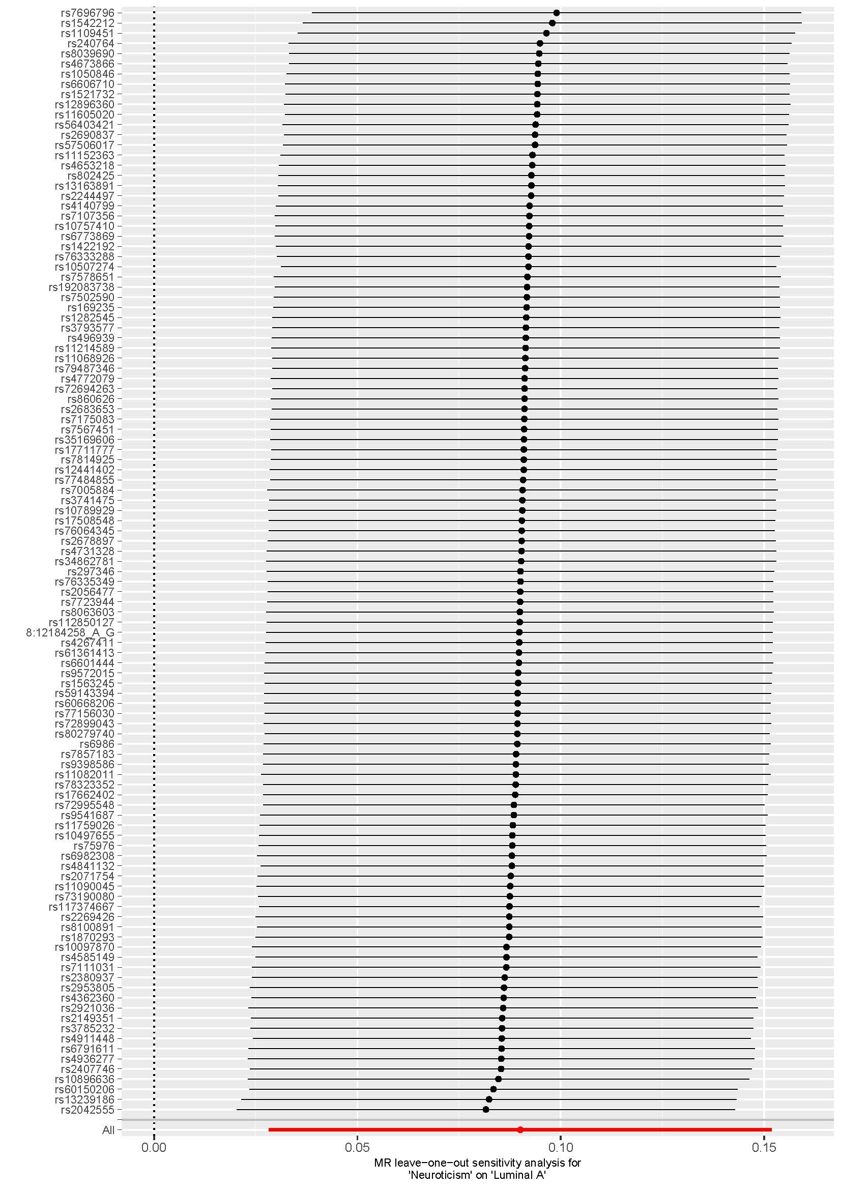

S1-C neuroticism and risk of luminal B like breast cancer
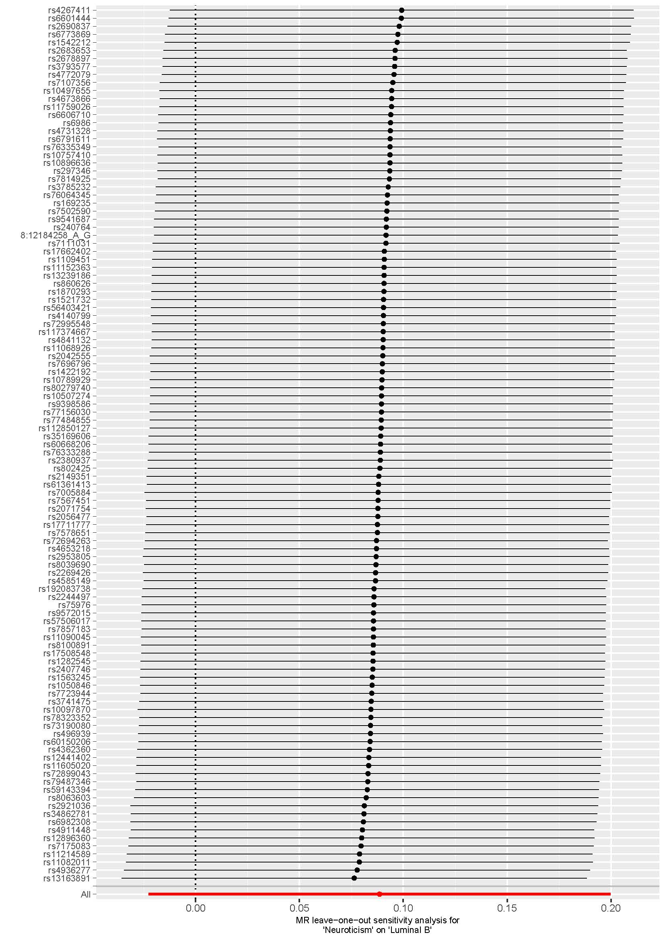

S1-D neuroticism and risk of luminal B HER2- breast cancer
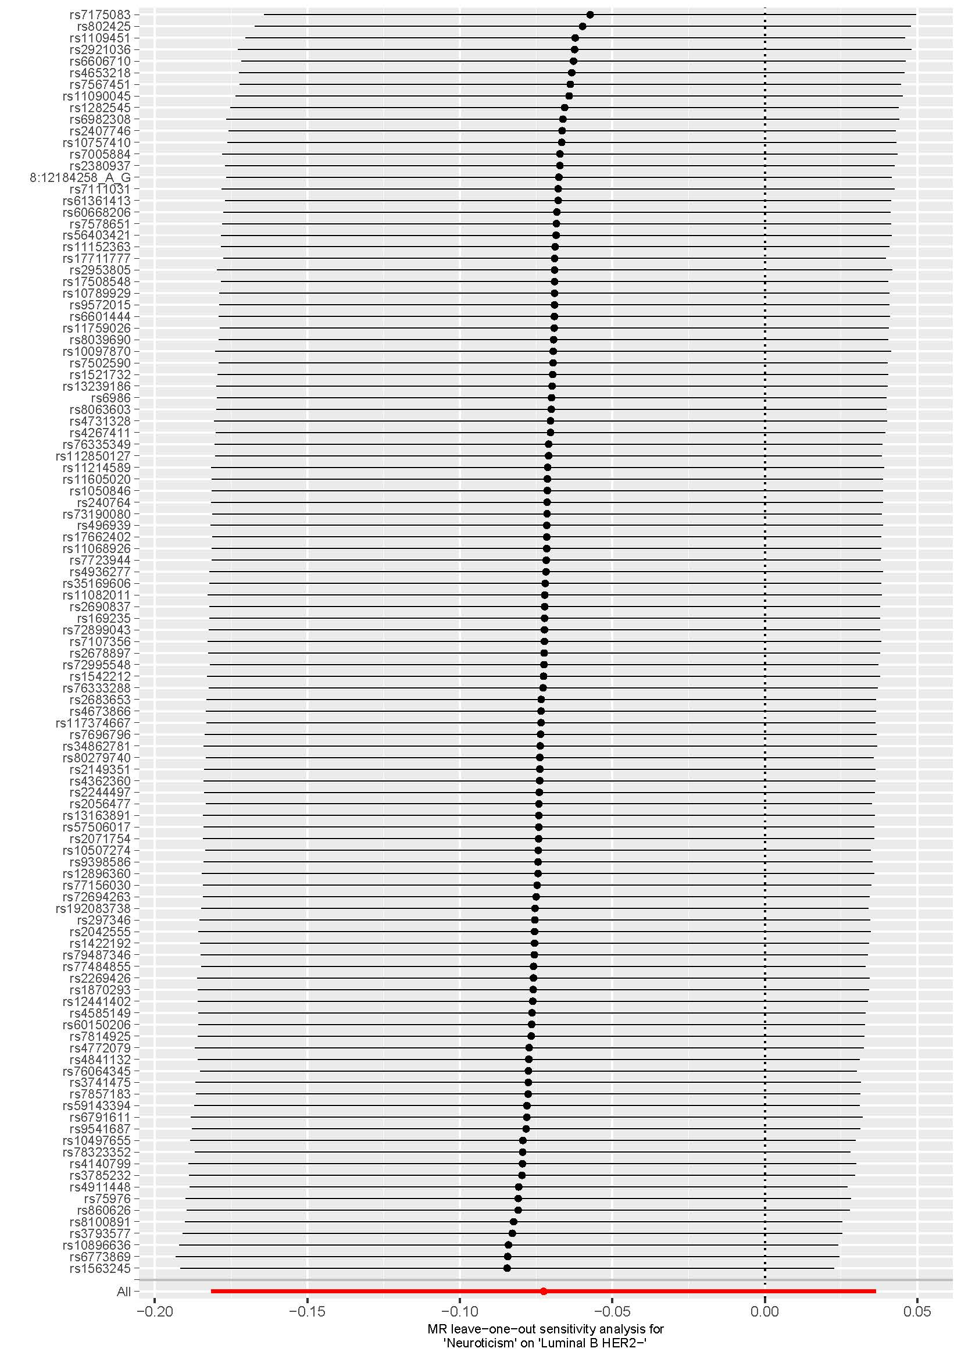

S1-E neuroticism and risk of HER2 enriched breast cancer
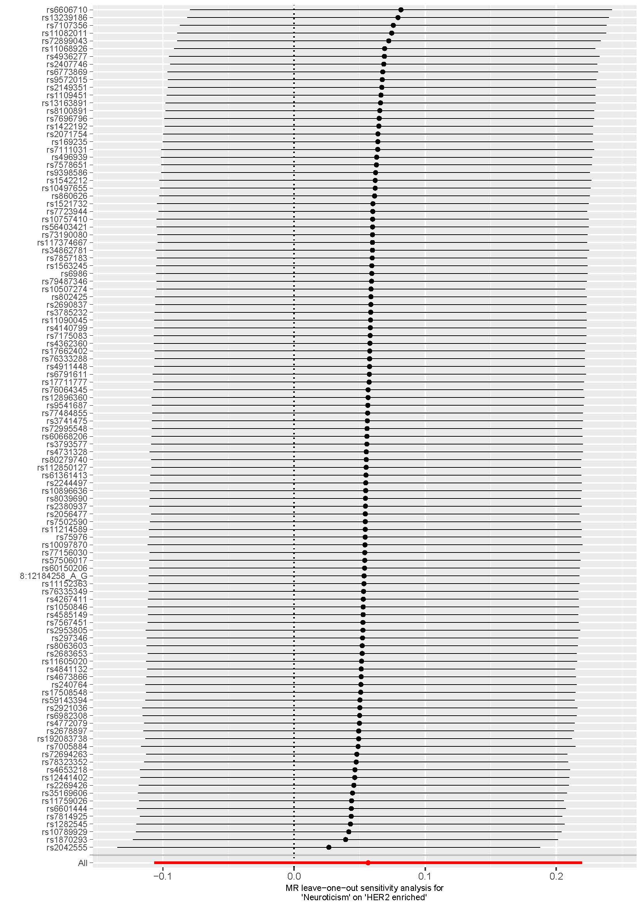

S1-F neuroticism and risk of Triple negative breast cancer
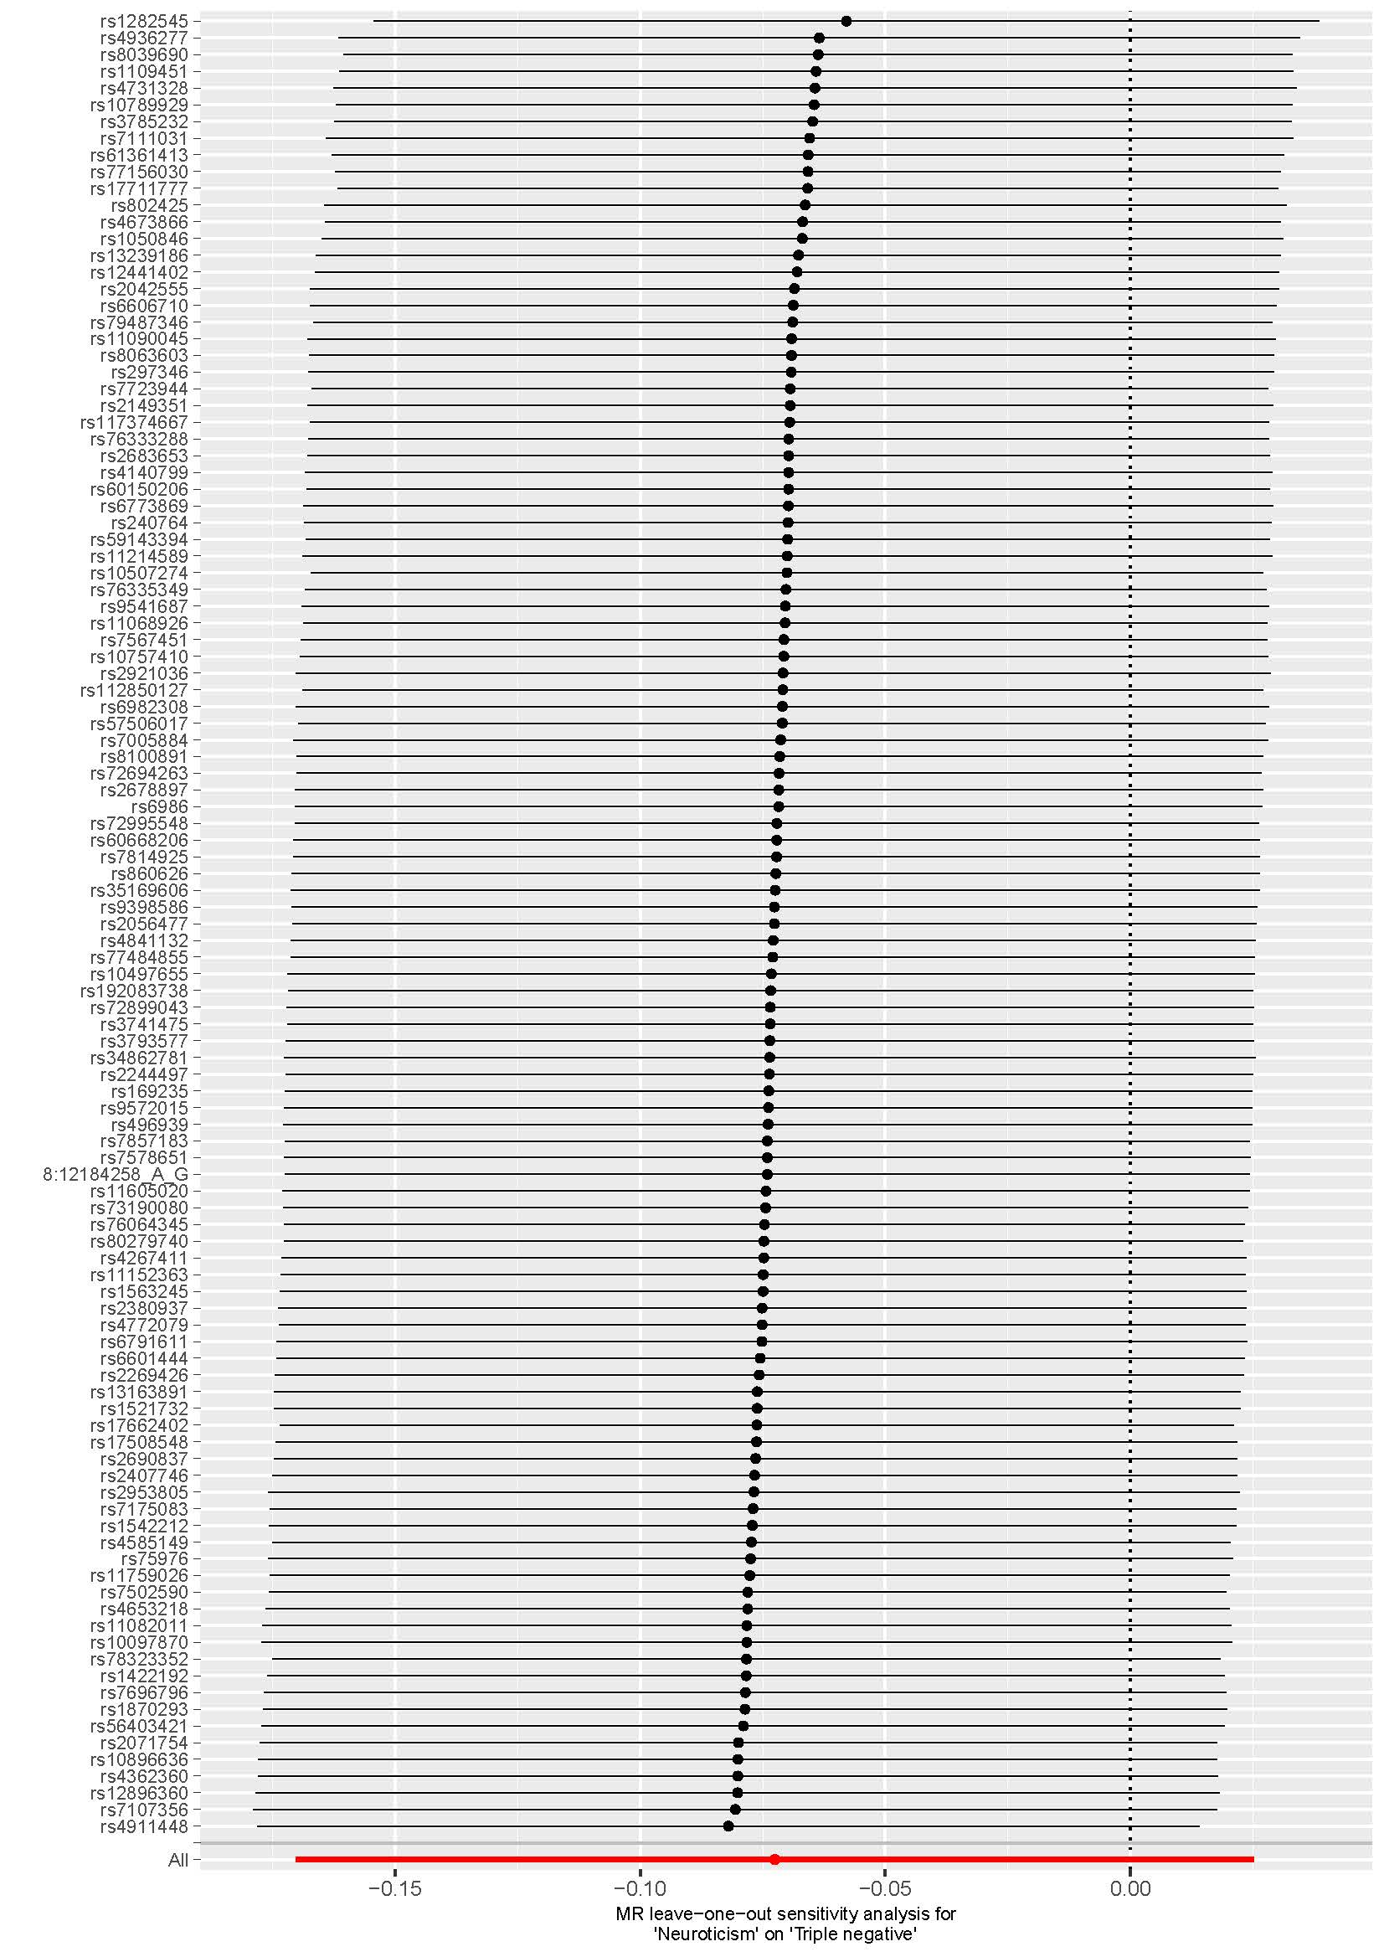

S1-G neuroticism and survival of breast cancer
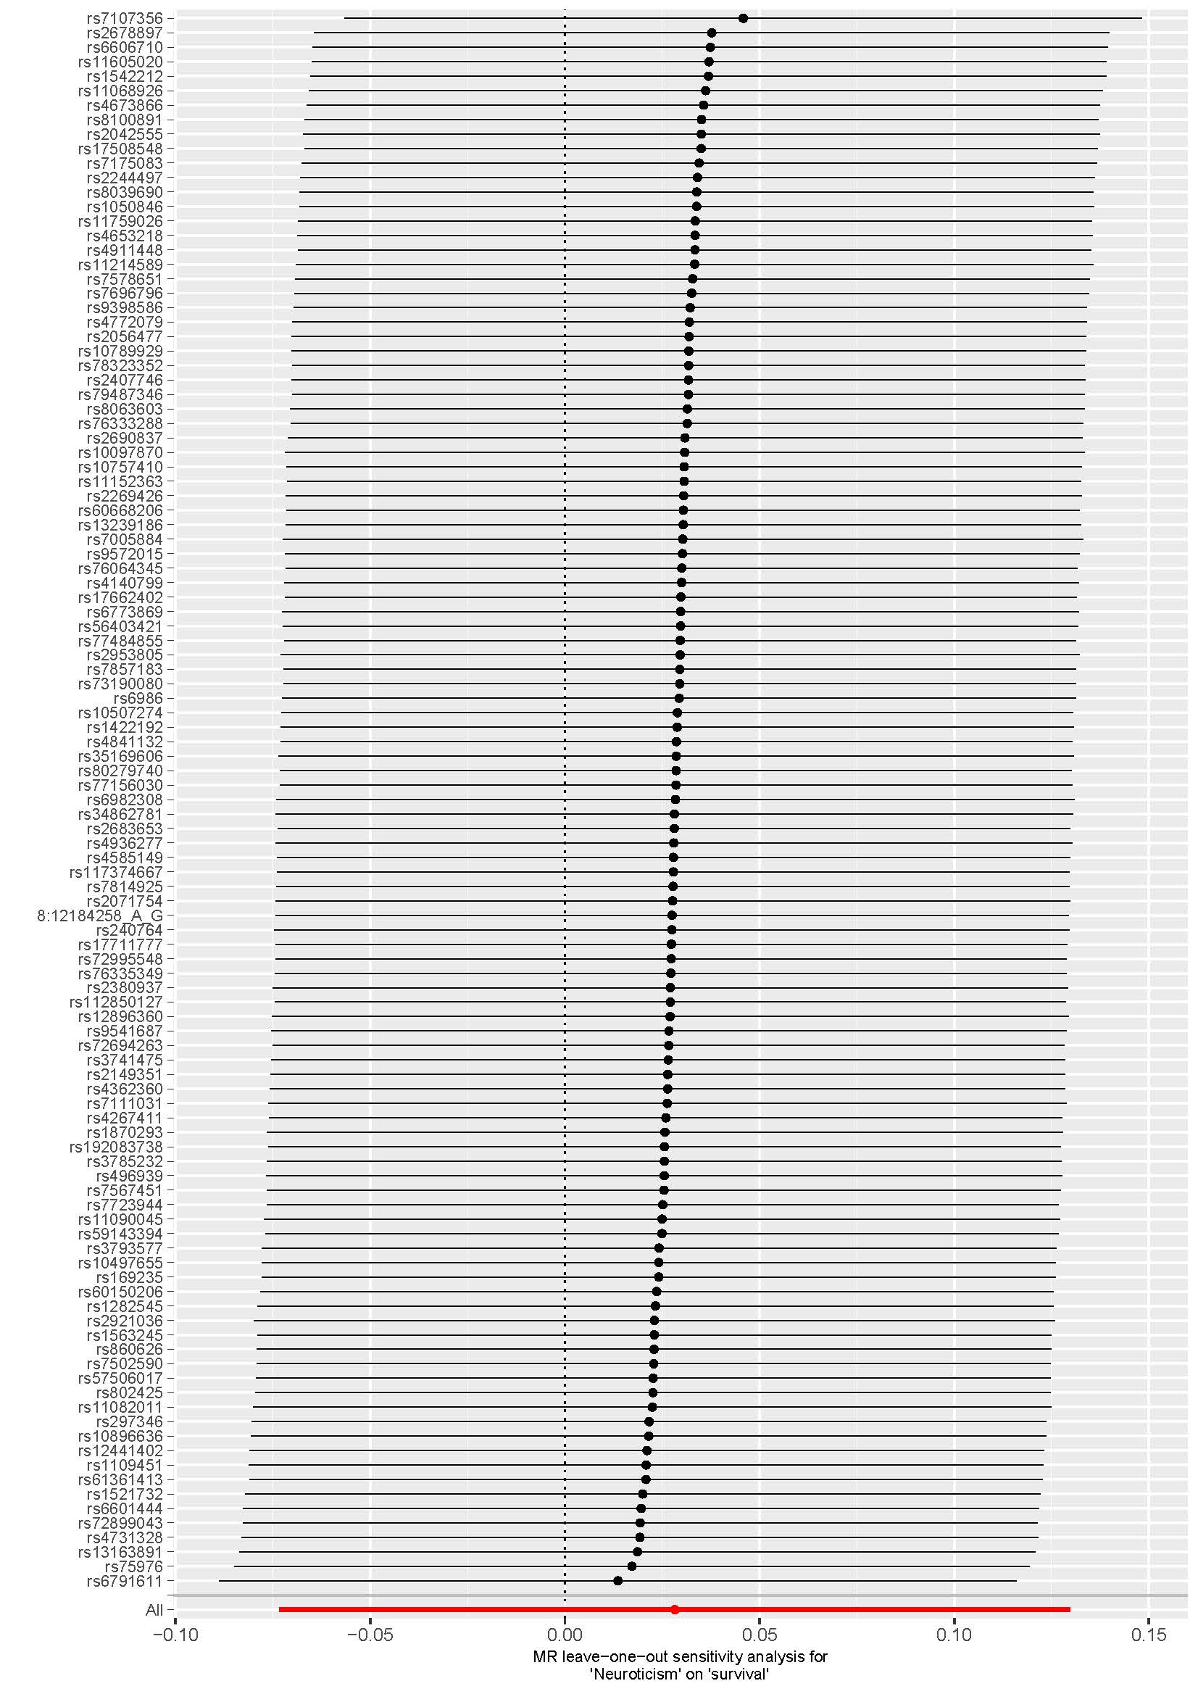

S1-H neuroticism and survival of ER+ breast cancer
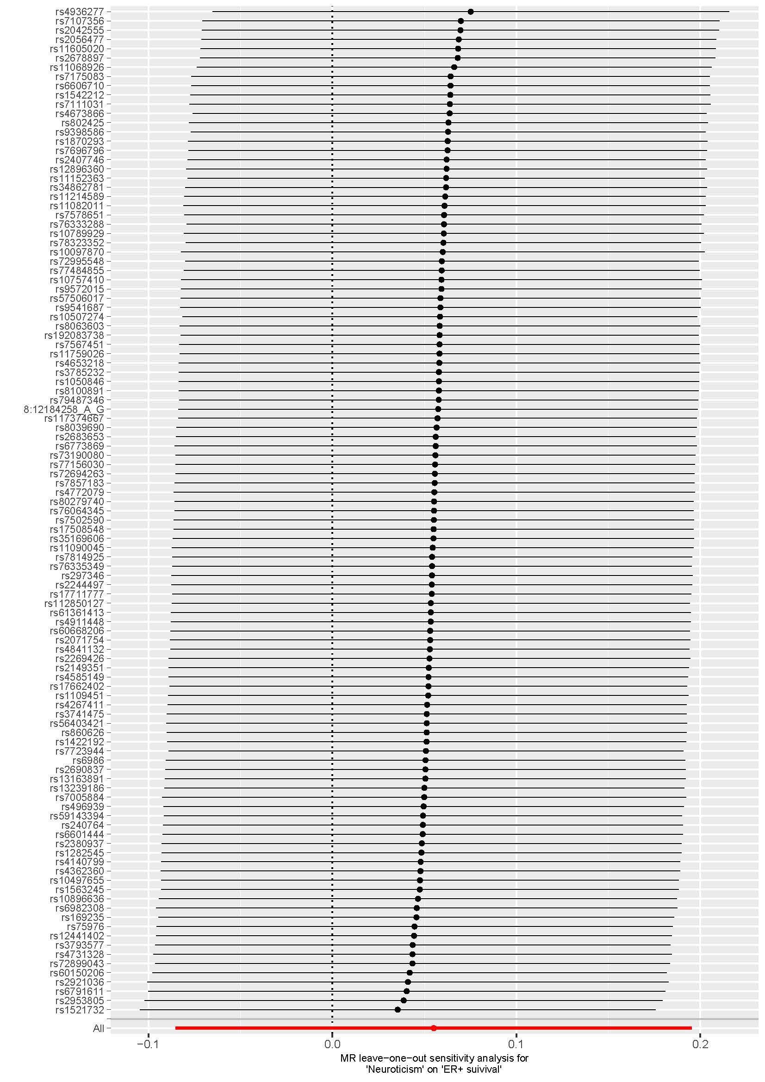

S1-I neuroticism and survival of ER- breast cancer
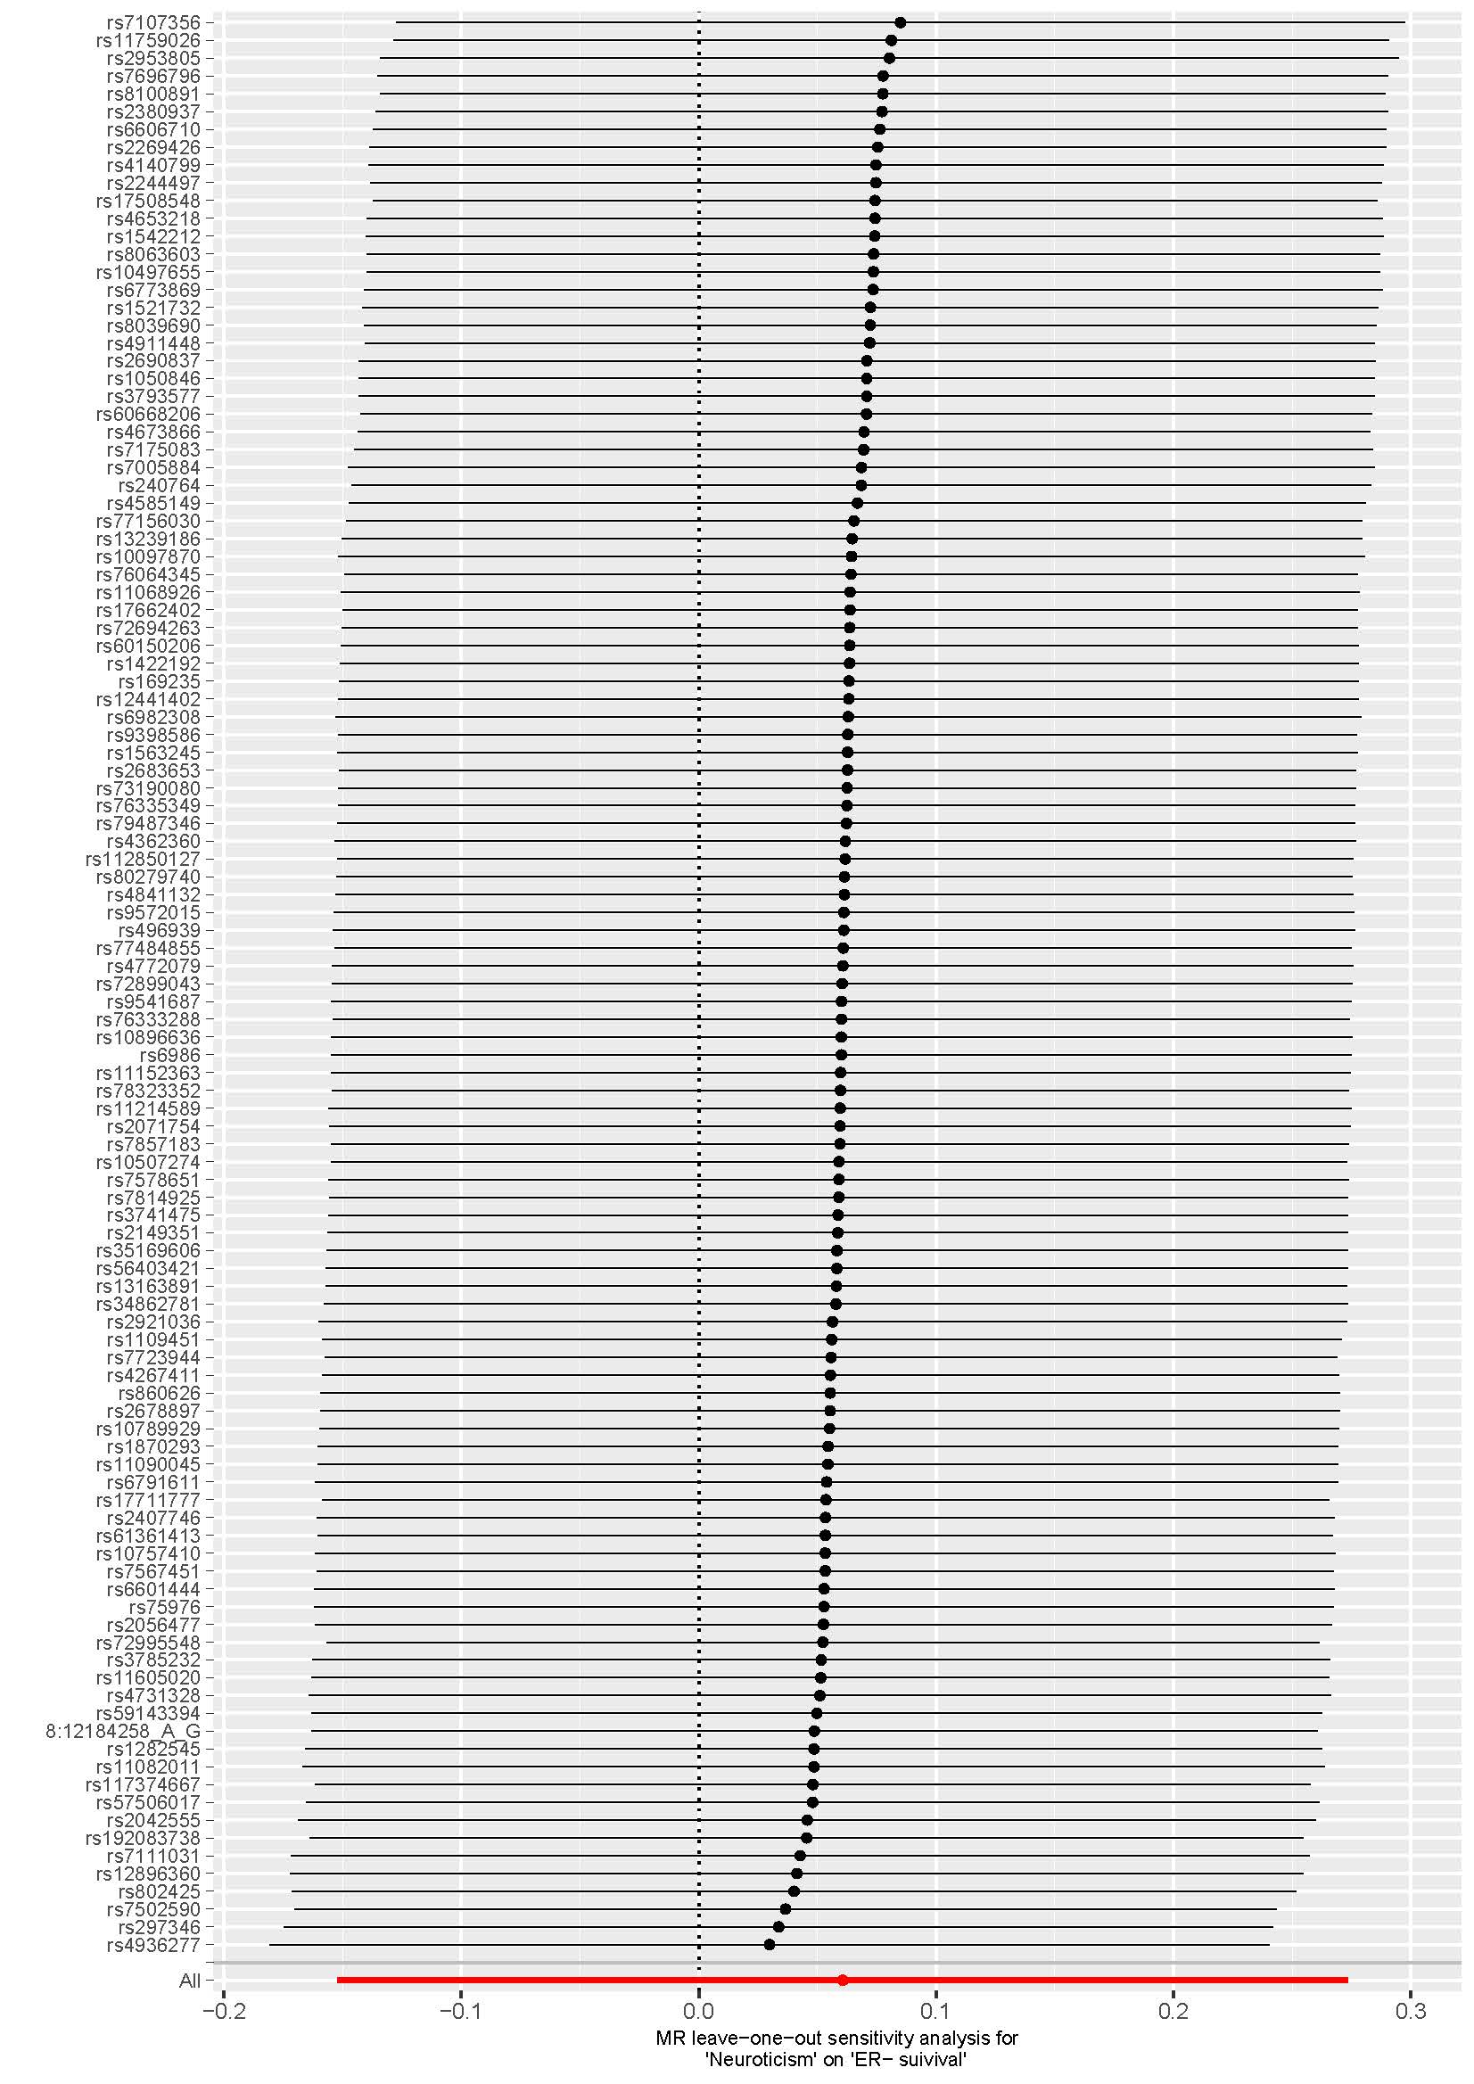

Figure S2. Leave-one-out analysis for extraversion and breast cancer
S2-A extraversion and risk of breast cancer
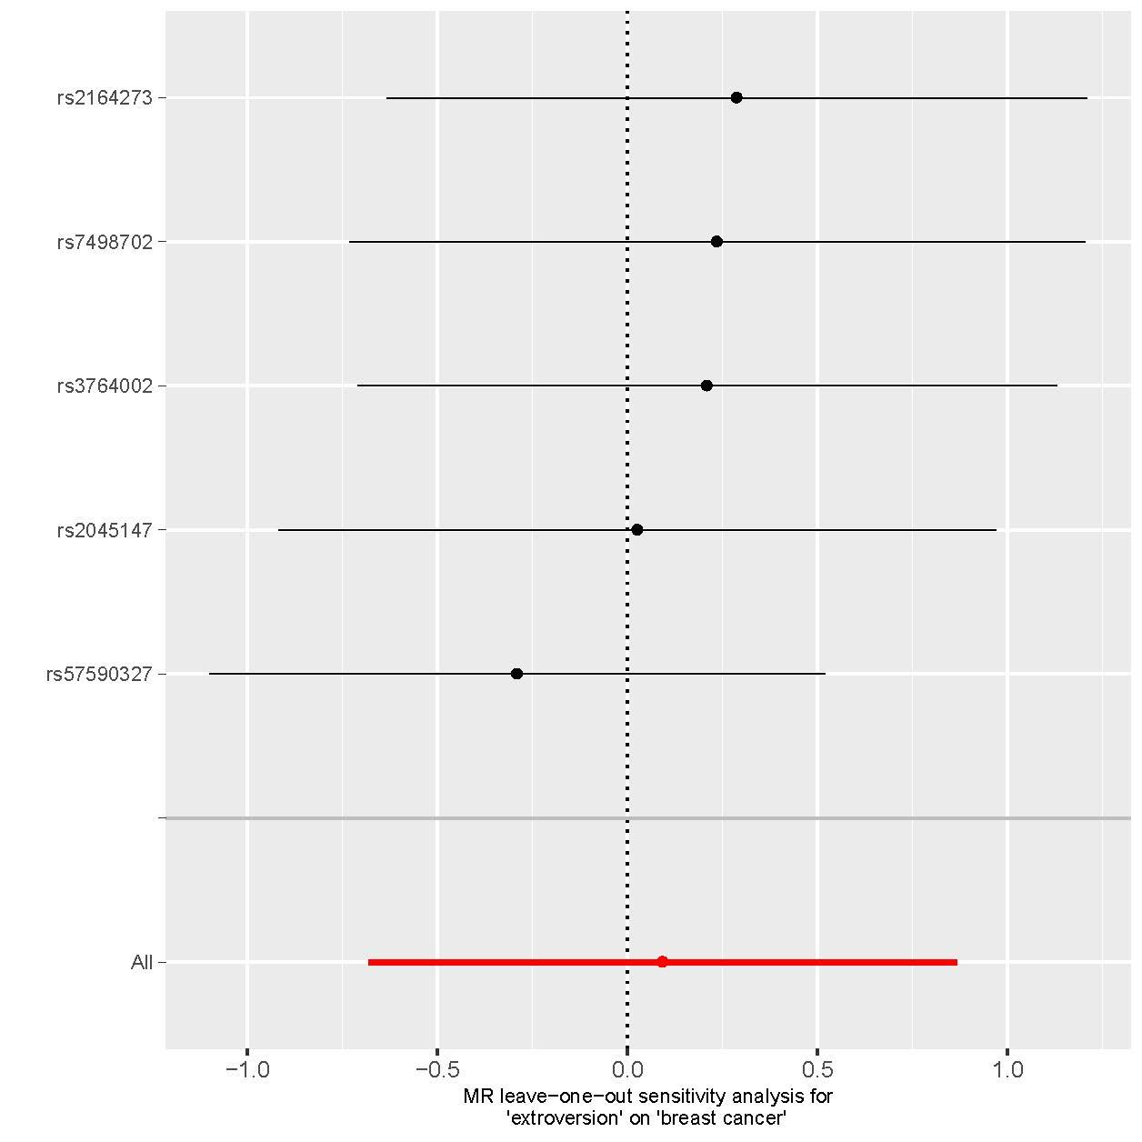

S2-B extraversion and risk of luminal A like breast cancer
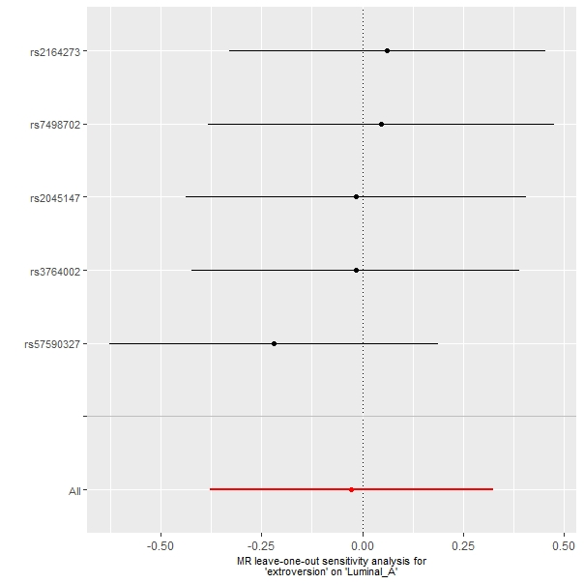

S2-C extraversion and risk of luminal B like breast cancer
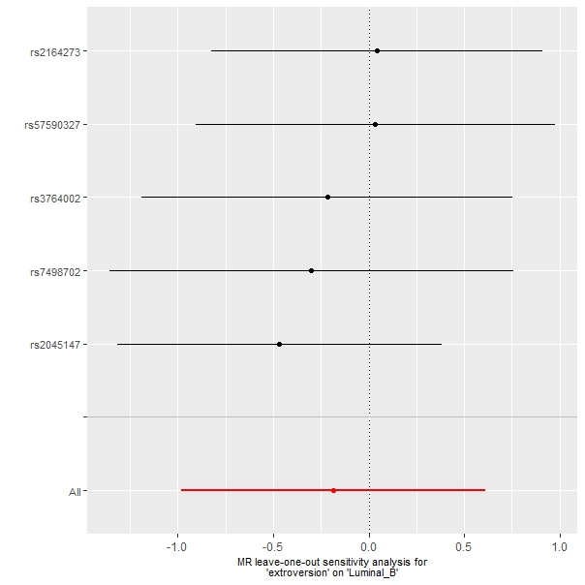

S2-D extraversion and risk of luminal B HER2- breast cancer
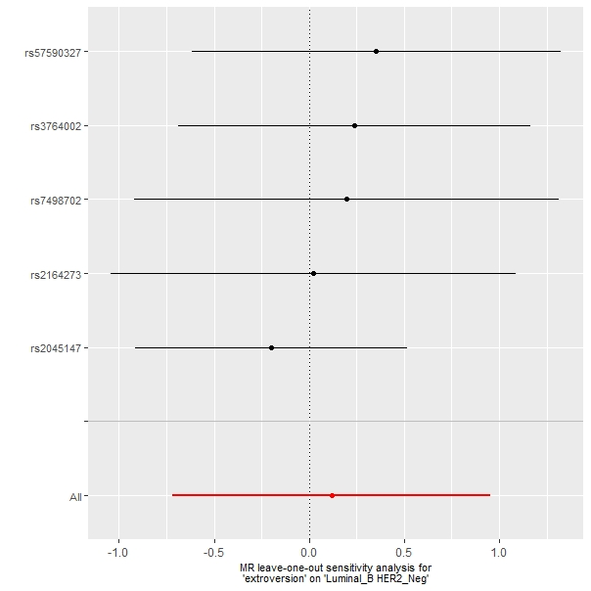

S2-E extraversion and risk of HER2 enriched breast cancer
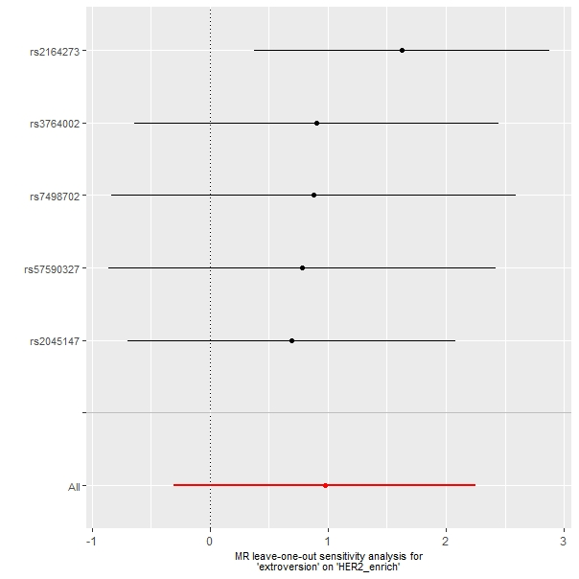

S2-F extraversion and risk of Triple negative breast cancer
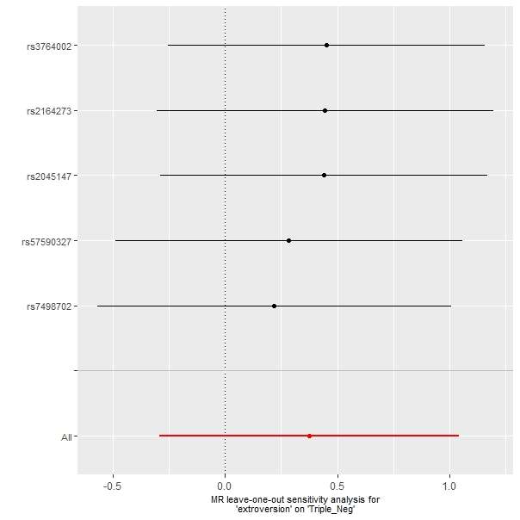

S2-G extraversion and survival of breast cancer
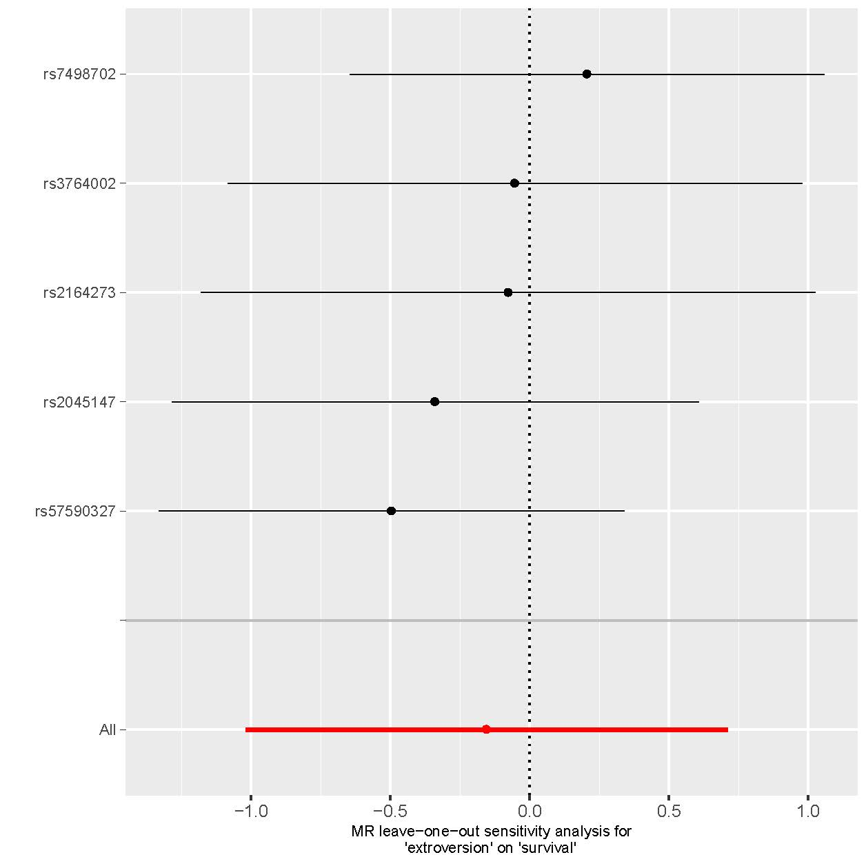

S2-H extraversion and survival of ER+ breast cancer
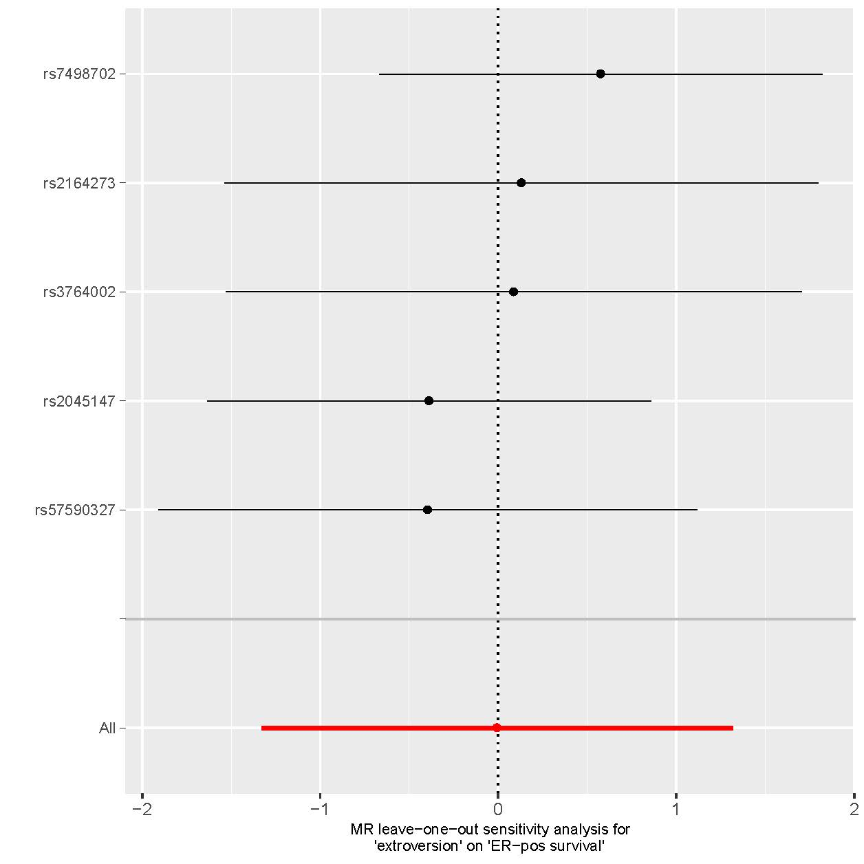

S2-I extraversion and survival of ER- breast cancer
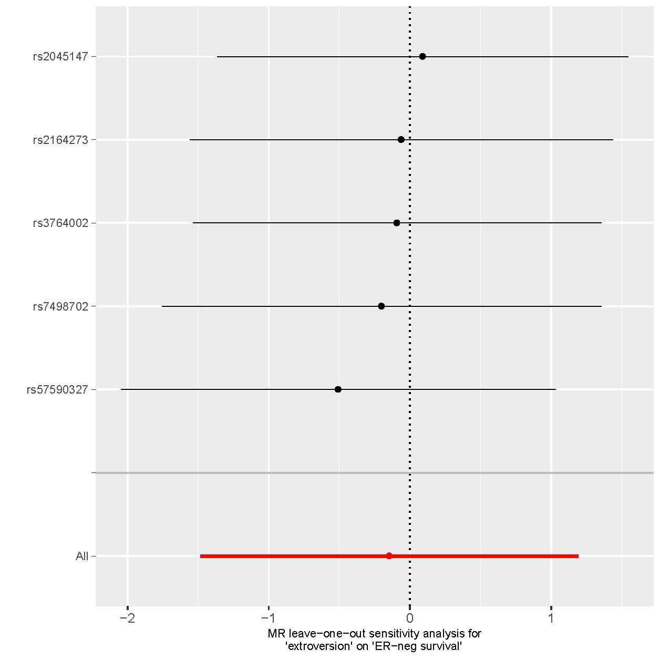

Figure S3. Funnel plot of neuroticism and breast cancer
S3-A neuroticism and risk of breast cancer
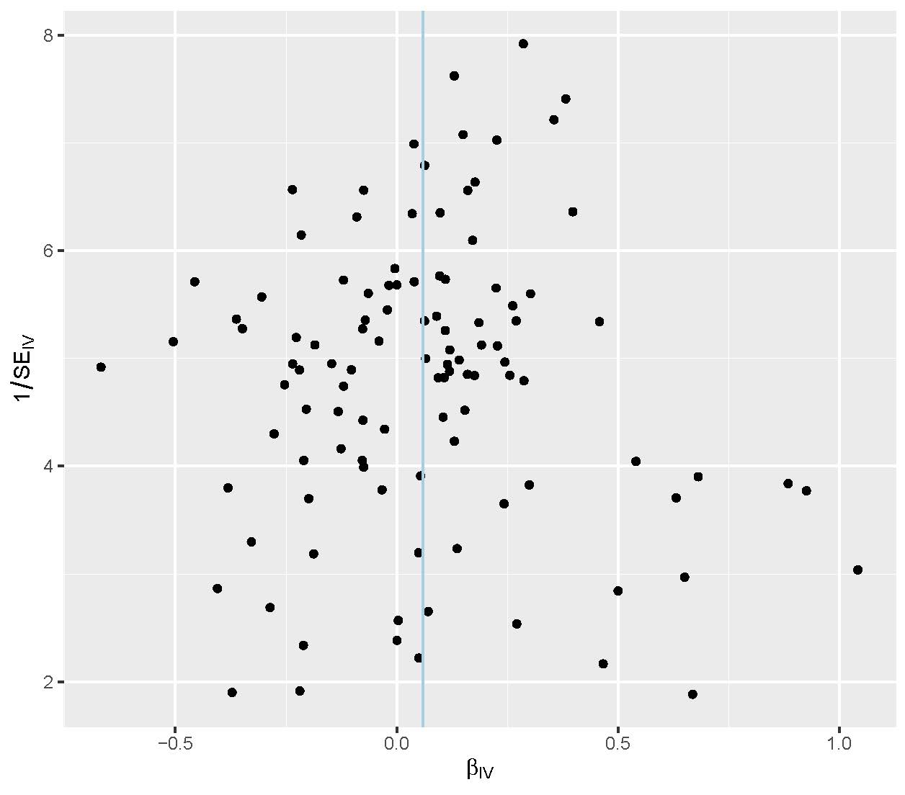
S3-B neuroticism and risk of luminal A like breast cancer
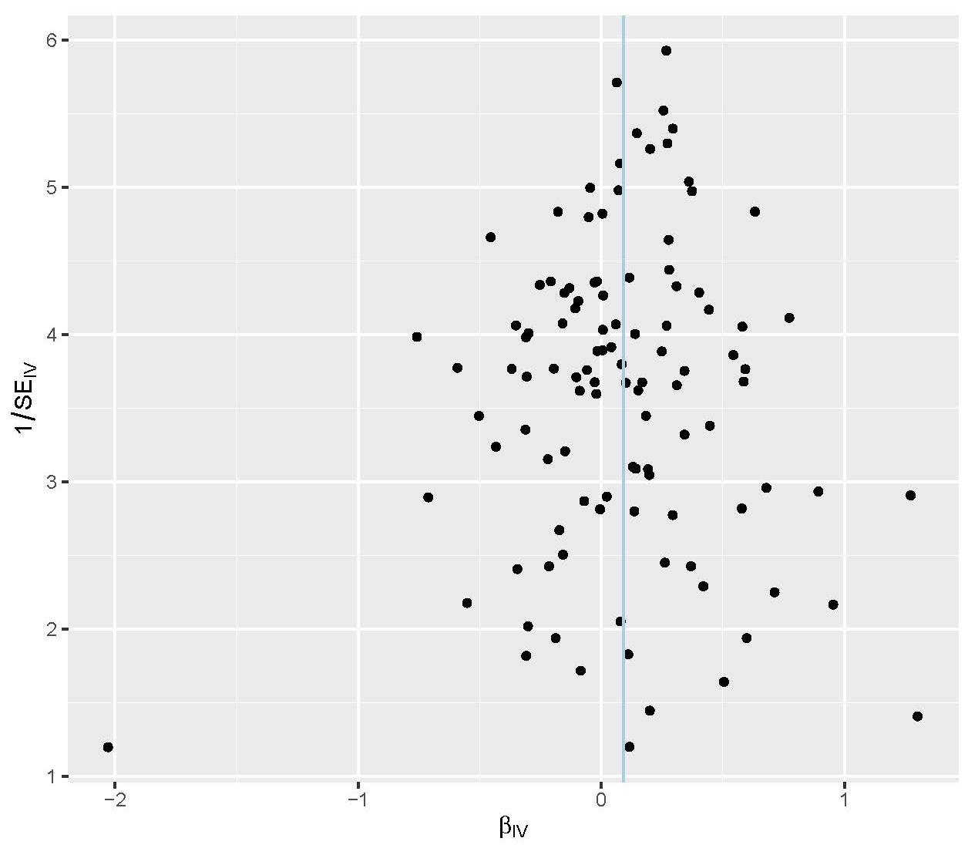
S3-C neuroticism and risk of luminal B like breast cancer
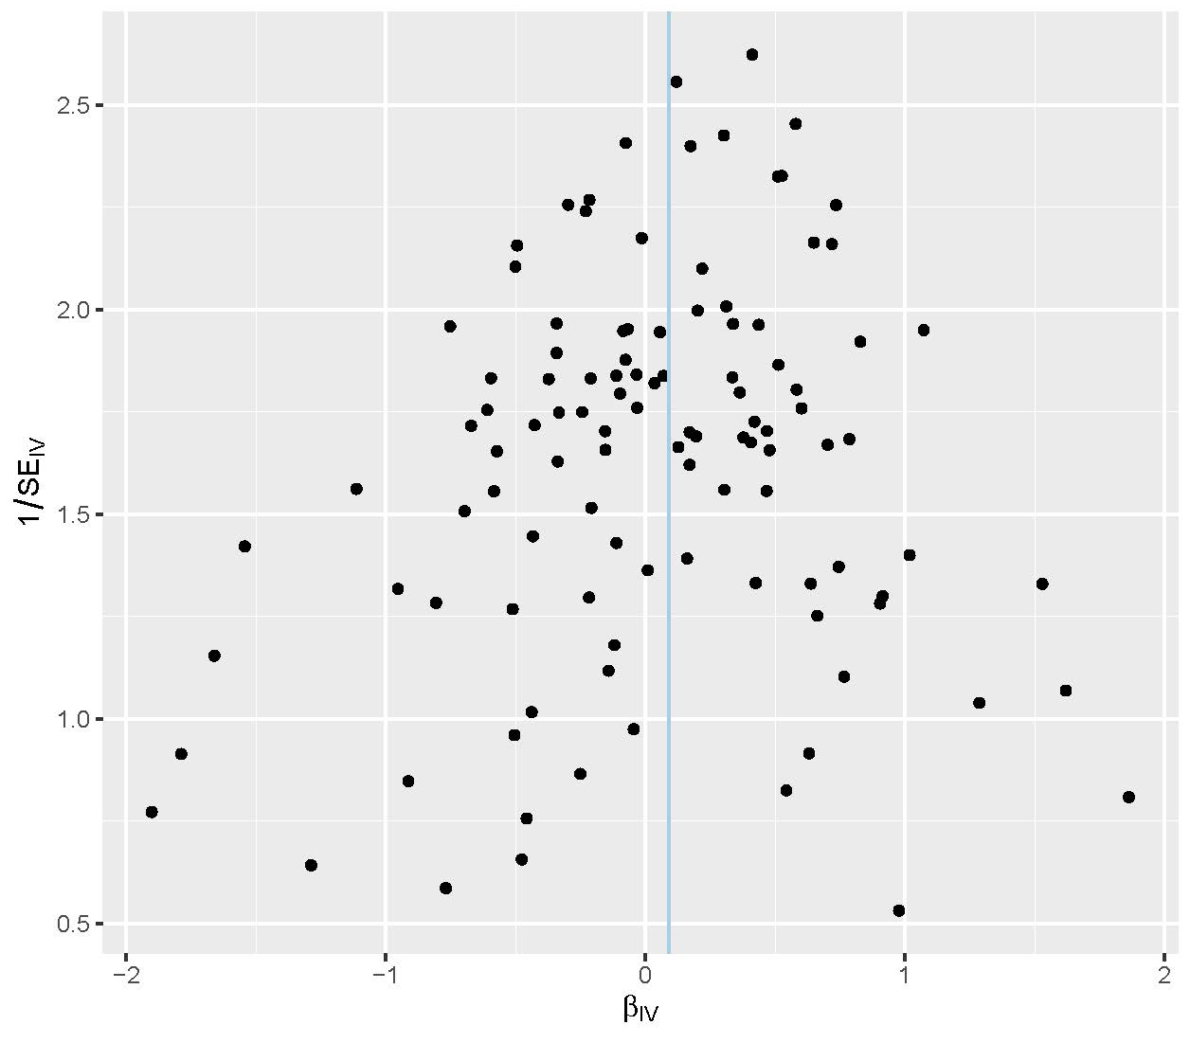
S3-D neuroticism and risk of luminal B HER2- breast cancer
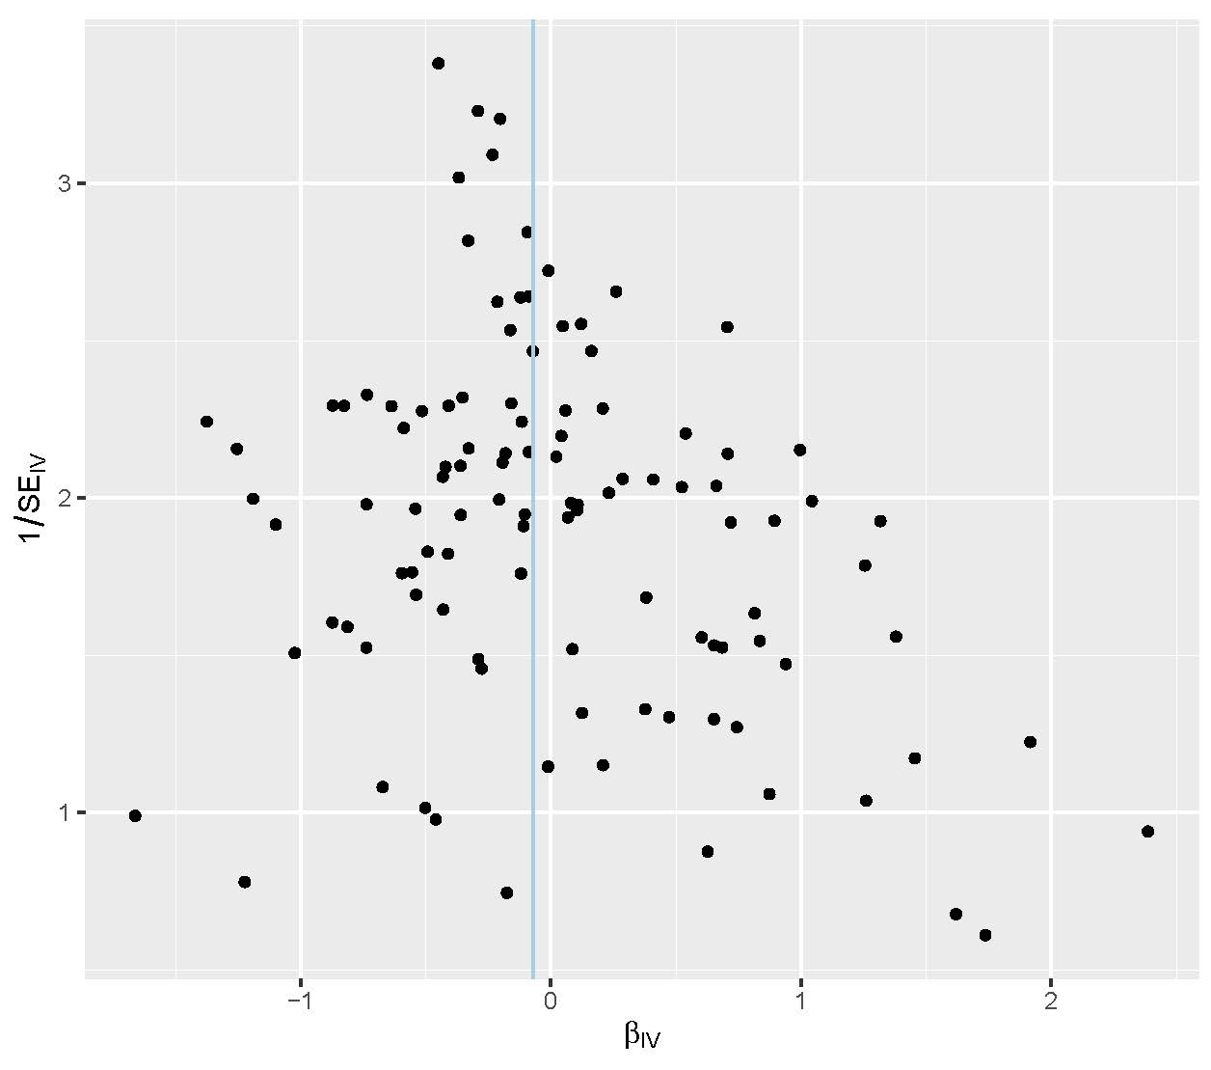
S3-E neuroticism and risk of HER2 enriched breast cancer
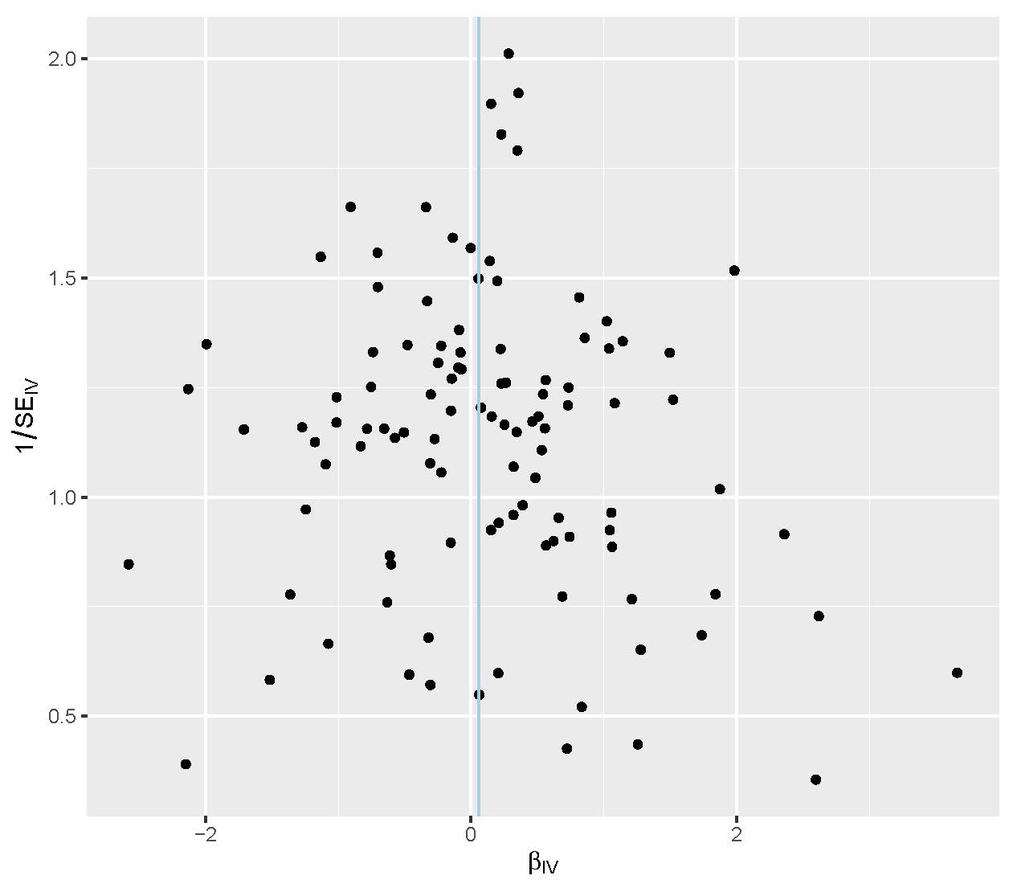
S3-F neuroticism and risk of Triple negative breast cancer
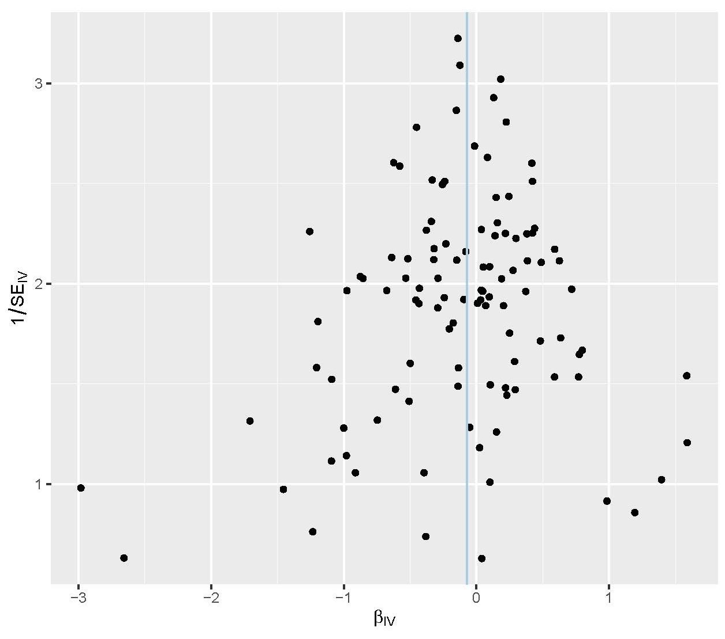
S3-G neuroticism and survival of breast cancer
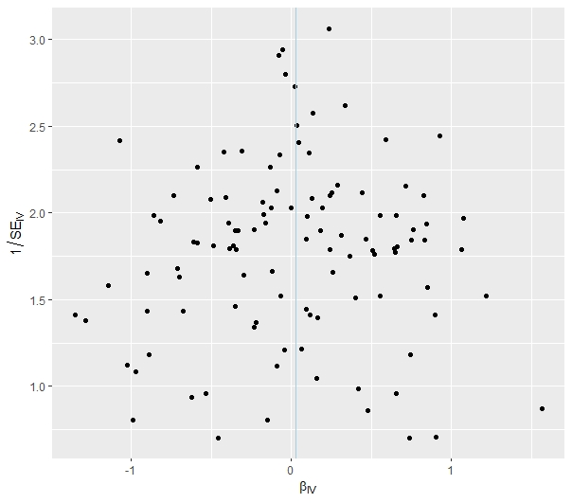

S3-H neuroticism and survival of ER+ breast cancer
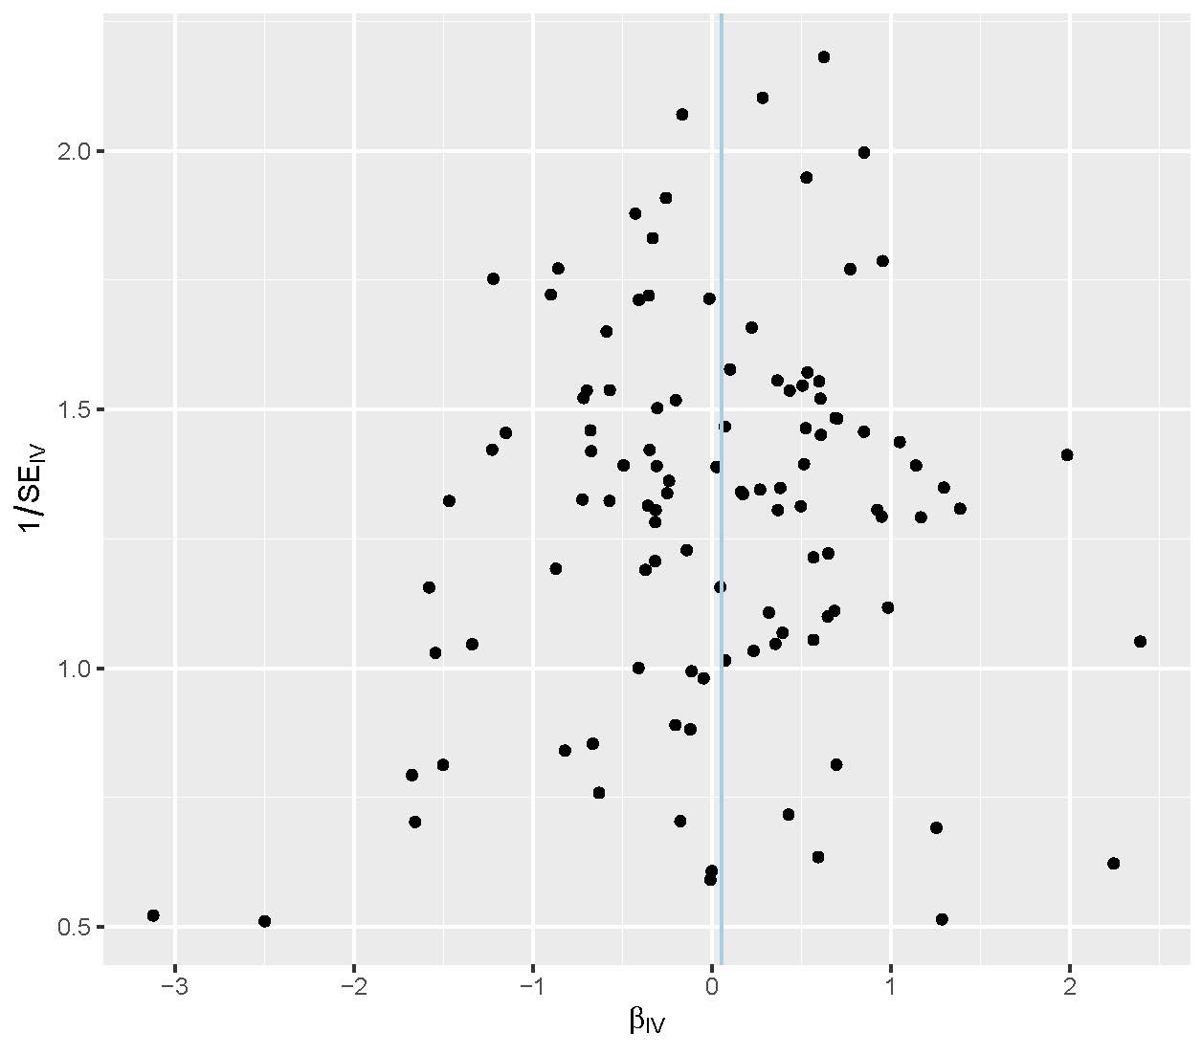
S3-I neuroticism and survival of ER- breast cancer
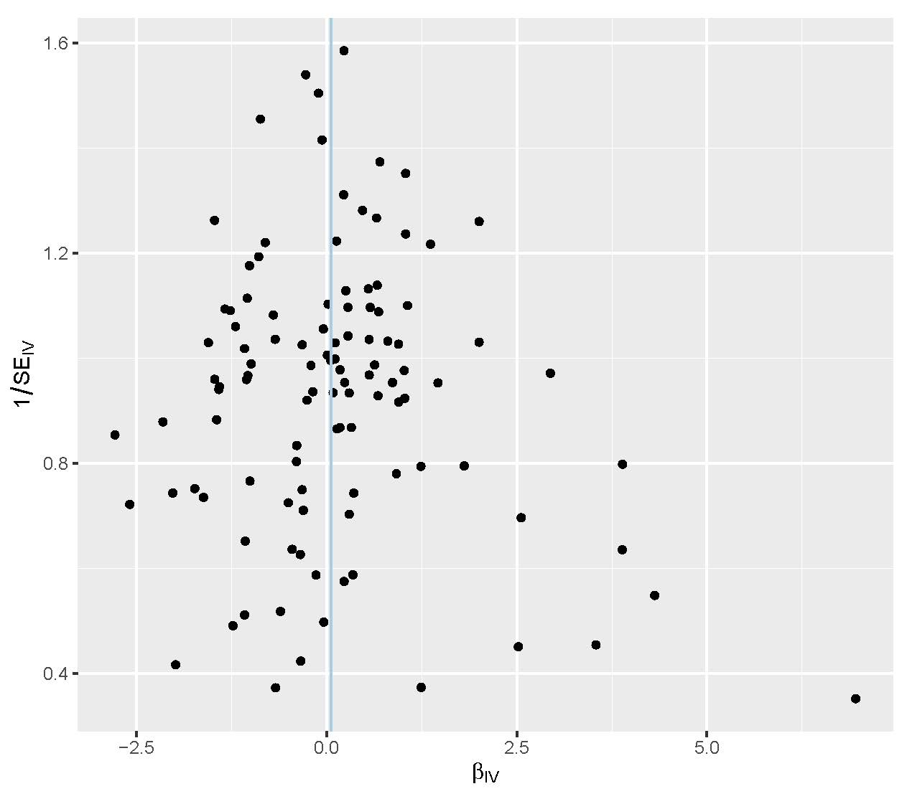

Figure S4. Funnel plot of extraversion and breast cancer
S4-A extraversion and risk of breast cancer
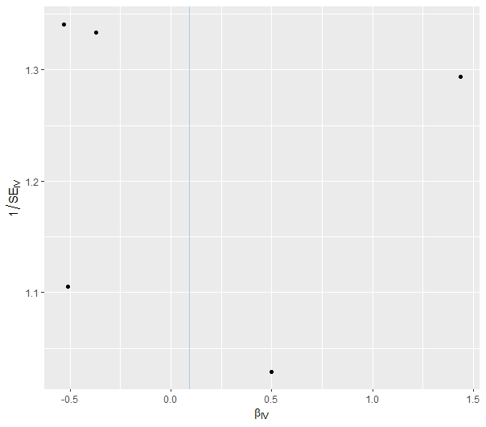

S4-B extraversion and risk of luminal A like breast cancer
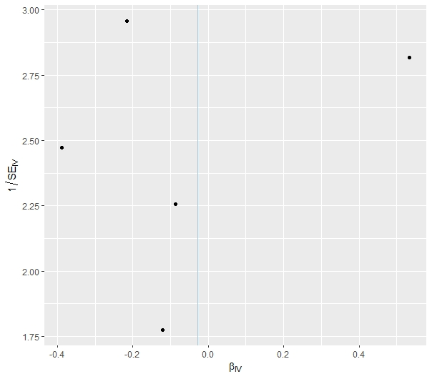

S4-C extraversion and risk of luminal B like breast cancer
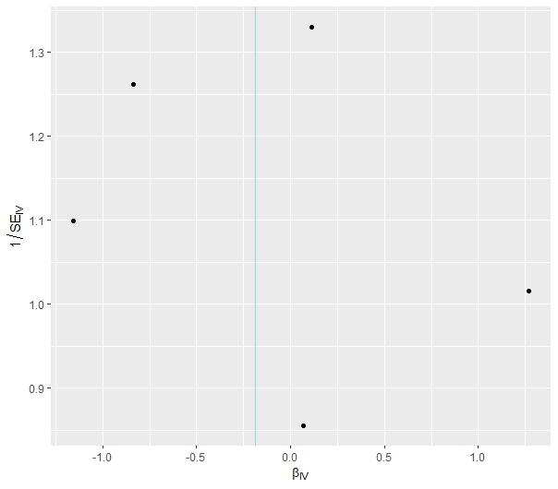

S4-D extraversion and risk of lumina B HER2- breast cancer
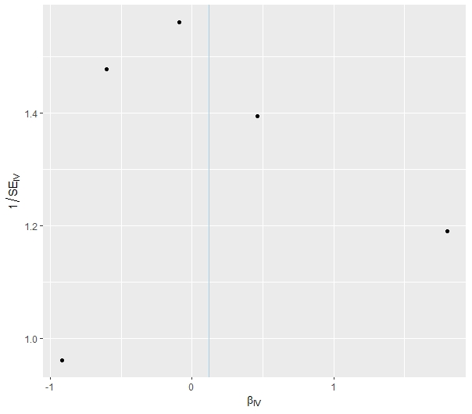

S4-E extraversion and risk of HER2 enriched breast cancer
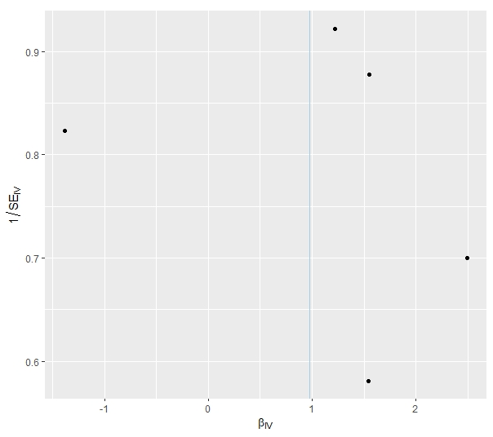

S4-F extraversion and risk of Triple negative breast cancer
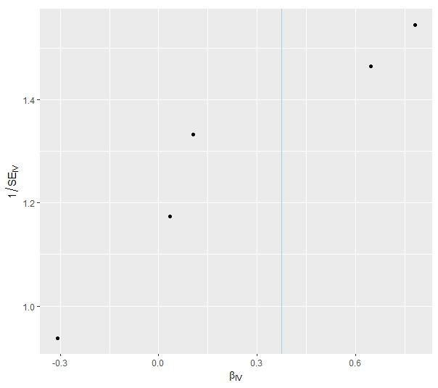

S4-G extraversion and survival risk of breast cancer
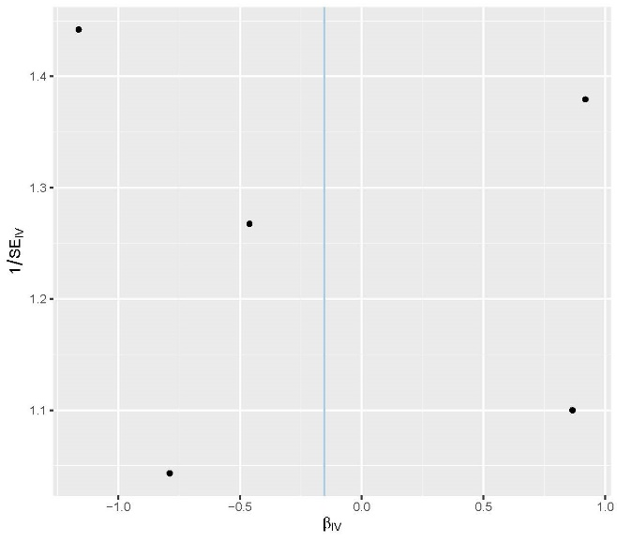

S4-H extraversion and survival risk of ER+ breast cancer
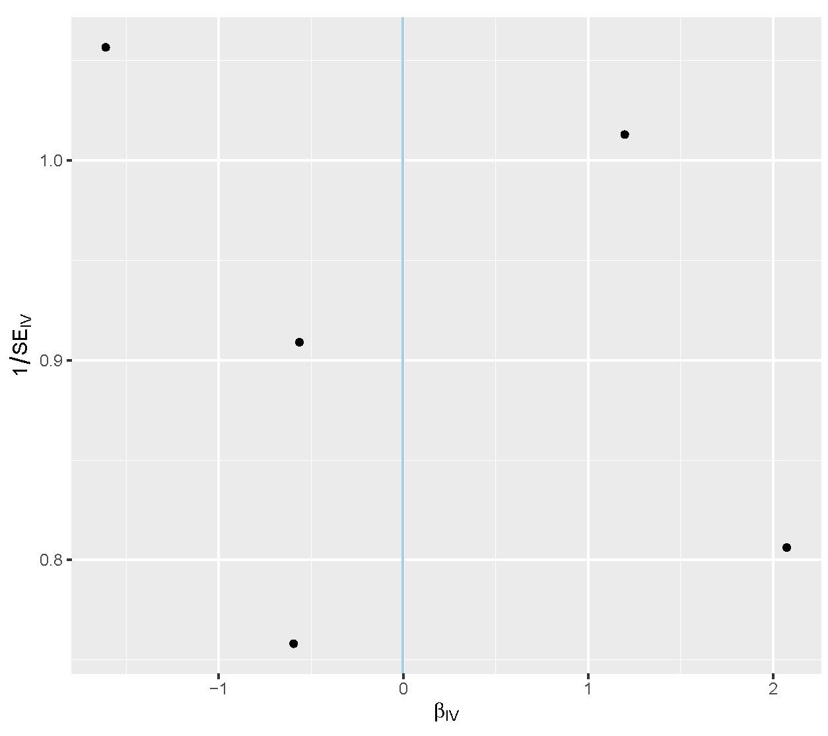

S4-I extraversion and survival risk of ER- breast cancer
