**Supplemental Material**

**List of Supplemental Tables**

eTable 1 in the Supplement: Database searches

eTable 2 in the Supplement: Quality assessment

eTable 1 in the Supplement: Database searches

|  |  |
| --- | --- |
| PubMed | "Bipolar Disorder"[Mesh Terms] OR “Bipolar Disorder”[Title/Abstract] OR "Schizophrenia"[Mesh Terms] OR Schizophrenia[Title/Abstract] OR "Depressive Disorder, Major"[Mesh Terms] OR “Depressive Disorder, Major” [Title/Abstract] OR “Major Depressive Disorder” [Title/Abstract] OR “Major Depression”[Title/Abstract] OR “Serious Mental Illness”[Title/Abstract] OR “Severe Mental Illness” [Title/Abstract]  **AND**  suicid*[Title/Abstract] OR mortalit*[Title/Abstract] OR death*[Title/Abstract]  **AND**  cohort[Title/Abstract] OR longitudinal[Title/Abstract] OR retrospective[Title/Abstract] OR prospective[Title/Abstract] OR follow-up[Title/Abstract] |
| Web of Science | TS=(“bipolar disorder” OR schizophrenia OR “major depression” OR “major depressive disorder” OR “depressive disorder, major” OR “serious mental illness” OR “severe mental illness”)  **AND**  TS=(suicid* OR mortalit* OR death*)  **AND**  TS=(cohort OR longitudinal OR retrospective OR prospective OR follow-up) |

eTable 2 in the Supplement: Quality assessment

|  |  |  |  |  |  |  |  |  |  |  |  |  |
| --- | --- | --- | --- | --- | --- | --- | --- | --- | --- | --- | --- | --- |
| Author, year | External Validity Questions | | | | Internal Validity Questions | | | | | | Total  Score | Risk of bias |
| 1 | 2 | 3 | 4 | 5 | 6 | 7 | 8 | 9 | 10 |
| Antolín-Concha et al, 2020 | √ | √ | √ | √ | × | √ | √ | √ | √ | √ | 1 | Low |
| Díaz-Fernández et al, 2020 | × | × | × | √ | √ | √ | √ | √ | √ | √ | 3 | Low |
| Lin et al, 2019 | √ | √ | √ | √ | × | √ | √ | √ | × | √ | 2 | Low |
| Plans et al, 2019 | × | √ | × | √ | √ | × | √ | √ | √ | √ | 3 | Low |
| Almeida et al, 2018 | √ | × | √ | × | × | √ | √ | √ | √ | √ | 3 | Low |
| Hansson et al, 2018 | √ | √ | √ | √ | × | √ | √ | √ | × | √ | 2 | Low |
| Persons et al, 2018 | √ | × | × | × | × | × | √ | √ | √ | √ | 5 | Moderate |
| Hayes et al, 2017 | √ | √ | × | √ | × | √ | √ | √ | √ | √ | 2 | Low |
| Kim et al, 2017 | √ | √ | √ | √ | × | √ | √ | √ | √ | √ | 1 | Low |
| Østergaard et al, 2017 | √ | √ | √ | √ | × | × | √ | √ | √ | √ | 2 | Low |
| Kaplan et al, 2016 | × | × | × | × | √ | √ | √ | √ | √ | √ | 4 | Moderate |
| Olfson et al, 2015 | √ | √ | √ | √ | × | √ | √ | √ | × | √ | 2 | Low |
| Björkenstam et al, 2014 | √ | √ | √ | √ | × | √ | √ | √ | × | √ | 2 | Low |
| Isometsä et al, 2014 | √ | √ | √ | √ | × | √ | √ | √ | √ | √ | 1 | Low |
| Crump et al, 2013 | √ | √ | √ | √ | × | √ | √ | √ | √ | √ | 1 | Low |
| Kiviniemi et al, 2013 | √ | √ | × | √ | × | √ | √ | √ | √ | √ | 2 | Low |
| Abdel-Baki et al, 2011 | × | √ | × | × | √ | √ | √ | √ | √ | √ | 3 | Low |
| Ceskova et al, 2011 | × | × | × | × | √ | √ | √ | √ | √ | √ | 4 | Moderate |
| Dennehy et al, 2011 | × | × | × | × | √ | × | √ | √ | × | √ | 6 | Moderate |
| Høye et al, 2011 | × | √ | × | × | √ | √ | √ | √ | √ | √ | 3 | Low |
| Teferra et al, 2011 | × | √ | √ | √ | × | √ | √ | × | √ | √ | 3 | Low |
| Webb et al, 2011 | √ | √ | √ | √ | × | √ | √ | √ | √ | √ | 1 | Low |
| Carlborg et al, 2010 | × | √ | × | × | × | √ | √ | √ | √ | √ | 4 | Moderate |
| Loas et al, 2009 | × | √ | × | × | √ | × | √ | √ | √ | √ | 4 | Moderate |
| Lui et al, 2009 | × | √ | × | × | √ | √ | √ | √ | × | √ | 4 | Moderate |
| Ran et al, 2009 | × | × | × | × | × | × | √ | √ | √ | √ | 6 | Moderate |
| Dutta et al, 2007 | × | √ | √ | √ | × | √ | √ | √ | √ | √ | 2 | Low |
| Limosin et al, 2007 | √ | √ | × | × | × | √ | √ | √ | √ | √ | 3 | Low |
| Oquendo et al, 2007 | × | × | × | × | √ | √ | √ | √ | × | √ | 5 | Moderate |
| Simon et al, 2007 | × | √ | × | × | √ | √ | √ | √ | × | √ | 4 | Moderate |
| Tseng et al, 2006 | × | × | × | × | √ | × | √ | √ | × | √ | 6 | Moderate |
| Coryell et al, 2005 | √ | √ | × | × | × | × | √ | √ | √ | √ | 4 | Moderate |
| Osby et al, 2001 | √ | √ | √ | √ | × | √ | √ | √ | √ | √ | 1 | Low |
| Schneider et al, 2001 | × | √ | × | × | √ | × | √ | √ | √ | √ | 4 | Moderate |
| Brown et al, 2000 | √ | √ | × | × | √ | × | √ | √ | √ | √ | 3 | Low |
| Tsai et al, 1999 | × | √ | × | × | √ | √ | √ | √ | √ | √ | 3 | Low |
| Wiersma et al, 1998 | × | √ | × | × | √ | √ | √ | √ | √ | √ | 3 | Low |
| Black et al, 1992 | × | √ | × | × | × | √ | √ | √ | √ | √ | 4 | Moderate |
| Newman et al, 1991 | √ | √ | × | × | × |  | √ | √ | √ | √ | 3 | Low |
| Tsoi et al, 1991 | × | × | × | × | × | √ | √ | √ | √ | √ | 5 | Moderate |
| Allebeck et al, 1986 | × | √ | √ | × | × | √ | √ | √ | √ | √ | 3 | Low |

**List of Supplemental Figure**

eFigure 1 in the Supplement: Funnel Plot of Suicide Rate Among People with Serious Mental Illness

eFigure 2 in the Supplement: Meta-regression Analyses for (A) Year of Publication (B) Mean Age (C) Proportion of female

eFigure 3 in the Supplement: Global Suicide Rates Among People with Serious Mental Illness According to Psychiatric Diagnosis

eFigure 4 in the Supplement: Suicide Rate Ratios (males: females) by Psychiatric Diagnosis

eFigure 1 in the Supplement: Funnel Plot of Suicide Rate Among People with Serious Mental Illness



eFigure 2 in the Supplement: Meta-regression Analyses for (A) Year of Publication (B) Mean Age (C) Proportion of female



A



B



C

eFigure 3 in the Supplement: Global Suicide Rates Among People with Serious Mental Illness According to Psychiatric Diagnosis

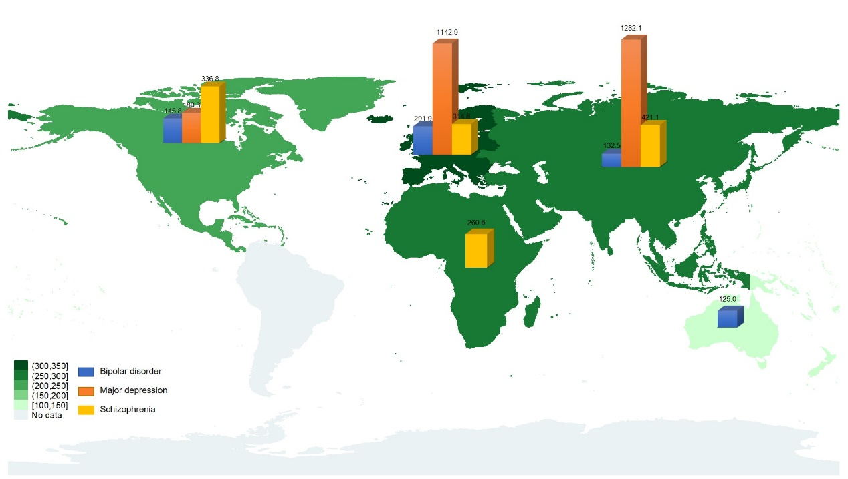

eFigure 4 in the Supplement: Suicide Rate Ratios (males: females) by Psychiatric Diagnosis

