– SUPPLEMENTARY MATERIAL –

Impaired attentional and socio-affective networks in subjects with antisocial behaviors:
A meta-analysis of resting-state functional connectivity studies.

Jules R. Dugré, MSc ^{1,2}, & Stéphane Potvin, PhD ^{1,2}

¹ Research Center of the Institut Universitaire en Santé Mentale de Montréal, Montreal, Canada

² Department of Psychiatry and Addictology, Faculty of medicine, University of Montreal, Montreal, Canada

Corresponding authors
Jules Roger Dugré, PhD Candidate & Stéphane Potvin, PhD;
Research Center of the Institut Universitaire en Santé Mentale de Montréal; 7331 Hochelaga, Montreal, Quebec, Canada; H1N 3V2; Phone: 514-251-4015;
Email: jules.dugre@umontreal.ca / stephane.potvin@umontreal.ca

Table of Contents
Supplementary Figure 1. Flow-chart of the studies included in the meta-analysis……………………….…………3
Method: Additional information………………………………………………………………………………….…...4
Supplementary Table 1. Characteristics and Findings from the Seed-Based Connectivity Studies………………....5
Supplementary Table 2. Characteristics and Findings from the Non-Seed-Based Connectivity Studies…..……….7
Supplementary Table 3. Characteristics and Findings from the Dimensional Connectivity Studies……………….9
Results: Additional information……………………………………………………………………………………..12
Supplementary Figure 2A-J: ROI-Based MACM maps………………………………………………………...…12
Supplementary Table 4. Functional Characterization of significant clusters………………………….……….…..23
Supplementary Table 5. Cross-Correlation Matrix between ROI-based MACM maps……………………………24
Supplementary Table 6. Spatial closeness between ROI-based MACM maps and Intrinsic Networks……….......24

Articles found through data base research:
N= 1240
Articles Screened:
N= 179
Excluded: 17
Not original paper
Abstract 7
Reviews 10

Excluded 109
Methodological issues
Structural imaging 3
Traumatic Brain Injury 12
Schizophrenia 25
Borderline Personality Disorders 3
Other Disorders 47
EEG 3
Other reasons 16
Articles rejected for non-relevance:
N= 994
Articles included in meta-analysis:
(N=53)
SBC: N=18
NSBC: N= 20
F1 Dimension: N= 14
F2 Dimension: N= 19
IMP Dimension: N= 10

Records of duplicates
N= 67

Supplementary Figure 1. Flow-chart of the studies included in the meta-analysis. Other reasons of studies exclusion: task-based connectivity ¹⁻⁵, no case-control analyses AND/OR no dimensional analyses on construct related to F1, F2, or impulsivity AND/OR only between-network analyses ⁶⁻¹⁴, Connectome classification study ¹⁵, MAOA Modulation¹⁶.

METHOD: Additional Information

Section 2.2.3. Subanalyses: Callous-Unemotional Traits & Age-of-Onset.

We calculated the POMP score of measures measuring callous-unemotional traits, as did previously. We used a median-split approach for determining high-vs-low callous-unemotional traits, since the ALE method doesn’t use effect sizes to compute meta-regression. Also, age-of-onset was assessed with two distinct groups of studies: 1) Childhood-onset (established by grouping studies with at least 50% of their sample meeting criteria for CD/ASPD) & 2) Those reporting explicitly late/adolescent-onset disorders & those reporting rate of less than 50% of subjects with CD/ASPD. This was done since studies do not report systematically the age-of-onset (more extensively in ASPD) and since the age-of-onset is closely linked with severity of antisocial behaviors ¹⁷.

Section 2.3. Exploratory Analyses

For each significant result, we computed task-based functional connectivity via meta-analytic connectivity modeling (MACM), using the BrainMap database¹⁸. This was performed to examine large scale and brain-wide co-activation profile for each brain region disrupted in CP/ASPD subjects. To do so, all neuroimaging experiments on healthy subjects that reported at least one activation foci in the selected area (clusters in the current meta-analysis) were identified from the BrainMap database and was included in a coordinate-based meta-analysis (Sleuth version 3.0.4). Using the ALE approach, brain-wide convergence across these experiments was tested for identifying consistent co-activation with the respective seed (clusters in the current meta-analysis). We used a voxel-level cluster forming threshold of p<0.001 with FWE cluster-level correction of p<0.05 with 2,500 permutations

In order to interpret results, each of them was functionally characterized using Behavioral Analysis and Paradigm Analysis plugins of the Multi-Image Analysis GUI ¹⁹. Using the BrainMap database, each cluster are analyzed to extract significant behavioral domains and paradigm. Behavioral domains or paradigm are tested against the null hypothesis that the distribution of foci within a ROI is not different that spatially random distribution across the brain. Domains/paradigms with Z-scores ≥ 3.0 are considered significant (equaling Bonferroni correcting to overall p-value of 0.05 for every sub-domains/paradigm.

Supplementary Table 1. Characteristics and Findings from the Seed-Based Connectivity Studies (19 samples)
First Author, Date | N (Cases) | Mean Age | # of Seeds | S2V or S2R | Results
Broulidakis, 2016²⁰ | 29 | 16.5 | 11 | S2R | PCC (L): ↓ with amPFC (L)
Contreras-Rodriguez 2015²¹ | 22 | 39.8 | 5 | S2V | dmPFC (R): ↓ with Amyg (Bilateral), ↓ with Insula (R), ↓ with Thalamus (L), ↓ with Hypothalamus (R), ↑ with lateral PFC (Bilateral); Amyg (R): ↓ with dmPFC (L), ↓ with lateral PFC (L), ↓ with Sensorimotor (R) and ↑ with FF (L); lateral PFC (R): ↓ with PCC (R), ↓ with Precuneus (R), ↑ with dmPFC (R), ↑ with Cerebellum (R); Lateral PFC (L): ↑ with dmPFC (R).
Dong 2019²² | 30 | 15.07 | 12 | S2R | vmPFC: ↓ with TPJ (R); dmPFC (R): ↓ with TPJ (R)
Gan 2019²³ | 11 | 35.36 | 1 | S2V | Habenula (L): ↓ with vlPFC (L), ↓ with Temporal Pole (L).
Jiang 2017²⁴ | 32 | 20.5 | 90 | S2R | mSFG (L): ↓ with SPG (L), ↓ with IPL (L); ORBmed (L): ↓ with IPL (L), ↓ with SMG (L); REC (L): ↓ with SMG (L), ↓ with PCG (L); SPG (R): ↓ with PCG (R); SMG (R): ↓ with FF (R), FF (L): ↓ with SMG (R); mSFG (R): ↓ with SPG (L), ↓ with PreCG (L), ↓ with IPL (L); SPG (R): ↓ with mSFG (L); ORBmed (R): ↓ with REC (L); TPOmid (R): ↓ with IPL (L); FF (R): ↓ with SMG (L).
Kärgel 2015 (A)²⁵ | 12 | 43.67 | 2 | S2V | PCC (L): ↓ with OFC (L), ↓ with ITG (L), ↓ with Cerebellum (L), ↓ with STG (Bilateral) and ↓ with Precentral (L); Amyg (L): ↓ with anterior PFC (L), ↓ with IOG (L), ↓ with OFC (L), ↓ with MTG (R), ↓ with MCC (L), ↓ with Caudate (L) and ↓ with MTG (L)
Kärgel 2015 (B)²⁵ | 14 | 28.07 | 2 | S2V | PCC (L): ↓ with IFG (L), ↓ with Cuneus (L) and ↑ with Subgyral (L).
Kolla 2018²⁶ | 21 | 36.2 | 3 | S2V | No Significant Result
Kneer 2019²⁷ | 20 | 38.25 | 2 | S2V | CeM Amyg (R): ↓ with dlPFC (L)
Leutgeb 2016²⁸ | 31 | 36.8 | 6 | S2V | Cerebellum (L): ↓ with OFC (Bilateral); Cerebellum (R): ↑ with Amyg (L), ↓ with OFC (Bilateral); Vermis: ↓ with OFC (L); dlPFC (L): ↑ with dlPFC (R)
Lindner 2018²⁹ | 23 | 23.71 | 6 | S2R | No Significant Result
Motzkin 2011³⁰ | 20 | 32.6 | 4 | S2V | Amyg (R): ↓ with vmPFC (L); PCC/Precuneus (L): ↓ with vmPFC (L), ↓ with ACC (R); vmPFC (L): ↓ with PCC (L)
Pujol 2012³¹ | 22 | 39.8 | 2 | S2V | mPFC (R): ↓ with PCC (R); PCC/Precuneus (R): ↓ with mPFC (L), ↓ with dlPFC (Bilateral) and ↓ with vlPFC (Bilateral)
Roy 2018³² | 20 | 6.99 | 1 | S2V | aMCC (R): ↓ with ACC (R), ↑ with Precuneus (L)
Siep 2019³³ | 18 | 35.17 | 2 | S2V | Amyg (L): ↑ with mPFC (L), ↓ with Uncus (L), ↓ with pInsula (R) and ↓ with STS (R)
Tang 2013³⁴ | 32 | 20.5 | 116 | S2R | mSFG (L): ↓ with SPG (L); MTG (L): ↓ with IPL (L); MTG (R): ↓ with IPL (L); mSFG (R): ↓ with SPL (L); Precuneus (R): ↓ with Mid Frontal (L), ↓ with Frontal Inf Orb (L), ↓ with Crus 1 (R); Precuneus (L): ↓ with Crus 1-2 (L); Frontal Superior (R): ↓ with Cerebellum 6 (R); Cingulum Posterior (R): ↓ with SPL (Bilateral); Rectus (L): ↓ with Frontal Inf Orb (R); SPL (R): ↓ with Crus 1 (Bilateral); SPL (L): ↓ with Crus 1 (L); Temporal Inf (R): ↓ with Crus 2 (R); Occipital Inf (R): ↓ with Precuneus (L), Frontal Inf Orb (R): ↓ with Temporal Inf (L)
Uytun 2017³⁵ | 10 | 9 to 16 | 4 | S2V | PCC: ↑ with STG (R), ITG (R) and Secondary Visual Cortex (R); vACC (R): ↑ with ITG (R); dACC (L): ↑ with dlPFC (L); SMG (R): ↑ with Somatosensory (L); mPFC: ↑ with FF (R)
Varkevisser 2017³⁶ | 28 | 36.5 | 10 | S2V | BL Amyg (L): ↑ with dlPFC (L); BL Amyg (R): ↑ with dlPFC (L); CeM Amyg (L): ↑ with Calcarine (L); ACC (L): ↑ with Calcarine Cortex (L) and ↑ with Cuneus (L); ACC (R): Cuneus (L); aInsula (L): ITG (R)
Werhan 2020³⁷ | 118 | 13.23 | 6 | S2V | PCC: ↓ with Frontal Pole (L); aInsula (L): ↓ with OFC (L)
Note. Brain Regions refer to Labels extracted from original studies. S2V = Seed-to-voxel; S2R = Seed-to-ROI; PCC = Posterior Cingulate Cortex; amPFC = anterior medial Prefrontal Cortex; Amyg = Amygdala; dmPFC = dorsomedial Prefrontal Cortex; FF = Fusiform Gyrus; vmPFC = ventromedial Prefrontal Cortex; TPJ = Temporoparietal Junction; vlPFC = ventrolateral Prefrontal Cortex; SPG = Superior Parietal Gyrus; mSFG = medial Superior Frontal Gyrus; IPL = Inferior Parietal Lobule; ORBmed = medial orbital gyrus; REC = Gyrus rectus; SMG = Supramarginal Gyrus; PCG = Posterior Cingulate Gyrus; PreCG = Precentral Gyrus; TPOmid = middle temporal pole; OFC = Orbitofrontal Cortex; STG = Superior Temporal Gyrus; MCC = MidCingulate Cortex; IOG = Inferior Occipital Gyrus; MTG = Middle Temporal Gyrus; IFG = Inferior Frontal Gyrus; dlPFC = dorsolateral Prefrontal Cortex; ACC = Anterior Cingulate Cortex; pInsula = posterior Insula; STS = Superior Temporal Sulcus; Inf = Inferior; Orb = Orbital; vACC = ventral Anterior Cingulate Cortex; aInsula = anterior Insula; BL Amyg = Basolateral Amygdala; CeM Amyg = CentroMedial Amygdala

Supplementary Table 2. Characteristics and Findings from the Non-Seed-Based Connectivity Studies (20 samples)
First Author, Date | N (Cases) | Mean Age | Non-Seed Based Approach | Results
Cao 2019 (A)³⁸ | 36 | 14.33 | ReHo | ReHo: ↓ Precuneus (L), ↓ MOG (L), ↓ Cerebellum (L), ↓ IPL (R), ↑ MFG (R), ↑ Insula (L), ↑ Postcentral (R), ↑ ACC (L)
Cao 2019 (B)³⁸ | 32 | 14.78 | ReHo | ReHo: ↓ Precuneus (Bilateral), ↓ Cerebellum (L), ↓ IPL (R)
Chen 2015³⁹ | 30 | 16 | ReHo | ReHo: ↓ mPFC (R), ↓ Caudate (R), ↓ Precuneus (L), ↑ SMG (R)
Gan 2019²³ | 11 | 35.36 | Graph Theory | Global Efficiency: ↑ Thalamus (L), ↑ dlPFC (L), ↑ Temporal Pole (R), ↑ Habenula (L), ↑ STG (R); Clustering Coefficient: ↓ SOG (L), ↓ Precuneus (L), ↓ Calcarine (L), ↓ dmPFC (L)
Kärgel 2015 (A)²⁵ | 12 | 43.67 | ReHo | ReHo: No Significant Result
Kärgel 2015 (B)²⁵ | 14 | 28.07 | ReHo | ReHo: No Significant Result
Kim 2018⁴⁰ | 8 | 14.5 | fALFF | fALFF: ↑ STG (L), ↑ IPL (L), ↑ MFG (L), ↑ Precuneus (R).
Liu 2014⁴¹ | 32 | 20.5 | ALFF | ALFF: ↓ ITG (R), ↓ Temporal Pole (L), ↓ OFC (R), ↓ Cerebellum (L)
Lu 2015⁴² | 18 | 16.1 | ICA | Within-Network Diagnostic Effect: ↓ SMA (Bilateral), ↓ Postcentral (R), ↓ SOG (L), ↓ FF (R), ↓ Lingual Gyrus (L), ↓ Calcarine (R), ↓ MFG (L)
Lu 2017a⁴³ | 18 | 16.1 | Short/Long Range Density | Short Range: ↑ PCC (Bilateral), ↑ Precuneus (Bilateral), ↓ Calcarine (Bilateral), ↓ Cuneus (R); Long Range: ↑ FF (R), ↑ MCC (L), ↑ Precuneus (R), ↓ Lingual (Bilateral), ↓ MOG (Bilateral), ↓ Calcarine (R), ↓ SOG (L)
Lu 2017b ⁴⁴ | 18 | 16.1 | Graph Theory | Betweenness Centrality: ↓ Rolandic operculum (R), ↓ FF (L), ↓ Precuneus (L), ↑ Lingual (L), ↑ ACC (R); Nodal Efficiency: ↓ Rolandic Operculum (R).
Lu 2020a ⁴⁵ | 18 | 17.06 | Static/Dynamic ALFF | Static: ↑ MTG (R), ↑ ITG (R), ↓ Calcarine (Bilateral) ↓ Cuneus (L), ↓ MCC (R), ↓ Precuneus (R), ↓ Postcentral (Bilateral), ↓ Precentral (R). Dynamic: ↓ ACC (Bilateral), ↓ Calcarine (R), ↓ MTG (L), ↓ orbSFG (R), ↓ Precuneus (R), ↓ Precentral (R), ↓ Postcentral (R), ↓ SFG (R)
Lu 2020b ⁴⁶ | 18 | 17.06 | VMHC | VMHC: ↓ MOG (Bilateral), ↓ Postcentral (Bilateral), ↓ Rolandic Operculum (Bilateral), ↓ Precentral (Bilateral), ↓ Paracentral Lobule (Bilateral)
Pu 2017 ⁴⁷ | 42 | 15 | ICA | Within-Network Diagnostic Effect: ↑ aInsula (L), ↑ vmPFC (R), ↑ Precentral (R), ↑ FF (L), ↑ Postcentral (L)
Tang 2016 ⁴⁸ | 32 | 20.5 | Graph Theory | Betweenness Centrality: ↓ SPL (R), ↓ MT Pole (L), ↓ Rolandic operculum (R), ↓ AG (L), ↓ mSFG (R), ↓ Precentral (R), ↑ MTG (L)
Tang 2013⁴⁹ | 32 | 20.5 | ReHo | ReHo: ↑ Cerebellum (R), ↓ MOG (R), ↓ ITG (L), ↓ IOG (R), ↑ MFG (R)
Wu 2017⁵⁰ | 28 | 14.79 | ReHo | ReHo: ↑ Insula (Bilateral), ↓ IPL (R), ↓ MTG (R), ↓ Cerebellum (Bilateral)
Zhang 2017⁵¹ | 18 | 15-17 | Power Spectral Density | Power: ↑ SMA (Bilateral), ↑ PCC (R), ↑ Parahippocampal (R), ↓ Lingual (L), ↑ ITG (R)
Zhou 2015 ⁵² | 18 | 16.1 | ALFF | ALFF: ↓ Amyg (Bilateral), ↓ Lingual (R), ↓ Cuneus (L), ↓ Insula (R), ↑ FF (R), ↑ Thalamus (R).
Zhou 2016 ⁵³ | 18 | 16.1 | ICA | Within-Network Diagnostic Effect: ↓ STG (R), ↓ PCC (L), ↓ Precuneus (L)
Note. Brain Regions refer to Labels extracted from original studies. ReHo = Regional Homogeneity; ALFF = Amplitude of Low Frequency Fluctuations; fALFF = Fractional Amplitude of Low Frequency Fluctuations; ICA = Independent Component Analysis; VMHC = Voxel-Mirrored Homotopic Connectivity; MOG = Middle Occipital Gyrus; IPL = Inferior Parietal Lobule; MFG = Middle Frontal Gyrus; ACC = Anterior Cingulate Cortex; mPFC = medial Prefrontal Cortex; SMG = Supramarginal Gyrus; dlPFC = dorsolateral Prefrontal Cortex; STG = Superior Temporal Gyrus; SOG = Superior Occipital Gyrus; dmPFC = dorsomedial Prefrontal Cortex; ITG = Inferior Temporal Gyrus; OFC = Orbitofrontal Cortex; SMA = Supplementary Motor Area; FF = Fusiform Gyrus; PCC = Posterior Cingulate Cortex; MCC = Midcingulate Cortex; MTG = Middle Temporal Cortex; orbSFG = orbital Superior Frontal Gyrus; SFG = Superior Frontal Gyrus; aInsula = anterior Insula; vmPFC = ventromedial Prefrontal Cortex; MT Pole = Middle Temporal Pole; AG = Angular Gyrus; Amyg = Amygdala

Supplementary Table 3. Characteristics and Findings from the Dimensional Connectivity Studies (20 samples)
First Author, Date | N | Mean Age | Group | FC approach | IMP/  HYPER | F1-Score | F2-Score | Results
Afzali 2020⁵⁴ | 125 | 13.5 | High School Students | SBC |  |  | X | Conduct Problems (SDQ): ↑ with caudate-accumbens; caudate-cerebellum; cerebellum-pACC
Broulidakis 2016²⁰ | 29 | 16.5 | CD | SBC | X | X |  | CU Traits (YPI): No Significant Result; ADHD symptoms (SADS-PL): ↑ with aMPFC-PCC (L); ↑ with aMPFC-Retrospenial (L)
Buades-Rotger 2019⁵⁵ | 39 | 23.22 | Healthy Subjects | SBC |  |  | X | Aggression (Social Threat Aggression Paradigm): ↓ with BL Amygdala-STG
Cao 2018⁵⁶ | 51 | 14.69 | CD | NSBC | X | X |  | CU traits (APSD); No Significant Result; Impulsivity (BIS Total Score): No Significant Result
Cohn 2015⁵⁷ | 130 | 17.8 | Arrestees | NSBC (Network) |  | X | X | CU traits (YPI): ↑ with Frontopolar (L); Impulsive-Irresponsible (YPI): ↑ with IFG (L), Amygdala (L)
Contreras-Rodriguez 2015²¹ | 22 | 39.8 | Criminals with Psychopathy | SBC |  | X | X | F1-Score (PCL-R): ↑ with dmPFC (L), mPFC (R), lateral PFC (R); F2-Score (PCL-R): No Significant Result
Dong 2019²² | 30 | 15.07 | CD | SBC |  | X |  | Affective Empathy (IRI): No Significant Result
Espinoza 2018⁵⁸ | 985 | 33.7 | Inmates | SBC |  | X | X | F1-Score (PCL-R): No Significant Result; F2-Score (PCL-R): ↑ with Cerebellum-SMA; SOG-SMA; Cuneus-SMA; IOG-SMA; ACC-MOG; PCC-ACC; MFG-Cuneus; OFC-IOG; MFG-ACC; IPL-IOG; IPL-PCC; Cuneus-Cerebellum; ↓ with Lingual-Cerebellum; Lingual-Lingual;
Espinoza 2019⁵⁹ | 824 | 33.7 | Inmates | SBC |  | X | X | F1-Score (PCL-R): ↑ with MFG-Cerebellum; Precuneus-Putamen; ↓ with Insula-Precentral; Insula-SMA; Amygdala-STG; STG-SOG; MTG-Postcentral; MTG-SMA; MTG-SOG; F2-Score (PCL-R): No Significant Result
Gan 2019²³ | 11 | 35.36 | HC-Reactive Aggressive | NSBC |  |  | X | Trait Aggression (BPQ): ↓ with Habenula (L)
Hosking 2017⁶⁰ | 49 | 31 | Inmates | SBC |  | X | X | F1-Score (PCL-R): ↓ with Accumbens-vmPFC; F2-Score (PCL-R): ↓ with Accumbens-vmPFC
Kolla 2016⁶¹ | 19 | 36 | ASPD (Community) | SBC | X |  |  | Impulsivity (NEO-PI-R): ↓ with vsStriatum-dmPFC
Korponay 2017a⁶² | 124 | 31.6 | Inmates | SBC |  | X | X | F1-Score (PCL-R): No Significant Result; F2-Score (PCL-R): ↑ with Caudate-Putamen; Accumbens-dlPFC; Putamen-vMidbrain; Putamen-Globus Pallidus; Putamen-Putamen; ↓ with Accumbens-Postcentral; Globus Pallidus-Precentral; Globus Pallidus-Postcentral; Putamen-sLOC; Putamen-Postcentral
Korponay 2017b⁶³ | 124 | 31.6 | Inmates | SBC |  |  | X | F2-Score (PCL-R): ↑ with MFG-AG; MFG-AnteroLateral PFC; MFG-MFG; MFG-FrontoPolar
Kneer 2019²⁷ | 20 | 38.25 | Child Sex Offenders | SBC | X |  |  | Impulsivity (BIS-Total Score, ADHS-SB; WURS-K): No Significant Result
Lindner 2018⁶⁴ | 43 | 24.6 | ex-Substance Misuse Treatment | SBC |  | X | X | F1-Score (PCL-R): No Significant Result; F2-Score (PCL-R): ↑ SMA-Rectus (Bilateral); Insula-SMA; Insula-Precentral; Insula-SMA; AG-AG; AG-PCC; PCC-Insula; Cuneus-Amygdala; MTG-Precentral; MTG-SMA; MTG-Cuneus; MTG-SOG; MTG-FF; MTG-Cuneus
Liu 2014⁴¹ | 32 | 20.5 | ASPD | NSBC |  | X |  | Psychopathy (MMPI): ↓ with OFC (R)
Lu 2017a⁴³ | 18 | 16.1 | CD | NSBC | X |  |  | Impulsivity (BIS Total Score): ↑ with PCC (L)
Lu 2017b⁴⁴ | 18 | 16.1 | CD | NSBC | X |  |  | Impulsivity (BIS Total Score): ↑ with ACC (R), Lingual (L), PCC (R), Calcarine (L); ↓ with Pallidum (R), Precentral (L), Amygdala (L), IFG (L)
Lu 2020⁴⁵ | 18 | 17.06 | CD | NSBC | X |  |  | Impulsivity (BIS Total Score): ↓ with Calcarine (R)
Pu 2017⁴⁷ | 42 | 15 | CD | NSBC | X |  |  | Impulsivity (BIS Total Score): ↑ with aInsula (L)
Philippi 2015⁶⁵ | 142 | 30.2 | Inmates | SBC |  | X | X | F1-Score (PCL-R): ↓ with PCC-SFG; IPL-SFG; IPL-PCC; IPS-SFG; IPS-Precuneus; dlPFC-SPL; aInsula-dACC; aInsula-aInsula; aInsula-SMG; aInsula-dACC; aInsula-postcentral; aInsula-IFG; F2-Score (PCL-R): ↑ with mPFC-dmPFC; mPFC-SFG; mPFC-PCC; mPFC-Precuneus; PCC-dmPFC; PCC-SFG; dlFC-MFG; dlPFC-SMG; aInsula-midInsula; aInsula-dACC; aInsula-postcentral; aInsula-IFG; aInsula-MFG; aInsula-IFG; dACC-Precuneus
Qi 2018⁶⁶ | 43 | 20.05 | University Students | SBC |  |  | X | Reactive Aggression (Taylor aggression paradigm): ↓ with omPFC-AG; omPFC-Caudate; omPFC-Caudate (R)
Roy 2018³² | 20 | 6.99 | Severe Temper | SBC | X |  |  | Hyperactivity/Impulsivity (BASC-2-PRS): ↓ with aMCC-ACC
Shannon 2011⁶⁷ | 107 | 17 | Juvenile Offenders | NSBC |  | X | X | F1-Score (PCL-YV): No Significant Result; F2-Score (PCL-YV): ↑ Bilateral Premotor
Siep 2019³³ | 18 | 35.17 | Violent Offenders | SBC |  |  | X | Proactive Aggression (RPQ): ↑ with mPFC; ↓ with STG; Reactive Aggression (RPQ): ↑ with mPFC; ↓ with pInsula; ↓ Amygdala
Thijssen 2017⁶⁸ | 177 | 17.19 | Youth inmates | NSBC (Network) |  | X | X | F1-Score (PCL-R): ↑ between Salience Network and STG (L), Subgyral (R), Caudate (R), SFG (R); ↓ between Salience Network and MFG (Bilateral), STG (Bilateral), mPFC, SFG (Bilateral), Postcentral (L), Precentral (L),. Precuneus (R); ↑ between Executive Network and MFG (Bilateral), STG (Bilateral), Culmen (L), Extra-Nuclear (Bilateral), SMG (L), Subgyral (L), Thalamus (R), Precentral (L); ↓ between Executive Network and Declive (L), Subgyral (L), IPL (L), MCC, Paracentral Lobule (L), Cuneus (Bilateral), Uncus (L), MTG (L), ITG (L); F2-Score (PCL-R): ↑ between Executive Network and ITG (L), IFG (R), Cuneus (L), FF (L), Declive (L), Parahipp. (L); ↓ between Executive Network and MFG (BIlateral), Culmen (L), STG (Bilateral), Thalamus (Bilateral), Precentral (R), Extra Nuclear (R), Subgyral (L), Insula (L), Declive (L).
Werhan 2020³⁷ | 118 | 13.23 | DBDs | SBC |  | X | X | Proactive Aggression (RPQ): ↑ with PCC-Calcarine; ↑ with Amyg(L)-Precuneus(L) and Amyg(L)-SFG(R); ↑ with aInsula(R)-Postcentral(L). Reactive Aggression (RPQ): ↑ with PCC (L)-FF (L); ↑ with Amyg (L)-Precuneus(L); ↓ with aInsula(R)-Calcarine; ICU Total Score: ↑ with aMPFC(L)-Putamen(R); ↑ with PCC(L)-Precentral(L); ↑ with aInsula(L)-pMFC(L); ↑ with aInsula(R)-Paracentral Lobule (L); Callousness (ICU): ↑ with aMPFC(L)-SPL(L) and aMPFC(L)-Precuneus(R); ↑ with PCC(L)-pMFC(L) and PCC(L)-Postcentral(L).
Wu 2017⁵⁰ | 28 | 14.79 | CD | NSBC | X |  |  | Impulsivity (BIS Total Score): ↑ with aInsula (Bilateral)
Xiao 2019⁶⁹ | 123 | 19.8 | College Students | NSBC |  |  | X | Displaced Aggression (BPQ): ↓ with dmPFC (L), ↑ with Calcarine (L)
Zhou 2015⁵² | 18 | 16.1 | CD | NSBC |  |  | X | CD Symptoms: No Significant Result
Zhu 2019⁷⁰ | 240 | 20.31 | College Students | SBC |  |  | X | Proactive Aggression (RPQ): ↓ with dlPFC-IPL; PCC-mPFC; PCC-Precuneus; PCC-IPL; PCC-dlPFC; Reactive Aggression (RPQ): No Significant Result
Note. Brain Regions refer to Labels extracted from original studies. SBC = Seed-based Connectivity; NSBC = Non-Seed-Based Connectivity; BOLD = Psychometric Scale used in the original study. CD = Conduct disorder; ASPD = Antisocial Personality Disorder

Section 3.3. Additional analyses.

Meta-analysis on early-onset disorder replicated results found in the vPCC, the right parietal operculum/posterior insula and right dmPFC. Analyses also revealed a significant peak in the right SPL (x=26, y=-58, z=62, ALE=0.035, 118 voxels). When restricting these analyses to children/adolescent (<18 years old) with early-onset CD, analyses replicated vPCC, parietal operculum/posterior insula and the right calcarine cortex. For studies with other samples (late-onset and subthreshold diagnosis), no significant peak was observed using a conservative threshold (cFWE <0.05). Nevertheless, the meta-analysis revealed that the vPCC and the left cuneus were replicated when using a more liberal threshold (p<0.0001 uncorrected), but also uncovered a small peak in the medial PFC (frontal pole, x=-8, y=66, z=10, ALE=0.0149, 58 voxels).

Section 3.4. Exploratory analyses.

Results from the MACM analyses a presented below. For each significant cluster, we performed a meta-analytical coactivation map (red). Overlays of clusters that were significantly associated with CP/ASPD are displayed in blue.

Information for each MACM map:

Supplementary Figure 2A. dmPFC clusters: 2077 foci, 131 experiments & 1956 individuals
Supplementary Figure 2B. MCC cluster: 7235 foci, 341 experiments & 4970 individuals.
Supplementary Figure 2C. Amygdala cluster: 3949 foci, 220 experiments & 3683 individuals.
Supplementary Figure 2D. Parietal Operculum: 1058 foci, 67 experiments & 950 individuals.
Supplementary Figure 2E. vPCC/Precuneus: 2005 foci, 117 experiments & 1771 individuals.
Supplementary Figure 2F. Premotor: 3970 foci, 181 experiments & 2548 individuals.
Supplementary Figure 2G. SPL: 3773 foci, 167 experiments & 2254 individuals.
Supplementary Figure 2H. vmPFC cluster: 1452 foci, 94 experiments & 1507 individuals.
Supplementary Figure 2I. Calcarine cluster:
Supplementary Figure 2J. Cuneus cluster:

Figures of each ROI-based MACM map:

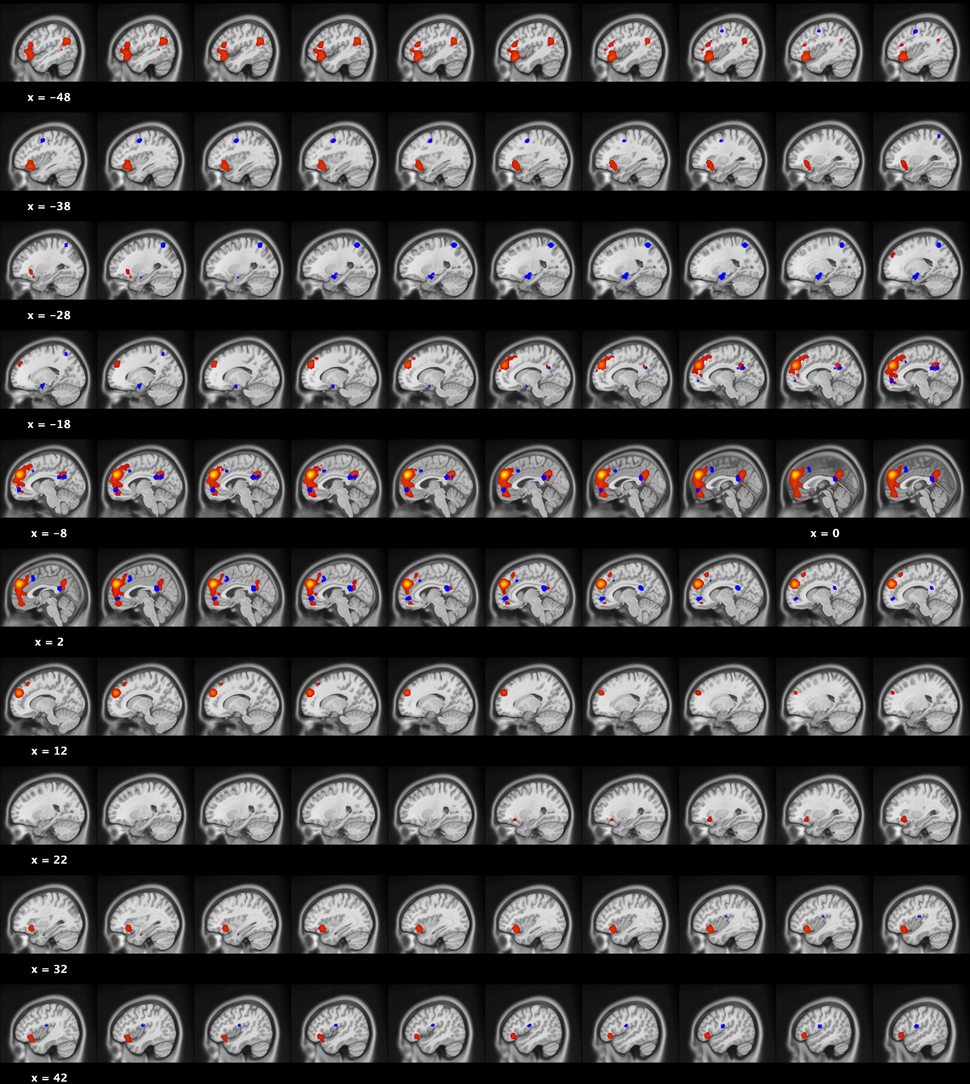

Supplementary Figure 2A (S2A): Meta-analytical connectivity modelling map of dmPFC clusters (red): 2077 foci, 131 experiments & 1956 individuals. Blue regions represent significant results observed in the meta-analysis.

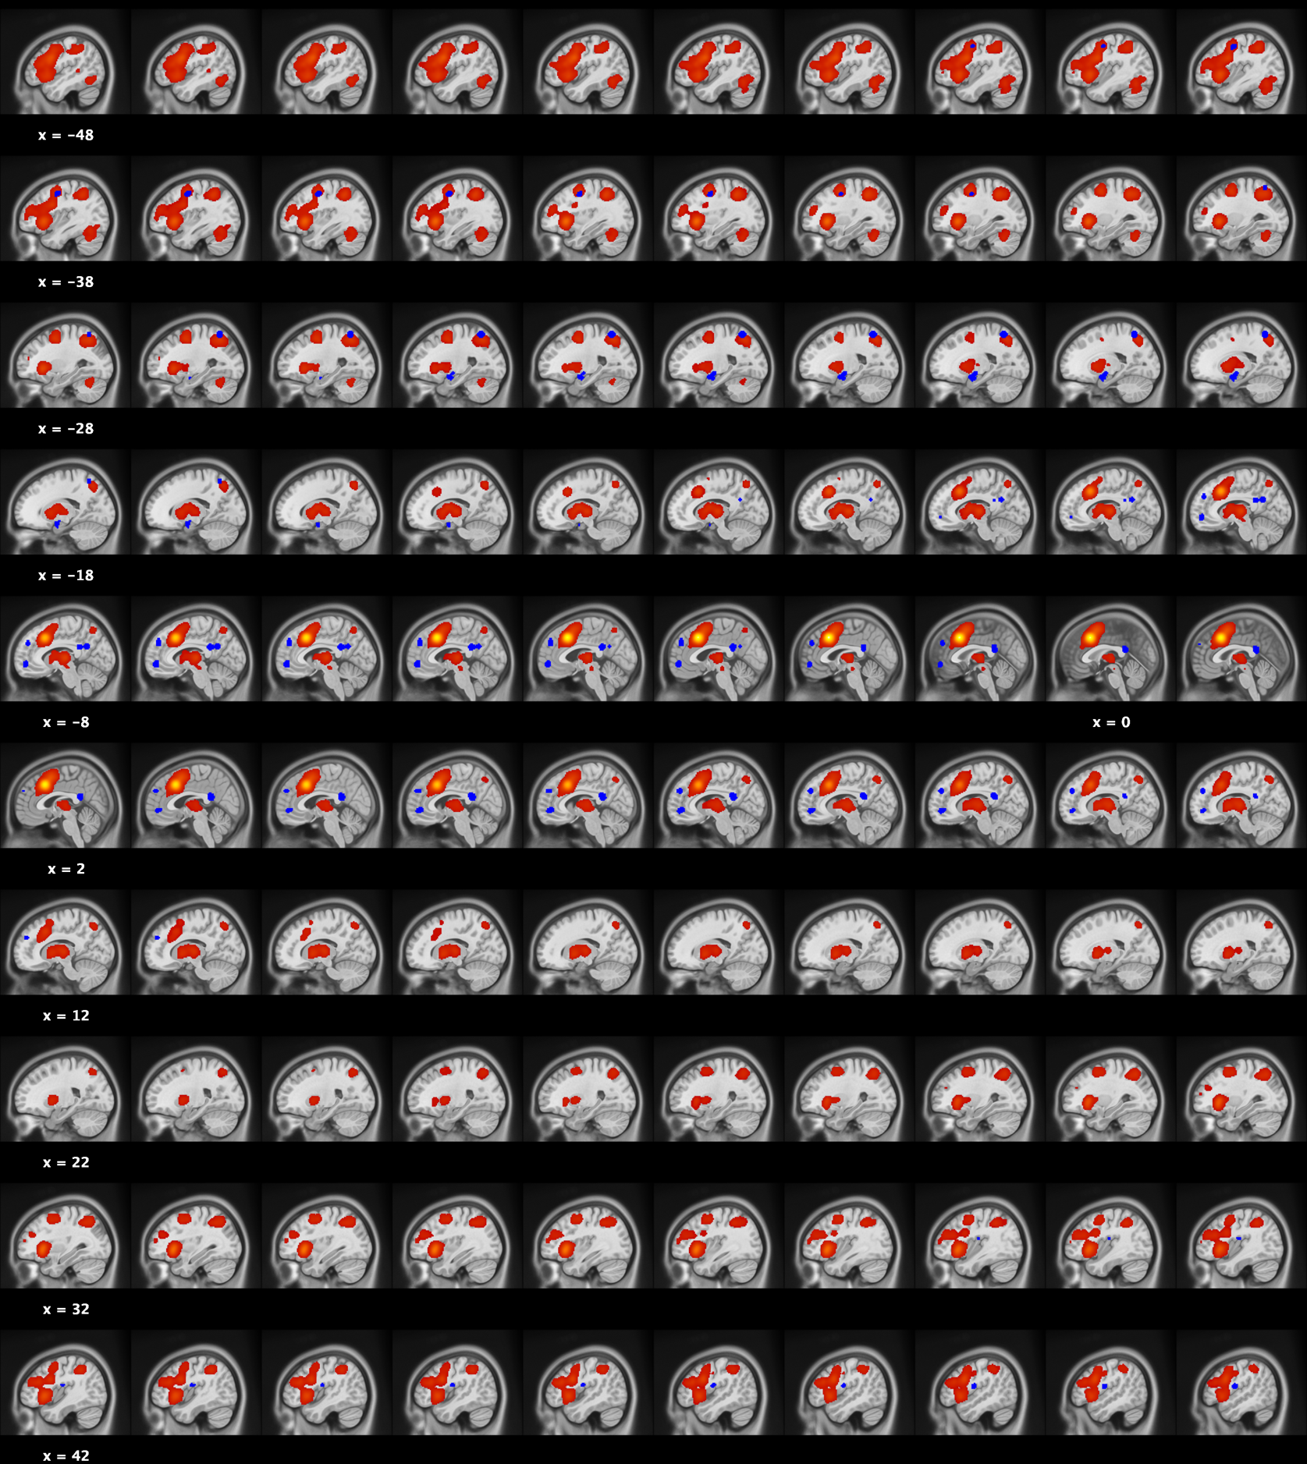

Supplementary Figure 2B (S2B): Meta-analytical connectivity modelling map of MCC cluster (red): 7235 foci, 341 experiments & 4970 individuals. Blue regions represent significant results observed in the meta-analysis.

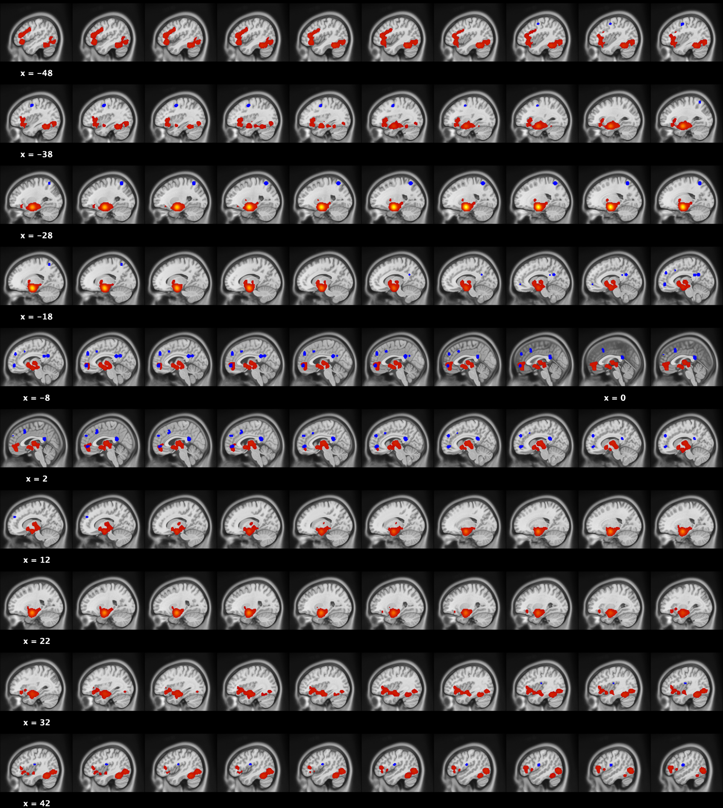

Supplementary Figure 2C (S2C): Meta-analytical connectivity modelling map of Amygdala cluster (red): 3949 foci, 220 experiments & 3683 individuals. Blue regions represent significant results observed in the meta-analysis.

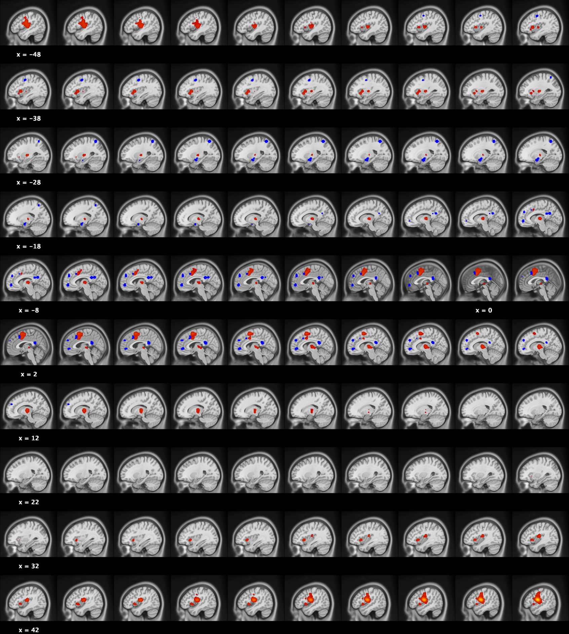

Supplementary Figure 2D (S2D): Meta-analytical connectivity modelling map of Parietal Operculum (red): 1058 foci, 67 experiments & 950 individuals. Blue regions represent significant results observed in the meta-analysis.

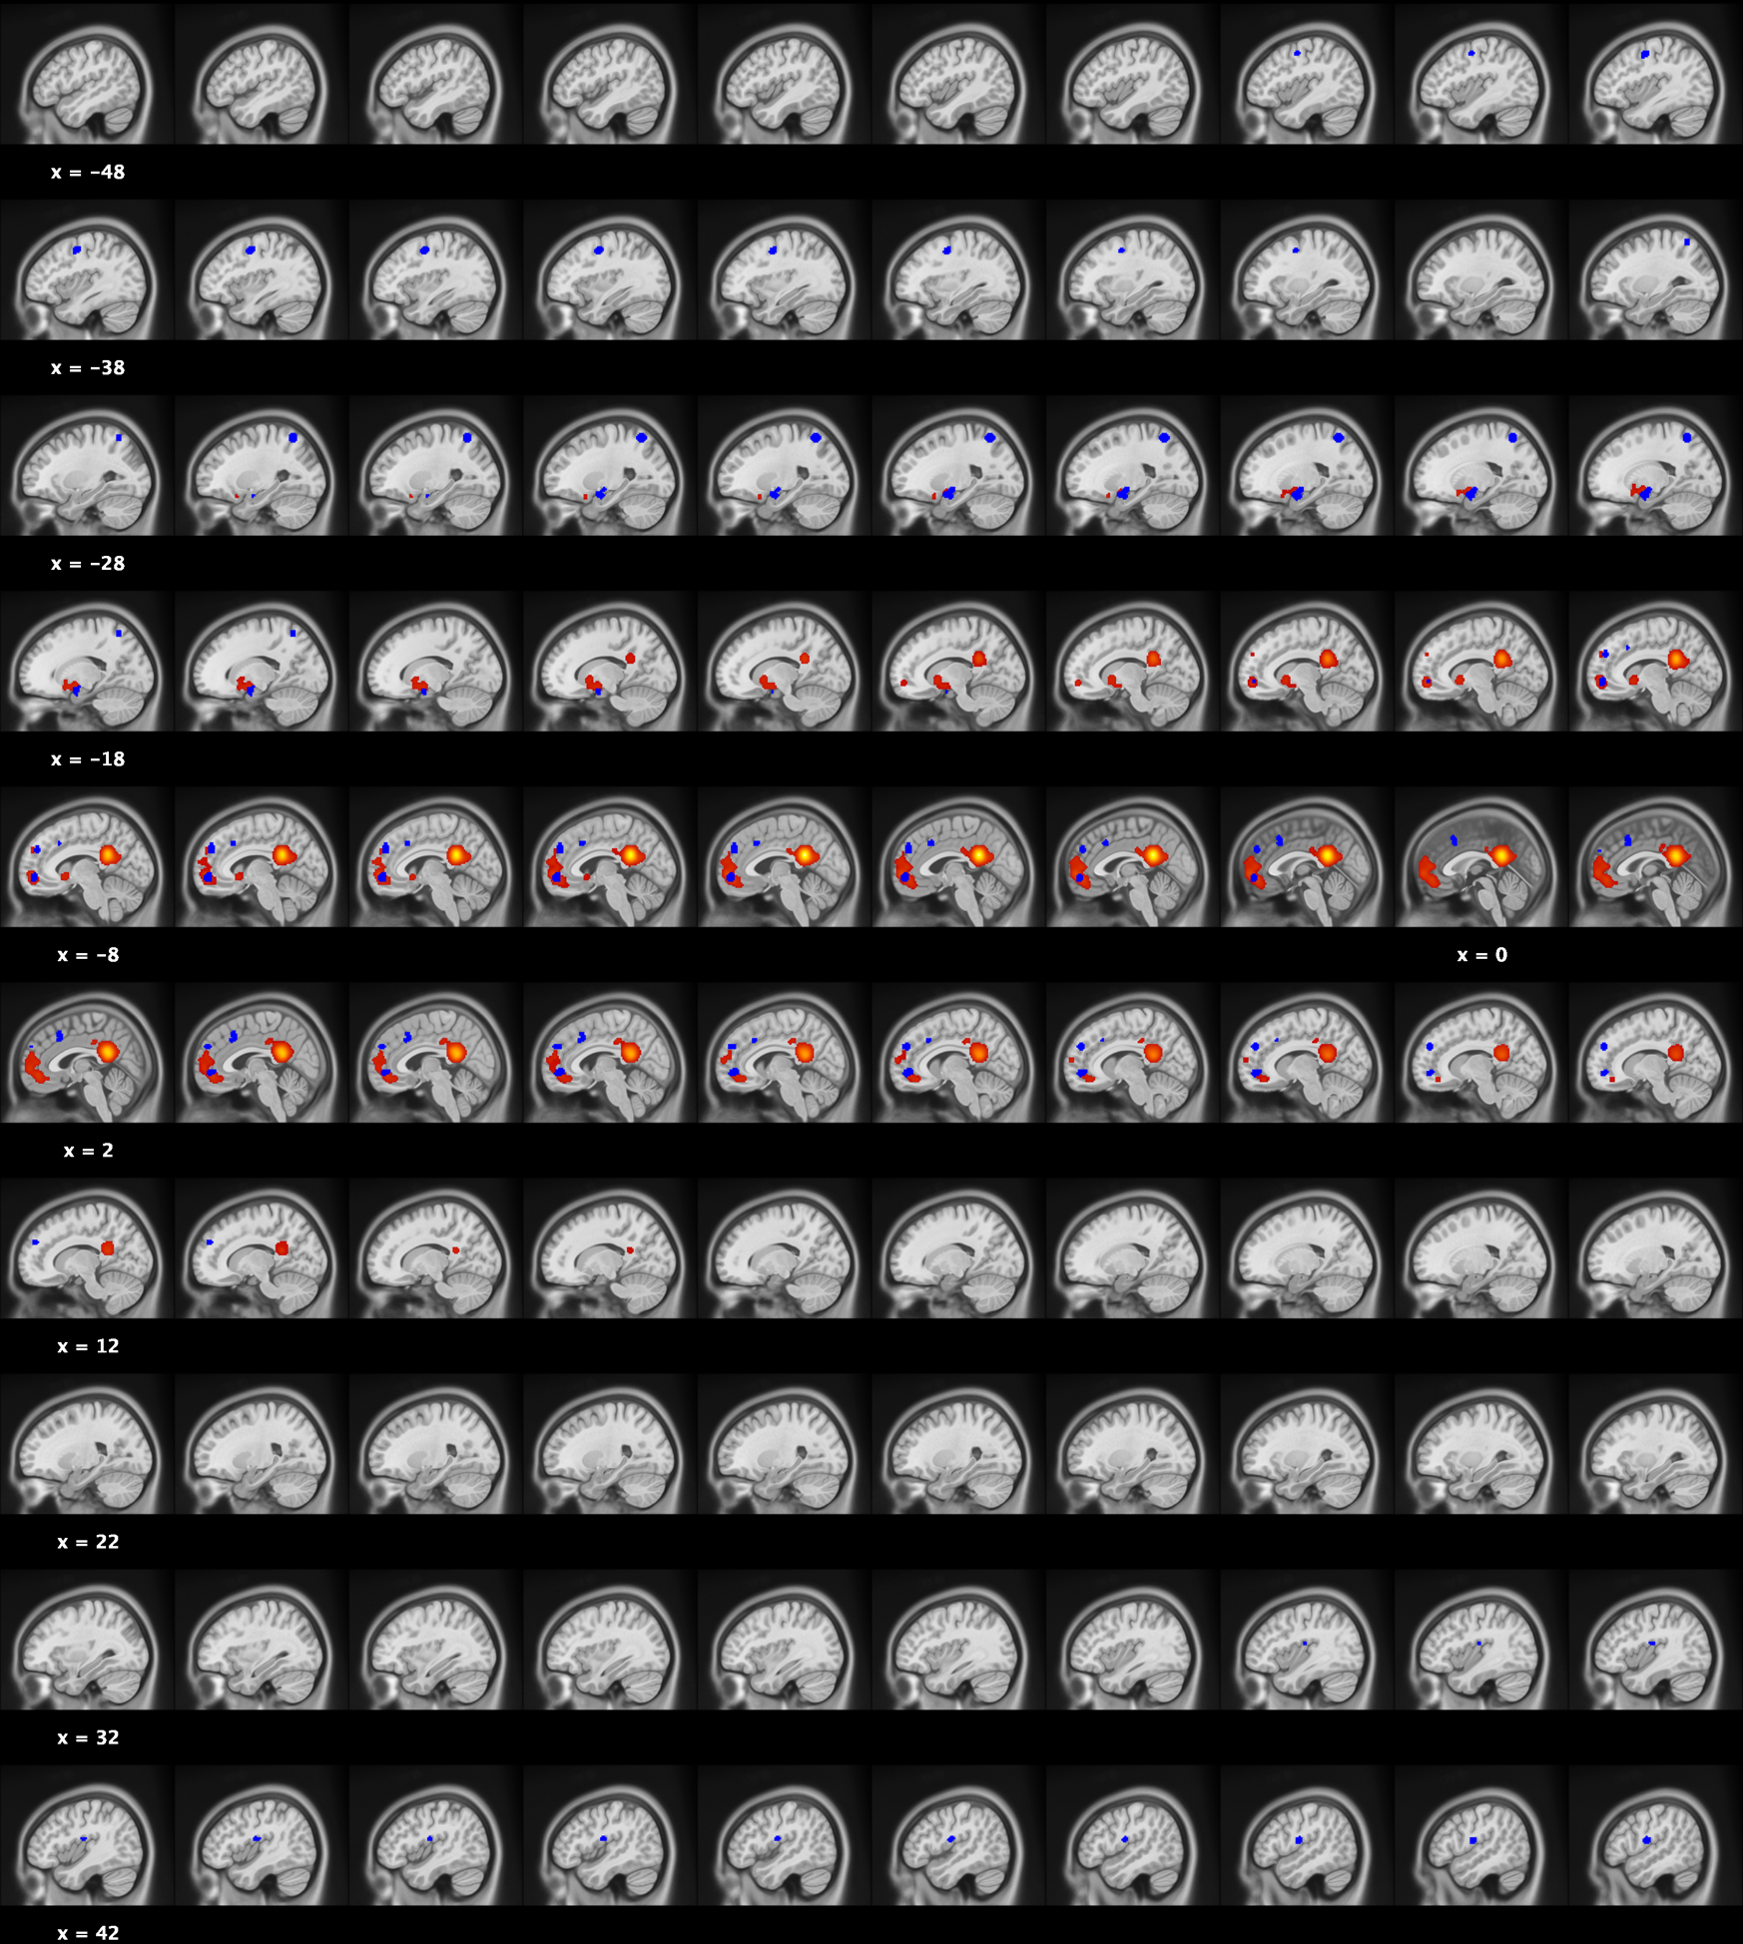

Supplementary Figure 2E (S2E): Meta-analytical connectivity modelling map of ventral Posterior Cingulate Cortex/Precuneus (red): 2005 foci, 117 experiments & 1771 individuals. Blue regions represent significant results observed in the meta-analysis.
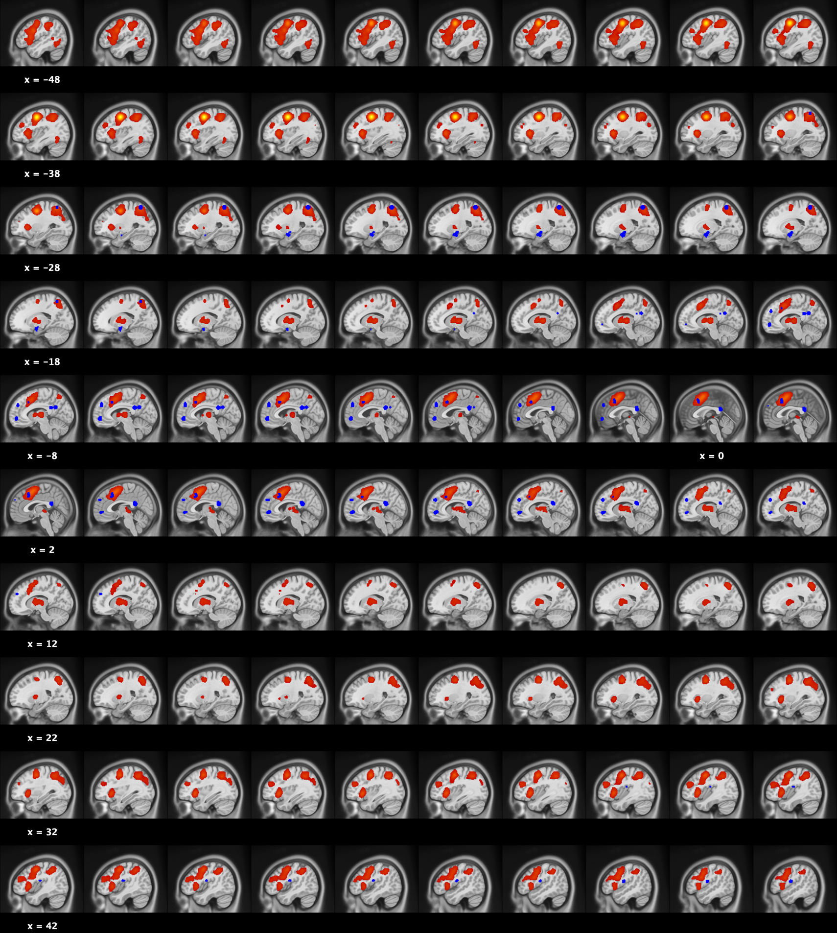

Supplementary Figure 2F (S2F): Meta-analytical connectivity modelling map of Premotor(red): 3970 foci, 181 experiments & 2548 individuals. Blue regions represent significant results observed in the meta-analysis.

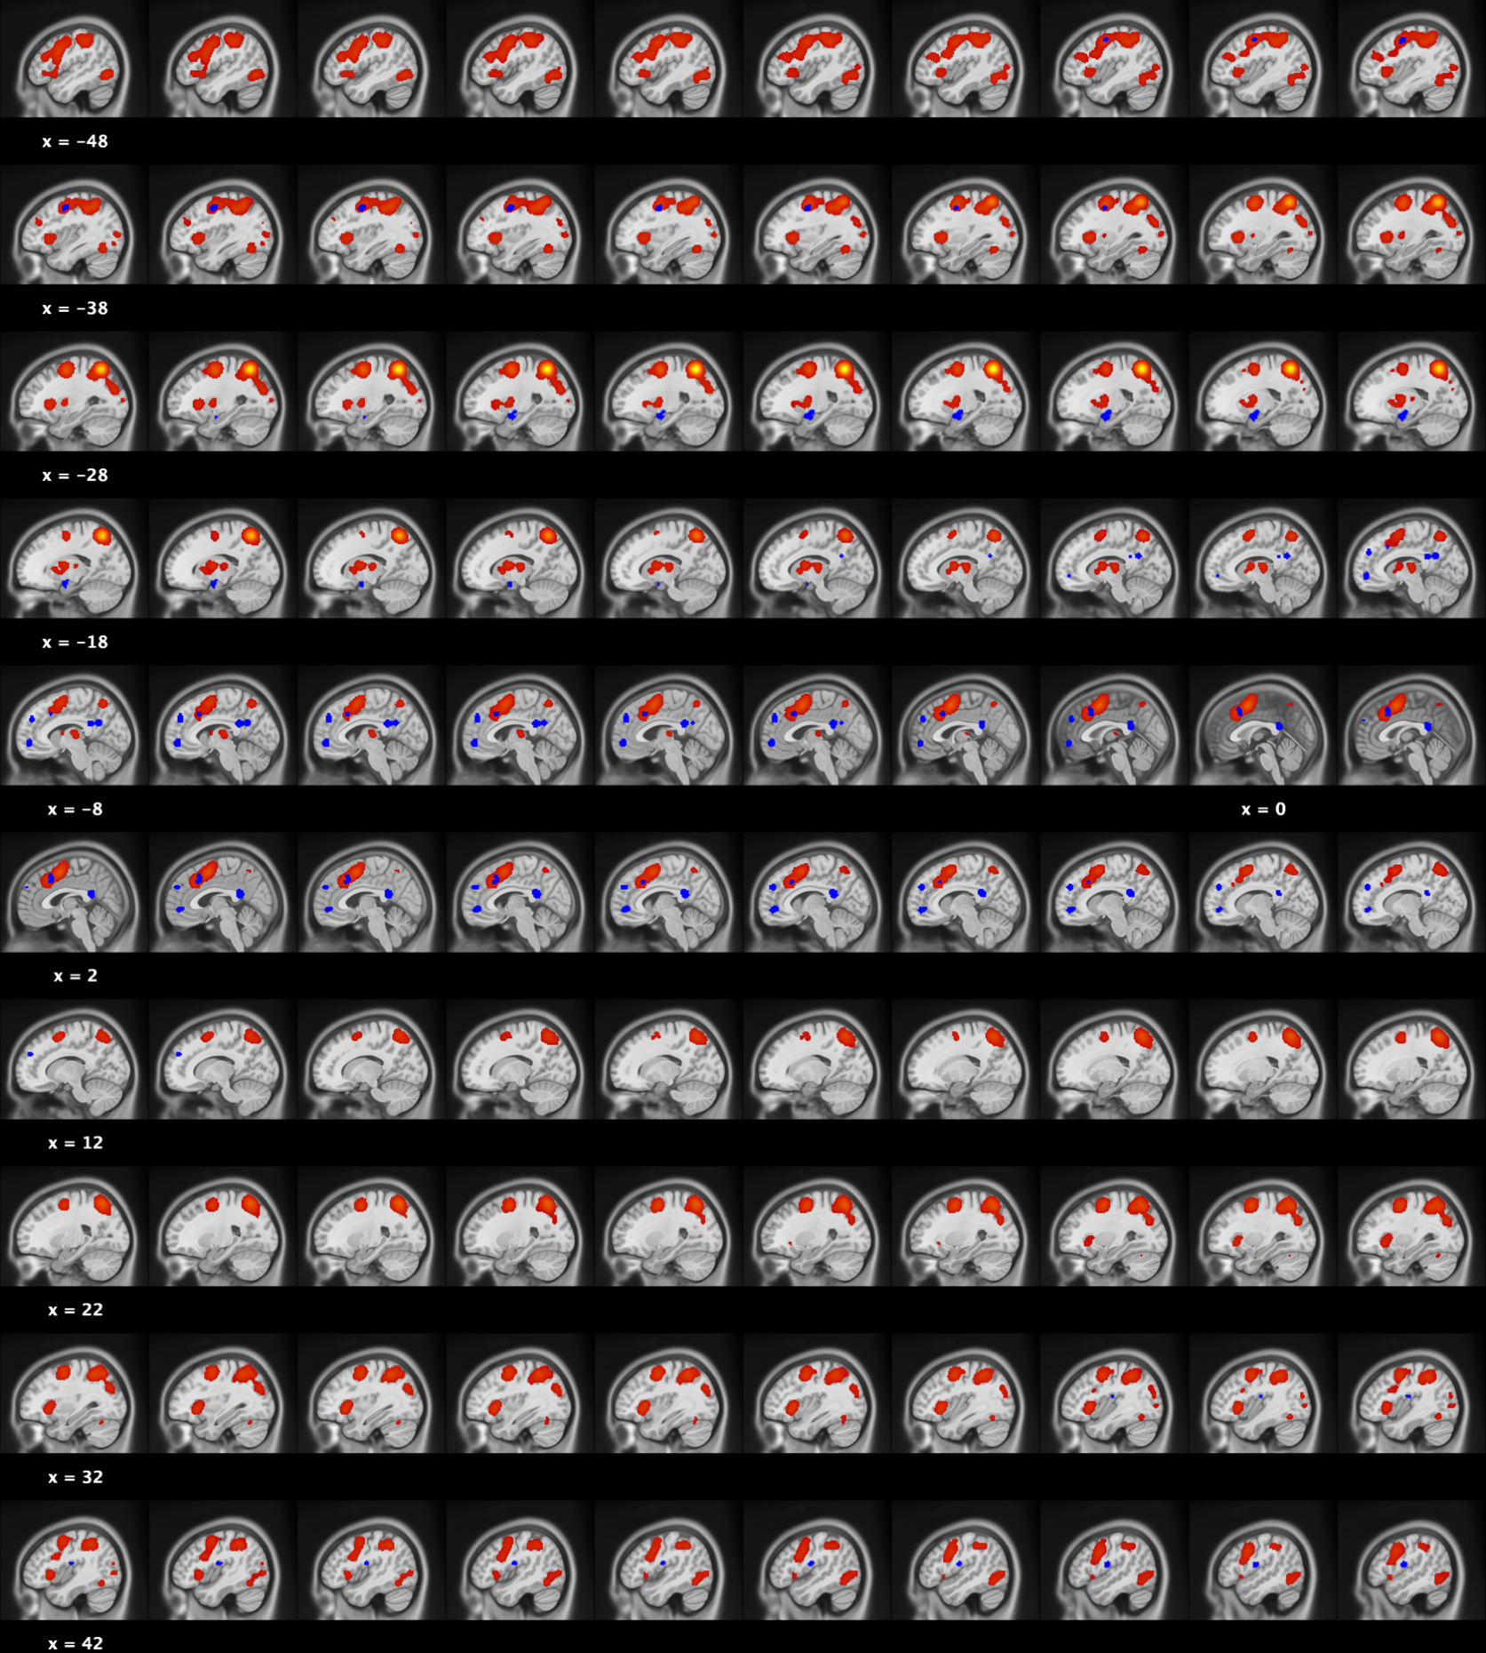

Supplementary Figure 2G (S2G): Meta-analytical connectivity modelling map of Superior Parietal Lobule (red): 3773 foci, 167 experiments & 2254 individuals. Blue regions represent significant results observed in the meta-analysis.

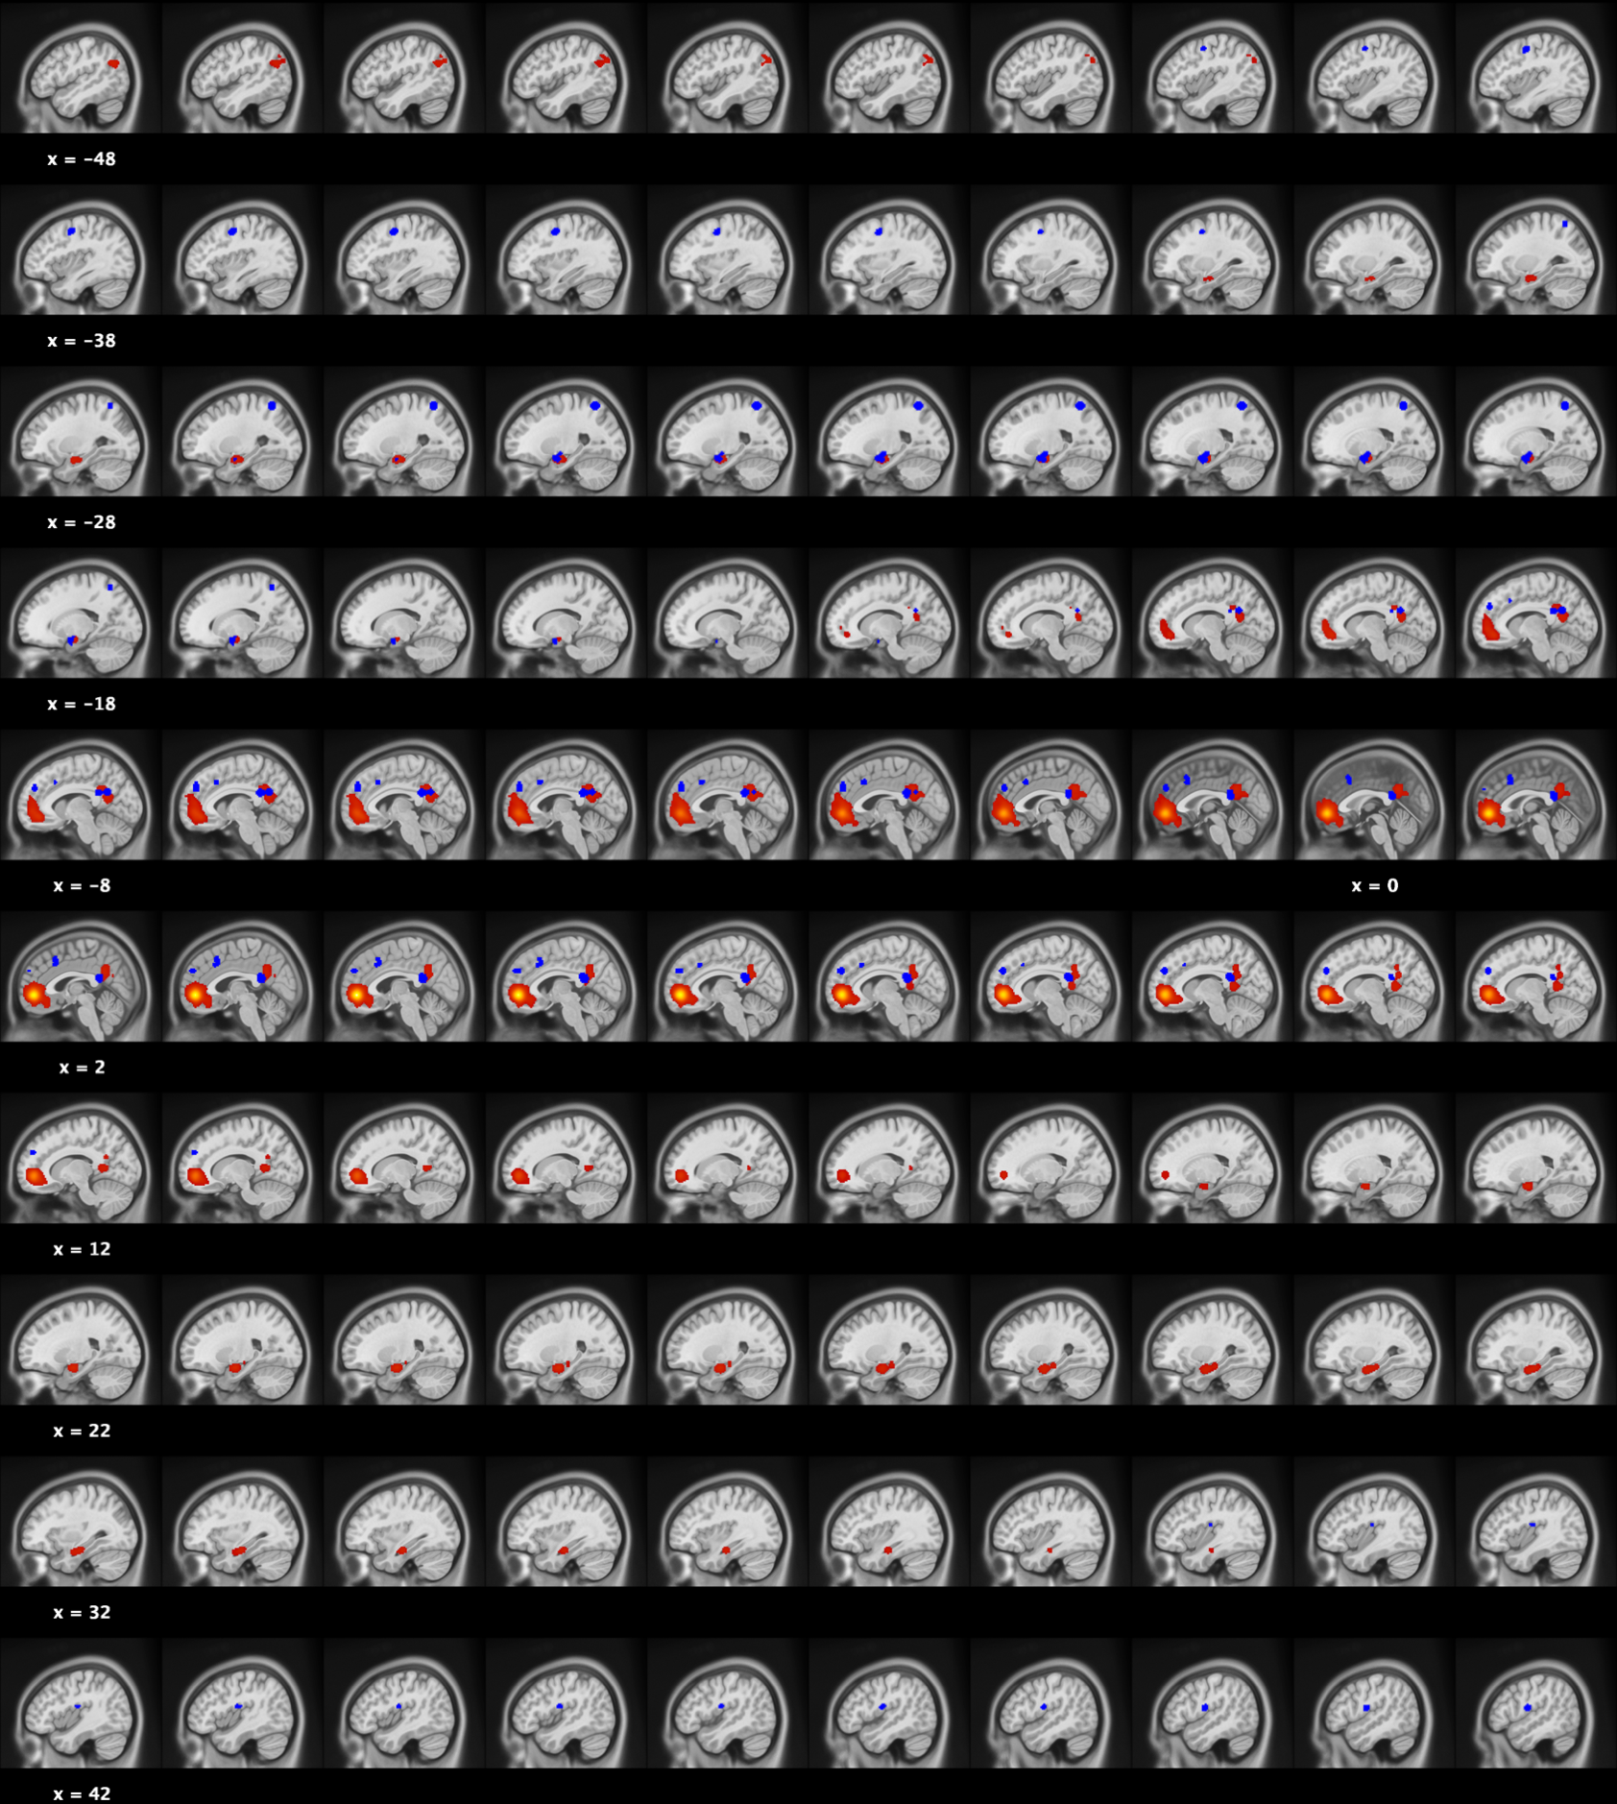

Supplementary Figure 2H (S2H): Meta-analytical connectivity modelling map of ventromedial Prefrontal Cortex (red): 1452 foci, 94 experiments & 1507 individuals. Blue regions represent significant results observed in the meta-analysis.

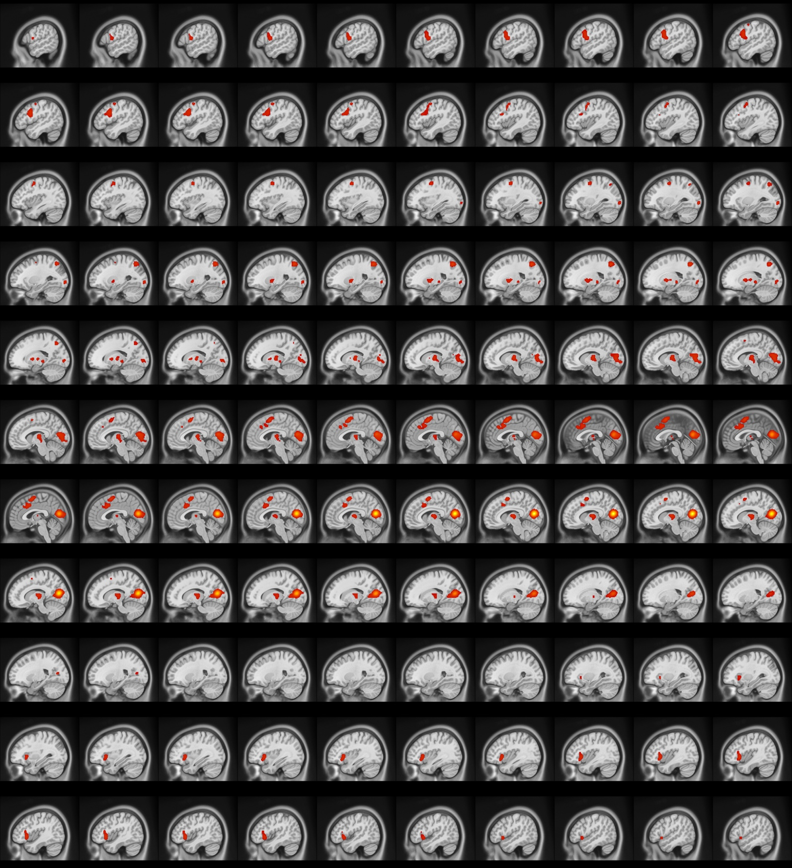

Supplementary Figure 2I (S2I): Meta-analytical connectivity modelling map of Calcarine Cortex (red): 1997 foci, 85 experiments & 1285 individuals.

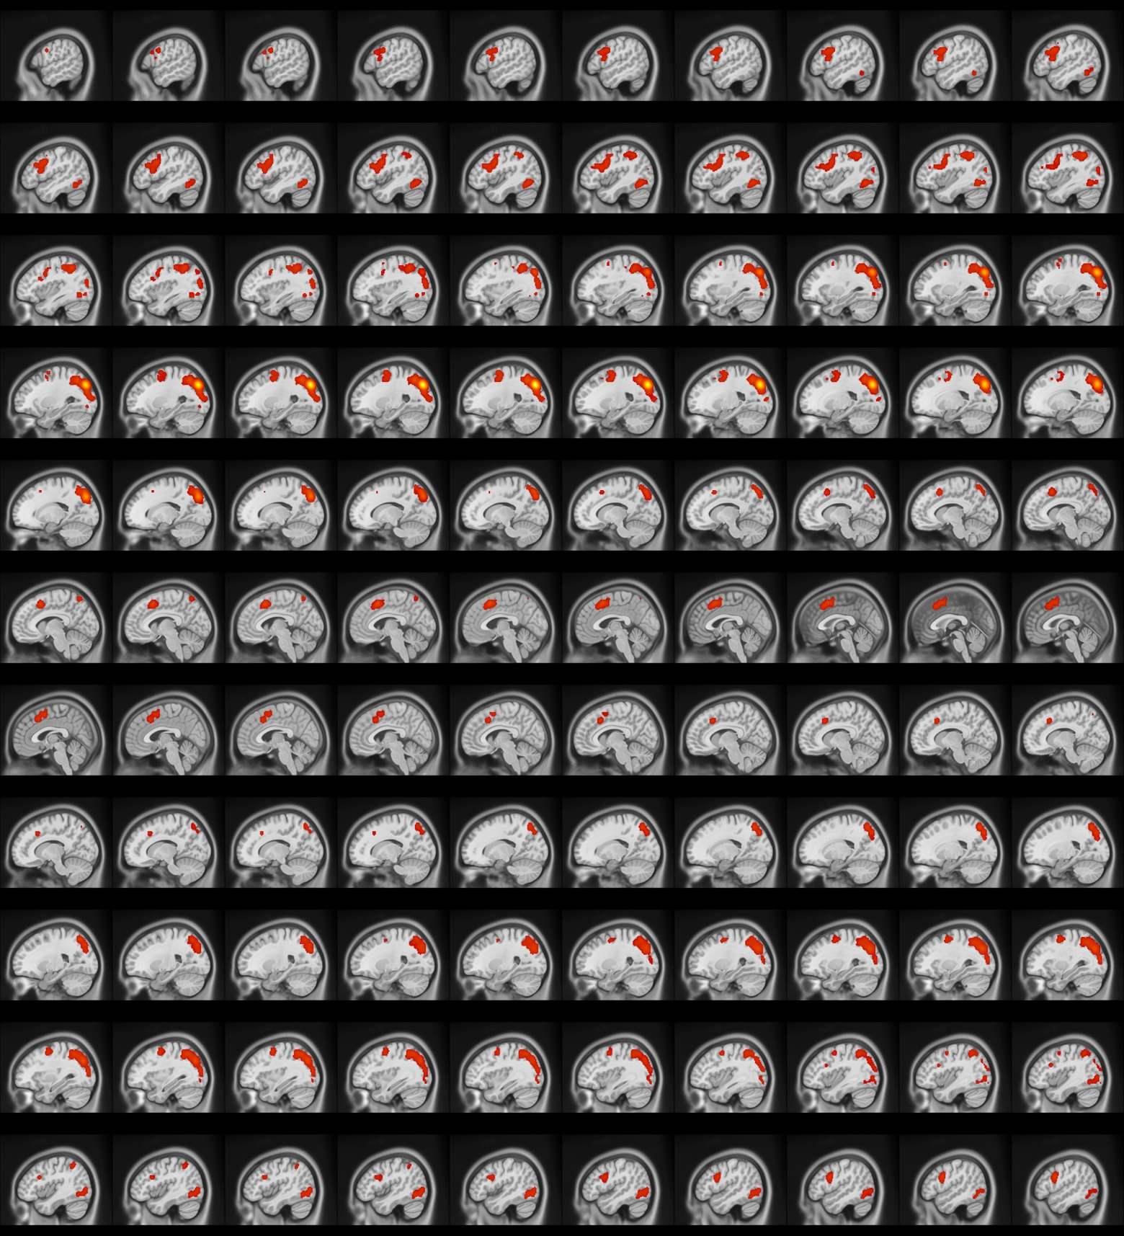

Supplementary Figure 2J (S2J): Meta-analytical connectivity modelling map of Cuneus (red): 2044 foci, 77 experiments & 1215 individuals.

Supplementary Table 4. Functional Characterization of clusters in meta-analysis on CP/ASPD
Clusters | Paradigm | Behavioral (Z-Score)
dmPFC | Theory of Mind (4.06);  Emotion Induction (3.82) | Social Cognition (4.01);  Valence (3.2)
OP4 | Pain Monitor/Discrim. (3.33) | Execution-Speech (3.18);  Somesthesis-Pain (3.00)
vmPFC | Reward (4.55);  Face Monitor/Discrim. (3.85) | Positive Emotion-Reward (4.21);  Reasoning (3.51);  Social Cognition (3.03)
SPL | Visuospatial Attention (4.95) | Attention (5.63); Execution (5.01);  Working Memory (3.65); Vision-Motion (3.54)
PMC | Saccades (3.63) | Vision-Motion (4.00); Execution (3.11)
vPCC/Precuneus | N.S. | Social Cognition (2.93)
Amygdala | Face Monitor/Discrim. (6.72); Passive Viewing (4.67);  Emotion Induction (3.89); Affective Pictures (3.89);  Explicit Recogn./Recall (3.67) | Fear (5.60); Vision (5.43); Negative Emotions (4.58); Disgust (4.33); Sadness (4.15); Happiness (4.08); Olfaction (3.94); Sexuality (3.76); Explicit Memory (3.41); Positive Emotion (3.38); Memory (3.28); Anxiety (3.08)
MCC | Semantic Monitor/Discrim. (5.13);  Go/No-Go (4.43);  Reward (4.31);  N-Back (3.50);  Stroop-Color (3.48) | Attention (7.32); Semantics (6.28); Speech (5.04); Reasoning (4.72); Inhibition (4.55); Reward (4.33); Working Memory (4.12); Explicit Memory (3.85); Somesthesis-Pain (3.25); Vision-Shape (3.23); Vision-Motion (3.19); Negative Emotion (3.02)
CUN | N.S. | N.S.
CAL | N.S. | N.S.
Note. dmPFC = dorsomedial Prefrontal Cortex; OP4 = Parietal Operculum; vmPFC = ventromedial Prefrontal Cortex; SPL = Superior Parietal Lobule; vPCC = ventral Posterior Cingulate Cortex; MCC = Middle Cingulate Cortex. CUN = Cuneus; CAL = Calcarine Cortex.

Supplementary Table 5. Cross-Correlation Matrix between ROI-based MACM maps.
ROI | ROI-Based MACM Maps
 | PCC | vmPFC | dmPFC | AMY | OP4 | CAL | CUN | MCC | PMC | SPL
PCC | - | 0.53 | 0.25 | 0.33 | 0.60 | 0.34 | 0.52 | 0.52 | 0.20 | 0.38
vmPFC | 0.53 | - | 0.26 | 0.31 | 0.55 | 0.33 | 0.60 | 0.61 | 0.21 | 0.21
dmPFC | 0.25 | 0.26 | - | 0.49 | 0.30 | 0.44 | 0.25 | 0.18 | 0.37 | 0.19
AMY | 0.33 | 0.31 | 0.49 | - | 0.39 | 0.43 | 0.30 | 0.25 | 0.43 | 0.37
OP4 | 0.60 | 0.55 | 0.30 | 0.39 | - | 0.37 | 0.72 | 0.68 | 0.21 | 0.45
CAL | 0.34 | 0.33 | 0.44 | 0.43 | 0.37 | - | 0.32 | 0.27 | 0.42 | 0.26
CUN | 0.52 | 0.60 | 0.25 | 0.30 | 0.72 | 0.32 | - | 0.75 | 0.13 | 0.32
MCC | 0.52 | 0.61 | 0.18 | 0.25 | 0.68 | 0.27 | 0.75 | - | 0.11 | 0.31
PMC | 0.20 | 0.21 | 0.37 | 0.43 | 0.21 | 0.42 | 0.13 | 0.11 | - | 0.24
SPL | 0.38 | 0.21 | 0.19 | 0.37 | 0.45 | 0.26 | 0.32 | 0.31 | 0.24 | -
Note. Values represent Spearman's rank-order correlation coefficient between each ROI-based MACM map. Blue = Group #1 identified by the dendrogram; Green = Group #2 Identified by the dendrogram. PCC = Posterior Cingulate Cortex; vmPFC = ventromedial Prefrontal Cortex; dmPFC = dorsomedial Prefrontal Cortex; OP4 = Operculum Parietale (Area 4); CAL = Calcarine Cortex; CUN = Cuneus; MCC = MidCingulate Cortex; PMC = Premotor Cortex; SPL = Superior Parietal Lobule

Supplementary Table 6. Results on spatial closeness between ROI-based MACM maps and Intrinsic Networks.
Intrinsic Networks | ROI-Based MACM maps
 | PCC |  | vmPFC |  | dmPFC |  | AMY |  | OP4 |  | CAL |  | CUN |  | MCC |  | PMC |  | SPL
Visual | -0.01 |  | -0.01 |  | 0.02 |  | 0.06 |  | -0.05 |  | 0.29 |  | 0.19 |  | 0.03 |  | 0.06 |  | 0.09
VentAttn | 0.09 |  | 0.07 |  | 0.04 |  | 0.09 |  | 0.16 |  | 0.11 |  | 0.07 |  | 0.28 |  | 0.20 |  | 0.17
SomMot | -0.03 |  | -0.01 |  | -0.09 |  | -0.06 |  | 0.27 |  | 0.00 |  | -0.03 |  | 0.02 |  | 0.03 |  | 0.06
Limbic | -0.09 |  | -0.04 |  | -0.05 |  | -0.02 |  | -0.08 |  | -0.15 |  | -0.15 |  | -0.17 |  | -0.19 |  | -0.18
DMN | 0.23 |  | 0.28 |  | 0.37 |  | 0.17 |  | -0.01 |  | -0.01 |  | -0.04 |  | -0.07 |  | -0.06 |  | -0.14
DorsAttn | 0.05 |  | -0.02 |  | 0.02 |  | 0.05 |  | -0.01 |  | 0.09 |  | 0.28 |  | 0.13 |  | 0.25 |  | 0.35
Control | 0.10 |  | 0.01 |  | 0.06 |  | -0.03 |  | -0.06 |  | 0.07 |  | 0.15 |  | 0.18 |  | 0.16 |  | 0.16
Note. Values represent Spearman's rank-order correlation coefficient between ROI-based MACM maps and Intrinsic Network. Intrinsic Connectivity Networks were derived from Schaefer et al., 2018's 7-Networks. BOLD represents highest coefficient. PCC = Posterior Cingulate Cortex; vmPFC = ventromedial Prefrontal Cortex; dmPFC = dorsomedial Prefrontal Cortex; OP4 = Operculum Parietale (Area 4); CAL = Calcarine Cortex; CUN = Cuneus; MCC = MidCingulate Cortex; PMC = Premotor Cortex; SPL = Superior Parietal Lobule

REFERENCES

1. Decety J, Michalska KJ, Akitsuki Y, Lahey BB. Atypical empathic responses in adolescents with aggressive conduct disorder: a functional MRI investigation. Biological psychology 2009; 80(2): 203-211.

2. Finger EC, Marsh A, Blair KS, Majestic C, Evangelou I, Gupta K et al. Impaired functional but preserved structural connectivity in limbic white matter tracts in youth with conduct disorder or oppositional defiant disorder plus psychopathic traits. Psychiatry Research: Neuroimaging 2012; 202(3): 239-244.

3. Marsh AA, Finger EC, Fowler KA, Jurkowitz IT, Schechter JC, Henry HY et al. Reduced amygdala–orbitofrontal connectivity during moral judgments in youths with disruptive behavior disorders and psychopathic traits. Psychiatry Research: Neuroimaging 2011; 194(3): 279-286.

4. Marsh AA, Finger EC, Mitchell DG, Reid ME, Sims C, Kosson DS et al. Reduced amygdala response to fearful expressions in children and adolescents with callous-unemotional traits and disruptive behavior disorders. American Journal of Psychiatry 2008; 165(6): 712-720.

5. Yoder K, Harenski C, Kiehl K, Decety J. Neural networks underlying implicit and explicit moral evaluations in psychopathy. Translational psychiatry 2015; 5(8): e625-e625.

6. Dotterer HL, Hyde LW, Shaw DS, Rodgers EL, Forbes EE, Beltz AM. Connections that characterize callousness: Affective features of psychopathy are associated with personalized patterns of resting-state network connectivity. NeuroImage: Clinical 2020; 28: 102402.

7. Fulwiler CE, King JA, Zhang N. Amygdala-orbitofrontal resting state functional connectivity is associated with trait anger. Neuroreport 2012; 23(10): 606.

8. Gilam G, Maron-Katz A, Kliper E, Lin T, Fruchter E, Shamir R et al. Tracing the neural carryover effects of interpersonal anger on resting-state fMRI in men and their relation to traumatic stress symptoms in a subsample of soldiers. Frontiers in Behavioral Neuroscience 2017; 11: 252.

9. Kashyap R, Bhattacharjee S, Yeo BT, Chen SA. Maximizing dissimilarity in resting state detects heterogeneous subtypes in healthy population associated with high substance use and problems in antisocial personality. Human Brain Mapping 2020; 41(5): 1261-1273.

10. Takami K, Haruno M. Dissociable behavioral and neural correlates for target-changing and conforming behaviors in interpersonal aggression. eNeuro 2020.

11. Takami K, Haruno M. Behavioral and functional connectivity basis for peer-influenced bystander participation in bullying. Social cognitive and affective neuroscience 2019; 14(1): 23-33.

12. Weathersby FL, King JB, Fox JC, Loret A, Anderson JS. Functional connectivity of emotional well-being: Overconnectivity between default and attentional networks is associated with attitudes of anger and aggression. Psychiatry Research: Neuroimaging 2019; 291: 52-62.

13. Sato JR, Biazoli Jr CE, Salum GA, Gadelha A, Crossley N, Satterthwaite TD et al. Temporal stability of network centrality in control and default mode networks: Specific associations with externalizing psychopathology in children and adolescents. Human brain mapping 2015; 36(12): 4926-4937.

14. Cantor J, Lafaille S, Hannah J, Kucyi A, Soh D, Girard T et al. Independent component analysis of resting-state functional magnetic resonance imaging in pedophiles. The journal of sexual medicine 2016; 13(10): 1546-1554.

15. Zhang J, Liu Y, Luo R, Du Z, Lu F, Yuan Z et al. Classification of pure conduct disorder from healthy controls based on indices of brain networks during resting state. Medical & Biological Engineering & Computing 2020; 58(9): 2071-2082.

16. Klasen M, Wolf D, Eisner PD, Habel U, Repple J, Vernaleken I et al. Neural networks underlying trait aggression depend on MAOA gene alleles. Brain structure and function 2018; 223(2): 873-881.

17. Bevilacqua L, Hale D, Barker ED, Viner R. Conduct problems trajectories and psychosocial outcomes: a systematic review and meta-analysis. European Child & Adolescent Psychiatry 2018; 27(10): 1239-1260.

18. Robinson JL, Laird AR, Glahn DC, Lovallo WR, Fox PT. Metaanalytic connectivity modeling: delineating the functional connectivity of the human amygdala. Human brain mapping 2010; 31(2): 173-184.

19. Lancaster JL, Laird AR, Eickhoff SB, Martinez MJ, Fox PM, Fox PT. Automated regional behavioral analysis for human brain images. Frontiers in neuroinformatics 2012; 6: 23.

20. Broulidakis MJ, Fairchild G, Sully K, Blumensath T, Darekar A, Sonuga-Barke EJ. Reduced default mode connectivity in adolescents with conduct disorder. Journal of the American Academy of Child & Adolescent Psychiatry 2016; 55(9): 800-808. e801.

21. Contreras-Rodríguez O, Pujol J, Batalla I, Harrison BJ, Soriano-Mas C, Deus J et al. Functional connectivity bias in the prefrontal cortex of psychopaths. Biological Psychiatry 2015; 78(9): 647-655.

22. Dong D, Jiang Y, Gao Y, Ming Q, Wang X, Yao S. Atypical frontotemporal connectivity of cognitive empathy in male adolescents with conduct disorder. Frontiers in psychology 2019; 9: 2778.

23. Gan G, Zilverstand A, Parvaz M, Preston-Campbell R, Uquillas FdO, Moeller S et al. Habenula-prefrontal resting-state connectivity in reactive aggressive men–A pilot study. Neuropharmacology 2019; 156: 107396.

24. Jiang W, Shi F, Liao J, Liu H, Wang T, Shen C et al. Disrupted functional connectome in antisocial personality disorder. Brain imaging and behavior 2017; 11(4): 1071-1084.

25. Kärgel C, Massau C, Weiß S, Walter M, Kruger TH, Schiffer B. Diminished functional connectivity on the road to child sexual abuse in pedophilia. The journal of sexual medicine 2015; 12(3): 783-795.

26. Kolla NJ, Dunlop K, Meyer JH, Downar J. Corticostriatal connectivity in antisocial personality disorder by MAO-A genotype and its relationship to aggressive behavior. International journal of neuropsychopharmacology 2018; 21(8): 725-733.

27. Kneer J, Borchardt V, Kärgel C, Sinke C, Massau C, Tenbergen G et al. Diminished fronto-limbic functional connectivity in child sexual offenders. Journal of psychiatric research 2019; 108: 48-56.

28. Leutgeb V, Wabnegger A, Leitner M, Zussner T, Scharmüller W, Klug D et al. Altered cerebellar-amygdala connectivity in violent offenders: A resting-state fMRI study. Neuroscience letters 2016; 610: 160-164.

29. Lindner P, Flodin P, Larm P, Budhiraja M, Savic-Berglund I, Jokinen J et al. Amygdala-orbitofrontal structural and functional connectivity in females with anxiety disorders, with and without a history of conduct disorder. Scientific reports 2018; 8(1): 1-12.

30. Motzkin JC, Newman JP, Kiehl KA, Koenigs M. Reduced prefrontal connectivity in psychopathy. Journal of Neuroscience 2011; 31(48): 17348-17357.

31. Pujol J, Batalla I, Contreras-Rodríguez O, Harrison BJ, Pera V, Hernández-Ribas R et al. Breakdown in the brain network subserving moral judgment in criminal psychopathy. Social cognitive and affective neuroscience 2012; 7(8): 917-923.

32. Roy AK, Bennett R, Posner J, Hulvershorn L, Castellanos FX, Klein RG. Altered intrinsic functional connectivity of the cingulate cortex in children with severe temper outbursts. Development and psychopathology 2018; 30(2): 571-579.

33. Siep N, Tonnaer F, van de Ven V, Arntz A, Raine A, Cima M. Anger provocation increases limbic and decreases medial prefrontal cortex connectivity with the left amygdala in reactive aggressive violent offenders. Brain imaging and behavior 2019; 13(5): 1311-1323.

34. Tang Y, Jiang W, Liao J, Wang W, Luo A. Identifying individuals with antisocial personality disorder using resting-state FMRI. PloS one 2013; 8(4): e60652.

35. Uytun MC, Karakaya E, Oztop DB, Gengec S, Gumus K, Ozmen S et al. Default mode network activity and neuropsychological profile in male children and adolescents with attention deficit hyperactivity disorder and conduct disorder. Brain Imaging and behavior 2017; 11(6): 1561-1570.

36. Varkevisser T, Gladwin TE, Heesink L, van Honk J, Geuze E. Resting-state functional connectivity in combat veterans suffering from impulsive aggression. Social cognitive and affective neuroscience 2017; 12(12): 1881-1889.

37. Werhahn JE, Mohl S, Willinger D, Smigielski L, Roth A, Hofstetter C et al. Aggression subtypes relate to distinct resting state functional connectivity in children and adolescents with disruptive behavior. European Child & Adolescent Psychiatry 2020: 1-13.

38. Cao W, Li C, Zhang J, Dong D, Sun X, Yao S et al. Regional homogeneity abnormalities in early-onset and adolescent-onset conduct disorder in boys: a resting-state fMRI study. Frontiers in Human Neuroscience 2019; 13: 26.

39. Chen C, Zhou J, Liu C, Witt K, Zhang Y, Jing B et al. Regional homogeneity of resting-state brain abnormalities in violent juvenile offenders: a biomarker of brain immaturity? The Journal of neuropsychiatry and clinical neurosciences 2015; 27(1): 27-32.

40. Kim JI, Kang Y-H, Lee J-M, Cha J, Park Y-H, Kweon K-J et al. Resting-state functional magnetic resonance imaging investigation of the neural correlates of cognitive-behavioral therapy for externalizing behavior problems in adolescent bullies. Progress in neuro-psychopharmacology and biological psychiatry 2018; 86: 193-202.

41. Liu H, Liao J, Jiang W, Wang W. Changes in low-frequency fluctuations in patients with antisocial personality disorder revealed by resting-state functional MRI. PLoS One 2014; 9(3): e89790.

42. Lu F-M, Zhou J-S, Zhang J, Xiang Y-T, Zhang J, Liu Q et al. Functional connectivity estimated from resting-state fMRI reveals selective alterations in male adolescents with pure conduct disorder. PloS one 2015; 10(12): e0145668.

43. Lu F-M, Zhou J-S, Wang X-P, Xiang Y-T, Yuan Z. Short-and long-range functional connectivity density alterations in adolescents with pure conduct disorder at resting-state. Neuroscience 2017; 351: 96-107.

44. Lu F-M, Zhou J-S, Zhang J, Wang X-P, Yuan Z. Disrupted small-world brain network topology in pure conduct disorder. Oncotarget 2017; 8(39): 65506.

45. Lu F, Liu P, Chen H, Wang M, Xu S, Yuan Z et al. More than just statics: Abnormal dynamic amplitude of low-frequency fluctuation in adolescent patients with pure conduct disorder. Journal of Psychiatric Research 2020; 131: 60-68.

46. Lu F, Wang M, Xu S, Chen H, Yuan Z, Luo L et al. Decreased interhemispheric resting-state functional connectivity in male adolescents with conduct disorder. Brain imaging and behavior 2020: 1-10.

47. Pu W, Luo Q, Jiang Y, Gao Y, Ming Q, Yao S. Alterations of brain functional architecture associated with psychopathic traits in male adolescents with conduct disorder. Scientific reports 2017; 7(1): 1-11.

48. Tang Y, Long J, Wang W, Liao J, Xie H, Zhao G et al. Aberrant functional brain connectome in people with antisocial personality disorder. Scientific reports 2016; 6: 26209.

49. Tang Y, Liu W, Chen J, Liao J, Hu D, Wang W. Altered spontaneous activity in antisocial personality disorder revealed by regional homogeneity. Neuroreport 2013; 24(11): 590-595.

50. Wu Q, Zhang X, Dong D, Wang X, Yao S. Altered spontaneous brain activity in adolescent boys with pure conduct disorder revealed by regional homogeneity analysis. European child & adolescent psychiatry 2017; 26(7): 827-837.

51. Zhang J, Zhou J, Lu F, Chen L, Huang Y, Chen H et al. Investigation of the changes in the power distribution in resting-state brain networks associated with pure conduct disorder. Scientific Reports 2017; 7(1): 1-11.

52. Zhou J, Yao N, Fairchild G, Zhang Y, Wang X. Altered hemodynamic activity in conduct disorder: a resting-state FMRI investigation. PloS one 2015; 10(3): e0122750.

53. Zhou J, Yao N, Fairchild G, Cao X, Zhang Y, Xiang Y-T et al. Disrupted default mode network connectivity in male adolescents with conduct disorder. Brain Imaging and Behavior 2016; 10(4): 995-1003.

54. Afzali MH, Dagher A, Edalati H, Bourque J, Spinney S, Sharkey RJ et al. Adolescent resting-state brain networks and unique variability of conduct problems within the externalizing dimension. Journal of Personality Disorders 2020; 34(5): 609-627.

55. Buades-Rotger M, Engelke C, Krämer UM. Trait and state patterns of basolateral amygdala connectivity at rest are related to endogenous testosterone and aggression in healthy young women. Brain imaging and behavior 2019; 13(2): 564-576.

56. Cao W, Sun X, Dong D, Yao S, Huang B. Sex differences in spontaneous brain activity in adolescents with conduct disorder. Frontiers in Psychology 2018; 9: 1598.

57. Cohn MD, Pape LE, Schmaal L, van den Brink W, van Wingen G, Vermeiren RR et al. Differential relations between juvenile psychopathic traits and resting state network connectivity. Human Brain Mapping 2015; 36(6): 2396-2405.

58. Espinoza FA, Vergara VM, Reyes D, Anderson NE, Harenski CL, Decety J et al. Aberrant functional network connectivity in psychopathy from a large (N= 985) forensic sample. Human brain mapping 2018; 39(6): 2624-2634.

59. Espinoza FA, Anderson NE, Vergara VM, Harenski CL, Decety J, Rachakonda S et al. Resting-state fMRI dynamic functional network connectivity and associations with psychopathy traits. NeuroImage: Clinical 2019; 24: 101970.

60. Hosking JG, Kastman EK, Dorfman HM, Samanez-Larkin GR, Baskin-Sommers A, Kiehl KA et al. Disrupted prefrontal regulation of striatal subjective value signals in psychopathy. Neuron 2017; 95(1): 221-231. e224.

61. Kolla NJ, Dunlop K, Downar J, Links P, Bagby RM, Wilson AA et al. Association of ventral striatum monoamine oxidase-A binding and functional connectivity in antisocial personality disorder with high impulsivity: a positron emission tomography and functional magnetic resonance imaging study. European Neuropsychopharmacology 2016; 26(4): 777-786.

62. Korponay C, Pujara M, Deming P, Philippi C, Decety J, Kosson DS et al. Impulsive-antisocial dimension of psychopathy linked to enlargement and abnormal functional connectivity of the striatum. Biological Psychiatry: Cognitive Neuroscience and Neuroimaging 2017; 2(2): 149-157.

63. Korponay C, Pujara M, Deming P, Philippi C, Decety J, Kosson DS et al. Impulsive-antisocial psychopathic traits linked to increased volume and functional connectivity within prefrontal cortex. Social cognitive and affective neuroscience 2017; 12(7): 1169-1178.

64. Lindner P, Flodin P, Budhiraja M, Savic I, Jokinen J, Tiihonen J et al. Associations of psychopathic traits with local and global brain network topology in young adult women. Biological Psychiatry: Cognitive Neuroscience and Neuroimaging 2018; 3(12): 1003-1012.

65. Philippi CL, Pujara MS, Motzkin JC, Newman J, Kiehl KA, Koenigs M. Altered resting-state functional connectivity in cortical networks in psychopathy. Journal of Neuroscience 2015; 35(15): 6068-6078.

66. Qi J, Lulu H, Jiang Q, Changran L, Huanzhen W. The relationship between the caudate nucleus-orbitomedial prefrontal cortex connectivity and reactive aggression: A resting-state fMRI study. Acta Psychologica Sinica 2018; 50(6): 655-666.

67. Shannon BJ, Raichle ME, Snyder AZ, Fair DA, Mills KL, Zhang D et al. Premotor functional connectivity predicts impulsivity in juvenile offenders. Proceedings of the National Academy of Sciences 2011; 108(27): 11241-11245.

68. Thijssen S, Kiehl KA. Functional connectivity in incarcerated male adolescents with psychopathic traits. Psychiatry research: neuroimaging 2017; 265: 35-44.

69. Xiao M, Zhu W, Wei J, Lei X, Xia L-x. The relationship among resting-state brain activity and connectivity, agreeableness and displaced aggression: Two possible mediation models. Journal of affective disorders 2019; 256: 641-649.

70. Zhu W, Zhou X, Xia L-X. Brain structures and functional connectivity associated with individual differences in trait proactive aggression. Scientific reports 2019; 9(1): 1-12.

