Supplementary Figure 1. Ascertainment of the original Great Smoky Mountains study sample

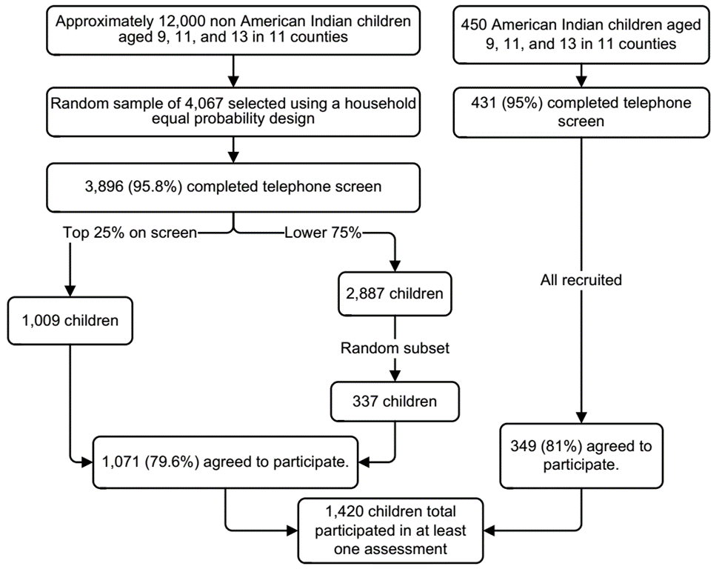

Supplementary Figure 2.

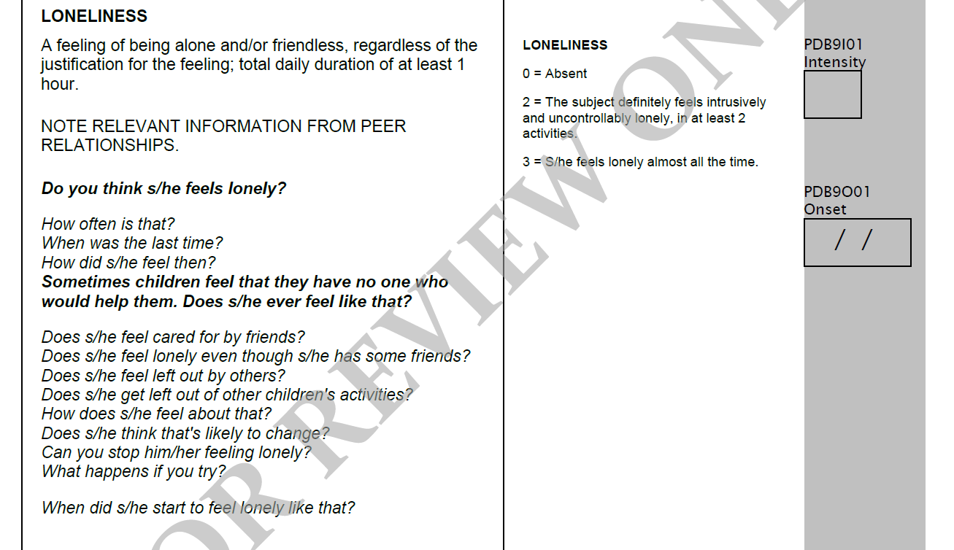

Supplementary Table 1. Prevalence of childhood loneliness between ages 9 to 16 and
association with childhood peer relationship

 | Child- and parent-report loneliness
 | Never lonely  n (%) | Ever lonely  n (%) | p value ª
Overall childhood loneliness | 1230 (86.6) | 190 (13.8%)
Peer relationship
Frequency of contact with peers | 494 (40.2) | 106 (55.8) | 0.081
No Confidant(e) among peers | 712 (57.9) | 116 (61.1) | 0.843
No confidant(e) in family | 685 (57.9) | 116 (61.1) | 0.322
Number of arguments with peers | 104 (8.5) | 48 (25.3) | 0.001
Shyness with peers | 369 (30) | 93 (48.9) | 0.056
Teased or bullied | 372 (30.2) | 115 (60.5) | <0.0001

Numbers denotes children included in one or more analyses. Numbers are unweighted, and
percentages are weighted.
ªp value from binary logistic regression of childhood loneliness and childhood peer relationship
outcomes. The models (Odds ratio [ORs]) are adjusted for child sex.

Supplementary Table 2. Comparison of latent class growth analysis of
loneliness trajectories model fit indices

 | Fit indices
 | Entropyª | AIC^{b} | BIC^{c} | BLRTp value^{d}
Number of class
2 | 0.91 | 175.86 | 180.21 | <0.001

ªAIC = Akaike’s Information Criterion; ^{b}BIC = Bayesian Information
Criterion; ^{c}BLRT = Bootstrap Likelihood Ratio Test.

