Table S1. The cue words list (with English description)
Positive cues | Neutral cues | Control cues
收到 礼物  Receive a gift | 清洗 衣服  Do the laundry | 摩托 轿车  Motorcycle sedan
完成 手工  Complete a DIY | 咨询 客服  Consult a customer service staff | 帽子 眼镜  Hat glasses
得到 帮助  Get help from someone | 外出 问路  Ask for directions | 图钉 卷尺  Pin tape
欣赏 音乐  Enjoy music | 查找 信息  Look up information | 水杯 铁桶  Cup bucket
享用 美食  Enjoy delicious food | 超市 买单  Pay a check at a store | 布鞋 纽扣  Shoes button
享受 运动  Enjoy sports | 打扫 房间  Clean the room | 硬币 钱包  Coin wallet
游戏 获胜  Win a game | 攀爬 楼梯  Climb stairs | 瓶子 书桌  Bottle desk
联系 老友  Contact an old friend | 软件 更新  Update a software | 书包 铅笔  Bag pencil
计划 约会  Plan a dating | 发呆 走神  Mind wandering | 衬衫 手套  Shirt gloves
受到 表扬  Be praised by someone | 参加 会议  Attend a conference | 书本 邮票  Book stamp
演讲 成功  Deliver a success speech | 填写 材料  Fill a form | 篮球 乒乓  Basketball table tennis ball
计划 旅行  Plan travelling | 乘坐 汽车  Be in a car | 椅子 沙发  Chair sofa
阅读 小说
Read a novel
家人 团聚
Family reunion
挣到 外快
Earn extra money
欣赏 雪景
Enjoy the snowing
午间 休息
Have a lunch break
通过 考核
Pass a test
闻到 花香
Smell the flowers
习得 技能
Master a new skill
登山 游览
Go hiking
享受 阳光
Enjoy sunshine
观看 电影
Watch a movie
散步 放松
Take a relaxing walk

Table S2. Brain activation during prospection (vs. control imagination) in all participants
Brain region (AAL) | Peak MNI Coordinates |  |  | Voxels | T | FWE p
 | X | Y | Z
Cingulum_Post_L | -15 | -42 | 24 | 5643 | 11.33 | <0.001
Frontal_Sup_L | -15 | 45 | 21 | 1768 | 8.61 | <0.001
Temporal_Mid_L | -51 | -9 | -21 | 568 | 9.97 | <0.001
Temporal_Mid_R | 54 | 3 | -24 | 223 | 6.68 | 0.004
Cerebelum_9_R | 9 | -54 | -48 | 146 | 5.47 | 0.02
Rolandic_Oper_L | -39 | -15 | 15 | 132 | 4.68 | 0.03
Note: Cingulum_Post_L, left posterior cingulate cortex; Frontal_Sup_L. left superior frontal gyrus; Temporal_Mid_L, left middle temporal gyrus ; Temporal_Mid_R, right middle temporal gyrus.

Figure S1 Brain activations during prospection (vs. control imagination) in all participants. L, left; R, right; A, anterior; P, posterior. Threshold: initial p < 0.001 with cluster-level FWE 0.05 correction.

Table S3. Duration of each stage in each condition
 | SocAhn  (N=46) | Control  (N=32) | t | P
Pos_C | 3.80(2.26) | 3.93(2.64) | -1.09 | 0.28
Pos_E | 14.20(2.26) | 14.07(2.64) | 1.09 | 0.28
Neu_C | 3.86(2.52) | 4.01(2.59) | -0.87 | 0.39
Neu_E | 14.14(2.52) | 14.00(2.59) | 0.87 | 0.39
Con_C | 4.00(2.06) | 4.07(2.70) | -0.38 | 0.70
Con_E | 14..00(2.06) | 13.93(2.70) | 0.38 | 0.70
Note: SocAhn, individuals with social anhedonia; Pos, positive; Neu, neutral; Con, control; C, Construction; E, Elaboration

In the control analysis, hemodynamic activity of the entire 18 seconds of the prospection phase (collapsing the construction and elaboration stage) was modeled in the first-level analysis. One-sample t tests were conducted for the prospection contrast (positive + neutral - control) in all participants and for the emotion contrast (positive - neutral) in each group.
Then a two-sample t test was used to investigate group differences for the emotion contrast. A cluster-level FWE 0.05 correction (initial p < 0.001) was applied as previous analysis did. Results showed a similar pattern compared with previous findings:
(1) The typical prospection network was engaged when prospecting future events in all participants (Table S4; Figure S2);
(2) In the control group, the left frontal regions, the right occipital lobe and the left caudate were more activated when envisioning positive future episodes relative to neutral ones, while less engagement of the precuneus cortex in positive prospection (relative to neutral prospection) was detected in individuals with SocAnh (Table S5; Figure S3);
(3) Compared with controls, individuals with SocAnh exhibited reduced activations in the right caudate during positive prospection (vs. neutral ones) (Table S5; Figure S3).

Table S4. Brain activation for the prospection contrast in all participants in control analysis
Brain region (AAL) | Peak MNI Coordinates |  |  | Voxels | T | FWE p
 | X | Y | Z
Cingulum_Post_L | -12 | -45 | 18 | 2968 | 8.87 | <0.001
Frontal_Sup_L | -12 | 45 | 27 | 1757 | 9.49 | <0.001
Temporal_Mid_L | -39 | -48 | 15 | 280 | 6.54 | 0.002
Temporal_Mid_L | -51 | -12 | -21 | 260 | 9.51 | 0.002
Temporal_Mid_R | 54 | 3 | -24 | 185 | 6.93 | 0.01
Cerebelum_4_5_L | -21 | -36 | -24 | 120 | 7.29 | 0.004
Note: Cingulum_Post_L, left posterior cingulate cortex; Frontal_Sup_L. left superior frontal gyrus; Temporal_Mid_L, left middle temporal gyrus; Temporal_Mid_R, right middle temporal gyrus.

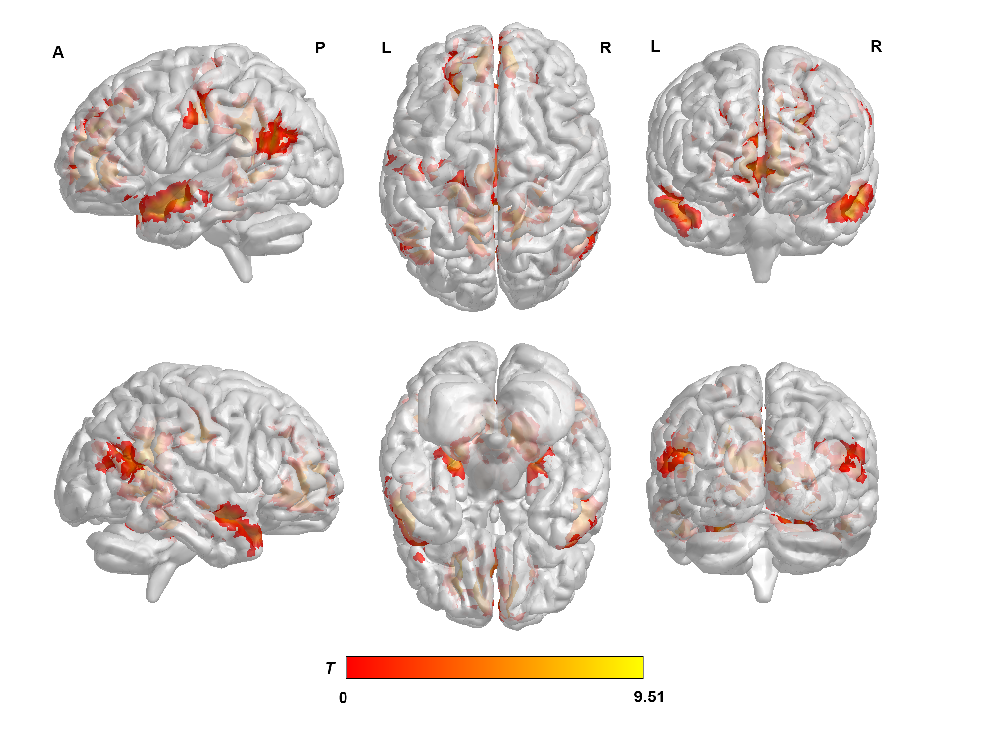

Figure S2 Brain activations during prospection (vs. control imagination) in all participants in the control analysis. L, left; R, right; A, anterior; P, posterior. Threshold: initial p < 0.001 with cluster-level FWE 0.05 correction.

Table S5. Brain activations for the emotion contrast in the control analysis
Brain region (AAL) | Peak MNI Coordinates |  |  | Voxels | T | FWE p
 | X | Y | Z
SocAnh
Precuneus_R | 12 | -57 | 45 | 402 | -4.87 | <0.001
Angular_R | 45 | -51 | 36 | 147 | -4.29 | 0.02
Controls
Postcentral_L | -39 | -21 | 45 | 739 | 8.58 | <0.001
Cerebelum_6_R | 12 | -54 | -27 | 478 | 6.02 | <0.001
Cingulum_Ant_L | 0 | 21 | 12 | 220 | 6.91 | 0.001
Lingual_R | 18 | -81 | 0 | 117 | 4.40 | 0.02
Caudate_L* | -15 | 15 | 6 | 15 | 4.31 | 0.03
SocAhn < Controls
Caudate_R* | 21 | 21 | 0 | 12 | 3.56 | 0.02
Note: * small volume correction was applied; SocAhn, individuals with social anhedonia; Postcentral_L, left postcentral gyrus; Cingulum_Ant_L, left anterior cingulate cortex; Lingual_R, right lingual cortex.

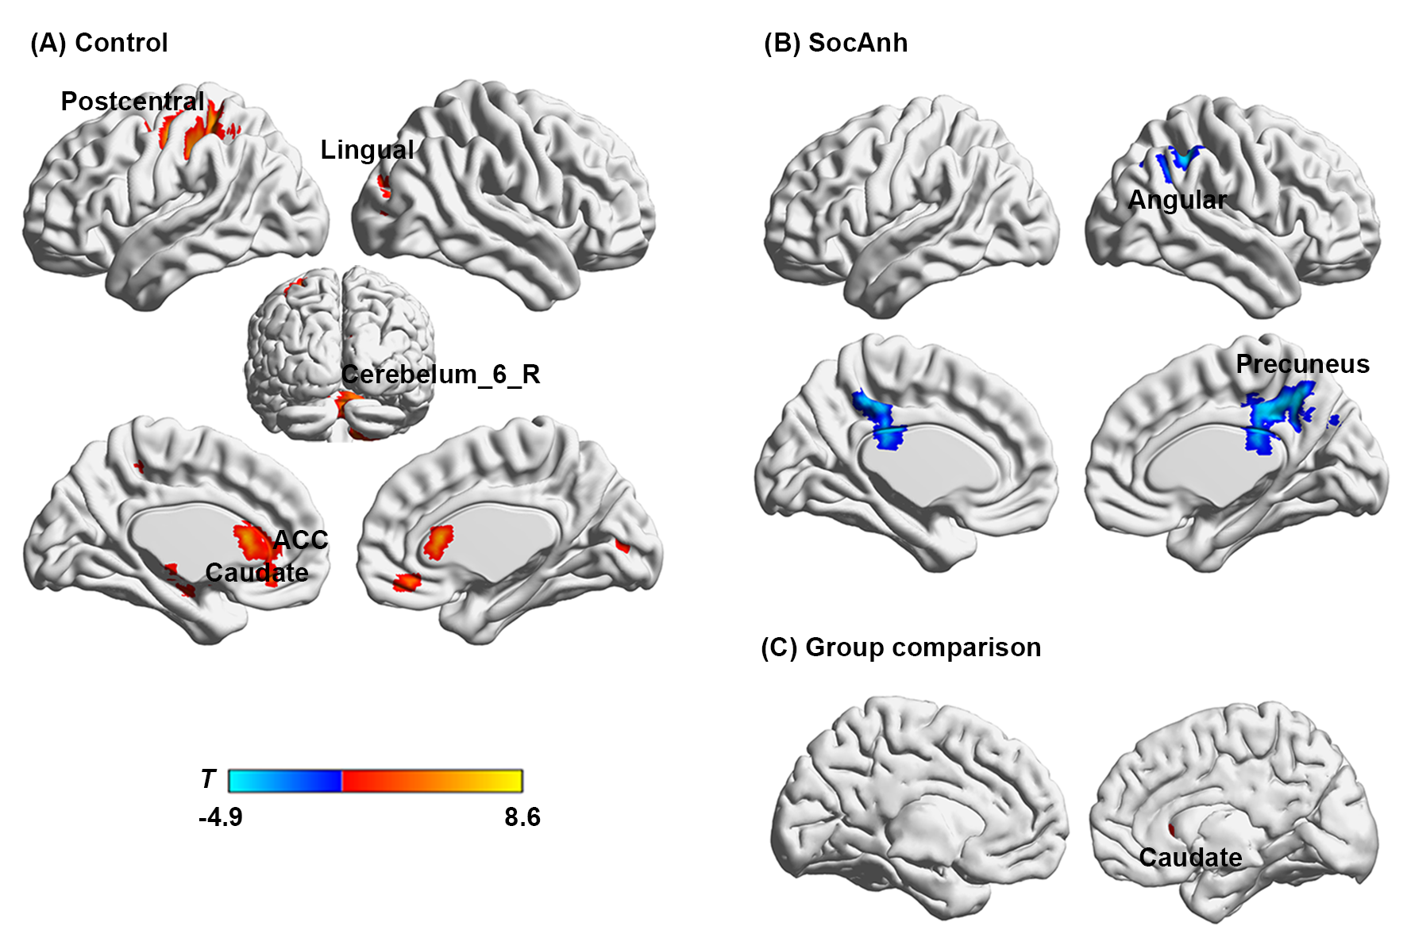

Figure S3. Brain activations for the emotion contrast (positive prospection vs. neutral prospection) in the control analysis. (A) Brain regions engaged in the control group. (B) Brain activations in the SocAnh group. (C) Significant clusters in group comparison (Control - SocAnh). SocAnh, social anhedonia; ACC, anterior cingulate. Threshold: initial p < 0.001 with cluster-level FWE 0.05 correction.

