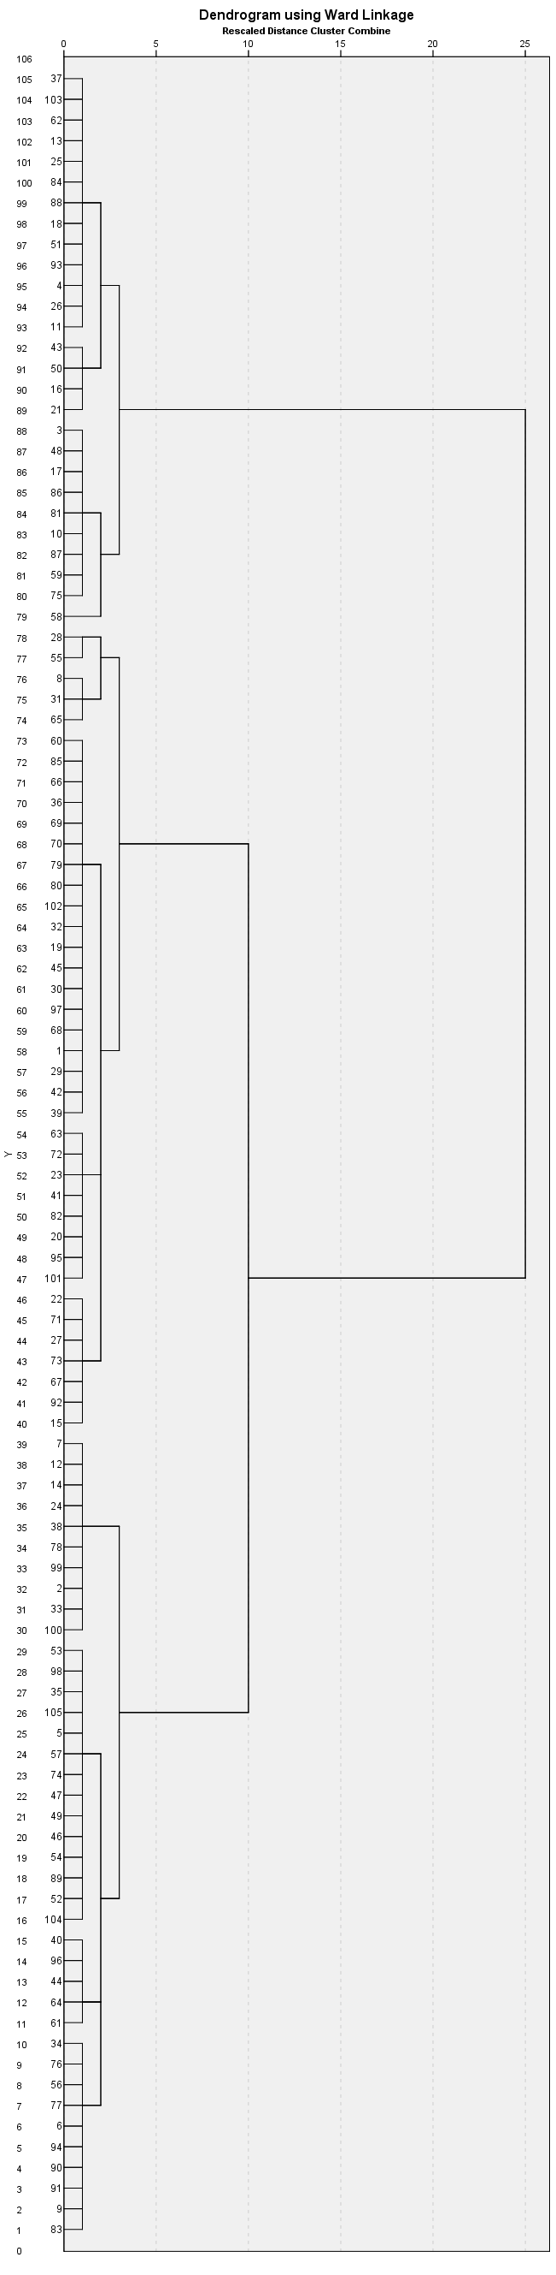
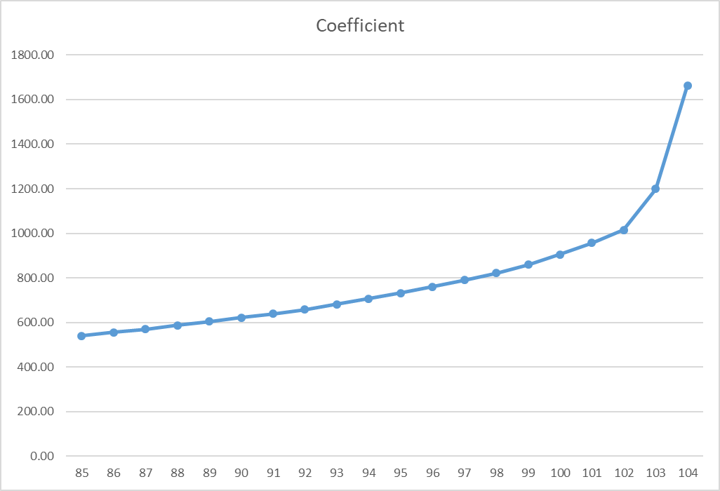

Supplementary Figure 1. Dendrogram and agglomeration scree plot of the hierarchical cluster solution

