Figure A1

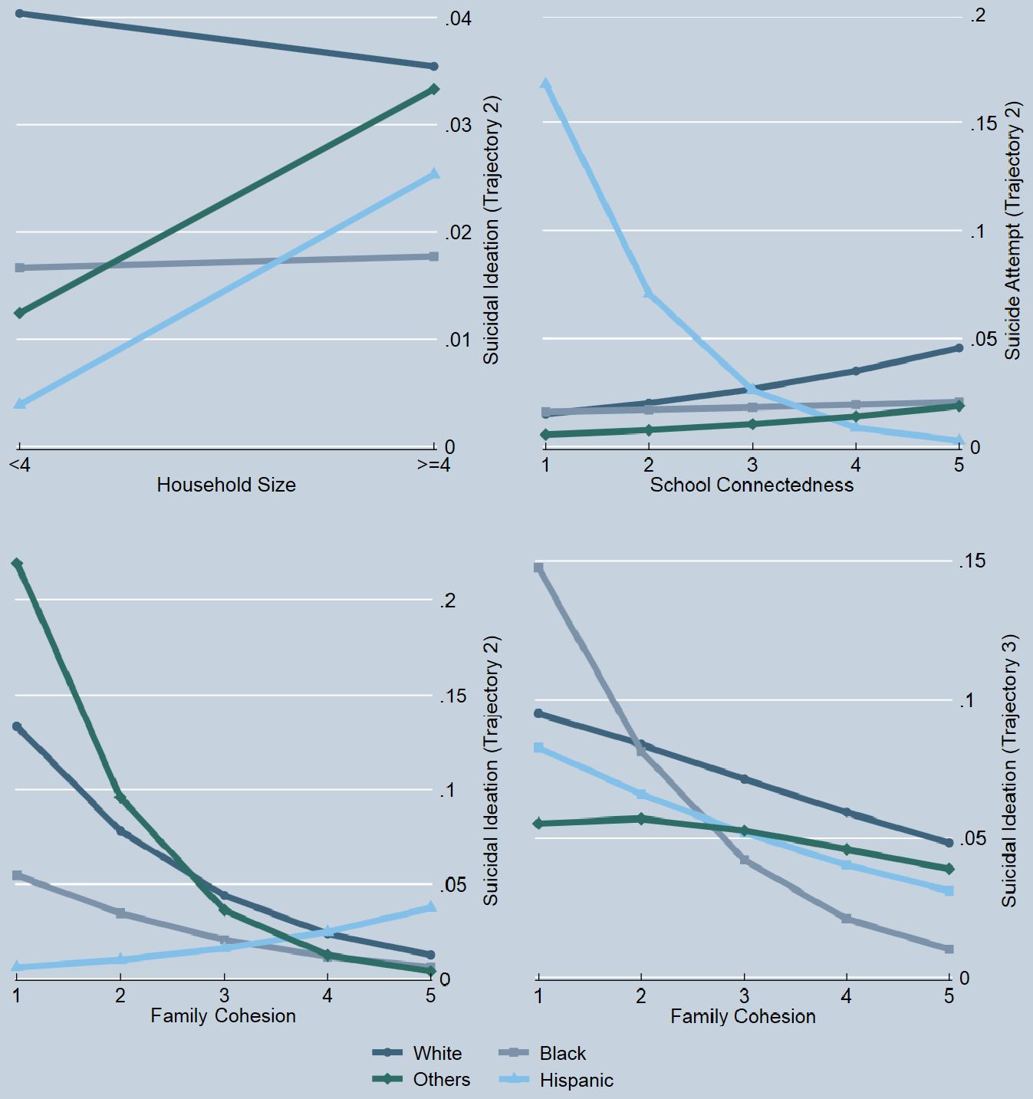
Moderation Effect of Race/ethnicity on the Association between Social Networks and Suicidal Trajectories

