Figure A2
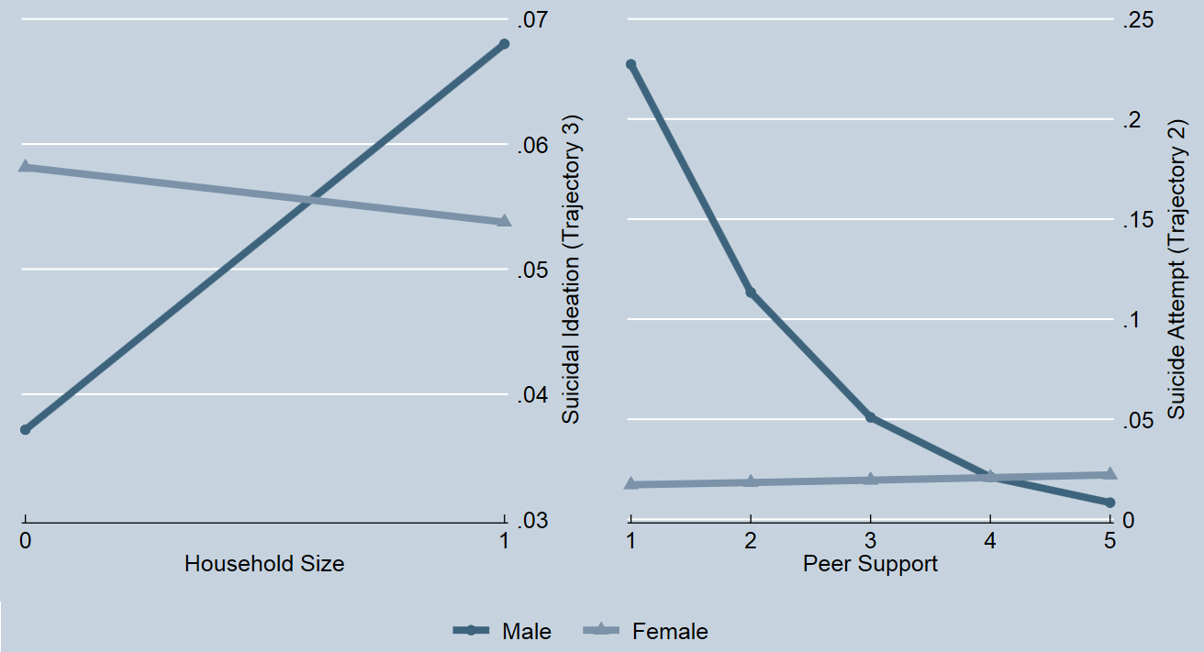
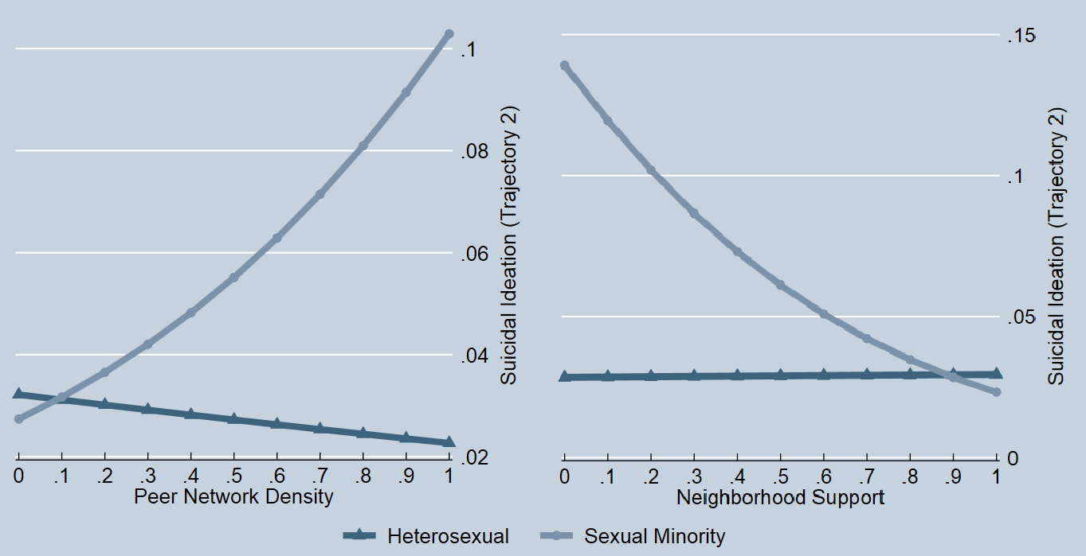
Moderation Effect of Sex and Sexual Identity on the Association

