Figure A1

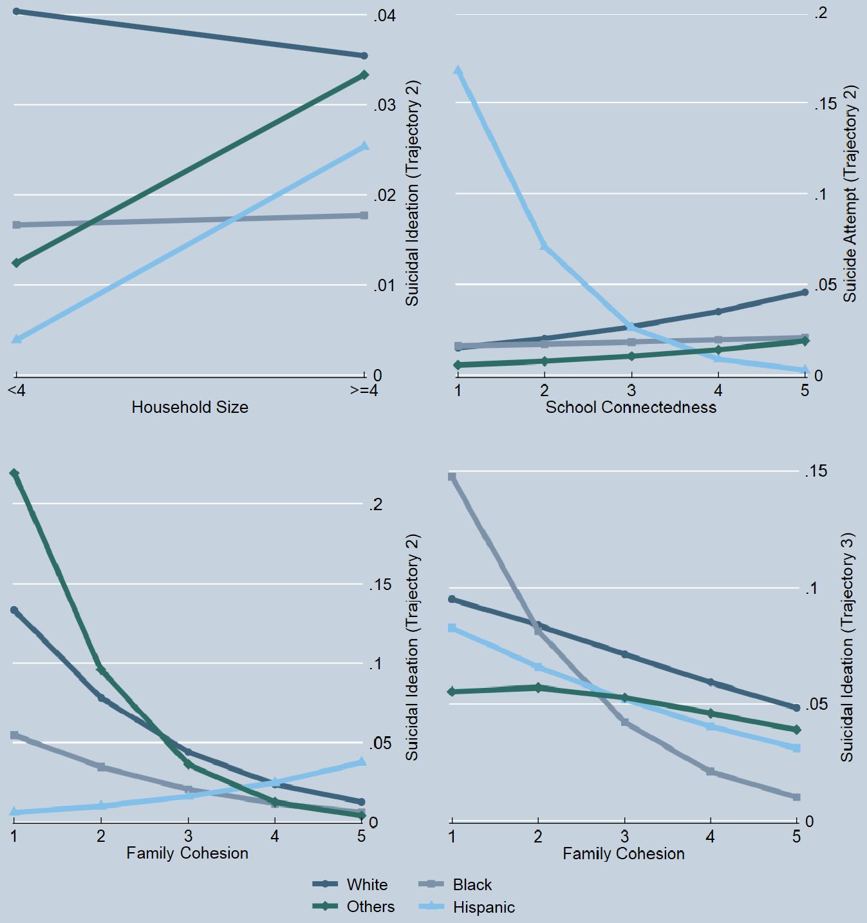
Moderation Effect of Race/ethnicity on the Association between Social Networks and Suicidal Trajectories

Figure A2

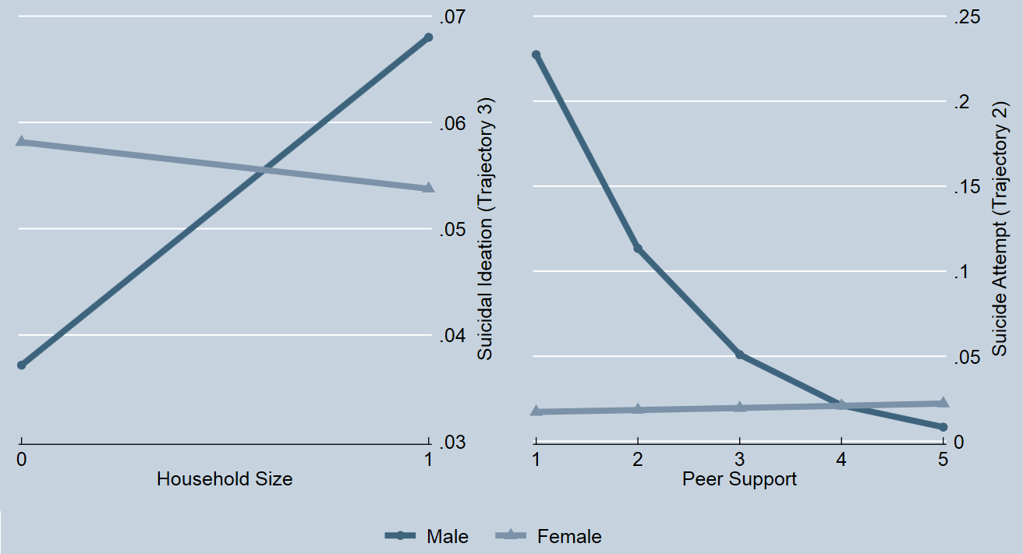
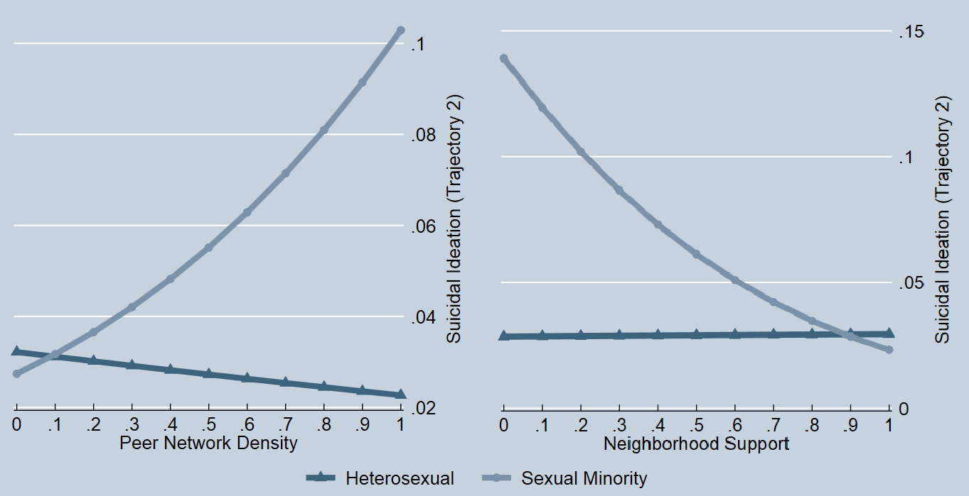
Moderation Effect of Sex and Sexual Identity on the Association between Social Networks and Suicidal Trajectories

Table A1

Summary of Latent Class Growth Analysis Model Identification and Fit Statistics
No. of Classes | AIC | BIC | Adjusted BIC | Smallest Class, % | Entropy | LMR-LRT | P
Suicidal Ideation
1 | 24147.4 | 24333.3 | 24250.7 | - | - | N/A | N/A
2 | 22966.8 | 23174.1 | 23082.0 | 8.95% | 0.713 | 1156.054 | 0.00
3 | 22892.2 | 23121.1 | 23019.4 | 3.42% | 0.846 | 76.848 | 0.13
4 | 22870.5 | 23120.8 | 23009.5 | 0.83% | 0.881 | 27.355 | 0.05
5 | 22875.9 | 23147.6 | 23026.9 | 0.00% | 0.800 | 0.209 | 0.45
Suicide Attempt
1 | 9254.1 | 9440.0 | 9357.4 | - | - | N/A | N/A
2 | 8939.3 | 9146.6 | 9054.5 | 2.21% | 0.816 | 306.95 | 0.00
3 | 8935.7 | 9164.6 | 9062.9 | 0.71% | 0.870 | 8.99 | 0.49
4 | 8939.6 | 9189.9 | 9078.7 | 0.06% | 0.900 | 2.05 | 0.60
5 | 8945.4 | 9217.1 | 9096.4 | 0.04% | 0.902 | 0.21 | 0.58
Note. AIC = Akaike Information Criterion; BIC = Bayesian Information Criteria; Adjusted BIC = Sample size adjusted Bayesian Information Criteria; LMR-LRT = Lo-Mendell-Rubin adjusted likelihood ratio test. Bolded models were selected.

Table A2

Sociodemographic Characteristics, Social Networks and Psychological Differences across Suicidal Trajectoriesª
 | Suicidal Ideation Trajectory |  |  |  |  | Suicide Attempt Trajectory
 | Trajectory 1 | Trajectory 2 | Trajectory 3 | p | χ² / F | Trajectory 1 | Trajectory 2 | p | χ² / t
 | [Low-stable] | [High-decreasing] | [Moderate-decreasing-increasing] |  |  | [Low-stable] | [Moderate-decreasing]
 | [n = 8,603, 91.32%] | [n = 325, 3.45%] | [n = 493, 5.23%] |  |  | [n = 9,213, 97.79%] | [n = 208, 2.21%]
Age [M±SD] | 15.02 [1.62] | 15.28 [1.47] | 15.01 [1.63] | 0.120 | F[2, 9418] = 2.12 | 15.04 [1.61] | 14.89 [1.53] | 0.173 | t = 1.36
Sex, n [%] |  |  |  | <0.001 | χ²[2] = 55.59 |  |  | 0.619 | χ²[1] = 0.25
Male | 4007 [46.58] | 98 [30.15] | 174 [35.29] |  |  | 4181 [45.38] | 98 [47.12]
Female | 4596 [53.42] | 227 [69.85] | 319 [64.71] |  |  | 5032 [54.62] | 110 [52.88]
Sexual Identity, n[%] |  |  |  | <0.001 | χ²[2] = 195.99 |  |  | <0.001 | χ²[1] = 30.01
Heterosexual | 7532 [87.55] | 246 [75.69] | 330 [66.94] |  |  | 7956 [86.36] | 152 [73.08]
Sexual minority | 1071 [12.45] | 79 [24.31] | 163 [33.06] |  |  | 1257 [13.64] | 56 [26.92]
Race/ethnicity, n[%] |  |  |  | 0.099 | χ²[12] = 18.61 |  |  | 0.154 | χ²[6] = 9.37
White | 4833 [56.18] | 192 [59.08] | 295 [56.47] |  |  | 5205 [56.50] | 115 [55.29]
Black | 1804 [20.97] | 47 [14.46] | 83 [16.84] |  |  | 1901 [20.63] | 33 [15.87]
Hispanic | 1317 [15.31] | 58 [17.85] | 74 [15.01] |  |  | 1406 [15.26] | 43 [20.67]
Asian | 540 [6.28] | 25 [7.69] | 32 [6.49] |  |  | 585 [6.35] | 12 [5.77]
American Indian | 65 [0.76] | 2 [0.62] | 6 [1.22] |  |  | 70 [0.76] | 3 [1.44]
Other races | 33 [0.38] | 1 [0.31] | 1 [0.20] |  |  | 34 [0.37] | 1 [0.48]
Multiracial | 11 [0.13] | 0 [0.00] | 2 [0.41] |  |  | 12 [0.13] | 1 [0.48]
Maternal Education, n[%] |  |  |  | 0.061 | χ²[6] = 12.06 |  |  | 0.449 | χ²[3] = 2.65
No school/Less than high school | 1369 [16.82] | 74 [23.79] | 71 [15.64] |  |  | 1568 [17.02] | 43 [20.67]
High school or equivalent | 3328 [40.90] | 112 [36.01] | 187 [41.19] |  |  | 3779 [41.02] | 83 [39.90]
Some college | 1067 [13.11] | 34 [10.93] | 61 [13.44] |  |  | 1183 [12.84] | 29 [13.94]
Graduate school and higher | 2373 [29.16] | 91 [29.26] | 135 [29.74] |  |  | 2683 [29.12] | 53 [25.48]
Public assistance, n[%] |  |  |  | 0.263 | χ²[2] = 2.67 |  |  | 0.042 | χ²[1] = 4.13
None | 5575 [73.18] | 209 [74.38] | 305 [69.79] |  |  | 6713 [72.86] | 142 [68.27]
At least one | 2043 [26.82] | 72 [25.62] | 132 [30.21] |  |  | 2500 [27.14] | 66 [31.73]
Social Networks
Network Structure ^{b.}
Family structure | 5573 [91.09] | 210 [3.39] | 313 [5.52] | 0.829 | χ²[2] = 0.58 | 5972 [97.79] | 124 [2.21] | 0.072 | χ²[1] = 9.19
Household size | 6825 [90.82] | 261 [3.52] | 380 [5.66] | 0.492 | χ²[2] = 2.62 | 7307 [97.55] | 159 [2.45] | 0.927 | χ²[1] = 0.01
Peer network size | 4.89 [3.68] | 5.07 [4.29] | 4.54 [3.28] | 0.135 | F[2, 6778] = 2.00 | 4.58 [3.69] | 4.79 [3.62] | 0.502 | t =-0.67
Peer network density | 0.29 [0.14] | 0.28 [0.16] | 0.30 [0.14] | 0.758 | F[2, 6581] = 0.28 | 0.30 [0.14] | 0.27 [0.12] | 0.055 | t =1.92
Network Function
Family cohesion | 3.82 [0.80] | 3.01 [0.85] | 3.39 [0.88] | <0.001 | F[2, 9390] = 195.18 | 3.75 [0.81] | 3.14 [0.96] | <0.001 | t =10.61
Peer support | 3.96 [0.65] | 3.59 [0.73] | 3.72 [0.71] | <0.001 | F[2, 9412] = 48.73 | 3.93 [0.65] | 3.67 [0.77] | <0.001 | t =5.56
School connectedness | 3.53 [0.53] | 3.17 [0.57] | 3.29 [0.59] | <0.001 | F[2, 9393] = 90.33 | 3.48 [0.53] | 3.15 [0.64] | <0.001 | t =8.87
Neighborhood support | 0.82 [0.26] | 0.72 [0.30] | 0.81 [0.27] | <0.001 | F[2, 9389] = 16.10 | 0.81 [0.26] | 0.77 [0.27] | 0.039 | t =2.06
Depression [M±SD] | 0.60 [0.44] | 1.18 [0.57] | 0.93 [0.60] | <0.001 | F[2, 9409] = 370.47 | 0.64 [0.46] | 1.21 [0.63] | <0.001 | t =-17.36
Note.
ª Chi-square (χ²) tests for categorical variables, Analysis of variance analyses (ANOVA) for continuous variables by suicidal ideation trajectories, t-tests for continuous variables by suicide attempt trajectories. Cells in bold print indicate significant results.
^{b.} Family-level network structure included family structure (0 = all other arrangements; 1 = married, two parents) and household size (0 = ≤ 3 people; 1 = ≥ 4 people).

Table A3

Moderation Effect of Race/Ethnicity on Social Networks and Suicidal Trajectoriesª
 | Suicidal Ideation |  | Suicide Attempt
 | Trajectory 2  [High-decreasing] | Trajectory 3  [Moderate-decreasing-increasing] | Trajectory 2  [Moderate-decreasing]
 | OR [95% CI] | OR [95% CI] | OR [95% CI]
Sex
Male
Female | 1.99** [1.28-3.09] | 0.93 [0.56-1.55] | 0.68 [0.39-1.20]
Sexual Identity
Heterosexual
Sexual minority | 1.80* [1.04-3.13] | 3.01*** [1.93-4.68] | 2.92*** [1.70-5.00]
Age [Wave 1] | 1.02 [0.90-1.16] | 0.96 [0.86-1.07] | 0.98 [0.85-1.13]
Race/Ethnicity^{b.}
White
Black | 0.20 [0.01-4.79] | 3.23 [0.11-98.30] | 0.00 [0.00-6.93]
Hispanic | 0.02 [0.00-6.31] | 1.1 [0.018-68.70] | 0.55 [0.02-19.50]
Others | 0.04 [0.00-23.9] | 19.4 [0.26-1455.60] | 0.69 [0.01-52.10]
Maternal Education
No school/Less than high school
High school or equivalent | 0.86 [0.54-1.37] | 1.13 [0.68-1.85] | 1.09 [0.51-2.34]
Some college | 0.71 [0.32-1.57] | 1.52 [0.86-2.69] | 1.27 [0.50-3.23]
Graduate school and higher | 1.07 [0.58-1.98] | 0.97 [0.58-1.62] | 1.24 [0.59-2.60]
Public Assistance
None
At least one | 0.85 [0.52-1.38] | 0.76 [0.52-1.11] | 1.31 [0.71-2.42]
Social Networks
Network Structure ^{c.}
Family structure | 2.01* [1.00-4.05] | 1.05 [0.60-1.86] | 0.67 [0.31-1.44]
Household size | 0.87 [0.47-1.62] | 1.13 [0.69-1.85] | 1.48 [0.67-3.27]
Peer network size | 1.02 [0.96-1.09] | 0.99 [0.94-1.04] | 1.01 [0.93-1.10]
Peer network density | 0.48 [0.10-2.40] | 2.06 [0.75-5.62] | 0.35 [0.05-2.30]
Network Function
Family cohesion | 0.49*** [0.35-0.69] | 0.78* [0.61-0.99] | 0.61* [0.38-0.98]
Peer support | 0.87 [0.62-1.23] | 0.84 [0.60-1.17] | 0.7 [0.40-1.24]
School detachment | 0.97 [0.64-1.47] | 0.8 [0.56-1.15] | 1.39 [0.78-2.47]
Neighborhood support | 0.58 [0.23-1.46] | 2.18 [0.99-4.79] | 1.44 [0.49-4.19]
Race/Ethnicity × Network Structure
Black × Married | 0.91 [0.25-3.33] | 0.66 [0.23-1.86] | 4.06 [0.76-21.8]
Hispanic × Married | 0.25 [0.06-1.00] | 0.58 [0.21-1.59] | 1.11 [0.23-5.38]
Other race × Married | 0.14 [0.02-1.16] | 0.31 [0.08-1.31] | 0.18 [0.02-1.56]
Black × >=4 members | 1.28 [0.27-6.05] | 1.29 [0.41-4.04] | 0.46 [0.08-2.65]
Hispanic × >=4 members | 8.89* [1.47-53.90] | 1.57 [0.34-7.33] | 18.00 [0.92-352.90]
Other race × >=4 members | 4.52 [0.25-81.1] | 1.59 [0.45-5.60] | 5.72 [0.50-66.1]
Black × Peer network size | 1.06 [0.86-1.31] | 1.04 [0.93-1.16] | 1.12 [0.95-1.32]
Hispanic × Peer network size | 1.02 [0.89-1.16] | 0.99 [0.86-1.15] | 1.03 [0.88-1.19]
Other race × Peer network size | 1.07 [0.86-1.35] | 1.00 [0.79-1.28] | 1 [0.85-1.19]
Black × Peer network density | 3.39 [0.09-123.30] | 1.06 [0.10-12.20] | 6.97 [0.25-197.00]
Hispanic × Peer network density | 2 [0.01-350.60] | 0.21 [0.00-10.20] | 0.42 [0.00-52.30]
Other race × Peer network density ^{d.} | 1409.5*** [28.9-68781.10] | 0.12 [0.00-3.75] | 1.2 [0.04-40.00]
Race/Ethnicity × Network Function
Black × Family cohesion | 1.04 [0.49-2.21] | 0.60* [0.38-0.92] | 2.51 [0.63-10.00]
Hispanic × Family cohesion | 3.25*** [1.72-6.17] | 1.00 [0.53-1.88] | 1.49 [0.56-3.96]
Other race × Family cohesion | 0.55 [0.24-1.28] | 1.04 [0.45-2.40] | 1.3 [0.68-2.47]
Black × Peer support | 1.03 [0.49-2.16] | 0.99 [0.44-2.23] | 1.25 [0.48-3.26]
Hispanic × Peer support | 1.50 [0.38-5.89] | 0.81 [0.37-1.78] | 1.29 [0.49-3.37]
Other race × Peer support | 1.12 [0.43-2.89] | 1.24 [0.41-3.69] | 0.69 [0.25-1.95]
Black × School connectedness | 0.56 [0.15-2.01] | 1.33 [0.41-4.28] | 0.77 [0.25-2.41]
Hispanic × School connectedness | 0.48 [0.11-2.13] | 1.20 [0.42-3.45] | 0.22* [0.05-0.91]
Other race × School connectedness | 0.90 [0.31-2.63] | 0.60 [0.17-2.08] | 1.04 [0.53-2.03]
Black × Neighborhood support | 7.23 [0.69-75.6] | 0.20 [0.031-1.29] | 2.51 [0.13-48.0]
Hispanic × Neighborhood support | 0.26 [0.01-4.94] | 1.28 [0.21-7.86] | 1.38 [0.07-28.3]
Other race × Neighborhood support | 12.4 [0.11-1463.80] | 0.13 [0.01-2.10] | 0.21 [0.03-1.41]
Depression | 5.14*** [3.50-7.56] | 3.02*** [2.25-4.03] | 6.33*** [4.22-9.48]
Note. OR = odds ratio; 95% CI = 95% confidence interval. Cells in bold print indicate significant results for social networks. *p<0.05; **p<0.01; ***p<0.001
^{a.} Reference group = Trajectory 1.
^{b.} Asian, Native American, multiracial and others were collapsed into one group due to small sample sizes.
^{c.} Family-level network structure included family structure (0 = all other arrangements; 1 = married, two parents) and household size (0 = ≤ 3 people; 1 = ≥ 4 people).
^{d.} OR may not be reliable due to data sparseness.

Table A4

Moderation Effect of Sex on Social Networks and Suicidal Trajectoriesª
 | Suicidal Ideation |  | Suicide Attempt
 | Trajectory 2  [High-decreasing] | Trajectory 3  [Moderate-decreasing-increasing] | Trajectory 2  [Moderate-decreasing]
 | OR [95% CI] | OR [95% CI] | OR [95% CI]
Sex
Male
Female | 0.96 [0.06-14.50] | 1.23 [0.16-9.47] | 0.17 [0.00-3.95]
Sexual Identity
Heterosexual
Sexual minority | 1.66 [0.97-2.85] | 3.10*** [1.98-4.85] | 2.83*** [1.63-4.90]
Age [Wave 1] | 1.00 [0.88-1.14] | 0.96 [0.87-1.07] | 0.99 [0.86-1.14]
Race/Ethnicity^{b.}
White
Black | 0.37** [0.20-0.70] | 0.48** [0.28-0.81] | 0.41 [0.15-1.14]
Hispanic | 0.48 [0.23-1.02] | 0.66 [0.40-1.09] | 0.83 [0.43-1.58]
Others | 0.84 [0.30-2.34] | 0.72 [0.39-1.34] | 0.29* [0.09-0.91]
Maternal Education
No school/Less than high school
High school or equivalent | 0.95 [0.59-1.54] | 1.05 [0.66-1.69] | 1.19 [0.56-2.54]
Some college | 0.75 [0.35-1.61] | 1.39 [0.79-2.44] | 1.41 [0.56-3.54]
Graduate school and higher | 1.20 [0.65-2.20] | 0.92 [0.56-1.50] | 1.27 [0.63-2.58]
Public Assistance
None
At least one | 0.82 [0.50-1.34] | 0.76 [0.53-1.08] | 1.32 [0.69-2.54]
Social Networks
Network Structure ^{c.}
Family structure | 1.26 [0.36-4.37] | 1.17 [0.59-2.35] | 0.84 [0.30-2.37]
Household size | 2.11 [0.68-6.60] | 2.06* [1.06-4.04] | 1.13 [0.49-2.58]
Peer network size | 0.99 [0.88-1.11] | 0.98 [0.92-1.05] | 1.07 [0.99-1.16]
Peer network density | 4.68 [0.61-35.9] | 2.51 [0.66-9.60] | 0.15 [0.02-1.58]
Network Function
Family cohesion | 0.38*** [0.25-0.58] | 0.75 [0.53-1.06] | 0.91 [0.43-1.94]
Peer support | 0.67 [0.37-1.24] | 0.94 [0.55-1.63] | 0.37** [0.20-0.68]
School connectedness | 1.03 [0.53-2.01] | 0.68 [0.36-1.30] | 1.46 [0.54-3.99]
Neighborhood support | 0.77 [0.14-4.13] | 1.12 [0.33-3.81] | 1.87 [0.43-8.10]
Sex × Network Structure
Female × Married | 1.14 [0.28-4.57] | 0.63 [0.29-1.38] | 0.92 [0.28-3.04]
Female × >=4 members | 0.42 [0.11-1.61] | 0.44* [0.19-0.89] | 1.65 [0.41-6.62]
Female × Peer network size | 1.05 [0.91-1.20] | 1.01 [0.93-1.10] | 0.91 [0.81-1.02]
Female × Peer network density | 0.08 [0.02-1.71] | 0.46 [0.09-2.70] | 4.35 [0.10-192.90]
Sex × Network Function
Female × Family cohesion | 1.56 [0.91-2.70] | 0.95 [0.64-1.41] | 0.68 [0.27-1.69]
Female × Peer support | 1.46 [0.73-2.91] | 0.84 [0.46-1.55] | 2.91* [1.19-7.13]
Female × School connectedness | 0.79 [0.31-2.00] | 1.41 [0.64-3.12] | 0.67 [0.17-2.68]
Female × Neighborhood support | 0.89 [0.13-6.35] | 2.10 [0.49-8.97] | 0.85 [0.16-4.45]
Depression | 4.89*** [3.31-7.24] | 3.03*** [2.27-4.05] | 5.86*** [3.99-8.60]
Note. OR = odds ratio; 95% CI = 95% confidence interval. Cells in bold print indicate significant results for social networks. *p<0.05; **p<0.01; ***p<0.001
^{a.} Reference group = Trajectory 1.
^{b.} Asian, Native American, multiracial and others were collapsed into one group due to small sample sizes.
^{c.} Family-level network structure included family structure (0 = all other arrangements; 1 = married, two parents) and household size (0 = ≤ 3 people; 1 = ≥ 4 people).

Table A5

Moderation Effect of Sexual Identity on Social Networks and Suicidal Trajectoriesª
 | Suicidal Ideation
 | Trajectory 2  [High-decreasing] | Trajectory 3  [Moderate-decreasing-increasing]
 | OR [95% CI] | OR [95% CI]
Sex
Male
Female | 1.87** [1.22-2.87] | 0.94 [0.56-1.55]
Sexual Identity
Heterosexual
Sexual minority | 1.8 [0.032-102.4] | 2.05 [0.19-22.5]
Age [Wave 1] | 1.02 [0.90-1.16] | 0.97 [0.87-1.07]
Race/Ethnicity^{b.}
White
Black | 0.34*** [0.19-0.63] | 0.47** [0.27-0.80]
Hispanic | 0.50 [0.24-1.06] | 0.66 [0.40-1.07]
Others | 0.83 [0.26-2.63] | 0.74 [0.40-1.36]
Maternal Education
No school/Less than high school
High school or equivalent | 0.91 [0.57-1.47] | 1.09 [0.66-1.78]
Some college | 0.73 [0.34-1.58] | 1.49 [0.85-2.62]
Graduate school and higher | 1.11 [0.60-2.05] | 0.93 [0.56-1.54]
Public Assistance
None
At least one | 0.86 [0.53-1.41] | 0.76 [0.53-1.09]
Social Networks
Network Structure ^{c.}
Family structure | 1.14 [0.64-2.03] | 0.94 [0.58-1.54]
Household size | 1.06 [0.57-1.94] | 1.22 [0.77-1.94]
Peer network size | 0.99 [0.93-1.06] | 0.98 [0.93-1.04]
Peer network density | 0.75 [0.16-3.46] | 2.15 [0.74-6.24]
Network Function
Family cohesion | 0.54*** [0.40-0.73] | 0.70** [0.54-0.91]
Peer support | 0.96 [0.69-1.32] | 0.94 [0.65-1.36]
School connectedness | 0.85 [0.56-1.28] | 0.75 [0.50-1.12]
Neighborhood support | 1.09 [0.46-2.59] | 1.60 [0.74-3.44]
Sexual Identity × Network Structure
Sexual minority × Married | 4.12 [0.91-18.6] | 0.87 [0.39-1.92]
Sexual minority × >=4 members | 1.10 [0.21-5.68] | 1.13 [0.44-2.90]
Sexual minority × Peer network size | 7.74 [0.28-212.2] | 0.36 [0.047-2.78]
Sexual minority × Peer network density | 1.19* [1.02-1.40] | 1.03 [0.93-1.14]
Sexual Identity × Network Function
Sexual minority × Family cohesion | 1.02 [0.50-2.10] | 1.24 [0.77-2.00]
Sexual minority × Peer support | 0.87 [0.37-2.04] | 0.64 [0.37-1.12]
Sexual minority × School connectedness | 0.76 [0.24-2.40] | 1.49 [0.74-2.99]
Sexual minority × Neighborhood support | 0.10** [0.02-0.57] | 1.21 [0.31-4.66]
Depression | 5.06*** [3.45-7.40] | 3.01*** [2.27-3.99]
Note. OR = odds ratio; 95% CI = 95% confidence interval. Cells in bold print indicate significant results for social networks. *p<0.05; **p<0.01; ***p<0.001
^{a.} Reference group = Trajectory 1.
^{b.} Asian, Native American, multiracial and others were collapsed into one group due to small sample sizes.
^{c.} Family-level network structure included family structure (0 = all other arrangements; 1 = married, two parents) and household size (0 = ≤ 3 people; 1 = ≥ 4 people).

