**Supplementary materials**

**Figure 1. Directed Acyclic Graph (DAG) of the proposed causal associations between screen time, depressive symptoms, and covariates**

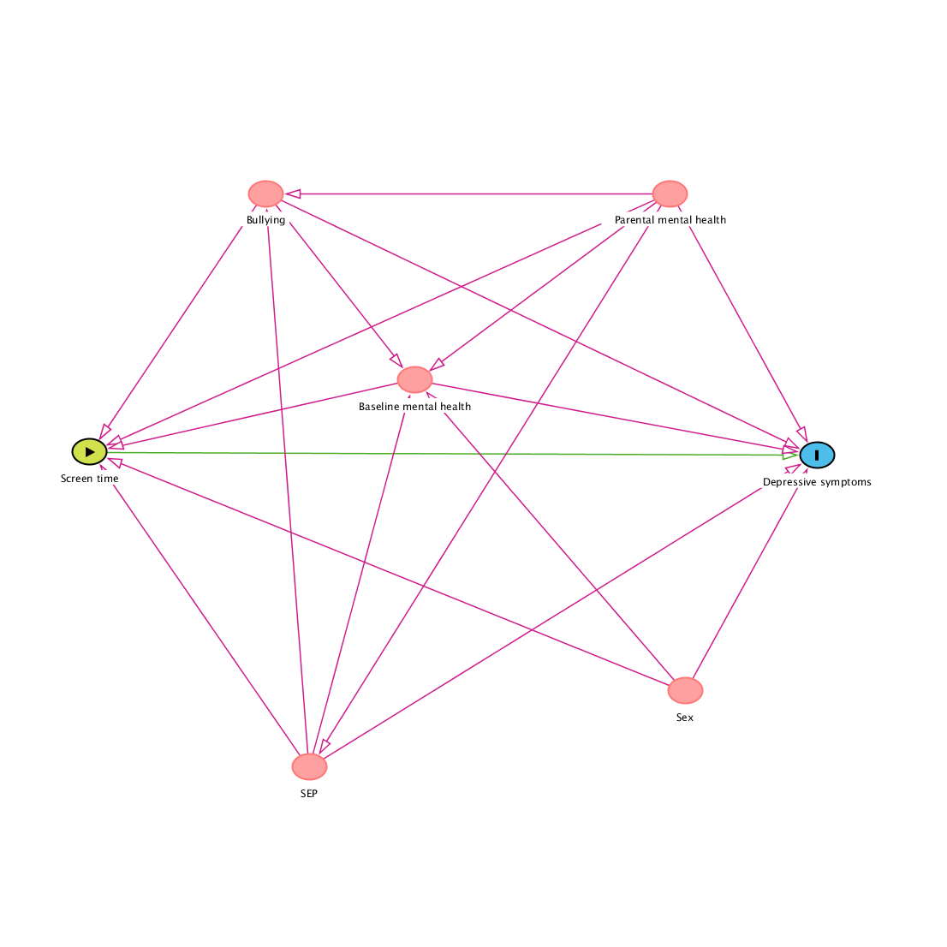

*SEP = socioeconomic position; BMI = body mass index*

*This DAG was generated using the online software available from Daggity.net*

**Figure 2. Distribution of depressive symptoms scores as the outcome**



**Methodology 1. Multiple imputation modelling**

We used multiple imputation by chained equations to fully impute 30 datasets for all 11,341 participants in the sample (1). A separate condition distribution is generated per imputed variable and results from all 30 datasets are pooled into a single multiple imputation dataset. We use predictive mean matching for non-normally distributed variables. The dataset consists of adjusted standard errors that account for the uncertainty of predictions in multiple datasets. We used all the exposure, outcome, and exposure variables in the imputation models. We also included BMI at age 14, total SDQ scores at ages 11 and 14, and child health in the models to improve predictions. To stratify models by sex, it was necessary to exclude participants with missing data for sex (n = 1,358). Below the stratified models include imputed data from 9,983 participants.

**Table 1. Crude models of associations of screen time and depressive symptoms**

|  |  |  |  |  |  |  |  |
| --- | --- | --- | --- | --- | --- | --- | --- |
|  |  | Depression scores (MFQ) | | | | | |
| Exposure | **Variable** | **Male (n = 4583)** | | | **Female (n = 4860)** | | |
| **IRR** | **95% CI** | **P** | **IRR** | **95% CI** | **P** |
| Video gaming | Most days | 0.74 | 0.58, 0.96 | 0.024 | 1.02 | 0.93, 1.14 | 0.605 |
| At least once a week | 0.70 | 0.52, 0.90 | 0.006 | 0.91 | 0.83, 1.01 | 0.084 |
| At least once a month | 0.70 | 0.55, 0.90 | 0.006 | 0.96 | 0.820, 1.07 | 0.189 |
| Less than once a month/never | Reference | | | | | |
| Social media | Most days | 1.05 | 0.97, 1.14 | 0.255 | 1.25 | 1.16, 1.33 | < 0.001 |
| At least once a week | 1.03 | 0.92 1.15 | 0.602 | 1.03 | 0.94 1.11 | 0.548 |
| At least once a month | 0.98 | 0.86, 1.13 | 0.860 | 1.01 | 0.90, 1.15 | 0.769 |
| Less than once a month/never | Reference | | | | | |
| Internet | Most days | 0.79 | 0.66, 0.94 | 0.010 | 1.05 | 0.92, 1.19 | 0.439 |
| At least once a week | 0.78 | 0.65, 0.94 | 0.010 | 0.89 | 0.79, 1.02 | 0.106 |
| At least once a month | 0.81 | 0.66, 1.00 | 0.053 | 0.86 | 0.73, 1.0 | 0.052 |
| Less than once a month/never | Reference | | | | | |

**Table 2. Fully-adjusted models in a full sample with imputed missing data**

|  |  |  |  |  |  |  |  |
| --- | --- | --- | --- | --- | --- | --- | --- |
|  |  | Depression scores (MFQ) | | | | | |
| Exposure | **Variable** | **Male (n = 4877)** | | | **Female (n = 5106)** | | |
| **IRR** | **95% CI** | **P** | **IRR** | **95% CI** | **P** |
| Video gaming | Most days | 0.78 | 0.69, 0.89 | <0.001 | 1.01 | 1.00, 1.18 | 0.039 |
| At least once a week | 0.76 | 0.67, 0.87 | <0.001 | 1.00 | 0.92, 1.09 | 0.999 |
| At least once a month | 0.76 | 0.64, 0.90 | 0.001 | 0.99 | 0.91, 1.09 | 0.921 |
| Less than once a month/never | Reference | | | | | |
| Social media | Most days | 1.02 | 0.96, 1.09 | 0.533 | 1.16 | 1.09, 1.23 | <0.001 |
| At least once a week | 0.99 | 0.92 1.12 | 0.839 | 1.04 | 0.98, 1.12 | 0.165 |
| At least once a month | 1.02 | 0.92, 1.12 | 0.668 | 1.00 | 0.90, 1.11 | 0.971 |
| Less than once a month/never | Reference | | | | | |
| Internet | Most days | 0.85 | 0.78, 0.98 | 0.017 | 1.09 | 0.98,  1.21 | 0.092 |
| At least once a week | 0.83 | 0.74, 0.93 | 0.002 | 0.98 | 0.88, 1.09 | 0.738 |
| At least once a month | 0.90 | 0.79, 1.03 | 0.138 | 0.90 | 0.79, 1.02 | 0.105 |
| Less than once a month/never | Reference | | | | | |

|  |  |  |  |  |  |  |  |
| --- | --- | --- | --- | --- | --- | --- | --- |
|  |  | Depression scores (MFQ) | | | | | |
| Exposure | **Variable** | **Male (n = 3710)** | | | **Female (n = 3991)** | | |
| **IRR** | **95% CI** | **P** | **IRR** | **95% CI** | **P** |
| Video gaming | Most days | 0.77 | 0.66, 0.91 | 0.002 | 1.01 | 0.91, 1.11 | 0.853 |
| At least once a week | 0.76 | 0.64, 0.91 | 0.002 | 0.93 | 0.84, 1.04 | 0.198 |
| At least once a month | 0.69 | 0.57, 0.83 | <0.001 | 0.93 | 0.83, 1.05 | 0.221 |
| Less than once a month/never | Reference | | | | | |
| Social media | Most days | 1.06 | 0.97, 1.16 | 0.183 | 1.12 | 1.05, 1.20 | 0.002 |
| At least once a week | 1.03 | 0.91 1.17 | 0.629 | 0.96 | 0.88, 1.05 | 0.344 |
| At least once a month | 1.01 | 0.86, 1.17 | 0.933 | 0.966 | 0.85, 1.08 | 0.491 |
| Less than once a month/never | Reference | | | | | |
| Internet | Most days | 0.84 | 0.75, 1.00 | 0.051 | 1.10 | 0.95,  1.26 | 0.194 |
| At least once a week | 0.87 | 0.75, 1.01 | 0.076 | 0.96 | 0.83, 1.11 | 0.610 |
| At least once a month | 0.97 | 0.81, 1.17 | 0.744 | 0.94 | 0.79, 1.10 | 0.419 |
| Less than once a month/never | Reference | | | | | |

**Table 3. Fully-adjusted models with total SDQ as a confounding variable**

|  |  |  |  |  |  |  |  |
| --- | --- | --- | --- | --- | --- | --- | --- |
|  |  | Depression scores (MFQ) | | | | | |
| Exposure | **Variable** | **Male (n = 3710)** | | | **Female (n = 3991)** | | |
| **IRR** | **95% CI** | **P** | **IRR** | **95% CI** | **P** |
| Video gaming | Most days | 0.94 | 0.83, 1.00 | 0.052 | 1.05 | 0.98, 1.14 | 0.150 |
| At least once a week | 0.91 | 0.80, 1.04 | 0.201 | 0.97 | 0.90, 1.06 | 0.547 |
| At least once a month, less than once a month/never | Reference |  | | | | |

**Table 4. Fully-adjusted models with a combined reference group for video gaming**