Demographic and clinical variables associated with response to clozapine in schizophrenia: a systematic review and meta-analysis.

SUPPLEMENTARY MATERIALS

CONTENTS
Table 1. Summary of all included studies………………………………….....……2-21
Table 2. Rates of clozapine response and non-response..………...………......22-23
Table 3. Daily clozapine doses and plasma levels………………………..……...24-26
Table 4. Study results, where reported..…………………………………….….....27-57
Table 5. Articles and variables eligible for meta-analysis.……..........……..……58-59
Table 6. Summary data for studies included in the meta-analyses...................60-61

Figure 1. Meta-analysis forest and funnel plots….………………………….……62-65

Table 1. Summary of all included articles.
Authors (year) | Study design | N | Study population | Study duration | Demographic and clinical variables | Outcome measure | Analysis
(Buckley, Thompson, Way, & Meltzer, 1994) | Prospective observational, open-label clozapine treatment | 118 | Inpatient and outpatients treated at the Mental Health Research Centre, Cleveland, USA.  DSM-III-R diagnosis of schizophrenia or schizoaffective disorder, with or without presence of a lifetime or current RCD/DSM-III-R diagnosis of substance abuse.  Treatment resistance defined as inadequate clinical response to at least three trials of non-clozapine antipsychotics at doses of 800mg/day chlorpromazine equivalent. | 6 months | - History of or current substance abuse | Clinical: ≥ 20% reduction in BPRS from baseline | Investigated differences in clozapine response rate between substance abuse / non-substance abuse groups.
(Conley, Carpenter, & Tamminga, 1997) | Prospective observational, open-label clozapine treatment | 50 | Inpatients on the Treatment Research Unit, Spring Grove Hospital Centre, Baltimore, USA.  DSM-III-R diagnosis of schizophrenia.  Treatment resistance defined as 1) inadequate response to two 6-week trials of antipsychotics at doses of 600mg/day chlorpromazine equivalent, 2) no period of good clinical functioning in the past 5 years, and 3) prospective trial of haloperidol to confirm treatment resistance (or perphenazine if haloperidol intolerant). | 12 months | - Age  - Sex  - Age of onset  - Duration of illness  - Length of hospitalisation | Clinical: ≥ 20% reduction in BPRS from baseline plus total BPRS ≤ 35 or CGI ≤ 3 | Survivor analysis to estimate time to respond and dose required to respond.  Between group comparison of responder vs. non-responder groups.  Length of illness and length of hospitalization assessed using ANOVA.
(El-Badri & Mellsop, 2011) | Retrospective chart review.  Databases searched:  Waikato hospital and Community Mental Health Services database and Clozapine Authorisation and Monitoring Program databases for patients treated with clozapine between. | 201 | Inpatients and outpatients with schizophrenia diagnosis treated with clozapine in hospital and community of the Waikato district, New Zealand between January 2001 and December 2006.  Clozapine prescription used as a proxy for treatment resistance. | Minimum treatment with clozapine for 3 months | - Age  - Sex  - Ethnicity | Service use: number of hospitalisations and length of hospital stay post clozapine  Functional: HoNOS item scores change | Between group comparison of responder vs. non-responder groups.  Investigated differences in clozapine response between groups stratified by age, gender and ethnicity.
(Fabrazzo et al., 2002) | Prospective observational, open-label clozapine treatment | 88 | Patients enrolled in a clozapine monitoring programme.  DSM-IV diagnosis of schizophrenia.  Kane’s criteria for treatment resistance. | Up to 52 weeks; response assessed at 4, 8, 12 and 24 weeks | - Age  - Sex  - Age of onset  - Number of previous hospitalisations  - Education | Clinical: ≥ 20% reduction in BPRS total score from baseline plus total ≤ 47 | Between group comparison of responder vs. non-responder groups.  ANOVA to compare groups of all responders, new responders at 4, 8, 12, 24 weeks and non-responders.
(Gee, Shergill, & Taylor, 2016) | Retrospective chart review | 102 | Patients treated in the South London and Maudsley Trust, UK, between January 2006 and April 2010.  No diagnosis specified in inclusion criteria although. Study included all patients who commenced clozapine over the four-year period. | Data collected from first period of presentation until end of study (1 November 2014)  Average study period = 33000 days (range 90 – 7102 days) | - Age  - Sex  - Delay in clozapine initiation  - Number of previous antipsychotic trials | Service use: net change in number of admissions and net change in days of admission | Mirror image analysis; within-subjects comparisons of outcome measures in the pre and post clozapine initiation period.
(Hofer et al., 2003) | Prospective observational, open-label clozapine treatment | 95 | Inpatients who started a first trial of clozapine between 1989 and 1996 at the Department of Psychiatry, Innsbruck University Clinics, Germany.  DSM-III-R schizophrenia or schizophreniform; 39 first episode and 56 multi-episode.  Treatment resistance defined as failure to respond to two 4-week trials of antipsychotics, corresponding to 15-20mg/d haloperidol. | 6 weeks | - Age  - Sex  - Duration of illness | Clinical: ≥ 2 point reduction in CGI score from baseline or total ≤ 3 | Between group comparison of responder vs. non-responder groups.  Regression analyses to identify associations between clinical and demographic variables with CGI % change
(Kaneda, Jayathilak, & Meltzer, 2010) | Prospective observational, open-label clozapine treatment | 59 | Study conducted at Vanderbilt University, Tennessee, USA.  DSM-III-R diagnosis schizophrenia or schizoaffective disorder.  Kane’s criteria for treatment resistance. | 12 months | - Age  - Sex  - Ethnicity  - Age of onset  - Duration of illness  - Education  - Number of previous hospitalisations  - IQ | Functional: employment status | Between group comparison of employed vs. unemployed groups.
(Kelly, Gale, & Conley, 2003) | Prospective observational, open-label clozapine treatment | 45 | Followed patients discharged from a research unit between April 1991 and March 1996.  DSM-III-R diagnosis of schizophrenia.  Treatment resistance defined as three unsuccessful antipsychotic trials in the preceding 5 years at doses of 1000mg/d chlorpromazine equivalent for at least 6 weeks. | 12 months | - Prior history of substance abuse (DSM-III-R criteria) | Service use: time to rehospitalisation | Time to rehospitalisation measured by the product-limit (Kaplan-Meier) survival analysis and compared using log-rank chi squared.
(Kelly et al., 2006) | Retrospective chart review.  Databases searched: the Clozapine Authorization and Monitoring Program, the State of Maryland Antipsychotic Database, and the Health Maintenance Information System Database. | 373 | Inpatients treated with clozapine between March 1994 and December 2000, Maryland, USA.  DSM-IV diagnosis of schizophrenia, schizoaffective disorder or psychotic disorder not otherwise specified.  Treatment resistance defined as two unsuccessful trials of non-clozapine antipsychotics. | 12 months | - Ethnicity | Clinical: change in BPRS score across clozapine treatment; continuous variable  Service use: time to hospital discharge | Response to clozapine was compared between groups stratified by ethnicity.
(Kelly, Feldman, Boggs, Gale, & Conley, 2010) | Prospective observational, open-label clozapine treatment | 85 | Inpatients treated with clozapine between 1992 and 2002.  DSM-III-R and DSM-IV diagnosis of schizophrenia.  Treatment resistance defined as 1) persistent positive psychotic symptoms, item score 4 or higher on at least 2 of 4 positive symptom items on BPRS; 2) current presence of at least moderately severe illness rated by total BPRS ≥ 40 and CGI ≥ 4; 3) two failed antipsychotic trials of at least 6-week duration at a minimum dose of 600mg/day chlorpromazine equivalent; and 4) no stable period of good social and/or occupational functioning within the last five years. | 6 months | - Age  - Sex  - Ethnicity  - Age of onset  - Education  - Ever married  - Age at first hospitalisation  - Number of previous Hospitalisations  - Length of illness  - Level of functioning (Cannon-Spoor Premorbid Adjustment Scale) | Clinical: ≥ 20% reduction in BPRS from baseline | Between group comparison of responder vs. non-responder groups.
(Kim, Yi, Lee, & Kim, 2013) | Prospective observational, open-label clozapine treatment | 40 | Participants with DSM-IV diagnosis of schizophrenia.  Treatment resistance defined as poor response to two antipsychotic trials of 6-weeks at a minimum dose of 100mg/d chlorpromazine equivalent. | 8 weeks | - Age  - Sex  - Duration of illness  - Education | Clinical: ≥ 20% reduction in PANSS from baseline and ≥ 2 point reduction in CGI | Between group comparison of responder vs. non-responder groups.
(Köhler-Forsberg, Horsdal, Legge, MacCabe, & Gasse, 2017) | Retrospective chart review.  Databases searched: the Danish Psychiatric Central Research Register; the Danish Schizophrenia Registry; and the Danish National Prescription Registry. | 502 | Inpatients and outpatients prescribed clozapine between January 2004 and December 2011.  Diagnosis of schizophrenia ICD-10 F20-20.9. | 2 years | - Age  - Sex  - Education  - Employment status  - Relationship status  - Duration of illness  - Detainment during hospitalisation  - Coercive measures applied during hospitalisation  - Number of psychiatric hospital contacts within first 30days of clozapine treatment | Service use: non-hospitalization due to schizophrenia  Functional: improvement on GAF-F where moderate improvement = GAF-F increase ≥ 10 and substantial improvement = GAF-F increase ≥ 20 plus total GAF-F ≥ 50. | Cox regression models to assess the relationship between variables and 1) likelihood of non-hospitalization, 2) improvement on GAF. Hazard ratios reported.  Additional analyses stratified by gender.
(Krivoy et al., 2018) | Cross-sectional assessment supplemented with retrospective information from patient records where available. | 89 | Inpatients and outpatients treated at Geha mental health centre, Israel.  DSM-IV-TR diagnosis of schizophrenia. | Minimum treatment with clozapine 18 weeks, including treatment on a stable daily dose for at least 4 weeks | - Age  - Sex  - Smoking status | Clinical: change in PANSS from baseline or less than 2 positive PANSS items scores at less than moderate (4) | Between group comparison of responder vs. non-responder groups.
(Lieberman et al., 1994) | Prospective observational, open-label clozapine treatment | 84 | Inpatients commenced on clozapine between 1985 and 1990. 59 were followed for 12 weeks and 45 were followed for 52 weeks.  DSM-III-R diagnosis of schizophrenia or schizoaffective disorder.  Treatment resistance defined as persistent psychotic symptoms for at least 2 years, despite adequate trials of three antipsychotics for 6-weeks at doses of at least 1000mg/d chlorpromazine equivalent. | 52 weeks | - Age  - Sex  - Age of onset  - Duration of illness  - Paranoid subtype  - Presence of side effects | Clinical: time to meet response criteria and likelihood of meeting response criteria.  ≥ 20% reduction in BPRS from baseline and total ≤ 36 and CGI ≤ 3 | Between group comparison of responder vs. non-responder groups.  Time to improvement measured using survival analysis (Kaplan Meier).
(Llorca et al., 2002) | Prospective observational, open-label clozapine treatment | 37 | Inpatients in the Adult Psychiatry Department at Hospital Sainte-Marguerite, Marseilles, France.  DSM-IV diagnosis of schizophrenia.  Treatment resistance defined at inadequate response to three antipsychotic trials of 6-weeks, at doses of at least 100mg/d chlorpromazine equivalent over the past 5 years. | 18 weeks | - Age  - Sex  - Weight | Clinical: ≥ 20% reduction in PANSS score from baseline | Between group comparison of responder vs. non-responder groups.
(Manschreck, Redmond, Candela, & Maher, 1999) | Prospective observational, open-label clozapine treatment | 54 | Inpatients, USA state hospitals.  DSM-III-R schizophrenia or schizoaffective diagnosis. | 1 year | - Age  - Sex  - Age of onset  - Duration of illness  - Education  - Length of hospitalisation  - Diagnosis (schizophrenia vs. schizoaffective disorder)  - Hand preference | Service use: hospitalised vs. discharged | Between group comparison of responder vs. non-responder groups.  Survival analysis techniques used to predict likelihood of discharge based on baseline and change scores for clinical variables.
(McEvoy, Freudenreich, & Wilson, 1999) | Prospective observational, open-label clozapine treatment | 70 | Participants with DSM-III-R diagnoses of schizophrenia.  Treatment resistance defined at failure to respond to two adequate antipsychotic trials. | 12 weeks | - Smoking status | Clinical: ≥ 33.33% reduction in BPRS from baseline | Investigated differences in clozapine response rate between smoking / non-smoking groups.
(Nielsen, Nielsen, & Correll, 2012) | Retrospective chart review.  Databases searched: the Danish Central Psychiatric Research Registry and the National Prescription Database. | 633 | Patients with a first prescription of antipsychotic medication after January 1, 1997 and a first prescription of clozapine before 31 December, 2005.  ICD-10 diagnosis of schizophrenia. | 2 years (minimum follow-up period) | - Age  - Sex  - Age of onset  - Average clozapine dose  - Number of previous different antipsychotics  - Mean CPZ equivalent during year prior to clozapine  - Duration of illness  - Number of previous hospitalisations | Service use: time to admission; psychiatric hospitalization during clozapine treatment | Cox and logistic regression analyses testing the association between clinical and demographic variables and outcome. Hazard ratios reported.
(Rodriguez, Catalina, García-Noblejas, & Cuesta, 1998) | Prospective observational, open-label clozapine treatment | 49 | Participants with DSM-IV diagnosis of schizophrenia.  Treatment resistance defines as non-response to two 2-week trials of antipsychotics at doses of at least 800mg/d in the past year. | 6 months | - Age  - Age of onset  - Parkinsonism | Clinical: ≥ 50% reduction in global SANS plus SAPS from baseline and CGI ≤ 3 | Between group comparison of responder vs. non-responder groups.
(Semiz et al., 2007) | Prospective observational, open-label clozapine treatment | 97 | Participants recruited at the Adult Psychiatry Department of the GATA Haydarpasa Veteren Hospital in Istanbul, Turkey.  DSM-IV diagnosis of schizophrenia.  Treatment resistance defined as non-response to two antipsychotic trials lasting 6-8 week. | 16 weeks | - Age  - Sex  - Age of onset  - Diagnosis subtype | Clinical: 20% reduction in BPRS from baseline and total < 35 | Between group comparison of responder vs. non-responder groups.  Logistic regression analyses to assess effects of baseline variables on response outcome.
(Shah et al., 2020) | Retrospective chart review.  Database searched: Toronto’s Centre for Addiction and Mental Health (CAMH) clinical information system. |  | 206 inpatients and outpatients treated at CAMH Toronto, Canada between October 2017 – November 2018.  Diagnosis of schizophrenia or schizoaffective disorder.  Treatment resistance defined as non-response to two non-clozapine antipsychotics, taken for at least 6 weeks at a dose greater than 400mg/day chlorpromazine equivalent. | Between 1 – 2 years after being on stable clozapine dose for 3 months. | - Sex  - Age  - Age at onset  - Education  - Ethnicity  - Delay in clozapine initiation  - Duration of illness  - Number of hospitalisations prior to clozapine  - Number of hospital admission days  - Diagnosis subtype (schizophrenia vs. schizoaffective disorder)  - Family history of psychiatric illness  - Total number of antipsychotics taken  - Duration of non-clozapine antipsychotics  - Smoking status  - Substance use  - Comorbid conditions | Clinical: a score of 2 or less on global improvement and positive symptom domains on CGI constituted response. Non-response was a score greater than 2 on global improvement or positive symptom domains.  Patients also considered as clozapine non-responders if taking another antipsychotic with clozapine or undergoing electroconvulsive therapy. | Patients included in analysis if they were stable in response status between short and long follow-ups.  Between group comparison of responder vs. non-responder groups.  Binary logistic regression to assess predictors of clozapine response.
(Spina et al., 2000) | Prospective observational, open-label clozapine treatment | 45 | Patients treated at the Centres of Mental Health, Azienda USL 5, Messina, Italy.  DSM-IV diagnosis of schizophrenia.  Treatment resistance defined as non-response to two antipsychotic trials at doses of at least 500mg/day chlorpromazine equivalent. | 12 weeks | - Age  - Sex  - Weight | Clinical: 20% reduction in BPRS from baseline or total < 35 | Between group comparison of responder vs. non-responder groups.
(Stern, Kahn, Davidson, Nora, & Davis, 1994) | Prospective observational, open-label clozapine treatment | 40 | Inpatients with diagnosis of schizophrenia.  Treatment resistance defined from chart review or a failed 5-week prospective trial of haloperidol. | 5 weeks | - Age  - Sex  - Age of onset  - Number of previous hospitalisations | Clinical: 1-point reduction CGI score from baseline  35 on BPRS required for minimum entry to study | Between group comparison of responder vs. non-responder groups.
(Sumiyoshi, Hasegawa, Jayathilake, & Meltzer, 1997) | Prospective observational, open-label clozapine treatment | 18 | Inpatients at the University Hospitals of Cleveland, Ohio, USA.  DSM-III-R diagnosis of schizophrenia.  Treatment resistance defined as 1) two failed antipsychotic trials in the past five years at doses of at least 800mg/d chlorpromazine equivalent to a period of 6 weeks and 2) poor social functioning within the past two years or longer. | 6 months | - Age  - Age of onset  - Duration of illness | Clinical: ≥ 20% reduction in BPRS from baseline | Between group comparison of responder vs. non-responder groups.
(Szymanski et al., 1996) | Prospective observational, open-label clozapine treatment | 69 | Inpatients and outpatients treated at Hillside Hospital, Philadelphia and New York metropolitan area.  DSM-III diagnosis of schizophrenia.  Treatment resistance defined as non-response to at least three antipsychotic trials of a duration of 6 weeks at a minimum dosage of 1000mg/d chlorpromazine equivalent. | 12 weeks | Sex | Clinical: ≥ 20% reduction in BPRS from baseline | Investigated differences in response between males and females in the time-course of recovery.  Calculated cumulative proportion of patients not recovering over 12 weeks.
(Üçok et al., 2015) | Retrospective chart review.  Databases searched: the First Episode Schizophrenia Follow-up Project and the Psychotic Disorders Research Program Outpatient Unit clinical information systems. | 137 | Outpatients with schizophrenia diagnosis treated at Istanbul Faculty of Medicine, Department of Psychiatry, Turkey.  Treatment resistance defined as non-response to two antipsychotic trials of at least 6-weeks in duration. | Minimum of 1 month after reaching target dose | - Number of previous antipsychotic trials  - Number of previous hospitalisations  - Delay in clozapine initiation  - Duration of illness  - Smoking status  - Higher than recommended dose of non-clozapine antipsychotic | Clinical: improvement in symptoms classified as remarkable response; moderate response and no response. Based on scores symptom severity and collective opinion of patient, carers and clinician. | Between group comparison of responder vs. non-responder groups.  Regression analyses to identify associations between clinical and demographic variables with clozapine response.
(Umbricht et al., 2002) | Randomized control trial: participants randomised to clozapine or haloperidol. Double-blind. Clozapine group then stratified based on response. | 37 | Outpatients recruited at research sites in New York, Los Angeles and Pittsburgh, USA.  DSM-III-R diagnosis of schizophrenia or schizoaffective disorder. | 29 weeks | - Age  - Sex  - Age at first symptom  - Age at first hospitalisation  - Duration of illness  - Premorbid functioning | Clinical: ≥ 20% reduction in BPRS-psychosis from baseline | Between group comparison of responder vs. non-responder groups.  Cox regression models to assess association between baseline variables and response group status.
(Usall, Suarez, Haro, & SOHO, 2007) | Prospective observational, open-label clozapine treatment | 274 | Patients with schizophrenia treated with clozapine between 1 September 2000 and 31 December 2001, recruited to the Schizophrenia Outpatient Health Outcomes (SOHO) study | 6 months | - Sex  - Age first treatment | Clinical: ≥ 2-point reduction in CGI  Functional: EQ-VAS | Multivariate models with CGI or EQ-VAS change from baseline as the outcome.
(Wong et al., 2006) | Prospective observational, open-label clozapine treatment | 51 | Inpatients at Castle Peak Hospital, Hong Kong.  DSM-IV diagnosis of schizophrenia or schizoaffective disorder.  Treatment resistance defined as non-response to two antipsychotic trials of 6 weeks in duration at therapeutic dose. | 12 weeks | - Age  - Sex  - Age of onset  - Length of illness  - Smoking status  - Number of cigarettes consumed per day  - Diagnosis subtype (schizophrenia versus schizoaffective)  - Schizophrenia subtype (paranoid versus other)  - Body weight  - Length of current hospitalisation  - Number of hospitalisations in past five years  - Length of hospitalisation in past five years | Clinical: ≥ 20% reduction in BPRS from baseline and BPRS total ≤ 35 or CGI total ≤ 3 | Between group comparison of responder vs. non-responder groups.
(Yoshimura, Yada, So, Takaki, & Yamada, 2017) | Retrospective chart review | 90 | Inpatients at Okayama Psychiatric Medical Centre, Japan, who initiated clozapine between 1 January 2010 and 28 February 2015.  ICD-10 diagnosis of treatment resistant schizophrenia. | patients on clozapine for a minimum of 3 months | - Age  - Sex  - Duration of illness  - Delay in clozapine initiation  - Number of previous hospitalisations | Clinical: ≥ 40% reduction in BPRS from baseline | Regression analyses to identify associations between clinical and demographic variables with clozapine response.

Table 2. Rates of clozapine response and non-response.
First author (year) | Total | Responder | Non-Responder | % Non-Response
Buckley (1994)ª | 118 | - | - | -
Conley (1997) | 50 | 34 | 16 | 32%
El-Badri (2011)^{b} | 163 | - | - | -
Fabrazzo (2002) | 32 | 23 | 9 | 28%
Gee (2016) | 102 | 67 | 35 | 34%
Hofer (2003) | 95 | 46 | 49 | 52%
Kaneda (2010) | 59 | 12 | 47 | 80%
Kelly (2006)^{c} | 373 | - | - | -
Kelly (2003)^{d} | 45 | - | - | -
Kelly (2010) | 85 | 35 | 50 | 59%
Kim (2013) | 40 | 15 | 25 | 63%
Kohler-Forsberg (2017)^{e} | 502 | - | - | 63 – 94%
Krivoy (2018) | 89 | 54 | 35 | 39%
Liberman (1994)^{f} | 45 | - | - | 43%
Llorca (2002) | 37 | 19 | 18 | 49%
Manschreck (1999) | 54 | 35 | 19 | 54%
McEvoy (1999) | 70 | 46 | 24 | 34%
Nielsen (2012)^{g} | 633 | - | - | -
Rodriguez (1998) | 49 | 31 | 18 | 37%
Semiz (2007) | 97 | 54 | 43 | 44%
Shah (2020) | 206 | 102 | 104 | 50%
Spina (2000)^{k} | 45 | 18 | 27 | 60%
Stern (1994) | 40 | 18 | 22 | 55%
Sumiyoshi (1997) | 18 | 7 | 11 | 61%
Üçok (2015)^{h} | 137 | - | - | -
Umbricht (2002) | 33 | 22 | 15 | 45%
Usall (2007)^{i} | 274 | - | - | -
Wong (2006) | 51 | 22 | 29 | 57%
Yoshimura (2017) | 90 | 47 | 43 | 48%
Szymanski (1996) | 69 | - | - | -

ªDifference in response between substance abuse / non-substance abuse groups. Number of responders and non-responders in each group not reported.
^{b}139 of the 163 participants were still on clozapine at the time of data collection/ Of these, 61 had HoNOS scores available before and after treatment. Study reports one third of these patients improved on most items.
^{c}Difference in response between African American / White groups. Number of responders and non-responders in each group not reported.
^{d}Difference in response between substance abuse / non-substance abuse groups. Number of responders and non-responders in each group not reported.
^{e}Percentage of participants responding differed within the study based on which outcome measure of response was applied. 63% of participants were hospitalised due to schizophrenia during the follow-up period, 89.9% did not achieve moderate functional improvement and 94.2% did not achieve substantial functional improvement (as measured using GAF).
^{f}Percentage of non-response for total group at 52 weeks. Total group was divided into those displaying refractory symptoms and those intolerant to non-clozapine antipsychotics. At 52 weeks, 50% of the refractory group were non-responders, and 34% of treatment intolerant patients were non-responders.
^{h}16% showed minimal or no improvement, 34.5% showed moderate improvement and 34.5% showed marked improvement. The remaining 14% were excluded due to clozapine discontinuation within the first month of treatment.
^{g, I, j}Not reported.
^{k}Refers to participants who showed sustained response status between timepoint one (median = 10.8 months) and timepoint two (median = 7.2 years)
Table 3. Daily clozapine doses and plasma levels.
First author (year) | Dose (M ± SD) | Dose, range | Plasma levels (M ± SD) | Plasma levels, range
Buckley (1994) | Substance abuse: 416.3 ± 231.5  Non substance abuse: 438.9 ± 196.0 | - | - | -
Conley (1997) | Total: 540 ± 201 | 100-900 | - | -
El-Badri (2011) | Total: 362.5 | - | - | -
Fabrazzo (2002) | - | - | R: 537.8 ± 209  NR: < 260 | -
Gee (2016) | - | - | - | -
Hofer (2003) | 263.5 ± 141 | - | 169.0 ± 125.4 | -
Kaneda (2010) | - | - | - | -
Kelly (2006) | African American: 385.3 ± 200.6  White: 447.3 ± 230.3 | - | - | -
Kelly (2003 | - | - | - | -
Kelly (2010) | - | - | - | -
Kim (1013) | Total: 260.0 ± 73.3  R: 250.0 ± 80.2  NR: 266.0 ± 69.9 | - | - | -
Kohler-Forsberg (2017) | - | - | - | -
Krivoy (2018) | R: 339.4 ± 136.6  NR: 395.5 ± 149.5 | - | - | -
Liberman (1994) | - | - | - | -
Llorca (2002) | R: 492 ± 141.7  NR: 480.6 ± 136.3 | R: 300-800  NR: 200-700 | R: 555.2 ± 236.6  NR: 546.7 ± 227.4 | R: 155-1152  NR: 161-1240
Manschreck (1999) | R: 470.5 ± 172.0  NR: 501.7 ± 237.4 | - | - | -
McEvoy (1999) | - | - | - | -
Nielsen (2012) | 344.0 (25th - 75th percentile) | 184.5-526.2 | - | -
Rodriguez 1998) | - | 300-600 | - | -
Semiz (2007) | R: 294.4 ± 94.0  NR: 352.6 ± 87.5 | Up to 450 | - | -
Shah (2020) | R: 350.0 ± 103.1  NR: 412 ± 150.0 | - | - | -
Spina (2000) | R: 306 ± 54  NR: 311 ± 70 | R: 200 – 400  NR: 200 - 500 | R: 472 ± 220  NR: 328 ± 128 | R: 165 – 974  NR: 174 - 700
Stern (1994) | R: 306 ± 54  NR: 311 ± 70 | R: 200-400  NR: 200-500 | R: 472 ± 220  NR: 328 ± 128 | R: 165-974  NR: 147-700
Sumiyoshi (1997) | R: 507.1 ± 214.9  NR: 468.2 ± 161.7 | - | - | -
Üçok (2015) | 304.4 ± 161 | - | - | -
Umbricht (2002) | - | 250-850 | - | -
Usall (2007) | Male: 125.03 ± 112.5  Female: 125.63 ± 100 | - | - | -
Wong (2006) | ‘Total clozapine’  R: 942.73 ± 410.75  NR: 1017.5 ± 584.7 | ‘Total clozapine’  R: 390 – 1760  NR: 360 - 2640 | ‘Plasma clozapine’ (ng/ml)  R: 654.55 ± 323.72  NR: 701.79 ± 441.04 | ‘Plasma clozapine’ (ng/ml)  R: 220 – 1280  NR: 220 - 1920
Yoshimura (2017) | 377 ± 141 | - | - | -
Szymanski (1996) | - | - | - | -
R = responder; NR = non-responder; - = not reported
Table 4. Study results, where reported.
OR = odds ratio; OR∞ = adjusted odds ratio; N/R = not reported
Variable | First author (year) | Results | Notes
Age | Kaneda (2010) | t = 2.64, p = 0.01 | Responders younger.
 | Conley (1997) | t = 2.45, p = 0.02 | Responders younger.
 | Üçok (2015) | t = 2.1, p = 0.01 | Responders younger.
 | Hofer (2003) | N/R, p = 0.02  F = 4.22, p = 0.045 | Responders younger. Age was the only significant predictor of % change in CGI.
 | Gee (2016) | Multivariate analysis:  Θ = 0.81, F = 3.22, p = 0.027 | Multivariate analysis showed age had a significant effect on length of hospitalisation after clozapine was started. As age increases, net change in number of days of admission per year decreases.
 | Kelly (2003) | Total group:  r = 0.37, p = 0.01  Non-substance abuse group:  r = 0.43, p = 0.03 | Across whole patient sample (with and without dual diagnosis), older patients had lower rate of rehospitalisation.
 | Kohler-Forsberg (2017) | No further hospitalisations:  OR 1.00 (0.98 – 1), p = N/R  OR∞ 1.00 (0.98 - 1.02), p = N/R  Moderate GAF improvement:  OR 0.99 (0.97 - 1.01), p = N/R  OR∞ 0.99 (0.95 - 1.02), p = N/R  Substantial GAF improvement  OR 0.99 (0.95 - 1.03), p = N/R  OR∞ 1.01(0.95 - 1.07), p = N/R | Age not associated with increased odds of clozapine response.
 | Llorca (2002) | N/R, p = 0.11 | No significant difference in mean age between responder and non-responder groups.
 | Semiz (2007) | t = 0.9, p = 0.36  β = 0.05, 95% CI (0.96 - 1.16), p = 0.26 | No significant difference in mean age between responder and non-responder groups. Age not significantly associated with clozapine response in regression analysis.
 | Kelly (2010) | t = 0.28, p = 0.78 | No significant difference in mean age between responder and non-responder groups.
 | Manschreck (1999) | t = 0.69, p = > 0.05 | No significant difference in mean age between responder and non-responder groups.
 | Spina (2000) | N/R, p > 0.05 | No significant difference in mean age between responder and non-responder groups.
 | Umbricht (2002) | N/R, p > 0.05 | No significant difference in mean age between responder and non-responder groups.
 | Sumiyoshi (1997) | N/R, p > 0.05 | No significant difference in mean age between responder and non-responder groups.
 | Stern (1994) | N/R | No significant difference in mean age between responder and non-responder groups.
 | Kim (2013) | N/R, p = 0.34 | No significant difference in mean age between responder and non-responder groups.
 | Rodriguez (1998) | F = 1.55, p > 0.05 | No significant difference in mean age between responder, partial responder and non-responder groups.
 | El-Badri (2011) | 30-40 vs. < 30 vs. > 40:  F = 1.8, p = 0.14  HoNOS1 over-activity:  N/R, p = 0.054 | No significant difference in clozapine response rate between different age groups.
 | Fabrazzo (2002) | F = 0.472, p = N/R | No significant difference in mean age between responders at 4, 8, 12, 24 weeks, and non-responders.
 | Yoshimura (2017) | Outcome is BPRS total:  R = 0.164, p = 0.090  Outcome is BPRS psychosis:  R = 0.105, p = 0.315 | Age not significantly associated with clozapine response.
 | Shah (2020) | U – 4894, z = -0.95, p = 0.342 | No significant difference in mean age between responder and non-responder groups.
Age of onset | Lieberman (1994) | T = 4.2, p = 0.04 | Survival analysis, where later age of onset was associated with less time to reach clozapine response criteria.
 | Semiz (2007) | t = 2.36, p = 0.03  β = -0.16 (0.74 - 0.99), p = 0.03) | Responders had later age of onset. Later age of onset predicted therapeutic response to clozapine in logistic regression model controlling for gender, age weight gain, diagnosis subtype, baseline BPRS and baseline SANS.
 | Nielsen (2012) | Time to psychiatric admission:  OR = 0.98 (0.96 – 0.99), p = 0.004 | Older age of onset associated with longer time to admission when psychiatric hospitalisation occurred.
 | Kaneda (2010) | t = 0.09, p = 0.93 | No significant difference in mean age between responder and non-responder groups.
 | Kelly (2010) | Age onset:  t = 0.29, p = 0.77  Age first hospitalisation:  t = 1.04, p = 0.32 | Mean age of onset and age of first hospitalisation was not significantly different between groups.
 | Manschreck (1999) | t = 0.16, p = N/R | No significant difference in mean age between responder and non-responder groups.
 | Krivoy (2017) | p > 0.05 | No significant difference in mean age between responder and non-responder groups.
 | Sumiyoshi (1997) | N/R | No significant difference in mean age between responder and non-responder groups.
 | Stern (1994) | N/R | No significant difference in mean age between responder and non-responder groups.
 | Rodriguez (1998) | F = 2.81, p = N/R | No significant difference in mean age of onset between responder, partial responder and non-responder groups.
 | Conley (1997) | N/R | No significant difference in mean age between responder and non-responder groups.
 | Wong (2006) | U = 315, p = 0.94 | No significant difference in mean age between responder and non-responder groups.
 | Fabrazzo (2002) | F = 0.271, p = N/R | No significant difference in mean age of onset between responders at 4, 8, 12, 24 weeks, and non-responders.
 | Umbricht (2002) | N/R | No significant difference in mean age of onset between responder and non-responder groups.
 | Shah (2020) | U = 4634, z = 0.59, p = 0.554 | No significant difference in mean age of onset between responder and non-responder groups.
Sex | Szymanski (1996) | Survival analysis statistics not reported.  X² = 3.4, df = 1, p < 0.07 | Survival analysis of the time course to recovery found women tended to have poorer response to treatment over the first 12 weeks compared to men. A higher proportion of women than men dropped out the study due to non-response and adverse effects over the second half of the study period (weeks 6 to 12).  No difference in proportion of males / females between responder and non-responder groups.
 | Yoshimura (2017) | Outcome BPRS total  R = = 0.164, p = 0.252  Outcome BPRS psychosis R = -0.110, p = 0.480 | Sex was not a predictor of symptomatic improvement in multiple linear regression analyses.
 | Usall (2007) | CGI score change:  OR Male 0.56 (0.34 - 0.93), p = 0.025  EQ-VAS change:  OR Male -2.03 (-6.06 - 2.00), p = 0.324 | Females had a higher odds of clozapine response compared to males when CGI was outcome.  Females also had numerically higher response on EQ-VAS but this difference did not reach statistical significance.
 | Wong (2006) | X² = 2.41, p = 0.12 | No difference in number of males / females between clozapine responder and non-responder groups.
 | Umbricht (2002) | N/R, p < 0.10 | No difference in number of males / females between clozapine responder and non-responder groups.
 | Stern (1994) | N/R | No difference in number of males / females between clozapine responder and non-responder groups.
 | Spina (2000) | N/R | No difference in number of males / females between clozapine responder and non-responder groups.
 | Semiz (2007) | X² = 0.6, p = 0.43  β = - 0.41 (0.17 - 2.62), p = 0.56 | No sex difference between responder / non-responder groups and no association between sex and therapeutic response in regression model.
 | Nielsen (2012) | Time to psychiatric admission:  OR Male: 1.5 (1.17 – 1.97), p < 0.002  Mirror image design, number of hospitalisations:  OR Male: 1.84 (1.31 – 2.58), p = 0.001 | Males had increased odds of longer time to psychiatric readmission.  52.5% of males had no psychiatric hospitalisation during the 2-year mirror-image clozapine period compared to 34.2% of females.
 | Manschreck (1990) | X² = 0.008, p > 0.05 | No difference in number of males / females between clozapine responder and non-responder groups.
 | Llorca (2002) | N/R, p = 0.15 | Male to female ratio not significantly different between groups. Responders 16 male 3 female versus non-responders 12 male 6 female.
 | Lieberman (1994) | T = 2.8, p = 0.09 | Survival analysis. Females tended to respond less well than males (median response time > 104 vs, 39 weeks).
 | Krivoy (2017) | N/R, p > 0.05 | No difference in number of males / females between clozapine responder and non-responder groups.
 | Kohler-Forsberg (2017) | No further hospitalisations:  HRR Female 1.07 (0.92 – 1.39), p = N/R  HRR∞ 1.03 (0.76 – 1.36), p = N/R  Moderate GAF improvement:  HRR Female 1.37 (0.92 – 2.05), p = N/R  HRR∞ 1.25 (0.81 – 1.94), p = N/R  Substantial GAF improvement:  HRR Female 1.32 (0.53 – 2.34), p = N/R  HRR∞ 1.30 (0.56 – 3.01), p = N/R | Basic HRR model adjusted for age and sex. Full HRR model adjusted for age, sex, education, work status, marital status, calendar year, time since first schizophrenia diagnosis until clozapine prescription, inpatient or outpatient status, length of hospitalisation and detainment if inpatient.  Trend toward female sex being associated with moderate and substantial improvement on GAF.
 | Kim (2013) | N/R, p = 0.28 | No difference in number of males / females between clozapine responder and non-responder groups.
 | Kelly (2010) | X² = 2.38, p = 0.12 | No difference in number of males / females between clozapine responder and non-responder groups.
 | Kaneda (2010) | X² = 0.61, p = 0.43 | No difference in number of males / females between clozapine responder and non-responder groups.
 | Hofer (2003) | N/R | No difference in number of males / females between clozapine responder and non-responder groups.
 | Gee (2016) | N/R | Sex not associated with net change in number of days of admission in mirror image analysis. Also not associated with number of admissions per year after clozapine initiation.
 | Fabrazzo (2002) | N/R | More males in late responder groups, unclear if tested statistically.
 | El-Badri (2011) | F = 3.1, p = 0.08 | Female patients had numerically more hospitalisations than men (6.2 +/- 7.9 vs. 4.4 +/- 4.5, but this difference was not significant.
 | Conley (1997) | X²= 6.88, df = 1, p = 0.009 | In group treated with at least 450mg.day, significant more males than females (64% vs. 17%).
 | Shah (2020) | N/R, p = 0.305  OR = 0.66, 95% CI = 0.34 – 1.28, p = 0.218 | No difference in number of males / females between clozapine responder and non-responder groups.  Sex not associated with different odds of clozapine response in logistic regression.
Ethnicity | Kelly (2006) | Time-by-group effects:  BPRS-total  F = 4.80, df = 301, p = 0.03  BPRS anxiety-depression  F = 10.04, df = 303, p = 0.002  Estimated rate of hospital discharge:  Log-rank X² = 0.523, p = 0.470 | African American patients showed improved symptom severity on BPRS total and BPRS anxiety-depression factor over the first year of clozapine treatment.  There was no difference in rates of discharge between ethnicities.
 | El-Badri (2010) | F = 0.21, p = 0.81 | No difference in number of hospitalisations between European, Maori and other ethnic groups.
 | Kelly (2010) | X² = 0.81, p = 0.37 | Clozapine responders and non-responders did not differ in ethnicity (white versus other – not specified).
 | Kaneda (2010) | X² = 2.42, p = 0.12 | No difference in employment status after clozapine treatment between Caucasian and African American clozapine treated patients.
 | Shah (2020) | N/R, p = 0.495 | Clozapine responders and non-responders did not differ in ethnicity (White vs. Black vs. Hispanic vs. Asian vs. Unknown vs. Other).
 | Gee (2016) | N/R | Ethnicity not associated with new change in number of days of admission or the number of admissions per year after clozapine was started.
Duration of illness | Kaneda (2010) | t = 1.99, p = 0.05 | Responders had significantly shorter mean duration of illness than non-responders.
 | Wong (2006) | t = 2.1, 95% CI = 8.9 – 0.16, p = 0.04 | Responders had significantly shorter mean duration of illness than non-responders.
 | Üçok (2015) | Z = 3.6, p = 0.001 | Responders had significantly shorter mean duration of illness than non-responders.
 | Kim (2013) | N/R, p = 0.3 | No difference in mean duration of illness between clozapine responder and non-responder groups.
 | Kelly (2010) | X² = 0.857, p = 0.355 | No difference in mean duration of illness between clozapine responder and non-responder groups.
 | Manschreck (1999) | r = -0.32, p < 0.02 | A significant negative correlation between length of illness and percentage change in BPRS.
 | Umbricht (2002) | p > 0.05 | No difference in mean duration of illness between clozapine responder and non-responder groups.
 | Conley (1997) | p > 0.05 | No difference in mean duration of illness between clozapine responder and non-responder groups.
 | Sumiyoshi (1997) | N/R | No difference in mean duration of illness between clozapine responder and non-responder groups.
 | Hofer (2003) | N/R | No difference in mean duration of illness between clozapine responder and non-responder groups.
 | Fabrazzo (2002) | F = 0.525, p = N/R | Comparison of all responders, responders at 4, 8, 12, 24 weeks, and non-responders.
 | Lieberman (1994) | Survival analysis  T = 1.9, p = 0.16  Generalised savage statistic  S = 3.0, p = 0.08 | Authors report poorer response to clozapine treatment, defined as longer time to reach response criteria, was associated with longer duration of illness.
 | Nielsen (2012) | N/R | Time from onset of psychosis to first clozapine prescription was not a significant predictor for clozapine response.
 | Kohler-Forsberg (2017) | No further hospitalisations:  HRR 0.99 (0.97 – 1.02)  HRR∞ 0.99 (0.97 – 1.02)  Moderate GAF improvement:  HRR 1.03 (0.99 – 1.07), p = N/R  HRR∞ 1.03 (0.99 – 1.07), p = N/R  Substantial GAF improvement:  HRR 0.97 (0.89 – 1.94), p = N/R  HRR∞ 0.94 (0.86 – 1.04), p = N/R  Substantial GAF improvement, female:  HRR 0.85 (0.72 – 1.00), p = N/R | No association between duration of illness and clozapine response.  In sex-specific analysis, shorter duration of illness associated with better outcomes in women only.
 | Shah (2020) | U = 3769, z = -1.85, p = 0.065 | No difference in mean duration of illness between clozapine responder and non-responder groups.
Delay in clozapine initiation | Üçok (2015) | β = - 0.63, SE = 0.31, p = 0.04 | Time gap between fulfilling TRS and starting clozapine was significant associated with outcome in logistic regression analysis. Shorter time gap associated with better response.
 | Yoshimura (2017) | BPRS total  Standardised regression coefficient:  R = 0.45, p < 0.0001  Partial regression coefficient  R = 0.137, p < 0.0001  BPRS psychosis  Standardised regression coefficient:  R = 0.429, p < 0.0001  Partial regression coefficient:  R = 0.387, p < 0.0001 | Delay in clozapine initiation identified as independent predictor of BPRS total and BPRS psychosis.
 | Gee (2016) | F = 0.901, p = 0.345 | No association between length of clozapine delay and number or length of inpatient admissions once clozapine had been initiated.
 | Shah (2020) | U = 4531, z = -1.59  OR = 0.94, 95% CI = 0.88 – 0.99, p = 0.021  U = 4531, z = -1.59  OR = 1.00, 95% CI = 0.96 – 1.04, p = 0.870 | Responders had significantly shorter delay in clozapine initiation than non-responders. Significant associated in logistic regression analysis.  Age of clozapine initiation not significantly different between responder groups or significantly associated with clozapine non-response in logistic regression.
Hospitalisation | Semiz (2007) | t = 0.5, p = 0.61  Beta = 0.02 (0.98 - 1.06), p = 0.96  Dichotomised to more or less than three:  X² = 0.7, p = 0.41 | Responders had fewer previous hospitalisations.
 | Üçok (2015) | One year before clozapine:  Z = 2.15, p = 0.03  In total before clozapine:  Z = 2.29, p = 0.02 | Responders had fewer previous hospitalisations.
 | Nielsen (2012) | Time to psychiatric admission:  OR = 1.04 (1.03 – 1.05), p = 0.001  Mirror image design, number of hospitalisations:  OR = 1.08 (1.04 – 1.11), p = 0.001 | Responders had fewer hospitalisations in the year before starting clozapine and for the total duration of illness.
 | Kelly (2010) | X² = 0.774, p = 0.38 | No difference in number of previous hospitalisations between responder and non-responder groups.
 | Fabrazzo (2002) | F = 0.445, p = N/S | No difference in number of previous hospitalisations between all responders, groups of responders at 4, 8, 12 and 24 weeks, and non-responders.
 | Kaneda (2010) | t = 0.61, p = 0.54 | No difference in number of hospitalisations between response and non-response groups.
 | Üçok (2015) | β = -0.21, p = 0.6 | Total number of hospitalisations not significantly associated with symptomatic improvement in regression analysis.
 | Yoshimura (2017) | BPRS total  R = 0.131, p = 0.222  BPRS-psychosis  R = 0.081, p = 0.489 | Total number of hospitalisations not significantly associated with symptomatic improvement in regression analysis.
 | Conley (1997) | F = 10.42, p < 0.01 | Responders spent significantly less time in hospital before clozapine initiation, after accounting for age as a covariate.
 | Kohler-Forsberg (2017) | HRR = 0.70, 95% CI = 0.49 – 1.01 | Hospitalisation for more than 90 days before first clozapine prescription indicated lower risk for rehospitalisation, compared with initiation of clozapine whilst an outpatient.  Voluntary status at hospitalisation within 30 days before clozapine initiation not associated with clozapine response.
 | Wong (2006) | U = 155, p = 0  U = 235.5, p = 0.12 | Non-responders significantly had longer length of current hospitalisation.  No significant difference in number of hospitalisations over the past five years prior to clozapine initiation between clozapine responder and non-responder groups.
 | Manschreck (1999) | t = 0.7, p > 0.05 | No significant difference in length of current hospitalisation between clozapine responder and non-responder groups.
 | Stern (1994) | N/R | No difference in total number or cumulative length of prior hospitalisations between responders and non-responders.
 | Kelly (2003) | Prior to hospital discharge:  N/R  Prior to starting clozapine:  N/R | Group stratified by history of substance abuse vs. no history of substance abuse. No difference in time to discharge between two groups.  Group stratified by history of substance abuse vs. no history of substance abuse. No difference in time to discharge between two groups.  Fewer previous hospitalisations correlated with decreased risk of rehospitalisation.
 | Kelly (2003) | N/R | Group stratified by history of substance abuse vs. no substance abuse. No difference in time to discharge between two groups.
 | Shah (2020) | U = 3812, z = -2.71, p = 0.007  OR = 0.95, 95% CI = 0.90 – 0.99, p = 0.023 | Clozapine responders had significantly fewer hospitalisations prior to clozapine initiation than clozapine non-responders.  Number of hospitalisations also significantly associated with clozapine non-response in logistic regression.
Previous antipsychotic use | Nielsen (2012) | Number of previous outpatient antipsychotic trials  Time to psychiatric admission:  OR = 1.08 (1.01 – 1.15), p = 0.029  Mirror image design, number of hospitalisations:  OR = 1.11 (1.00 – 1.22), p = 0.001 | Higher number of antipsychotic trials before clozapine was associated with higher odds of non-response to clozapine.  Average chlorpromazine equivalent during the last year before clozapine was not identified as a significant predictor of clozapine response in any model.  Likelihood of clozapine response decreased by up to 11% with each previous antipsychotic trial. On average, patients had four trials prior to the initiation of clozapine treatment.
 | Üçok (2015) | Β = 2.22, p = 0.1 | Higher than recommended dose of standard antipsychotic did not significantly contribute to clozapine response in logistic regression analysis.
 | Gee (2016) | N/R | Number of antipsychotics prior to initiation not associated with the net change in the number of days of admission or the number of admissions per year after clozapine was started.
 | Shah (2020) | Total number of non-clozapine antipsychotics:  U = 3757, z = -3.07  Duration of non-clozapine antipsychotic treatment:  U = 3843, z = -1.01 | Clozapine responders had significantly fewer antipsychotic trials prior to clozapine compared to non-responders. The duration of non-clozapine antipsychotic medication did not significantly differ between responder and non-responders.
Diagnosis subtype | Manschreck (1999) | Schizophrenia vs. schizoaffective:  X² = 1.8, p = N/R | Number of patients with a diagnosis of schizophrenia or schizoaffective disorder did not significantly differ between clozapine responder and non-responder groups.
 | Wong (2006) | Schizophrenia vs. schizoaffective:  X² = 0.13, p = 0.59  Paranoid schizophrenia vs. other:  X² = 3.68, p = 0.06 | Number of patients with a diagnosis of schizophrenia or schizoaffective disorder did not significantly differ between clozapine responder and non-responder groups.
 | Semiz (2007) | Schizophrenia vs. schizoaffective:  X² = 0.1, p = 0.71  β = 0.58 (0.49 - 6.47), p = 0.38 | Number of patients with a diagnosis of schizophrenia or schizoaffective disorder did not significantly differ between clozapine responder and non-responder groups.  Diagnosis was not significantly associated with clozapine response in regression analysis.
 | Lieberman (1994) | Paranoid schizophrenia vs. non-paranoid:  Generalised Wilcoxon statistic = 5.1, p = 0.02 | Paranoid schizophrenia subtype was associated with response to clozapine.
 | Shah (2020) | Schizophrenia vs. schizoaffective:  N/R, p = 0.499  OR = 0.60, 95% CI = 0.28 = 1.31, p = 0.198 | Number of patients with a diagnosis of schizophrenia or schizoaffective disorder did not significantly differ between clozapine responder and non-responder groups. Association between diagnosis and clozapine response not significant in regression analysis.
 | Gee (2016) | N/A | Diagnosis was not associated with the net change in number of admissions or the number of admissions per year after clozapine was started.
Hand preference | Manschreck (1999) | X² = 6.9, p = 0.01 | Significantly more patients in discharged group showed a right-hand advantage compared to those who remained hospitalised (77 vs. 36%).
Smoking | Üçok (2015) | β = 1.65, p = 0.3 | Smoking status was not significantly associated with response to clozapine in logistic regression model.
 | McEvoy (1999) | X² = 5.98, p = 0.015 | 21% of non-smokers met criteria for clozapine responders versus 79% of smokers.
 | Wong (2006) | Smoker versus non-smoker:  X² = 0.29, p = 0.59  Number of cigarettes consumed each day by smokers:  U = 99.5, p = 0.68 | No difference between responder and non-responder groups.
 | Krivoy (2017) | p > 0.05 | 27% of responders smoked versus 21% of non-responders. Difference was not significant.
 | Fabrazzo (2002) | X² = 0.0008, p = 0.90 | No difference between responder and non-responder groups.
 | Shah (2020) | N/R, p = 0.989 | Smoking status not associated with clozapine response.
Education | Fabrazzo (2002) | F(4,27) = 0.412, p = N/S | No difference in years of education between groups of all responders, responders at 4, 8, 12 and 24 weeks, and non-responders.
 | Kaneda (2010) | t - -0.20, p = 0.84 | No difference in years of education between clozapine responder and clozapine non-responder groups.
 | Kelly (2010) | t = 0.25, p = 0.81 | No difference in years of education between clozapine responder and non-responder groups.
 | Kim (2013) | N/R, p = 0.89 | No difference in years of education between clozapine responder and clozapine non-responder groups.
 | Kohler-Forsberg (2017) | No further hospitalisations:  OR higher education = 0.98 (0.75 – 1.29), p = N/R  OR∞ higher education = 0.99 (0.74 – 1.34), p = N/R  Moderate GAF improvement:  OR higher education = 1.07 (0.71 – 1.61), p = N/R  OR∞ higher education = 0.87 (0.56 – 1.36), p = N/R  Substantial GAF improvement:  OR higher education = 1.15 (0.54 – 2.47), p = N/R  OR∞ higher education = 1.05 (0.45 – 2.41), p = N/R | Primary school was the reference versus higher education. Higher education not associated with better outcomes when contrasted with primary school education.
 | Manschreck (1999) | t = 0.70, p = N/R | No significant difference in years of education between clozapine responder and non-responder groups.
 | Shah (2020) | U = 0.164, z = 1.39, p = 0.164 | No significant difference in years of education between clozapine responder and non-responder groups.
Presence of side effects from non-clozapine antipsychotics | Umbricht (2002) | Extrapyramidal symptoms:  N/R, p < 0.10  Wald X² = 5.44, p < 0.05 | There was no significant group difference in presence of extrapyramidal symptoms between clozapine responder and non-responder groups.  In cox regression analysis, EPS score was identified as a significant predictor of clozapine responder / non-responder status, where higher baseline score was associated with decreased likelihood of clozapine response.
 | Rodriguez (1998) | Parkinsonism:  F(2,46) = 0.89, p < 0.05 | Groups split into good, partial and non-responds. No between group difference in parkinsonism.
 | Lieberman (1994) | Rigidity (present vs. absence):  T = 5.7, p = 0.01 | Survival analysis looking at cumulative percentage of participants who responded at 12, 24 and 52 weeks. Compared groups where rigidity was present or absent at baseline.
 | Kelly (2010) | Deficit syndrome:  X² = 1.40, p = 0.24 | No significant difference in proportion of participants with deficit syndrome between clozapine responder and non-responder groups.
 | Kohler-Forsberg (2017) | No further hospitalisations:  OR 1.12 (0.74 – 1.69), p = N/R  OR∞ 1.10 (0.70 – 1.73), p = N/R  Moderate GAF improvement:  OR 1.54 (0.91 – 2.61), p = N/R  OR∞ 1.56 (0.88 – 2.76), p = N/R  Substantial GAF improvement:  OR 2.90 (0.91 – 6.98), p = N/R  OR∞ 2.78 (1.07 – 7.23), p = N/R | Being currently married or in a couple not significantly associated with increased odds to clozapine response in all three models.
 | Kelly (2010) | X² = 2.2, p = 0.53 | No difference in relationship status (ever married versus never married) between clozapine response groups.
Premorbid functioning / adjustment | Kelly (2006) | Adjustment during childhood:  Peer relationships, t - 1.78, p = 0.08  Sociability and withdrawal, t = 1.75, p = 0.08  Scholastic performance, t = 1.65, p = 0.1  Adjustment during early adolescence:  Peer relationships, t = 1.88, p = 0.06  Sociability and withdrawal, t = 1.20, p = 0.23  Scholastic performance, t = 0.86, p = 0.39  Adjustment during late adolescence:  Peer relationships, t = 1.48, p = 0.15  Sociability and withdrawal, t = 1.25, p = 0.22  Scholastic performance, t = 0.27, p = 0.78 | The association between peer relationships, sociability and withdrawal, and scholastic performance during 1) childhood, 2) adolescence, and 3) late adolescence were tested for an association with clozapine response. No significant associations found.
 | Umbricht (2002) | N/R | No difference in level of premorbid functioning between clozapine responders and non-responders.
 | Kelly (2010) | t = 1.22, p = 0.23 | Level of functioning not significantly different between responders and non-responders. Level of functioning measured on a scale of 0-4; 0, continuous or severe impairment; 4, no impairment.
 | Shah (2020) | N/R, p = 0.075 | No difference in neurocognitive / neurodevelopmental measures between clozapine responders and non-responders.
Substance abuse | Buckley (1994) | N/R | History of substance abuse was not associated with response to clozapine treatment.
 | Kelly (2003) | X² = 0.26, p = 0.61 | Groups stratified based on presence of comorbid substance abuse or non-substance abuse. No difference in response to clozapine between groups.
 | Shah (2020) | N/R, p = 0.187  N/R, p = 0.625 | Current, past or never used groups did not differ in proportion of clozapine responders and non-responders.  No difference in number of patients satisfying criteria for substance use disorder between clozapine responder and non-responder groups.
Workforce | Kohler-Forsberg (2017) | No further hospitalisations:  OR in work = 1.15 (0.68 – 1.92), p = N/R  OR∞ in work = 1.15 (0.66 – 2.02), p = N/R  Moderate GAF improvement:  OR in work = 1.13 (0.69 – 1.83), p = N/R  OR∞ in work = 1.22 (0.71 – 2.08), p = N/R  Substantial GAF improvement:  OR in work = 0.65 (0.26 – 1.64), p = N/R  OR∞ in work = 0.57 (0.20 – 1.68), p = N/R | In work versus early retirement did not significantly increase odds of good clozapine response in all three models.
Body weight | Wong (2006) | t = 0.16 (7.08 – 6.07), p = 0.88 | No difference in baseline body weight between clozapine responder and non-responder groups.
 | Llorca (2002) | N/R, p = 0.11 | No difference in body weight between responder and non-responder groups.
 | Spina (2000) | N/R, p > 0.05 | No difference in body weight between responder and non-responder groups.
 | Fabrazzo (2002) | F = 0.933, p = N/R | No difference in BMI between all responders, responders at 4, 8, 12 and 24 weeks, and non-responders.
 | Shah (2020) | N/R, p = 0.664 | No significant difference in number of those classified as obese between clozapine responder and non-responder groups.
IQ | Kaneda (2010) | t =−1.37, p = 0.17 | No significant difference in baseline IQ between clozapine responder and non-responder groups.
Other comorbid conditions | Shah (2020) | P values for variables listed in order of those in column to the right: p = 0.723, 0.280, 0.555, 0.085, 0.370, 0.664, 1.000, 1.000 | No difference in rates of comorbidity between clozapine responders and non-responders for the following: mood or personality disorder, head injury / neurological, other mental disorder, diabetes, obesity, heart-related, other medical.
Table 5. Articles and variables eligible for meta-analysis.
 |  | Continuous variables with summary data available for meta-analysis
First author (year) | Definition of clozapine response | Age | Age of onset | Duration of illness | Years of education | Body weight (kg)
Buckley (1994) | BPRS score decrease ≥ 20% | - | - | - | - | -
Conley (1997) | BPRS score decrease ≥ 20% or follow-up total ≤ 35 | ✓ | ✓ | ✓ | - | -
Fabrazzo (2002) | BPRS score decrease ≥ 20% and total ≤ 47 | ✓ | ✓ | ✓ | ✓ | -
Hofer (2003) | ≥ 2-point reduction in CGI score or follow-up total ≤ 3 | - | - | - | - | -
Kelly (2010) | BPRS score decrease ≥ 20% | ✓ | ✓ | ✓ | ✓ | -
Kim (2013) | PANSS score decrease ≥ 20% | - | - | ✓ | ✓ | -
Krivoy (2018) | PANSS score decrease ≥ 20% | - | - | - | - | -
Lieberman (1994) | BPRS score decrease ≥ 20% and follow-up total BPRS ≤ 36 and CGI ≤ 3 | - | - | - | - | -
Llorca (2002) | PANSS score decrease ≥ 20% | ✓ | - | - | - | ✓
McEvoy (1999) | BPRS score decrease ≥ 33.33% | - | - | - | - | -
Semiz (2007) | BPRS score decrease ≥ 20% or follow-up total ≤ 35 | ✓ | ✓ | - | - | -
Spina (2000) | BPRS score decrease ≥ 20% or follow-up total ≤ 35 | ✓ | - | - | - | ✓
Sumiyoshi (1997) | BPRS score decrease ≥ 20% | ✓ | ✓ | ✓ | - | -
Szymanski (1996) | BPRS score decrease ≥ 20% | - | - | - | - | -
Umbricht (2002) | BPRS-psychosis score decrease ≥ 20% | ✓ | ✓ | ✓ | - | -
Wong (2006) | BPRS score decrease ≥ 20%, and follow-up total BPRS ≤ 35 or CGI ≤ 3 |  | ✓ | ✓ | - | ✓
Yoshimura (2017) | BPRS score decrease ≥ 40% | - | - | - | - | -

Table 6. Summary data for studies included in the meta-analyses.
 |  | Responder |  | Non-Responder
Variable | Study | N | Mean (SD) | N | Mean (SD)
Age | Kelly et al. (2010) | 35 | 37.8 (8.60) | 50 | 38.4 (8.70)
 | Conley et al. (1997) | 34 | 33.8 (7.66) | 16 | 39.9 (9.16)
 | Wong et al. (2006) | 22 | 34.5 (7.42) | 29 | 40.0 (8.92)
 | Sumiyoshi et al. (1997) | 7 | 35.1 (6.00) | 11 | 35.2 (6.00)
 | Fabrazzo et al. (2002) | 23 | 35.1 (11.30) | 9 | 36.3 (10.50)
 | Umbricht et al. (2002) | 22 | 41.1 (9.70) | 11 | 41.1 (11.20)
 | Kim et al. (2013) | 15 | 34.6 (6.40) | 25 | 32.0 (8.90)
 | Semiz et al. (2007) | 54 | 31.3 (11.00) | 43 | 29.3 (9.70)
 | Llorca et al. (2002) | 9 | 32.1 (8.40) | 18 | 37.6 (11.80)
 | Krivoy et al. (2018) | 54 | 43.1 (10.90) | 35 | 41.5 (10.30)
 | Hofer et al. (2003) | 46 | 26.2 (9.00) | 49 | 31.1 (9.90)
 | Spina et al. (2000) | 18 | 37.7 (8.80) | 27 | 38.4 (11.50)
Age Onset | Kelly et al. (2010) | 35 | 19.6 (4.10) | 50 | 19.3 (4.70)
 | Conley et al. (1997) | 34 | 19.7 (3.98) | 16 | 20.8 (4.48)
 | Wong et al. (2006) | 22 | 19.0 (3.57) | 29 | 19.7 (4.60)
 | Sumiyoshi et al. (1997) | 7 | 20.4 (4.80) | 11 | 19.8 (4.10)
 | Fabrazzo et al. (2002) | 23 | 23.3 (6.10) | 9 | 23.5 (5.80)
 | Umbricht et al. (2002) | 22 | 22.1 (4.20) | 11 | 21.7 (6.10)
 | Semiz et al. (2007) | 54 | 25.1 (9.50) | 43 | 21.6 (5.30)
Duration of Illness | Kelly et al., (2010) | 35 | 20.3 (8.40) | 50 | 24.9 (8.40)
 | Conley et al., (1997) | 34 | 14.1 (6.06) | 16 | 18.4 (7.30)
 | Wong et al., (2006) | 22 | 16.1 (7.40) | 29 | 20.6 (7.91)
 | Sumiyoshi et al., (1997) | 7 | 14.7 (5.20) | 11 | 15.4 (6.30)
 | Fabrazzo et al., (2002) | 23 | 11.7 (7.60) | 9 | 12.5 (6.50)
 | Umbricht et al., (2002) | 22 | 19.0 (10.30) | 15 | 19.4 (12.10)
 | Kim et al., (2013) | 15 | 11.5 (5.10) | 25 | 9.0 (8.20)
Years Education | Kelly et al. (2010) | 35 | 11.3 (2.70) | 50 | 11.4 (1.90)
 | Fabrazzo et al. (2002) | 23 | 8.5 (3.30) | 9 | 8.8 (3.20)
 | Kim et al. (2013) | 15 | 13.8 (1.70) | 25 | 13.9 (2.30)
Body Weight | Wong et al. (2006) | 22 | 62.2 (12.90) | 29 | 62.7 (10.50)
 | Llorca et al. (2002) | 19 | 70.9 (10.60) | 18 | 66.6 (9.30)
 | Spina et al. (2000) | 18 | 77.9 (10.30) | 27 | 72.5 (8.90)

Figure 1. Forest and funnel plots for all non-significant meta-analyses.
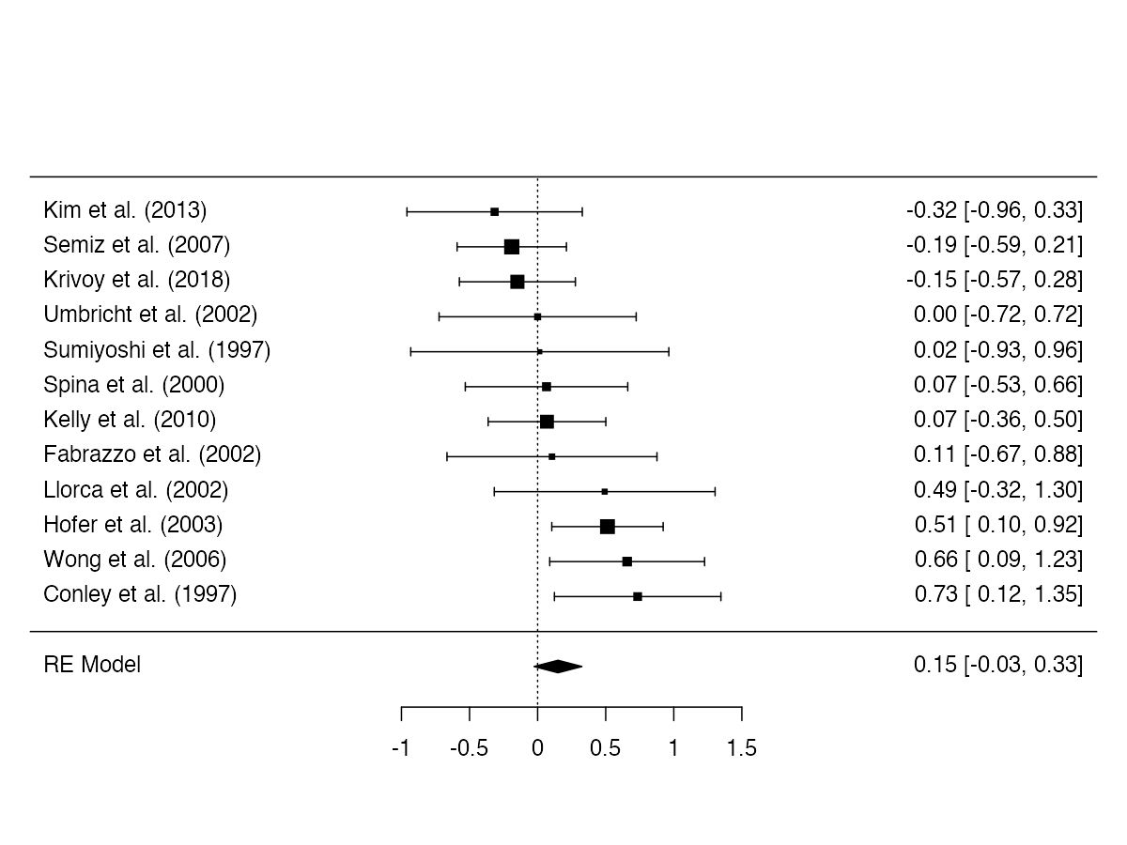
- Age
Study
Standardised Mean Difference [95% CI]
Clozapine non-responders younger
Clozapine non-responders older

(I² = 16.15%)

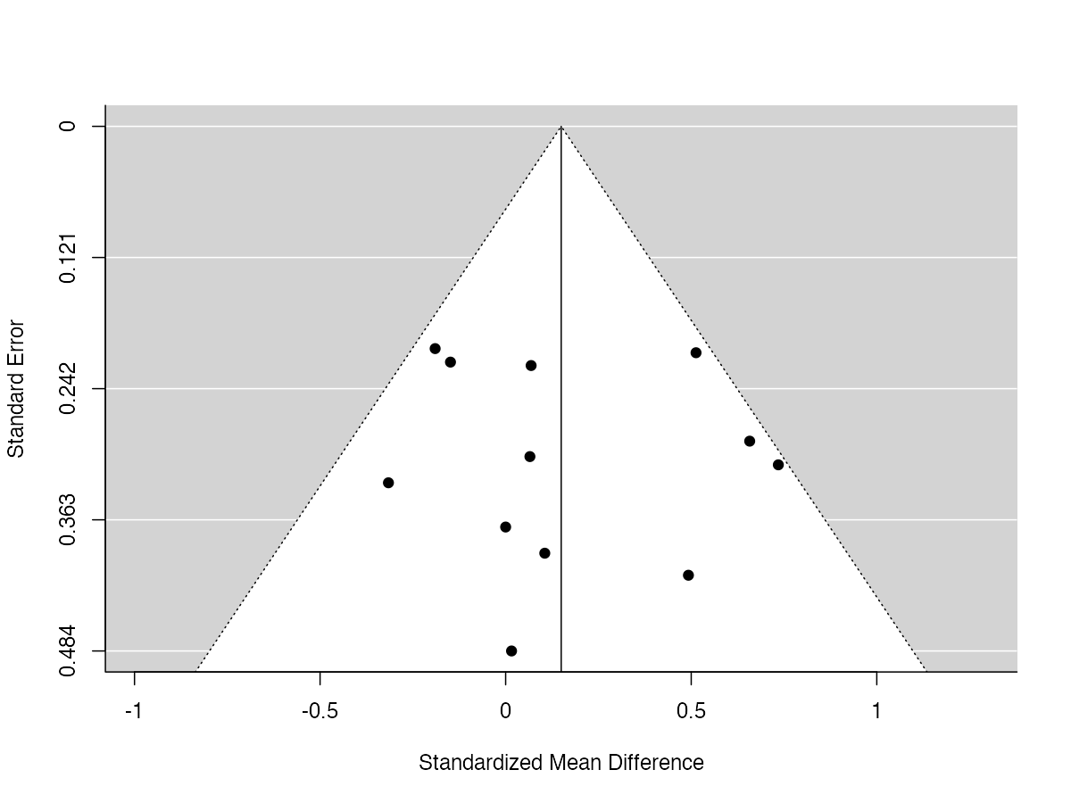

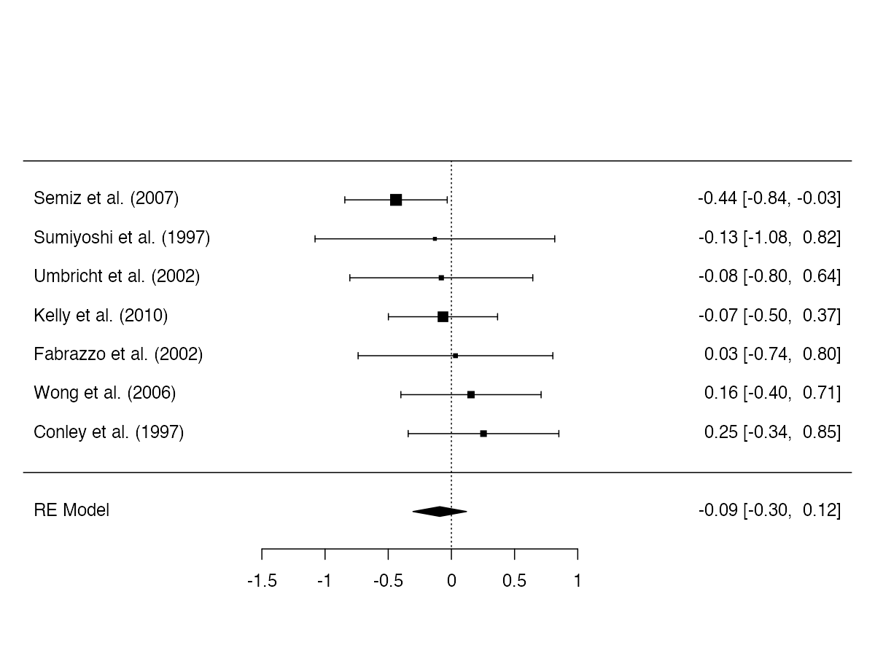
- Age of onset
Study
Standardised Mean Difference [95% CI]
Clozapine non-responders younger age of onset
Clozapine non-responders older age of onset
(I² = 0%)

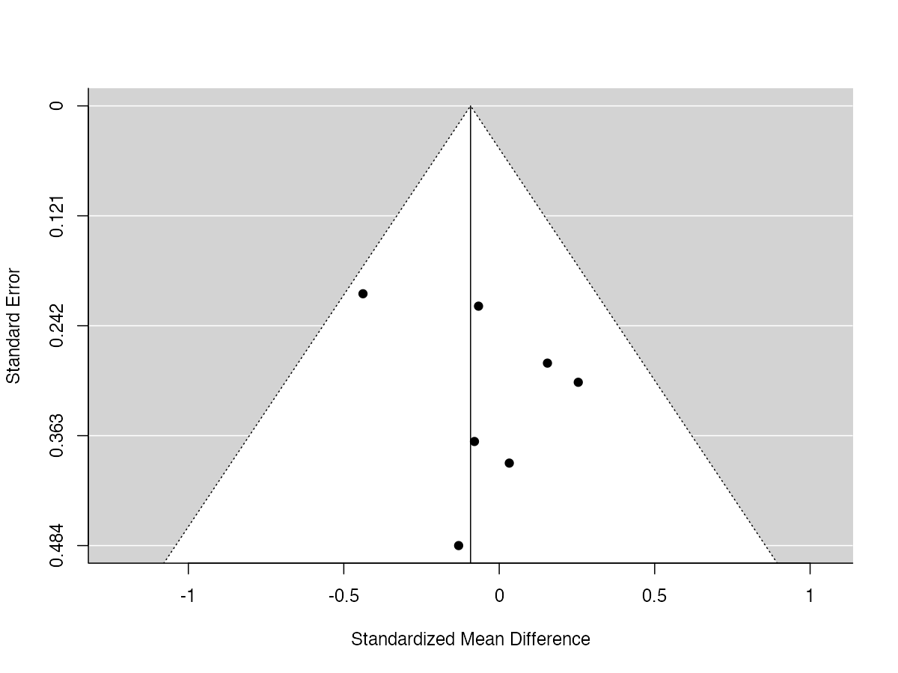

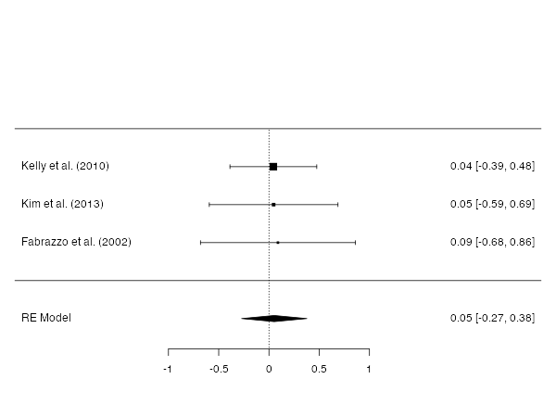
- Years of education

Study
Standardised Mean Difference [95% CI]
Clozapine non-responders fewer years of education
Clozapine non-responders more years of education
(I² = 0%)

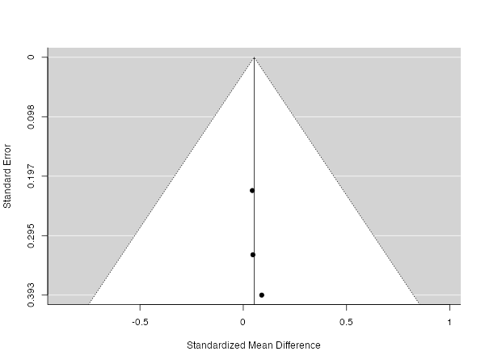

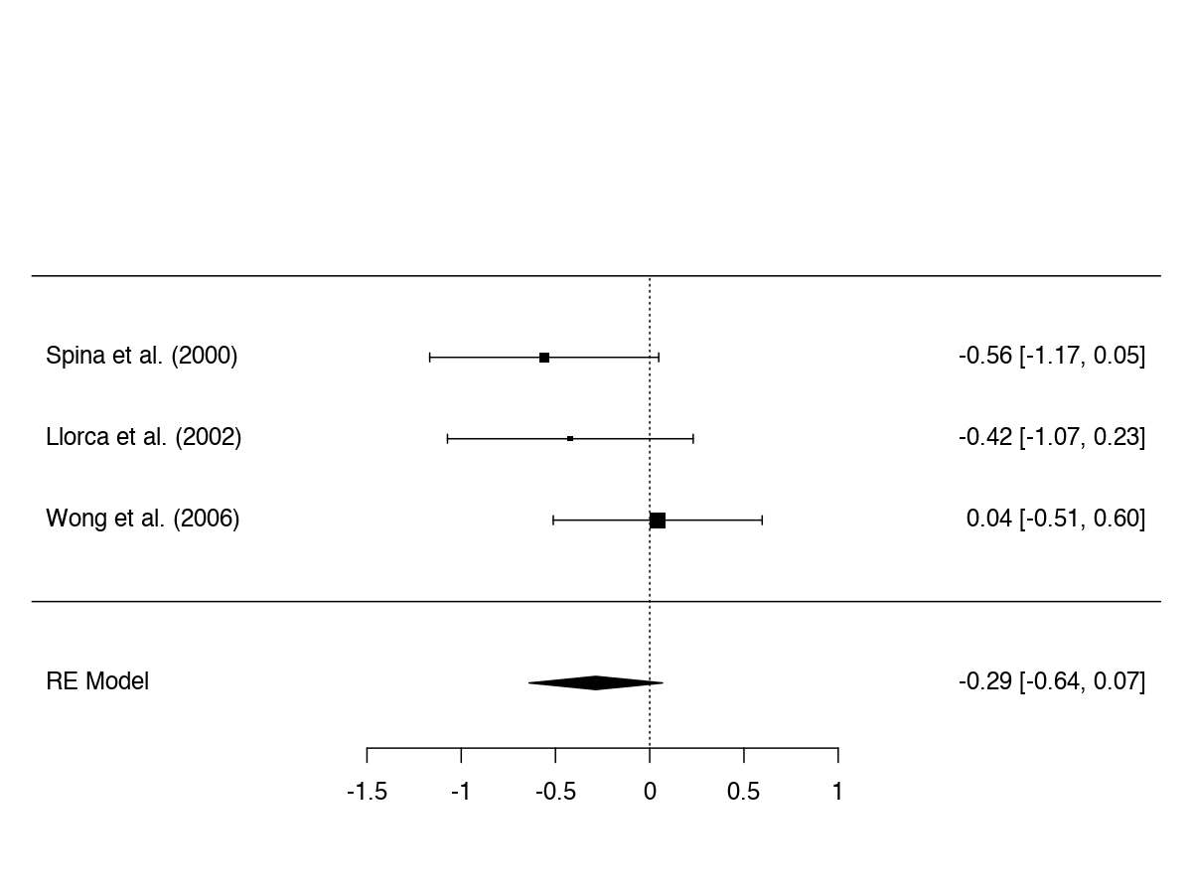
- Body weight

(I² = 3.98%)
Study
Standardised Mean Difference [95% CI]
Clozapine non-responders lower body weight

Clozapine non-responders higher body weight
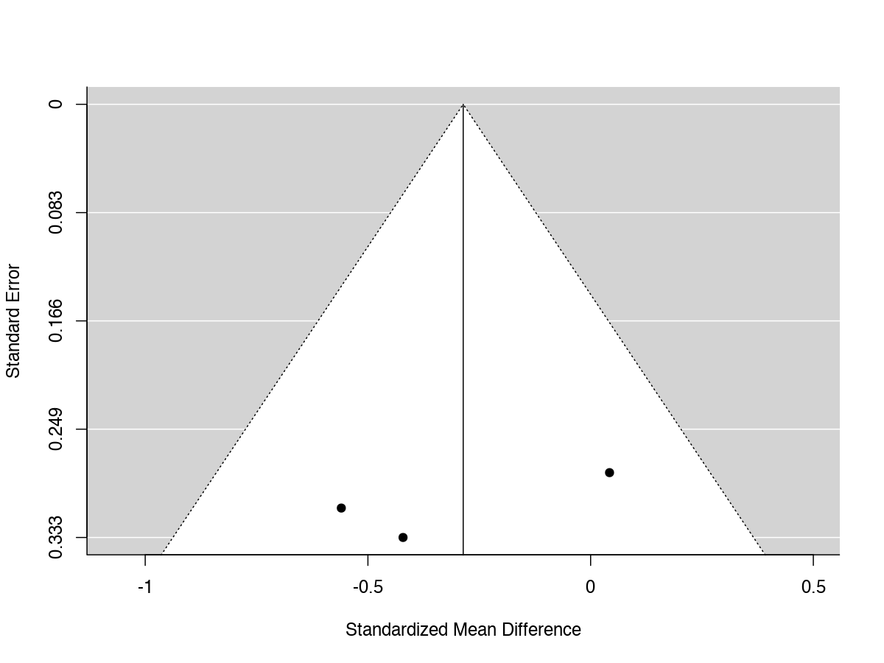
REFERENCES

Buckley, P., Thompson, P., Way, L., & Meltzer, H. Y. (1994). Substance abuse among patients with treatment-resistant schizophrenia: characteristics and implications for clozapine therapy. The American Journal of Psychiatry, 151(3), 385-389. doi:10.1176/ajp.151.3.385
Conley, R. R., Carpenter, W. T., & Tamminga, C. A. (1997). Time to clozapine response in a standardized trial. The American Journal of Psychiatry, 154(9), 1243-1247. doi:10.1176/ajp.154.9.1243
El-Badri, S., & Mellsop, G. (2011). Clozapine use and outcomes among patients with treatment resistant schizophrenia. Australasian Psychiatry, 19(5), 410-414. doi:10.3109/10398562.2011.602078
Fabrazzo, M., La Pia, S., Monteleone, P., Esposito, G., Pinto, A., De Simone, L., ... & Maj, M. (2002). Is the time course of clozapine response correlated to the time course of clozapine plasma levels? A one-year prospective study in drug-resistant patients with schizophrenia. Neuropsychopharmacology, 27(6), 1050-1055. doi:10.1016/S0893-133X(02)00319-6
Gee, S. H., Shergill, S. S., & Taylor, D. M. (2016). Factors associated with changes in hospitalisation in patients prescribed clozapine. Journal of Psychopharmacology, 30(8), 819-825. doi:10.1177/0269881116642745
Hofer, A., Hummer, M., Kemmler, G., Kurz, M., Kurzthaler, I., & Fleischhacker, W. W. (2003). The safety of clozapine in the treatment of first- and multiple-episode patients with treatment-resistant schizophrenia. International Journal of Neuropsychopharmacology, 6(3), 201-206. doi:10.1017/S1461145703003456
Kaneda, Y., Jayathilak, K., & Meltzer, H. (2010). Determinants of work outcome in neuroleptic-resistant schizophrenia and schizoaffective disorder: cognitive impairment and clozapine treatment. Psychiatry Research, 178(1), 57-62. doi:10.1016/j.psychres.2009.04.001
Kelly, D. L., Dixon, L. B., Kreyenbuhl, J. A., Medoff, D., Lehman, A. F., Love, R. C., ... & Conley, R. R. (2006). Clozapine utilization and outcomes by race in a public mental health system: 1994-2000. The Journal of Clinical Psychiatry, 67(9), 1404-1411. doi:10.4088/JCP/v67n0911
Kelly, D. L., Feldman, S., Boggs, D. L., Gale, E., & Conley, R. R. (2010). Nonresponse to clozapine and premorbid functioning in treatment of refractory schizophrenia. Comprehevsive Psychiatry, 51(3), 298-302. doi:10.1016/j.comppsych.2009.07.003
Kelly, D. L., Gale, E. A., & Conley, R. R. (2003). Clozapine treatment in patients with prior substance abuse. The Canadian Journal of Psychiatry, 48(2), 111-114. doi:10.1177/070674370304800208
Kim, J. H., Yi, S. H., Lee, J., & Kim, Y. S. (2013). Effects of clozapine on heart rate dynamics and their relationship with therapeutic response in treatment-resistant schizophrenia. Journal of Clinical Psychopharmacology, 33(1), 69-73. doi:10.1097/JCP.0b013e31827d14e3
Köhler-Forsberg, O., Horsdal, H. T., Legge, S. E., MacCabe, J. H., & Gasse, C. (2017). Predictors of Nonhospitalization and Functional Response in Clozapine Treatment: A Nationwide, Population-Based Cohort Study. Journal of Clinical Psychopharmacology, 37(2), 148-154. doi:10.1097/JCP.0000000000000649
Krivoy, A., Hochman, E., Sendt, K. V., Hollander, S., Vilner, Y., Selakovic, M., ... & Taler, M. (2018). Association between serum levels of glutamate and neurotrophic factors and response to clozapine treatment. Schizophrenia Research, 192, 226-231. doi:10.1016/j.schres.2017.05.040
Lieberman, J. A., Safferman, A. Z., Pollack, S., Szymanski, S., Johns, C., Howard, A., ... & Kane, J. M. (1994). Clinical effects of clozapine in chronic schizophrenia: response to treatment and predictors of outcome. The American Journal of Psychiatry, 151(12), 1744-1752. doi:10.1176/ajp.151.12.1744
Llorca, P. M., Lancon, C., Disdier, B., Farisse, J., Sapin, C., & Auquier, P. (2002). Effectiveness of clozapine in neuroleptic-resistant schizophrenia: clinical response and plasma concentrations. Journal of Psychiatry and Neuroscience, 27(1), 30-37. Retrieved from https://www.ncbi.nlm.nih.gov/pubmed/11836974
Manschreck, T. C., Redmond, D. A., Candela, S. F., & Maher, B. A. (1999). Effects of clozapine on psychiatric symptoms, cognition, and functional outcome in schizophrenia. Journal of Neuropsychiatry and Clinical Neurosciences, 11(4), 481-489. doi:10.1176/jnp.11.4.481
McEvoy, J. P., Freudenreich, O., & Wilson, W. H. (1999). Smoking and therapeutic response to clozapine in patients with schizophrenia. Biological Psychiatry, 46(1), 125-129. Retrieved from https://www.ncbi.nlm.nih.gov/pubmed/10394482
Nielsen, J., Nielsen, R. E., & Correll, C. U. (2012). Predictors of clozapine response in patients with treatment-refractory schizophrenia: results from a Danish Register Study. Journal of Clinical Psychopharmacology, 32(5), 678-683. doi:10.1097/JCP.0b013e318267b3cd
Rodriguez, V. M., Catalina, M. L., García-Noblejas, J. A., & Cuesta, P. (1998). Schizophrenic syndromes and clozapine response in treatment-resistant schizophrenia. Psychiatry Research, 77(1), 21-28. Retrieved from https://www.ncbi.nlm.nih.gov/pubmed/10710171
Semiz, U. B., Cetin, M., Basoglu, C., Ebrinc, S., Uzun, O., Herken, H., ... & Ates, A. (2007). Clinical predictors of therapeutic response to clozapine in a sample of Turkish patients with treatment-resistant schizophrenia. Progress in Neuropsychopharmacology and Biological Psychiatry, 31(6), 1330-1336. doi:10.1016/j.pnpbp.2007.06.002
Shah, P., Iwata, Y., Brown, E. E., Kim, J., Sanches, M., Takeuchi, H., . . . Graff-Guerrero, A. (2020). Clozapine response trajectories and predictors of non-response in treatment-resistant schizophrenia: a chart review study. European Archives of Psychiatry and Clinical Neuroscience, 270(1), 11-22. doi:10.1007/s00406-019-01053-6
Spina, E., Avenoso, A., Facciolà, G., Scordo, M. G., Ancione, M., Madia, A. G., . . . Perucca, E. (2000). Relationship between plasma concentrations of clozapine and norclozapine and therapeutic response in patients with schizophrenia resistant to conventional neuroleptics. Psychopharmacology, 148(1), 83-89. doi:10.1007/s002130050028
Stern, R. G., Kahn, R. S., Davidson, M., Nora, R. M., & Davis, K. L. (1994). Early response to clozapine in schizophrenia. The American Journal of Psychiatry, 151(12), 1817-1818. doi:10.1176/ajp.151.12.1817
Sumiyoshi, T., Hasegawa, M., Jayathilake, K., & Meltzer, H. Y. (1997). Prediction of short-term changes in symptom severity by baseline plasma homovanillic acid levels in schizophrenic patients receiving clozapine. Psychiatry Research, 69(2-3), 113-121. doi:10.1016/s0165-1781(96)02993-9
Szymanski, S., Lieberman, J., Pollack, S., Kane, J. M., Safferman, A., Munne, R., . . . Kronig, M. (1996). Gender differences in neuroleptic nonresponsive clozapine-treated schizophrenics. Biological Psychiatry, 39(4), 249-254. doi:10.1016/0006-3223(95)00138-7
Üçok, A., Çikrikçili, U., Karabulut, S., Salaj, A., Öztürk, M., Tabak, Ö., & Durak, R. (2015). Delayed initiation of clozapine may be related to poor response in treatment-resistant schizophrenia. International Clinical Psychopharmacology, 30(5), 290-295. doi:10.1097/YIC.0000000000000086
Umbricht, D. S., Wirshing, W. C., Wirshing, D. A., McMeniman, M., Schooler, N. R., Marder, S. R., & Kane, J. M. (2002). Clinical predictors of response to clozapine treatment in ambulatory patients with schizophrenia. The Journal of Clinical Psychiatry, 63(5), 420-424. doi:10.4088/jcp.v63n0508
Usall, J., Suarez, D., Haro, J. M., & SOHO Study Group. (2007). Gender differences in response to antipsychotic treatment in outpatients with schizophrenia. Psychiatry Research, 153(3), 225-231. doi:10.1016/j.psychres.2006.09.016
Wong, J. O., Leung, S. P., Mak, T., Ng, R. M., Chan, K. T., Hon-Kee Cheung, H., ... & Wai-Kiu Tsang, A. (2006). Plasma clozapine levels and clinical response in treatment-refractory Chinese schizophrenic patients. Progress in Neuropsychopharmacology & Biological Psychiatry, 30(2), 251-264. doi:10.1016/j.pnpbp.2005.10.008
Yoshimura, B., Yada, Y., So, R., Takaki, M., & Yamada, N. (2017). The critical treatment window of clozapine in treatment-resistant schizophrenia: Secondary analysis of an observational study. Psychiatry Research, 250, 65-70. doi:10.1016/j.psychres.2017.01.064

