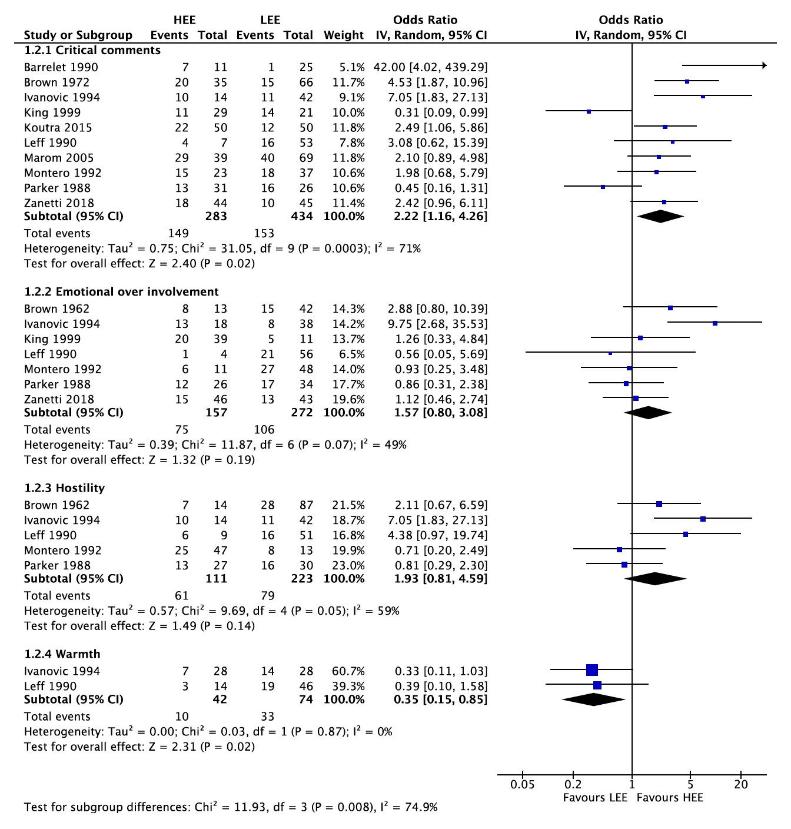

Fig. 3. Forest plot of association of EE domain and relapse

