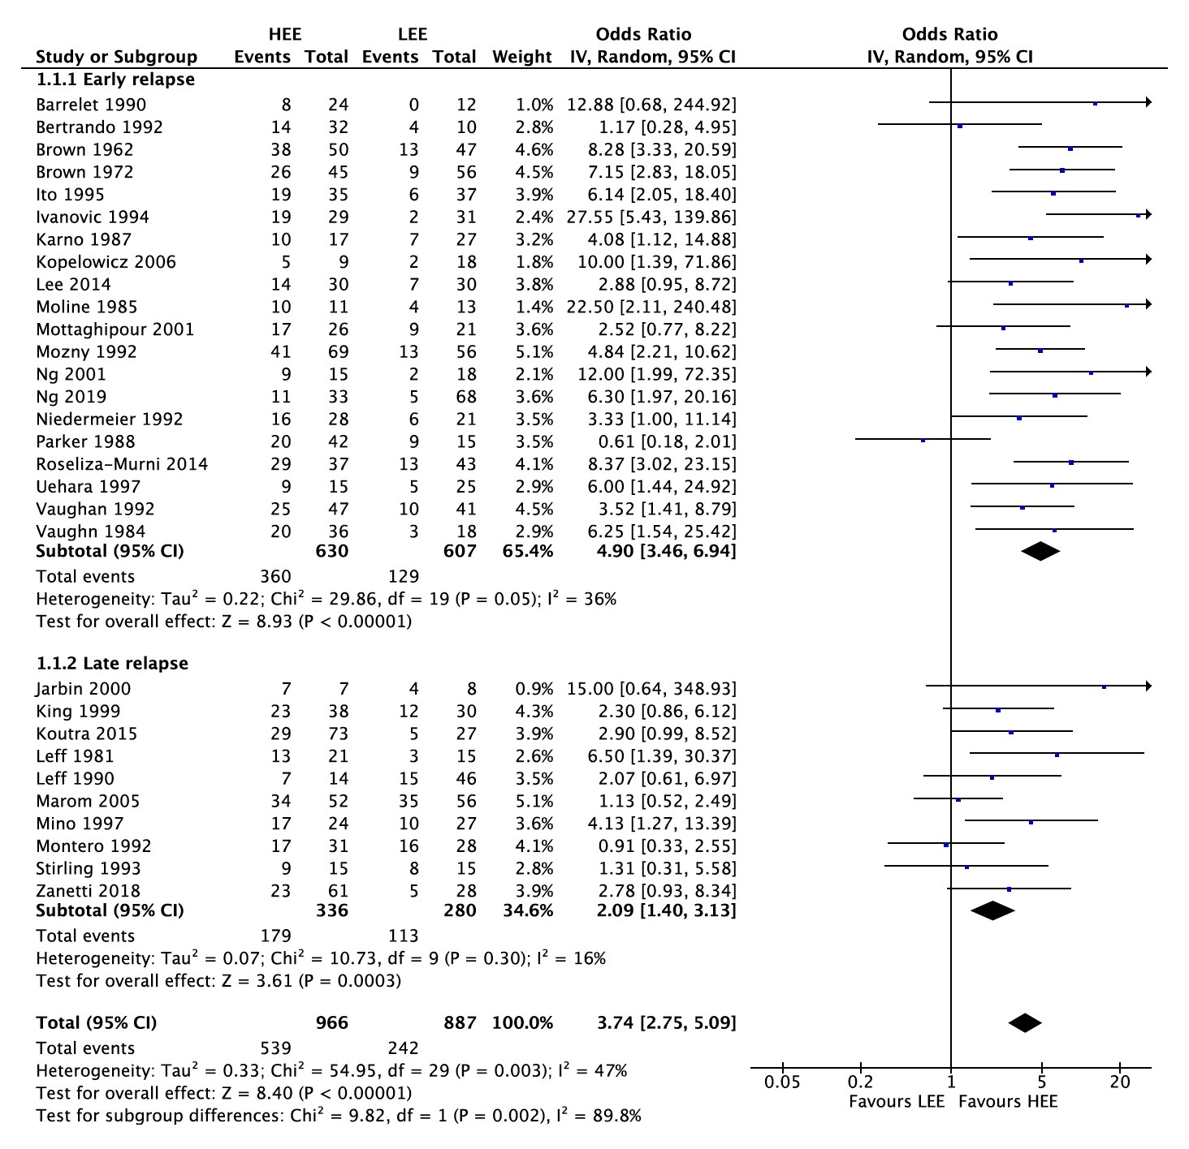

Fig. 2. Forest plot of association of global EE and relapse

