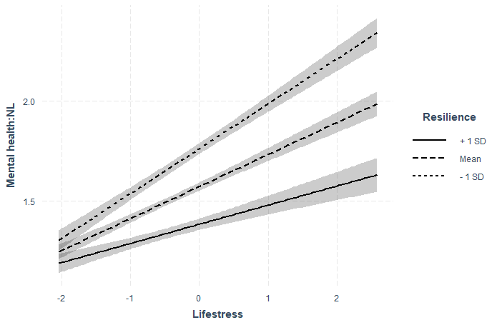
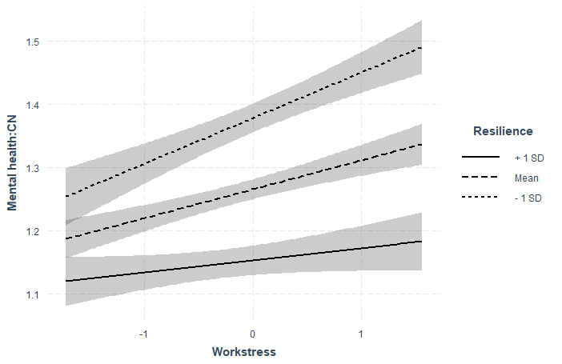

A：Resilience and life stress among Netherlands B：Resilience and work stress among Netherlands

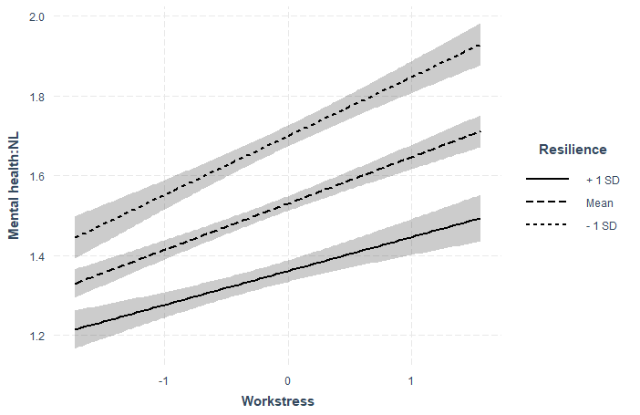
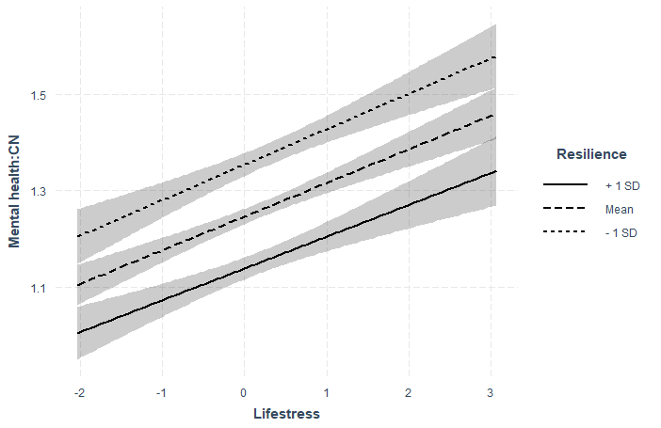

C：Resilience and life stress among China D：Resilience and work stress among China
Fig S1. The interaction of life stress, work stress, and resilience

