Symptom network as a prediction marker
for remission in first episode psychosis

Supplemental materials

Included in this file are:
Table S1. Global connectivity of the networks in the remitters and non-remitters at baseline and 6-month after adjusting baseline severity of the PANSS. 2
Table S2. Correlation matrix of the network in the remitters at baseline 3
Table S3. Correlation matrix of the network in the non-remitters at baseline 4
Table S4. Correlation matrix of the network in the remitters at 6-month 5
Table S5. Correlation matrix of the network in the non-remitters at 6-month 6
Table S6. Centrality indices of single node in the remitters and non-remitters at baseline and 6-month 7
Figure S1. Bootstrapped 95% confidence intervals (CI) for the estimated edge weights in the networks. 11
Figure S2. Case-dropping bootstrap for the networks. 15
Figure S3. Bootstrapped difference tests of edge weights in the networks. 19
Figure S4. Bootstrapped difference tests of strength centrality in the network 23

R code 24

Table S1. Global connectivity of the networks in the remitters and non-remitters at baseline and 6-month after adjusting baseline severity of the PANSS.
Characteristics | Baseline |  | p-valueª | 6-month |  | p-valueª | Remitters |  | p-valueª | Non-Remitters |  | p-valueª
 | Remitters | Non-Remitters |  | Remitters | Non-Remitters |  | Baseline | 6-month |  | Baseline | 6-month
 | (N = 68) | (N = 68) |  | (N = 68) | (N = 68) |  | (N = 68) | (N = 68) |  | (N = 68) | (N = 68)
Density | 0.377 | 0.511 | 0.028 | 0.533 | 0.422 | 0.063 | 0.377 | 0.533 | 0.005 | 0.511 | 0.422 | 0.176
Global strength | 3.394 | 4.09 | 0.58 | 4.647 | 4.1 | 0.354 | 3.394 | 4.647 | 0.243 | 4.09 | 4.1 | 0.984
Average clustering coefficient | 0.2666 | 0.3732 | 0.496 | 0.35 | 0.33 | 0.901 | 0.2666 | 0.35 | 0.649 | 0.373 | 0.33 | 0.825
Modularity quality index (Q) | 0.3902 | 0.3428 | 0.736 | 0.1502 | 0.3407 | 0.179 | 0.3902 | 0.1502 | 0.214 | 0.342 | 0.34 | 0.993
Average shortest path length | 1.8889 | 1.5111 | 0.625 | 1.4667 | 1.6 | 0.476 | 1.8889 | 1.4667 | 0.526 | 1.511 | 1.6 | 0.728
ª is the results of permutation test (global strength from NCT and the others from NetworkToolbox)

Table S2. Correlation matrix of the network in the remitters at baseline
 | P | N | G | CS | NS | PS | NO | PO | Em | Co
P |  | 0.000 | 0.611 | 0.022 | 0.000 | 0.000 | 0.000 | 0.000 | 0.000 | 0.000
N | 0.000 |  | 0.467 | 0.000 | 0.000 | -0.011 | 0.000 | 0.000 | 0.000 | 0.000
G | 0.611 | 0.467 |  | 0.083 | 0.000 | 0.000 | 0.000 | 0.000 | 0.000 | 0.000
CS | 0.022 | 0.000 | 0.083 |  | 0.153 | -0.146 | 0.149 | -0.021 | 0.012 | 0.104
NS | 0.000 | 0.000 | 0.000 | 0.153 |  | -0.048 | 0.274 | 0.000 | 0.000 | 0.322
PS | 0.000 | -0.011 | 0.000 | -0.146 | -0.048 |  | 0.000 | 0.274 | 0.000 | -0.014
NO | 0.000 | 0.000 | 0.000 | 0.149 | 0.274 | 0.000 |  | 0.000 | 0.119 | 0.083
PO | 0.000 | 0.000 | 0.000 | -0.021 | 0.000 | 0.274 | 0.000 |  | 0.000 | 0.000
Em | 0.000 | 0.000 | 0.000 | 0.012 | 0.000 | 0.000 | 0.119 | 0.000 |  | 0.482
Co | 0.000 | 0.000 | 0.000 | 0.104 | 0.322 | -0.014 | 0.083 | 0.000 | 0.482
Names of the nodes ("P","N","G", "CS","NS","PS","NO","PO","Em", "Co") were "Positive symptoms", "Negative symptoms", "General psychopathology", "Depressive symptoms (in the CDSS)", "Negative-self", "Positive-self", "Negative-others", "Positive-other", "Emotional domain" and "Cognitive domain" respectively

Table S3. Correlation matrix of the network in the non-remitters at baseline
 | P | N | G | CS | NS | PS | NO | PO | Em | Co
P |  | 0.000 | 0.562 | 0.045 | 0.000 | 0.087 | 0.000 | 0.000 | 0.020 | 0.084
N | 0.000 |  | 0.516 | 0.000 | 0.000 | -0.093 | 0.033 | 0.000 | 0.000 | 0.000
G | 0.562 | 0.516 |  | 0.088 | 0.000 | 0.000 | 0.062 | 0.000 | 0.000 | 0.000
CS | 0.045 | 0.000 | 0.088 |  | 0.236 | 0.000 | 0.060 | 0.000 | 0.067 | 0.000
NS | 0.000 | 0.000 | 0.000 | 0.236 |  | -0.187 | 0.323 | 0.000 | 0.188 | 0.259
PS | 0.087 | -0.093 | 0.000 | 0.000 | -0.187 |  | 0.000 | 0.315 | 0.079 | 0.000
NO | 0.000 | 0.033 | 0.062 | 0.060 | 0.323 | 0.000 |  | -0.118 | 0.183 | 0.000
PO | 0.000 | 0.000 | 0.000 | 0.000 | 0.000 | 0.315 | -0.118 |  | 0.000 | 0.003
Em | 0.020 | 0.000 | 0.000 | 0.067 | 0.188 | 0.079 | 0.183 | 0.000 |  | 0.477
Co | 0.084 | 0.000 | 0.000 | 0.000 | 0.259 | 0.000 | 0.000 | 0.003 | 0.477
Names of the nodes ("P","N","G", "CS","NS","PS","NO","PO","Em", "Co") were "Positive symptoms", "Negative symptoms", "General psychopathology", "Depressive symptoms (in the CDSS)", "Negative-self", "Positive-self", "Negative-others", "Positive-other", "Emotional domain" and "Cognitive domain" respectively
Table S4. Correlation matrix of the network in the remitters at 6-month
 | P | N | G | CS | NS | PS | NO | PO | Em | Co
P |  | 0.126 | 0.408 | 0.000 | 0.000 | 0.000 | 0.026 | 0.000 | 0.016 | 0.000
N | 0.126 |  | 0.474 | 0.000 | 0.000 | -0.021 | 0.000 | -0.047 | 0.000 | -0.098
G | 0.408 | 0.474 |  | 0.162 | 0.000 | 0.000 | 0.048 | -0.007 | 0.000 | 0.000
CS | 0.000 | 0.000 | 0.162 |  | 0.139 | -0.122 | 0.000 | 0.000 | 0.000 | 0.054
NS | 0.000 | 0.000 | 0.000 | 0.139 |  | -0.165 | 0.299 | 0.000 | 0.000 | 0.377
PS | 0.000 | -0.021 | 0.000 | -0.122 | -0.165 |  | 0.000 | 0.525 | 0.000 | 0.000
NO | 0.026 | 0.000 | 0.048 | 0.000 | 0.299 | 0.000 |  | 0.000 | 0.146 | 0.000
PO | 0.000 | -0.047 | -0.007 | 0.000 | 0.000 | 0.525 | 0.000 |  | 0.000 | 0.000
Em | 0.016 | 0.000 | 0.000 | 0.000 | 0.000 | 0.000 | 0.146 | 0.000 |  | 0.546
Co | 0.000 | -0.098 | 0.000 | 0.054 | 0.377 | 0.000 | 0.000 | 0.000 | 0.546
Names of the nodes ("P","N","G", "CS","NS","PS","NO","PO","Em", "Co") were "Positive symptoms", "Negative symptoms", "General psychopathology", "Depressive symptoms (in the CDSS)", "Negative-self", "Positive-self", "Negative-others", "Positive-other", "Emotional domain" and "Cognitive domain" respectively
Table S5. Correlation matrix of the network in the non-remitters at 6-month
 | P | N | G | CS | NS | PS | NO | PO | Em | Co
P |  | 0.000 | 0.446 | 0.000 | 0.000 | 0.000 | 0.021 | 0.000 | 0.056 | 0.000
N | 0.000 |  | 0.476 | 0.000 | 0.000 | 0.000 | 0.000 | 0.000 | 0.000 | -0.099
G | 0.446 | 0.476 |  | 0.336 | 0.000 | 0.050 | 0.069 | 0.000 | 0.000 | 0.000
CS | 0.000 | 0.000 | 0.336 |  | 0.243 | 0.000 | 0.088 | 0.000 | 0.000 | 0.000
NS | 0.000 | 0.000 | 0.000 | 0.243 |  | -0.275 | 0.304 | 0.000 | 0.016 | 0.265
PS | 0.000 | 0.000 | 0.050 | 0.000 | -0.275 |  | 0.000 | 0.423 | 0.000 | 0.000
NO | 0.021 | 0.000 | 0.069 | 0.088 | 0.304 | 0.000 |  | -0.068 | 0.211 | 0.000
PO | 0.000 | 0.000 | 0.000 | 0.000 | 0.000 | 0.423 | -0.068 |  | -0.127 | 0.000
Em | 0.056 | 0.000 | 0.000 | 0.000 | 0.016 | 0.000 | 0.211 | -0.127 |  | 0.526
Co | 0.000 | -0.099 | 0.000 | 0.000 | 0.265 | 0.000 | 0.000 | 0.000 | 0.526
Names of the nodes ("P","N","G", "CS","NS","PS","NO","PO","Em", "Co") were "Positive symptoms", "Negative symptoms", "General psychopathology", "Depressive symptoms (in the CDSS)", "Negative-self", "Positive-self", "Negative-others", "Positive-other", "Emotional domain" and "Cognitive domain" respectively

Table S6. Comparison of nodal strength in the remitters and non-remitters at baseline and 6-month
Node | Remitter |  |  |  | Non-remitter
 | R-B | R-6 | Change |  | NR-B | NR-6 | Change
P | -0.179 | -0.803 | -0.624 |  | -0.076 | -1.121 | -1.045
N | -0.79 | 0.021 | 0.811 |  | -0.662 | -0.925 | -0.264
G | 1.889 | 1.468 | -0.421 |  | 1.548 | 2.109 | 0.561
CS | 0.042 | -1.237 | -1.279 |  | -1.213 | -0.578 | 0.635
NS | 0.464 | 0.953 | 0.489 |  | 1.417 | 1.069 | -0.349
PS | -0.732 | 0.309 | 1.041 |  | -0.211 | -0.274 | -0.063
NO | -0.207 | -1.055 | -0.849 |  | -0.137 | -0.221 | -0.083
PO | -1.509 | -0.792 | 0.717 |  | -1.436 | -0.76 | 0.676
Em | -0.257 | -0.232 | 0.025 |  | 0.745 | 0.438 | -0.307
Co | 1.279 | 1.368 | 0.089 |  | 0.025 | 0.263 | 0.239
Centrality index is shown as standardized z-scores. The remitters at baseline and 6-month (R-B and R-6) and the non-remitters at baseline and 6-month (NR-B and NR-6).

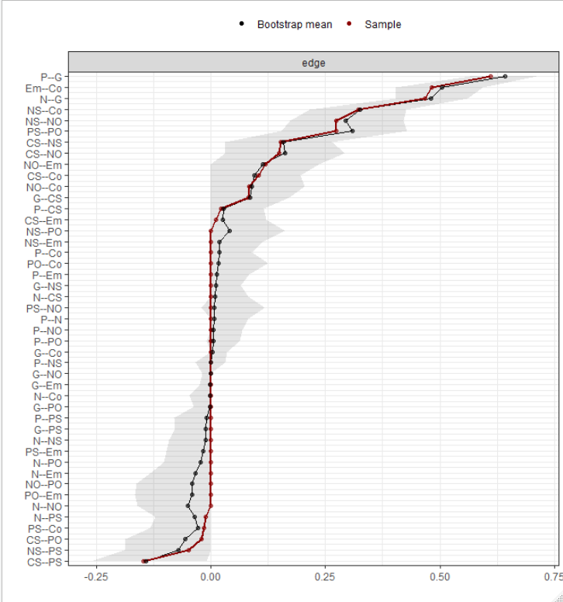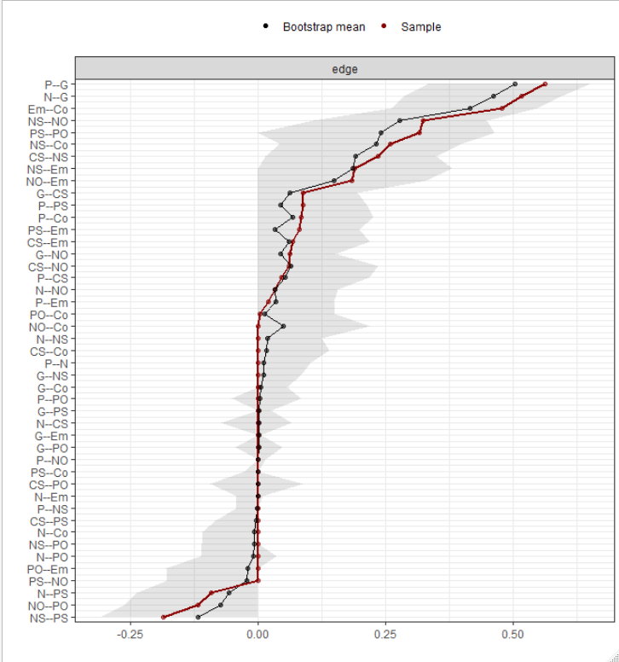
a)
b)
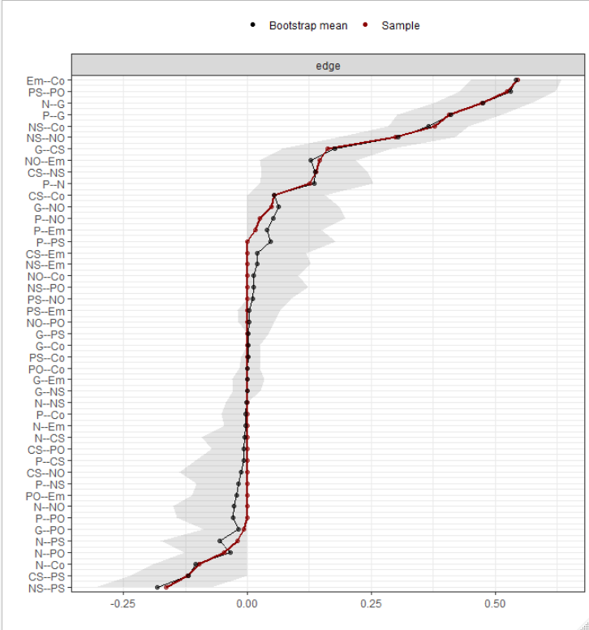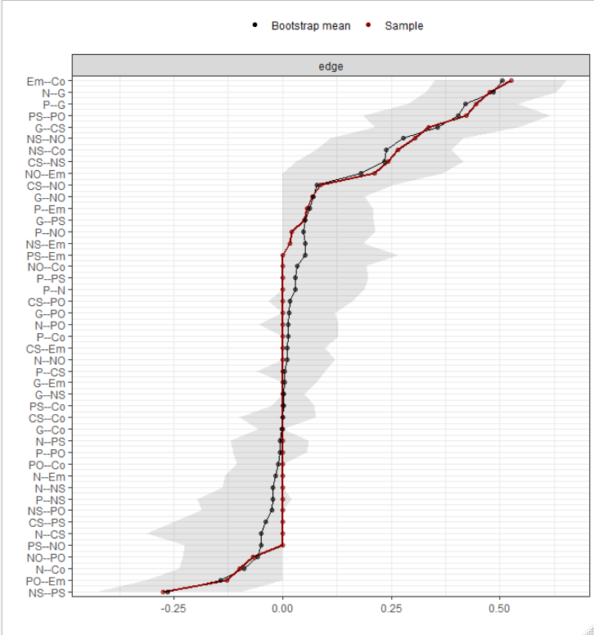
c)
d)
Figure S1. Bootstrapped 95% confidence intervals (CI) for the estimated edge weights in the networks.
a) the remitters at baseline; b) non-remitters at baseline; c) remitters at 6-month; and d) non-remitters at 6-month. The red line indicates the sample values and the gray area the bootstrapped CIs. Each horizontal line represents one edge of the network, ordered from the edge with the highest edge-weight to the edge with the lowest edge-weight.
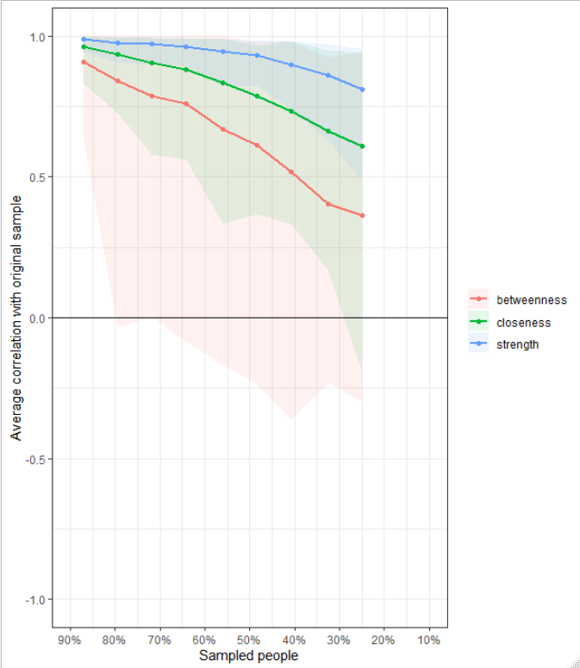
a)
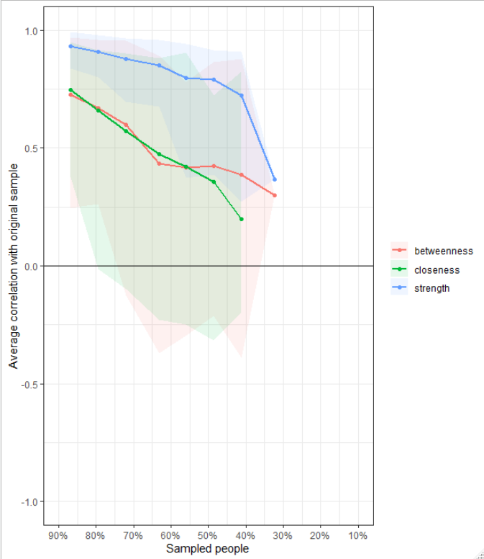
b)
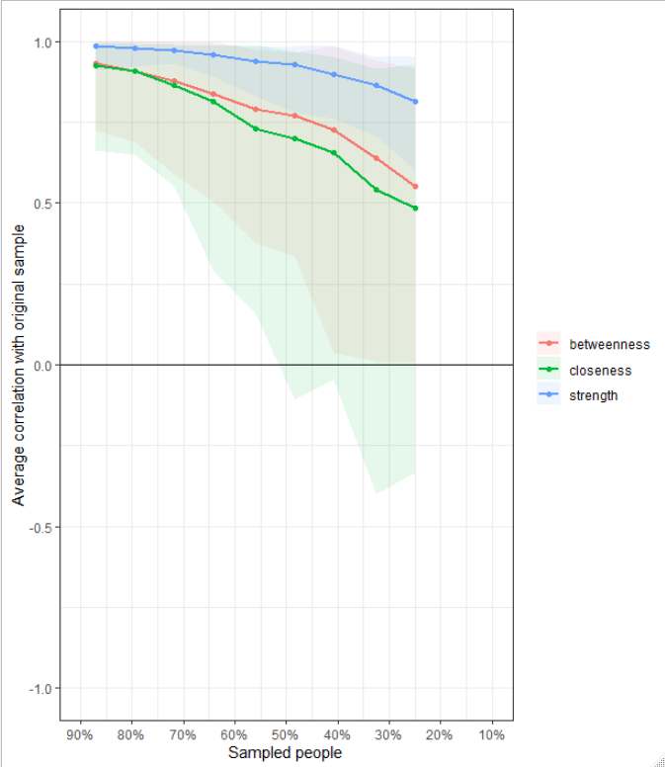
c)
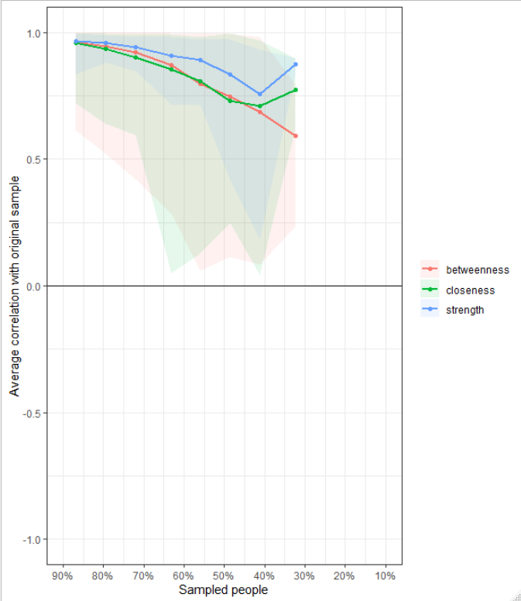
d)
Figure S2. Case-dropping bootstrap for the networks.
a) the remitters at baseline; b) non-remitters at baseline; c) remitters at 6-month; and d) non-remitters at 6-month (Average correlations between the centrality measures estimated with the full sample and the centrality measures estimated with smaller samples)

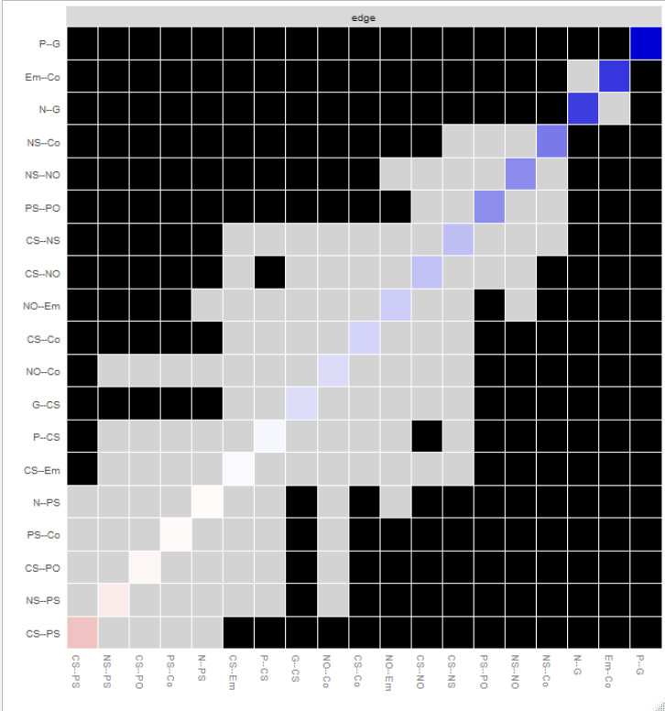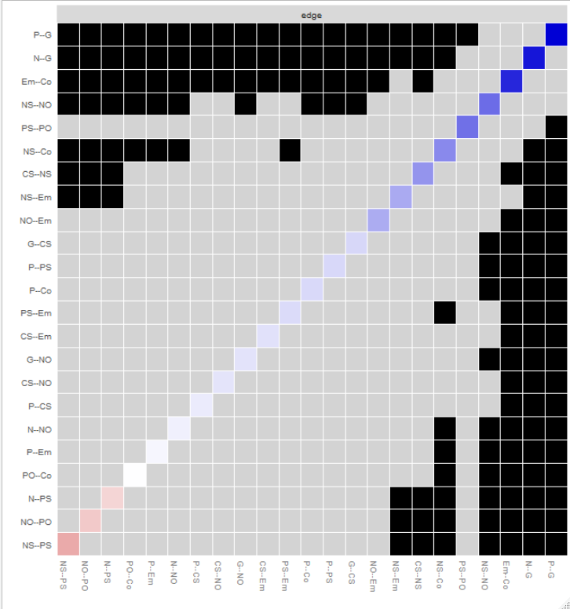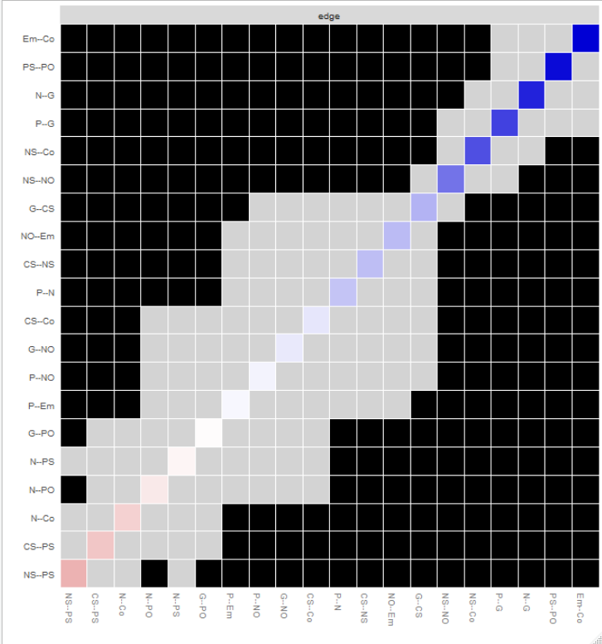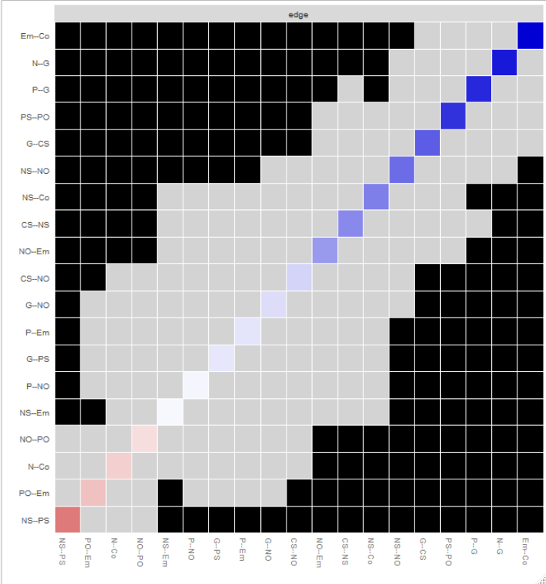
a)
b)
c)
d)
Figure S3. Bootstrapped difference tests of edge weights in the networks.
a) the remitters at baseline; b) non-remitters at baseline; c) remitters at 6-month; and d) non-remitters at 6-month. Black boxes indicate a significant difference between two edges (alpha = .05). Grey boxes indicate no significant difference.
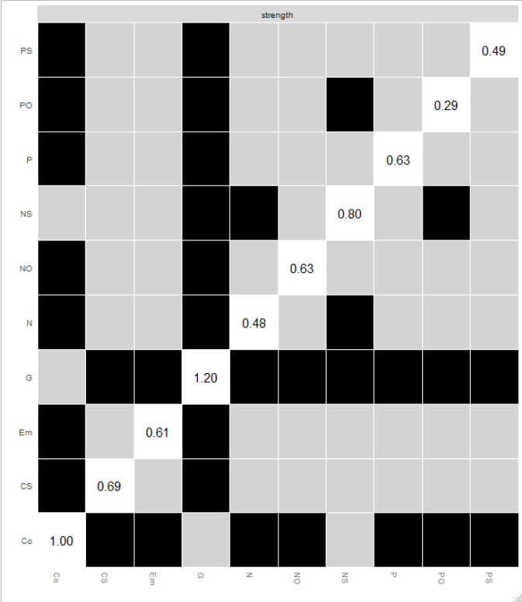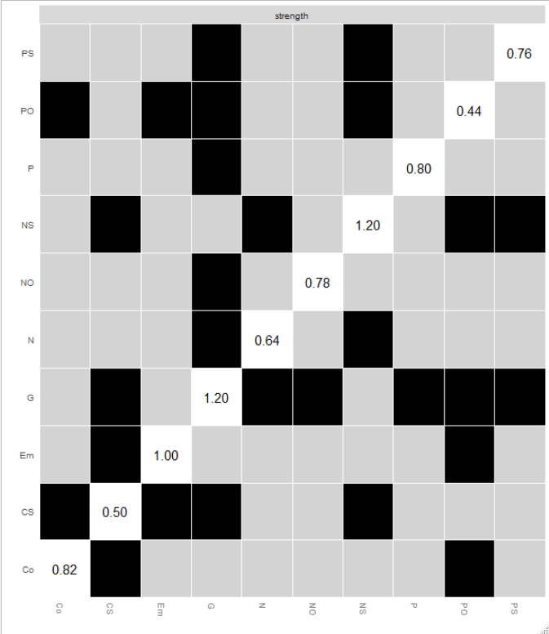
a)
b)
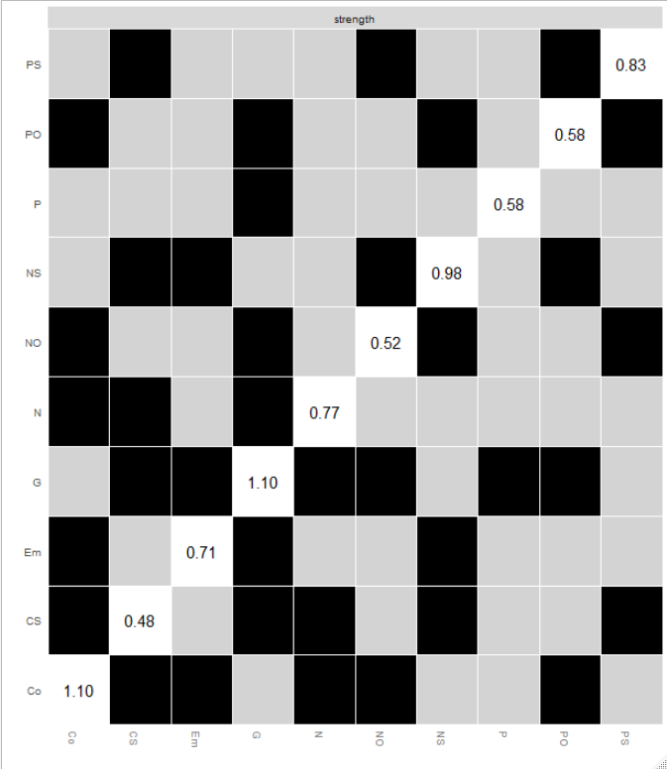
c)
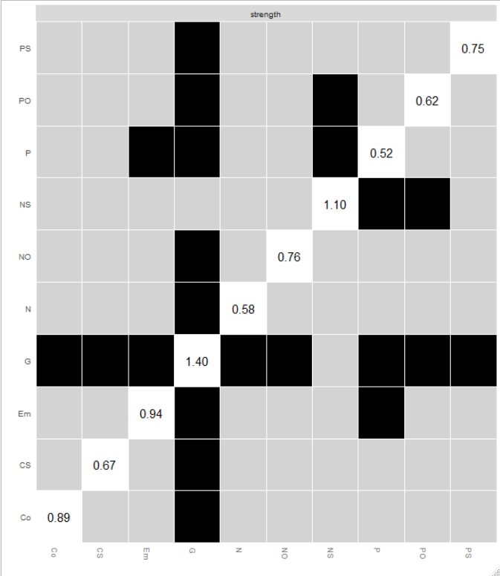
d)
Figure S4. Bootstrapped difference tests of strength centrality in the networks.
a) the remitters at baseline; b) non-remitters at baseline; c) remitters at 6-month; and d) non-remitters at 6-month. Black boxes indicate a significant difference between the strength centrality of two nodes (alpha = 0.05). Grey boxes indicate no significant difference.

R code
### Network analysis
##Required libraries
library("readxl")
library(qgraph)
library(huge)
library("psychTools")
library(reshape2)
library(NetworkComparisonTest)
library(data.table)
library("Deducer")

# Set the random seed:
set.seed(123)

#data
BS <- read_excel("D:/Research/ ") # Baseline
TM <- read_excel("D:/Research/ ") # 6 month

RB=subset(BS,RM=="1")
NRB=subset(BS,RM=="0")
R6=subset(TM,RM=="1")
NR6=subset(TM,RM=="0")

RB= RB[, c(2:10,11)] # remission group at baseline
NRB= NRB[, c(2:10,11)] # non-remission group at baseline
R6= R6[, c(2:10,11)] # remission group at 6 month
NR6= NR6[, c(2:10,11)] # non-remission group at 6 month

#Reset names
setnames (RB, old = c("PANSS-P-TO","PANSS-N-TO", "PANSS-G-TO", "CDSS TO", "BCSS-NS","BCSS-PS","BCSS-NO","BCSS-PO","BS-EM", "BS-CO"),
new = c("P","N","G", "CS","NS","PS","NO","PO","Em", "Co"))
setnames (NRB, old = c("PANSS-P-TO", "PANSS-N-TO", "PANSS-G-TO", "CDSS TO", "BCSS-NS","BCSS-PS","BCSS-NO","BCSS-PO","BS-EM", "BS-CO"),
new = c("P","N","G", "CS","NS","PS","NO","PO","Em", "Co"))
setnames (R6, old = c("PANSS-P-TO", "PANSS-N-TO", "PANSS-G-TO", "CDSS TO", "BCSS-NS","BCSS-PS","BCSS-NO","BCSS-PO","BS-EM", "BS-CO"),
new = c("P","N","G", "CS","NS","PS","NO","PO","Em", "Co"))
setnames (NR6, old = c("PANSS-P-TO", "PANSS-N-TO", "PANSS-G-TO", "CDSS TO", "BCSS-NS","BCSS-PS","BCSS-NO","BCSS-PO","BS-EM", "BS-CO"),
new = c("P","N","G", "CS","NS","PS","NO","PO","Em", "Co"))
#Nonparanormal Transformation

NRB1 <- huge.npn(NRB )
RB1<- huge.npn(RB)
R61 <- huge.npn(R6 )
NR61<- huge.npn(NR6)

# Estimate networks
library('bootnet')
net1 <- estimateNetwork(RB1,default = "EBICglasso",corMethod = "cor_auto",tuning = 0.5)
net2 <- estimateNetwork(NRB1,default = "EBICglasso",corMethod = "cor_auto",tuning = 0.5)
net3 <- estimateNetwork(R61,default = "EBICglasso",corMethod = "cor_auto",tuning = 0.5)
net4 <- estimateNetwork(NR61,default = "EBICglasso",corMethod = "cor_auto",tuning = 0.5)
#get matrices
net1$graph
net2$graph
net3$graph
net4$graph

#Plot

L <- averageLayout(net1,net2,net3,net4)
group.item1 <- list("PANSS" = 1:3,"CDSS" = 4,"BCSS" = 5:8,"BS " = 9:10)
n1=plot(net1, title="a)", groups = group.item1,cut = 0.03,negDashed=TRUE,layout = L)
n2=plot(net2, title="b)", groups = group.item1,cut = 0.03,negDashed=TRUE,layout = L)
n3=plot(net3, title="c)", groups = group.item1,cut = 0.03,negDashed=TRUE,layout = L)
n4=plot(net4, title="d)", groups = group.item1,cut = 0.03,negDashed=TRUE,layout = L)
#centrality

Cent1 <- centralityTable(net1, standardized = TRUE)
Cent2 <- centralityTable(net2, standardized = TRUE)
Cent3 <- centralityTable(net3, standardized = TRUE)

centralityPlot(Centrality = list("R-B" = net1,"NR-B" = net2),
include=c("Strength","Closeness", "Betweenness"),
labels = names(RB),decreasing=T)+ theme(legend.title = element_blank())

#Stability

b1 <- bootnet(net1, nCores = 8,nBoots = 1000, type = 'nonparametric')
b2 <- bootnet(net1, nCores = 8,nBoots = 1000, type = 'case',
statistics=c('strength','closeness','betweenness'))
b3 <- bootnet(net2, nCores = 8,nBoots = 1000, type = 'nonparametric')
b4 <- bootnet(net2, nCores = 8,nBoots = 1000, type = 'case',
statistics=c('strength','closeness','betweenness'))
b5 <- bootnet(net3, nCores = 8,nBoots = 1000, type = 'nonparametric')
b6 <- bootnet(net3, nCores = 8,nBoots = 1000, type = 'case',
statistics=c('strength','closeness','betweenness'))

b7 <- bootnet(net4, nCores = 8,nBoots = 1000, type = 'nonparametric')
b8 <- bootnet(net4, nCores = 8,nBoots = 1000, type = 'case',
statistics=c('strength','closeness','betweenness'))

plot(b1, order="sample", plot="area", prop0=F)# confidence intervals
plot(b1, "edge", plot = "difference", onlyNonZero = TRUE, order = "sample") # difference of edges
plot(b1, "strength", plot = "difference") # node strength
plot(b2 ,statistics=c('strength','closeness','betweenness'))+ theme(legend.title = element_blank())

corStability(b2 )
corStability(b4 )
corStability(b6 )
corStability(b8 )

##Network comparsion test

nct1<- NCT(net1, net2, it=1000,paired = FALSE,test.edges = TRUE,edges="all",
test.centrality=TRUE,centrality=c("strength","closeness","betweenness"))
nct2<- NCT(net3, net4, it=1000,paired = FALSE,test.edges = TRUE,edges="all",
test.centrality=TRUE,centrality=c("strength","closeness","betweenness"))
nct3<- NCT(net1, net3, it=1000,paired = TRUE,test.edges = TRUE,edges="all",
test.centrality=TRUE,centrality=c("strength","closeness","betweenness"))
nct4<- NCT(net2, net4, it=1000,paired = TRUE,test.edges = TRUE,edges="all",
test.centrality=TRUE,centrality=c("strength","closeness","betweenness"))
nct1

## Perform permutation test
library("NetworkToolbox")
perm.str <- network.permutation(RB1, NRB1, iter = 1000, network = "glasso",
measure = "strength", alternative = "two.tailed", ncores = 4)
#Average shortest path length
perm.aspl <- network.permutation(prev.perm = perm.str, measure = "ASPL", ncores = 4)
#Average clustering coefficient
perm.aspl <- network.permutation(prev.perm = perm.str, measure = "CC", ncores = 4)
# Modularity quality index
perm.aspl <- network.permutation(prev.perm = perm.str, measure = "Q", ncores = 4)
#smallworldness
perm.aspl <- network.permutation(prev.perm = perm.str, measure = "S", ncores = 4)
# Check results
perm.aspl$result
#density
g = as.igraph(n1, attributes=TRUE)
a=(degree(g))/(vcount(g)-1)
g = as.igraph(n2, attributes=TRUE)
b=(degree(g))/(vcount(g)-1)
perm.t.test(a,b,statistic=c("t","mean"),alternative=c("two.sided"), midp=TRUE, B=1000)

##Represent Node sizes represent the difference of centrality
#strength
Cent2 <- centralityTable(net1, standardized = TRUE)
Cent3 <- centralityTable(net3, standardized = TRUE)
table.data1 <- data.frame("Item" = Cent2[Cent2$measure == "Strength",3],
"Strength" = Cent2[Cent2$measure == "Strength",5])
table.data2 <- data.frame("Item" = Cent3[Cent3$measure == "Strength",3],
"Strength" = Cent3[Cent3$measure == "Strength",5])
data3 <- table.data1[,2]
data4 <- table.data2[,2]
data5=data4-data3
plot(net1, title="a)", groups = group.item1,cut = 0.03,negDashed=TRUE,layout = L,vsize =data3*10,esize=14)
plot(net3, title="b)", groups = group.item1,cut = 0.03,negDashed=TRUE,layout = L,vsize =data4*10,esize=14)
plot(net3, title="c)", groups = group.item1,cut = 0.03,negDashed=TRUE,layout = L,vsize =data5*10,esize=14)

#Closeness
Cent2 <- centralityTable(net1, standardized = TRUE)
Cent3 <- centralityTable(net3, standardized = TRUE)
table.data1 <- data.frame("Item" = Cent2[Cent2$measure == "Closeness",3],
"Closeness" = Cent2[Cent2$measure == "Closeness",5])
table.data2 <- data.frame("Item" = Cent3[Cent3$measure == "Closeness",3],
"Closeness" = Cent3[Cent3$measure == "Closeness",5])
data3 <- table.data1[,2]
data4 <- table.data2[,2]
data5=data4-data3
plot(net1, title="a)", groups = group.item1,cut = 0.03,negDashed=TRUE,layout = L,vsize =data3*10,esize=14)
plot(net3, title="b)", groups = group.item1,cut = 0.03,negDashed=TRUE,layout = L,vsize =data4*10,esize=14)
plot(net3, title="c)", groups = group.item1,cut = 0.03,negDashed=TRUE,layout = L,vsize =data5*10,esize=14)

#Betweenness
Cent2 <- centralityTable(net1, standardized = TRUE)
Cent3 <- centralityTable(net3, standardized = TRUE)
table.data1 <- data.frame("Item" = Cent2[Cent2$measure == "Betweenness",3],
"Betweenness" = Cent2[Cent2$measure == "Betweenness",5])
table.data2 <- data.frame("Item" = Cent3[Cent3$measure == "Betweenness",3],
"Betweenness" = Cent3[Cent3$measure == "Betweenness",5])
data3 <- table.data1[,2]
data4 <- table.data2[,2]
data5=data4-data3
plot(net1, title="a)", groups = group.item1,cut = 0.03,negDashed=TRUE,layout = L,vsize =data3*10,esize=14)
plot(net3, title="b)", groups = group.item1,cut = 0.03,negDashed=TRUE,layout = L,vsize =data4*10,esize=14)
plot(net3, title="c)", groups = group.item1,cut = 0.03,negDashed=TRUE,layout = L,vsize =data5*10,esize=14)

