Predicting suicidal ideation in a nationally representative sample of young adults: a 12 month prospective study

Supplementary materials

Figure S1: Study attrition from baseline to 12 month follow-up
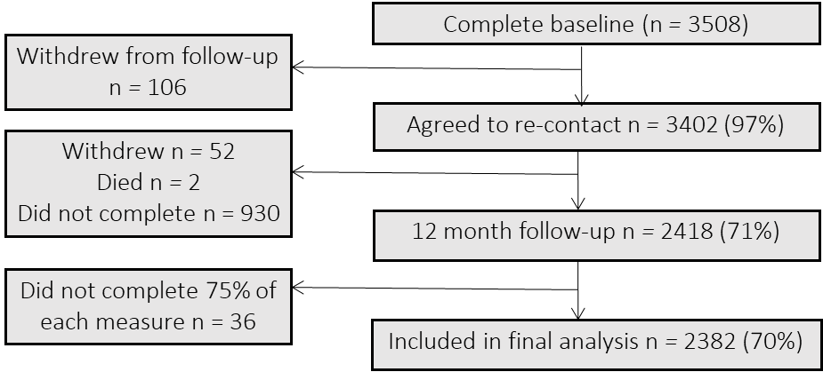

Table S1: Differences between those who did and did not complete follow-up on baseline characteristics
Variable | Did not complete follow-up  M (SD) n = 1088 | Did complete follow-up  M (SD) n = 2418
Age | 25.09 (4.94) | 25.64 (4.76)
Suicidal Ideation | 1.27 (4.19) | 0.90 (3.29)
Depressive symptoms | 11.43 (12.22) | 10.79 (10.95)
Perceived burdensomeness | 14.59 (8.18) | 13.61 (7.39)
Thwarted belongingness | 12.18 (6.98) | 11.37 (6.40)
Defeat | 16.90 (14.00) | 16.21 (13.07)
Internal entrapment | 3.93 (6.07) | 4.00 (6.01)
External entrapment | 6.37 (8.64) | 6.42 (8.30)
 | N (%) | N (%)
Gender  Male  Female | 655 (60.2)  433 (39.8) | 1085 (44.8)  1335 (55.2)
Marital status  Not married  Married | 967 (88.9)  121 (11.1) | 1970 (81.4)  449 (18.6)

Table S2: Correlationsª and partial correlations^{b} (controlling for baseline suicidal ideation) and means (SD) of all study variables (n=2418)
Variable^{c} | 12-month Suicidal Ideation | Suicidal Ideation | Depressive symptoms | Thwarted Belongingness | Perceived Burdensomeness | Defeat | External Entrapment | Internal Entrapment
12-month Suicidal Ideation | - | - | 0.13*** | 0.12*** | 0.19*** | 0.16*** | 0.14*** | 0.18***
Baseline suicidal Ideation | 0.51*** | - | - | - | - | - | - | -
Depressive symptoms | 0.39*** | 0.58*** | - | 0.50*** | 0.62*** | 0.78*** | 0.68*** | 0.73***
Thwarted Belongingness | 0.30*** | 0.39*** | 0.60*** | - | 0.58*** | 0.55*** | 0.50*** | 0.48***
Perceived Burdensomeness | 0.42*** | 0.55*** | 0.74*** | 0.66*** | - | 0.64*** | 0.57*** | 0.61***
Defeat | 0.39*** | 0.53*** | 0.84*** | 0.64*** | 0.75*** | - | 0.72*** | 0.77***
External Entrapment | 0.37*** | 0.52*** | 0.77*** | 0.60*** | 0.69*** | 0.79*** | -
Internal Entrapment | 0.42*** | 0.57*** | 0.82*** | 0.58*** | 0.73*** | 0.84*** | 0.84*** | -
Mean (SD) | 1.18 (3.78) | 0.90 (3.30) | 10.77 (10.92) | 11.36 (6.40) | 13.60 (7.38) | 16.19 (13.05) | 6.40 (8.30) | 3.99 (6.00)
ªCorrelations are reported on the bottom-half of the table, ^{b}partial correlations are reported on the top-half of the table, ^{c}all variables measured at baseline unless otherwise stated, *** p < 0.001.

In the correlation analysis all of the baseline variables were significantly associated with 12-month suicidal ideation; the strongest associations were with baseline suicidal ideation (r = 0.51, p < 0.001), perceived burdensomeness (r = 0.42, p < 0.001) and internal entrapment (r = 0.42, p < 0.001). This indicates that before controlling for any other variables, the key components of each model are significantly correlated with 12-month suicidal ideation. When controlling for baseline suicidal ideation, all of the study variables were still significantly associated with 12-month suicidal ideation, albeit with much smaller effect sizes. Perceived burdensomeness (r = 0.19, p < 0.001) and internal entrapment (r = 0.18, p < 0.001) still displayed the strongest correlations with 12-month suicidal ideation.

