Supplement 1 eMethods:

Assessment of mothers

Women were asked to participate in a prospective study of stress in pregnancy on their child’s development. Psychiatric diagnoses were made using the Structured Clinical Interview for DSM-IV Axis I Disorders with DSM-5 criteria. Self-ratings on Center for Epidemiological Studies of Depression-R (CESD-R), State-Trait Anxiety Inventory-State Version (STAI-S), and the Perceived Stress Scale (PSS) were acquired. Maternal sociodemographics and health, including infections, substance use, BMI, and prenatal vitamin use, were assessed. Labor, delivery, and neonatal parameters were recorded from the medical record. Investigators were blinded to maternal choline levels during assessments.
The medical record for all prenatal care was reviewed, and mothers had structured interviews to assess infection beginning at 16 weeks gestation. A mother’s self-report of infection was considered significant if it was also entered as a problem in the medical record. Treatment was provided for all reported genitourinary infections. Most respiratory infections were viral and were therefore not treated. The correlation between symptoms rated by the mother as moderate to severe on a Likert scale from 1-8 in the interview and problems in the medical record is r_{s} = 0.96, P < 0.001 (Freedman et al., 2019).
Mothers had structured interviews beginning at 16 weeks gestation to assess use at conception, including substance types and frequency, and use during subsequent weeks, anchored by calendar dates and gestational milestones including pregnancy tests and prenatal visits. The interview was repeated every 6 weeks through term. Urine toxicology (Alere iCup Dx14, Waltham MA) was obtained at 16 weeks. No mother tested positive by urine toxicology who denied cannabis or other substance use on interview (Hoffman et al., 2020).
Choline Assay
Maternal plasma choline and its metabolites were assayed by the Colorado Translational Research Center Metabolomics Laboratory using mass spectroscopy. Blood samples were obtained at least two hours after breakfast. Plasma was quickly separated by refrigerated centrifugation to prevent platelet phosphatidylcholine release. Stable isotope standards for betaine (N,N,N-trimethylglycine, cat no D-3352) and choline (cat no D-2464) were purchased from CDN Isotopes. Plasma samples were thawed on ice, then 20 μL was extracted with 480 μL of ice cold extraction buffer (5:3:2 MeOH:MeCN:H₂O) containing 0.1 μM each of N,N,N-trimethylglycine-D₉ (betaine) and [1,1,2,2-D₄]choline. Extraction was performed by vigorous agitation at 4ºC for 30 min followed by centrifugation at 12,000 rpm, 4 ºC for 10 min. A 100 μL aliquot of supernatant was transferred to a glass vial, dried under N₂ flow, and resuspended in an equal volume of water containing 0.1% (v/v) formic acid. Aqueous extracts were analyzed by ultra high pressure liquid chromatography-mass spectrometry (UHPLC-MS) on a Thermo Vanquish UHPLC (San Jose, CA) coupled to a Thermo Q Exactive mass spectrometer (Bremen, Germany) via positive electrospray ionization. Solvents were water (phase A) and acetonitrile (phase B) supplemented with formic acid (0.1%) and flow rate was 0.25 mL/min. Metabolites were separated using a Kinetex C18 (Phenomenex, Torrance, CA) column (2.1 x 150 mm, 1.7 μm) with a 6 minute gradient of 0-2 min 2% B; 2-2.5 min increase to 25% B; 2.5-4 min hold at 25% B; 4-4.01 min decrease to 2% B; 4.01-6 min hold at 2% B. The Q Exactive mass spectrometer was operated in full scan mode over the range of 65-950 m/z. Samples were randomized and a quality control sample was injected every 10 runs. The coefficient of variation was < 10%. Data analysis was performed using Maven Metabolomic Analysis and Visualization Engine (Princeton University) following file conversion by MassMatrix (Case Western Reserve University). Absolute concentrations were obtained using the following equation:
[light] = (peakarea_{light}/peakarea_{heavy})[heavy]*DF
where DF = dilution factor, in this case, 25 (i.e. 20μ of plasma in a total 500μ volume)
Electrophysiological Recording of Inhibition of cerebral P50 auditory evoked potentials
Newborns were studied at 1 month (44 weeks) after birth adjusted for gestational age. Vertex electroencephalogram, electro-oculogram, submental electromyogram, and respiration were continuously recorded while infants napped (Hunter, Kisley, McCarthy, Freedman, & Ross, 2011; Kisley, Polk, Ross, Levisohn, & Freedman, 2003). Recording of the cerebral auditory evoked potential P50, a positive EEG wave 50ms post stimulus, occurred in the second active sleep episode, the precursor of REM sleep, identified by low voltage desynchronized vertex activity with the absence of K-complexes, change in respiration, and large eye movements with submental atonia.(Anders, Emde, & Parmelee, 1971). The second active sleep episode was reached 45 minutes after sleep onset. In adults, P50 inhibition in REM and waking are equivalent (Griffith & Freedman, 1995).
Two identical auditory stimuli are delivered 500 ms apart to elicit P50_{S1} and P50_{S2}. Electroencephalographic activity is extracted from 100 ms before to 200 ms after S1 or S2. Trials in which the signal exceeds 75 mV are excluded to eliminate movement artifacts. The remaining trials are averaged and bandpass filtered between 10 and 50 Hz in order to isolate the P50 component. The largest positive peak between 50 and 125 ms after the stimulus is identified as P50, and the P50 amplitude is measured from this peak to the preceding negative trough. P50_{S1} and P50_{S2} amplitudes are determined independently from each other. A waveform from a subject in this study was previously published in an earlier report of the effect of inflammation on P50 inhibition (Hunter et al., 2019).
The figure is reproduced below.
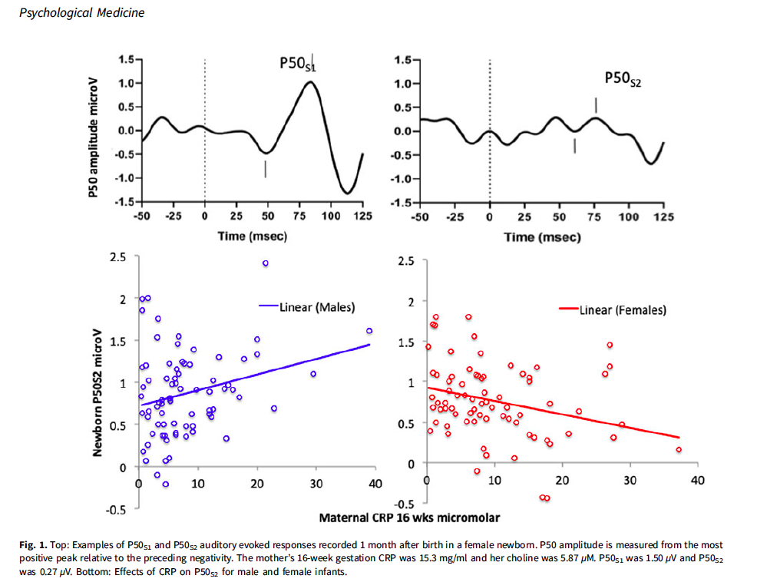
P50 inhibition is often assessed as amplitude ratios P50_{S2}/P50_{S1} or (P50_{S1}-P50_{S2})/P50_{S1} (Adler et al., 1982). However, the skew inherent in ratios limits their power for correlation with risk factors. P50_{S2} amplitude, covaried for P50_{S1}, which is normally distributed, has therefore also been used (Freedman, Olsen-Dufour, & Olincy, 2020; D. A. Smith, Boutors, & Schwarzkopf, 1994). Lower P50_{S2} amplitudes indicate increased inhibition. In 151 newborns, effect sizes for decrease in P50_{S2} amplitude were 0.21-0.50 (20). The effect of maternal schizotypy on newborn P50 inhibition has been replicated by another group, who also found increased P50_{S2} amplitudes (E. Smith, Crawford, Thomas, & Reid, 2018). Intraclass correlation between two newborn recordings 1 week apart is r_{ICC} = 0.84. Between 1 month and 4 years of age r_{ICC} = 0.73. Other technical aspects of recordings have been published (Hunter, Corral, Ponicsan, & Ross, 2008; Hunter, Gillow, & Ross, 2015)

References
Anders, T., Emde, R., & Parmelee, A. (1971). A manual of standardized terminology,
techniques and criteria for scoring of states of sleep and wakefulness
in newborn infants. Los Angeles: UCLA Brain Information Service,
NINDS Neurological Information Network.
Freedman, R., Olsen-Dufour, A. M., & Olincy, A. (2020). P50 inhibitory sensory
gating in schizophrenia: Analysis of recent studies. Schizophrenia
Research, 218, 93–98. https://doi.org/10.1016/j.schres.2020.02.003
Griffith, J. M., & Freedman, R. (1995). Normalization of the auditory P50 gating
deficit of schizophrenic patients after non-REM but not REM sleep.
Psychiatry Research, 56(3), 271–278. https://doi.org/10.1016/0165-1781(95)
02516-Y
Hunter, S. K., Corral, N., Ponicsan, H., & Ross, R. G. (2008). Reliability of P50
auditory sensory gating measures in infants during active sleep.
Neuroreport, 19(1), 79–82. https://doi.org/10.1097/WNR.0b013e3282f35823
Hunter, S. K., Gillow, S. J., & Ross, R. G. (2015). Stability of P50 auditory sensory
gating during sleep from infancy to 4years of age. Brain and Cognition,
94, 4–9. https://doi.org/10.1016/j.bandc.2014.12.004
Hunter, S. K., Hoffman, M. C., D’alessandro, A., Noonan, K., Wyrwa, A.,
Freedman, R., … Law, A. J. (2019). Male fetus susceptibility to maternal
inflammation: C-reactive protein and brain development. Psychological
Medicine, 1–10. https://doi.org/10.1017/S0033291719003313
Hunter, S. K., Kisley, M. A., McCarthy, L., Freedman, R., & Ross, R. G. (2011).
Diminished cerebral inhibition in neonates associated with risk factors for
schizophrenia: Parental psychosis, maternal depression, and nicotine use.
Schizophrenia Bulletin, 37(6), 1200–1208. https://doi.org/10.1093/schbul/
sbq036
Kisley, M. A., Polk, S. D., Ross, R. G., Levisohn, P. M., & Freedman, R. (2003).
Early postnatal development of sensory gating. Neuroreport, 14(5), 693–697.
https://doi.org/10.1097/01.wnr.0000064988.96259.b8
Smith, D. A., Boutors, N. N., & Schwarzkopf, S. B. (1994). Reliability of P50
auditory event-related potential indices of sensory gating. Psychophysiology,
31(5), 495–502. https://doi.org/10.1111/j.1469-8986.1994.tb01053.x
Smith, E., Crawford, T., Thomas, M., & Reid, V. (2018). Schizotypy and sensory
gating: A 6-month-old EEG study. Schizophrenia Bulletin, 44(suppl_1),
S301–S302. https://doi.org/10.1093/schbul/sby017.738

