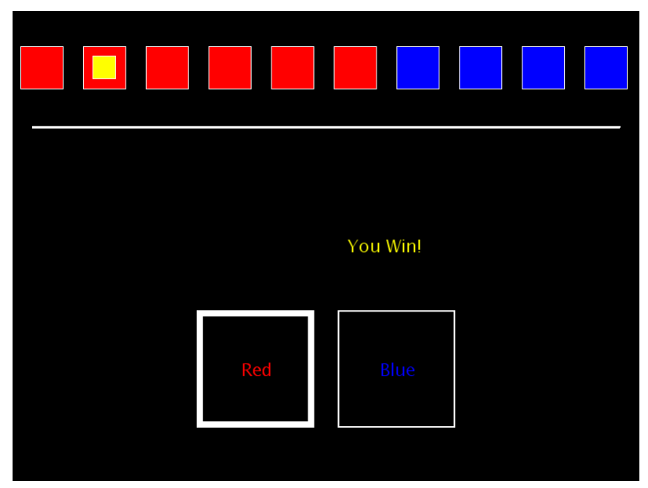

Supplementary Figure 2. The betting-stage of the Cambridge Gambling Task with a red:blue ratio of 6:4.

