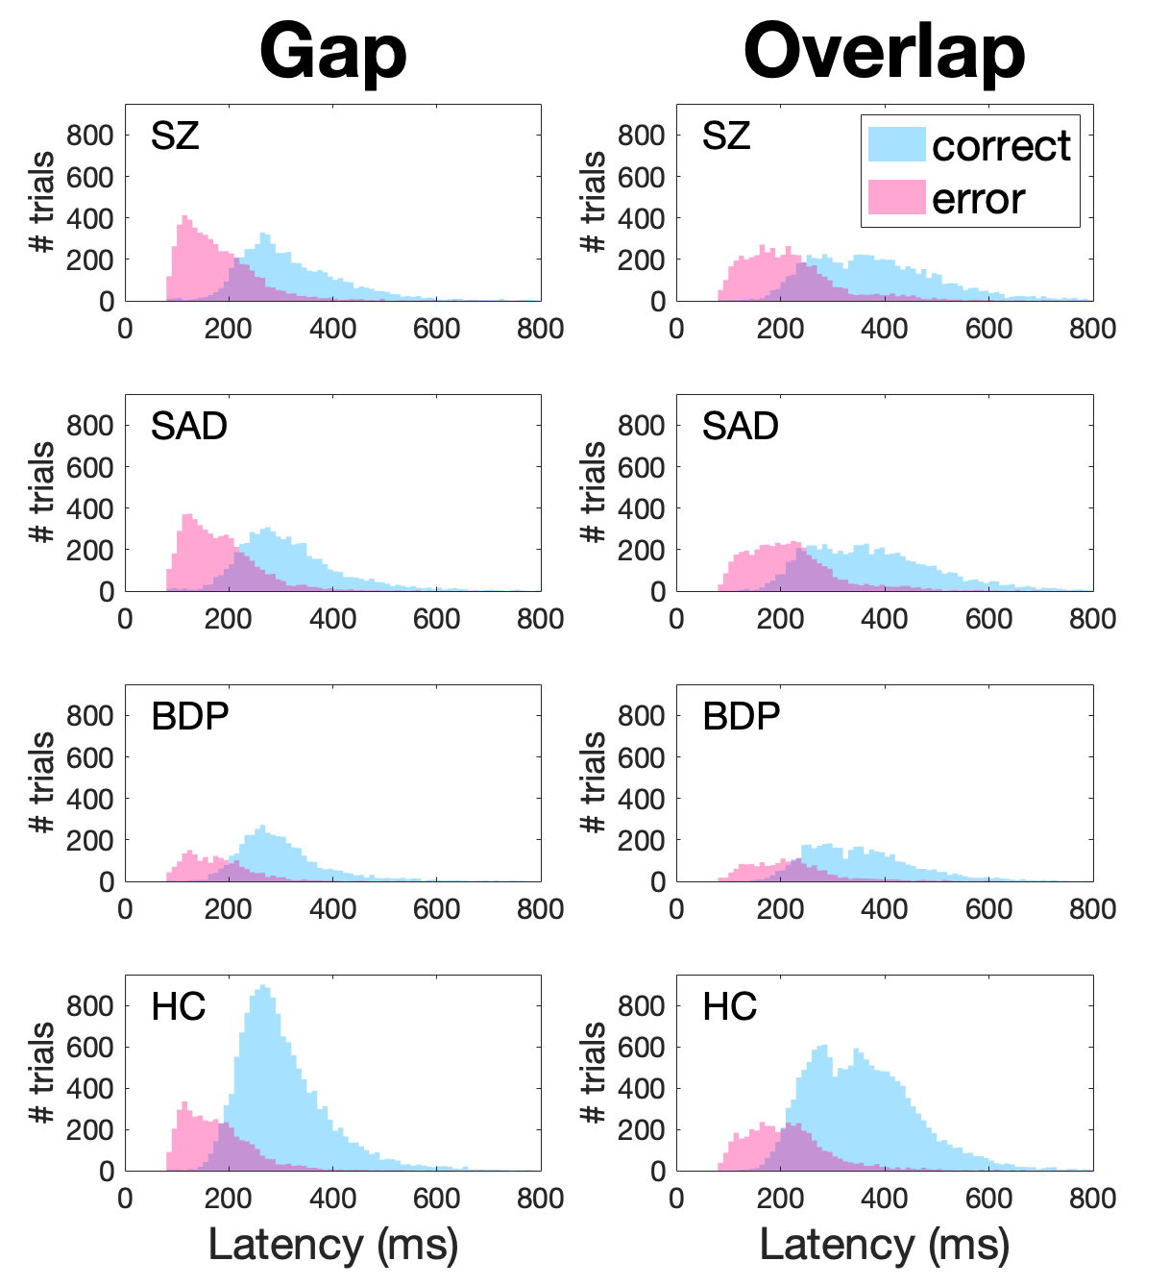

Figure S1. Number of correct and error trials from each condition of the antisaccade task in 10-ms latency bins (Schizophrenia (SZ); schizoaffective disorder (SAD); bipolar I with psychosis (BDP); healthy comparisons (HC)). For all groups, correct and error trials show relatively normal distributions, where at intermediate latencies (around 200-300ms) both correct and error responses occur at similar likelihood. However, average latency for error responses is shorter than average latency for correct antisaccades in all groups. See Figure 2 for group averages.

Gap | SZ |  | SAD |  | BDP |  | HC
Optimal Performance  (% error) | 15.3 |  | 13.1 |  | 13.1 |  | 5.76
SE | 1.02 |  | 0.67 |  | 1.32 |  | 0.76
95% Confidence (lower/upper) | 13.27 | 17.28 | 11.76 | 14.42 | 10.5 | 15.7 | 4.94 | 6.57
Tradeoff Rate  (% error / ms) | 0.0421 |  | 0.0373 |  | 0.0494 |  | 0.05
SE | 0.003 |  | 0.0018 |  | 0.0047 |  | 0.0017
95% Confidence (lower/upper) | 0.035 | 0.049 | 0.034 | 0.041 | 0.04 | 0.059 | 0.047 | 0.053
Time to 50% Correct  (ms) | 210.5 |  | 212.8 |  | 192.1 |  | 185.6
SE | 2.16 |  | 1.48 |  | 2.24 |  | 0.76
95% Confidence (lower/upper) | 206.2 | 214.7 | 209.9 | 215.8 | 187.7 | 196.5 | 184.1 | 187.1

Overlap | SZ |  | SAD |  | BDP |  | HC
Optimal Performance  (% error) | 11.1 |  | 11.0 |  | 11.5 |  | 5.52
SE | 0.62 |  | 0.63 |  | 0.77 |  | 0.41
95% Confidence (lower/upper) | 9.86 | 12.3 | 9.76 | 12.23 | 9.97 | 13.02 | 4.71 | 6.33
Tradeoff Rate  (% error / ms) | 0.0265 |  | 0.0254 |  | 0.0342 |  | 0.035
SE | 0.001 |  | 0.001 |  | 0.0017 |  | 0.001
95% Confidence (lower/upper) | 0.025 | 0.028 | 0.024 | 0.027 | 0.031 | 0.38 | 0.032 | 0.037
Time to 50% Correct  (ms) | 239.7 |  | 237.5 |  | 214.9 |  | 207.8
SE | 1.62 |  | 1.62 |  | 1.73 |  | 0.90
95% Confidence (lower/upper) | 236.5 | 242.8 | 234.3 | 240.7 | 211.5 | 218.3 | 206.0 | 209.6

Table S1. Parameter estimates for speed-performance tradeoff functions (schizophrenia (SZ); schizoaffective disorder (SAD); bipolar I with psychosis (BDP); healthy comparisons (HC)). Optimal performance: lower asymptote of the speed-performance function, indicating the minimum amount of error achievable by prolonging latency. Tradeoff rate: steepest slope of the speed-performance function. Time to 50%: x-intercept (latency in msec) where the maximum tradeoff rate occurs on the speed-performance function. SAD showed the lowest tradeoff rate in both conditions. Gap showed faster tradeoff rate than overlap in all groups. All functions accounted for 95% or more of each group’s total variance. For visualization, see Figure 4.

 | Correlation with Canonical Variate
Saccade Variables
Antisaccade % error (gap) | 0.95
Antisaccade % error (overlap) | 0.85
Antisaccade correct latency (overlap) | 0.56
Antisaccade correct latency (gap) | 0.47
BACS subscales
Verbal memory | -0.89
Verbal Fluency | -0.80
Token motor | 0.21
Symbol coding | -0.11
Tower of London | 0.06
Digit sequencing | -0.03

Table S2. Correlations between saccade variables/BACS subscales included in the canonical correlation analysis (CCA) and their corresponding outcome variates.

 | Correlation with Canonical Variate
Saccade Variables
Antisaccade correct latency (overlap) | 0.87
Antisaccade correct latency (gap) | 0.66
Antisaccade % error (gap) | 0.65
Antisaccade % error (overlap) | 0.38
Clinical Scales
Birchwood Social Functioning | -0.77
PANSS negative | 0.68
PANSS general | 0.41
PANSS positive | 0.23
MADRS | -0.11
YMRS | -0.01

Table S3. Correlations between saccade and clinical variables included in the canonical correlation analysis (CCA) and their corresponding outcome variates. MADRS: Montgomery Asberg Depression Rating Scale. YMRS: Young Mania Rating Scale. GAF: Global Assessment of Functioning (part of SCID-VI).

 |  | HC | SZ | SAD | BDP
B-SNIP2 | Prosaccade Latency
 | Gap | 159.7 (28.8) | 163.6 (32.0) | 165.8 (33.5) | 159.5 (32.4)
 | Synchronous | 181.4 (30.2) | 190.2 (33.6) | 194.9 (36.3) | 183.8 (31.4)
 | Overlap | 207.0 (42.0) | 214.6 (52.4) | 223.0 (57.0) | 206.0 (47.1)
 | Antisaccade Correct Latency
 | Gap | 305.2 (57.9) | 334.1 (84.8) | 327.5 (77.4) | 324.4 (93.0)
 | Overlap | 361.3 (67.8) | 400.7 (86.0) | 386.3 (92.6) | 377.8 (103.5)
 | Antisaccade Error Latency
 | Gap | 190.6 (45.3) | 183.7 (40.5) | 187.7 (40.1) | 183.5 (38.9)
 | Overlap | 229.0 (58.9) | 222.5 (53.2) | 227.3 (57.8) | 222.1 (46.0)
 | Antisaccade % Error
 | Gap | 25.2 (22.0) | 50.8 (26.5) | 49.5 (27.5) | 35.1 (27.3)
 | Overlap | 23.2 (18.4) | 43.9 (25.1) | 42.5 (25.1) | 32.1 (22.2)
B-SNIP1 | Prosaccade Latency
 | Gap | 167.8 (29.3) | 160.6 (31.8) | 169.3 (37.2) | 165.9 (30.0)
 | Synchronous | 197.5 (29.9) | 193.5 (32.6) | 199.2 (36.3) | 197.8 (31.7)
 | Overlap | 231.5 (43.3) | 220.1 (47.1) | 229.0 (51.9) | 225.5 (46.9)
 | Antisaccade Correct Latency
 | Overlap | 378.5 (59.6) | 410.8 (86.8) | 412.0 (82.1) | 392.5 (72.1)
 | Antisaccade Error Latency
 | Overlap | 257.4 (63.9) | 247.2 (65.3) | 253.5 (69.5) | 255.1 (71.5)
 | Antisaccade % Error
 | Overlap | 18.4 (12.5) | 44.1 (25.8) | 35.0 (22.8) | 31.8 (21.6)

Table S4. Raw mean (and standard deviation) values for antisaccade and prosaccade outcomes by group and fixation offset condition in B-SNIP1 and B-SNIP2.

