**Supplementary Figure 1.** Risk of Bias Graph and Summary for Each Included Study

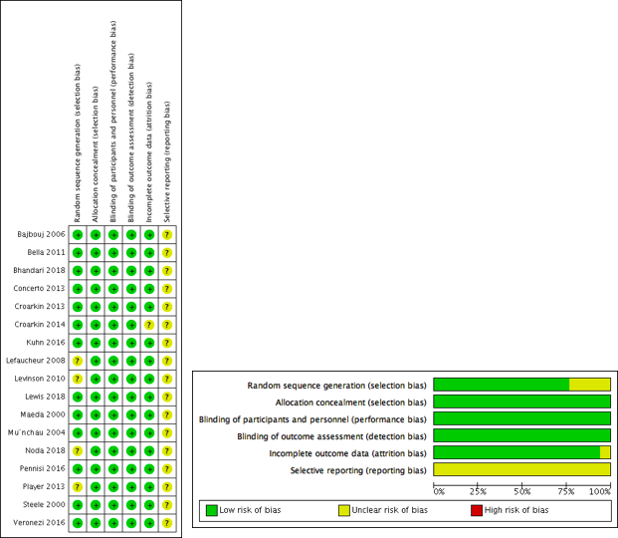

**Supplementary Figure 2.** PRISMA Diagram: flowchart mapping out the inclusion and exclusion process of records.

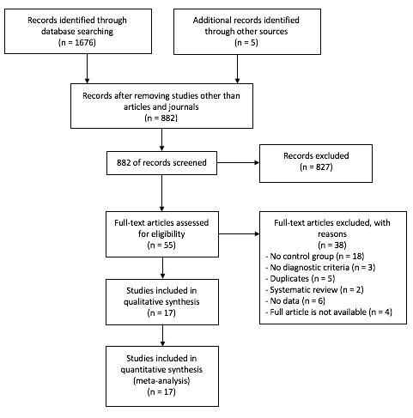

**Supplementary Figure 3.** The Results of Meta-Regression Analyses on Patients’ Age.

**(a) meta-regression of patients’ age and SMDs of SICI**



**(b) meta-regression of patients’ age and SMDs of CSP**



**(c) meta-regression of patients’ age and SMDs of ICF**



**Supplementary Figure 4.** The Results of Meta-Regression Analyses on Patients’ Gender Rate (%Female).

**(a) meta-regression of patients’ gender (% female) and SMDs of SICI**



**(b) meta-regression of patients’ gender (% female) and SMDs of CSP**



**(c) meta-regression of patients’ gender (% female) and SMDs of ICF**



**Supplementary Figure 5.** The Results of Meta-Regression Analyses on HRSD-17 Score.

**(a) meta-regression of HRSD-17 score and SMDs of SICI**



**(b) meta-regression of HRSD-17 score and SMDs of CSP**



**(c) meta-regression of HRSD-17 score and SMDs of ICF**



**Supplementary Figure 6.** Funnel Plots of Studies Included in Each Paradigm.

1. **SICI**

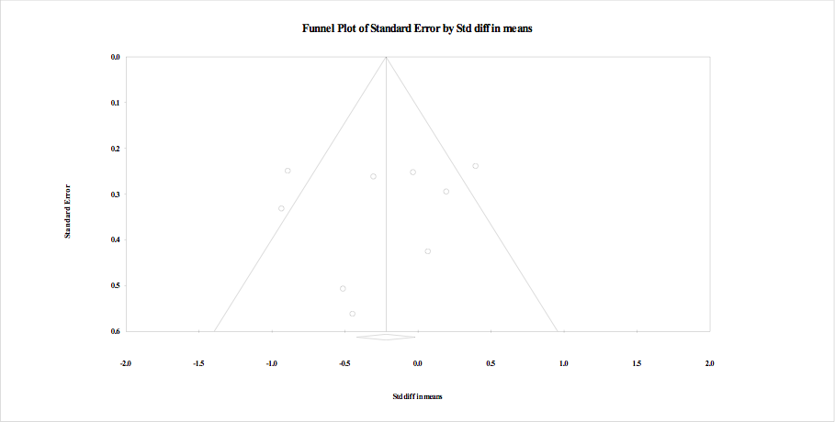

1. **CSP**

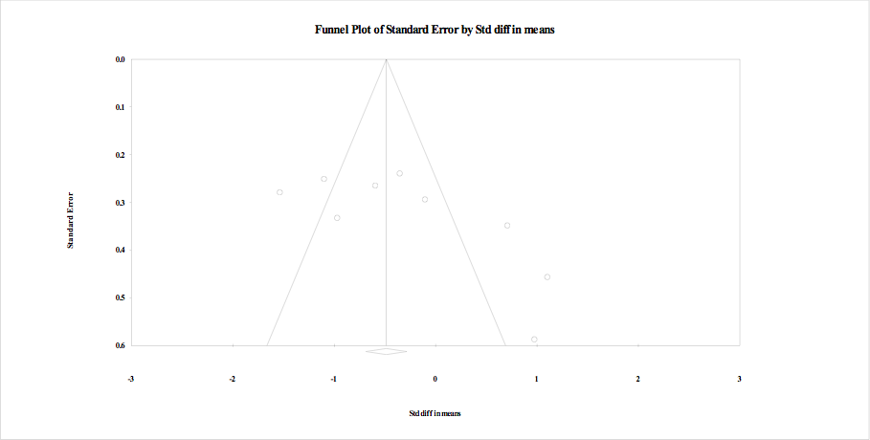

1. **ICF**

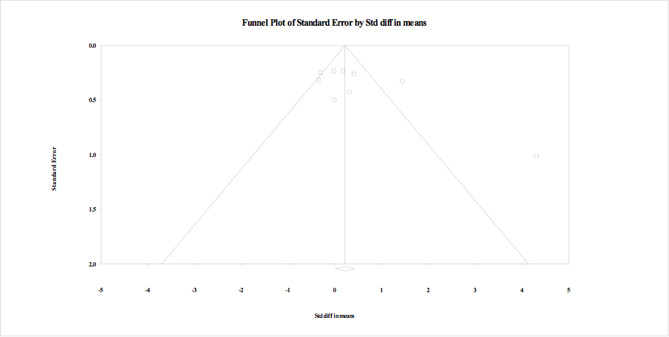

1. **PAS**

