**Supplemental Figure 1.** Flowchart of participants’ selection

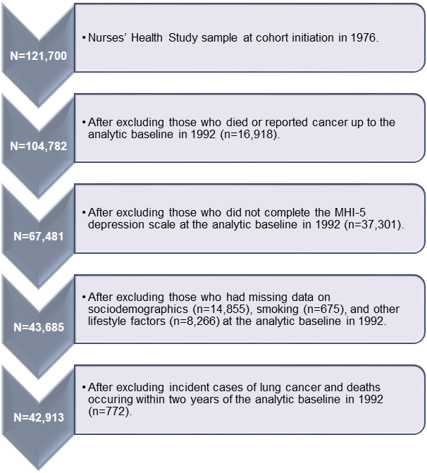

|  |  |  |  |  |  |
| --- | --- | --- | --- | --- | --- |
| **Supplemental Table 1.** Association of depressive symptoms with lung cancer incidence, stratified by smoking status. | | | | | |
|
|  | | | | | |
|  |  |  |  |  |  |
|  | **Person-years** | **Model 1:**  **Sociodemographics** | | **Model 2: Model 1 +**  **other factors** | |
|  | **(cases)** | **HR** | **(95% CI)** | **HR** | **(95% CI)** |
| **Per 1-SD increase in depressive symptoms** |  |  |  |  |  |
|  |  |  |  |  |
| Current smokers | 89,324 (457) | 1.07 | (0.98-1.18) | 1.06 | (0.96-1.16) |
| Former smokers | 314,968 (423) | 1.21 | (1.10-1.32)**** | 1.19 | (1.09-1.30)**** |
| Never smokers | 359,107 (129) | 1.07 | (0.90-1.28) | 1.07 | (0.89-1.28) |
| *p*-value for interaction test: |  | 0.27 |  | 0.29 |  |
|  |  |  |  |  |  |
| \*\*\*\**p*≤ .0001. CI=confidence intervals; HR=hazard ratio; SD=standard deviation. | | | | | |
| M1: stratified by age in 1992 (continuous) and calendar time (continuous); further adjusted for exposure to second-hand smoking during childhood (yes, no [reference]); parents' occupations when participant was 16 years old (both parents dead [reference], farmer, blue collar, white collar); familial history of lung cancer (yes, no [reference]); and husband's education (participant unmarried [reference], less than high school, high school graduate, college graduate, graduate school) | | | | | |
|
|
|
|
| M2: M1 + diet quality (AHEI score; continuous); physical activity (less than 150min/week of moderate-to-vigorous physical activity [reference], 150min/week or more of moderate-to-vigorous physical activity); years of shiftwork (never [reference], 1-14 years, 15-29 years, 30 years or more) | | | | | |
|
|

|  |  |  |  |  |  |
| --- | --- | --- | --- | --- | --- |
| **Supplemental Table 2.** Association of depressive symptoms with lung cancer incidence, stratified by smoking status, using a Poisson distribution. | | | | | |
|
|  | | | | | |
|  |  |  |  |  |  |
|  | **Person-years** | **Model 1:**  **Sociodemographics** | | **Model 2: Model 1 +**  **other factors** | |
|  | **(cases)** | **RR** | **(95% CI)** | **RR** | **(95% CI)** |
| **Per 1-SD increase in depressive symptoms** |  |  |  |  |  |
|  |  |  |  |  |
| Current smokers | 89,324 (457) | 1.01 | (0.93-1.10) | 1.00 | (0.92-1.09) |
| Former smokers | 314,968 (423) | 1.20 | (1.10-1.30)**** | 1.18 | (1.08-1.29)**** |
| Never smokers | 359,107 (129) | 1.06 | (0.89-1.26) | 1.06 | (0.89-1.26) |
| *p*-value for interaction test: |  | 0.13 |  | 0.14 |  |
|  |  |  |  |  |  |
| \*\*\*\**p*≤ .0001. CI=confidence intervals; RR=relative risk; SD=standard deviation. | | | | | |
| M1: stratified by age in 1992 (continuous) and calendar time (continuous); further adjusted for exposure to second-hand smoking during childhood (yes, no [reference]); parents' occupations when participant was 16 years old (both parents dead [reference], farmer, blue collar, white collar); familial history of lung cancer (yes, no [reference]); and husband's education (participant unmarried [reference], less than high school, high school graduate, college graduate, graduate school) | | | | | |
|
|
|
|
| M2: M1 + diet quality (AHEI score; continuous); physical activity (less than 150min/week of moderate-to-vigorous physical activity [reference], 150min/week or more of moderate-to-vigorous physical activity); years of shiftwork (never [reference], 1-14 years, 15-29 years, 30 years or more) | | | | | |
|
|

|  |  |  |  |  |  |  |  |  |  |
| --- | --- | --- | --- | --- | --- | --- | --- | --- | --- |
| **Supplemental Table 3.** Association of chronic depressive symptoms and time-updated depression status, separately, with lung cancer incidence. | | | | | | | | | |
|  |  |  |  |  |  |  |  |  |  |
|  | **Person-years** | **Model 1:**  **Sociodemographics** | | **Model 2: Model 1 +**  **smoking** | | **Model 3: Model 1 +**  **other factors** | | **Model 4:**  **All covariates** | |
|  | **(cases)** | **HR** | **(95% CI)** | **HR** | **(95% CI)** | **HR** | **(95% CI)** | **HR** | **(95% CI)** |
| **Chronicity of severe depressive symptomsa** | 763,399 (1,009) |  |  |  |  |  |  |  |  |
| At no time assessment | 576,194 (722) | 1.00 | (ref.) | 1.00 | (ref.) | 1.00 | (ref.) | 1.00 | (ref.) |
| At 1 time assessment | 123,639 (191) | 1.30 | (1.10-1.52)** | 1.10 | (0.93-1.29) | 1.26 | (1.07-1.48)** | 1.08 | (0.92-1.27) |
| At 2 or 3 time assessments | 63,566 (96) | 1.32 | (1.07-1.64)** | 1.11 | (0.89-1.38) | 1.25 | (1.00-1.55)* | 1.08 | (0.86-1.34) |
|  |  |  |  |  |  |  |  |  |  |
| **Time-updated  depression statusb** | 630,293 (387) |  |  |  |  |  |  |  |  |
| Not clinically depressed | 503,769 (228) | 1.00 | (ref.) | 1.00 | (ref.) | 1.00 | (ref.) | 1.00 | (ref.) |
| Clinically depressed | 126,523 (159) | 3.19 | (2.59-3.93)**** | 2.56 | (2.07-3.18)**** | 3.03 | (2.46-3.74)**** | 2.47 | (1.99-3.06)**** |
|  |  |  |  |  |  |  |  |  |  |
| a Chronicity was based on the number of assessments participants had a score of ≤60 (clinical cutpoint) on the MHI-5 in 1992, 1996, and 2000.  b Clinically depressed was defined as reporting a MHI-5 score of ≤60 (clinical cutpoint), or a physician-diagnosed depression, or the regular use of antidepressants, and was updated over the entire study period. | | | | | | | | | |
|
| *\*p*≤ .05; \*\**p*≤ .01; \*\*\*\**p*≤ .0001. CI=confidence intervals; HR=hazard ratio. | | | | | | | | | |
| M1: stratified by age in 1992 (continuous) and calendar time (continuous); further adjusted for exposure to second-hand smoking during childhood (yes, no [reference]); parents' occupations when participant was 16 years old (both parents dead [reference], farmer, blue collar, white collar); familial history of lung cancer (yes, no [reference]); and husband's education (participant unmarried [reference], less than high school, high school graduate, college graduate, graduate school) | | | | | | | | | |
|
|
| M2: M1 + average cigarette packs per day per year smoked (not a current smoker [reference], 1-10 packs/year, 11-30 packs/year, 30 or more packs/year) | | | | | | | | | |
|
| M3: M1 + diet quality (AHEI score; continuous); physical activity (less than 150min/week of moderate-to-vigorous physical activity [reference], 150min/week or more of moderate-to-vigorous physical activity); years of shiftwork (never [reference], 1-14 years, 15-29 years, 30 years or more) | | | | | | | | | |
|
| M4: all covariates mentioned above. | |  |  |  |  |  |  |  |  |

|  |  |  |  |  |  |
| --- | --- | --- | --- | --- | --- |
| **Supplemental Table 4.** Association between time-updated depression status and lung cancer incidence with stratification by smoking status. | | | | | |
|  |  |  | |  | |
|  |  |  | |  | |
|  | **Person-years** | **Model 1:**  **Sociodemographics** | | **Model 2: Model 1 +**  **other factors except smoking** | |
|  | **(cases)** | **HR** | **(95% CI)** | **HR** | **(95% CI)** |
|  |  |  |  |  |  |
|  | Current smokers | | | | |
| **Time-updated depression statusa** |
| 67,293 (160) |  |  |  |  |
| Not clinically depressed | 48,905 (77) | 1.00 | (ref.) | 1.00 | (ref.) |
| Clinically depressed | 18,388 (83) | 3.68 | (2.55-5.30)**** | 3.54 | (2.44-5.12)**** |
|  |  |  |  |  |  |
|  | Former smokers | | | | |
| **Time-updated depression statusa** |
| 260,426 (164) |  |  |  |  |
| Not clinically depressed | 205,650 (103) | 1.00 | (ref.) | 1.00 | (ref.) |
| Clinically depressed | 54,775 (61) | 2.48 | (1.78-3.46)**** | 2.38 | (1.70-3.32)**** |
|  |  |  |  |  |  |
|  | Never smokers | | | | |
| **Time-updated depression statusa** |
| 302,574 (63) |  |  |  |  |
| Not clinically depressed | 249,215 (48) | 1.00 | (ref.) | 1.00 | (ref.) |
| Clinically depressed | 53,359 (15) | 1.67 | (0.92-3.03)† | 1.64 | (0.90-2.99)† |
| *†p≤ .10;* \*\*\*\**p*≤ .0001. CI=confidence intervals; HR=hazard ratio. | | | | | |
|  |  |  |  |  |  |
| M1: stratified by age in 1992 (continuous) and calendar time (continuous); further adjusted for exposure to second-hand smoking during childhood (yes, no [reference]); familial history of lung cancer (yes, no [reference]); and husband's education (participant unmarried [reference], less than high school, high school graduate, college graduate, graduate school). Of note, in these models only, parents' occupations when participant was 16 years old was not included as a covariate because of a lack of variability in some strata. | | | | | |
|  | | | | | |
| M2: M1 + diet quality (AHEI score; continuous); physical activity (less than 150min/week of moderate-to-vigorous physical activity [reference], 150min/week or more of moderate-to-vigorous physical activity); years of shiftwork (never [reference], 1-14 years, 15-29 years, 30 years or more) | | | | | |