Supplementary materials

Figure S1. Forrest plot of studies estimating the proportion of CHR who converted to psychosis within the follow-up among those who were exposed to antipsychotics at baseline (i.e. baseline AP-exposed CHR).
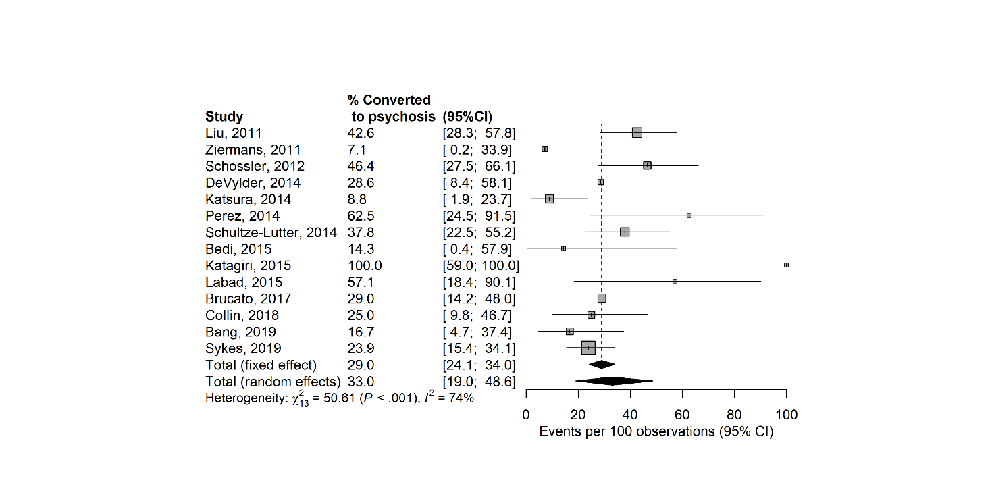

Figure S2. Forrest plot of studies estimating the proportion of CHR who converted to psychosis within the follow-up among those who were not exposed to antipsychotics at baseline (i.e. baseline AP-naïve CHR).
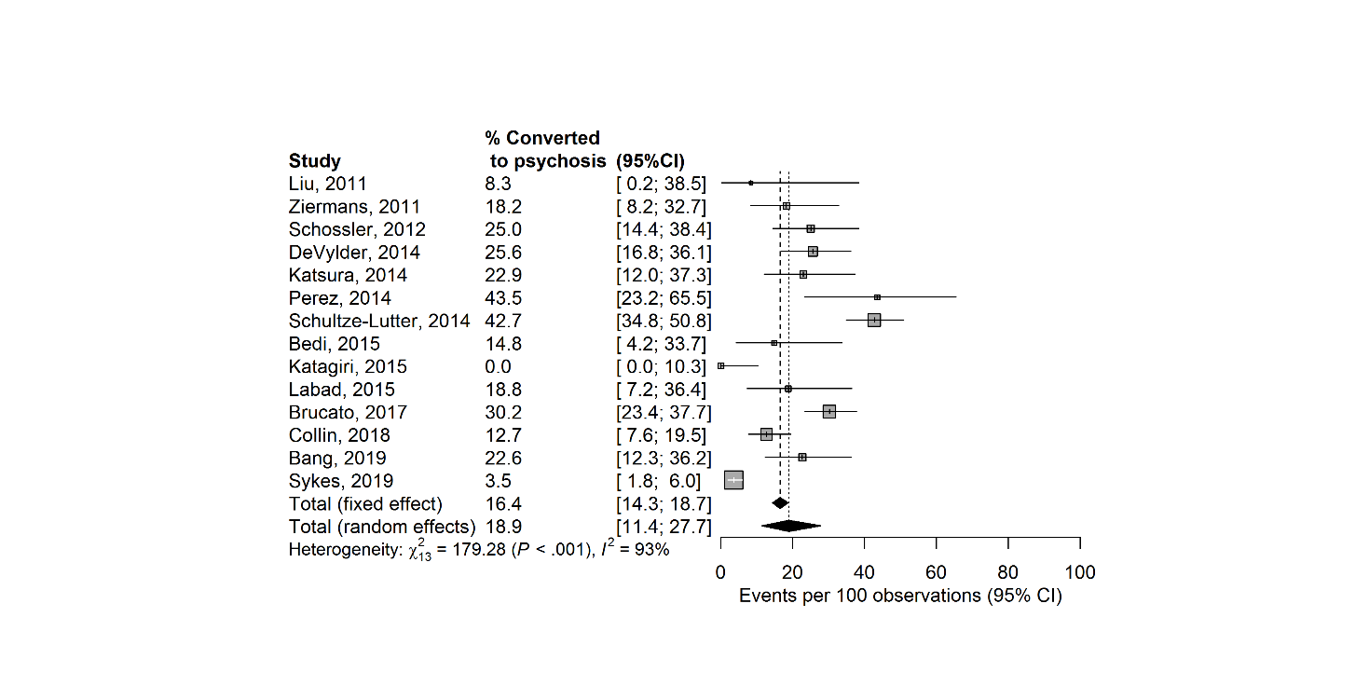

Figure S3. Funnel plot of comparison in risk ratio of conversion to psychosis between CHR who were or were not exposed to antipsychotics at baseline (on the left), and Egger’s regression test for the risk of publication bias in the same meta-analysis (on the right).

Figure S4. Funnel plot of comparison in risk ratio of conversion to psychosis between CHR who were or were not exposed to antipsychotics at baseline (on the left), and Egger’s regression test for the risk of publication bias in the same meta-analysis (on the right).after exclusion of outlier studies.

