**Supplemental Methods and Materials**

**Participants and Assessments**

Inclusion criteria for the FEP participants included age between 12 and 40, a diagnosis of schizophrenia, schizophreniform disorder, schizoaffective disorder, or psychotic disorder, not otherwise specified, and less than two months of prior antipsychotic exposure. Diagnoses were determined based on consensus discussions of a Structured Clinical Interview for Axis I Diagnostic and Statistical Manual-IV by senior diagnosticians, including two authors (DKS, GLH). To ensure that our patients were more likely to have a schizophrenia-spectrum disorder, we did not include individuals with concurrent mood-related diagnoses and rigorous assessments were made to rule out a diagnosis of a substance-induced psychotic disorder. Additional exclusion criteria included any medical illness affecting the central nervous system function, an intelligence quotient lower than 75 on the Wechsler Abbreviated Scale of Intelligence (WASI) (Wechsler, 1999), or contraindications to magnetic resonance scanning. At the time of the scan, 27 patients were receiving treatment via a second-generation antipsychotic drug, 14 patients were antipsychotic-naive, and one was not currently taking antipsychotic medication though had a remote history of antipsychotic medication exposure.

The FEP cohort was examined in relation to a group of thirty-five healthy control (HC) participants matched for age and sex. Exclusion criteria for the HC group included: history of a major psychiatric disorder, first-degree relatives with history of a psychotic disorder, neurological disorder, history of head trauma, and intellectual impairment as defined by the DSM-IV. All study participants or their legal guardians provided written informed consent after procedures were discussed. All participants were compensated for their time. MRI exclusions applied to all participants.

**Image Acquisition**

Structural images were collected with a magnetization-prepared rapid gra{Sarpal, 2017 #1}dient-echo (MPRAGE) sequence with a voxel size of 1 mm3, and 176 total slices. Parameters for the MPRAGE included the following: 2530 ms TR, 1260 ms TI, multi-echo TE (TE1= 1.74 ms, TE2= 3.6 ms, TE3= 5.46 ms, TE4= 7.32 ms), and a 7° flip angle. Functional images were acquired using a multiband (x5) echo-planar sequence sensitive to bold oxygen level-dependent (BOLD) images. Parameters consisted of: TR/TE: 1000/30 ms, flip angle: 55°, voxel size: 2.3 × 2.3 × 2.3 mm in-plane resolution, 60 contiguous axial slices, 360 TRs for each WM task run, and the resting-state run. Additionally, a high-resolution spin echo sequence was collected with 60 total slices, a TR of 5040 ms, TE of 30 ms, 55° flip angle, and a 220 × 220 × 138 mm FOV.

**Image analysis and Preprocessing**

Our quality control measures included visual inspection of all raw data and output scans following preprocessing. This included check of both structural (e.g. skull stripping) and functional images. Visual inspection looked for homogeneity in signal, and for gross abnormalities in alignment and orientation.

Standard preprocessing was performed with tools from AFNI (https://afni.nimh.nih.gov) and FSL (<http://www.fmrib.ox.ac.uk>) (Cox, 1996; Jenkinson, Beckmann, Behrens, Woolrich, & Smith, 2012). Slice-timing correction and motion correction were performed simultaneously using NIPy (<http://nipy.org>) (Gorgolewski et al., 2011). Functional images from both WM and resting-state scans and were registered to MNI152 space with affine (FSL FLIRT) and nonlinear (FSL FNIRT) transformations. Field warping on images were applied with FSL FUGUE to correct for spatial distortion.

We monitored movement with assessments of framewise displacement (FD) and DVARS. To mitigate confounds due to movement, we used a method for wavelet despiking our data, as described in our previous studies (Manivannan et al., 2019; Murty et al., 2018). Wavelet despiking was performed with the Brain Wavelet Toolbox (http://www.brainwavelet.org) to remove motion confounds (Patel et al., 2014). In our experience with this cohort of scans, the wavelet depiking method employed eliminated motion-related confounds. As a post-hoc quality check we examined the relationship between FD and our connectivity results (see below).

Images were spatially smoothed with a 5mm full width at half maximum (FWHM) Gaussian kernel. High-pass filtering at 100 volumes and grand median intensity normalization (10000/global median) were performed to rescale images.

**Task-Based Trial-Level Activation**

A first-level general linear model (GLM) (2x3) was constructed for each patient. Task phase (encoding, maintenance, retrieval) for each load (low, high) and incorrect task trials at each of the three task phases were modeled as regressors. All regressors were convolved with a double-gamma HRF. Individual maps of parameter estimates were created for contrasts of the maintenance phase during the highest WM load. Activation values of WM maintenance were extracted from significant clusters from our background connectivity analysis for each participant and used to compare between groups.

**Supplemental Figure 1**

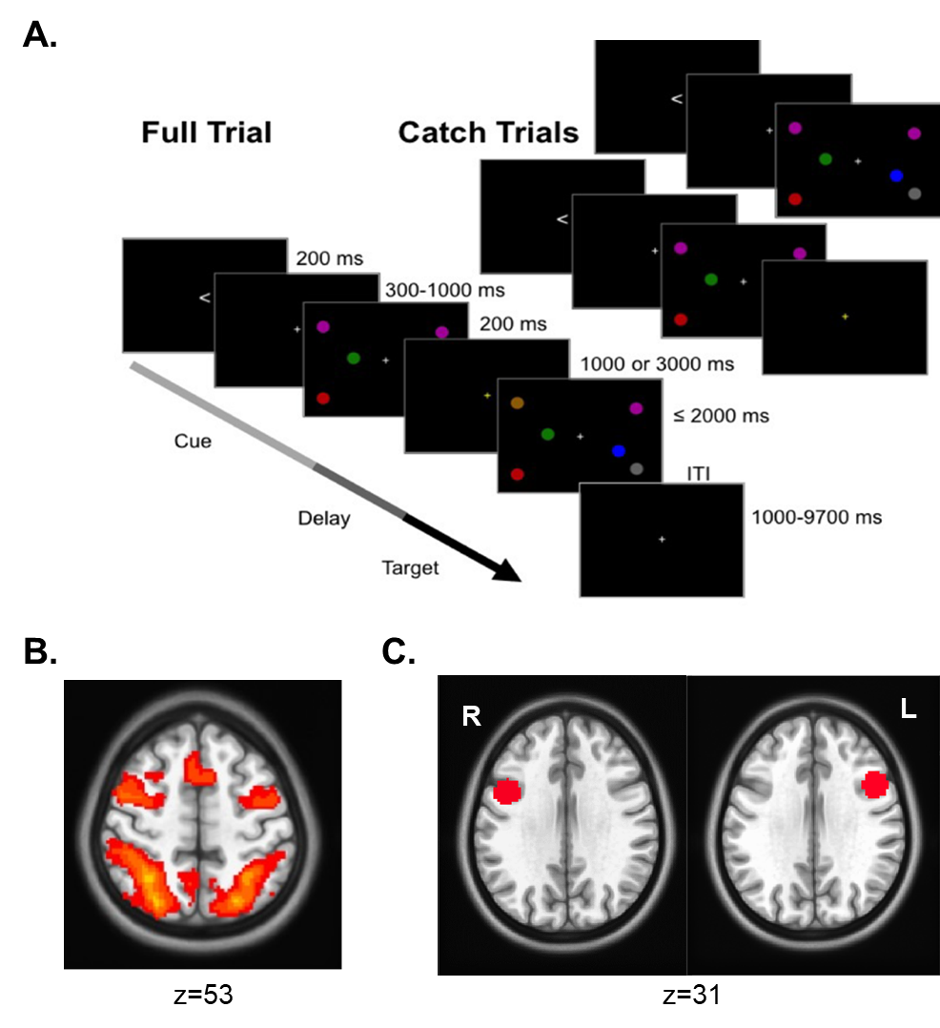

**Supplemental Figure 2**

Group difference in task-based activation across WM maintenance phases are displayed here from peak regions of our three significant clusters that emerged in our background connectivity analysis: A) right superior parietal lobule, B) left inferior parietal lobule, C) left superior parietal lobule. Between group results for all three regions are not significant (p > 0.05).

**Supplemental Table 1**

|  |  |  |  |  |  |  |  |
| --- | --- | --- | --- | --- | --- | --- | --- |
| **Cluster** | **x** | **y** | **Z** | **T score (max)** | **K (voxel size)** | **Brodmann Area** | **Functional Connection** |
| 1 | 22 | -70 | 47 | -5.47 | 297 | 7 | Right superior parietal lobule |
| 2 | -47 | -51 | 51 | -4.24 | 259 | 7 | Left superior parietal lobule |
| 3 | -24 | -72 | 61 | -4.22 | 197 | 40 | Left inferior parietal lobule |

Summary of background connectivity results following bandpass filtered data. Results above were virtually identical to group comparisons without bandpass filtering.

**Supplemental References**

Cox, R. W. (1996). AFNI: software for analysis and visualization of functional magnetic resonance neuroimages. *Computers and Biomedical Research, 29*(3), 162-173. doi:10.1006/cbmr.1996.0014

Gorgolewski, K., Burns, C. D., Madison, C., Clark, D., Halchenko, Y. O., Waskom, M. L., & Ghosh, S. S. (2011). Nipype: a flexible, lightweight and extensible neuroimaging data processing framework in python. *Frontiers in Neuroinformatics, 5*, 13. doi:10.3389/fninf.2011.00013

Jenkinson, M., Beckmann, C. F., Behrens, T. E., Woolrich, M. W., & Smith, S. M. (2012). Fsl. *NeuroImage, 62*(2), 782-790. doi:10.1016/j.neuroimage.2011.09.015

Manivannan, A., Foran, W., Jalbrzikowski, M., Murty, V. P., Haas, G. L., Tarcijonas, G., . . . Sarpal, D. K. (2019). Association Between Duration of Untreated Psychosis and Frontostriatal Connectivity During Maintenance of Visuospatial Working Memory. *Biological Psychiatry: Cognitive Neuroscience and Neuroimaging*. doi:10.1016/j.bpsc.2019.01.007

Murty, V. P., Shah, H., Montez, D., Foran, W., Calabro, F., & Luna, B. (2018). Age-Related Trajectories of Functional Coupling between the VTA and Nucleus Accumbens Depend on Motivational State. *The Journal of Neuroscience, 38*(34), 7420-7427. doi:10.1523/JNEUROSCI.3508-17.2018

Patel, A. X., Kundu, P., Rubinov, M., Jones, P. S., Vertes, P. E., Ersche, K. D., . . . Bullmore, E. T. (2014). A wavelet method for modeling and despiking motion artifacts from resting-state fMRI time series. *NeuroImage, 95*, 287-304. doi:10.1016/j.neuroimage.2014.03.012