Appendix: Online Supplementary Materials

Figure 1S: Subscale and Item Ratings for the Alda Scale
Legend for Figure 1S: The cohort comprised of 70 individuals with BD-I who were prescribed long-term Lithium. There were 25 GR and 45 NR (i.e. good responders or non-responders). Below we show distributions of the A scale score and scores for each item of the B scale according to GR or NR. (Note: TS2CATS refers to the Total Score on the Alda scale and the use of a cut-off score to identify 2 Lithium Response categories).
As the A score minus the B score is used to estimate Lithium response (and A-B >=8 defined GR) it is inappropriate to undertake statistical significance testing of the subscale scores. However, the graphs demonstrate that potential confounders show different distributions across groups.
The A scale measures change in illness activity (rated 0-10, with high scores identifying better response). The B scale items are all rated 0-2. Each item measures a clinical characteristics that may attenuate response, namely:
B1- number of episodes prior to Li (a score of 2 suggests fewer episodes, making judgements about the impact of Li more difficult).
B2- frequency of episodes prior to Li (a score of 2 suggests low frequency).
B3- assesses duration of Li treatment (a score of 2 would suggest a short period of time, making judgements about benefits more difficult).
B4- measures adherence with Li (with a score of 2 indicating poor adherence)
B5- assesses complexity of treatment regime, including polypharmacy and co-prescription of mood stabilizers (with a high score indicating a more complex treatment regime).
It is noteworthy that B3 and B4 distributions (specifically relevant to Lithium prescription and adherence) are similar for NR and GR.

i) Distribution of A scale scores according to group
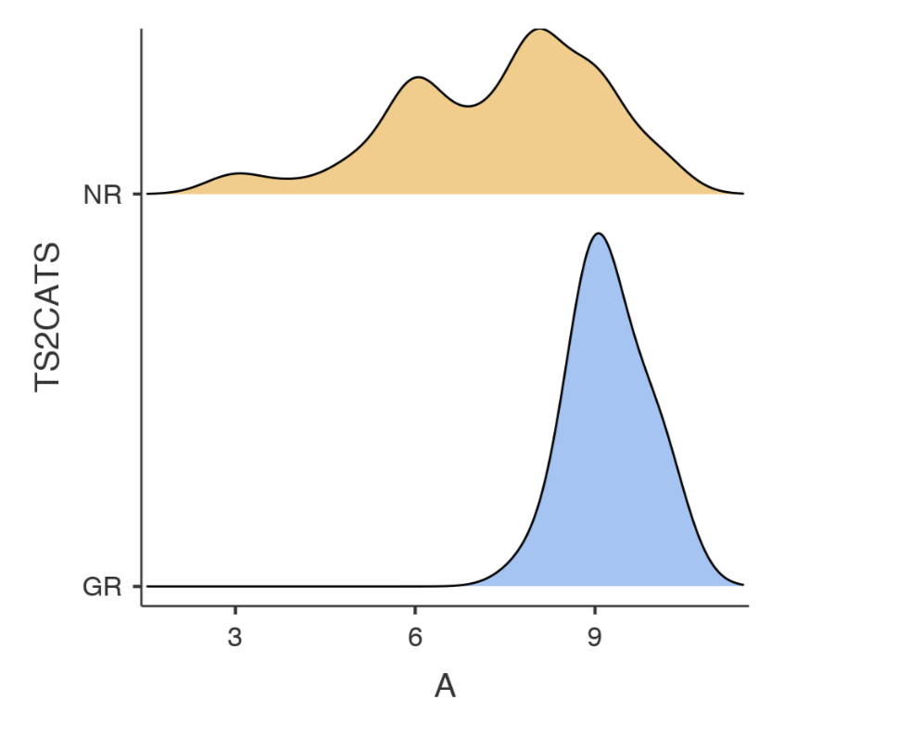

ii) Distribution of B scale item scores according to group
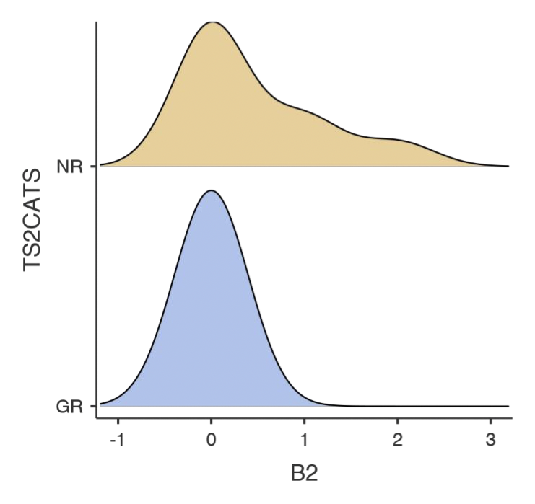
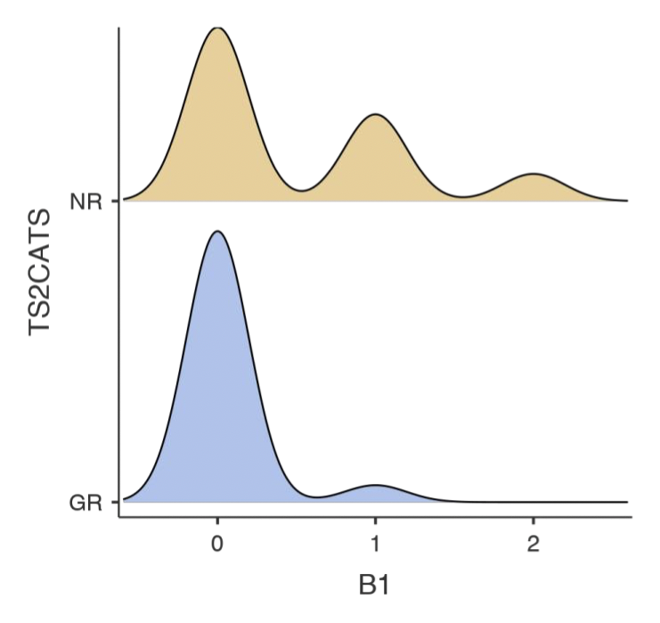
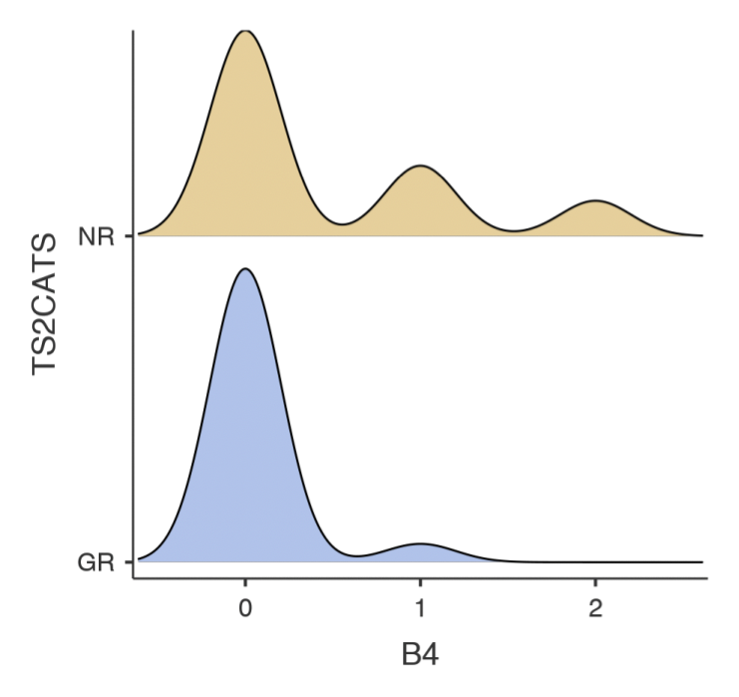
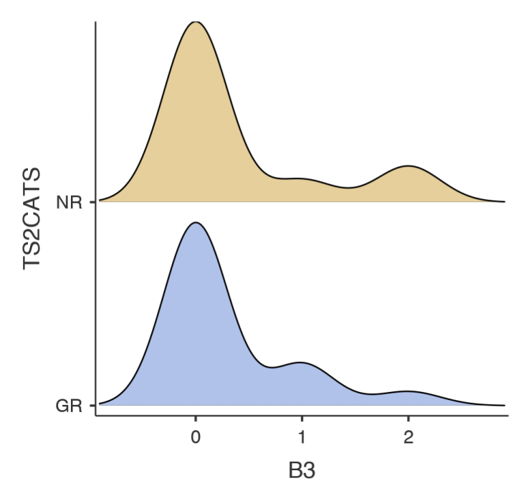

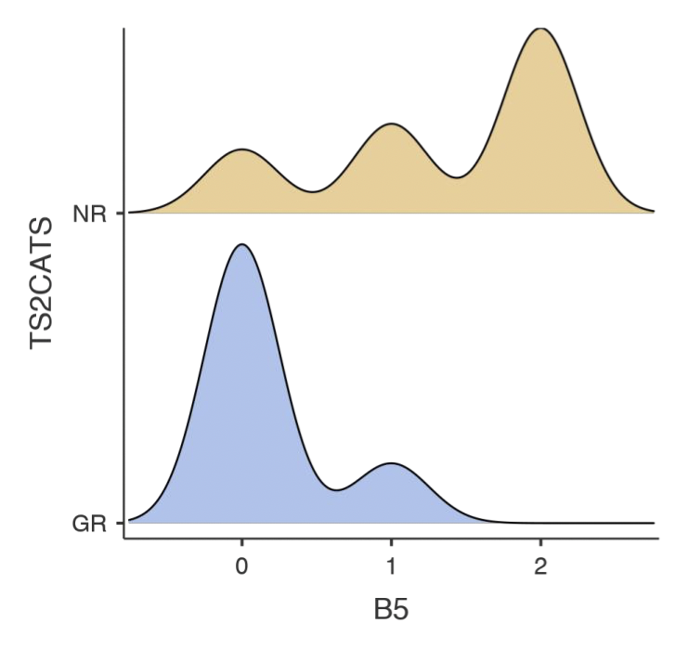

 | MW U | Wilcoxon W | Z- Value | Monte Carlo Sig. (2-tailed)
Parameter |  |  |  | Sig.* | 99% CI
TST | 410 | 686 | -1.01 | 0.318 |  | 0.306 | 0.33
WASO | 448 | 773 | -1.39 | 0.163 |  | 0.153 | 0.172
SOL | 468 | 793 | -1.16 | 0.254 |  | 0.242 | 0.265
SE | 459 | 1494 | -1.27 | 0.207 |  | 0.196 | 0.217
FI | 492 | 817 | -0.87 | 0.390 |  | 0.377 | 0.402
vTST | 396 | 672 | -1.19 | 0.241 |  | 0.23 | 0.252
vWASO | 389 | 665 | -1.29 | 0.206 |  | 0.195 | 0.216
vSOL | 349 | 625 | -1.84 | 0.070 |  | 0.063 | 0.076
vSE | 426 | 702 | -0.78 | 0.446 |  | 0.433 | 0.459
vFI | 482 | 1385 | -0.01 | 0.996 |  | 0.994 | 0.997
Inter-daily Stability | 466 | 1501 | -1.18 | 0.236 |  | 0.225 | 0.247
Intra-daily Variability | 348 | 673 | -2.64 | 0.008 |  | 0.006 | 0.01
L5 | 504 | 829 | -0.72 | 0.480 |  | 0.467 | 0.493
L5_Onset | 538 | 863 | -0.31 | 0.799 |  | 0.788 | 0.809
M10 | 368 | 1403 | -2.38 | 0.018 |  | 0.015 | 0.022
M10_Onset | 549 | 874 | -0.17 | 0.857 |  | 0.848 | 0.866
Amp | 357 | 1392 | -2.52 | 0.013 |  | 0.01 | 0.016
Rel_Amp | 369 | 1404 | -2.37 | 0.017 |  | 0.013 | 0.02
*Based on 10000 sampled tables with starting seed 2000000.

Table 1S: Additional details regarding Mann Whitney U (MW U) test with bootstrapping

Table 2S: Odds Ratios and 95% Confidence Intervals for the association between individual sleep and circadian parameters (analyses adjusted for age, sex and BMI), and the estimated association (aggregate OR) between sleep quantity, variability or circadian rhythmicity and Good Response to Lithium.

NB: Hedges g analyses (reporting standardized mean differences rather than OR) are available from the authors.

 | Odds Ratio | Lower  Limit | Upper  Limit | Z-  Value | signif.  (p)
TST | 1.57 | 0.62 | 3.96 | 0.96 | 0.34
WASO | 0.49 | 0.20 | 1.19 | -1.57 | 0.12
SOL | 0.51 | 0.21 | 1.24 | -1.49 | 0.14
SE | 2.10 | 0.86 | 5.15 | 1.63 | 0.10
FI | 0.54 | 0.22 | 1.31 | -1.37 | 0.17
SLEEP  QUANTITY | 0.84 | 0.56 | 1.27 | -0.85 | 0.40
vTST | 0.60 | 0.24 | 1.53 | -1.06 | 0.29
vWASO | 0.51 | 0.20 | 1.28 | -1.44 | 0.15
vSOL | 0.49 | 0.19 | 1.24 | -1.50 | 0.13
vSE | 0.53 | 0.21 | 1.34 | -1.35 | 0.18
vFI | 0.67 | 0.27 | 1.70 | -0.84 | 0.40
SLEEP VARIABILITY | 0.56 | 0.31 | 1.01 | -1.91 | 0.06
IS | 1.77 | 0.83 | 4.32 | 1.56 | 0.19
IV | 0.44 | 0.18 | 1.05 | -1.83 | 0.07
L5 | 0.53 | 0.22 | 1.29 | -1.40 | 0.16
L5_Onset | 1.03 | 0.42 | 2.49 | 0.06 | 0.95
M10 | 3.17 | 1.28 | 7.84 | 2.49 | 0.01
M10_Onset | 1.03 | 0.42 | 2.49 | 0.06 | 0.95
Amp | 3.48 | 1.40 | 8.66 | 2.69 | 0.01
Rel_Amp | 3.30 | 1.33 | 8.19 | 2.58 | 0.01
CIRCADIAN RHYTHMICITY | 1.41 | 1.08 | 2.05 | 2.07 | 0.04
NB: In this analysis, the coding of parameters included within a subset was adjusted to ensure directions of association were compatible (e.g. shorter SOL and higher SE were both coded as positive, whilst e.g. higher FI was coded as negative).

