Other Supplementary Material
Supplementary Methods
The automated anatomical labeling atlas (AAL, Tzourio-Mazoyer et al., 2002) was used to define our six regions of interests: the left dorsolateral prefrontal cortex (dlPFC), the right dlPFC, the left ventrolateral prefrontal cortex (vlPFC), the right vlPFC, the left amygdala and the right amygdala. Supplementary Table 1 shows the labels that were used to create each region of interest.
Supplementary Table 1: AAL labels used in the creation of our region of interest.
Region of Interest | Labels | Regions
Left dlPFC | 3 | Frontal_Sup_L
 | 7 | Frontal_Mid_L
Right dlPFC | 4 | Frontal_Sup_R
 | 8 | Frontal_Mid_R
Left vlPFC | 11 | Frontal_Inf_Oper_L
 | 13 | Frontal_Inf_Tri_L
Right vlPFC | 12 | Frontal_Inf_Oper_R
 | 14 | Frontal_Inf_Tri_R
Left amygdala | 41 | Amydgala_L
Right amygdala | 42 | Amydgala_R

Note: dlPFC = Dorsolateral prefrontal cortex, vlPFC = Ventrolateral prefrontal cortex
Supplementary Results

Supplementary Table 2: Comparison against initial randomized population sample (N = 100 vs. n = 62)
 | Randomized sample (N = 100) | Analysis sample (n = 62)
 | Mean (sd) | Mean (sd) | t-statistic | p-value
Age (years) | 25.1 (5.5) | 26.2 (6.2) | 1.06 | 0.29
Emotion management performance  (t-score) | 42.9 (13.5) | 43.5 (12.7) | 0.28 | 0.78
CPZ eq (mg) | 434.0 (336.6) | 490.5 (356.8) | 0.97 | 0.33
Duration of Illness (years) | 4.0 (2.4) | 4.5 (2.5) | 1.19 | 0.24
IQ | 108.1 (10.4) | 110.3 (10.3) | 1.33 | 0.19
 | Counts | Counts | Chi-squared-statistic | p-value
Site (Boston) | 47 | 27 | 0.07 | 0.79
Sex (M) | 74 | 47 | 0.0051 | 0.94
Race (CA) | 57 | 37 | 0.15 | 0.93
Diagnosis (SZ) | 81 | 48 | 0.12 | 0.73
Note: CPZ eq = chlorpromazine equivalence, IQ = Intelligence Quotient estimate based on two-subtest form of the Wechsler Abbreviated Scale Intelligence 2nd Edition (WASI-II), M = Male, CA = Caucasian, SZ = Schizophrenia
Supplementary Figure 1: Effect of treatment on emotion management performance in rsfMRI sample (3.1)
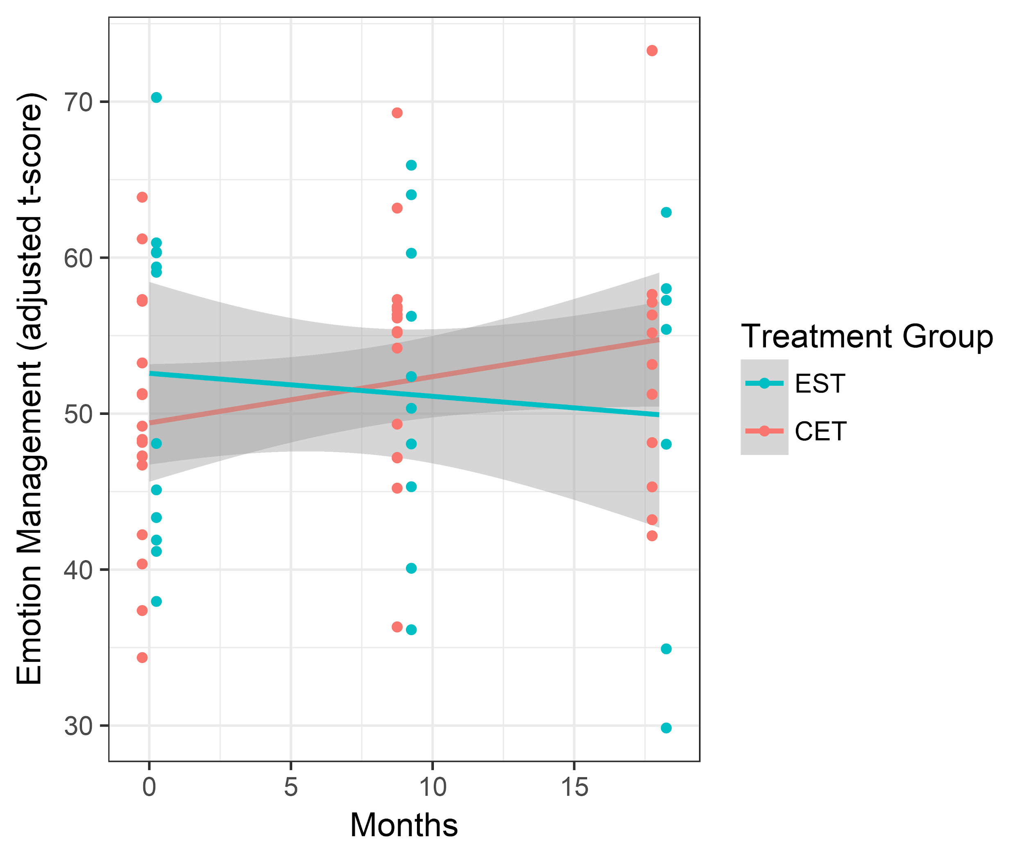
Note: Emotion management performance t-scores are adjusted for age, sex and site. (EST = enriched supportive therapy, CET= cognitive enhancement therapy)

Supplementary Table 3: Results of functional connectivity vs. interaction between treatment group and time, covariates of age, sex, site, and mean framewise displacement (3.2)
 | Interaction Beta | Interaction  t-statistic | Interaction  p-value
LA_LdlPFC | 0.0083 | 0.0439 | 0.965
LA_RdlPFC | 0.0826 | 0.433 | 0.667
RA_LdlPFC | 0.174 | 0.962 | 0.341
RA_RdlPFC | -0.0135 | -0.074 | 0.941
LA_LvlPFC | -0.0175 | -0.103 | 0.918
LA_RvlPFC | -0.0303 | -0.205 | 0.838
RA_LvlPFC | 0.0242 | 0.129 | 0.898
RA_RvlPFC | -0.0928 | -0.513 | 0.610

Note: LA = Left amygdala, RA = Right amygdala, LdlPFC = Left dorsolateral prefrontal cortex, RdlPFC = Right dorsolateral prefrontal cortex, LvlPFC = Left ventrolateral prefrontal cortex, RvlPFC = Right ventrolateral prefrontal cortex

Supplementary Table 4: Overall treatment effect between change in emotion management scores vs. change in functional connectivity across treatment groups (3.3)

 | Beta | t-statistic | p-value
LA_LdlPFC | 0.148 | 0.815 | 0.422
LA_RdlPFC | -0.0914 | -0.465 | 0.646
RA_LdlPFC | 0.00925 | 0.0496 | 0.961
RA_RdlPFC | 0.0661 | 0.346 | 0.732
LA_LvlPFC | -0.213 | -1.16 | 0.257
LA_RvlPFC | -0.115 | -0.572 | 0.573
RA_LvlPFC | -0.239 | -1.27 | 0.215
RA_RvlPFC | -0.209 | -1.07 | 0.295

Note: LA = Left amygdala, RA = Right amygdala, LdlPFC = Left dorsolateral prefrontal cortex, RdlPFC = Right dorsolateral prefrontal cortex, LvlPFC = Left ventrolateral prefrontal cortex, RvlPFC = Right ventrolateral prefrontal cortex

Supplementary Table 5: Overall group treatment differences in functional connectivity at baseline (3.3)
 | Beta | t-statistic | p-value
LA_LdlPFC | 0.00134 | 0.0071 | 0.994
LA_RdlPFC | -0.149 | -0.795 | 0.433
RA_LdlPFC | -0.023 | -0.122 | 0.904
RA_RdlPFC | -0.0726 | -0.385 | 0.703
LA_LvlPFC | 0.0367 | 0.194 | 0.848
LA_RvlPFC | 0.0765 | 0.406 | 0.688
RA_LvlPFC | 0.017 | 0.0901 | 0.929
RA_RvlPFC | 0.0468 | 0.248 | 0.806

Note: LA = Left amygdala, RA = Right amygdala, LdlPFC = Left dorsolateral prefrontal cortex, RdlPFC = Right dorsolateral prefrontal cortex, LvlPFC = Left ventrolateral prefrontal cortex, RvlPFC = Right ventrolateral prefrontal cortex

