Supplementary materials
Methods
Externalized problems
The level of externalizing problems (EP) was assessed using YouthMap12 (Pedersen et al., 2017). Items to compute EP6 (a composite score based on 6 items for externalizing problems) include ‘Were/are you a troublemaker in school?’, ‘Have you had/do you have conflicts with teachers?’ whereas items to compute IP6 (internalizing problems) include ‘Have you been affected by depression?’, ‘Have you experienced anxiety?’. It is well-documented that externalizing is associated with increased risk of problematic substance use (Fischer et al., 2012, Heron et al., 2013, Miettunen et al., 2014). Using EP6 we found strong associations between externalizing behaviour problems and use of alcohol, cigarettes and cannabis in a representative Danish sample (Pedersen et al., 2017) and across Nordic countries (Pedersen et al., 2018); e.g. among 15-16-year-olds, odds ratios for EP6 ≥ 90 percentile and binge drinking at least once a week (past 30 days) was 1.71, p < 0.001 (Pedersen et al., 2017). A cut-off of EP6= 4 – 6 and IP6 = 0/1 yielded 84.8% of sensitivity and 99.6% of specificity in classifying individuals with the same binge drinking (Pedersen et al., 2017). We have previously reported that specific impulsivity traits in this sample, such as urgency and lack of perseverance, are positively associated with substance and non-substance addiction-related behaviours (Rømer Thomsen et al., 2018), and that distraction towards task-based alcohol cues and subjective craving are positively associated with alcohol use (Kvamme et al., 2018). Medication-free participants were included if they had no current major psychiatric disorder or substance use disorder assessed with the Mini International Neuropsychiatric Inventory (Lecrubier et al., 1997).

Self-report measures of addictive behaviours
Other than AUDIT, the brief 8-item version of the Cannabis Use Disorder Identification Test-Revised (CUDIT-R; Adamson and Sellman, 2003) was used for problematic cannabis use which has equivalent or superior psychometric properties to the full length CUDIT. Problematic use of drugs (other than cannabis) was measured using the Drug Use Disorder Identification Test (DUDIT; Berman et al., 2005), a validated 11-item questionnaire assessing patterns of drug use and drug-related problems. We used the Internet Gaming Disorder Scale Short Format (IGD; Pontes and Griffiths, 2015), a validated 9-item questionnaire adapted from criteria that define internet gaming disorder. Problematic pornography use was measured using the Pornography Craving Questionnaire, (PCQ; Kraus and Rosenberg, 2014), a 12-item questionnaire assessing current craving for pornography with good internal consistency and reliability (Kraus and Rosenberg, 2014). The Binge Eating Scale (BES; Gormally et al., 1982), a 16-item questionnaire with high sensitivity and specificity was used for problematic binge eating.
The AUDIT, CUDIT-R and DUDIT were available in Danish, and remaining questionnaires were translated from English to Danish by two Danish researchers with proficient English language abilities. Correlations between self-reported addictive behaviours are shown in Supplementary Table 1. The change in AUDIT score did not correlate with changes in other substance or behavioural addiction measures.
Impulsivity traits were measured using the UPPS-P Impulsive Behaviour Scale (Cyders et al., 2007, Lynam et al., 2006), a 59-item questionnaire assessing impulsivity traits. Correlations between UPPS-P subscores and AUDIT scores can be found in Supplementary Table 2. In the current sample, all baseline UPPS-P subscales were positively associated with the AUDIT at baseline, 1-year and 2-year follow-ups. The correlations between baseline UPPS-P subscales and change in AUDIT scores were significant at the 2-year follow-up for Urgency, Premeditation, and Perseveration, all indicating a negative relationship between impulsivity levels and change in AUDIT scores.

Multicollinearity assessment
The condition index (CI) indicates near-dependency to each eigenvector of the covariance matrix of a given data, and a threshold of 30 is commonly used. Variance inflation factor (VIF) is a reciprocal of 1-R² of a model explaining one variable by all the variables, values larger than 10 are problematic.

Age confounding in AUDIT changes
Given the biphasic trend of alcohol consupmtion in youth (inclining up to a peak around age of 20–24 years and declining after that [World Health Organization, 2018]), it is reasonable to see if our data is also confounded by baseline age (i.e., a younger subject shows a incline; a older subject shows a decline). However, we did not find any significant effect of age on base line AUDIT scores (t[84] = 0.19, p = 0.85 for a liner effect; t[84] = 0.2, p = 0.84 for a quadratic effect). More importantly, linear and quadlinear models revealed no signifcant effect of baseline age in AUDIT changes (t[84] = -0.70, p = 0.48 for a linear effect on $∆$AUDIT[1-0]); t[84] = -0.77, p = 0.45 for a quadratic effect on $∆$AUDIT[2-0]; t[84] = -0.97, p = 0.34 for a linear effect on $∆$AUDIT[2-0]; t[84] = -1.03, p = 0.31 for a quadratic effect on $∆$AUDIT[2-0]]. It is still possible that adding covariate with non-significant trends improves a model fit, but it was not the case here (adjusted R2 = -0.006 for $∆$AUDIT[2-0]; adjusted R2 = -0.007 for $∆$AUDIT[2-0]). Therefore, we determined not to covary age in testing changes of behavioural scores.

Control analysis
In addition to R1, we also investigated local grey matter volume (GMV), which is grey matter probability modulated by Jacobian determinant (Ashburner and Friston, 2000), and fractional anisotropy (FA) based on diffusion-weighted images (Basser et al., 1994). See below for information on diffusion-weighted imaging sequence.
As of GMV, grey matter probability maps, which were estimated from the unified segmentation, were normalized to the MNI template space and modulated by Jacobian determinant of the inverse deformation field to incorporate global brain size variation across individuals. The GMV maps were resampled and smoothed with the same parameters described above for the R1 maps.
Although FA was significantly associated with cross-sectional baseline AUDIT scores covarying for age and sex (similar to GLM 4), there were no significant correlations with FA (cluster-p > 0.43). We found a negative association with GMV in the right precentral gyrus and cerebellum (cluster-p < 0.004); however, this is not further discussed given the focus on the longitudinal AUDIT changes ($∆$AUDIT). There were no significant correlations with GMV or FA with other baseline substance or behavioural addiction measures. We also tested the association between GMV and FA and longitudinal changes in behavioural parameters. There were no significant findings in GMV nor FA (cluster-p > 0.85); thus, we focused on the R1 findings in the main text.

Diffusion sequence and analysis
Diffusion-weighted echo-planar imaging data was acquired using a diffusion kurtosis imaging (DKI) sequence (b-values = 0, 1,000, 2,000, 2,500 s/mm²; 90 directions) with the following parameters: TE = 95 ms, TR = 6,800 ms, FA = 90 º, voxel size = 2.7 x 2.7 x 2.7 mm³. Using FMRIB's Diffusion Toolbox (FDT, v 3.0) in FMRIB Software Library (FSL; https://fsl.fmrib.ox.ac.uk/fsl), a tensor model was fit to the diffusion-weighted data and fractional anisotropy (FA) was calculated. The DKI analysis of the current data is currently ongoing as a separate study. Using SPM12, FA images were normalized into the Montreal Neurological Institute (MNI) space and resampled at 2.7-mm isotropic resolution. For the lower spatial resolution, the effective FWHM of FA images was similar to that of R1 and grey matter volume images (i.e., 5.4 x 5.6 x 5.6 mm³) without additional smoothing. A minimal (FWHM = 3 mm) smoothing was explored but it did not alter the results.

Results
Correlation coefficients between self-reported addictive behaviours
At baseline, some of the measures were correlated whereas only few of the longitudinal changes were correlated (diagonal blocks). Interestingly, changes in measures that showed significant decreases (i.e., Alcohol Use Disorder Identification Test, AUDIT; Cannabis Use Disorder Identification Test-Revised, CUDIT; Internet Gaming Disorder Scale Short Format, IGD) showed negative correlation with the baseline measures, indicating that individuals with high baseline addiction scores showed greater decreases over time (see Supplementary Table 1).

UPPS subscores and addictive behaviours
Correlations between baseline AUDIT, change in AUDIT ($∆$AUDITs), and baseline UPPS-P (Supplementary Table 2). Baseline UPPS-P was positively associated with the AUDIT at baseline and 1-year. The $∆$AUDITs were negatively correlated with UPPS-P indicating that the individuals with high baseline-AUDIT scores also had high baseline UPPS-P scores with many of these individuals reporting decreased AUDIT scores at 2-year follow-up.

Age and Sex
Age and sex significantly increased explained variance of GLM (2) and (3), respectively in the left hippocampus and the left cerebellum (cluster-p < 0.033; Supplementary Figure 1a) and the thalamus, globus pallidus, brainstem, cerebellum (cluster-p < 0.044; Supplementary Figure 1b). Thus, age and sex were covaried in all subsequent analyses.

Supplementary table and figure legends
Supplementary Table 1.
Title: Correlation Coefficients between self-reported addictive behaviours at baseline and follow-ups.
Legend: Significant correlations are indicated in bold. * reflects p < 0.05 at |r| > 0.21 and ** p < 0.01 at |r| > 0.28. Change from baseline is indicated by Δ. AUDIT = Alcohol Use Disorder Identification Test, CUDIT = Cannabis Use Disorder Identification Test-Revised, DUDIT = Drug Use Disorder Identification Test, IGD = Internet Gaming Disorder Scale Short Format, PCQ = Pornography Craving Questionnaire, BES = Binge Eating Scale. Urgency (combining positive and negative), premeditation, perseveration, and sensation seeking refer to the respective UPPS-P subscales.

Supplementary Table 2.
Title: Pearson correlation coefficients of UPPS subscores and AUDIT scores at baseline and follow-ups (minus baseline).
Legend: Significant correlations are indicated in bold. * reflects p < 0.05 at |r| > 0.21 and ** p < 0.01 at |r| > 0.28.Change from baseline is indicated by Δ. AUDIT = Alcohol Use Disorder Identification Test. Urgency (combining positive and negative), premeditation, perseveration, and sensation seeking refer to the respective UPPS-P subscales.

Supplementary Table 3.
Title: Multicollinearity assessments of regressors.
Legend: CI = condition index; VIF = variance inflation factor. Change from baseline is indicated by Δ. AUDIT = Alcohol Use Disorder Identification Test, CUDIT = Cannabis Use Disorder Identification Test-Revised, DUDIT = Drug Use Disorder Identification Test, IGD = Internet Gaming Disorder Scale Short Format, PCQ = Pornography Craving Questionnaire, BES = Binge Eating Scale. Urgency (combining positive and negative), premeditation, perseveration, and sensation seeking refer to the respective UPPS-P subscales.

Supplementary Figure 1.
Title: Age and sex effects on R1
Legend: The effect of covariates in GLMs. A: T-statistic maps for the effect of age thresholded at the cluster-level of 0.05. B: T-statistic maps for the effect of sex.

Supplementary Figure 2.
Title: Relationships between AUDIT scores
Legend: Scatterplots of the relationship between AUDIT scores at baseline and at follow-up.

Supplementary Figure 2.
Title: Effect of age in AUDIT.
Legend: Left: all data points of 86 subjects and 3 sessions. Each dot represents a measurement and a line connects sessions of each subject. Center: AUDIT change after one year over age at baseline. T-statistics, degrees of freedom, and P-value for the effect of age are noted above. A linear regression line is given in red. Right: AUDIT change after two years over age at baseline.

Supplementary Table 1
Variables | 2 | 3 | 4 | 5 | 6 | 7 | 8 | 9 | 10 | 11 | 12 | 13 | 14 | 15 | 16 | 17 | 18
1. AUDIT(0) | 0.20 | 0.34** | 0.14 | 0.26* | 0.07 | -0.39** | 0.02 | -0.15 | 0.05 | 0.04 | 0.03 | -0.60** | 0.13 | -0.10 | 0.11 | 0.02 | -0.09
2. CUDIT(0) |  | 0.71** | 0.15 | 0.23* | -0.08 | 0.15 | -0.54** | -0.35** | 0.19 | -0.15 | 0.02 | 0.00 | -0.25* | -0.32** | 0.12 | -0.02 | -0.01
3. DUDIT(0) |  |  | 0.11 | 0.02 | -0.01 | 0.01 | -0.35** | -0.59** | 0.29** | 0.09 | 0.03 | -0.05 | 0.08 | -0.56** | 0.18 | 0.18 | -0.02
4. IGD9(0) |  |  |  | 0.41** | -0.19 | 0.02 | 0.04 | 0.00 | -0.54** | 0.12 | -0.13 | 0.01 | 0.10 | 0.01 | -0.48** | -0.09 | 0.06
5. PCQ(0) |  |  |  |  | -0.14 | 0.05 | 0.00 | 0.17 | -0.16 | -0.22* | 0.03 | -0.02 | -0.05 | 0.17 | -0.26* | -0.22* | -0.01
6. BES(0) |  |  |  |  |  | 0.05 | 0.00 | -0.13 | 0.05 | 0.02 | -0.21* | -0.14 | 0.03 | -0.07 | 0.06 | 0.04 | -0.68**
7. ΔAUDIT(1-0) |  |  |  |  |  |  | 0.09 | 0.12 | 0.12 | 0.14 | 0.08 | 0.60** | 0.06 | 0.10 | 0.07 | -0.04 | 0.02
8. ΔCUDIT(1-0) |  |  |  |  |  |  |  | 0.61** | -0.03 | 0.17 | 0.04 | -0.01 | 0.52** | 0.57** | -0.05 | 0.05 | 0.06
9. ΔDUDIT(1-0) |  |  |  |  |  |  |  |  | -0.22* | -0.08 | 0.10 | 0.15 | -0.04 | 0.91** | -0.31** | -0.11 | 0.13
10. ΔIGD9(1-0) |  |  |  |  |  |  |  |  |  | 0.15 | 0.15 | 0.01 | 0.24* | -0.20 | 0.72** | 0.18 | 0.08
11. ΔPCQ(1-0) |  |  |  |  |  |  |  |  |  |  | 0.16 | 0.10 | 0.31** | -0.02 | 0.21* | 0.50** | 0.17
12. ΔBES(1-0) |  |  |  |  |  |  |  |  |  |  |  | 0.06 | 0.00 | 0.09 | 0.03 | 0.30** | 0.53**
13. ΔAUDIT(2-0) |  |  |  |  |  |  |  |  |  |  |  |  | 0.02 | 0.09 | -0.15 | 0.02 | 0.20
14. ΔCUDIT(2-0) |  |  |  |  |  |  |  |  |  |  |  |  |  | -0.12 | 0.10 | 0.21* | 0.05
15. ΔDUDIT(2-0) |  |  |  |  |  |  |  |  |  |  |  |  |  |  | -0.20 | -0.06 | 0.07
16. ΔIGD9(2-0) |  |  |  |  |  |  |  |  |  |  |  |  |  |  |  | 0.13 | 0.01
17. ΔPCQ(2-0) |  |  |  |  |  |  |  |  |  |  |  |  |  |  |  |  | 0.07
18. ΔBES(2-0)

Supplementary Table 2
 | AUDIT(0) | AUDIT(1) | AUDIT(2) | ΔAUDIT(1-0) | ΔAUDIT(2-0)
Urgency | 0.39** | 0.39** | 0.24** | -0.04 | -0.32**
Premeditation | 0.33** | 0.30** | 0.21* | -0.08 | -0.26*
Perseveration | 0.31** | 0.32** | 0.22* | -0.02 | -0.22*
Sensation seeking | 0.44** | 0.50** | 0.43** | 0.05 | -0.16

Supplementary Table 3
Variables | Max CI | Max VIF
ΔAUDIT(1-0), age, sex | 2 | 1.1
ΔAUDIT(1-0), age, sex, urgency, premeditation, perseveration, sensation seeking | 16 | 1.6
ΔAUDIT(1-0), age, sex, ΔCUDIT(1-0), ΔDUDIT(1-0), ΔIGD, ΔPCQ(1-0), ΔBES(1-0) | 3 | 1.9
ΔAUDIT(2-0), age, sex | 2 | 1.0
ΔAUDIT(2-0), age, sex, urgency, premeditation, perseveration, sensation seeking | 16 | 1.6
ΔAUDIT(2-0), age, sex, ΔCUDIT(2-0), ΔDUDIT(2-0), ΔIGD(2-0), ΔPCQ(2-0), ΔBES(2-0) | 4 | 1.1

Supplementary Figure 1
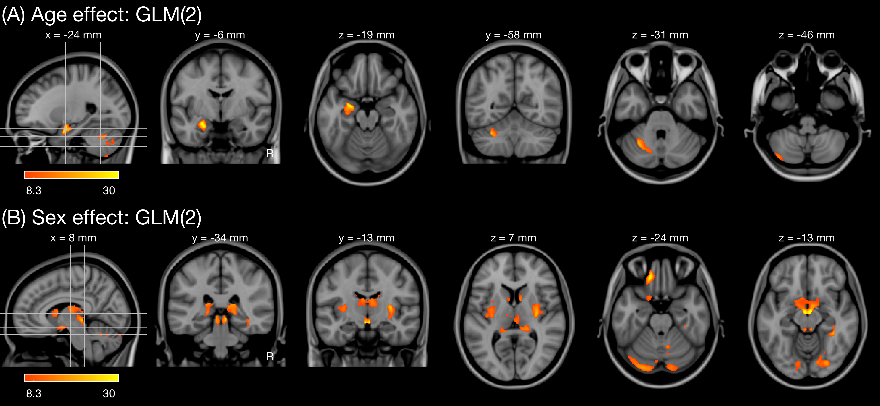

Supplementary Figure 2 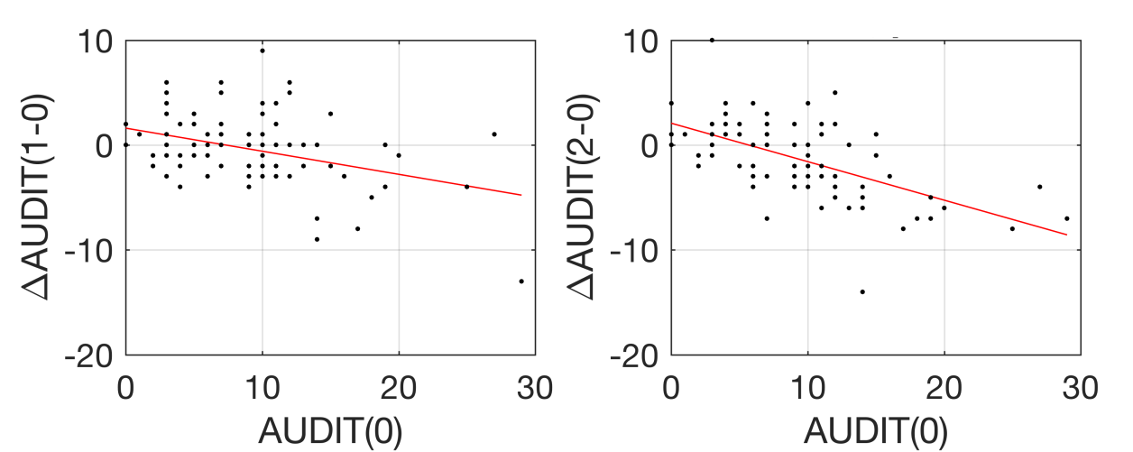

Supplementary Figure 3
